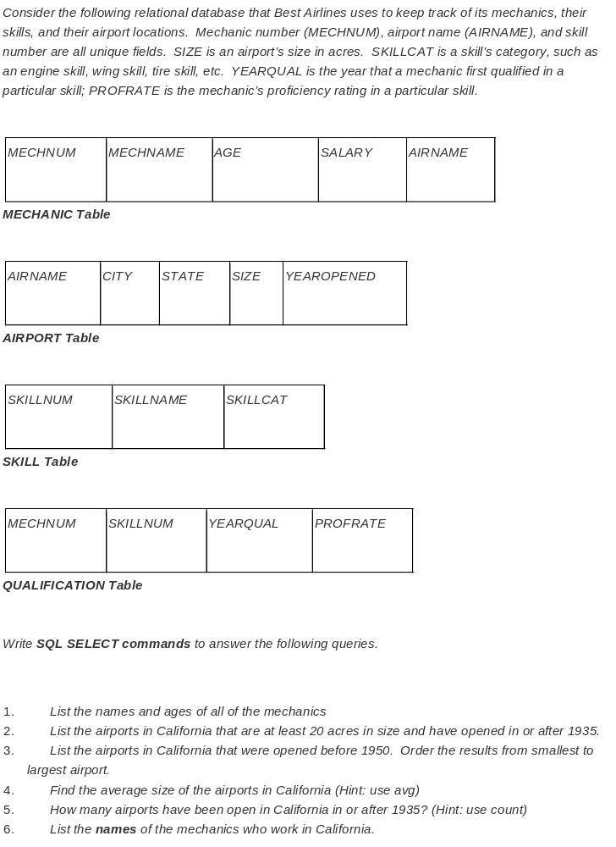Question 1:
select MECHNAME, AGE from MECHANIC;

Question 2:
select * from AIRPORT
where STATE = ‘California’
and SIZE >= 20
and YEAROPENED >= 1935;

Question 3:
select * from AIRPORT
where STATE = ‘California’
and YEAROPENED < 1950
order by SIZE asc;

Question 4:
select avg(SIZE) from AIRPORT
where STATE = ‘California’;

Question 5:
select count(*) from AIRPORT
where STATE = ‘California’
and YEAROPENED >= 1935;

Question 6:
select MECHANIC.MECHNAME from MECHANIC, AIRPORT
where MECHANIC.AIRNAME = AIRPORT.AIRNAME
and AIRPORT .STATE = ‘California’;

