1.A.i This is the answer for this question

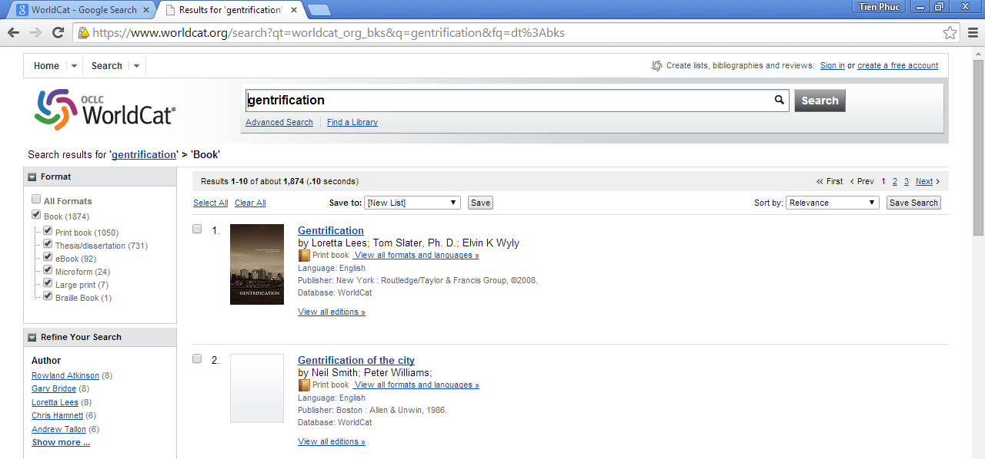

1.A.ii This is the answer for this question
Web of Science – Cannot access, you must access on your school library computer to open the website

1.A.iii This is the answer for this question
LexisNexis Academic database – Cannot access, you must access on your school library computer to open the website
1.B.i This is the answer for this question

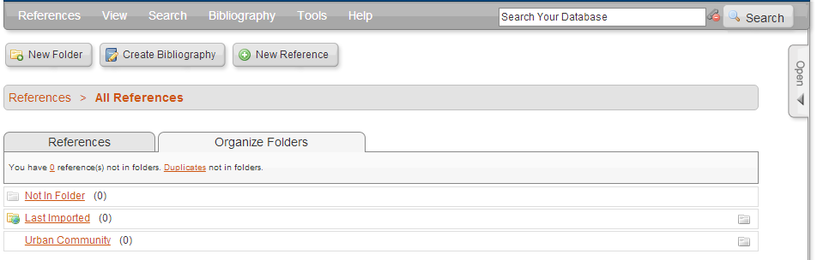
2.A This is the answer for this question

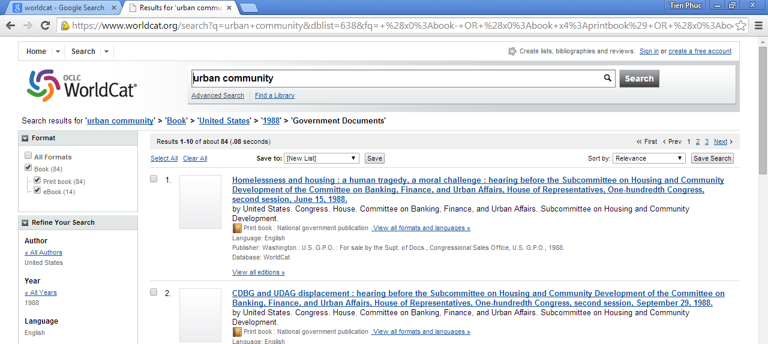

→ By using the digital library, we can find the data from the past that help us to understand more about what was happened in the past. The reference of “Homelessness and housing : a human tragedy, a moral challenge : hearing before the Subcommittee on Housing and Community Development of the Committee on Banking, Finance, and Urban Affairs, House of Representatives, One-hundredth Congress, second session, June 15, 1988.” gives us a deep knowledge about the urban community in the past. By using this digital library, we can find articles that we cannot find in the normal search engine like Google or Yahoo
2.B This is the answer for this question
I use the RefWorks and I can create a citation database for the search term that I want. I just search the articles on the WorldCat, take the reference, then add the reference into the RefWorks, and then I can re-reference the articles as many times as I want. I can divide the references into different sub-category that make me easy to locate the info that I need. Moreover, If I want to cite for the article, I just use the create bibliography function in the Refworks to create the APA v6 reference style for my writing papers.

2.C This is the answer for this question
1. Here are the bibliography that downloaded in the Refworks
United States. (1988). Community Housing Partnership Act: Hearing before the Subcommittee on Housing and Community Development of the Committee on Banking, Finance, and Urban Affairs, House of Representatives, One-hundredth Congress, second session on H.R. 3891 ... July 12, 1988. Washington: U.S. G.P.O.

United States. (1988). CDBG and UDAG displacement: Hearing before the Subcommittee on Housing and Community Development of the Committee on Banking, Finance, and Urban Affairs, House of Representatives, One-hundredth Congress, second session, September 29, 1988. Washington: U.S. G.P.O.

United States. (1988). Homelessness and housing: A human tragedy, a moral challenge : hearing before the Subcommittee on Housing and Community Development of the Committee on Banking, Finance, and Urban Affairs, House of Representatives, One-hundredth Congress, second session, June 15, 1988. Washington: U.S. G.P.O.

2.
2.1 In this Community guide of the City Guide category, we will se the APA v6 to format for the bibliography. And the citation for articles, we will take from the WorldCat. We take all the reference from the WorldCat, then add the references to the RefsWorks one by one under the Community folder. Then, if we want to add the these citation into our writing papers, we can use the Create bibliography fuction from the Refsworks to export the citation in the APA v6 for us

2.2
Nebraska. (1977). Nebraska community profile. Lincoln: Nebraska Dept. of Economic Development.

Time-Life Books. (1976). The community. New York: Time-Life Books.

Harmon, D., Russo, J., McHale, J., Jacobs, G., Pudi, D., Brown, Y. N., Brie, A., ... Sony Pictures Home Entertainment (Firm),. (2010). Community: The complete first season.

The Link: http://www.refworks.com/refworks2/default.aspx?r=references|MainLayout::init

