2.E.vii This is the answer for this question

CollegeGrads |  | PovertyRate |  | RentalRate |  | VacancyRate
Mean | 0.348413353 | Mean | 0.139942205 | Mean | 0.078587341 | Mean | 0.405970662
Standard Error | 0.008357957 | Standard Error | 0.005901957 | Standard Error | 0.002820092 | Standard Error | 0.012721911
Median | 0.339787028 | Median | 0.113651208 | Median | 0.069982649 | Median | 0.367695962

2.F.v. This is the answer for this question

 | CollegeGrads | PovertyRate | RentalRate | VacancyRate
CollegeGrads | 1
PovertyRate | -0.603089506 | 1
RentalRate | -0.19148542 | 0.377088547 | 1
VacancyRate | -0.334876681 | 0.618957602 | 0.311168323 | 1

2.G.viii.: This is the answer for this question
R Square:
R Square | 0.363717

P-value
Independent variable coefficient
How do you interpret these statistics for your regression?
 | Coefficients | Standard Error | t Stat | P-value | Lower 95% | Upper 95% | Lower 95.0% | Upper 95.0%
Intercept | 0.288321213 | 0.012020999 | 23.98479554 | 4.79429E-73 | 0.264669614 | 0.311972813 | 0.264669614 | 0.311972813
X Variable 1 | -0.425870614 | 0.031736995 | -13.41874415 | 8.80287E-33 | -0.488313899 | -0.36342733 | -0.488313899 | -0.36342733

2.H This is the answer for this question

1. What would you have hypothesized about the Census data that you downloaded? In particular, what relationships would you have expected to find between these datasets?
The data that we have downloaded in the Census give us a general data about the Sex, Poverty, Occupation, and Tenure of the population. And from that data we can do the data analysis to find the relationship between them.

We are expecting to find the relationship about the Sex and the Occupation. We need to find how the sex effect to the occupation. We need to see whether male have a higher change to get the good jobs than female or not. And, between the occupation and the poverty. We need to see which type of occupation that has a change to get higher payments than the rest.

2. Give us a statistical overview (using your descriptive stats) of the county that you examined.
From the table of descriptive stats above , we can see that
+CollegeGrads: Our country gets a high rate for this
+PovertyRate: Our country gets a low rate for this
+RentalRate: Our country gets a medium rate for this
+VacancyRate: Out country get a medium rate for this

3. What are the results of the correlation analysis? How significant are these results? Are these in any way surprising?
The result of correlation analysis as

 | CollegeGrads | PovertyRate | RentalRate | VacancyRate
CollegeGrads | 1
PovertyRate | -0.603089506 | 1
RentalRate | -0.19148542 | 0.377088547 | 1
VacancyRate | -0.334876681 | 0.618957602 | 0.311168323 | 1

The data show that even the CollegeGrads – PovertyRate is a negative number but the PovertyRate-VacancyRate is rather high

4. What are the results of the regression analysis? How significant are these results? Are these in any way surprising?
The result of regression analysis as

 | df | SS | MS | F | Significance F
Regression | 1 | 1.269117841 | 1.269117841 | 180.0626945 | 8.80287E-33
Residual | 315 | 2.220182926 | 0.0070482
Total | 316 | 3.489300766

5. Include a copy of the chart that was produced in the regression, and explain (in your own words) how a reader should interpret this chart.

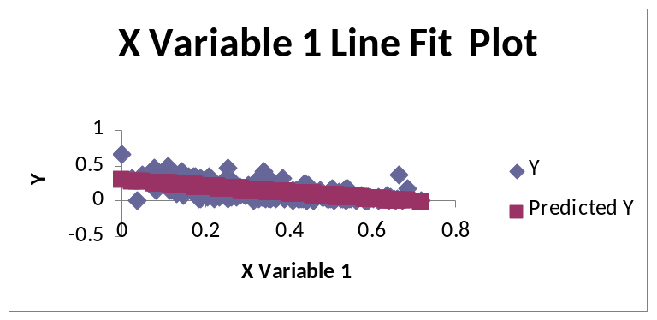

The chart should understand as the Y is the Poverty rate and the X is the Graduate rate. This chart the view of how the Poverty and the Graduate have a relationship

6. Discussion of the results - what do these data tell us about your county? How might the information that you've produced here impact the ways that a planner or community developer would approach this county?
The graph is between the Graduate and the Poverty. The graph shows that the higher value of the graduate X, the lower of the Poverty value Y. So, the government should try to invest more on the education of the graduate to reduce the poverty rate

