**Written Response 1.B.iii:** The answer for the question is
When collaborating on a project with others, what is the benefit of adding viewers and editors to a Google document rather than attaching a Word document to an email?

When we attach a document to an email to send to a group of users, each of users need to download then open the document to see. And, users need to have the software, Microsoft Word for example, to see the document. Moreover, if any changes in the document by the editors, the viewers will not know the change to update the document. The owner of the document needs to resend the updated document again to viewers. If we use the Google Drive, we do not need to do this

**Written Response 1.B.iv:** The answer for the question is
Why might you choose to publish your document as a webpage rather than use the sharing or collaboration feature?

If we share the document to others, they may download and have the copy of our document. If we use the collaboration feature, other users may be able to edit our document. So, by choosing to publish our document s a webpage, we offer a view of the document to other people without letting them to download or edit our original document

**Written Responses 1.C.i:** The answer for the question is
1. Describe one hypothetical situation in which you can imagine using a Google Spreadsheet form (3-5 sentences).
We can use the Google Spreadsheet to calculate the salary for all of the employees in the company
2. What is the procedure to convert a chart that you've created in Google Spreadsheets into an image that you could use in a document or presentation?
To convert our chart in the Google Spreadsheet to an image, we can follow these steps:
→Click the chart.
→Click the Chart drop-down menu in the top-left corner.
→Select Save image.
→In the window that appears, select "Save to disk" (or "Save file") and click OK. Your chart will be saved to your computer.

**Written Responses 1.D.i:** The answer for the question is
1. How does Google suggest that you deal with the copyright issue when working with images from the Internet in your Google Slides? What is the maximum files size and dimension of an image that you can use in Slides?
To use the image on the Internet, Google recommends us to make sure that we have the permission before we use that image
To use in the Google Slices, images can have a maximum of 2500 pixels in dimension and a maximum of 5 megabytes (MB) in size.
2. What is the procedure to add a video to your Google Presentation?
→To add a video to the Google Presentation, we need to upload that video into the Youtube first.
→Then, we go to the Google Presentation to create a new presentation.
→Click on Insert, then Click on Video
→Search for the Video we want to add in the Youtube
→From the Youtube search result, click on the Video we want to insert it into the presentation

**File Output 1.E.i - 1.E.ii:** The answer for the question is
1.

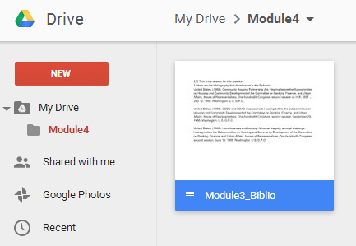

https://docs.google.com/document/d/1X5KQf0qA78rDdWpzM3CGajPIg-s3F2s8PSnRCLYvtz8/pub

2. Publish 'Module4Workbook' spreadsheet as a web page
https://docs.google.com/spreadsheets/d/1EfHyNr4TGOyTfiFmNd3FzuMqYG2VRrQfnb6TiplWS3Y/pubhtml

**Written Responses 2.A:** The answer for the question is
What is the cultural event or phenomenon that you've identified? What ethnic group (or groups) is linked to this event/phenomenon? Please use at least 4-5 sentences to describe the event/phenomenon.

The town that I choose is the Sacramento of California where there are a lot of Asian Chinese is living. For the Chinese, the most important event in the year is the Lunar New Year. This is the time all of the member in the family gather together so share what they have done in the whole year and give other member a good wishes. And, for single person, they can get the “red package” with a little lucky money from the elder people,

**File Output 2.B:** The answer for the question is
Publish your Google Spreadsheet (as a web page) from this step and include a link to it in your written response document (also be sure that your chart is included in the spreadsheet that you publish!).

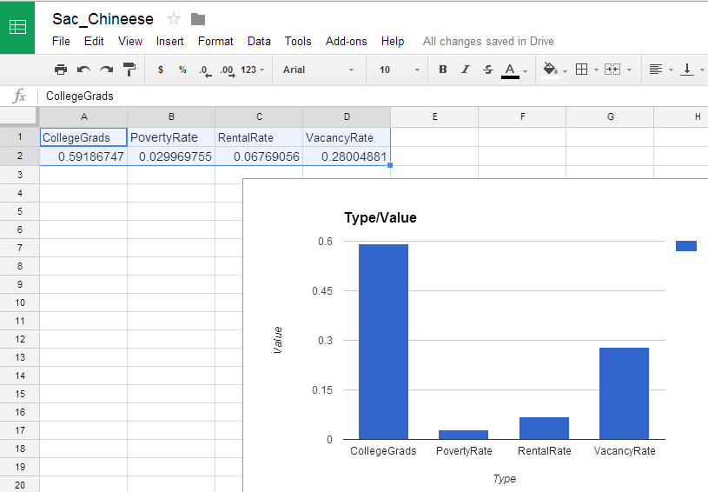

https://docs.google.com/spreadsheets/d/1Bxr4WP9V9W3uvE3wFeOR0_mPnefuKx2IRQ8PLOJdkUc/pubhtml

**File Output 2.C:** The answer for the question is
If you've found images, then add them directly to your written response document along with a citation for each of them. If you've found videos, then add a web address (URL) to your written response document for each of them.


https://commons.wikimedia.org/wiki/File:Seattle_-_Chinese_New_Year_2011_-_85.jpg

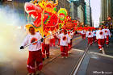
https://encrypted-tbn3.gstatic.com/images?q=tbn:ANd9GcQEN0oItG6OT9lC8qiHFxJhnG0Vdln8seLvMhWfmgb_oPJwoj7DcOJjcqOk

**File Output 2.E(1):** The answer for the question is
Publish your presentation to the web and include a link to it in your written response document.
https://docs.google.com/presentation/d/1uHrQFm7GU3PF6uuwAeEObCemIMDFxcMtPBQjjH7I6jo/pub?start=false&loop=false&delayms=3000

**File Output 2.E(2):** The answer for the question is
Add a new page called 'Culture' to the City Guide category of your portfolio, and on this page include an overview (150-250 words) of the cultural event/phenomenon that you examined. Provide a link to your published presentation on this page as well.

The town that I choose is the Sacramento of California where there are a lot of Asian Chinese is living. For the Chinese, the most important event in the year is the Lunar New Year. This is the time all of the member in the family gather together so share what they have done in the whole year and give other member a good wishes. And, for single person, they can get the “red package” with a little lucky money from the elder people,

https://docs.google.com/presentation/d/1uHrQFm7GU3PF6uuwAeEObCemIMDFxcMtPBQjjH7I6jo/pub?start=false&loop=false&delayms=3000

