Final Report

A. Introduction
For all of the works that I have done for recent assignment, I focus on the Sacramento town of the California State. This town can be considered as a big town with many landmarks and the diversity of races as Black, Asian, Hispanic and White people. Therefore, the town has many traditional cultures that mix together to form a unique culture for itself.

Here is the position of the Sacramento town in the United States map taken from the Google Earth

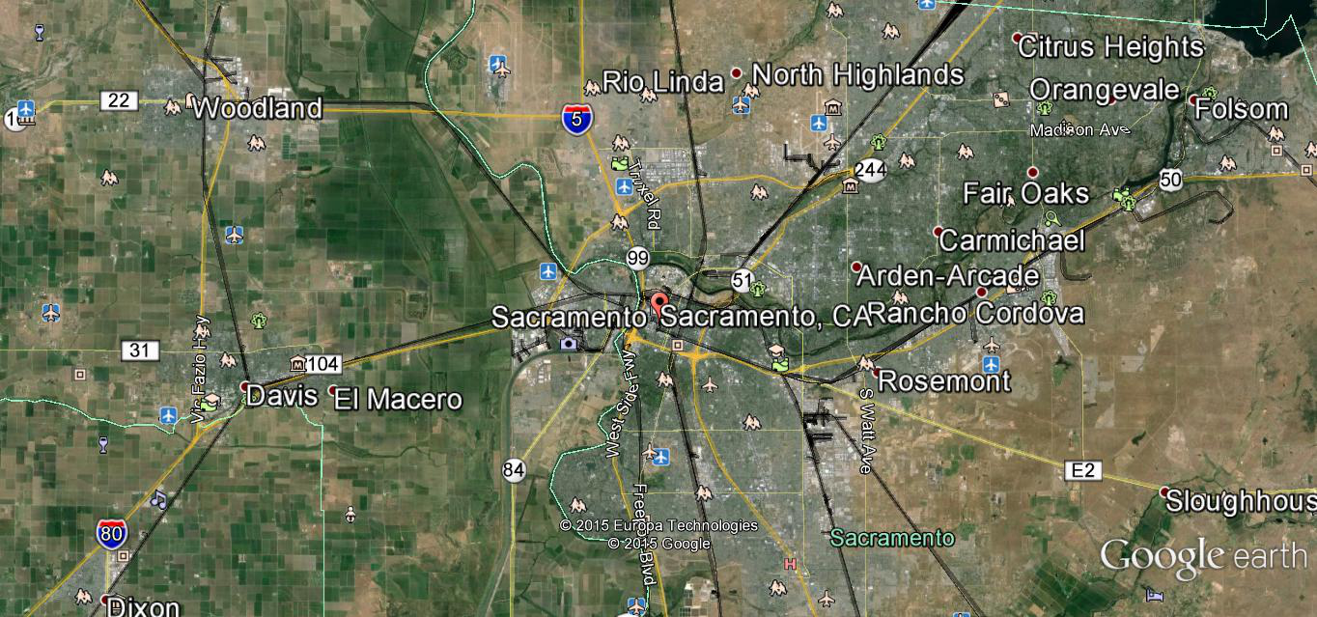

The town Sacramento of California. has many popular landmarks as
+ Adams and Company Building at Old Sacramento State Historic Park, 1014 2nd St. this is the oldest building in the ton that has many popular company resided in
+ African Methodist Episcopal Church at 715 Seventh St. This is the old church that has many historical memories for the Africans hen they first time reach in the ton
+ B.F. Hastings Bank Building at Old Sacramento State Historic Park, 1000 2nd St. This the old building that the B.F. Hastings bank build for them for a long time ago
+ California’s First Passenger Railroad at 3rd and R Sts. This is one of the most valuable historical senses of the state. This the railroads station for the time that the California state welcome first passengers
+ California State Capitol at 10th St and Capitol Mall. This is the important building for the state that built for a long time in the past

B. Data Analysis for Sacramento
1. Data On Community And Housing

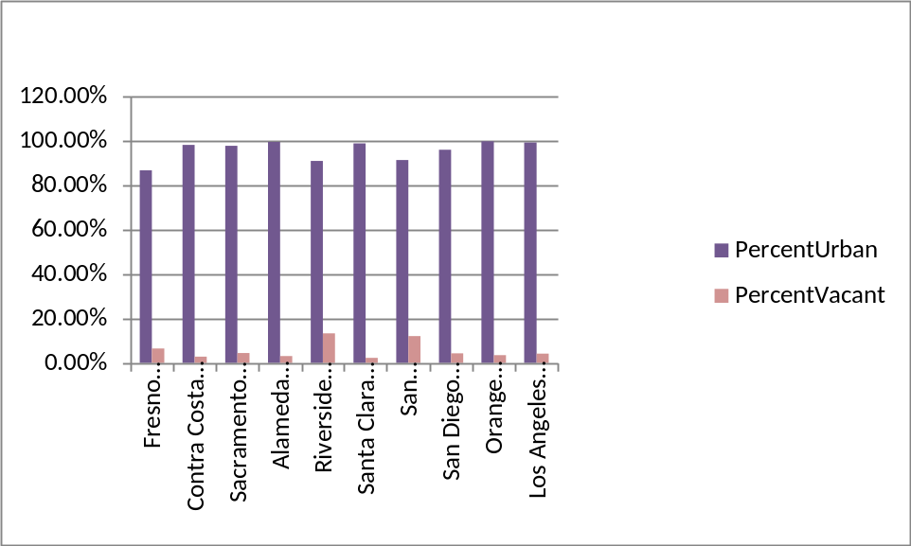

Based on the data on the graph, we can see that in general, most of the people in the California State live in the Urban (>80%). And the Sacramento town has one of the highest rate (>90%). Not only have the highest rate on Percent Urban, the town also has the low rate on the vacant of housing. With the rate of vacant housing is nearly 5%, Sacramento in one of the town has the lowest Vacant Percent in the California. In general, the vacant percent of California Sate is rather low (almost all of the towns are below 10%)

2. College Graduate, Poverty, House Rental, And Vacancy Data Analysis

College  Grads |  | Poverty  Rate |  | Rental  Rate |  | Vacancy  Rate
Mean | 0.348413353 | Mean | 0.139942205 | Mean | 0.078587341 | Mean | 0.405970662
Standard  Error | 0.008357957 | Standard  Error | 0.005901957 | Standard  Error | 0.002820092 | Standard  Error | 0.012721911
Median | 0.339787028 | Median | 0.113651208 | Median | 0.069982649 | Median | 0.367695962

Looking at the table data analysis above, we have
+College Graduate: 0.339787028 (33.97%)
+Poverty: 0.113651208 (11.36%)
+House Rental: 0.069982649 (6.99%)
+Vacancy: 0.367695962 (36.76%)

This is the data that we take from the site http://factfinder.census.gov/ for analyzing for the College Graduate and the Poverty of the Sacramento town. The data shows me that the College Graduate of the town is rather high at 33.97%, and the poverty rate is rather low at 11.36%.

In my opinion, the data analysis doesn’t surprise me because we know that California State is one of the richest states in the United State. According to World Economy (2014), by considering the state GDP to some of the power countries as England, Germany, France, Spain, Italia, etc. California has the higher GDP than France, Spain, and Italia.

Next, we will analysis the data on another way:

 | CollegeGrads | PovertyRate | RentalRate | VacancyRate
CollegeGrads | 1
PovertyRate | -0.603089506 | 1
RentalRate | -0.19148542 | 0.377088547 | 1
VacancyRate | -0.334876681 | 0.618957602 | 0.311168323 | 1

From the table of descriptive stats above , we can see that
+CollegeGrads: Our country gets a high rate for this
+PovertyRate: Our country gets a low rate for this
+RentalRate: Our country gets a medium rate for this
+VacancyRate: Out country get a medium rate for this

The data show that even the CollegeGrads – PovertyRate is a negative number but the PovertyRate-VacancyRate is rather high

2.1 Poverty Rate And Home Rate

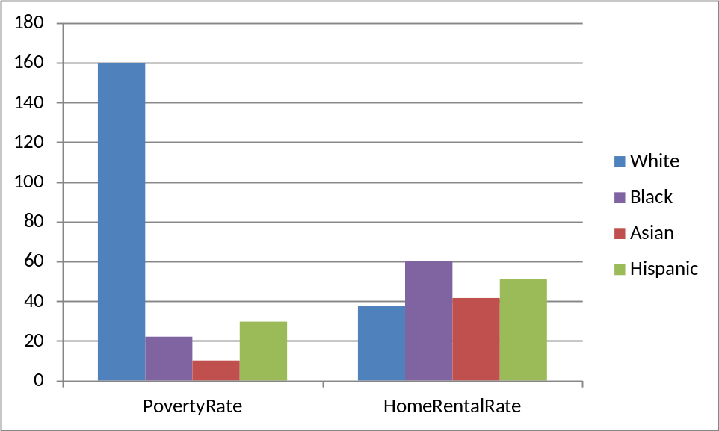

Based on this graph we see that the poverty of Asian is highest and the White is lowest. But, the house rental rate is not much different, all four races have nearly the same house rental rate

2.2 Graduate Rate And College Rate

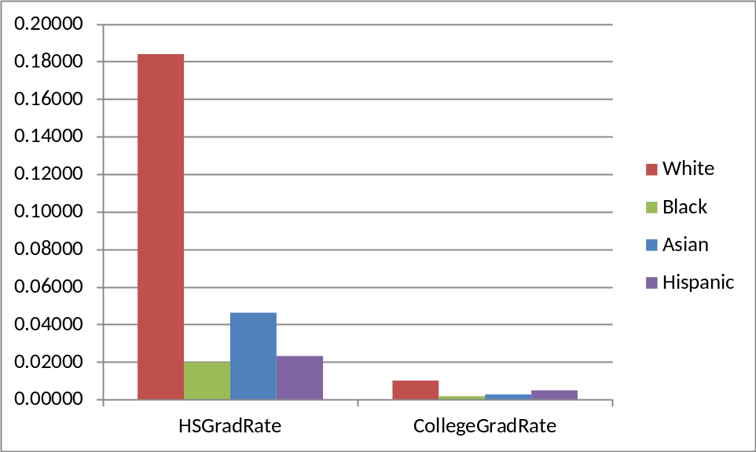

Based on the graph we see that the college rate and the graduate rate are much different. This indicates that all four races focus on the higher education. For both college and the graduate, the White has the highest rate and the rest three races have nearly the same rate of education

3. Data Analysis On The Sex And Occupation

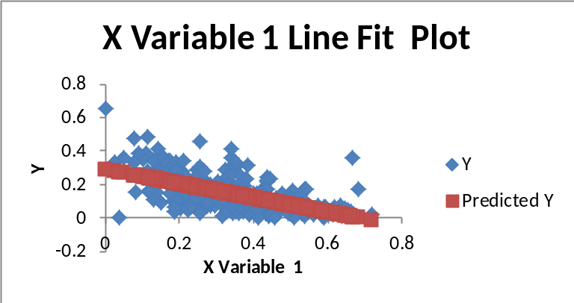

The chart should understand as the Y is the Poverty rate and the X is the Graduate rate. This chart the view of how the Poverty and the Graduate have a relationship

We are expecting to find the relationship about the Sex and the Occupation. We need to find how the sex effect to the occupation. We need to see whether male have a higher change to get the good jobs than female or not. And, between the occupation and the poverty. We need to see which type of occupation that has a change to get higher payments than the rest.

The graph is between the Graduate and the Poverty. The graph shows that the higher value of the graduate X, the lower of the Poverty value Y. So, the government should try to invest more on the education of the graduate to reduce the poverty rate
C. Conclusion
Finally, in my conclusion, I see that Sacramento town of California is a good place for living, studying and working. All the analyzed data show that Sacramento has a good rate on Gratedate, Poverty, Housing, and Occupation.

This time is the first time we try to use the data on the site
http://factfinder.census.gov/ to make a analyzing. Therefore, even though I try best to reference the data and do the calculation, I think the analyzing may have some mistakes that make the final result not 100% accuracy. So, next time, when we do a new analysis for another, I will have the experience to take the data as well as do the estimation for the best outcomes.

I know that the California State is one of the richest states in the United States. But, the data showing makes me surprise for the higher rate of Gratedate, Poverty, Housing, and Occupation. By looking at the Graduate and the Poverty rate relationship, we can be sure that for the town that has the higher rate of Graduate will have the lower rate of Poverty

The data on the Graduate and the Poverty is really interesting me. But, if you have a chance to analysis for the Sacramento town, you may take a look at the Sex and the Occupation data. It may provide you a deep and specific look on how sex and occupation effect to each other in this town

References

Nebraska. (1977). Nebraska community profile. Lincoln: Nebraska Dept. of Economic Development.

Harmon, D., Russo, J., McHale, J., Jacobs, G., Pudi, D., Brown, Y. N., Brie, A., ... Sony Pictures Home Entertainment (Firm),. (2010). Community: The complete first season.

Time-Life Books. (1976). The community. New York: Time-Life Books.

United States. (1988). Community Housing Partnership Act: Hearing before the Subcommittee on Housing and Community Development of the Committee on Banking, Finance, and Urban Affairs, House of Representatives, One-hundredth Congress, second session on H.R. 3891 ... July 12, 1988. Washington: U.S. G.P.O.

United States. (1988). CDBG and UDAG displacement: Hearing before the Subcommittee on Housing and Community Development of the Committee on Banking, Finance, and Urban Affairs, House of Representatives, One-hundredth Congress, second session, September 29, 1988. Washington: U.S. G.P.O.

United States. (1988). Homelessness and housing: A human tragedy, a moral challenge : hearing before the Subcommittee on Housing and Community Development of the Committee on Banking, Finance, and Urban Affairs, House of Representatives, One-hundredth Congress, second session, June 15, 1988. Washington: U.S. G.P.O.

