Project Name: ATM Monitoring System Project

Project Description: This project is to develop a system to monitor the performance of ATM machine using in banks
Project Time: 8 months

Project Sponsor: This project is completed by the sponsor of following parties:
Student One Name (Leader of the Project)
Student Two Name
Student Three Name

1. The Revised Of System Request
In this system, our team will develop a Web base system that can monitor all of the working of ATM such as:
- ATM Device Management
- Transaction Handling
- ATM Status Handling
- Cash Load Management
- Report Management
- Realtime Notification System

We will develop this system using the Java Technology, with the Servlet and JSP in the Strut 2 Framework. For the database, we use the Oracle 11g. The hibernate will be use to handle the data management between the application the data layer. The system will be deployed in the Apache Tomcat 6 Server. The system will be tested to make sure it is compatible for most of the popular browsers as Internet Explorer, Firefox and Chrome.

2. The Revised of Feasibility Analysis
2.1 Technical Feasibility
In this part, we will examine about the technical of the project. For the general estimating, by looking at the layout, cost, and time resource, we believe that we can finish this project on time with the lowest cost as possible.

The belief to able to deliver the finial outcome of the project is base on our deeply understand about the specification and the requirement of the project. Yet, we understand what the function and feature that the project need to have to compete with others in the market. We know what the technology is best to implement this project. Before doing this project, we already have made a research for others from the competitors. So, we know how to make this project to become one of the best project to manage the ATM machine that helpful to the bank.

Our project is a medium project with high technology using to develop. All of the technology as Java, Strut, Oracle, or Tomcat, that we using are considered carefully. They are the most technologies used to develop this kind of business project in the market.

2.2 Economic Feasibility

 | Cost
1. Labor Cost  Each Engineer is $4,000 USD per month | $4,000x3x8 = $96,000
2. Hardware Cost (PC, Server, etc) | $10,000
3. Utility Cost | $5,000
4. Other Cost | $20,000
Total | $131,000

The project will cost as estimated as the table above. But, it is really a value product to build. We have done a research in the market, our competitor has sold the same product in the range $800,000 to $1,000,000 USD. We understand that the project will cost us more money. But, we can ask for the sponsor from parties or stakeholders. Or, we can save the cost from other side as Hardware and Utilities cost.

We can see that the cost for the product is only 2/10 of the sale price. So, if we can sale the product, we can take at least 300% of the profit. And, for every year, we can charge the supporting fee. So, we can earn a lot of revenue from this project. This is the essential base that we can ask the stakeholders to invest more in this product
2.3 Organizational Feasibility
As we stated in the project description in the beginning of this paper, our clients are banks. Banks will use our products to manage their ATM machine. Staffs in the bank will see out products to make use the chain of ATM can bring the most benefit to them. And, the ATM manufacturer may use out system. They will use our system as a test system to make sure that their machines are working in the right manner.

Every bank ATM system must have a monitoring system. So, the main concern here is how to compete to replace the old system of the competitors that bank are using. We may show to bank that our products are better than in features, and we can offer them with a competitive price.

3. System Requirements Document
The system can be able to help banks to manage the ATM machine, make sure all of the ATM machines in the bank working well. So, the system will guarantee to offer these of services:
- Requirement 3.1: Have the ability to manage all of the ATM machine in the bank. No matter what is the brand of the ATM as NCR, Wincor, or Debold. The system must support to manage of all the available ATM brands in the market
- Requirement 3.2: The system must help the bank staff to monitor all of the real-time transactions performed in the ATMs as withdraw, deposit, check balance, etc.
- Requirement 3.3: The system must show to the bank staff the status of the ATM, whether the ATM is normal, offline, error, etc. And, each of the device in the ATM as dispenser, keypad, card reader, etc, do they have any fault or problem.
- Requirement 3.4: The system can show out the cash status in each ATM, whether an ATM is full cash, cash shortage or empty cash. The system also forecast the day that the bank staffs need to load cash to am ATM
- Requirement 3.5: The system will do necessary reports to the bank to make the bank know about the operation and the performance of the ATM machine
- Requirement 3.6: All of the issue or problem on the ATM machine must be notified to the responsible staffs as soon as possible by SMS or Email

4. Functional Model of System
Here is the functional model of the ATM Monitoring System

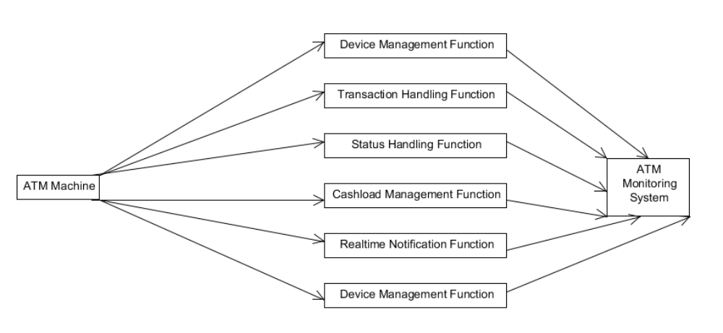
The model including all of the functions listed in the Part 1

5. Activity Diagram Of Your System.
5.1 View Terminal Hardware Activity Diagram

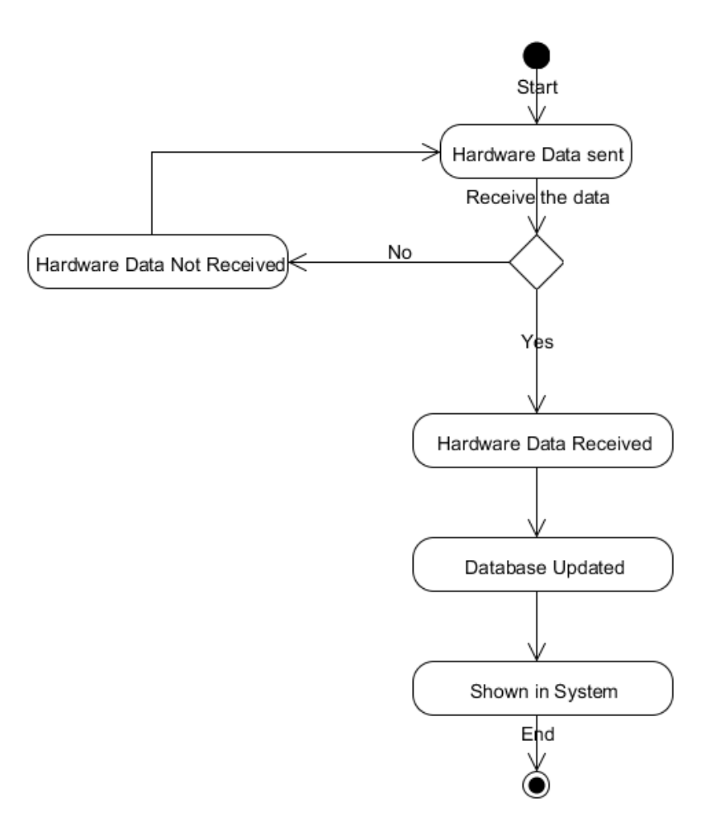

5.2 Send SMS Notification Activity Diagram

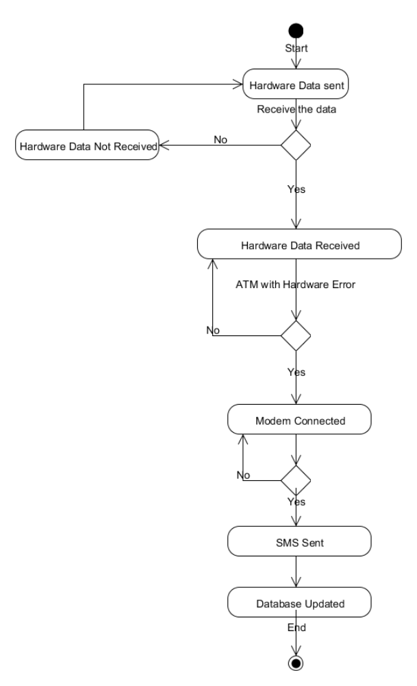
6. Use-Case Diagrams Of The System

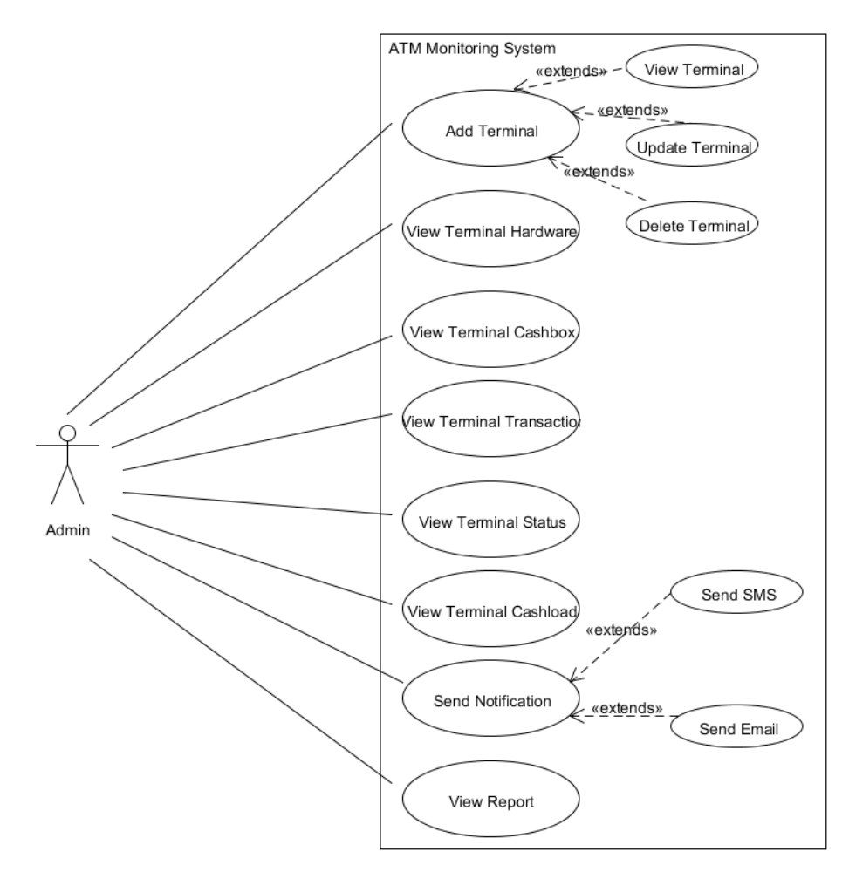
7. Use-Case and Activity Description
7.1 Use Case Description

Use Case | Description
1.Add Terminal | Admin can add a new ATM machine into the system
1.1 View Terminal | Admin can view the details of the ATM machine
1.2 Update Terminal | Admin can edit and update the information for an ATM
1.3 Delete Terminal | Remove an ATM machine out of the system
2.View Terminal Hardware | Admin can view all of the details of all devices in an ATM
3.View Terminal Cashbox | Admin can view the cash details in an ATM as number of note remains, number of note dispense, etc.
4.View Terminal Transaction | Admin can view the transaction of an ATM or all of the transactions performed within the ATM system
5.View Terminal Status | Admin can view the ATM status as normal, offline, error, empty cash, etc.
6.View Terminal Cashload | Admin can view the number of cash are put in an ATM for a specific of time
7.Send Notification | System can notify to user if any issue on ATM devices
7.1 Send SMS | The notification can be alert by SMS
7.2 Send Email | The notification can be alert by Email
8.View Report | Admin can view reports about the performance of the ATM machine in the system

7.2 Activity Description
7.1 View Terminal Hardware Activity Diagram
This is the activity diagram describe step by step how the hardware can be shown in the screen

7.2 Send SMS Notification Activity Diagram
This is the activity diagram describe step by step how the SMS will be sent to the user if any devices in an ATM occur errors

