1. Context Diagram

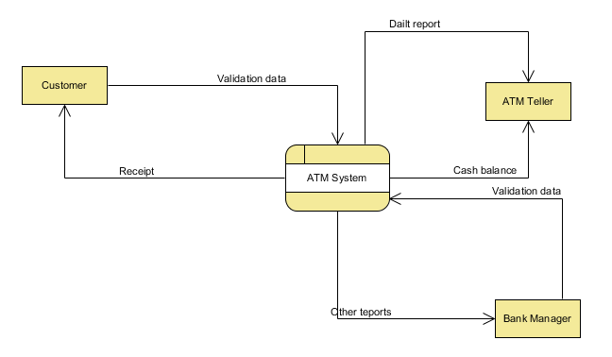

2. Level 0 Diagram

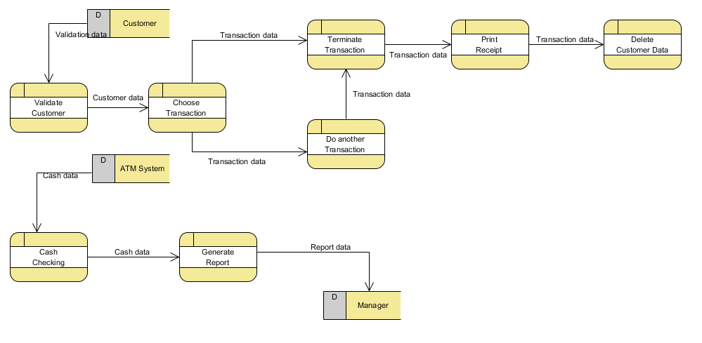

3. Low Level DFD

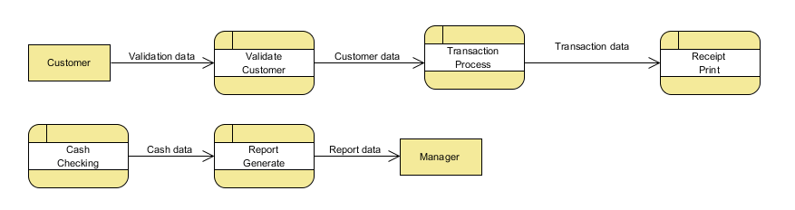

Process Description using Structure English

1. Validation Process
IF Customer in ATM System Data Store
THEN Allow Customer to Choose the Transaction
ELSE Ask Customer to Validate Again

2. The process that triggers an ATM refill request
IF ATM Cash Balance < 500
THEN Trigger A Refill Request

3, The process that prints a customer receipt
IF Customer Session is End
IF Customer Request For A Receipt
THEN Print the Receipt

