In screen 7, you have made a request to check the rollback process after a failed, so in the previous step, you have to set return 1 to intentionally go wrong.

and after taking a screenshot I fixed it to make it run properly

require:

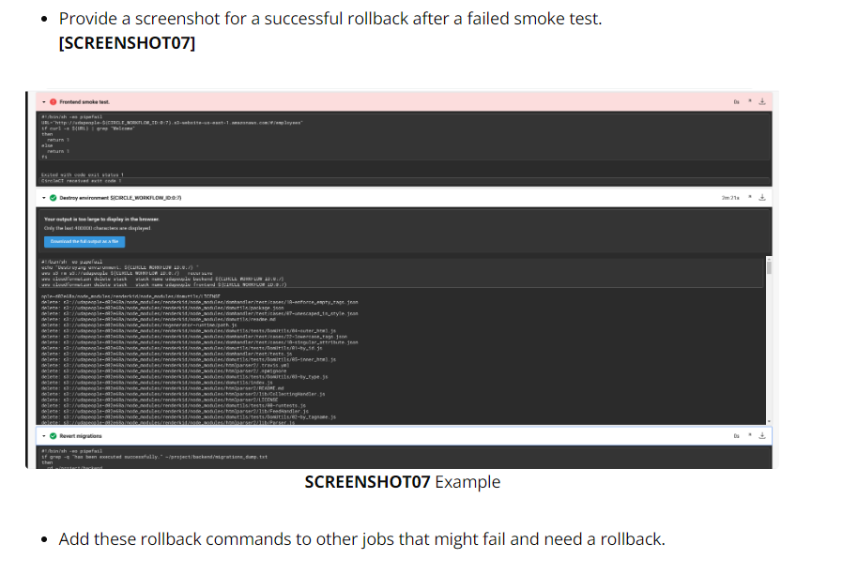

My run:

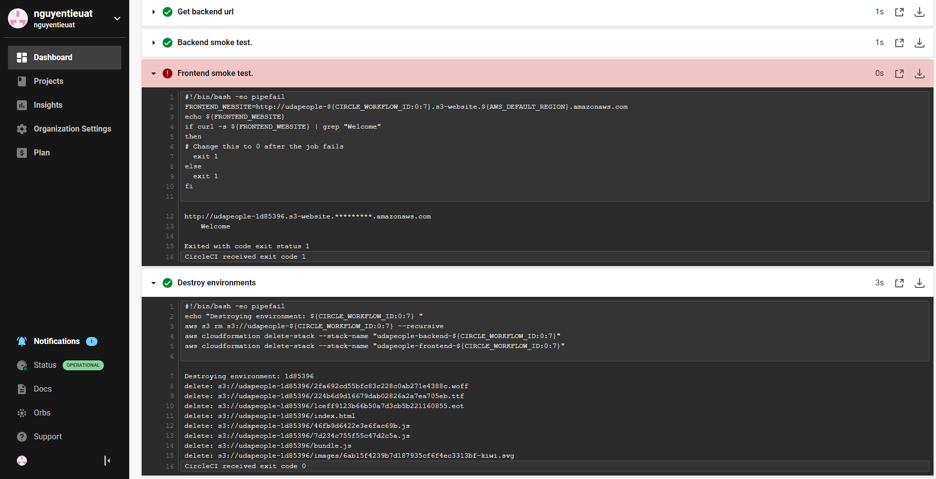

And after screen i had edit:

