1.1 Actors

# | Actor | Description
1 | Guest | Users who have not logged into the system can view information regarding the hotel, rooms, rates, and services offered. Guests can search for and view room details but must register or log in to make a reservation.
2 | Customer | The customer has registered and logged into the system. They can search for and book rooms, manage personal information, view and manage bookings, use hotel services, and make payments.
3 | Housekeeper | Housekeeping staff are responsible for managing the cleanliness status of rooms. They can view the room list and status, update rooms as cleaned, and flag rooms requiring maintenance.
4 | Receptionist | The receptionist is responsible for managing room reservations and providing front-desk service to guests. Duties include managing bookings (deletions require administrator confirmation), assisting with check-in and check-out procedures, and updating room status.
5 | Admin | The system administrator is responsible for managing the entire hotel system. They can manage rooms, services, staff, accounts, and access permissions, while also monitoring operations and viewing revenue reports.
6 | Email | Supports sending emails to customers for account verification and booking notifications.
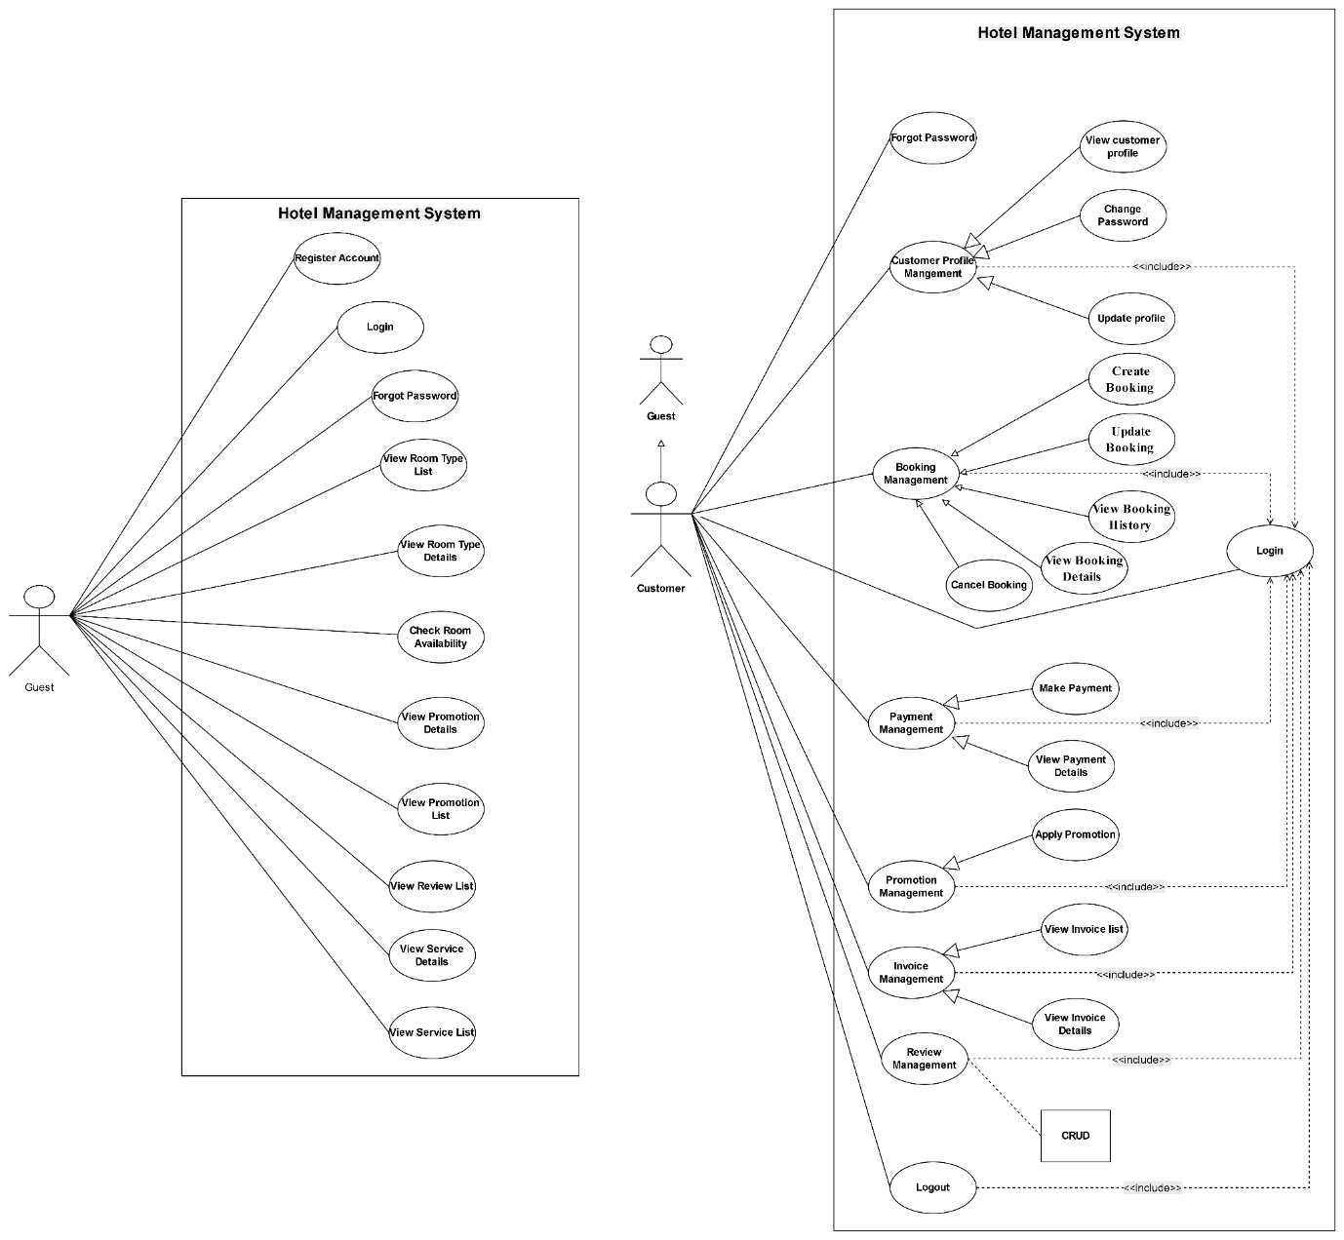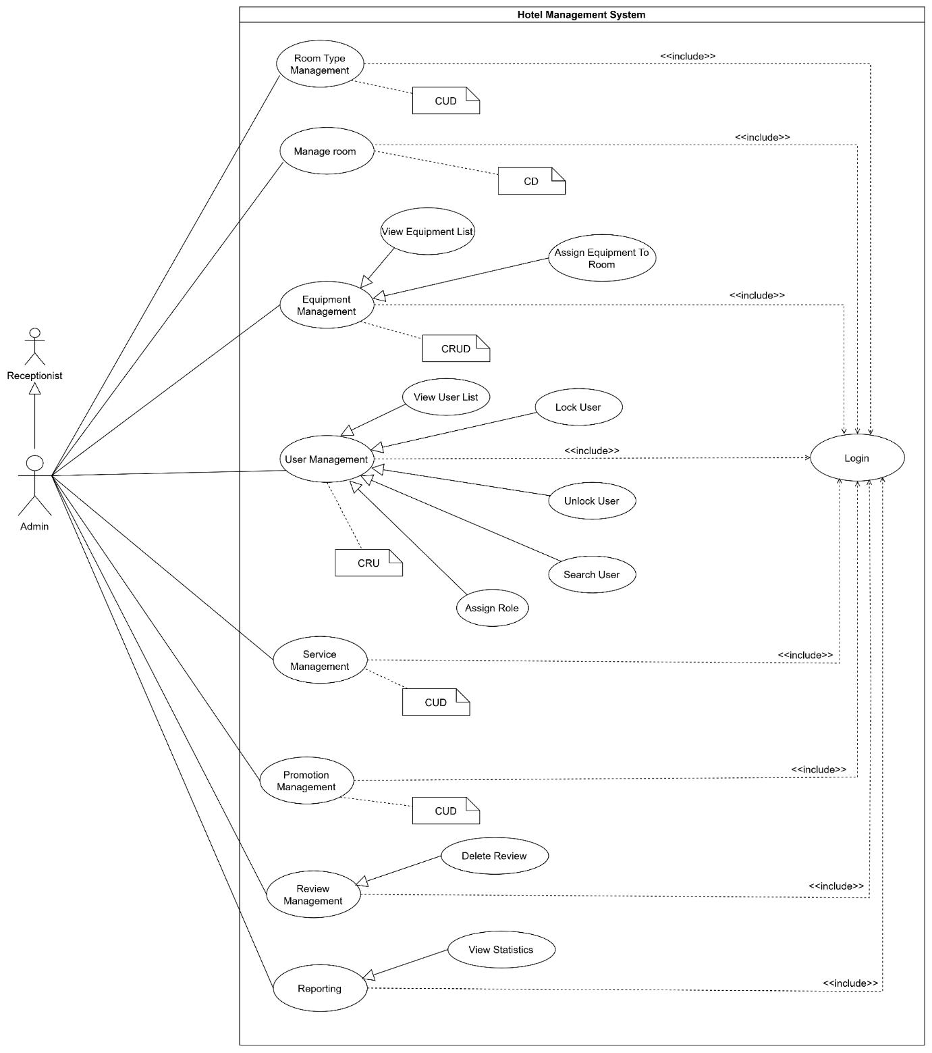
ID | Feature | Use Case | Use Case Description
UC-01.1 | Authentication | Register Account | Allows a new user to create an account by providing their email, password, full name, and phone number. The system creates the user with an ACTIVE status and assigns the CUSTOMER role.
UC-01.2 | Authentication | Login | Allows users to access the system by providing their registered email and password. The system verifies the credentials and account status before granting access.
UC-01.3 | Authentication | Logout | Allows authenticated users to end their current session and leave the system securely.
UC-01.4 | Authentication | Forgot Password | Allows users who forget their password to recover or reset their password through the website.
UC-02.1 | Customer Profile Management | Change Password | Allows customers to change their current account password to a new password.
UC-02.2 | Customer Profile Management | View Customer Profile | Allows customers to view their personal account and profile information.
UC-02.3 | Customer Profile Management | Update Customer Profile | Allows customers to update their personal profile information.
UC-03.1 | Staff Profile Management | Change Password | Allows staff members to change their current account password to a new password.
UC-03.2 | Staff Profile Management | View Staff Profile | Allows staff members to view their personal account and profile information.
UC-03.3 | Staff Profile Management | Update Staff Profile | Allows staff members to update their personal profile information.
UC-04.1 | Room Type Management | Add Room Type | Allows the admin to create a new room type with its relevant information and pricing.
UC-04.2 | Room Type Management | View Room Type List | Allows users to view a list of available room types and their basic information.
UC-04.3 | Room Type Management | View Room Type Details | Allows users to view detailed information about a selected room type.
UC-04.4 | Room Type Management | Update Room Type | Allows the admin to modify the information of an existing room type.
UC-04.5 | Room Type Management | Delete Room Type | Allows the admin to remove an existing room type from the system.
UC-05.1 | Room Management | Add Room | Allows the admin to create a new room and assign its relevant information.
UC-05.2 | Room Management | View Room List | Allows users to view a list of rooms and their current information.
UC-05.3 | Room Management | View Room Details | Allows users to view detailed information about a selected room.
UC-05.4 | Room Management | Update Room | Allows the admin to modify the information of an existing room.
UC-05.5 | Room Management | Delete Room | Allows the admin to remove an existing room from the system.
UC-05.6 | Room Management | Update Room Status | Allows authorized staff to update the current status of a room.
UC-06.1 | Equipment Management | Add Equipment | Allows the admin to add a new equipment item to the system.
UC-06.2 | Equipment Management | View Equipment List | Allows the admin to view a list of equipment managed by the system.
UC-06.3 | Equipment Management | View Equipment Details | Allows the admin to view detailed information about a selected equipment item.
UC-06.4 | Equipment Management | Update Equipment | Allows the admin to modify the information of an existing equipment item.
UC-06.5 | Equipment Management | Delete Equipment | Allows the admin to remove an equipment item from the system.
UC-06.6 | Equipment Management | Assign Equipment To Room | Allows the admin to assign an equipment item to a specific room.
UC-06.7 | Equipment Management | Inspect Room Equipment | Allows the housekeeper to inspect equipment in a room after guest check-out and record its condition.
UC-06.8 | Equipment Management | View Equipment Inspection Report | Allows authorized staff to view the inspection results and recorded equipment conditions for a room.
UC-07.1 | Booking Management | Check Room Availability | Allows users to check the availability of rooms for a selected period.
UC-07.2 | Booking Management | Create Booking | Allows customers or receptionists to create a room booking by providing the required booking information.
UC-07.3 | Booking Management | View Booking History | Allows users to view the history of their or managed bookings.
UC-07.4 | Booking Management | View Booking Details | Allows users to view detailed information about a selected booking.
UC-07.5 | Booking Management | Update Booking | Allows authorized users to modify the information of an existing booking.
UC-07.6 | Booking Management | Cancel Booking | Allows authorized users to cancel an existing booking according to the applicable booking conditions.
UC-08.1 | Reception Management | Check-in Guest | Allows the receptionist to verify a booking and complete the guest check-in process.
UC-08.2 | Reception Management | Check-out Guest | Allows the receptionist to complete the guest check-out process and update the booking status.
UC-08.3 | Reception Management | Assign Room to Booking | Allows the receptionist to assign an available room to a booking.
UC-09.1 | Payment Management | Make Payment | Allows customers to make a payment for their booking or applicable charges.
UC-09.2 | Payment Management | View Payment List | Allows authorized staff to view a list of payment transactions.
UC-09.3 | Payment Management | View Payment Details | Allows users to view detailed information about a selected payment transaction.
UC-09.4 | Payment Management | Confirm Payment | Allows the receptionist to verify and confirm a customer's payment.
UC-10.1 | Invoice Management | Generate Invoice | Allows the receptionist to generate an invoice containing the applicable charges for a booking.
UC-10.2 | Invoice Management | View Invoice List | Allows users to view a list of available invoices.
UC-10.3 | Invoice Management | View Invoice Details | Allows users to view detailed information about a selected invoice and its charges.
UC-10.4 | Invoice Management | Calculate Damage Fee | Allows the receptionist to calculate the fee resulting from damaged or missing room equipment based on the inspection result.
UC-10.5 | Invoice Management | Add Damage Fee to Invoice | Allows the receptionist to add the calculated damage fee to the corresponding invoice.
UC-11.1 | User Management | View User List | Allows the admin to view a list of user accounts in the system.
UC-11.2 | User Management | View User Details | Allows the admin to view detailed information about a selected user account.
UC-11.3 | User Management | Create User | Allows the admin to create a new user account in the system.
UC-11.4 | User Management | Update User | Allows the admin to modify information of an existing user account.
UC-11.5 | User Management | Lock User | Allows the admin to lock a user account and prevent the user from accessing the system.
UC-11.6 | User Management | Unlock User | Allows the admin to unlock a previously locked user account.
UC-11.7 | User Management | Search User | Allows the admin to search for user accounts using relevant search criteria.
UC-11.8 | User Management | Assign Role | Allows the admin to assign an appropriate role and permissions to a user account.
UC-12.1 | Service Management | Add Service | Allows the admin to create a new hotel service with its relevant information and pricing.
UC-12.2 | Service Management | View Service List | Allows users to view a list of available hotel services.
UC-12.3 | Service Management | View Service Details | Allows users to view detailed information about a selected hotel service.
UC-12.4 | Service Management | Update Service | Allows the admin to modify the information of an existing hotel service.
UC-12.5 | Service Management | Delete Service | Allows the admin to remove an existing hotel service from the system.
UC-13.1 | Promotion Management | Add Promotion | Allows the admin to create a new promotion with its applicable conditions and discount information.
UC-13.2 | Promotion Management | View Promotion List | Allows users to view a list of available promotions.
UC-13.3 | Promotion Management | View Promotion Details | Allows users to view detailed information about a selected promotion.
UC-13.4 | Promotion Management | Update Promotion | Allows the admin to modify the information and conditions of an existing promotion.
UC-13.5 | Promotion Management | Delete Promotion | Allows the admin to remove an existing promotion from the system.
UC-13.6 | Promotion Management | Apply Promotion | Allows users to apply an eligible promotion to a booking.
UC-14.1 | Housekeeping Management | View Cleaning Task List | Allows housekeepers to view their assigned cleaning tasks.
UC-14.2 | Housekeeping Management | View Cleaning Task Details | Allows housekeepers to view detailed information about a selected cleaning task.
UC-14.3 | Housekeeping Management | Update Cleaning Status | Allows housekeepers to update the status of an assigned cleaning task.
UC-14.4 | Housekeeping Management | Assign Cleaning Task | Allows the receptionist to assign cleaning tasks to housekeepers.
UC-15.1 | Review Management | Create Review | Allows customers to submit a review about their hotel experience.
UC-15.2 | Review Management | View Review List | Allows users to view reviews submitted for the hotel.
UC-15.3 | Review Management | Update Review | Allows customers to modify their existing review.
UC-15.4 | Review Management | Delete Review | Allows customers or the admin to remove an existing review.
UC-16.1 | Reporting | View Statistics | Allows the Admin to view hotel statistics, including revenue, bookings, room status, payments, and service usage.
UC-17.1 | Notification | Send Account Verification Email | Allows the system to send an email containing an account verification request to a newly registered user.
UC-17.2 | Notification | Send Booking Confirmation Email | Allows the system to send a booking confirmation email containing relevant booking information.
UC-17.3 | Notification | Send Forgot Password Email | Allows the system to send an email containing instructions or a link for resetting a forgotten password.
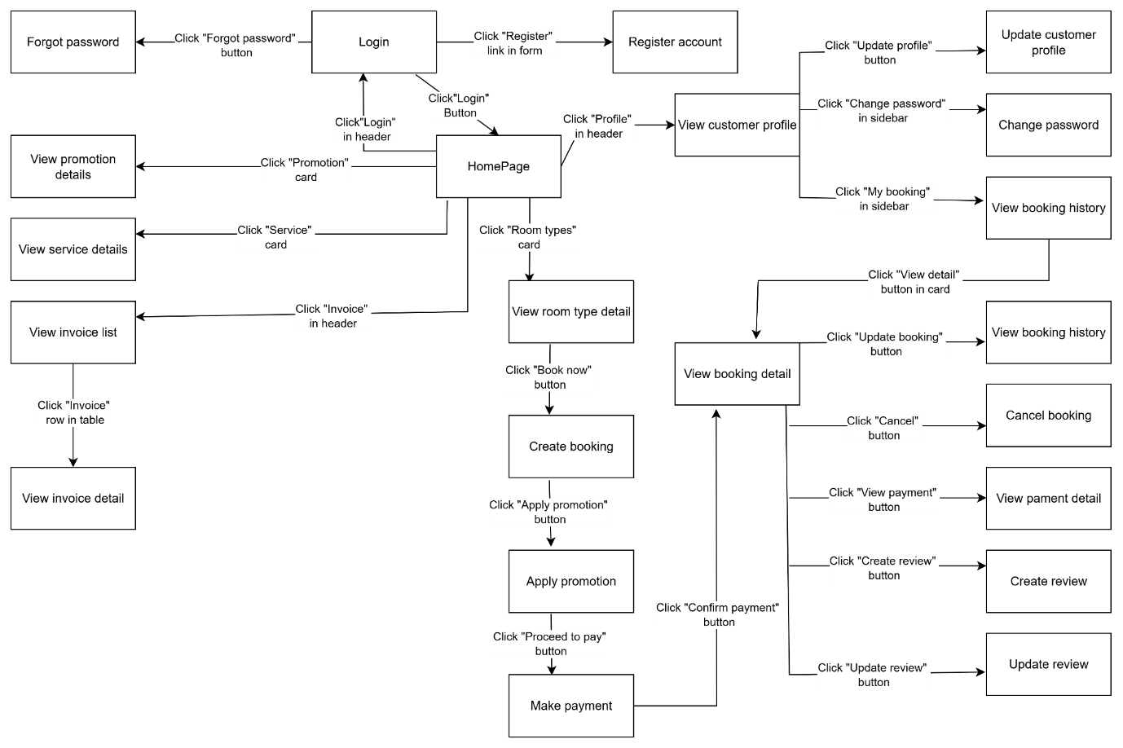Figure 6 Screen flow of Customer
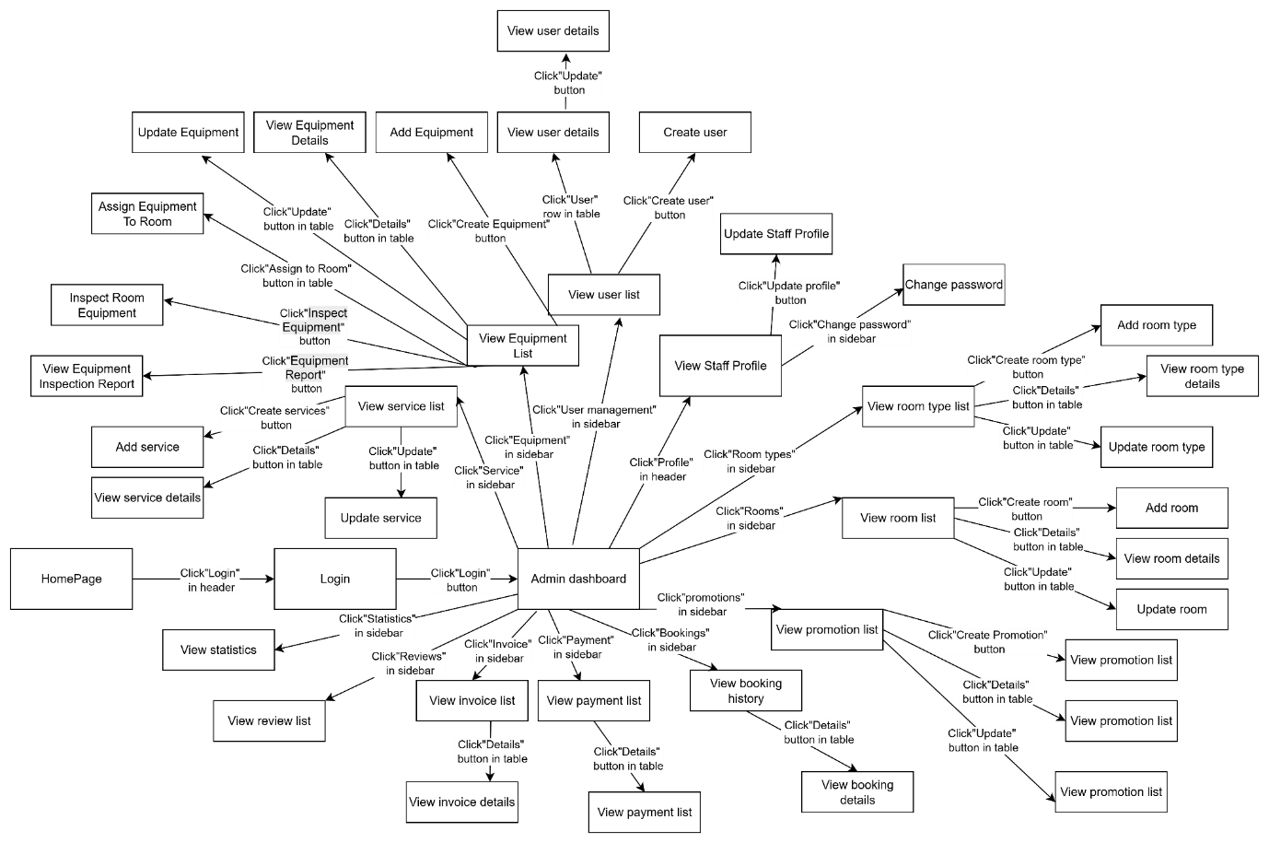
Figure 9 Screen flow of Admin

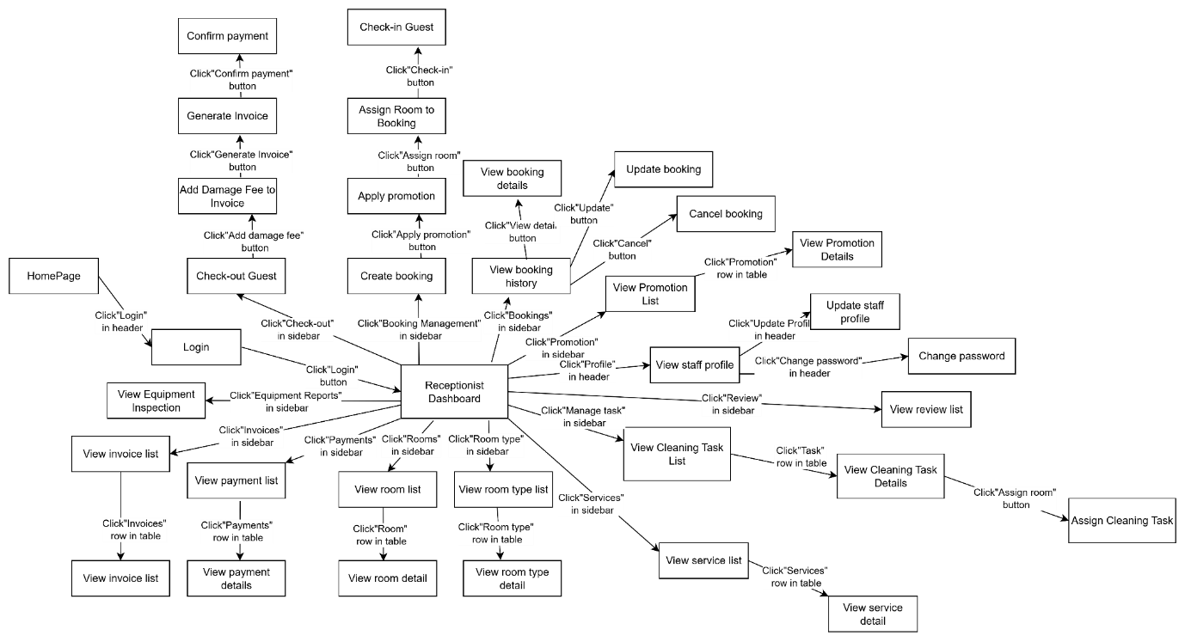
Figure 7 Screen flow of Receptionist

# | Feature | Screen | Description
1 | Authentication | Login | Allows users to log in to the system using their email and password credentials.
2 | Authentication | Register | Allows new customers to create an account by providing required personal details.
3 | Authentication | Forgot Password | Enables users to request a password reset link or code via email.
4 | Authentication | Change Password | Allows logged-in users to update their current account password.
5 | General | HomePage | Main landing page displaying general hotel information, banners, room search widgets, and navigation links.
6 | General | Housekeeper Dashboard | Landing dashboard for housekeepers showing assigned daily cleaning tasks, quick operational status, and workload metrics.
7 | General | Receptionist Dashboard | Operations dashboard for receptionists displaying room grid status, today's check-ins/check-outs, and quick action shortcuts.
8 | General | Admin Dashboard | Executive dashboard displaying system statistics, overall revenue metrics, and main management navigation.
9 | Account Management | View Profile | Displays the detailed personal profile information of the logged-in user.
10 | Account Management | Update Profile | Allows users to edit their personal information (full name, phone number, date of birth, address).
11 | Room Type Management | View Room Type List | Displays all available room types offered by the hotel.
12 | Room Type Management | View Room Type Detail | Shows comprehensive details of a specific room type, including pricing, description, photos, and amenities.
13 | Room Type Management | Add Room Type | Enables admin to create and add a new room type entry into the system.
14 | Room Type Management | Update Room Type | Allows admin to modify information, pricing, or amenities of an existing room type.
15 | Room Management | View Room List | Displays the list of all physical rooms managed by the hotel.
16 | Room Management | View Room Detail | Provides detailed information about a physical room, including room number, assigned room type, floor, and current status.
17 | Room Management | Add Room | Enables admin to configure and add a new physical room unit to the system.
18 | Room Management | Update Room | Allows admin to edit physical room details such as room number, type, or assignment.
19 | Room Management | Update Room Status | Allows staff to change the operational state of a room (e.g., Available, Occupied, Cleaning, Out of Service).
20 | Equipment Management | View Equipment List | Displays all equipment items cataloged in the hotel inventory.
21 | Equipment Management | View Equipment Detail | Shows detailed specifications, quantity, and current status of a specific equipment item.
22 | Equipment Management | Add Equipment | Allows administrators to register new equipment items into the system
23 | Equipment Management | Update Equipment | Allows administrators to modify equipment information, condition, or records.
24 | Equipment Management | Assign Equipment To Room | Modal/Interface allowing administrators to allocate specific equipment units from inventory to a designated room.
25 | Equipment Management | Inspect Room Equipment | Interface for housekeepers/admin to inspect and record equipment conditions (damaged/missing/good) inside a room.
26 | Equipment Management | View Equipment Inspection Report | Displays inspection summaries and reported damaged/missing equipment for management review
27 | Booking Management | Check Room Availability | Allows users to filter and view available rooms based on check-in/check-out dates and guest count.
28 | Booking Management | Create Booking | Interface for entering guest information, stay dates, selecting room options, and additional services to initiate a reservation.
29 | Booking Management | Booking History | Displays a list of past and upcoming room bookings for the customer or staff lookup.
30 | Booking Management | View Booking Details | Displays detailed reservation records, including guest information, reserved room type, stay duration, prices, and booking status.
31 | Booking Management | Update Booking | Enables staff or customers to modify reservation details (e.g., extend stay, change room type, edit guest details).
32 | Booking Management | Cancel Booking | Confirmation modal/screen for canceling a reservation and viewing cancellation policies.
33 | Reception Management | Check-in Guest | Interface for receptionist to confirm guest arrival, verify credentials, assign physical room numbers, and complete check-in.
34 | Reception Management | Check-out Guest | Interface for receptionist to review charges, complete guest checkout, and mark the room as pending cleaning.
35 | Reception Management | Assign Room to Booking | Allows receptionists to assign a specific physical room to a reservation during the check-in process.
36 | Payment Management | Make Payment | Interface allowing customers or staff to complete transactions online or at the counter via selected payment gateways
37 | Payment Management | Confirm Payment | Confirms the payment status, displays transaction confirmation, and updates booking payment records.
38 | Payment Management | View Payment List | Displays the complete history of payments and transactions logged in the system.
39 | Payment Management | View Payment Detail | Shows specific transaction logs, payment method, timestamp, and breakdown of amounts paid.
40 | Invoice Management | Generate Invoice | Interface for compiling service charges, room rates, and taxes to issue a formal invoice upon check-out.
41 | Invoice Management | View Invoice List | Displays a summary list of all generated hotel invoices and their payment status.
42 | Invoice Management | View Invoice Detail | Provides full breakdown of charges, guest details, tax info, and payment status for a specific invoice.
43 | User Management | View User List | Displays system user accounts, roles, and status with filtering and keyword search options
44 | User Management | View User Detail | Shows full profile details, assigned permissions, and system access logs for a specific user account.
45 | User Management | Create User | Interface for administrators to register new internal user accounts
46 | User Management | Update User | Allows administrators to modify user account details, update emails, or change account info.
47 | User Management | Lock / Unlock User | Confirmation modal to suspend or restore user access rights to the system.
48 | Service Management | View Service List | Displays all supplementary hotel services offered (e.g., laundry, spa, breakfast, airport shuttle).
49 | Service Management | View Service Detail | Shows detailed descriptions, unit pricing, and availability conditions for a specific service.
50 | Service Management | Add Service | Allows staff/admin to add new add-on services or amenities to the hotel catalog.
51 | Service Management | Update Service | Enables staff/admin to modify service names, unit pricing, or availability status.
52 | Promotion Management | View Promotion List | Displays active, scheduled, and past promotional campaigns or discount codes.
53 | Promotion Management | View Promotion Detail | Details terms, validity periods, discount rates, and applicable conditions for a specific promotion.
54 | Promotion Management | Add Promotion | Allows staff/admin to design and publish new promotional discounts or voucher codes.
55 | Promotion Management | Update Promotion | Enables staff/admin to adjust promotion validity dates, discount values, or terms.
56 | Promotion Management | Apply Promotion | Interface element during booking/checkout to enter or select coupon codes for instant discounts.
57 | Housekeeping Management | View Cleaning Task List | Displays assigned room cleaning assignments and current housekeeping workload.
58 | Housekeeping Management | View Cleaning Task Detail | Details instructions, special guest requests, and room conditions for a specific cleaning task.
59 | Housekeeping Management | Update Cleaning Status | Allows housekeepers to mark room status (Not Started, In Progress, Completed, or Maintenance Required with notes).
60 | Housekeeping Management | Assign Cleaning Task | Enables receptionists or managers to assign specific room cleaning tasks to individual housekeepers.
61 | Review Management | View Review List | Displays customer reviews, ratings, and feedback regarding rooms and services.
62 | Review Management | Create Review | Allows guests who completed their stay to submit feedback, write comments, and rate their stay.
63 | Review Management | Update Review | Allows guests to edit their submitted ratings or feedback within the allowed timeframe.
64 | Reporting | View statistic | Lists available analytical reports (occupancy rates, daily revenue, staff shift summaries).

2.3 Screen Authorization

Screen | Guest | Customer | Receptionist | Housekeeper | Admin
Authentication
Login | X | X | X | X | X
Register | X
Forgot password |  | X | X | X | x
Log out |  | X | X | X | X
Profile Management
Change Password |  | X | X | X | X
View Profile |  | X | X | X | X
Update Profile |  | X | X | X | X
General & Home
HomePage | X | X | X | X | X
Dashboards |  |  | X | X | X
Room Type Management
Add Room Type |  |  |  |  | X
View Room Type List | X | X | X |  | X
View Room Type Details | X | X | X |  | X
Update Room Type |  |  |  |  | X
Room Management
Add Room |  |  |  |  | X
View Room List |  |  | X |  | X
View Room Details |  |  | X |  | X
Update Room |  |  |  |  | X
Update Room Status |  |  | X | X | X
Equipment Management
Add Equipment |  |  |  |  | X
View Equipment List |  |  |  |  | X
View Equipment Details |  |  |  |  | X
Update Equipment |  |  |  |  | X
Assign Equipment To Room |  |  |  |  | X
Inspect Room Equipment |  |  |  | X | X
View Equipment Inspection Report |  |  | X |  | X
Booking Management
Create Booking |  | X | X
View Booking History |  | X | X |  | X
View Booking Details |  | X | X |  | X
Update Booking |  | X | X
Cancel Booking |  | X | X
Reception Management
Check-in Guest |  |  | X
Check-out Guest |  |  | X
Assign Room to Booking |  |  | X
Payment Management
Make Payment |  | X
View Payment List |  |  | X |  | X
View Payment Details |  | X | X |  | X
Confirm Payment |  |  | X
Invoice Management
Generate Invoice |  |  | X
View Invoice List |  | X | X |  | X
View Invoice Details |  | X | X |  | X
Add Damage Fee to Invoice |  |  | X
User Management
View User List |  |  |  |  | X
View User Details |  |  |  |  | X
Create User |  |  |  |  | X
Update User |  |  |  |  | X
Lock User |  |  |  |  | X
Unlock User |  |  |  |  | X
Service Management
Add Service |  |  |  |  | X
View Service List | X | X | X |  | X
View Service Details | X | X | X |  | X
Update Service |  |  |  |  | X
Promotion Management
Add Promotion |  |  |  |  | X
View Promotion List | X | X | X |  | X
View Promotion Details | X | X | X |  | X
Update Promotion |  |  |  |  | X
Apply Promotion |  | X | X
Housekeeping Management
View Cleaning Task List |  |  |  | X
View Cleaning Task Details |  |  |  | X
Update Cleaning Status |  |  |  | X
Assign Cleaning Task |  |  | X
Review Management
Create Review |  | X
View Review List | X | X | X |  | X
Update Review |  | X
Reporting
View statistic |  |  |  |  | X

2.4 Non-UI Functions

# | Feature | System Function | Description
1 | Room Type Management | Delete Room Type | Inline action button on the Room Type List/Detail page that triggers a confirmation modal to remove room type data without navigating to a new screen.
2 | Room Management | Delete Room | Inline action button on the Room List/Detail page that triggers a confirmation modal to remove a physical room unit from the system.
3 | Service Management | Delete Service | Inline action button on the Service List/Detail page that opens a confirmation modal to remove an existing service from the catalog.
4 | Promotion Management | Delete Promotion | Inline action button on the Promotion List/Detail page that opens a confirmation modal to remove a promotional discount code.
5 | Review Management | Delete Review | Inline action button on the Review List page that triggers a confirmation modal to remove customer feedback or infringing comments.
6 | Notification | Send Account Verification Email | Backend system event that automatically generates and sends an email containing a verification link/code immediately after a user completes account registration.
7 | Notification | Send Booking Confirmation Email | Backend system event that automatically generates and sends an email with reservation details and receipt immediately after a payment transaction is completed.
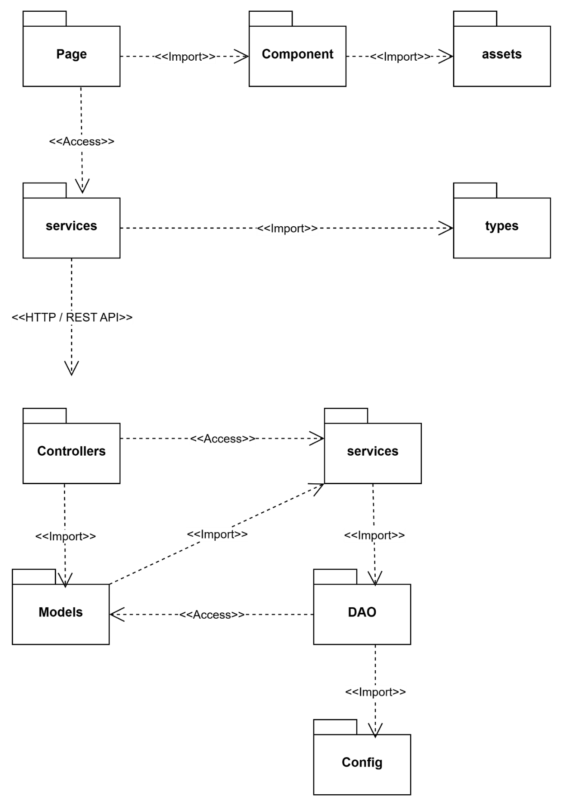
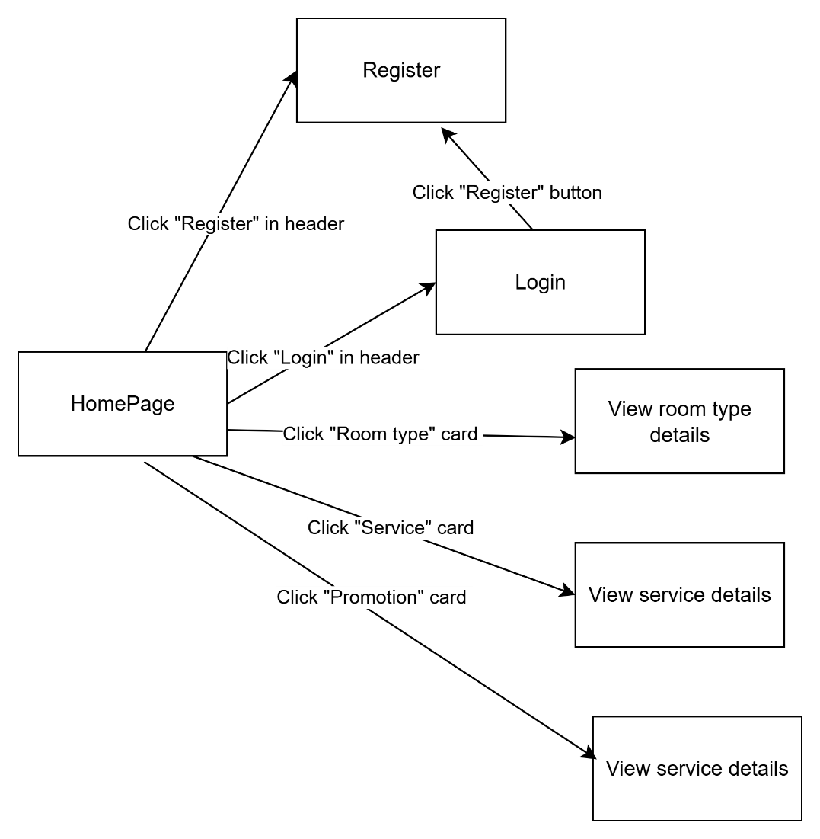
USE [master]
GO
/****** Object: Database [hotel_management] Script Date: 10/14/2026 7:52:10 PM ******/
CREATE DATABASE [hotel_management]
CONTAINMENT = NONE
ON PRIMARY
( NAME = N'hotel_management', FILENAME = N'C:\Program Files\Microsoft SQL Server\MSSQL15.MSSQLSERVER\MSSQL\DATA\hotel_management.mdf' , SIZE = 8192KB , MAXSIZE = UNLIMITED, FILEGROWTH = 65536KB )
LOG ON
( NAME = N'hotel_management_log', FILENAME = N'C:\Program Files\Microsoft SQL Server\MSSQL15.MSSQLSERVER\MSSQL\DATA\hotel_management_log.ldf' , SIZE = 8192KB , MAXSIZE = 2048GB , FILEGROWTH = 65536KB )
WITH CATALOG_COLLATION = DATABASE_DEFAULT
GO
ALTER DATABASE [hotel_management] SET COMPATIBILITY_LEVEL = 150
GO
IF (1 = FULLTEXTSERVICEPROPERTY('IsFullTextInstalled'))
begin
EXEC [hotel_management].[dbo].[sp_fulltext_database] @action = 'enable'
end
GO
ALTER DATABASE [hotel_management] SET ANSI_NULL_DEFAULT OFF
GO
ALTER DATABASE [hotel_management] SET ANSI_NULLS OFF
GO
ALTER DATABASE [hotel_management] SET ANSI_PADDING OFF
GO
ALTER DATABASE [hotel_management] SET ANSI_WARNINGS OFF
GO
ALTER DATABASE [hotel_management] SET ARITHABORT OFF
GO
ALTER DATABASE [hotel_management] SET AUTO_CLOSE OFF
GO
ALTER DATABASE [hotel_management] SET AUTO_SHRINK OFF
GO
ALTER DATABASE [hotel_management] SET AUTO_UPDATE_STATISTICS ON
GO
ALTER DATABASE [hotel_management] SET CURSOR_CLOSE_ON_COMMIT OFF
GO
ALTER DATABASE [hotel_management] SET CURSOR_DEFAULT GLOBAL
GO
ALTER DATABASE [hotel_management] SET CONCAT_NULL_YIELDS_NULL OFF
GO
ALTER DATABASE [hotel_management] SET NUMERIC_ROUNDABORT OFF
GO
ALTER DATABASE [hotel_management] SET QUOTED_IDENTIFIER OFF
GO
ALTER DATABASE [hotel_management] SET RECURSIVE_TRIGGERS OFF
GO
ALTER DATABASE [hotel_management] SET ENABLE_BROKER
GO
ALTER DATABASE [hotel_management] SET AUTO_UPDATE_STATISTICS_ASYNC OFF
GO
ALTER DATABASE [hotel_management] SET DATE_CORRELATION_OPTIMIZATION OFF
GO
ALTER DATABASE [hotel_management] SET TRUSTWORTHY OFF
GO
ALTER DATABASE [hotel_management] SET ALLOW_SNAPSHOT_ISOLATION OFF
GO
ALTER DATABASE [hotel_management] SET PARAMETERIZATION SIMPLE
GO
ALTER DATABASE [hotel_management] SET READ_COMMITTED_SNAPSHOT OFF
GO
ALTER DATABASE [hotel_management] SET HONOR_BROKER_PRIORITY OFF
GO
ALTER DATABASE [hotel_management] SET RECOVERY FULL
GO
ALTER DATABASE [hotel_management] SET MULTI_USER
GO
ALTER DATABASE [hotel_management] SET PAGE_VERIFY CHECKSUM
GO
ALTER DATABASE [hotel_management] SET DB_CHAINING OFF
GO
ALTER DATABASE [hotel_management] SET FILESTREAM( NON_TRANSACTED_ACCESS = OFF )
GO
ALTER DATABASE [hotel_management] SET TARGET_RECOVERY_TIME = 60 SECONDS
GO
ALTER DATABASE [hotel_management] SET DELAYED_DURABILITY = DISABLED
GO
ALTER DATABASE [hotel_management] SET ACCELERATED_DATABASE_RECOVERY = OFF
GO
EXEC sys.sp_db_vardecimal_storage_format N'hotel_management', N'ON'
GO
ALTER DATABASE [hotel_management] SET QUERY_STORE = OFF
GO
USE [hotel_management]
GO
/****** Object: Table [dbo].[room_types] Script Date: 10/14/2026 7:52:11 PM ******/
SET ANSI_NULLS ON
GO
SET QUOTED_IDENTIFIER ON
GO
CREATE TABLE [dbo].[room_types](
[id] [int] IDENTITY(1,1) NOT NULL,
[name] [nvarchar](100) NOT NULL,
[description] [nvarchar](max) NULL,
[base_price] [decimal](12, 2) NOT NULL,
[max_adults] [tinyint] NOT NULL,
[max_children] [tinyint] NOT NULL,
PRIMARY KEY CLUSTERED
(
[id] ASC
)WITH (PAD_INDEX = OFF, STATISTICS_NORECOMPUTE = OFF, IGNORE_DUP_KEY = OFF, ALLOW_ROW_LOCKS = ON, ALLOW_PAGE_LOCKS = ON, OPTIMIZE_FOR_SEQUENTIAL_KEY = OFF) ON [PRIMARY]
) ON [PRIMARY] TEXTIMAGE_ON [PRIMARY]
GO
/****** Object: Table [dbo].[rooms] Script Date: 10/14/2026 7:52:11 PM ******/
SET ANSI_NULLS ON
GO
SET QUOTED_IDENTIFIER ON
GO
CREATE TABLE [dbo].[rooms](
[id] [int] IDENTITY(1,1) NOT NULL,
[room_number] [varchar](10) NOT NULL,
[room_type_id] [int] NOT NULL,
[floor] [tinyint] NULL,
[status] [varchar](20) NOT NULL,
PRIMARY KEY CLUSTERED
(
[id] ASC
)WITH (PAD_INDEX = OFF, STATISTICS_NORECOMPUTE = OFF, IGNORE_DUP_KEY = OFF, ALLOW_ROW_LOCKS = ON, ALLOW_PAGE_LOCKS = ON, OPTIMIZE_FOR_SEQUENTIAL_KEY = OFF) ON [PRIMARY],
UNIQUE NONCLUSTERED
(
[room_number] ASC
)WITH (PAD_INDEX = OFF, STATISTICS_NORECOMPUTE = OFF, IGNORE_DUP_KEY = OFF, ALLOW_ROW_LOCKS = ON, ALLOW_PAGE_LOCKS = ON, OPTIMIZE_FOR_SEQUENTIAL_KEY = OFF) ON [PRIMARY]
) ON [PRIMARY]
GO
/****** Object: View [dbo].[vw_stat_room_status_now] Script Date: 10/14/2026 7:52:11 PM ******/
SET ANSI_NULLS ON
GO
SET QUOTED_IDENTIFIER ON
GO

/* ------------------------------------------------
26.5 UC-16.2 Room status snapshot right now
One row per room type + one grand-total row.
------------------------------------------------ */

CREATE VIEW [dbo].[vw_stat_room_status_now]
AS
SELECT
rt.id AS room_type_id,
CASE WHEN GROUPING(rt.id) = 1
THEN N'Tất cả loại phòng'
ELSE rt.name
END AS room_type_name,
COUNT(r.id) AS total_rooms,
SUM(CASE WHEN r.status = 'OCCUPIED' THEN 1 ELSE 0 END) AS occupied_rooms,
SUM(CASE WHEN r.status = 'AVAILABLE' THEN 1 ELSE 0 END) AS available_rooms,
SUM(CASE WHEN r.status = 'CLEANING' THEN 1 ELSE 0 END) AS cleaning_rooms,
SUM(CASE WHEN r.status = 'MAINTENANCE' THEN 1 ELSE 0 END) AS maintenance_rooms,
CAST(
100.0 * SUM(CASE WHEN r.status = 'OCCUPIED' THEN 1 ELSE 0 END)
/ NULLIF(COUNT(r.id), 0)
AS DECIMAL(5,2)
) AS occupancy_rate_pct
FROM room_types rt
LEFT JOIN rooms r ON r.room_type_id = rt.id
GROUP BY ROLLUP ((rt.id, rt.name));
GO
/****** Object: UserDefinedFunction [dbo].[fn_stat_period] Script Date: 10/14/2026 7:52:11 PM ******/
SET ANSI_NULLS ON
GO
SET QUOTED_IDENTIFIER ON
GO

/* ================================================================
26. STATISTICS - UC-16
================================================================

UC-16 was renamed from "Reporting" to "Statistics Management".
Nothing is stored: every figure is computed on demand.

UC-16.1 View Revenue Statistics
usp_stat_revenue invoices
usp_stat_payment_collection payments
UC-16.2 View Room Occupancy Statistics
usp_stat_room_occupancy booking_rooms + bookings + rooms
vw_stat_room_status_now rooms

NOTE: room_problem_reports.repair_cost is intentionally NOT
included in any procedure below. It is an internal maintenance
cost, not customer revenue, and stays out of UC-16. Admin reads
it directly from room_problem_reports (see section 34.1 example
queries) instead.

Common parameters
@FromDate, @ToDate inclusive date range
@PeriodType 'DAY' | 'MONTH' | 'YEAR' (default 'DAY')

Business assumptions (change the procedures if a rule differs)
- Revenue = invoices with status 'PAID', dated by invoices.issued_at
(ISSUED = not paid yet, VOID = ignored).
- Cash collected = payments with status 'SUCCESS', dated by
payments.paid_at. This is NOT the same as revenue: a deposit is
cash in the month it is paid, but revenue only when the invoice
is issued at check-out.
- Capacity = number of rows in rooms today. There is no room
history, so rooms in MAINTENANCE are still counted.
- Occupied room-night = one night of a booking_rooms row that has
a room_id and whose booking is CHECKED_IN or CHECKED_OUT.
Dates come from actual_check_in / actual_check_out, falling back
to bookings.check_in_date / check_out_date when they are NULL.
A night d is occupied when stay_from <= d < stay_to.
- Revenue / cash procedures return only periods that have data.
The occupancy procedure returns every period in the range.
================================================================ */

/* ------------------------------------------------
26.1 Helper: period start + display label
------------------------------------------------ */

CREATE FUNCTION [dbo].[fn_stat_period]
(
@PeriodType VARCHAR(5),
@Dt DATETIME2
)
RETURNS TABLE
AS
RETURN
(
SELECT
s.period_start,
CASE @PeriodType
WHEN 'DAY' THEN CONVERT(VARCHAR(10), s.period_start, 103)
WHEN 'MONTH' THEN RIGHT(CONVERT(VARCHAR(10), s.period_start, 103), 7)
WHEN 'YEAR' THEN CAST(YEAR(s.period_start) AS VARCHAR(4))
END AS period_label
FROM (
SELECT
CASE @PeriodType
WHEN 'DAY' THEN CAST(@Dt AS DATE)
WHEN 'MONTH' THEN DATEFROMPARTS(YEAR(@Dt), MONTH(@Dt), 1)
WHEN 'YEAR' THEN DATEFROMPARTS(YEAR(@Dt), 1, 1)
END AS period_start
) AS s
);
GO
/****** Object: Table [dbo].[amenities] Script Date: 10/14/2026 7:52:11 PM ******/
SET ANSI_NULLS ON
GO
SET QUOTED_IDENTIFIER ON
GO
CREATE TABLE [dbo].[amenities](
[id] [int] IDENTITY(1,1) NOT NULL,
[name] [nvarchar](100) NOT NULL,
PRIMARY KEY CLUSTERED
(
[id] ASC
)WITH (PAD_INDEX = OFF, STATISTICS_NORECOMPUTE = OFF, IGNORE_DUP_KEY = OFF, ALLOW_ROW_LOCKS = ON, ALLOW_PAGE_LOCKS = ON, OPTIMIZE_FOR_SEQUENTIAL_KEY = OFF) ON [PRIMARY],
UNIQUE NONCLUSTERED
(
[name] ASC
)WITH (PAD_INDEX = OFF, STATISTICS_NORECOMPUTE = OFF, IGNORE_DUP_KEY = OFF, ALLOW_ROW_LOCKS = ON, ALLOW_PAGE_LOCKS = ON, OPTIMIZE_FOR_SEQUENTIAL_KEY = OFF) ON [PRIMARY]
) ON [PRIMARY]
GO
/****** Object: Table [dbo].[booking_guests] Script Date: 10/14/2026 7:52:11 PM ******/
SET ANSI_NULLS ON
GO
SET QUOTED_IDENTIFIER ON
GO
CREATE TABLE [dbo].[booking_guests](
[id] [bigint] IDENTITY(1,1) NOT NULL,
[booking_id] [bigint] NOT NULL,
[full_name] [nvarchar](150) NOT NULL,
[phone] [varchar](20) NULL,
[id_card_number] [varchar](20) NULL,
[id_card_image_url] [varchar](500) NULL,
[id_card_verified] [bit] NOT NULL,
PRIMARY KEY CLUSTERED
(
[id] ASC
)WITH (PAD_INDEX = OFF, STATISTICS_NORECOMPUTE = OFF, IGNORE_DUP_KEY = OFF, ALLOW_ROW_LOCKS = ON, ALLOW_PAGE_LOCKS = ON, OPTIMIZE_FOR_SEQUENTIAL_KEY = OFF) ON [PRIMARY]
) ON [PRIMARY]
GO
/****** Object: Table [dbo].[booking_rooms] Script Date: 10/14/2026 7:52:11 PM ******/
SET ANSI_NULLS ON
GO
SET QUOTED_IDENTIFIER ON
GO
CREATE TABLE [dbo].[booking_rooms](
[id] [bigint] IDENTITY(1,1) NOT NULL,
[booking_id] [bigint] NOT NULL,
[room_type_id] [int] NOT NULL,
[room_id] [int] NULL,
[price_per_night] [decimal](12, 2) NOT NULL,
[actual_check_in] [datetime2](7) NULL,
[actual_check_out] [datetime2](7) NULL,
PRIMARY KEY CLUSTERED
(
[id] ASC
)WITH (PAD_INDEX = OFF, STATISTICS_NORECOMPUTE = OFF, IGNORE_DUP_KEY = OFF, ALLOW_ROW_LOCKS = ON, ALLOW_PAGE_LOCKS = ON, OPTIMIZE_FOR_SEQUENTIAL_KEY = OFF) ON [PRIMARY]
) ON [PRIMARY]
GO
/****** Object: Table [dbo].[booking_services] Script Date: 10/14/2026 7:52:11 PM ******/
SET ANSI_NULLS ON
GO
SET QUOTED_IDENTIFIER ON
GO
CREATE TABLE [dbo].[booking_services](
[id] [bigint] IDENTITY(1,1) NOT NULL,
[booking_room_id] [bigint] NOT NULL,
[service_id] [int] NOT NULL,
[quantity] [int] NOT NULL,
[unit_price] [decimal](12, 2) NOT NULL,
[used_at] [datetime2](7) NOT NULL,
PRIMARY KEY CLUSTERED
(
[id] ASC
)WITH (PAD_INDEX = OFF, STATISTICS_NORECOMPUTE = OFF, IGNORE_DUP_KEY = OFF, ALLOW_ROW_LOCKS = ON, ALLOW_PAGE_LOCKS = ON, OPTIMIZE_FOR_SEQUENTIAL_KEY = OFF) ON [PRIMARY]
) ON [PRIMARY]
GO
/****** Object: Table [dbo].[bookings] Script Date: 10/14/2026 7:52:11 PM ******/
SET ANSI_NULLS ON
GO
SET QUOTED_IDENTIFIER ON
GO
CREATE TABLE [dbo].[bookings](
[id] [bigint] IDENTITY(1,1) NOT NULL,
[booking_code] [varchar](20) NOT NULL,
[customer_id] [bigint] NOT NULL,
[guest_full_name] [nvarchar](150) NOT NULL,
[guest_phone] [varchar](20) NOT NULL,
[guest_email] [varchar](150) NOT NULL,
[check_in_date] [date] NOT NULL,
[check_out_date] [date] NOT NULL,
[adults] [tinyint] NOT NULL,
[children] [tinyint] NOT NULL,
[status] [varchar](20) NOT NULL,
[promotion_id] [int] NULL,
[total_amount] [decimal](14, 2) NOT NULL,
[deposit_amount] [decimal](14, 2) NOT NULL,
[created_at] [datetime2](7) NOT NULL,
[special_request] [nvarchar](500) NULL,
PRIMARY KEY CLUSTERED
(
[id] ASC
)WITH (PAD_INDEX = OFF, STATISTICS_NORECOMPUTE = OFF, IGNORE_DUP_KEY = OFF, ALLOW_ROW_LOCKS = ON, ALLOW_PAGE_LOCKS = ON, OPTIMIZE_FOR_SEQUENTIAL_KEY = OFF) ON [PRIMARY],
UNIQUE NONCLUSTERED
(
[booking_code] ASC
)WITH (PAD_INDEX = OFF, STATISTICS_NORECOMPUTE = OFF, IGNORE_DUP_KEY = OFF, ALLOW_ROW_LOCKS = ON, ALLOW_PAGE_LOCKS = ON, OPTIMIZE_FOR_SEQUENTIAL_KEY = OFF) ON [PRIMARY]
) ON [PRIMARY]
GO
/****** Object: Table [dbo].[cleaning_tasks] Script Date: 10/14/2026 7:52:11 PM ******/
SET ANSI_NULLS ON
GO
SET QUOTED_IDENTIFIER ON
GO
CREATE TABLE [dbo].[cleaning_tasks](
[id] [bigint] IDENTITY(1,1) NOT NULL,
[room_id] [int] NOT NULL,
[booking_room_id] [bigint] NULL,
[assigned_to] [bigint] NOT NULL,
[priority] [varchar](10) NOT NULL,
[status] [varchar](20) NOT NULL,
[special_instructions] [nvarchar](500) NULL,
[notes] [nvarchar](500) NULL,
[started_at] [datetime2](7) NULL,
[completed_at] [datetime2](7) NULL,
PRIMARY KEY CLUSTERED
(
[id] ASC
)WITH (PAD_INDEX = OFF, STATISTICS_NORECOMPUTE = OFF, IGNORE_DUP_KEY = OFF, ALLOW_ROW_LOCKS = ON, ALLOW_PAGE_LOCKS = ON, OPTIMIZE_FOR_SEQUENTIAL_KEY = OFF) ON [PRIMARY]
) ON [PRIMARY]
GO
/****** Object: Table [dbo].[email_verifications] Script Date: 10/14/2026 7:52:11 PM ******/
SET ANSI_NULLS ON
GO
SET QUOTED_IDENTIFIER ON
GO
CREATE TABLE [dbo].[email_verifications](
[id] [bigint] IDENTITY(1,1) NOT NULL,
[user_id] [bigint] NOT NULL,
[token] [varchar](255) NOT NULL,
[type] [varchar](30) NOT NULL,
[expires_at] [datetimeoffset](7) NOT NULL,
[used_at] [datetimeoffset](7) NULL,
[created_at] [datetimeoffset](7) NOT NULL,
PRIMARY KEY CLUSTERED
(
[id] ASC
)WITH (PAD_INDEX = OFF, STATISTICS_NORECOMPUTE = OFF, IGNORE_DUP_KEY = OFF, ALLOW_ROW_LOCKS = ON, ALLOW_PAGE_LOCKS = ON, OPTIMIZE_FOR_SEQUENTIAL_KEY = OFF) ON [PRIMARY],
UNIQUE NONCLUSTERED
(
[token] ASC
)WITH (PAD_INDEX = OFF, STATISTICS_NORECOMPUTE = OFF, IGNORE_DUP_KEY = OFF, ALLOW_ROW_LOCKS = ON, ALLOW_PAGE_LOCKS = ON, OPTIMIZE_FOR_SEQUENTIAL_KEY = OFF) ON [PRIMARY]
) ON [PRIMARY]
GO
/****** Object: Table [dbo].[equipment_items] Script Date: 10/14/2026 7:52:11 PM ******/
SET ANSI_NULLS ON
GO
SET QUOTED_IDENTIFIER ON
GO
CREATE TABLE [dbo].[equipment_items](
[id] [int] IDENTITY(1,1) NOT NULL,
[name] [nvarchar](100) NOT NULL,
[is_active] [bit] NOT NULL,
PRIMARY KEY CLUSTERED
(
[id] ASC
)WITH (PAD_INDEX = OFF, STATISTICS_NORECOMPUTE = OFF, IGNORE_DUP_KEY = OFF, ALLOW_ROW_LOCKS = ON, ALLOW_PAGE_LOCKS = ON, OPTIMIZE_FOR_SEQUENTIAL_KEY = OFF) ON [PRIMARY],
UNIQUE NONCLUSTERED
(
[name] ASC
)WITH (PAD_INDEX = OFF, STATISTICS_NORECOMPUTE = OFF, IGNORE_DUP_KEY = OFF, ALLOW_ROW_LOCKS = ON, ALLOW_PAGE_LOCKS = ON, OPTIMIZE_FOR_SEQUENTIAL_KEY = OFF) ON [PRIMARY]
) ON [PRIMARY]
GO
/****** Object: Table [dbo].[invoice_items] Script Date: 10/14/2026 7:52:11 PM ******/
SET ANSI_NULLS ON
GO
SET QUOTED_IDENTIFIER ON
GO
CREATE TABLE [dbo].[invoice_items](
[id] [bigint] IDENTITY(1,1) NOT NULL,
[invoice_id] [bigint] NOT NULL,
[item_type] [varchar](20) NOT NULL,
[description] [nvarchar](255) NOT NULL,
[quantity] [decimal](10, 2) NOT NULL,
[unit_price] [decimal](12, 2) NOT NULL,
[amount] [decimal](14, 2) NOT NULL,
PRIMARY KEY CLUSTERED
(
[id] ASC
)WITH (PAD_INDEX = OFF, STATISTICS_NORECOMPUTE = OFF, IGNORE_DUP_KEY = OFF, ALLOW_ROW_LOCKS = ON, ALLOW_PAGE_LOCKS = ON, OPTIMIZE_FOR_SEQUENTIAL_KEY = OFF) ON [PRIMARY]
) ON [PRIMARY]
GO
/****** Object: Table [dbo].[invoices] Script Date: 10/14/2026 7:52:11 PM ******/
SET ANSI_NULLS ON
GO
SET QUOTED_IDENTIFIER ON
GO
CREATE TABLE [dbo].[invoices](
[id] [bigint] IDENTITY(1,1) NOT NULL,
[invoice_number] [varchar](20) NOT NULL,
[booking_id] [bigint] NOT NULL,
[room_amount] [decimal](14, 2) NOT NULL,
[service_amount] [decimal](14, 2) NOT NULL,
[discount_amount] [decimal](14, 2) NOT NULL,
[tax_amount] [decimal](14, 2) NOT NULL,
[total_amount] [decimal](14, 2) NOT NULL,
[deposit_paid] [decimal](14, 2) NOT NULL,
[amount_due] [decimal](14, 2) NOT NULL,
[status] [varchar](10) NOT NULL,
[issued_at] [datetime2](7) NOT NULL,
PRIMARY KEY CLUSTERED
(
[id] ASC
)WITH (PAD_INDEX = OFF, STATISTICS_NORECOMPUTE = OFF, IGNORE_DUP_KEY = OFF, ALLOW_ROW_LOCKS = ON, ALLOW_PAGE_LOCKS = ON, OPTIMIZE_FOR_SEQUENTIAL_KEY = OFF) ON [PRIMARY],
UNIQUE NONCLUSTERED
(
[booking_id] ASC
)WITH (PAD_INDEX = OFF, STATISTICS_NORECOMPUTE = OFF, IGNORE_DUP_KEY = OFF, ALLOW_ROW_LOCKS = ON, ALLOW_PAGE_LOCKS = ON, OPTIMIZE_FOR_SEQUENTIAL_KEY = OFF) ON [PRIMARY],
UNIQUE NONCLUSTERED
(
[invoice_number] ASC
)WITH (PAD_INDEX = OFF, STATISTICS_NORECOMPUTE = OFF, IGNORE_DUP_KEY = OFF, ALLOW_ROW_LOCKS = ON, ALLOW_PAGE_LOCKS = ON, OPTIMIZE_FOR_SEQUENTIAL_KEY = OFF) ON [PRIMARY]
) ON [PRIMARY]
GO
/****** Object: Table [dbo].[notifications] Script Date: 10/14/2026 7:52:11 PM ******/
SET ANSI_NULLS ON
GO
SET QUOTED_IDENTIFIER ON
GO
CREATE TABLE [dbo].[notifications](
[id] [bigint] IDENTITY(1,1) NOT NULL,
[user_id] [bigint] NOT NULL,
[notification_type] [varchar](30) NOT NULL,
[title] [nvarchar](150) NOT NULL,
[content] [nvarchar](500) NULL,
[is_read] [bit] NOT NULL,
PRIMARY KEY CLUSTERED
(
[id] ASC
)WITH (PAD_INDEX = OFF, STATISTICS_NORECOMPUTE = OFF, IGNORE_DUP_KEY = OFF, ALLOW_ROW_LOCKS = ON, ALLOW_PAGE_LOCKS = ON, OPTIMIZE_FOR_SEQUENTIAL_KEY = OFF) ON [PRIMARY]
) ON [PRIMARY]
GO
/****** Object: Table [dbo].[password_resets] Script Date: 10/14/2026 7:52:11 PM ******/
SET ANSI_NULLS ON
GO
SET QUOTED_IDENTIFIER ON
GO
CREATE TABLE [dbo].[password_resets](
[id] [bigint] IDENTITY(1,1) NOT NULL,
[user_id] [bigint] NOT NULL,
[otp_code] [varchar](10) NULL,
[token] [varchar](255) NULL,
[expires_at] [datetime2](7) NOT NULL,
[is_used] [bit] NOT NULL,
[created_at] [datetime2](7) NOT NULL,
PRIMARY KEY CLUSTERED
(
[id] ASC
)WITH (PAD_INDEX = OFF, STATISTICS_NORECOMPUTE = OFF, IGNORE_DUP_KEY = OFF, ALLOW_ROW_LOCKS = ON, ALLOW_PAGE_LOCKS = ON, OPTIMIZE_FOR_SEQUENTIAL_KEY = OFF) ON [PRIMARY]
) ON [PRIMARY]
GO
/****** Object: Table [dbo].[payments] Script Date: 10/14/2026 7:52:11 PM ******/
SET ANSI_NULLS ON
GO
SET QUOTED_IDENTIFIER ON
GO
CREATE TABLE [dbo].[payments](
[id] [bigint] IDENTITY(1,1) NOT NULL,
[payment_code] [varchar](30) NOT NULL,
[booking_id] [bigint] NOT NULL,
[invoice_id] [bigint] NULL,
[amount] [decimal](14, 2) NOT NULL,
[payment_type] [varchar](10) NOT NULL,
[method] [varchar](20) NOT NULL,
[status] [varchar](10) NOT NULL,
[vnpay_transaction_no] [varchar](100) NULL,
[paid_at] [datetime2](7) NULL,
PRIMARY KEY CLUSTERED
(
[id] ASC
)WITH (PAD_INDEX = OFF, STATISTICS_NORECOMPUTE = OFF, IGNORE_DUP_KEY = OFF, ALLOW_ROW_LOCKS = ON, ALLOW_PAGE_LOCKS = ON, OPTIMIZE_FOR_SEQUENTIAL_KEY = OFF) ON [PRIMARY],
UNIQUE NONCLUSTERED
(
[payment_code] ASC
)WITH (PAD_INDEX = OFF, STATISTICS_NORECOMPUTE = OFF, IGNORE_DUP_KEY = OFF, ALLOW_ROW_LOCKS = ON, ALLOW_PAGE_LOCKS = ON, OPTIMIZE_FOR_SEQUENTIAL_KEY = OFF) ON [PRIMARY]
) ON [PRIMARY]
GO
/****** Object: Table [dbo].[promotion_room_types] Script Date: 10/14/2026 7:52:11 PM ******/
SET ANSI_NULLS ON
GO
SET QUOTED_IDENTIFIER ON
GO
CREATE TABLE [dbo].[promotion_room_types](
[promotion_id] [int] NOT NULL,
[room_type_id] [int] NOT NULL,
PRIMARY KEY CLUSTERED
(
[promotion_id] ASC,
[room_type_id] ASC
)WITH (PAD_INDEX = OFF, STATISTICS_NORECOMPUTE = OFF, IGNORE_DUP_KEY = OFF, ALLOW_ROW_LOCKS = ON, ALLOW_PAGE_LOCKS = ON, OPTIMIZE_FOR_SEQUENTIAL_KEY = OFF) ON [PRIMARY]
) ON [PRIMARY]
GO
/****** Object: Table [dbo].[promotions] Script Date: 10/14/2026 7:52:11 PM ******/
SET ANSI_NULLS ON
GO
SET QUOTED_IDENTIFIER ON
GO
CREATE TABLE [dbo].[promotions](
[id] [int] IDENTITY(1,1) NOT NULL,
[code] [varchar](30) NOT NULL,
[name] [nvarchar](150) NOT NULL,
[description] [nvarchar](max) NULL,
[discount_type] [varchar](20) NOT NULL,
[discount_value] [decimal](12, 2) NOT NULL,
[max_discount] [decimal](12, 2) NULL,
[valid_from] [datetime2](7) NOT NULL,
[valid_to] [datetime2](7) NOT NULL,
[is_active] [bit] NOT NULL,
PRIMARY KEY CLUSTERED
(
[id] ASC
)WITH (PAD_INDEX = OFF, STATISTICS_NORECOMPUTE = OFF, IGNORE_DUP_KEY = OFF, ALLOW_ROW_LOCKS = ON, ALLOW_PAGE_LOCKS = ON, OPTIMIZE_FOR_SEQUENTIAL_KEY = OFF) ON [PRIMARY],
UNIQUE NONCLUSTERED
(
[code] ASC
)WITH (PAD_INDEX = OFF, STATISTICS_NORECOMPUTE = OFF, IGNORE_DUP_KEY = OFF, ALLOW_ROW_LOCKS = ON, ALLOW_PAGE_LOCKS = ON, OPTIMIZE_FOR_SEQUENTIAL_KEY = OFF) ON [PRIMARY]
) ON [PRIMARY] TEXTIMAGE_ON [PRIMARY]
GO
/****** Object: Table [dbo].[refresh_tokens] Script Date: 10/14/2026 7:52:11 PM ******/
SET ANSI_NULLS ON
GO
SET QUOTED_IDENTIFIER ON
GO
CREATE TABLE [dbo].[refresh_tokens](
[id] [bigint] IDENTITY(1,1) NOT NULL,
[user_id] [bigint] NOT NULL,
[token] [varchar](255) NOT NULL,
[expires_at] [datetimeoffset](7) NOT NULL,
[revoked_at] [datetimeoffset](7) NULL,
[created_at] [datetimeoffset](7) NOT NULL,
PRIMARY KEY CLUSTERED
(
[id] ASC
)WITH (PAD_INDEX = OFF, STATISTICS_NORECOMPUTE = OFF, IGNORE_DUP_KEY = OFF, ALLOW_ROW_LOCKS = ON, ALLOW_PAGE_LOCKS = ON, OPTIMIZE_FOR_SEQUENTIAL_KEY = OFF) ON [PRIMARY],
UNIQUE NONCLUSTERED
(
[token] ASC
)WITH (PAD_INDEX = OFF, STATISTICS_NORECOMPUTE = OFF, IGNORE_DUP_KEY = OFF, ALLOW_ROW_LOCKS = ON, ALLOW_PAGE_LOCKS = ON, OPTIMIZE_FOR_SEQUENTIAL_KEY = OFF) ON [PRIMARY]
) ON [PRIMARY]
GO
/****** Object: Table [dbo].[reviews] Script Date: 10/14/2026 7:52:11 PM ******/
SET ANSI_NULLS ON
GO
SET QUOTED_IDENTIFIER ON
GO
CREATE TABLE [dbo].[reviews](
[id] [bigint] IDENTITY(1,1) NOT NULL,
[booking_id] [bigint] NOT NULL,
[customer_id] [bigint] NOT NULL,
[room_type_id] [int] NULL,
[rating] [tinyint] NOT NULL,
[comment] [nvarchar](max) NULL,
[is_hidden] [bit] NOT NULL,
PRIMARY KEY CLUSTERED
(
[id] ASC
)WITH (PAD_INDEX = OFF, STATISTICS_NORECOMPUTE = OFF, IGNORE_DUP_KEY = OFF, ALLOW_ROW_LOCKS = ON, ALLOW_PAGE_LOCKS = ON, OPTIMIZE_FOR_SEQUENTIAL_KEY = OFF) ON [PRIMARY],
UNIQUE NONCLUSTERED
(
[booking_id] ASC
)WITH (PAD_INDEX = OFF, STATISTICS_NORECOMPUTE = OFF, IGNORE_DUP_KEY = OFF, ALLOW_ROW_LOCKS = ON, ALLOW_PAGE_LOCKS = ON, OPTIMIZE_FOR_SEQUENTIAL_KEY = OFF) ON [PRIMARY]
) ON [PRIMARY] TEXTIMAGE_ON [PRIMARY]
GO
/****** Object: Table [dbo].[roles] Script Date: 10/14/2026 7:52:11 PM ******/
SET ANSI_NULLS ON
GO
SET QUOTED_IDENTIFIER ON
GO
CREATE TABLE [dbo].[roles](
[id] [tinyint] IDENTITY(1,1) NOT NULL,
[code] [varchar](20) NOT NULL,
[name] [nvarchar](50) NOT NULL,
PRIMARY KEY CLUSTERED
(
[id] ASC
)WITH (PAD_INDEX = OFF, STATISTICS_NORECOMPUTE = OFF, IGNORE_DUP_KEY = OFF, ALLOW_ROW_LOCKS = ON, ALLOW_PAGE_LOCKS = ON, OPTIMIZE_FOR_SEQUENTIAL_KEY = OFF) ON [PRIMARY],
UNIQUE NONCLUSTERED
(
[code] ASC
)WITH (PAD_INDEX = OFF, STATISTICS_NORECOMPUTE = OFF, IGNORE_DUP_KEY = OFF, ALLOW_ROW_LOCKS = ON, ALLOW_PAGE_LOCKS = ON, OPTIMIZE_FOR_SEQUENTIAL_KEY = OFF) ON [PRIMARY]
) ON [PRIMARY]
GO
/****** Object: Table [dbo].[room_problem_reports] Script Date: 10/14/2026 7:52:11 PM ******/
SET ANSI_NULLS ON
GO
SET QUOTED_IDENTIFIER ON
GO
CREATE TABLE [dbo].[room_problem_reports](
[id] [bigint] IDENTITY(1,1) NOT NULL,
[room_id] [int] NOT NULL,
[reported_by] [bigint] NOT NULL,
[equipment_item_id] [int] NULL,
[title] [nvarchar](150) NOT NULL,
[description] [nvarchar](max) NOT NULL,
[status] [varchar](20) NOT NULL,
[reported_at] [datetime2](7) NOT NULL,
[repair_cost] [decimal](12, 2) NULL,
[resolved_at] [datetime2](7) NULL,
PRIMARY KEY CLUSTERED
(
[id] ASC
)WITH (PAD_INDEX = OFF, STATISTICS_NORECOMPUTE = OFF, IGNORE_DUP_KEY = OFF, ALLOW_ROW_LOCKS = ON, ALLOW_PAGE_LOCKS = ON, OPTIMIZE_FOR_SEQUENTIAL_KEY = OFF) ON [PRIMARY]
) ON [PRIMARY] TEXTIMAGE_ON [PRIMARY]
GO
/****** Object: Table [dbo].[room_type_amenities] Script Date: 10/14/2026 7:52:11 PM ******/
SET ANSI_NULLS ON
GO
SET QUOTED_IDENTIFIER ON
GO
CREATE TABLE [dbo].[room_type_amenities](
[room_type_id] [int] NOT NULL,
[amenity_id] [int] NOT NULL,
PRIMARY KEY CLUSTERED
(
[room_type_id] ASC,
[amenity_id] ASC
)WITH (PAD_INDEX = OFF, STATISTICS_NORECOMPUTE = OFF, IGNORE_DUP_KEY = OFF, ALLOW_ROW_LOCKS = ON, ALLOW_PAGE_LOCKS = ON, OPTIMIZE_FOR_SEQUENTIAL_KEY = OFF) ON [PRIMARY]
) ON [PRIMARY]
GO
/****** Object: Table [dbo].[room_type_images] Script Date: 10/14/2026 7:52:11 PM ******/
SET ANSI_NULLS ON
GO
SET QUOTED_IDENTIFIER ON
GO
CREATE TABLE [dbo].[room_type_images](
[id] [bigint] IDENTITY(1,1) NOT NULL,
[room_type_id] [int] NOT NULL,
[image_url] [varchar](500) NOT NULL,
[is_primary] [bit] NOT NULL,
[image_data] [varbinary](max) NULL,
[mime_type] [varchar](100) NULL,
PRIMARY KEY CLUSTERED
(
[id] ASC
)WITH (PAD_INDEX = OFF, STATISTICS_NORECOMPUTE = OFF, IGNORE_DUP_KEY = OFF, ALLOW_ROW_LOCKS = ON, ALLOW_PAGE_LOCKS = ON, OPTIMIZE_FOR_SEQUENTIAL_KEY = OFF) ON [PRIMARY]
) ON [PRIMARY] TEXTIMAGE_ON [PRIMARY]
GO
/****** Object: Table [dbo].[services] Script Date: 10/14/2026 7:52:11 PM ******/
SET ANSI_NULLS ON
GO
SET QUOTED_IDENTIFIER ON
GO
CREATE TABLE [dbo].[services](
[id] [int] IDENTITY(1,1) NOT NULL,
[name] [nvarchar](100) NOT NULL,
[description] [nvarchar](max) NULL,
[price] [decimal](12, 2) NOT NULL,
[unit] [nvarchar](30) NOT NULL,
[is_active] [bit] NOT NULL,
[is_deleted] [bit] NOT NULL,
[booking_policy] [varchar](20) NOT NULL,
PRIMARY KEY CLUSTERED
(
[id] ASC
)WITH (PAD_INDEX = OFF, STATISTICS_NORECOMPUTE = OFF, IGNORE_DUP_KEY = OFF, ALLOW_ROW_LOCKS = ON, ALLOW_PAGE_LOCKS = ON, OPTIMIZE_FOR_SEQUENTIAL_KEY = OFF) ON [PRIMARY]
) ON [PRIMARY] TEXTIMAGE_ON [PRIMARY]
GO
/****** Object: Table [dbo].[support_tickets] Script Date: 10/14/2026 7:52:11 PM ******/
SET ANSI_NULLS ON
GO
SET QUOTED_IDENTIFIER ON
GO
CREATE TABLE [dbo].[support_tickets](
[id] [bigint] IDENTITY(1,1) NOT NULL,
[user_id] [bigint] NOT NULL,
[title] [nvarchar](150) NOT NULL,
[content] [nvarchar](max) NOT NULL,
[status] [varchar](20) NOT NULL,
[created_at] [datetime2](7) NOT NULL,
PRIMARY KEY CLUSTERED
(
[id] ASC
)WITH (PAD_INDEX = OFF, STATISTICS_NORECOMPUTE = OFF, IGNORE_DUP_KEY = OFF, ALLOW_ROW_LOCKS = ON, ALLOW_PAGE_LOCKS = ON, OPTIMIZE_FOR_SEQUENTIAL_KEY = OFF) ON [PRIMARY]
) ON [PRIMARY] TEXTIMAGE_ON [PRIMARY]
GO
/****** Object: Table [dbo].[users] Script Date: 10/14/2026 7:52:11 PM ******/
SET ANSI_NULLS ON
GO
SET QUOTED_IDENTIFIER ON
GO
CREATE TABLE [dbo].[users](
[id] [bigint] IDENTITY(1,1) NOT NULL,
[role_id] [tinyint] NOT NULL,
[email] [varchar](150) NOT NULL,
[password_hash] [varchar](255) NOT NULL,
[full_name] [nvarchar](150) NOT NULL,
[phone] [varchar](20) NULL,
[status] [varchar](20) NOT NULL,
PRIMARY KEY CLUSTERED
(
[id] ASC
)WITH (PAD_INDEX = OFF, STATISTICS_NORECOMPUTE = OFF, IGNORE_DUP_KEY = OFF, ALLOW_ROW_LOCKS = ON, ALLOW_PAGE_LOCKS = ON, OPTIMIZE_FOR_SEQUENTIAL_KEY = OFF) ON [PRIMARY],
UNIQUE NONCLUSTERED
(
[email] ASC
)WITH (PAD_INDEX = OFF, STATISTICS_NORECOMPUTE = OFF, IGNORE_DUP_KEY = OFF, ALLOW_ROW_LOCKS = ON, ALLOW_PAGE_LOCKS = ON, OPTIMIZE_FOR_SEQUENTIAL_KEY = OFF) ON [PRIMARY]
) ON [PRIMARY]
GO
/****** Object: Index [idx_bg_booking] Script Date: 10/14/2026 7:52:11 PM ******/
CREATE NONCLUSTERED INDEX [idx_bg_booking] ON [dbo].[booking_guests]
(
[booking_id] ASC
)WITH (PAD_INDEX = OFF, STATISTICS_NORECOMPUTE = OFF, SORT_IN_TEMPDB = OFF, DROP_EXISTING = OFF, ONLINE = OFF, ALLOW_ROW_LOCKS = ON, ALLOW_PAGE_LOCKS = ON, OPTIMIZE_FOR_SEQUENTIAL_KEY = OFF) ON [PRIMARY]
GO
SET ANSI_PADDING ON
GO
/****** Object: Index [idx_bg_id_card] Script Date: 10/14/2026 7:52:11 PM ******/
CREATE NONCLUSTERED INDEX [idx_bg_id_card] ON [dbo].[booking_guests]
(
[id_card_number] ASC
)WITH (PAD_INDEX = OFF, STATISTICS_NORECOMPUTE = OFF, SORT_IN_TEMPDB = OFF, DROP_EXISTING = OFF, ONLINE = OFF, ALLOW_ROW_LOCKS = ON, ALLOW_PAGE_LOCKS = ON, OPTIMIZE_FOR_SEQUENTIAL_KEY = OFF) ON [PRIMARY]
GO
/****** Object: Index [idx_br_booking] Script Date: 10/14/2026 7:52:11 PM ******/
CREATE NONCLUSTERED INDEX [idx_br_booking] ON [dbo].[booking_rooms]
(
[booking_id] ASC
)WITH (PAD_INDEX = OFF, STATISTICS_NORECOMPUTE = OFF, SORT_IN_TEMPDB = OFF, DROP_EXISTING = OFF, ONLINE = OFF, ALLOW_ROW_LOCKS = ON, ALLOW_PAGE_LOCKS = ON, OPTIMIZE_FOR_SEQUENTIAL_KEY = OFF) ON [PRIMARY]
GO
/****** Object: Index [idx_br_room] Script Date: 10/14/2026 7:52:11 PM ******/
CREATE NONCLUSTERED INDEX [idx_br_room] ON [dbo].[booking_rooms]
(
[room_id] ASC
)WITH (PAD_INDEX = OFF, STATISTICS_NORECOMPUTE = OFF, SORT_IN_TEMPDB = OFF, DROP_EXISTING = OFF, ONLINE = OFF, ALLOW_ROW_LOCKS = ON, ALLOW_PAGE_LOCKS = ON, OPTIMIZE_FOR_SEQUENTIAL_KEY = OFF) ON [PRIMARY]
GO
/****** Object: Index [idx_br_type] Script Date: 10/14/2026 7:52:11 PM ******/
CREATE NONCLUSTERED INDEX [idx_br_type] ON [dbo].[booking_rooms]
(
[room_type_id] ASC
)WITH (PAD_INDEX = OFF, STATISTICS_NORECOMPUTE = OFF, SORT_IN_TEMPDB = OFF, DROP_EXISTING = OFF, ONLINE = OFF, ALLOW_ROW_LOCKS = ON, ALLOW_PAGE_LOCKS = ON, OPTIMIZE_FOR_SEQUENTIAL_KEY = OFF) ON [PRIMARY]
GO
/****** Object: Index [idx_bs_booking_room] Script Date: 10/14/2026 7:52:11 PM ******/
CREATE NONCLUSTERED INDEX [idx_bs_booking_room] ON [dbo].[booking_services]
(
[booking_room_id] ASC
)WITH (PAD_INDEX = OFF, STATISTICS_NORECOMPUTE = OFF, SORT_IN_TEMPDB = OFF, DROP_EXISTING = OFF, ONLINE = OFF, ALLOW_ROW_LOCKS = ON, ALLOW_PAGE_LOCKS = ON, OPTIMIZE_FOR_SEQUENTIAL_KEY = OFF) ON [PRIMARY]
GO
/****** Object: Index [idx_bs_service] Script Date: 10/14/2026 7:52:11 PM ******/
CREATE NONCLUSTERED INDEX [idx_bs_service] ON [dbo].[booking_services]
(
[service_id] ASC
)WITH (PAD_INDEX = OFF, STATISTICS_NORECOMPUTE = OFF, SORT_IN_TEMPDB = OFF, DROP_EXISTING = OFF, ONLINE = OFF, ALLOW_ROW_LOCKS = ON, ALLOW_PAGE_LOCKS = ON, OPTIMIZE_FOR_SEQUENTIAL_KEY = OFF) ON [PRIMARY]
GO
/****** Object: Index [idx_bk_created_at] Script Date: 10/14/2026 7:52:11 PM ******/
CREATE NONCLUSTERED INDEX [idx_bk_created_at] ON [dbo].[bookings]
(
[created_at] ASC
)WITH (PAD_INDEX = OFF, STATISTICS_NORECOMPUTE = OFF, SORT_IN_TEMPDB = OFF, DROP_EXISTING = OFF, ONLINE = OFF, ALLOW_ROW_LOCKS = ON, ALLOW_PAGE_LOCKS = ON, OPTIMIZE_FOR_SEQUENTIAL_KEY = OFF) ON [PRIMARY]
GO
/****** Object: Index [idx_bk_customer] Script Date: 10/14/2026 7:52:11 PM ******/
CREATE NONCLUSTERED INDEX [idx_bk_customer] ON [dbo].[bookings]
(
[customer_id] ASC
)WITH (PAD_INDEX = OFF, STATISTICS_NORECOMPUTE = OFF, SORT_IN_TEMPDB = OFF, DROP_EXISTING = OFF, ONLINE = OFF, ALLOW_ROW_LOCKS = ON, ALLOW_PAGE_LOCKS = ON, OPTIMIZE_FOR_SEQUENTIAL_KEY = OFF) ON [PRIMARY]
GO
/****** Object: Index [idx_bk_dates] Script Date: 10/14/2026 7:52:11 PM ******/
CREATE NONCLUSTERED INDEX [idx_bk_dates] ON [dbo].[bookings]
(
[check_in_date] ASC,
[check_out_date] ASC
)WITH (PAD_INDEX = OFF, STATISTICS_NORECOMPUTE = OFF, SORT_IN_TEMPDB = OFF, DROP_EXISTING = OFF, ONLINE = OFF, ALLOW_ROW_LOCKS = ON, ALLOW_PAGE_LOCKS = ON, OPTIMIZE_FOR_SEQUENTIAL_KEY = OFF) ON [PRIMARY]
GO
SET ANSI_PADDING ON
GO
/****** Object: Index [idx_bk_status] Script Date: 10/14/2026 7:52:11 PM ******/
CREATE NONCLUSTERED INDEX [idx_bk_status] ON [dbo].[bookings]
(
[status] ASC
)WITH (PAD_INDEX = OFF, STATISTICS_NORECOMPUTE = OFF, SORT_IN_TEMPDB = OFF, DROP_EXISTING = OFF, ONLINE = OFF, ALLOW_ROW_LOCKS = ON, ALLOW_PAGE_LOCKS = ON, OPTIMIZE_FOR_SEQUENTIAL_KEY = OFF) ON [PRIMARY]
GO
SET ANSI_PADDING ON
GO
/****** Object: Index [idx_ct_assignee] Script Date: 10/14/2026 7:52:11 PM ******/
CREATE NONCLUSTERED INDEX [idx_ct_assignee] ON [dbo].[cleaning_tasks]
(
[assigned_to] ASC,
[status] ASC
)WITH (PAD_INDEX = OFF, STATISTICS_NORECOMPUTE = OFF, SORT_IN_TEMPDB = OFF, DROP_EXISTING = OFF, ONLINE = OFF, ALLOW_ROW_LOCKS = ON, ALLOW_PAGE_LOCKS = ON, OPTIMIZE_FOR_SEQUENTIAL_KEY = OFF) ON [PRIMARY]
GO
/****** Object: Index [idx_ct_room] Script Date: 10/14/2026 7:52:11 PM ******/
CREATE NONCLUSTERED INDEX [idx_ct_room] ON [dbo].[cleaning_tasks]
(
[room_id] ASC
)WITH (PAD_INDEX = OFF, STATISTICS_NORECOMPUTE = OFF, SORT_IN_TEMPDB = OFF, DROP_EXISTING = OFF, ONLINE = OFF, ALLOW_ROW_LOCKS = ON, ALLOW_PAGE_LOCKS = ON, OPTIMIZE_FOR_SEQUENTIAL_KEY = OFF) ON [PRIMARY]
GO
/****** Object: Index [uq_ct_room_active] Script Date: 10/14/2026 7:52:11 PM ******/
CREATE UNIQUE NONCLUSTERED INDEX [uq_ct_room_active] ON [dbo].[cleaning_tasks]
(
[room_id] ASC
)
WHERE ([status] IN ('NOT_STARTED', 'IN_PROGRESS'))
WITH (PAD_INDEX = OFF, STATISTICS_NORECOMPUTE = OFF, SORT_IN_TEMPDB = OFF, IGNORE_DUP_KEY = OFF, DROP_EXISTING = OFF, ONLINE = OFF, ALLOW_ROW_LOCKS = ON, ALLOW_PAGE_LOCKS = ON, OPTIMIZE_FOR_SEQUENTIAL_KEY = OFF) ON [PRIMARY]
GO
/****** Object: Index [idx_ii_invoice] Script Date: 10/14/2026 7:52:11 PM ******/
CREATE NONCLUSTERED INDEX [idx_ii_invoice] ON [dbo].[invoice_items]
(
[invoice_id] ASC
)WITH (PAD_INDEX = OFF, STATISTICS_NORECOMPUTE = OFF, SORT_IN_TEMPDB = OFF, DROP_EXISTING = OFF, ONLINE = OFF, ALLOW_ROW_LOCKS = ON, ALLOW_PAGE_LOCKS = ON, OPTIMIZE_FOR_SEQUENTIAL_KEY = OFF) ON [PRIMARY]
GO
/****** Object: Index [idx_inv_booking] Script Date: 10/14/2026 7:52:11 PM ******/
CREATE NONCLUSTERED INDEX [idx_inv_booking] ON [dbo].[invoices]
(
[booking_id] ASC
)WITH (PAD_INDEX = OFF, STATISTICS_NORECOMPUTE = OFF, SORT_IN_TEMPDB = OFF, DROP_EXISTING = OFF, ONLINE = OFF, ALLOW_ROW_LOCKS = ON, ALLOW_PAGE_LOCKS = ON, OPTIMIZE_FOR_SEQUENTIAL_KEY = OFF) ON [PRIMARY]
GO
SET ANSI_PADDING ON
GO
/****** Object: Index [idx_inv_status] Script Date: 10/14/2026 7:52:11 PM ******/
CREATE NONCLUSTERED INDEX [idx_inv_status] ON [dbo].[invoices]
(
[status] ASC
)WITH (PAD_INDEX = OFF, STATISTICS_NORECOMPUTE = OFF, SORT_IN_TEMPDB = OFF, DROP_EXISTING = OFF, ONLINE = OFF, ALLOW_ROW_LOCKS = ON, ALLOW_PAGE_LOCKS = ON, OPTIMIZE_FOR_SEQUENTIAL_KEY = OFF) ON [PRIMARY]
GO
/****** Object: Index [idx_noti_user] Script Date: 10/14/2026 7:52:11 PM ******/
CREATE NONCLUSTERED INDEX [idx_noti_user] ON [dbo].[notifications]
(
[user_id] ASC,
[is_read] ASC
)WITH (PAD_INDEX = OFF, STATISTICS_NORECOMPUTE = OFF, SORT_IN_TEMPDB = OFF, DROP_EXISTING = OFF, ONLINE = OFF, ALLOW_ROW_LOCKS = ON, ALLOW_PAGE_LOCKS = ON, OPTIMIZE_FOR_SEQUENTIAL_KEY = OFF) ON [PRIMARY]
GO
SET ANSI_PADDING ON
GO
/****** Object: Index [idx_pr_user_token_otp] Script Date: 10/14/2026 7:52:11 PM ******/
CREATE NONCLUSTERED INDEX [idx_pr_user_token_otp] ON [dbo].[password_resets]
(
[user_id] ASC,
[token] ASC,
[otp_code] ASC
)WITH (PAD_INDEX = OFF, STATISTICS_NORECOMPUTE = OFF, SORT_IN_TEMPDB = OFF, DROP_EXISTING = OFF, ONLINE = OFF, ALLOW_ROW_LOCKS = ON, ALLOW_PAGE_LOCKS = ON, OPTIMIZE_FOR_SEQUENTIAL_KEY = OFF) ON [PRIMARY]
GO
/****** Object: Index [idx_pay_booking] Script Date: 10/14/2026 7:52:11 PM ******/
CREATE NONCLUSTERED INDEX [idx_pay_booking] ON [dbo].[payments]
(
[booking_id] ASC
)WITH (PAD_INDEX = OFF, STATISTICS_NORECOMPUTE = OFF, SORT_IN_TEMPDB = OFF, DROP_EXISTING = OFF, ONLINE = OFF, ALLOW_ROW_LOCKS = ON, ALLOW_PAGE_LOCKS = ON, OPTIMIZE_FOR_SEQUENTIAL_KEY = OFF) ON [PRIMARY]
GO
/****** Object: Index [idx_pay_invoice] Script Date: 10/14/2026 7:52:11 PM ******/
CREATE NONCLUSTERED INDEX [idx_pay_invoice] ON [dbo].[payments]
(
[invoice_id] ASC
)WITH (PAD_INDEX = OFF, STATISTICS_NORECOMPUTE = OFF, SORT_IN_TEMPDB = OFF, DROP_EXISTING = OFF, ONLINE = OFF, ALLOW_ROW_LOCKS = ON, ALLOW_PAGE_LOCKS = ON, OPTIMIZE_FOR_SEQUENTIAL_KEY = OFF) ON [PRIMARY]
GO
SET ANSI_PADDING ON
GO
/****** Object: Index [idx_pay_type_status] Script Date: 10/14/2026 7:52:11 PM ******/
CREATE NONCLUSTERED INDEX [idx_pay_type_status] ON [dbo].[payments]
(
[payment_type] ASC,
[status] ASC
)WITH (PAD_INDEX = OFF, STATISTICS_NORECOMPUTE = OFF, SORT_IN_TEMPDB = OFF, DROP_EXISTING = OFF, ONLINE = OFF, ALLOW_ROW_LOCKS = ON, ALLOW_PAGE_LOCKS = ON, OPTIMIZE_FOR_SEQUENTIAL_KEY = OFF) ON [PRIMARY]
GO
SET ANSI_PADDING ON
GO
/****** Object: Index [idx_pay_vnpay_transaction] Script Date: 10/14/2026 7:52:11 PM ******/
CREATE NONCLUSTERED INDEX [idx_pay_vnpay_transaction] ON [dbo].[payments]
(
[vnpay_transaction_no] ASC
)WITH (PAD_INDEX = OFF, STATISTICS_NORECOMPUTE = OFF, SORT_IN_TEMPDB = OFF, DROP_EXISTING = OFF, ONLINE = OFF, ALLOW_ROW_LOCKS = ON, ALLOW_PAGE_LOCKS = ON, OPTIMIZE_FOR_SEQUENTIAL_KEY = OFF) ON [PRIMARY]
GO
/****** Object: Index [idx_rv_customer] Script Date: 10/14/2026 7:52:11 PM ******/
CREATE NONCLUSTERED INDEX [idx_rv_customer] ON [dbo].[reviews]
(
[customer_id] ASC
)WITH (PAD_INDEX = OFF, STATISTICS_NORECOMPUTE = OFF, SORT_IN_TEMPDB = OFF, DROP_EXISTING = OFF, ONLINE = OFF, ALLOW_ROW_LOCKS = ON, ALLOW_PAGE_LOCKS = ON, OPTIMIZE_FOR_SEQUENTIAL_KEY = OFF) ON [PRIMARY]
GO
/****** Object: Index [idx_rv_type] Script Date: 10/14/2026 7:52:11 PM ******/
CREATE NONCLUSTERED INDEX [idx_rv_type] ON [dbo].[reviews]
(
[room_type_id] ASC,
[is_hidden] ASC
)WITH (PAD_INDEX = OFF, STATISTICS_NORECOMPUTE = OFF, SORT_IN_TEMPDB = OFF, DROP_EXISTING = OFF, ONLINE = OFF, ALLOW_ROW_LOCKS = ON, ALLOW_PAGE_LOCKS = ON, OPTIMIZE_FOR_SEQUENTIAL_KEY = OFF) ON [PRIMARY]
GO
/****** Object: Index [idx_rpr_equipment] Script Date: 10/14/2026 7:52:11 PM ******/
CREATE NONCLUSTERED INDEX [idx_rpr_equipment] ON [dbo].[room_problem_reports]
(
[equipment_item_id] ASC
)WITH (PAD_INDEX = OFF, STATISTICS_NORECOMPUTE = OFF, SORT_IN_TEMPDB = OFF, DROP_EXISTING = OFF, ONLINE = OFF, ALLOW_ROW_LOCKS = ON, ALLOW_PAGE_LOCKS = ON, OPTIMIZE_FOR_SEQUENTIAL_KEY = OFF) ON [PRIMARY]
GO
/****** Object: Index [idx_rpr_reported_at] Script Date: 10/14/2026 7:52:11 PM ******/
CREATE NONCLUSTERED INDEX [idx_rpr_reported_at] ON [dbo].[room_problem_reports]
(
[reported_at] ASC
)WITH (PAD_INDEX = OFF, STATISTICS_NORECOMPUTE = OFF, SORT_IN_TEMPDB = OFF, DROP_EXISTING = OFF, ONLINE = OFF, ALLOW_ROW_LOCKS = ON, ALLOW_PAGE_LOCKS = ON, OPTIMIZE_FOR_SEQUENTIAL_KEY = OFF) ON [PRIMARY]
GO
/****** Object: Index [idx_rpr_room] Script Date: 10/14/2026 7:52:11 PM ******/
CREATE NONCLUSTERED INDEX [idx_rpr_room] ON [dbo].[room_problem_reports]
(
[room_id] ASC
)WITH (PAD_INDEX = OFF, STATISTICS_NORECOMPUTE = OFF, SORT_IN_TEMPDB = OFF, DROP_EXISTING = OFF, ONLINE = OFF, ALLOW_ROW_LOCKS = ON, ALLOW_PAGE_LOCKS = ON, OPTIMIZE_FOR_SEQUENTIAL_KEY = OFF) ON [PRIMARY]
GO
SET ANSI_PADDING ON
GO
/****** Object: Index [idx_rpr_status] Script Date: 10/14/2026 7:52:11 PM ******/
CREATE NONCLUSTERED INDEX [idx_rpr_status] ON [dbo].[room_problem_reports]
(
[status] ASC
)WITH (PAD_INDEX = OFF, STATISTICS_NORECOMPUTE = OFF, SORT_IN_TEMPDB = OFF, DROP_EXISTING = OFF, ONLINE = OFF, ALLOW_ROW_LOCKS = ON, ALLOW_PAGE_LOCKS = ON, OPTIMIZE_FOR_SEQUENTIAL_KEY = OFF) ON [PRIMARY]
GO
SET ANSI_PADDING ON
GO
/****** Object: Index [idx_rooms_type_status] Script Date: 10/14/2026 7:52:11 PM ******/
CREATE NONCLUSTERED INDEX [idx_rooms_type_status] ON [dbo].[rooms]
(
[room_type_id] ASC,
[status] ASC
)WITH (PAD_INDEX = OFF, STATISTICS_NORECOMPUTE = OFF, SORT_IN_TEMPDB = OFF, DROP_EXISTING = OFF, ONLINE = OFF, ALLOW_ROW_LOCKS = ON, ALLOW_PAGE_LOCKS = ON, OPTIMIZE_FOR_SEQUENTIAL_KEY = OFF) ON [PRIMARY]
GO
SET ANSI_PADDING ON
GO
/****** Object: Index [idx_ticket_status] Script Date: 10/14/2026 7:52:11 PM ******/
CREATE NONCLUSTERED INDEX [idx_ticket_status] ON [dbo].[support_tickets]
(
[status] ASC,
[created_at] ASC
)WITH (PAD_INDEX = OFF, STATISTICS_NORECOMPUTE = OFF, SORT_IN_TEMPDB = OFF, DROP_EXISTING = OFF, ONLINE = OFF, ALLOW_ROW_LOCKS = ON, ALLOW_PAGE_LOCKS = ON, OPTIMIZE_FOR_SEQUENTIAL_KEY = OFF) ON [PRIMARY]
GO
/****** Object: Index [idx_ticket_user] Script Date: 10/14/2026 7:52:11 PM ******/
CREATE NONCLUSTERED INDEX [idx_ticket_user] ON [dbo].[support_tickets]
(
[user_id] ASC
)WITH (PAD_INDEX = OFF, STATISTICS_NORECOMPUTE = OFF, SORT_IN_TEMPDB = OFF, DROP_EXISTING = OFF, ONLINE = OFF, ALLOW_ROW_LOCKS = ON, ALLOW_PAGE_LOCKS = ON, OPTIMIZE_FOR_SEQUENTIAL_KEY = OFF) ON [PRIMARY]
GO
SET ANSI_PADDING ON
GO
/****** Object: Index [idx_users_name] Script Date: 10/14/2026 7:52:11 PM ******/
CREATE NONCLUSTERED INDEX [idx_users_name] ON [dbo].[users]
(
[full_name] ASC
)WITH (PAD_INDEX = OFF, STATISTICS_NORECOMPUTE = OFF, SORT_IN_TEMPDB = OFF, DROP_EXISTING = OFF, ONLINE = OFF, ALLOW_ROW_LOCKS = ON, ALLOW_PAGE_LOCKS = ON, OPTIMIZE_FOR_SEQUENTIAL_KEY = OFF) ON [PRIMARY]
GO
SET ANSI_PADDING ON
GO
/****** Object: Index [idx_users_role_status] Script Date: 10/14/2026 7:52:11 PM ******/
CREATE NONCLUSTERED INDEX [idx_users_role_status] ON [dbo].[users]
(
[role_id] ASC,
[status] ASC
)WITH (PAD_INDEX = OFF, STATISTICS_NORECOMPUTE = OFF, SORT_IN_TEMPDB = OFF, DROP_EXISTING = OFF, ONLINE = OFF, ALLOW_ROW_LOCKS = ON, ALLOW_PAGE_LOCKS = ON, OPTIMIZE_FOR_SEQUENTIAL_KEY = OFF) ON [PRIMARY]
GO
ALTER TABLE [dbo].[booking_guests] ADD DEFAULT ((0)) FOR [id_card_verified]
GO
ALTER TABLE [dbo].[booking_services] ADD DEFAULT ((1)) FOR [quantity]
GO
ALTER TABLE [dbo].[booking_services] ADD DEFAULT (sysdatetime()) FOR [used_at]
GO
ALTER TABLE [dbo].[bookings] ADD DEFAULT ((1)) FOR [adults]
GO
ALTER TABLE [dbo].[bookings] ADD DEFAULT ((0)) FOR [children]
GO
ALTER TABLE [dbo].[bookings] ADD DEFAULT ('PENDING') FOR [status]
GO
ALTER TABLE [dbo].[bookings] ADD DEFAULT ((0)) FOR [total_amount]
GO
ALTER TABLE [dbo].[bookings] ADD DEFAULT ((0)) FOR [deposit_amount]
GO
ALTER TABLE [dbo].[bookings] ADD DEFAULT (sysdatetime()) FOR [created_at]
GO
ALTER TABLE [dbo].[cleaning_tasks] ADD DEFAULT ('MEDIUM') FOR [priority]
GO
ALTER TABLE [dbo].[cleaning_tasks] ADD DEFAULT ('NOT_STARTED') FOR [status]
GO
ALTER TABLE [dbo].[email_verifications] ADD DEFAULT ('email_verification') FOR [type]
GO
ALTER TABLE [dbo].[email_verifications] ADD DEFAULT (sysutcdatetime()) FOR [created_at]
GO
ALTER TABLE [dbo].[equipment_items] ADD DEFAULT ((1)) FOR [is_active]
GO
ALTER TABLE [dbo].[invoice_items] ADD DEFAULT ((1)) FOR [quantity]
GO
ALTER TABLE [dbo].[invoices] ADD DEFAULT ((0)) FOR [room_amount]
GO
ALTER TABLE [dbo].[invoices] ADD DEFAULT ((0)) FOR [service_amount]
GO
ALTER TABLE [dbo].[invoices] ADD DEFAULT ((0)) FOR [discount_amount]
GO
ALTER TABLE [dbo].[invoices] ADD DEFAULT ((0)) FOR [tax_amount]
GO
ALTER TABLE [dbo].[invoices] ADD DEFAULT ((0)) FOR [total_amount]
GO
ALTER TABLE [dbo].[invoices] ADD DEFAULT ((0)) FOR [deposit_paid]
GO
ALTER TABLE [dbo].[invoices] ADD DEFAULT ((0)) FOR [amount_due]
GO
ALTER TABLE [dbo].[invoices] ADD DEFAULT ('ISSUED') FOR [status]
GO
ALTER TABLE [dbo].[invoices] ADD DEFAULT (sysdatetime()) FOR [issued_at]
GO
ALTER TABLE [dbo].[notifications] ADD DEFAULT ((0)) FOR [is_read]
GO
ALTER TABLE [dbo].[password_resets] ADD DEFAULT ((0)) FOR [is_used]
GO
ALTER TABLE [dbo].[password_resets] ADD DEFAULT (sysdatetime()) FOR [created_at]
GO
ALTER TABLE [dbo].[payments] ADD DEFAULT ('PENDING') FOR [status]
GO
ALTER TABLE [dbo].[promotions] ADD DEFAULT ((1)) FOR [is_active]
GO
ALTER TABLE [dbo].[refresh_tokens] ADD DEFAULT (sysutcdatetime()) FOR [created_at]
GO
ALTER TABLE [dbo].[reviews] ADD DEFAULT ((0)) FOR [is_hidden]
GO
ALTER TABLE [dbo].[room_problem_reports] ADD DEFAULT ('OPEN') FOR [status]
GO
ALTER TABLE [dbo].[room_problem_reports] ADD DEFAULT (sysdatetime()) FOR [reported_at]
GO
ALTER TABLE [dbo].[room_type_images] ADD DEFAULT ((0)) FOR [is_primary]
GO
ALTER TABLE [dbo].[room_types] ADD DEFAULT ((2)) FOR [max_adults]
GO
ALTER TABLE [dbo].[room_types] ADD DEFAULT ((0)) FOR [max_children]
GO
ALTER TABLE [dbo].[rooms] ADD DEFAULT ('AVAILABLE') FOR [status]
GO
ALTER TABLE [dbo].[services] ADD DEFAULT (N'lần') FOR [unit]
GO
ALTER TABLE [dbo].[services] ADD DEFAULT ((1)) FOR [is_active]
GO
ALTER TABLE [dbo].[services] ADD CONSTRAINT [DF_services_is_deleted] DEFAULT ((0)) FOR [is_deleted]
GO
ALTER TABLE [dbo].[services] ADD CONSTRAINT [DF_services_booking_policy] DEFAULT ('ON_DEMAND') FOR [booking_policy]
GO
ALTER TABLE [dbo].[support_tickets] ADD DEFAULT ('NEW') FOR [status]
GO
ALTER TABLE [dbo].[support_tickets] ADD DEFAULT (sysdatetime()) FOR [created_at]
GO
ALTER TABLE [dbo].[users] ADD DEFAULT ('ACTIVE') FOR [status]
GO
ALTER TABLE [dbo].[booking_guests] WITH CHECK ADD CONSTRAINT [fk_bg_booking] FOREIGN KEY([booking_id])
REFERENCES [dbo].[bookings] ([id])
ON DELETE CASCADE
GO
ALTER TABLE [dbo].[booking_guests] CHECK CONSTRAINT [fk_bg_booking]
GO
ALTER TABLE [dbo].[booking_rooms] WITH CHECK ADD CONSTRAINT [fk_br_booking] FOREIGN KEY([booking_id])
REFERENCES [dbo].[bookings] ([id])
ON DELETE CASCADE
GO
ALTER TABLE [dbo].[booking_rooms] CHECK CONSTRAINT [fk_br_booking]
GO
ALTER TABLE [dbo].[booking_rooms] WITH CHECK ADD CONSTRAINT [fk_br_room] FOREIGN KEY([room_id])
REFERENCES [dbo].[rooms] ([id])
GO
ALTER TABLE [dbo].[booking_rooms] CHECK CONSTRAINT [fk_br_room]
GO
ALTER TABLE [dbo].[booking_rooms] WITH CHECK ADD CONSTRAINT [fk_br_type] FOREIGN KEY([room_type_id])
REFERENCES [dbo].[room_types] ([id])
GO
ALTER TABLE [dbo].[booking_rooms] CHECK CONSTRAINT [fk_br_type]
GO
ALTER TABLE [dbo].[booking_services] WITH CHECK ADD CONSTRAINT [fk_bs_br] FOREIGN KEY([booking_room_id])
REFERENCES [dbo].[booking_rooms] ([id])
ON DELETE CASCADE
GO
ALTER TABLE [dbo].[booking_services] CHECK CONSTRAINT [fk_bs_br]
GO
ALTER TABLE [dbo].[booking_services] WITH CHECK ADD CONSTRAINT [fk_bs_service] FOREIGN KEY([service_id])
REFERENCES [dbo].[services] ([id])
GO
ALTER TABLE [dbo].[booking_services] CHECK CONSTRAINT [fk_bs_service]
GO
ALTER TABLE [dbo].[bookings] WITH CHECK ADD CONSTRAINT [fk_bk_customer] FOREIGN KEY([customer_id])
REFERENCES [dbo].[users] ([id])
GO
ALTER TABLE [dbo].[bookings] CHECK CONSTRAINT [fk_bk_customer]
GO
ALTER TABLE [dbo].[bookings] WITH CHECK ADD CONSTRAINT [fk_bk_promotion] FOREIGN KEY([promotion_id])
REFERENCES [dbo].[promotions] ([id])
GO
ALTER TABLE [dbo].[bookings] CHECK CONSTRAINT [fk_bk_promotion]
GO
ALTER TABLE [dbo].[cleaning_tasks] WITH CHECK ADD CONSTRAINT [fk_ct_assignee] FOREIGN KEY([assigned_to])
REFERENCES [dbo].[users] ([id])
GO
ALTER TABLE [dbo].[cleaning_tasks] CHECK CONSTRAINT [fk_ct_assignee]
GO
ALTER TABLE [dbo].[cleaning_tasks] WITH CHECK ADD CONSTRAINT [fk_ct_br] FOREIGN KEY([booking_room_id])
REFERENCES [dbo].[booking_rooms] ([id])
GO
ALTER TABLE [dbo].[cleaning_tasks] CHECK CONSTRAINT [fk_ct_br]
GO
ALTER TABLE [dbo].[cleaning_tasks] WITH CHECK ADD CONSTRAINT [fk_ct_room] FOREIGN KEY([room_id])
REFERENCES [dbo].[rooms] ([id])
GO
ALTER TABLE [dbo].[cleaning_tasks] CHECK CONSTRAINT [fk_ct_room]
GO
ALTER TABLE [dbo].[email_verifications] WITH CHECK ADD CONSTRAINT [FK_email_verifications_users] FOREIGN KEY([user_id])
REFERENCES [dbo].[users] ([id])
GO
ALTER TABLE [dbo].[email_verifications] CHECK CONSTRAINT [FK_email_verifications_users]
GO
ALTER TABLE [dbo].[invoice_items] WITH CHECK ADD CONSTRAINT [fk_ii_invoice] FOREIGN KEY([invoice_id])
REFERENCES [dbo].[invoices] ([id])
ON DELETE CASCADE
GO
ALTER TABLE [dbo].[invoice_items] CHECK CONSTRAINT [fk_ii_invoice]
GO
ALTER TABLE [dbo].[invoices] WITH CHECK ADD CONSTRAINT [fk_inv_booking] FOREIGN KEY([booking_id])
REFERENCES [dbo].[bookings] ([id])
GO
ALTER TABLE [dbo].[invoices] CHECK CONSTRAINT [fk_inv_booking]
GO
ALTER TABLE [dbo].[notifications] WITH CHECK ADD CONSTRAINT [fk_noti_user] FOREIGN KEY([user_id])
REFERENCES [dbo].[users] ([id])
ON DELETE CASCADE
GO
ALTER TABLE [dbo].[notifications] CHECK CONSTRAINT [fk_noti_user]
GO
ALTER TABLE [dbo].[password_resets] WITH CHECK ADD CONSTRAINT [fk_pr_user] FOREIGN KEY([user_id])
REFERENCES [dbo].[users] ([id])
ON DELETE CASCADE
GO
ALTER TABLE [dbo].[password_resets] CHECK CONSTRAINT [fk_pr_user]
GO
ALTER TABLE [dbo].[payments] WITH CHECK ADD CONSTRAINT [fk_pay_booking] FOREIGN KEY([booking_id])
REFERENCES [dbo].[bookings] ([id])
GO
ALTER TABLE [dbo].[payments] CHECK CONSTRAINT [fk_pay_booking]
GO
ALTER TABLE [dbo].[payments] WITH CHECK ADD CONSTRAINT [fk_pay_invoice] FOREIGN KEY([invoice_id])
REFERENCES [dbo].[invoices] ([id])
GO
ALTER TABLE [dbo].[payments] CHECK CONSTRAINT [fk_pay_invoice]
GO
ALTER TABLE [dbo].[promotion_room_types] WITH CHECK ADD CONSTRAINT [fk_prt_promo] FOREIGN KEY([promotion_id])
REFERENCES [dbo].[promotions] ([id])
ON DELETE CASCADE
GO
ALTER TABLE [dbo].[promotion_room_types] CHECK CONSTRAINT [fk_prt_promo]
GO
ALTER TABLE [dbo].[promotion_room_types] WITH CHECK ADD CONSTRAINT [fk_prt_type] FOREIGN KEY([room_type_id])
REFERENCES [dbo].[room_types] ([id])
ON DELETE CASCADE
GO
ALTER TABLE [dbo].[promotion_room_types] CHECK CONSTRAINT [fk_prt_type]
GO
ALTER TABLE [dbo].[refresh_tokens] WITH CHECK ADD CONSTRAINT [FK_refresh_tokens_users] FOREIGN KEY([user_id])
REFERENCES [dbo].[users] ([id])
GO
ALTER TABLE [dbo].[refresh_tokens] CHECK CONSTRAINT [FK_refresh_tokens_users]
GO
ALTER TABLE [dbo].[reviews] WITH CHECK ADD CONSTRAINT [fk_rv_booking] FOREIGN KEY([booking_id])
REFERENCES [dbo].[bookings] ([id])
GO
ALTER TABLE [dbo].[reviews] CHECK CONSTRAINT [fk_rv_booking]
GO
ALTER TABLE [dbo].[reviews] WITH CHECK ADD CONSTRAINT [fk_rv_customer] FOREIGN KEY([customer_id])
REFERENCES [dbo].[users] ([id])
GO
ALTER TABLE [dbo].[reviews] CHECK CONSTRAINT [fk_rv_customer]
GO
ALTER TABLE [dbo].[reviews] WITH CHECK ADD CONSTRAINT [fk_rv_type] FOREIGN KEY([room_type_id])
REFERENCES [dbo].[room_types] ([id])
GO
ALTER TABLE [dbo].[reviews] CHECK CONSTRAINT [fk_rv_type]
GO
ALTER TABLE [dbo].[room_problem_reports] WITH CHECK ADD CONSTRAINT [fk_rpr_equipment] FOREIGN KEY([equipment_item_id])
REFERENCES [dbo].[equipment_items] ([id])
GO
ALTER TABLE [dbo].[room_problem_reports] CHECK CONSTRAINT [fk_rpr_equipment]
GO
ALTER TABLE [dbo].[room_problem_reports] WITH CHECK ADD CONSTRAINT [fk_rpr_room] FOREIGN KEY([room_id])
REFERENCES [dbo].[rooms] ([id])
GO
ALTER TABLE [dbo].[room_problem_reports] CHECK CONSTRAINT [fk_rpr_room]
GO
ALTER TABLE [dbo].[room_problem_reports] WITH CHECK ADD CONSTRAINT [fk_rpr_user] FOREIGN KEY([reported_by])
REFERENCES [dbo].[users] ([id])
GO
ALTER TABLE [dbo].[room_problem_reports] CHECK CONSTRAINT [fk_rpr_user]
GO
ALTER TABLE [dbo].[room_type_amenities] WITH CHECK ADD CONSTRAINT [fk_rta_amenity] FOREIGN KEY([amenity_id])
REFERENCES [dbo].[amenities] ([id])
ON DELETE CASCADE
GO
ALTER TABLE [dbo].[room_type_amenities] CHECK CONSTRAINT [fk_rta_amenity]
GO
ALTER TABLE [dbo].[room_type_amenities] WITH CHECK ADD CONSTRAINT [fk_rta_type] FOREIGN KEY([room_type_id])
REFERENCES [dbo].[room_types] ([id])
ON DELETE CASCADE
GO
ALTER TABLE [dbo].[room_type_amenities] CHECK CONSTRAINT [fk_rta_type]
GO
ALTER TABLE [dbo].[room_type_images] WITH CHECK ADD CONSTRAINT [fk_rti_type] FOREIGN KEY([room_type_id])
REFERENCES [dbo].[room_types] ([id])
ON DELETE CASCADE
GO
ALTER TABLE [dbo].[room_type_images] CHECK CONSTRAINT [fk_rti_type]
GO
ALTER TABLE [dbo].[rooms] WITH CHECK ADD CONSTRAINT [fk_rooms_type] FOREIGN KEY([room_type_id])
REFERENCES [dbo].[room_types] ([id])
GO
ALTER TABLE [dbo].[rooms] CHECK CONSTRAINT [fk_rooms_type]
GO
ALTER TABLE [dbo].[support_tickets] WITH CHECK ADD CONSTRAINT [fk_ticket_user] FOREIGN KEY([user_id])
REFERENCES [dbo].[users] ([id])
GO
ALTER TABLE [dbo].[support_tickets] CHECK CONSTRAINT [fk_ticket_user]
GO
ALTER TABLE [dbo].[users] WITH CHECK ADD CONSTRAINT [fk_users_role] FOREIGN KEY([role_id])
REFERENCES [dbo].[roles] ([id])
GO
ALTER TABLE [dbo].[users] CHECK CONSTRAINT [fk_users_role]
GO
ALTER TABLE [dbo].[booking_rooms] WITH CHECK ADD CONSTRAINT [chk_br_price] CHECK (([price_per_night]>=(0)))
GO
ALTER TABLE [dbo].[booking_rooms] CHECK CONSTRAINT [chk_br_price]
GO
ALTER TABLE [dbo].[booking_services] WITH CHECK ADD CONSTRAINT [chk_bs_price] CHECK (([unit_price]>=(0)))
GO
ALTER TABLE [dbo].[booking_services] CHECK CONSTRAINT [chk_bs_price]
GO
ALTER TABLE [dbo].[booking_services] WITH CHECK ADD CONSTRAINT [chk_bs_quantity] CHECK (([quantity]>(0)))
GO
ALTER TABLE [dbo].[booking_services] CHECK CONSTRAINT [chk_bs_quantity]
GO
ALTER TABLE [dbo].[bookings] WITH CHECK ADD CONSTRAINT [chk_booking_amounts] CHECK (([total_amount]>=(0) AND [deposit_amount]>=(0)))
GO
ALTER TABLE [dbo].[bookings] CHECK CONSTRAINT [chk_booking_amounts]
GO
ALTER TABLE [dbo].[bookings] WITH CHECK ADD CONSTRAINT [chk_booking_dates] CHECK (([check_out_date]>[check_in_date]))
GO
ALTER TABLE [dbo].[bookings] CHECK CONSTRAINT [chk_booking_dates]
GO
ALTER TABLE [dbo].[bookings] WITH CHECK ADD CONSTRAINT [chk_booking_status] CHECK (([status]='PENDING_PAYMENT' OR [status]='CHECKED_OUT' OR [status]='CHECKED_IN' OR [status]='CONFIRMED' OR [status]='CANCELLED'))
GO
ALTER TABLE [dbo].[bookings] CHECK CONSTRAINT [chk_booking_status]
GO
ALTER TABLE [dbo].[cleaning_tasks] WITH CHECK ADD CONSTRAINT [chk_ct_priority] CHECK (([priority]='URGENT' OR [priority]='HIGH' OR [priority]='MEDIUM' OR [priority]='LOW'))
GO
ALTER TABLE [dbo].[cleaning_tasks] CHECK CONSTRAINT [chk_ct_priority]
GO
ALTER TABLE [dbo].[cleaning_tasks] WITH CHECK ADD CONSTRAINT [chk_ct_status] CHECK (([status]='UNDER_MAINTENANCE' OR [status]='COMPLETED' OR [status]='IN_PROGRESS' OR [status]='NOT_STARTED'))
GO
ALTER TABLE [dbo].[cleaning_tasks] CHECK CONSTRAINT [chk_ct_status]
GO
ALTER TABLE [dbo].[invoice_items] WITH CHECK ADD CONSTRAINT [chk_invoice_item_amount] CHECK (([amount]>=(0)))
GO
ALTER TABLE [dbo].[invoice_items] CHECK CONSTRAINT [chk_invoice_item_amount]
GO
ALTER TABLE [dbo].[invoice_items] WITH CHECK ADD CONSTRAINT [chk_invoice_item_price] CHECK (([unit_price]>=(0)))
GO
ALTER TABLE [dbo].[invoice_items] CHECK CONSTRAINT [chk_invoice_item_price]
GO
ALTER TABLE [dbo].[invoice_items] WITH CHECK ADD CONSTRAINT [chk_invoice_item_quantity] CHECK (([quantity]>(0)))
GO
ALTER TABLE [dbo].[invoice_items] CHECK CONSTRAINT [chk_invoice_item_quantity]
GO
ALTER TABLE [dbo].[invoice_items] WITH CHECK ADD CONSTRAINT [chk_invoice_item_type] CHECK (([item_type]='OTHER' OR [item_type]='SERVICE' OR [item_type]='ROOM'))
GO
ALTER TABLE [dbo].[invoice_items] CHECK CONSTRAINT [chk_invoice_item_type]
GO
ALTER TABLE [dbo].[invoices] WITH CHECK ADD CONSTRAINT [chk_invoice_amounts] CHECK (([room_amount]>=(0) AND [service_amount]>=(0) AND [discount_amount]>=(0) AND [tax_amount]>=(0) AND [total_amount]>=(0) AND [deposit_paid]>=(0) AND [amount_due]>=(0)))
GO
ALTER TABLE [dbo].[invoices] CHECK CONSTRAINT [chk_invoice_amounts]
GO
ALTER TABLE [dbo].[invoices] WITH CHECK ADD CONSTRAINT [chk_invoice_deposit] CHECK (([deposit_paid]<=[total_amount]))
GO
ALTER TABLE [dbo].[invoices] CHECK CONSTRAINT [chk_invoice_deposit]
GO
ALTER TABLE [dbo].[invoices] WITH CHECK ADD CONSTRAINT [chk_invoice_due] CHECK (([amount_due]<=[total_amount]))
GO
ALTER TABLE [dbo].[invoices] CHECK CONSTRAINT [chk_invoice_due]
GO
ALTER TABLE [dbo].[invoices] WITH CHECK ADD CONSTRAINT [chk_invoice_status] CHECK (([status]='VOID' OR [status]='PAID' OR [status]='ISSUED'))
GO
ALTER TABLE [dbo].[invoices] CHECK CONSTRAINT [chk_invoice_status]
GO
ALTER TABLE [dbo].[notifications] WITH CHECK ADD CONSTRAINT [chk_notification_type] CHECK (([notification_type]='SYSTEM' OR [notification_type]='TICKET_SUBMITTED' OR [notification_type]='ROOM_PROBLEM' OR [notification_type]='PAYMENT_CONFIRMED' OR [notification_type]='BOOKING_UPDATED' OR [notification_type]='CLEANING_TASK_ASSIGNED'))
GO
ALTER TABLE [dbo].[notifications] CHECK CONSTRAINT [chk_notification_type]
GO
ALTER TABLE [dbo].[password_resets] WITH CHECK ADD CONSTRAINT [chk_pr_code] CHECK (([otp_code] IS NOT NULL OR [token] IS NOT NULL))
GO
ALTER TABLE [dbo].[password_resets] CHECK CONSTRAINT [chk_pr_code]
GO
ALTER TABLE [dbo].[payments] WITH CHECK ADD CONSTRAINT [chk_payment_amount] CHECK (([amount]>(0)))
GO
ALTER TABLE [dbo].[payments] CHECK CONSTRAINT [chk_payment_amount]
GO
ALTER TABLE [dbo].[payments] WITH CHECK ADD CONSTRAINT [chk_payment_method] CHECK (([payment_type]='DEPOSIT' AND [method]='VNPAY' OR [payment_type]='FINAL' AND ([method]='CARD' OR [method]='CASH')))
GO
ALTER TABLE [dbo].[payments] CHECK CONSTRAINT [chk_payment_method]
GO
ALTER TABLE [dbo].[payments] WITH CHECK ADD CONSTRAINT [chk_payment_status] CHECK (([status]='CANCELLED' OR [status]='FAILED' OR [status]='SUCCESS' OR [status]='PENDING'))
GO
ALTER TABLE [dbo].[payments] CHECK CONSTRAINT [chk_payment_status]
GO
ALTER TABLE [dbo].[payments] WITH CHECK ADD CONSTRAINT [chk_payment_type] CHECK (([payment_type]='FINAL' OR [payment_type]='DEPOSIT'))
GO
ALTER TABLE [dbo].[payments] CHECK CONSTRAINT [chk_payment_type]
GO
ALTER TABLE [dbo].[promotions] WITH CHECK ADD CONSTRAINT [chk_promo_dates] CHECK (([valid_to]>[valid_from]))
GO
ALTER TABLE [dbo].[promotions] CHECK CONSTRAINT [chk_promo_dates]
GO
ALTER TABLE [dbo].[promotions] WITH CHECK ADD CONSTRAINT [chk_promo_max_discount] CHECK (([max_discount] IS NULL OR [max_discount]>=(0)))
GO
ALTER TABLE [dbo].[promotions] CHECK CONSTRAINT [chk_promo_max_discount]
GO
ALTER TABLE [dbo].[promotions] WITH CHECK ADD CONSTRAINT [chk_promo_percent] CHECK (([discount_type]<>'PERCENT' OR [discount_value]<=(100)))
GO
ALTER TABLE [dbo].[promotions] CHECK CONSTRAINT [chk_promo_percent]
GO
ALTER TABLE [dbo].[promotions] WITH CHECK ADD CONSTRAINT [chk_promo_type] CHECK (([discount_type]='FIXED_AMOUNT' OR [discount_type]='PERCENT'))
GO
ALTER TABLE [dbo].[promotions] CHECK CONSTRAINT [chk_promo_type]
GO
ALTER TABLE [dbo].[promotions] WITH CHECK ADD CONSTRAINT [chk_promo_value] CHECK (([discount_value]>(0)))
GO
ALTER TABLE [dbo].[promotions] CHECK CONSTRAINT [chk_promo_value]
GO
ALTER TABLE [dbo].[reviews] WITH CHECK ADD CONSTRAINT [chk_review_rating] CHECK (([rating]>=(1) AND [rating]<=(5)))
GO
ALTER TABLE [dbo].[reviews] CHECK CONSTRAINT [chk_review_rating]
GO
ALTER TABLE [dbo].[room_problem_reports] WITH CHECK ADD CONSTRAINT [chk_rpr_repair_cost] CHECK (([repair_cost] IS NULL OR [repair_cost]>=(0)))
GO
ALTER TABLE [dbo].[room_problem_reports] CHECK CONSTRAINT [chk_rpr_repair_cost]
GO
ALTER TABLE [dbo].[room_problem_reports] WITH CHECK ADD CONSTRAINT [chk_rpr_status] CHECK (([status]='RESOLVED' OR [status]='IN_PROGRESS' OR [status]='OPEN'))
GO
ALTER TABLE [dbo].[room_problem_reports] CHECK CONSTRAINT [chk_rpr_status]
GO
ALTER TABLE [dbo].[room_types] WITH CHECK ADD CONSTRAINT [chk_room_type_price] CHECK (([base_price]>=(0)))
GO
ALTER TABLE [dbo].[room_types] CHECK CONSTRAINT [chk_room_type_price]
GO
ALTER TABLE [dbo].[rooms] WITH CHECK ADD CONSTRAINT [chk_rooms_status] CHECK (([status]='MAINTENANCE' OR [status]='CLEANING' OR [status]='OCCUPIED' OR [status]='AVAILABLE'))
GO
ALTER TABLE [dbo].[rooms] CHECK CONSTRAINT [chk_rooms_status]
GO
ALTER TABLE [dbo].[services] WITH CHECK ADD CONSTRAINT [chk_services_price] CHECK (([price]>=(0)))
GO
ALTER TABLE [dbo].[services] CHECK CONSTRAINT [chk_services_price]
GO
ALTER TABLE [dbo].[support_tickets] WITH CHECK ADD CONSTRAINT [chk_ticket_status] CHECK (([status]='RESOLVED' OR [status]='PROCESSING' OR [status]='NEW'))
GO
ALTER TABLE [dbo].[support_tickets] CHECK CONSTRAINT [chk_ticket_status]
GO
ALTER TABLE [dbo].[users] WITH CHECK ADD CONSTRAINT [chk_users_status] CHECK (([status]='LOCKED' OR [status]='ACTIVE'))
GO
ALTER TABLE [dbo].[users] CHECK CONSTRAINT [chk_users_status]
GO
/****** Object: StoredProcedure [dbo].[usp_stat_payment_collection] Script Date: 10/14/2026 7:52:11 PM ******/
SET ANSI_NULLS ON
GO
SET QUOTED_IDENTIFIER ON
GO

/* ------------------------------------------------
26.3 UC-16.1 Cash collected by day / month / year
(successful payments)
------------------------------------------------ */

CREATE PROCEDURE [dbo].[usp_stat_payment_collection]
@FromDate DATE,
@ToDate DATE,
@PeriodType VARCHAR(5) = 'DAY'
AS
BEGIN
SET NOCOUNT ON;

IF @PeriodType IS NULL OR @PeriodType NOT IN ('DAY', 'MONTH', 'YEAR')
THROW 50001, N'@PeriodType must be DAY, MONTH or YEAR.', 1;

IF @FromDate IS NULL OR @ToDate IS NULL OR @FromDate > @ToDate
THROW 50002, N'@FromDate and @ToDate are required and @FromDate must not be after @ToDate.', 1;

/* DEPOSIT is always VNPAY; FINAL is CASH or CARD
(see chk_payment_method). */
SELECT
p.period_start,
p.period_label,
COUNT(*) AS payment_count,
SUM(CASE WHEN pay.payment_type = 'DEPOSIT' THEN pay.amount ELSE 0 END) AS deposit_vnpay,
SUM(CASE WHEN pay.payment_type = 'FINAL' AND pay.method = 'CASH' THEN pay.amount ELSE 0 END) AS final_cash,
SUM(CASE WHEN pay.payment_type = 'FINAL' AND pay.method = 'CARD' THEN pay.amount ELSE 0 END) AS final_card,
SUM(pay.amount) AS total_collected
FROM payments pay
CROSS APPLY dbo.fn_stat_period(@PeriodType, pay.paid_at) p
WHERE pay.status = 'SUCCESS'
AND pay.paid_at >= @FromDate
AND pay.paid_at < DATEADD(DAY, 1, @ToDate)
GROUP BY p.period_start, p.period_label
ORDER BY p.period_start;
END
GO
/****** Object: StoredProcedure [dbo].[usp_stat_revenue] Script Date: 10/14/2026 7:52:11 PM ******/
SET ANSI_NULLS ON
GO
SET QUOTED_IDENTIFIER ON
GO

/* ------------------------------------------------
26.2 UC-16.1 Revenue by day / month / year
(paid invoices)
------------------------------------------------ */

CREATE PROCEDURE [dbo].[usp_stat_revenue]
@FromDate DATE,
@ToDate DATE,
@PeriodType VARCHAR(5) = 'DAY'
AS
BEGIN
SET NOCOUNT ON;

IF @PeriodType IS NULL OR @PeriodType NOT IN ('DAY', 'MONTH', 'YEAR')
THROW 50001, N'@PeriodType must be DAY, MONTH or YEAR.', 1;

IF @FromDate IS NULL OR @ToDate IS NULL OR @FromDate > @ToDate
THROW 50002, N'@FromDate and @ToDate are required and @FromDate must not be after @ToDate.', 1;

SELECT
p.period_start,
p.period_label,
COUNT(*) AS invoice_count,
SUM(i.room_amount) AS room_revenue,
SUM(i.service_amount) AS service_revenue,
SUM(i.discount_amount) AS discount_total,
SUM(i.tax_amount) AS tax_total,
SUM(i.total_amount) AS total_revenue
FROM invoices i
CROSS APPLY dbo.fn_stat_period(@PeriodType, i.issued_at) p
WHERE i.status = 'PAID'
AND i.issued_at >= @FromDate
AND i.issued_at < DATEADD(DAY, 1, @ToDate)
GROUP BY p.period_start, p.period_label
ORDER BY p.period_start;
END
GO
/****** Object: StoredProcedure [dbo].[usp_stat_room_occupancy] Script Date: 10/14/2026 7:52:11 PM ******/
SET ANSI_NULLS ON
GO
SET QUOTED_IDENTIFIER ON
GO

/* ------------------------------------------------
26.4 UC-16.2 Occupancy rate by day / month / year
Optional filter: @RoomTypeId
------------------------------------------------ */

CREATE PROCEDURE [dbo].[usp_stat_room_occupancy]
@FromDate DATE,
@ToDate DATE,
@PeriodType VARCHAR(5) = 'DAY',
@RoomTypeId INT = NULL
AS
BEGIN
SET NOCOUNT ON;

IF @PeriodType IS NULL OR @PeriodType NOT IN ('DAY', 'MONTH', 'YEAR')
THROW 50001, N'@PeriodType must be DAY, MONTH or YEAR.', 1;

IF @FromDate IS NULL OR @ToDate IS NULL OR @FromDate > @ToDate
THROW 50002, N'@FromDate and @ToDate are required and @FromDate must not be after @ToDate.', 1;

;WITH cal AS (
/* One row per calendar day in the requested range. */
SELECT @FromDate AS d
UNION ALL
SELECT DATEADD(DAY, 1, d) FROM cal WHERE d < @ToDate
),
cap AS (
SELECT COUNT(*) AS total_rooms
FROM rooms r
WHERE @RoomTypeId IS NULL OR r.room_type_id = @RoomTypeId
),
stays AS (
/* One row per physical room stay. */
SELECT
br.room_id,
CAST(COALESCE(br.actual_check_in, b.check_in_date) AS DATE) AS stay_from,
CAST(COALESCE(br.actual_check_out, b.check_out_date) AS DATE) AS stay_to
FROM booking_rooms br
INNER JOIN bookings b ON b.id = br.booking_id
INNER JOIN rooms r ON r.id = br.room_id
WHERE br.room_id IS NOT NULL
AND b.status IN ('CHECKED_IN', 'CHECKED_OUT')
AND (@RoomTypeId IS NULL OR r.room_type_id = @RoomTypeId)
),
daily AS (
/* Rooms occupied on each night. */
SELECT
c.d,
COUNT(DISTINCT s.room_id) AS occupied_rooms
FROM cal c
LEFT JOIN stays s
ON s.stay_from <= c.d
AND s.stay_to > c.d
GROUP BY c.d
)
SELECT
p.period_start,
p.period_label,
COUNT(*) AS days_in_period,
cap.total_rooms,
cap.total_rooms * COUNT(*) AS available_room_nights,
SUM(dl.occupied_rooms) AS occupied_room_nights,
CAST(
100.0 * SUM(dl.occupied_rooms)
/ NULLIF(cap.total_rooms * COUNT(*), 0)
AS DECIMAL(5,2)
) AS occupancy_rate_pct
FROM daily dl
CROSS JOIN cap
CROSS APPLY dbo.fn_stat_period(@PeriodType, dl.d) p
GROUP BY p.period_start, p.period_label, cap.total_rooms
ORDER BY p.period_start
OPTION (MAXRECURSION 0);
END
GO
USE [master]
GO
ALTER DATABASE [hotel_management] SET READ_WRITE
GO

