**Table of figures**

Figure 2 4

Figure 3 4

Figure 4 4

Figure 5 5

Figure 6 5

Figure 7 5

Figure 8 6

Figure 9 7

Figure 10 7

Figure 11 7

Figure 12 8

Figure 13 8

Figure 14 9

Figure 15 11

Figure 16 11

Figure 17 12

Figure 18 12

Figure 19 13

**Table of content**

Chapter 4: IMPLEMENTATION AND RESULTS 2

4.1 C source files in the design program 2

4.1.1 Main function 2

4.1.2 Input ID function 2

4.1.3 Input grades function 3

4.1.4 Input the number student and create student list function 3

4.1.5 Display all student list 3

4.1.6 Display students have highest/lowest grades 4

4.2 Plan program activity checks 4

4.2.1 Result of case-data 1: (Input valid data) 4

4.2.2 Result of case-data2: (Input invalid data) 6

4.3 Analyse and testing program 7

4.3.1 Table of detail 7

4.3.2 The console screen in the testing 8

4.4 Review/ Evolution of this program 10

4.4.1 Advantages 10

4.4.2 Disadvantages 11

4.5 Lessons learned after doing the homework 11

EPILOGUE 11

# Chapter 4: IMPLEMENTATION AND RESULTS

## 4.1 C source files in the design program

### 4.1.1 Main function

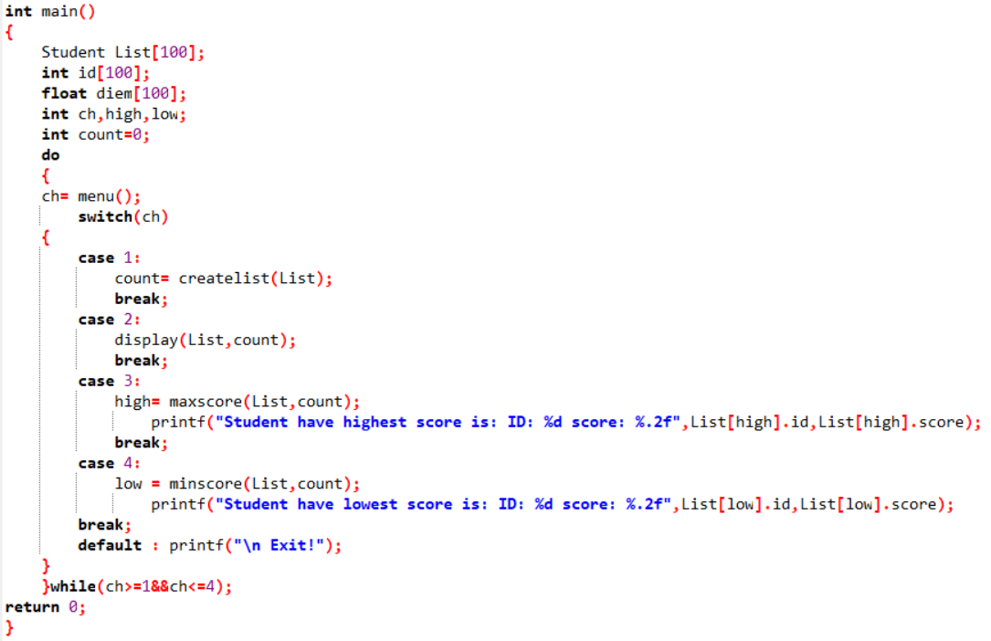

Figure

The main function includes declaring local variables, calling functions, and executing functions on the screen.

### 4.1.2 Input ID function

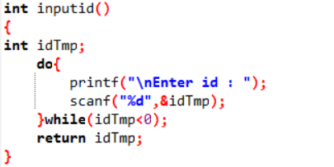

Figure

function used to enter data ID

### 4.1.3 Input grades function

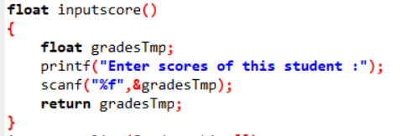

Figure

function used to enter grades data.

### 4.1.4 Input the number student and create student list function

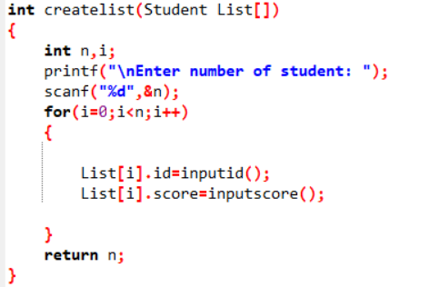

Figure

The function is used to enter student numbers and create a student list that allows entering student ID and scores.

### 4.1.5 Display all student list

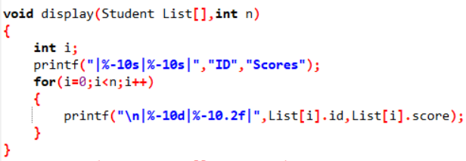

Figure

Function to print to the screen all student lists including ID and score

### 4.1.6 Display students have highest/lowest grades

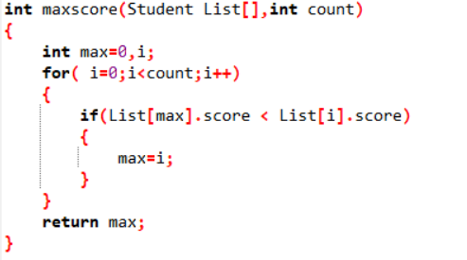

Figure

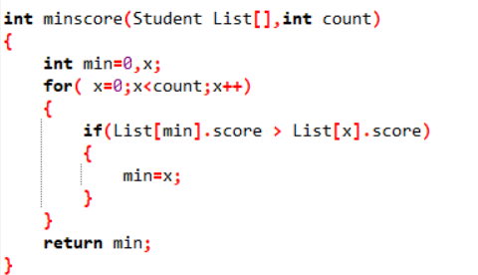

Figure

The function finds the student with the highest score and the lowest score

## 4.2 Plan program activity checks

### 4.2.1 Result of case-data 1: (Input valid data)

Press 1:

Enter 4 students

1. ID: 111; score: 6.7

2. ID: 222; score: 7.5

3. ID: 333; score: 4.2

4. ID: 444; score: 8.9

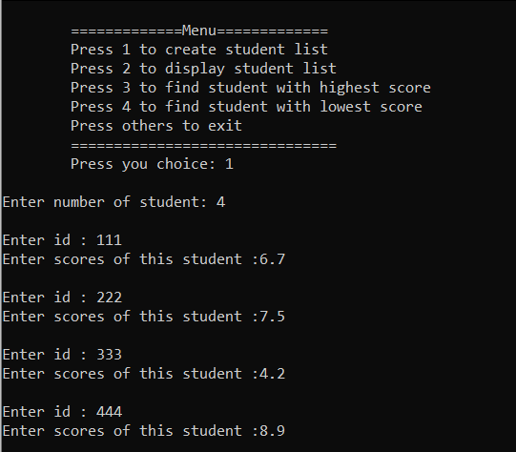

Figure

Press 2:

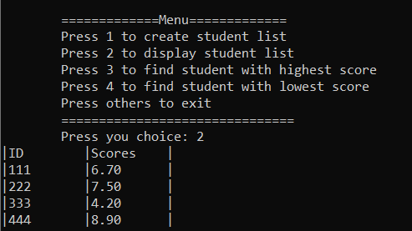

Figure

Display all student list.

Press 3:

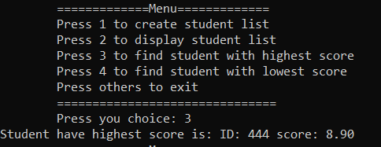

Figure

Display the student have highest score.

Press 4:

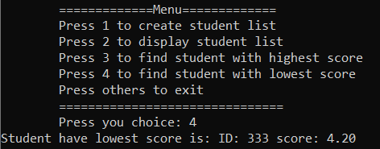

Figure

Display the student have lowest score.

### 4.2.2 Result of case-data2: (Input invalid data)

Case 1: Choice 10 on menu

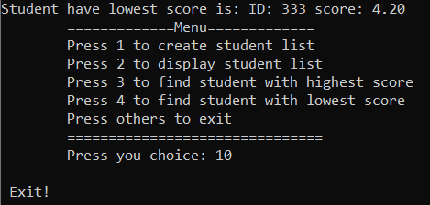

Figure

Announcement in the screen is: “ Exit! ” and exit the program.

Case 2: Choice 1 but input id is strings.

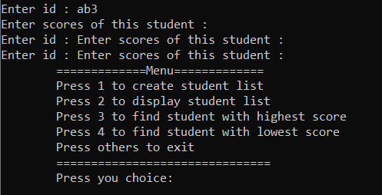

Figure

The program keeps running but can’t input others id or score.

Case 3: Input id < 0

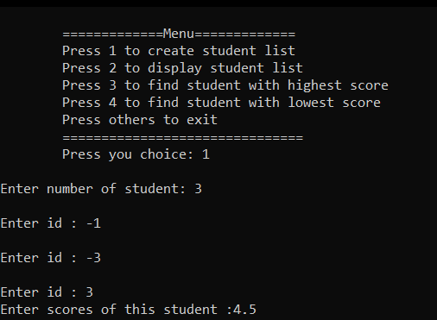

Figure

The program will force you to re-enter until id > 0

## 4.3 Analyse and testing program

### 4.3.1 Table of detail

|  |  |  |  |  |  |  |  |
| --- | --- | --- | --- | --- | --- | --- | --- |
| **Test case Numbe-r** | **Subjects to be inspecte-d** | **Preconditio-n** | **Step to take** | **Input data** | **Expecte-d Output** | **Actual-y output** | **Statu-s** |
| **1** | Input ID | ID is an integer | Press 1  Enter number 1  Enter ID: a3 | a3 | **ERRO** | Keep running but can input others variable | **Fail** |
| **2** | Input number of students | Number is an integer | Press 1  Enter number: z3 | z3 | **ERRO** | After a few seconds the program exits | **Pass** |
| **3** | Input scores | Score is float | Press 1  Enter number: 1  Enter ID: 111  Enter score: s15 | s15 | **ERRO** | Program keep running | **Fail** |
| **4** | Input ID | ID is an integer | Press 1  Enter number: 1  Enter ID: 1234567891011 | 1234567891011 | **ERRO** | Program keep running but display wrong id | **Pass** |

### 4.3.2 The console screen in the testing

Test case1:

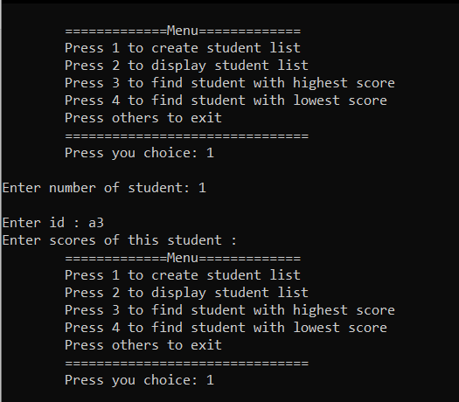

Figure

Test case 2:

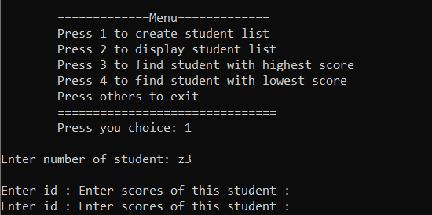

Figure

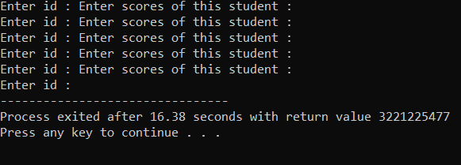

Figure

Test case 3:

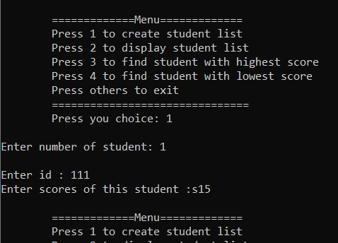

Figure

Test case 4:

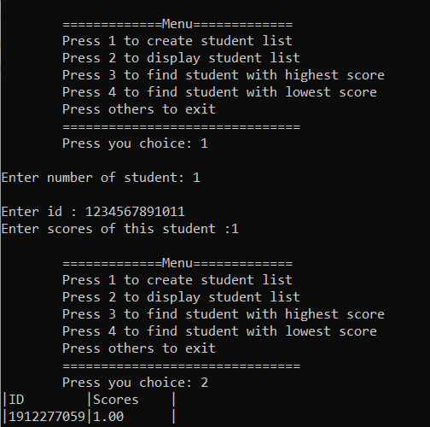

Figure

## 4.4 Review/ Evolution of this program

### 4.4.1 Advantages

Short, easy to understand and without many errors.

### 4.4.2 Disadvantages

A better layout should be presented, lacking in constraints for rolling input variables.

4.4.3 Directions for future processing and improvement

Add the conditions for the input variables. I have to research hard and try some other ways to come up with the best solution for this situation.

### 4.5 Lessons learned after doing the homework

A program can have many different directions, and I need to find the best path for my program. It takes hard work to improve my programming skills.

## EPILOGUE

Through lessons and practice, I realized the strengths and weaknesses of myself. Thereby improving his programming ability more. Understand how programming languages work and prepare yourself for the next semester.