HIGH LEVEL DESIGN
  - NXT Automated Signal and Trading System
Thuộc tính | Giá trị
Phiên bản | v0.1 — Desktop-first architecture
Ngày | 15/07/2026
Nguồn yêu cầu | BRD NXT Automated Signal and Trading System v0.2
Strategy baseline | NXT v3.5 USD-M BTCUSDT/BNBUSDT/SOLUSDT 1D; promoted rulebook 2026-07-14
Runtime MVP | Windows desktop: local app + Windows Task Scheduler + local durable store
Execution boundary | Binance USD-M Futures testnet first; live only after explicit approval and go-live controls

Architecture decision
MVP is a desktop-first modular monolith. Logical modules are independently testable, but are deployed locally together to minimize operational complexity. Cloud hosting is deliberately out of MVP scope and remains a later readiness decision.

1. Purpose and scope
This HLD defines the target architecture for a human-in-the-loop NXT system: it scans a promoted NXT ruleset, produces an approved order proposal, executes only within policy, monitors real exchange state, and records an auditable lifecycle.
In scope | Out of scope / deferred
Desktop scan, rule evaluation, approval workflow, USD-M testnet gateway, order protection, reconciliation, audit, Telegram/local UI. | Cloud runtime, autonomous rule promotion, HFT/intraday, multi-exchange routing, withdrawal automation, unattended live entry approval.

2. Architecture drivers and principles
Driver | Architectural response
Human approval | Proposal and Decision are durable records. Execution accepts only a non-expired approved proposal hash.
NXT latest changes | RuleVersion is immutable with parameters, artifact hash, source contract/session, and promotion timestamp. Existing positions retain their entry rule version.
USD-M execution risk | Risk engine sizes before leverage; isolated margin, exchange filters, liquidation buffer and portfolio caps are pre-trade gates.
Ambiguous exchange outcomes | Stable clientOrderId, query-before-retry, idempotency ledger and Binance reconciliation prevent duplicate logical orders.
Desktop-first reliability | Task Scheduler invokes a controlled service command; local health status, StartWhenAvailable, checkpoint recovery and operator alerting cover host interruptions.
Auditability | Append-only AuditEvent records actor, source, before/after state, correlation ID and external order IDs.

3. Logical architecture
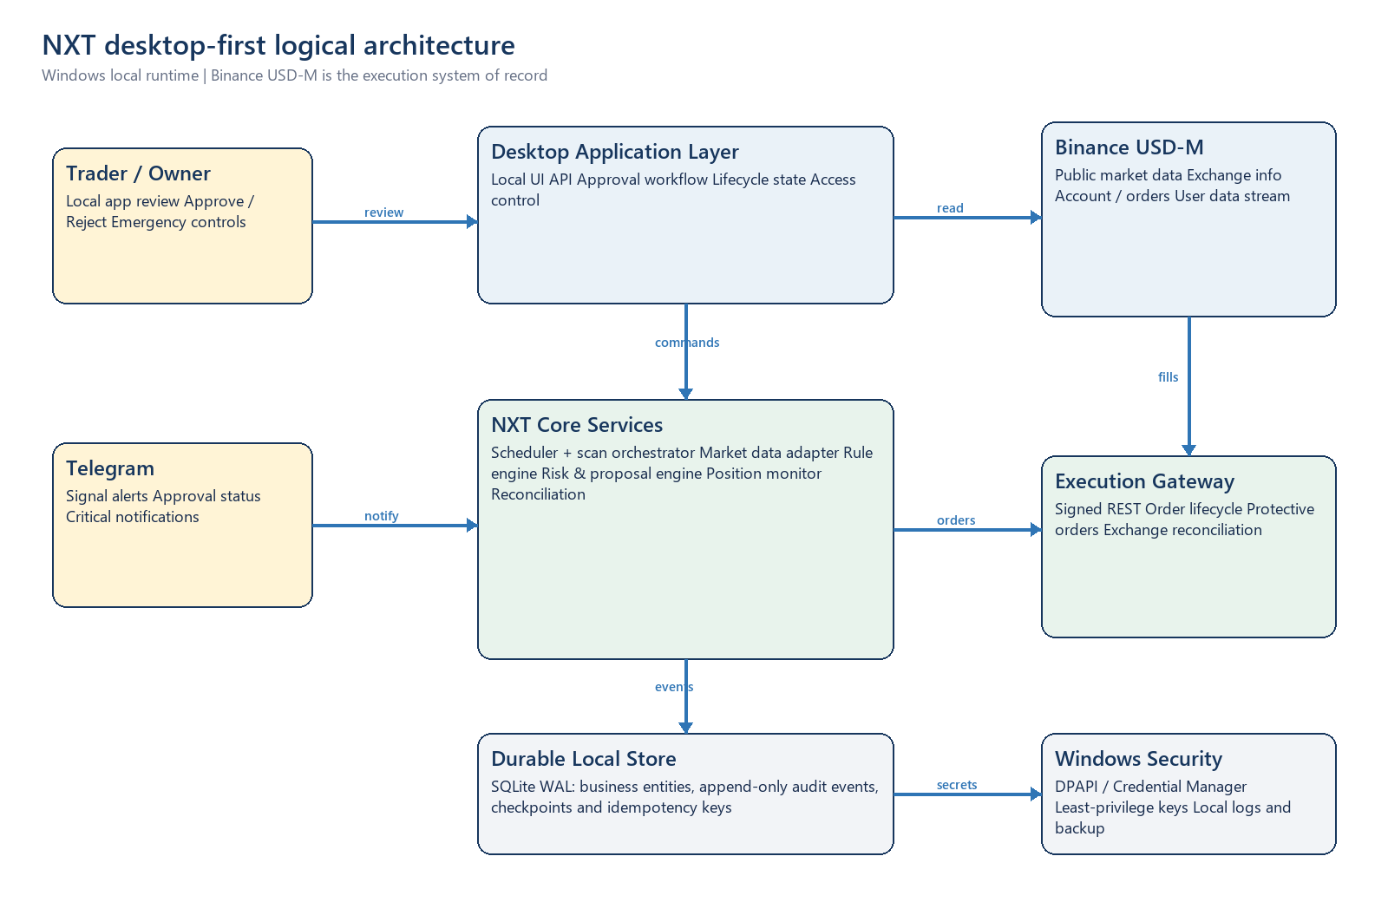
Figure 1. Desktop-first logical architecture
Layer | Components | Responsibility
Experience | Local App; Telegram notifier | Review proposals, display lifecycle/audit, capture Approve/Reject and provide alerts. Telegram is notification-first; privileged decisions remain policy-controlled.
Application | Workflow service; lifecycle manager; policy evaluator | Owns state transitions, approval expiry, idempotency and exception-to-Needs Review behavior.
Strategy | Market data adapter; NXT rule engine; RuleVersion registry | Reads closed USD-M candles, computes indicators, evaluates E/P/G rules, stores pass/fail rationale and signal snapshot.
Trading | Risk/proposal engine; execution gateway; position monitor | Calculates quantity/margin, validates filters, submits approved orders, maintains protective orders and reconciles exchange events.
Data/control | SQLite WAL store; audit log; settings/secrets; backup exporter | Durable local source for business state; Binance remains source of truth for exchange order/fill/position facts.
External | Binance USD-M APIs/streams; Telegram API | Market data, exchange status, trading/account events, delivery of notifications.

4. Desktop deployment topology
Node | Processes / stores | Operational responsibility
Windows desktop host | NXT local app/service; scheduled scan command; SQLite database; encrypted secrets; local log and backup folder. | Primary MVP runtime. Service must start after login/boot according to Task Scheduler configuration and publish health status.
Binance USD-M | Public market data; exchange information; signed REST; user data stream. | Execution system of record. All uncertain outcomes reconcile from Binance before another action.
Telegram | Bot API outbound notifications and optional review deep-link. | Secondary interaction channel. Notification failure must not lose persisted signal/proposal state.

Desktop boundary
No inbound public internet service is required for MVP. The local app binds to loopback by default. Remote access, public endpoints and cloud workers are not part of this HLD's deployment baseline.

5. Core workflows

5.1 Daily scan and proposal
Step | Flow and control
1. Schedule | Windows Task Scheduler starts the scan after USD-M 1D candle close (default 07:10 ICT). A ScanRun receives a correlation ID.
2. Data quality | Market Data Adapter verifies symbol, source, closed candle, freshness and expected session. Stale/incomplete data produces no new signal and raises an operator alert.
3. Rule evaluation | NXT Rule Engine loads the promoted immutable RuleVersion and creates a Signal snapshot only after all E/P/G conditions pass, including G-02.
4. Proposal | Risk Engine reads account snapshot, open-risk cap, exchange filters and policy; it computes quantity, notional, isolated margin requirement, leverage constraint, SL/TP1 and expiry.
5. Persist then notify | Workflow persists Signal and OrderProposal before Telegram/local UI notification. Signal deduplication uses versioned deterministic keys.
6. Decision | Trader approves/rejects the exact proposal hash. A changed price, expired proposal, changed policy or changed levels invalidates approval.

5.2 Execution and protection
Step | Flow and control
1. Pre-trade revalidation | Execution Gateway rechecks API permission, server time, account/margin, position state, leverage/margin mode, price deviation, filters, risk limits and idempotency.
2. Entry | Gateway writes clientOrderId before submit. A timeout or 5xx is an unknown outcome: query order and user stream before retrying.
3. Fill handling | Actual fills update Position and ExchangeOrder. Partial fill quantity becomes the maximum size for protective orders.
4. Protection | Create reduce-only SL and TP1 immediately. Rejection creates Critical state, blocks new entries and follows owner-approved fail-safe policy.
5. Exit lifecycle | Monitor detects TP1, Early-BE, stop and SSL runner action. Action is a recommendation or automated only at the approved automation level.

5.3 Monitoring and reconciliation
- User data stream is the low-latency feed for orders, fills and account/position changes; REST reconciliation repairs gaps after disconnect or restart.
- Binance is the source of truth for actual orders, fills and positions. Internal state is a reconciled projection, not a substitute for exchange facts.
- Every daily close runs a position recommendation using the entry RuleVersion or an explicit migration record. A new latest version cannot silently change an open position's policy.
- Any mismatch, ambiguous response, stale data or rejected protective order becomes Needs Review and suppresses dependent automation.

6. Data architecture
Entity | Key contents | Control
RuleVersion | version, parameters, USD-M contract/session, system document hash, promotedAt | Immutable and retained indefinitely.
ScanRun | runId, candle date, symbols, source/freshness, status, errors, duration | Unique run ID; operational retention at least two years.
Signal | deterministic signalId, RuleVersion, indicator snapshot, guard rationale, levels | Immutable once detected; deduplicated by source + rule version.
OrderProposal / Decision | proposal hash, quantity, risk, expiry, decision actor/channel/time | No in-place change after approval. New values require new proposal/decision.
ExchangeOrder / Position | clientOrderId, Binance order ID, fills, protective order IDs, actual quantity/lifecycle | Reconciled with exchange events and REST snapshots.
Recommendation / AuditEvent | action rationale, automation level, status; actor, before/after, correlation ID | Append-only; supports investigation and weekly audit.

Local storage selection
Proposed MVP store: SQLite in WAL mode with transactional writes, periodic encrypted backup/export and a migration layer. This meets the single-host desktop scope while preserving a future move to a managed database if cloud is approved.

7. Interfaces and integration boundaries
Interface | Direction | Purpose and resilience
USD-M market data | Outbound read | Fetch candles and exchange info. Validate closed bar and freshness; cache may support display only, never new signal generation when stale.
USD-M trading/account | Outbound signed REST | Query account/order status; submit/cancel/replace approved orders; use clientOrderId and query-before-retry.
USD-M user data stream | Inbound event | Receive account/order/fill events; reconnect and backfill via REST when sequence or connectivity is uncertain.
Telegram Bot API | Outbound notification | Signal, decision, fill and critical alerts. Retry delivery independently of business state persistence.
Local app API | Loopback only | UI reads business state and records permitted user actions. No public listener in MVP.

8. Security, risk and resilience
Concern | Design control
Secrets | Store API credentials in Windows Credential Manager/DPAPI-backed storage; never in source, SQLite, exports or logs. Keys must lack withdrawal permission.
Environment separation | Testnet and live use distinct configuration, credentials, clientOrderId namespace, database profile and visible UI banner.
Leverage and liquidation | Risk budget determines quantity first. Leverage is a margin-efficiency setting, capped by policy; pre-trade validation verifies isolated margin and liquidation buffer before approval/execution.
Failure handling | Unknown exchange outcome, stale data, protective failure or reconciliation mismatch transitions to Needs Review/Critical rather than inferring success.
Kill switch | Pause blocks new entry while monitoring/protection continues. Kill switch blocks automated action except an owner-approved emergency policy; all changes are audited.
Desktop continuity | Task Scheduler StartWhenAvailable, health check, alerting, checkpointed ScanRun and reconciliation on restart. Cloud is not the fallback in MVP.

9. NFR and requirement traceability
BRD area | HLD response | Verification evidence
FR-01 / FR-02; BR-01 to BR-11 | Scheduler, data-quality gate, NXT Rule Engine and RuleVersion registry. | Golden-signal test; G-02 regression; deterministic Signal ID.
FR-03 to FR-07; BR-12 to BR-15 | Risk/Proposal Engine, Approval workflow, Execution Gateway and Protective Order manager. | Testnet E2E; pre-trade checks; partial fill and protective failure tests.
FR-08 / FR-09; BR-16 / BR-17 | Position monitor, user data adapter, REST reconciliation and recommendation service. | Disconnect/restart/manual intervention reconciliation evidence.
FR-10 to FR-12; NFR-02/03/05/07 | Notifier, local dashboard, audit store, health monitor and operational controls. | Delivery retry logs, audit timeline, kill-switch UAT and scheduled-run status.
Desktop-first decision | Single-host modular deployment and local data store; cloud excluded from MVP boundary. | 30-day desktop paper/testnet operational run.

10. Key design decisions and open decisions
Decision | Status | Rationale / remaining action
Desktop-first modular monolith | Confirmed | Lowest operational complexity for MVP; components remain separable for later cloud assessment.
Binance USD-M as technical baseline | Confirmed | Matches promoted NXT data and funding model. Owner must still confirm account eligibility/contract availability before testnet/live.
Human approval for entry | Confirmed | No live entry without an approval record matching the proposal hash and environment.
Live risk, leverage ceiling and loss caps | Open / blocking | Owner must set per-trade and portfolio policies. HLD enforces a policy interface rather than hardcoding values.
Runner exit automation level | Open / high | Recommendation-only is the safe default until owner approves an automation policy.
Cloud readiness | Deferred | Evaluate only after desktop paper/testnet pilot achieves the BRD operational-run exit criteria.

11. Phased implementation view
Phase | Architecture increment | Exit condition
1. Desktop paper | SQLite schema, RuleVersion registry, scan workflow, local UI/Telegram approval, simulated exchange adapter and audit timeline. | Golden signal, approval, duplicate and restart UAT pass.
2. Desktop USD-M testnet | Signed gateway, exchange filters, user stream, protective orders, reconciliation, risk/portfolio pre-trade gates. | 30-day stable run without duplicate order or unresolved critical protection failure.
3. Desktop live assisted | Feature-gated live profile, manual entry approval, production monitoring, backup/restore drill and low-risk policy configuration. | Go-live checklist and owner approval.
4. Later assessment | Optional managed automation and cloud-readiness design only after desktop evidence supports it. | Separate decision record; no automatic migration.

12. HLD acceptance criteria
- Architecture supports every Must requirement in BRD v0.2 without requiring cloud deployment.
- Signals, proposals, decisions and exchange actions are traceable by correlation ID and immutable rule/proposal references.
- No execution path bypasses approval, pre-trade checks, idempotency or protective-order validation.
- Rule update, G-02 regression, stale-data block, restart recovery and manual Binance action have explicit handling paths.
- All open risk, leverage, margin and automation values remain policy-configured and require owner approval before live use.

Appendix A. References
- docs/BRD_NXT_Automated_Signal_Trading_System_v0.2.docx
- latest/NXT_Latest_Summary.md
- latest/NXT_Latest_NXT35_USDM_BlockShortAfterLosingLong_System_And_Indicators.docx
- latest/NXT_Latest_NXT35_USDM_BlockShortAfterLosingLong_SignalRegression.json
- app/nxt_signal_app.py and scripts/daily_nxt_signal_scan.py — current desktop scan core.

