Workshop 1

1. Updating the PATH Environment Variable.

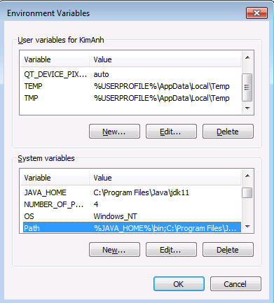

2. Updating the CLASSPATH Environment Variable

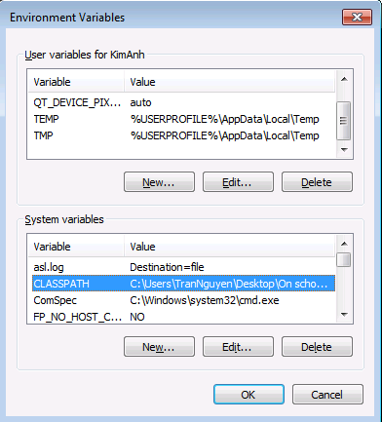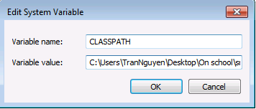

3. Let us look at a simple code that would print the words Hello World.

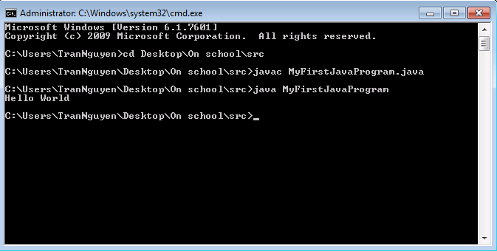

4. Modify the above program and print out your information to screen, including: your full name, your class name, your student id number and your age

