Name: Nguyen Tran

Class: CS 4375.004

NetID: HPT200001

Date: 02/03/2023

1. **Copy/paste runs of your code showing the output**

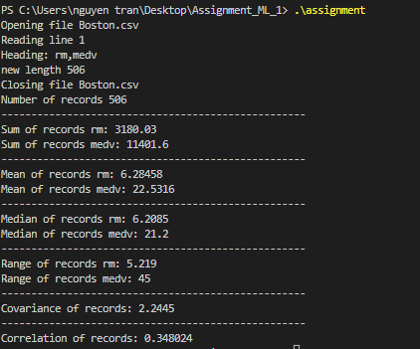

1. **Describing your experience using built-in functions in R versus coding your own functions in C++**

Since R is built to handle data processing and data manipulation, they provide more built-in function for number and data analysis compared with C++. On the other hand, the syntax of C++ is easier to read than R. With R, we don’t need to create these function since they already provide thus the it is easier to use than C++ and save more time.

1. **Describe the descriptive statistical measures mean, median, and range, and how these values might be useful in data exploration prior to machine learning**
2. **Describe the covariance and correlation statistics, and what information they give about two attributes. How might this information be useful in machine learning?**