PBL REPORT
XAI-FER Mask-Aware
Model, Evaluation and Preliminary Results
Real-time, multi-face, explainable facial expression recognition under mask occlusion
Student ID | Member | Role
SE200698 | Hồ Trường Thịnh | Data & Detection Pipeline
SE203691 | Nguyễn Trinh Quý | Deep Learning & Evaluation
SE194517 | Trịnh Quốc Sang | XAI & Real-Time System
Course: DSR301m · Companion document to XAI-FER_Slides.pptx

Contents
1. Overview 3
1.1 Scope of this phase 3
2. Data 3
2.1 Leakage-free split 3
3. Model 4
3.1 Architecture 4
3.2 Two-stage training 4
3.3 Class imbalance: logit adjustment and prior-bias calibration 4
4. Evaluation protocol 5
5. Preliminary results 5
5.1 Main comparison 5
5.2 Per-class results on masked faces 6
5.3 Ablation of post-processing 6
5.4 Explainability: attention shift 7
5.5 Real-time performance 7
5.6 Deployment to R 7
6. Limitations 8
7. Next steps 8
References 8

1. Overview
Facial expression recognition (FER) models trained on full faces fail when a surgical mask hides the lower half of the face. On our own RAF-DB-only model, accuracy drops from 89.15% on normal faces to 56.61% on masked faces, and 48% of masked happy faces are predicted as neutral.
This project builds a system that (1) recognises seven expressions on in-the-wild faces, (2) stays accurate when a mask is worn, (3) runs in real time on several faces at once and (4) explains each prediction with a Grad-CAM heatmap. This report covers the model, the evaluation protocol and the preliminary results; all numbers come from files in the repository (output/*.json) or were re-computed with scripts/study_analysis.py.

1.1 Scope of this phase
- Two trained checkpoints: a baseline trained on original RAF-DB and the proposed Mask-Aware model.
- Evaluation on three official test sets: unmasked (3,068), masked (1,975) and combined (5,043).
- A real-time demo pipeline (detection, alignment, tracking, Grad-CAM) and a TorchScript export used by the R/Shiny branch.

2. Data
RAF-DB (Real-world Affective Faces) contains 15,339 aligned colour faces collected from the internet: 12,271 official training and 3,068 official test images, labelled into seven classes (angry, disgust, fear, happy, neutral, sad, surprise). The data is strongly imbalanced: happy is 38.9% of training images while fear is only 2.3% (about 17×).
Masked faces were generated with MaskTheFace, which finds 68 dlib landmarks and warps a 2D surgical-mask template onto the nose, cheeks and chin. dlib finds a face in about 64% of the 100×100 images, giving 7,830 masked training and 1,975 masked test images. Labels are copied from the source image and file names keep the source ID (raf_train_00012_surgical.jpg).
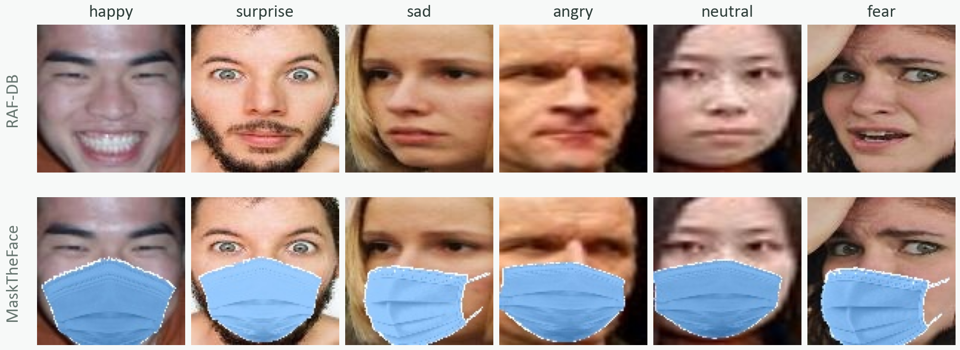
Figure 1. RAF-DB test images (top) and their MaskTheFace versions (bottom).

2.1 Leakage-free split
Each masked image is a near copy of its source image, so a random split would put the same face in both train and validation and inflate validation scores. We split by source group: an original image and all of its masked versions always land on the same side. 15% of groups per class go to validation (seed 42); the list is frozen in data/splits/val_groups_r15_s42.json and reused by both training stages.
Split | Original | Masked | Total
Train | 10,429 | 6,670 | 17,099
Validation | 1,842 | 1,160 | 3,002
Test (official) | 3,068 | 1,975 | 5,043
Table 1. Data splits. Train and validation share 0 source groups.
An independent audit (scripts/check_leakage.py) compares image content with a perceptual hash of the upper face plus pixel correlation. Result: 0 masked test images come from training sources and 0 groups are shared between train and validation. 49 test images (1.6%) are near-duplicates of training images inside the official RAF-DB split itself; removing them changes accuracy by only about 0.1–0.2 points.

3. Model

3.1 Architecture
The backbone is EfficientNet-B0 with HSEmotion weights (about 4.0M backbone parameters, 0.39 GFLOPs at 224×224). These weights were trained for face identification on VGGFace2 and then for emotion recognition on AffectNet, so the network already encodes facial muscle patterns. A 224×224 face goes through the backbone to a 1280×7×7 feature map, global average pooling and a dropout + linear head with seven outputs. The head is initialised from the AffectNet classifier with the contempt row removed, so the model predicts emotions from the first step.

3.2 Two-stage training
- Stage 1 – original RAF-DB: one epoch training only the head (backbone frozen), then 25 epochs of full fine-tuning. Output: best_model_rafdb.pth.
- Stage 2 – Mask-Aware: start from Stage 1 and fine-tune 20 epochs on original + masked images, adding LowerFaceOcclusion (a random mask-shaped patch over the lower face, p = 0.3) so the model cannot rely on the mouth. Output: best_model_mask_aware.pth.
Setting | Value
Optimizer | AdamW, weight decay 0.05, gradient clipping 5.0
Learning rate | backbone 1e-4, head 1e-3; 1-epoch linear warmup + cosine decay
Loss | Logit-Adjusted cross-entropy (τ = 1.0) + label smoothing 0.1
Augmentation | random resized crop, flip, ±10° rotation, colour jitter, RandomErasing 0.25, Mixup (α 0.2) / CutMix (α 1.0) on 50% of batches
Weight averaging | EMA 0.998; the EMA weights are evaluated and saved
Checkpoint selection | best validation Macro-F1; early stopping after 8 epochs without improvement
Training time | 108 min (Stage 1), 97 min (Stage 2)
Table 2. Training configuration (from output/*_metrics.json).

3.3 Class imbalance: logit adjustment and prior-bias calibration
During training the loss adds τ·log(class prior) to the logits. A rare class such as fear must then score much higher to win, so the model learns rare classes better. The side effect is that raw predictions behave as if all classes were equally frequent: on unmasked test images the RAF-DB model predicts fear with recall 0.78 but precision only 0.32.
After training we add t·log(prior) back to the logits at inference time. The value of t is searched from −0.5 to 1.5 (step 0.05) on the validation set only, maximising Macro-F1. This gives t* = 0.70 (RAF-DB model) and t* = 0.85 (Mask-Aware). The resulting bias vector is stored in the checkpoint and applied by the evaluation script, the apps and the TorchScript export.
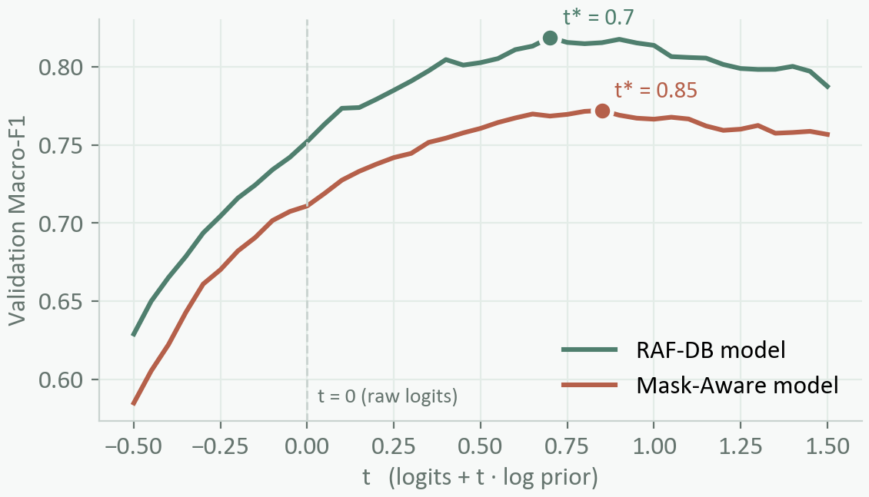
Figure 2. Validation Macro-F1 as a function of t. Dots mark the selected t*.

4. Evaluation protocol
- Test sets: official RAF-DB test split, unmasked (3,068), masked (1,975) and combined (5,043). The test set is used once, after all choices are fixed.
- Metrics: accuracy and Macro-F1 (unweighted mean of the seven per-class F1 scores). Macro-F1 is the main metric because accuracy rewards always predicting the frequent classes.
- Inference settings: fp32, horizontal-flip test-time augmentation (average of the image and its mirror), prior-bias with t chosen on validation.
- Explainability: Grad-CAM on layer bn2 (1280×7×7) of EfficientNet-B0, measured on 1,975 paired test images (each masked image with its unmasked original).
- Speed: full pipeline (detection + alignment + prediction + tracking + Grad-CAM) on an Apple M1 GPU (MPS), synthetic 1280×720 frames with 1–5 RAF-DB faces, TTA off.

5. Preliminary results

5.1 Main comparison
Model | Unmasked (3,068) | Masked (1,975) | Combined (5,043)
MobileNetV3 (old pipeline)* | 79.86% / F1 0.718 | 73.27% / F1 0.628 | 77.28% / F1 0.684
HSEmotion-B0, RAF-DB only | 89.15% / F1 0.833 | 56.61% / F1 0.534 | 76.40% / F1 0.725
HSEmotion-B0, Mask-Aware (proposed) | 88.43% / F1 0.822 | 79.29% / F1 0.708 | 84.85% / F1 0.779
Table 3. Test accuracy / Macro-F1 (fp32, flip TTA, prior-bias). *Old pipeline with a leaky validation split; reference only, not the same protocol.
On masked faces the Mask-Aware model gains +22.68 accuracy points (56.61% → 79.29%) and +0.174 Macro-F1 over the RAF-DB-only model, while losing only 0.72 points on unmasked faces. On all 5,043 test images it reaches 84.85% (+8.45 points).

5.2 Per-class results on masked faces
Class | Precision | Recall | F1 (Mask-Aware) | F1 (RAF-DB only) | Support
happy | 0.941 | 0.845 | 0.890 | 0.570 | 805
surprise | 0.798 | 0.806 | 0.802 | 0.634 | 206
sad | 0.738 | 0.849 | 0.790 | 0.733 | 305
angry | 0.800 | 0.706 | 0.750 | 0.519 | 102
neutral | 0.677 | 0.779 | 0.724 | 0.507 | 420
fear | 0.640 | 0.457 | 0.533 | 0.436 | 35
disgust | 0.484 | 0.451 | 0.467 | 0.340 | 102
Table 4. Per-class metrics on the masked test set (1,975 images).
Classes that can be read from the eyes and brows stay strong (happy F1 0.890, surprise 0.802, sad 0.790). Disgust (0.467) and fear (0.533) remain the hardest: disgust depends on nose wrinkling and the upper lip, both hidden, and fear has only 35 masked test images, so its score is noisy.
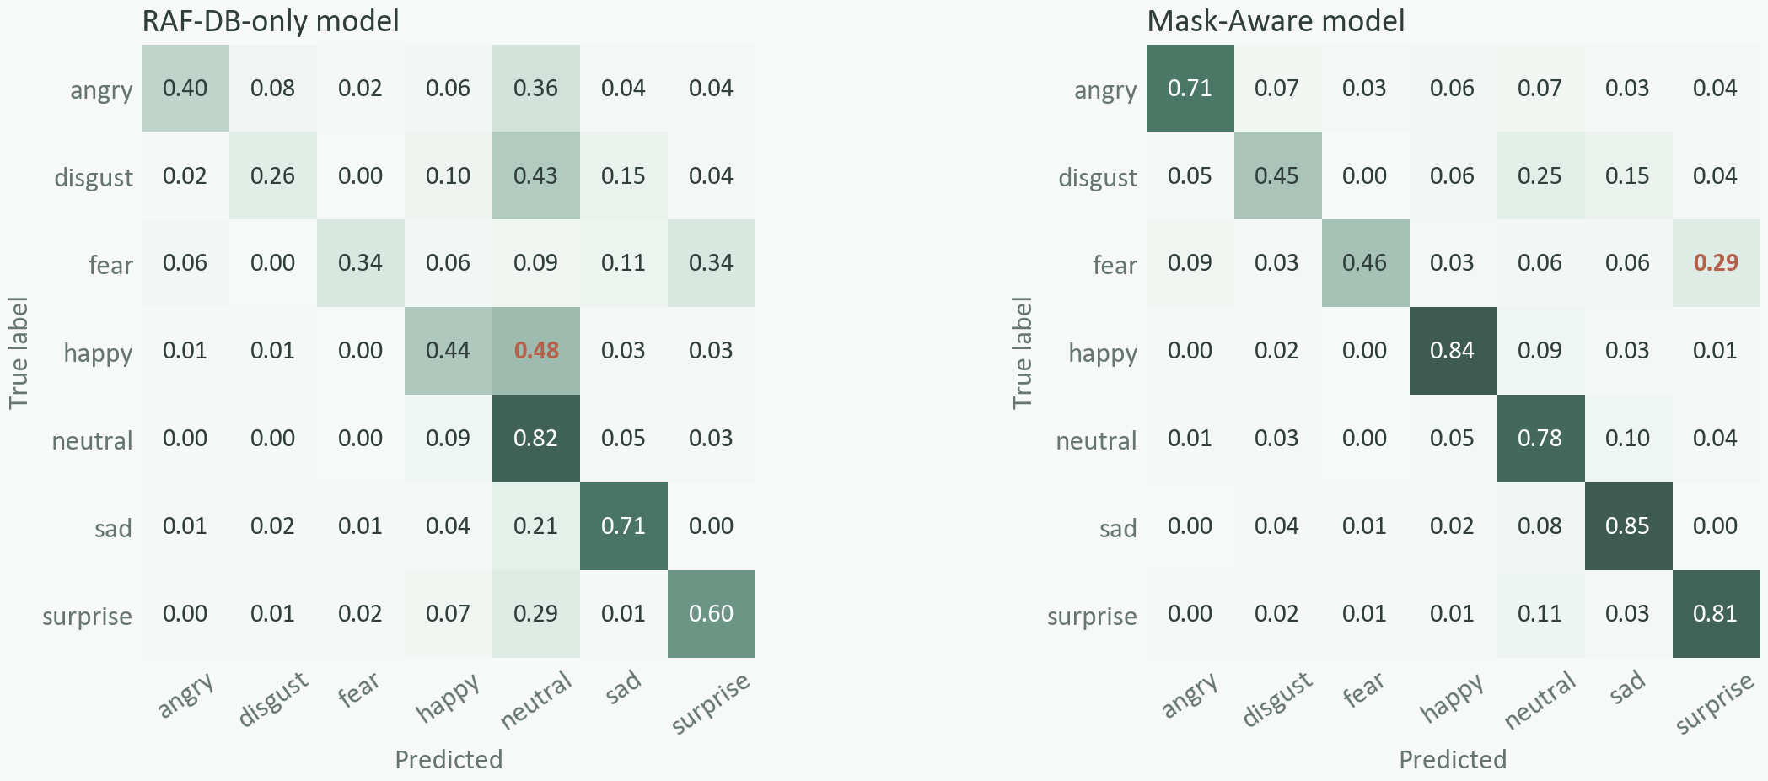
Figure 3. Row-normalised confusion matrices on masked faces. The RAF-DB-only model sends 48% of happy faces to neutral; the Mask-Aware model 9%. Fear is still confused with surprise (29%).

5.3 Ablation of post-processing
Model / test set | Raw logits | + flip TTA | + prior-bias | + TTA + prior-bias
RAF-DB only / unmasked | 84.22 | 83.93 | 89.05 | 89.15
RAF-DB only / masked | 49.37 | 49.97 | 56.20 | 56.61
Mask-Aware / unmasked | 83.70 | 84.06 | 88.43 | 88.43
Mask-Aware / masked | 73.27 | 73.22 | 79.75 | 79.29
Mask-Aware / combined | 79.62 | 79.81 | 85.03 | 84.85
Table 5. Test accuracy (%) when each post-processing step is added, same checkpoints.
Prior-bias calibration is the largest post-processing gain (+4.4 to +6.8 points). Flip TTA changes accuracy by less than 0.6 points, so it is switched off in the webcam app. The t chosen on validation is close to the best value that could be found on the test set (masked: 1.0 vs 0.85, F1 0.713 vs 0.708), which indicates the calibration generalises. Face alignment does not appear here because RAF-DB test images are already aligned; it only affects the live application.

5.4 Explainability: attention shift
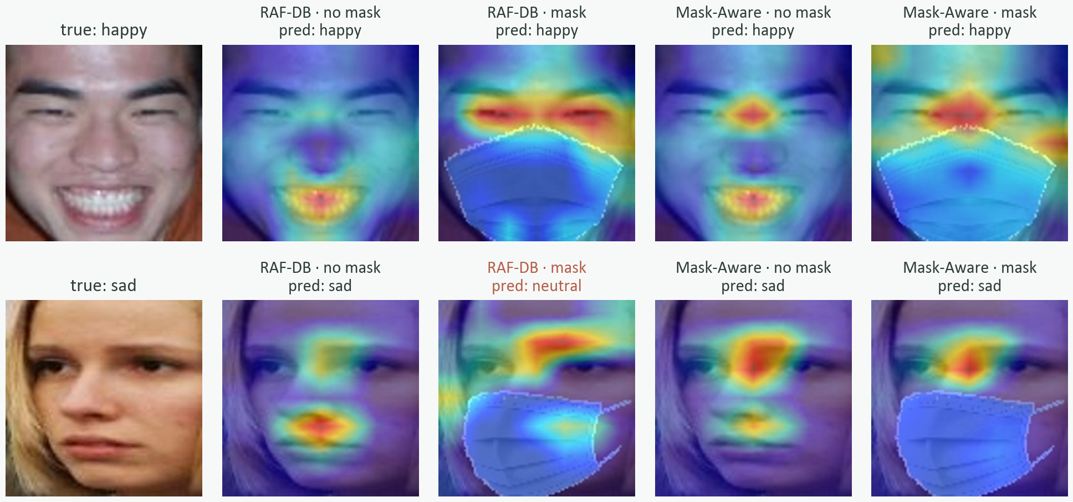
Figure 4. Grad-CAM for the true label on RAF-DB test images, both models, with and without a mask.
On 1,975 paired test images, the share of Grad-CAM energy above the mask line (upper half of the aligned face) rises from 47% to 58% for the Mask-Aware model when a mask is worn, and the heatmap concentrates in one peak between the eyes and brows. The RAF-DB-only model also looks up (42% → 55%) but its attention stays diffuse and it falls back to neutral. Grad-CAM is a coarse (7×7) qualitative explanation, so we report it as supporting evidence rather than proof.

5.5 Real-time performance
Faces | FPS (no Grad-CAM) | FPS (Grad-CAM every 10 frames) | Detect (ms) | Predict (ms) | Grad-CAM (ms/frame)
1 | 55.0 | 37.4 | 5.5 | 12.7 | 8.1
2 | 37.4 | 25.9 | 5.6 | 21.1 | 9.1
3 | 28.4 | 20.7 | 5.5 | 29.7 | 9.1
4 | 20.2 | 17.3 | 6.4 | 43.2 | 9.1
5 | 17.4 | 15.1 | 6.7 | 50.8 | 9.2
Table 6. Pipeline speed on Apple M1 (MPS), synthetic 1280×720 frames, TTA off (output/fps_benchmark_m1.json).
With one face the pipeline runs at 55.0 FPS, or 37.4 FPS with Grad-CAM refreshed every 10 frames. Detection cost is almost constant; prediction grows with the number of faces, and five faces still run at about 15 FPS.

5.6 Deployment to R
The Mask-Aware model is exported to TorchScript with the calibrated bias built in, so it can be loaded in R with torch::jit_load() without Python. A parity test on 10 images per model gives a maximum probability difference of 3×10⁻⁷ and identical predicted classes. The R modules (alignment, tracker, Grad-CAM maths) and the Shiny interface exist; live prediction and the Grad-CAM hook in the R app are still in progress.

6. Limitations
- Masks are synthetic (one MaskTheFace surgical type, applied to both train and test); there is no labelled real-mask test set yet.
- Results come from a single training seed, without confidence intervals.
- Grad-CAM is coarse and qualitative; the link to facial Action Units is an interpretation.
- Disgust and fear remain weak under masks; fear has only 35 masked test images.
- FPS was measured on an Apple M1 with synthetic frames, not on a live webcam or an NVIDIA GPU.

7. Next steps
- Label the real masked faces in data/real_masked_faces and report accuracy on them.
- Ablations: logit-adjusted loss vs plain cross-entropy, occlusion on/off, and several seeds with confidence intervals.
- Benchmark on a live webcam and an NVIDIA GPU.
- Finish live prediction and Grad-CAM in the R/Shiny application.

References
- Li, S., Deng, W., & Du, J. (2017). Reliable crowdsourcing and deep locality-preserving learning for expression recognition in the wild. CVPR.
- Savchenko, A. V. (2021). Facial expression and attributes recognition based on multi-task learning of lightweight neural networks. (HSEmotion).
- Tan, M., & Le, Q. (2019). EfficientNet: Rethinking model scaling for convolutional neural networks. ICML.
- Menon, A. K., et al. (2021). Long-tail learning via logit adjustment. ICLR.
- Selvaraju, R. R., et al. (2017). Grad-CAM: Visual explanations from deep networks via gradient-based localization. ICCV.
- Anwar, A., & Raychowdhury, A. (2020). MaskTheFace: Systematically masking faces for deep learning. arXiv:2008.06013.

