PHÁT TRIỂN ỨNG DỤNG DI ĐỘNG
Họ tên: Nguyễn Trọng Nguyên
MSSV: 2001230589

Bài tập tuần 4
Phần mềm: Visual Studio Code
Framework: Flutter
Ngôn ngữ: Dart
Link github:

Cây thư mục:
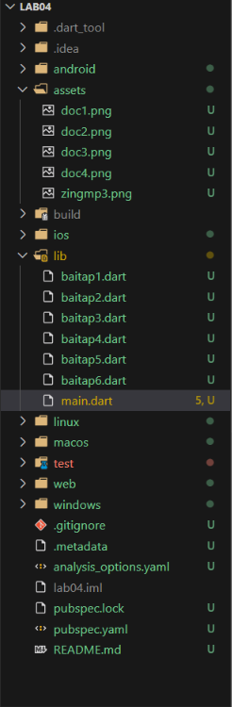

I. BÀI TẬP TỰ LÀM:
Bài tập 01. Hãy thiết kế ứng dụng máy tính trên thiết bị di động
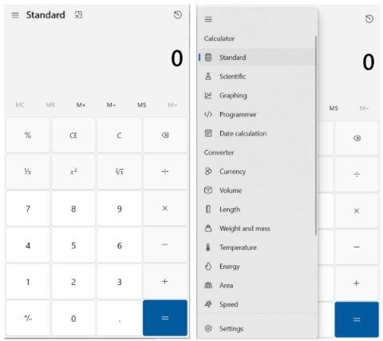
Source code:
lib/baitap1.dart
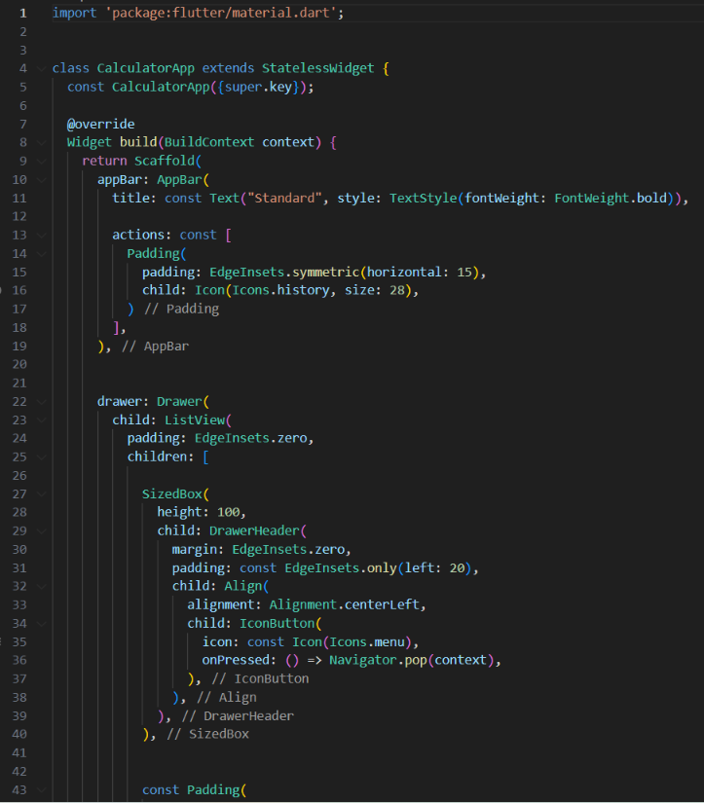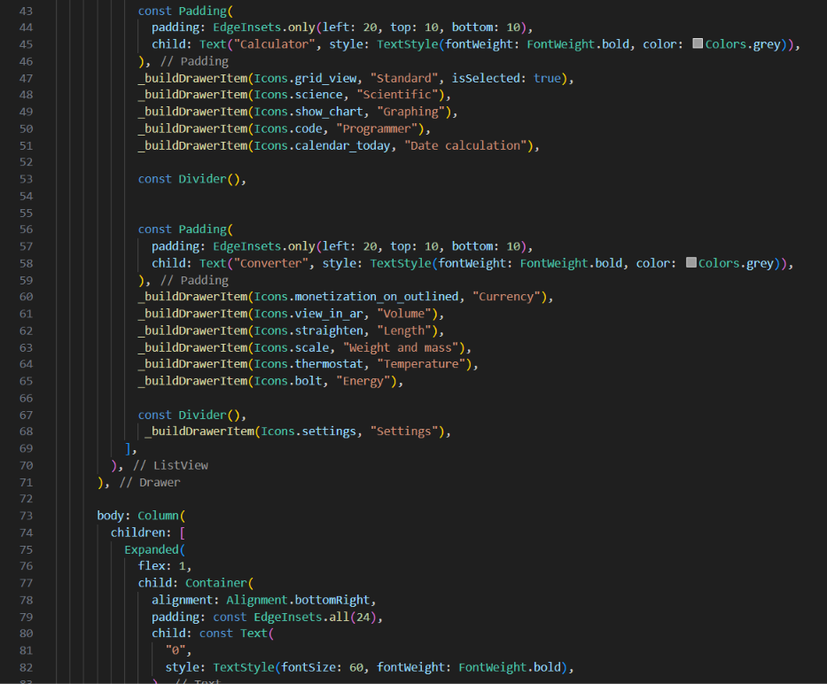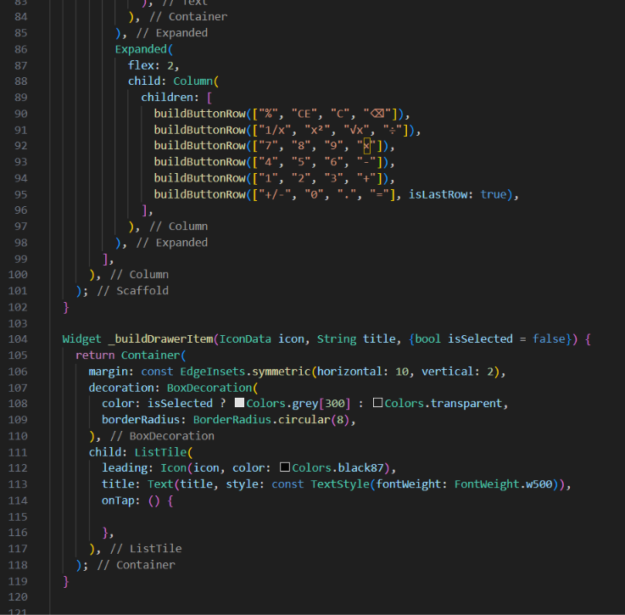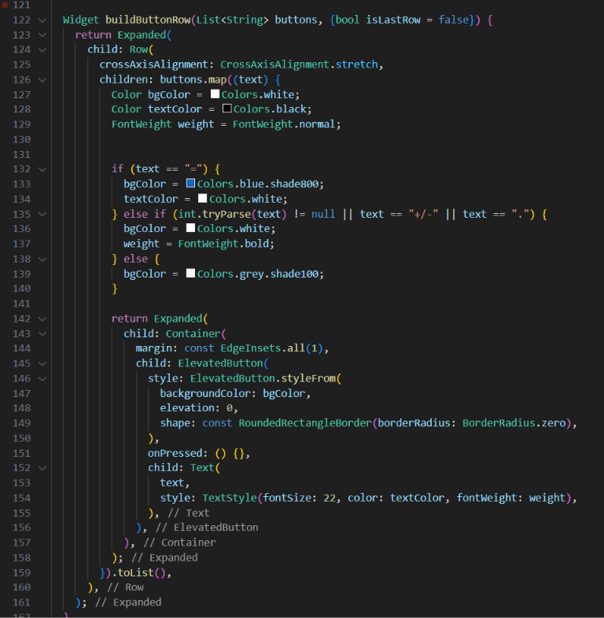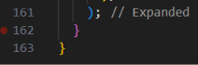

lib/main.dart (hàm main cho tất cả các bài)
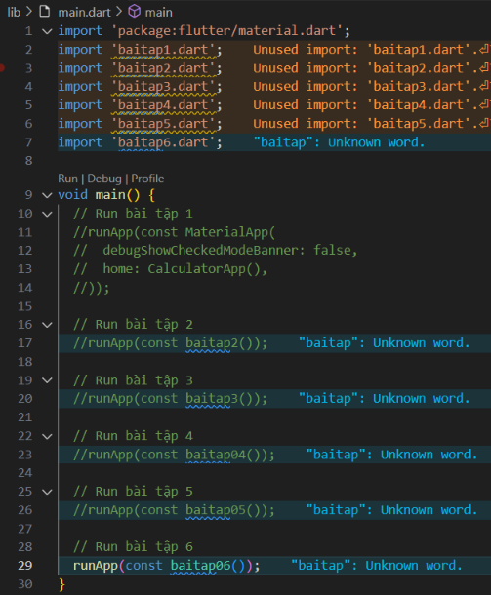

Kết quả:

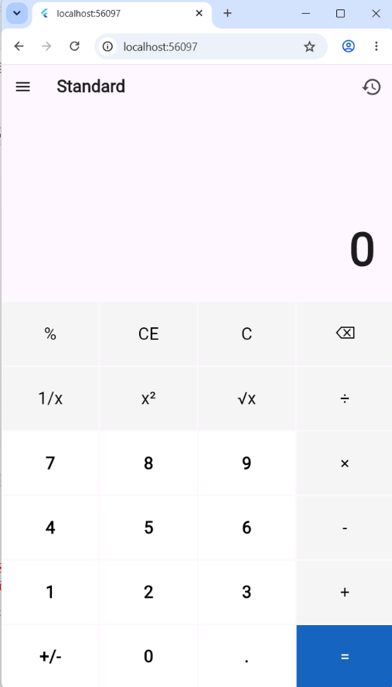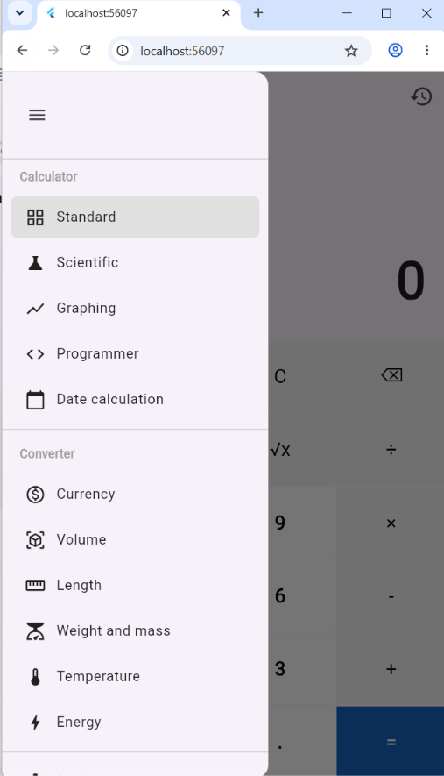
Bài tập 02. Sử dụng bottomNavigationBar xây dựng ứng dụng giới thiệu cơ sở vật chất của trường Đại học Công thương thành phố hồ Chí Minh như sau :
Source code:
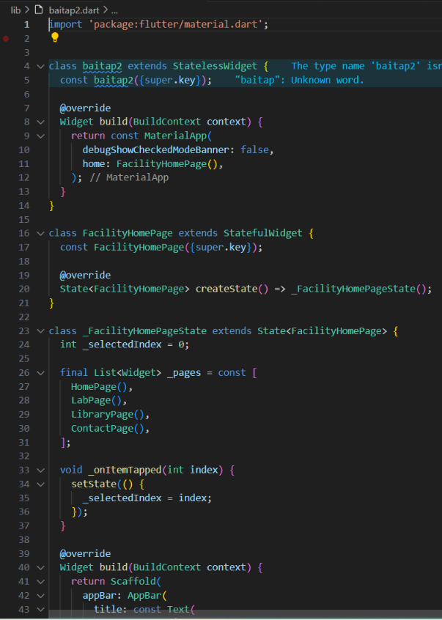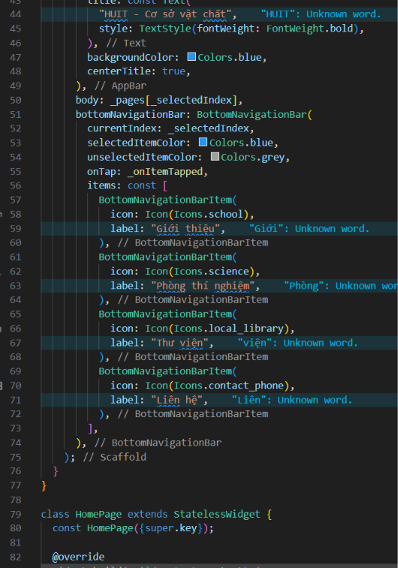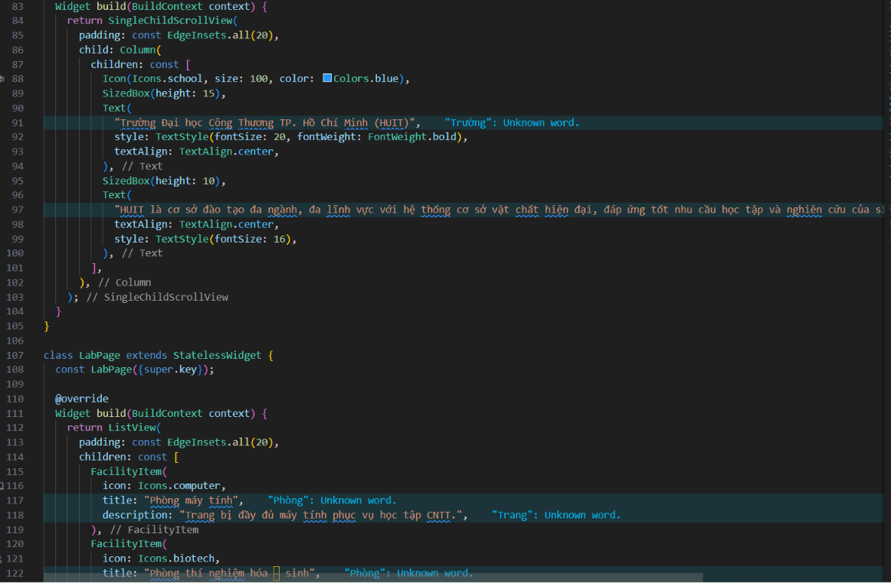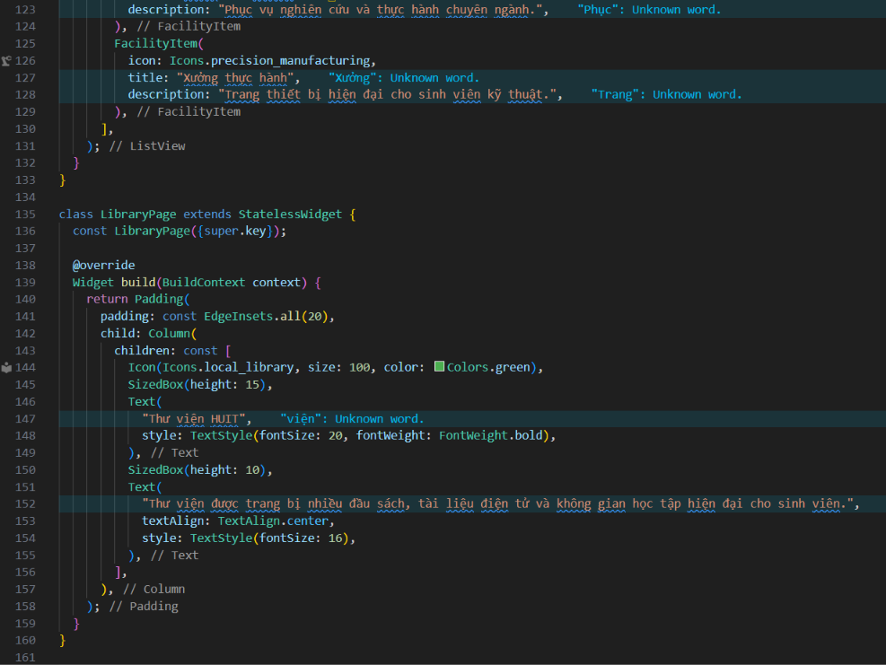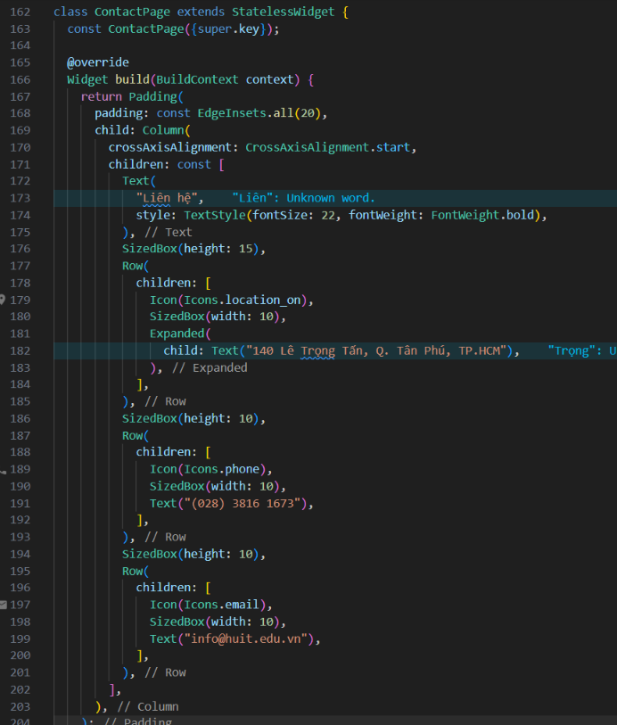
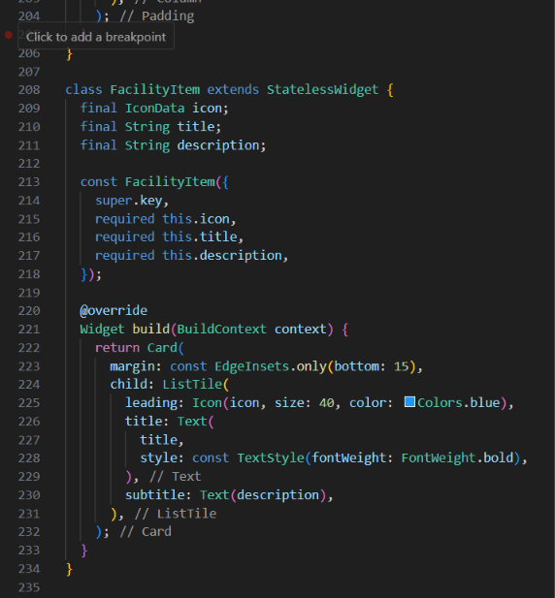

Kết quả:

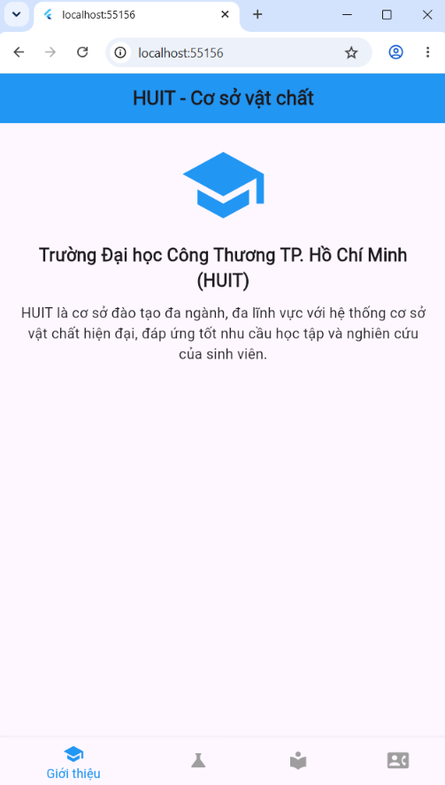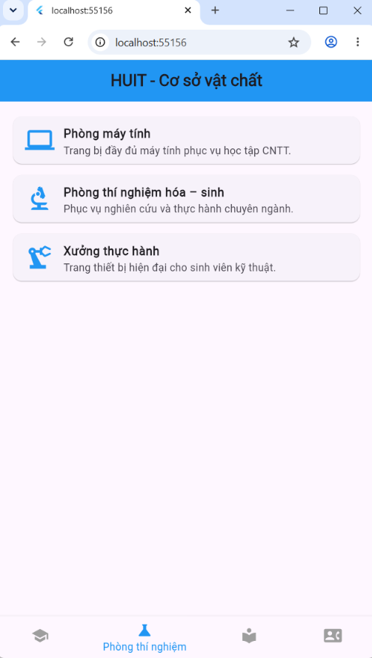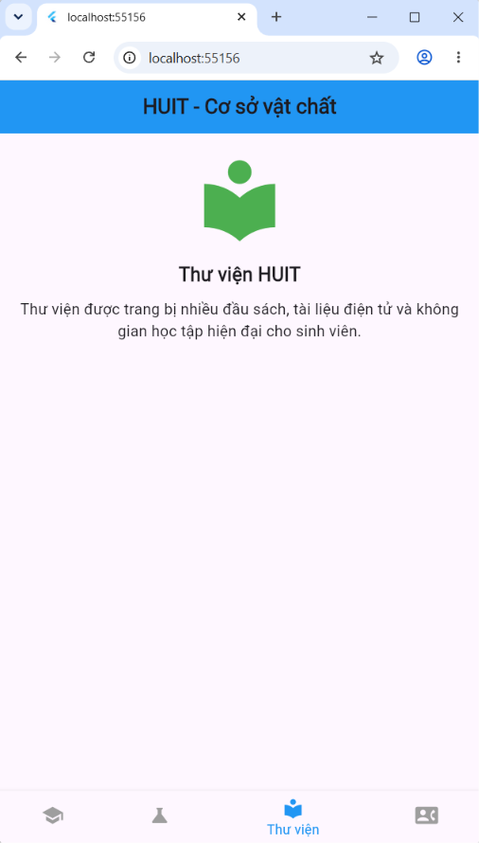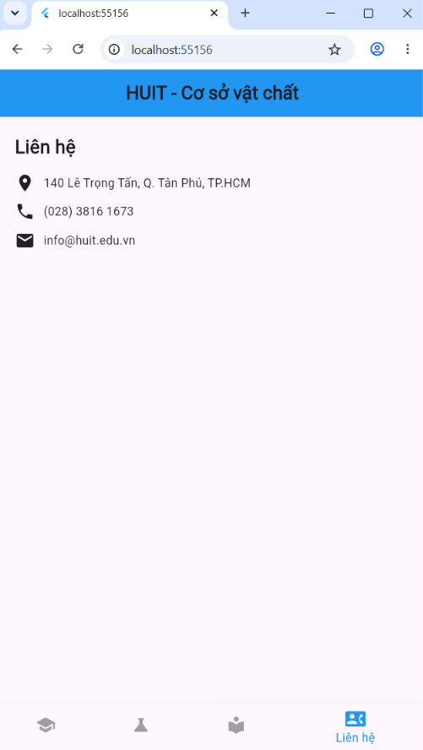
Bài tập 03. Thiết kế giao diện cho phép người dùng thể hiện tình trạng của một người dùng trong ngày
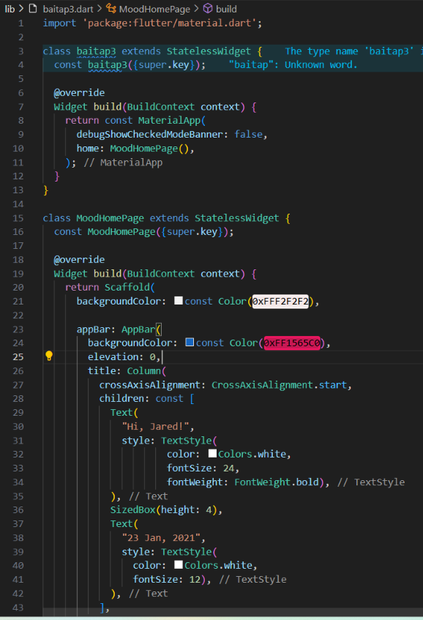
Source code:
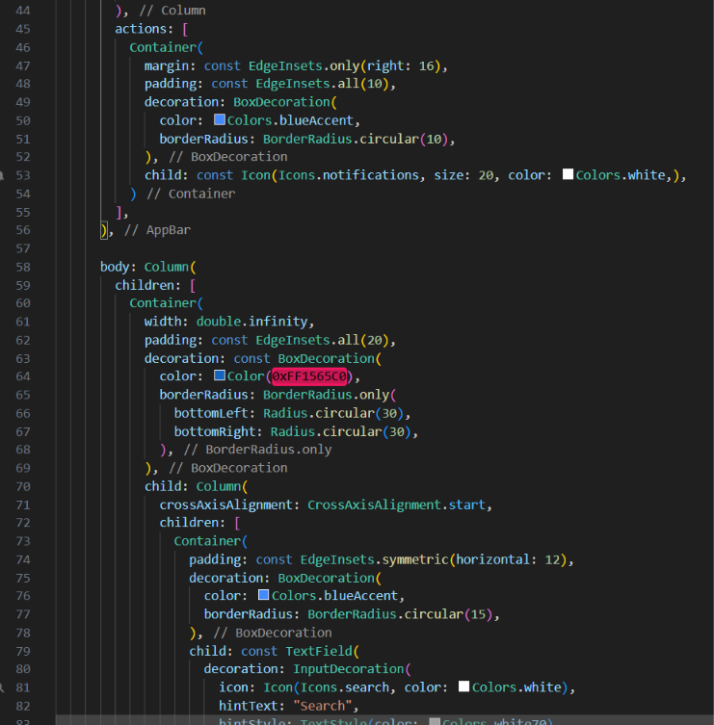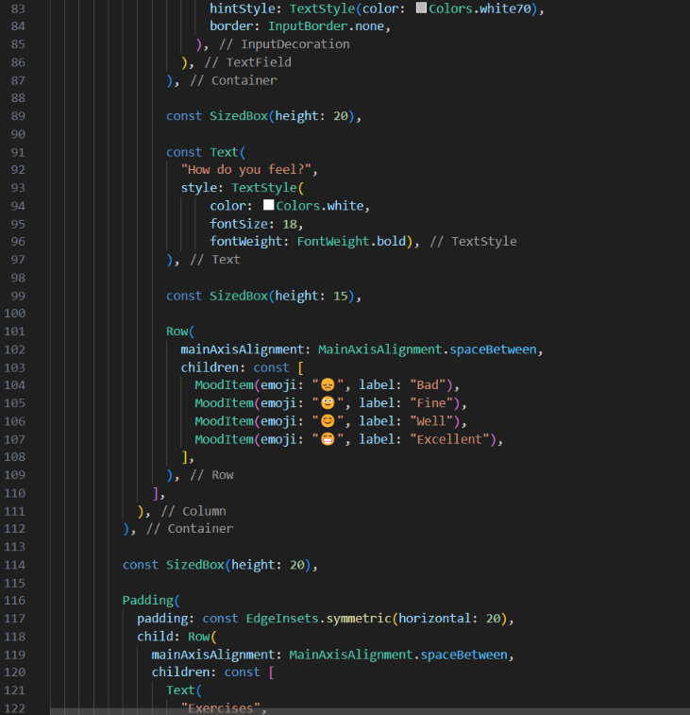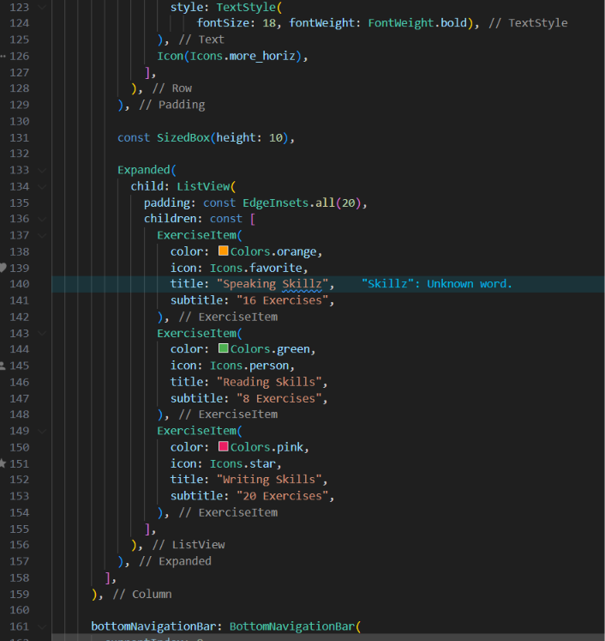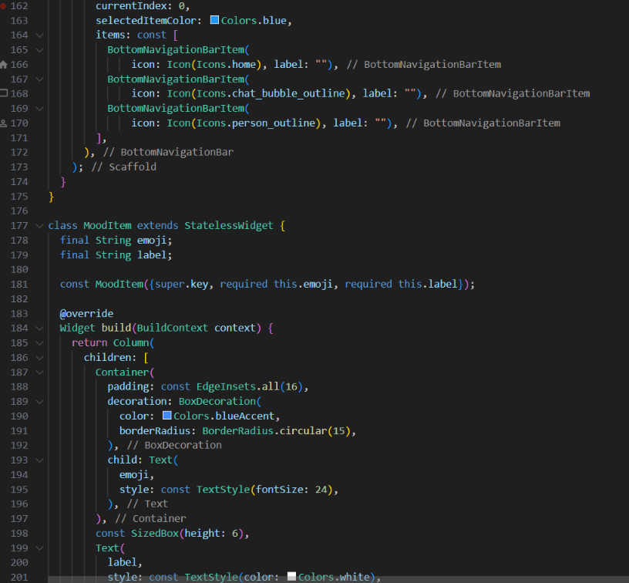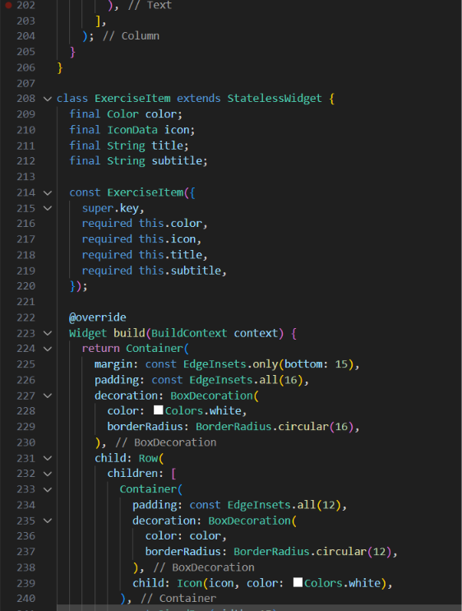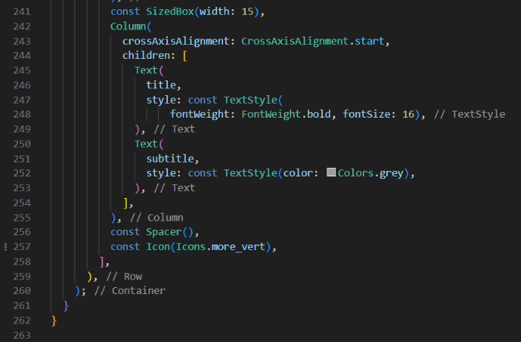

Kết quả:

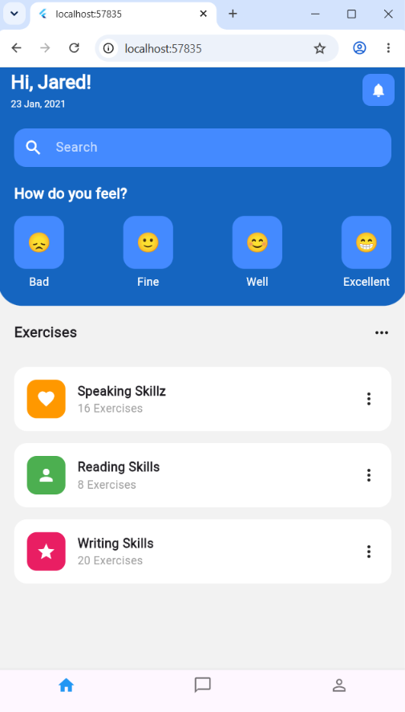

II. BÀI TẬP VỀ NHÀ:
Bài tập 04. Thiết kế giao diện mô phỏng chức năng của ví diện tử của khách hàng với giao diện như sau:
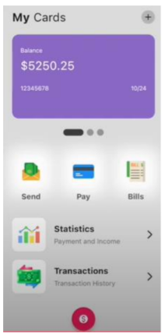
Source code:
import 'package:flutter/material.dart';

class baitap04 extends StatelessWidget {
const baitap04({super.key});

@override
Widget build(BuildContext context) {
return const MaterialApp(
debugShowCheckedModeBanner: false,
home: baitap4(),
);
}
}

class baitap4 extends StatelessWidget {
const baitap4({super.key});

@override
Widget build(BuildContext context) {
return Scaffold(
backgroundColor: Colors.grey[100],
body: SafeArea(
child: Padding(
padding: const EdgeInsets.all(25.0),
child: Column(
children: [
// Header
Row(
mainAxisAlignment: MainAxisAlignment.spaceBetween,
children: [
Row(
children: const [
Text(
"My",
style: TextStyle(fontSize: 26, fontWeight: FontWeight.bold),
),
Text(
" Cards",
style: TextStyle(fontSize: 26),
),
],
),
Container(
padding: const EdgeInsets.all(4),
decoration: const BoxDecoration(
color: Colors.grey,
shape: BoxShape.circle
),
child: const Icon(Icons.add, size: 30, color: Colors.white,),
)
],
),

const SizedBox(height: 20),

Container(
width: double.infinity,
padding: const EdgeInsets.all(20),
decoration: BoxDecoration(
color: Colors.deepPurple[300],
borderRadius: BorderRadius.circular(20),
gradient: const LinearGradient(
colors: [Color(0xFF8E24AA), Color(0xFF5E35B1)],
begin: Alignment.topLeft,
end: Alignment.bottomRight,
),
boxShadow: [
BoxShadow(
color: Colors.deepPurple.shade200,
blurRadius: 15,
spreadRadius: 2,
offset: const Offset(0, 10),
),
]
),
child: Column(
crossAxisAlignment: CrossAxisAlignment.start,
children: [
const Text("Balance", style: TextStyle(color: Colors.white70)),
const SizedBox(height: 5),
const Text(
"\$5250.25",
style: TextStyle(color: Colors.white, fontSize: 32, fontWeight: FontWeight.bold),
),
const SizedBox(height: 30),
Row(
mainAxisAlignment: MainAxisAlignment.spaceBetween,
children: const [
Text("12345678", style: TextStyle(color: Colors.white70)),
Text("10/24", style: TextStyle(color: Colors.white70)),
],
)
],
),
),

const SizedBox(height: 40),

Row(
mainAxisAlignment: MainAxisAlignment.center,
children: [
Container(width: 45, height: 20, decoration: BoxDecoration(color: Colors.grey[800], borderRadius: BorderRadius.circular(20))),
const SizedBox(width: 10),
Container(width: 20, height: 20, decoration: BoxDecoration(color: Colors.grey[400], shape: BoxShape.circle)),
const SizedBox(width: 10),
Container(width: 20, height: 20, decoration: BoxDecoration(color: Colors.grey[400], shape: BoxShape.circle)),
],
),

const SizedBox(height: 30),

Row(
mainAxisAlignment: MainAxisAlignment.spaceBetween,
children: [
_buildActionButton(Icons.send_rounded, "Send", Colors.orange),
_buildActionButton(Icons.credit_card, "Pay", Colors.blue),
_buildActionButton(Icons.receipt_long, "Bills", Colors.green),
],
),

const SizedBox(height: 30),

_buildListTile(
icon: Icons.bar_chart,
iconBg: Colors.orange.shade100,
iconColor: Colors.orange,
title: "Statistics",
subtitle: "Payment and Income"
),
const SizedBox(height: 30),
_buildListTile(
icon: Icons.attach_money,
iconBg: Colors.green.shade100,
iconColor: Colors.green,
title: "Transactions",
subtitle: "Transaction History"
),
],
),
),
),
floatingActionButton: Container(
width: 80,
height: 80,
decoration: const BoxDecoration(
color: Colors.pink,
shape: BoxShape.circle,
),
child: IconButton(
onPressed: () {},
icon: const Icon(
Icons.monetization_on_outlined,
size: 50,
color: Colors.white,
),
),
),

floatingActionButtonLocation: FloatingActionButtonLocation.centerFloat,
);
}

Widget _buildActionButton(IconData icon, String label, Color color) {
return Column(
children: [
Container(
height: 100,
width: 100,
decoration: BoxDecoration(
color: Colors.white,
borderRadius: BorderRadius.circular(20),
boxShadow: [
BoxShadow(
color: Colors.grey.shade300,
blurRadius: 15,
spreadRadius: 2,
offset: const Offset(0, 5)
)
]
),
child: Icon(icon, size: 30, color: color),
),
const SizedBox(height: 10),
Text(label, style: TextStyle(fontSize: 22, fontWeight: FontWeight.bold, color: Colors.grey[700]),)
],
);
}

Widget _buildListTile({required IconData icon, required Color iconBg, required Color iconColor, required String title, required String subtitle}) {
return Row(
mainAxisAlignment: MainAxisAlignment.spaceBetween,
children: [
Row(
children: [
Container(
padding: const EdgeInsets.all(12),
decoration: BoxDecoration(
color: iconBg,
borderRadius: BorderRadius.circular(12)
),
child: Icon(icon, color: iconColor, size: 60),
),
const SizedBox(width: 20),
Column(
crossAxisAlignment: CrossAxisAlignment.start,
children: [
Text(title, style: const TextStyle(fontSize: 22, fontWeight: FontWeight.bold)),
const SizedBox(height: 5),
Text(subtitle, style: const TextStyle(fontSize: 18, color: Colors.grey)),
],
),
],
),
const Icon(Icons.arrow_forward_ios, size: 30, color: Colors.grey,)
],
);
}
}

Kết quả:
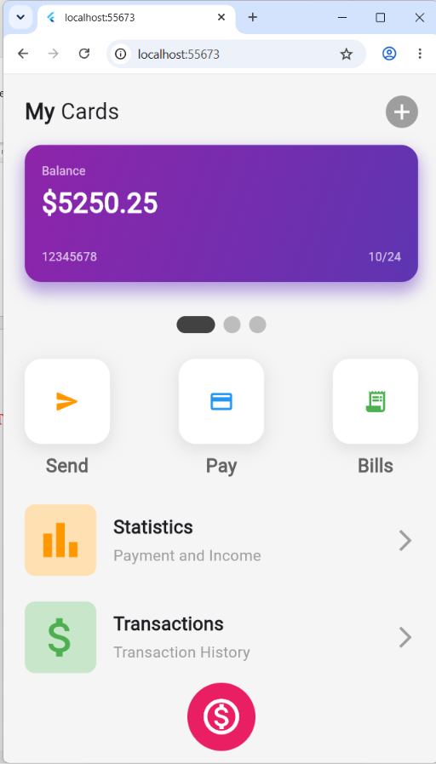

Bài tập 05. Thiết kế giao diện đăng ký khám chữa bệnh online như sau
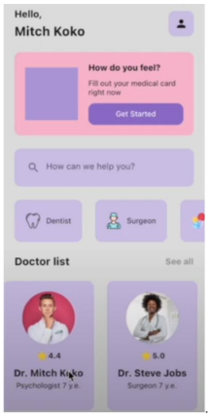
Source code:
import 'package:flutter/material.dart';

class baitap05 extends StatelessWidget {
const baitap05({super.key});

@override
Widget build(BuildContext context) {
return const MaterialApp(
debugShowCheckedModeBanner: false,
home: baitap5(),
);
}
}

class baitap5 extends StatelessWidget {
const baitap5({super.key});

@override
Widget build(BuildContext context) {
return Scaffold(
backgroundColor: Colors.grey[50],
body: SafeArea(
child: SingleChildScrollView(
child: Padding(
padding: const EdgeInsets.all(25.0),
child: Column(
crossAxisAlignment: CrossAxisAlignment.start,
children: [

Row(
mainAxisAlignment: MainAxisAlignment.spaceBetween,
children: [
Column(
crossAxisAlignment: CrossAxisAlignment.start,
children: const [
Text("Hello,", style: TextStyle(fontSize: 26, fontWeight: FontWeight.bold, color: Color.fromARGB(255, 0, 0, 0))),
SizedBox(height: 4),
Text("Mitch Koko", style: TextStyle(fontSize: 30, fontWeight: FontWeight.bold)),
],
),
Container(
padding: const EdgeInsets.all(20),
decoration: BoxDecoration(
color: Colors.deepPurple[50],
borderRadius: BorderRadius.circular(12)
),
child: const Icon(Icons.person),
)
],
),

const SizedBox(height: 25),

Container(
padding: const EdgeInsets.all(20),
decoration: BoxDecoration(
color: const Color(0xFFFFC0CB),
borderRadius: BorderRadius.circular(20),
),
child: Row(
children: [
Container(
height: 150,
width: 150,
decoration: BoxDecoration(
color: Colors.deepPurple[300],
borderRadius: BorderRadius.circular(12)
),
),
const SizedBox(width: 20),
Expanded(
child: Column(
crossAxisAlignment: CrossAxisAlignment.start,
children: [
const Text("How do you feel?", style: TextStyle(fontWeight: FontWeight.bold, fontSize: 30)),
const SizedBox(height: 8),
const Text("Fill out your medical card right now", style: TextStyle(fontSize: 26)),
const SizedBox(height: 12),
Container(
padding: const EdgeInsets.symmetric(horizontal: 80, vertical: 10),
decoration: BoxDecoration(
color: const Color(0xFF7B51D3),
borderRadius: BorderRadius.circular(12)
),
child: const Text("Get Started", style: TextStyle(color: Colors.white, fontSize: 14)),
)
],
),
)
],
),
),

const SizedBox(height: 25),

Container(
decoration: BoxDecoration(
color: Colors.deepPurple[50],
borderRadius: BorderRadius.circular(12)
),
child: const TextField(
decoration: InputDecoration(
border: InputBorder.none,
prefixIcon: Icon(Icons.search, color: Colors.grey),
hintText: "How can we help you?",
hintStyle: TextStyle(color: Colors.grey)
),
),
),

const SizedBox(height: 25),

SizedBox(
height: 80,
child: ListView(
scrollDirection: Axis.horizontal,
children: [
_buildCategoryItem("Dentist", Icons.medical_services_outlined),
const SizedBox(width: 30),
_buildCategoryItem("Surgeon", Icons.healing_outlined),
const SizedBox(width: 30),
_buildCategoryItem("Therapy", Icons.spa_outlined),
const SizedBox(width: 30 ),
],
),
),

const SizedBox(height: 25),

Row(
mainAxisAlignment: MainAxisAlignment.spaceBetween,
children: [
const Text("Doctor list", style: TextStyle(fontSize: 20, fontWeight: FontWeight.bold)),
Text("See all", style: TextStyle(fontSize: 16, color: Colors.grey[500])),
],
),

const SizedBox(height: 20),

SizedBox(
height: 220,
child: ListView(
scrollDirection: Axis.horizontal,
children: [
_buildDoctorCard(
"Dr. Mitch Koko",
"Psychologist 7 y.e.",
"assets/doc1.png",
4.4
),
const SizedBox(width: 15),
_buildDoctorCard(
"Dr. Steve Jobs",
"Surgeon 7 y.e.",
"assets/doc2.png",
5.0
),
const SizedBox(width: 15),
_buildDoctorCard(
"Dr. Michael Brown",
"Cardiologist · 10 y.e.",
"assets/doc3.png",
4.9
),
const SizedBox(width: 15),
_buildDoctorCard(
"Dr. Emily Davis",
"Therapist · 6 y.e.",
"assets/doc4.png",
4.3
),
],
),
)
],
),
),
),
),
);
}

Widget _buildCategoryItem(String name, IconData icon) {
return Container(
padding: const EdgeInsets.symmetric(horizontal: 20),
decoration: BoxDecoration(
color: Colors.deepPurple[50],
borderRadius: BorderRadius.circular(12)
),
child: Row(
children: [
Icon(icon, color: Colors.grey[600]),
const SizedBox(width: 10),
Text(name, style: const TextStyle(fontWeight: FontWeight.bold))
],
),
);
}

Widget _buildDoctorCard(
String name,
String job,
String imagePath,
double rating,
) {
return Container(
width: 160,
decoration: BoxDecoration(
color: Colors.white,
borderRadius: BorderRadius.circular(20),
border: Border.all(color: Colors.grey.shade100),
),
child: Column(
mainAxisAlignment: MainAxisAlignment.center,
children: [
CircleAvatar(
radius: 40,
backgroundImage: AssetImage(imagePath),
),
const SizedBox(height: 10),
Container(
padding: const EdgeInsets.symmetric(horizontal: 8, vertical: 4),
decoration: BoxDecoration(
color: Colors.orange[50],
borderRadius: BorderRadius.circular(8),
),
child: Row(
mainAxisSize: MainAxisSize.min,
children: [
const Icon(Icons.star, color: Colors.amber, size: 14),
const SizedBox(width: 4),
Text(
rating.toString(),
style: const TextStyle(fontSize: 12, fontWeight: FontWeight.bold),
),
],
),
),
const SizedBox(height: 10),
Text(name,
style: const TextStyle(fontWeight: FontWeight.bold, fontSize: 16)),
const SizedBox(height: 5),
Text(job,
style: const TextStyle(color: Colors.grey, fontSize: 12)),
],
),
);
}
}

Kết quả:

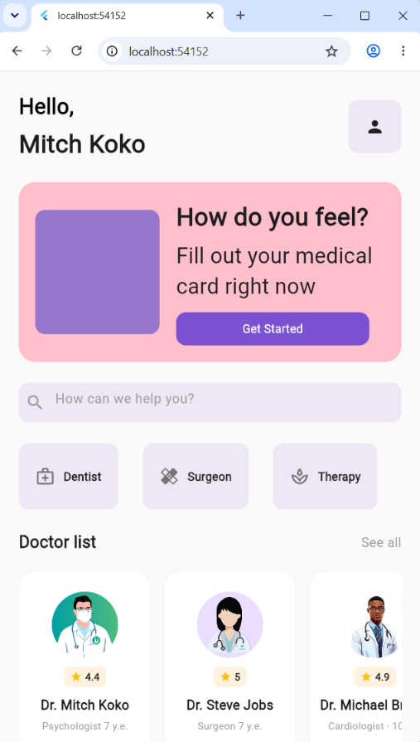
Bài tập 06. Xây dựng ứng dụng màn hình nghe nhạc như sau:
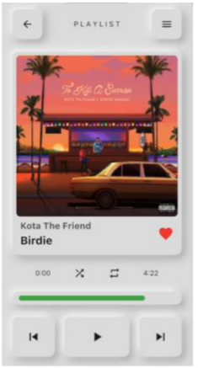
Source code:
import 'package:flutter/material.dart';

class baitap06 extends StatelessWidget {
const baitap06({super.key});

@override
Widget build(BuildContext context) {
return const MaterialApp(
debugShowCheckedModeBanner: false,
home: baitap6(),
);
}
}

class baitap6 extends StatelessWidget {
const baitap6({super.key});

@override
Widget build(BuildContext context) {
final backgroundColor = Colors.grey[300];

return Scaffold(
backgroundColor: backgroundColor,
body: SafeArea(
child: Padding(
padding: const EdgeInsets.symmetric(horizontal: 25.0),
child: Column(
children: [
const SizedBox(height: 20),
Row(
mainAxisAlignment: MainAxisAlignment.spaceBetween,
children: [
NeuBox(child: const Icon(Icons.arrow_back)),
Text("P L A Y L I S T", style: TextStyle(color: Colors.grey[700], letterSpacing: 2)),
NeuBox(child: const Icon(Icons.menu)),
],
),

const SizedBox(height: 40),

NeuBox(
padding: const EdgeInsets.all(8),
child: ClipRRect(
borderRadius: BorderRadius.circular(12),
child: Image.asset(
'assets/zingmp3.png',
height: 300,
width: 300,
fit: BoxFit.cover,
),

),
),

const SizedBox(height: 40),

Row(
mainAxisAlignment: MainAxisAlignment.spaceBetween,
children: [
Column(
crossAxisAlignment: CrossAxisAlignment.start,
children: [
Text("Kota The Friend", style: TextStyle(color: Colors.grey[600], fontSize: 16)),
const SizedBox(height: 6),
const Text("Birdie", style: TextStyle(fontSize: 24, fontWeight: FontWeight.bold)),
],
),
const Icon(Icons.favorite, color: Colors.red, size: 32)
],
),

const SizedBox(height: 30),

Row(
mainAxisAlignment: MainAxisAlignment.spaceBetween,
children: [
Text("0:00", style: TextStyle(color: Colors.grey[600], fontSize: 30)),
NeuBox(child: const Icon(Icons.shuffle, color: Colors.grey, size: 30)),
NeuBox(child: const Icon(Icons.repeat, color: Colors.grey, size: 30)),
Text("4:22", style: TextStyle(color: Colors.grey[600], fontSize: 30)),
],
),
const SizedBox(height: 10),
NeuBox(
padding: const EdgeInsets.all(0),
child: LinearProgressIndicator(
value: 0.7,
backgroundColor: Colors.transparent,
valueColor: const AlwaysStoppedAnimation(Colors.green),
minHeight: 10,
borderRadius: BorderRadius.circular(10),
),
),

const SizedBox(height: 40),

Row(
mainAxisAlignment: MainAxisAlignment.spaceEvenly,
children: [
NeuBox(child: const Icon(Icons.skip_previous, size: 60)),
NeuBox(child: const Icon(Icons.play_arrow, size: 60)),
NeuBox(child: const Icon(Icons.skip_next, size: 60)),
],
)
],
),
),
),
);
}
}

class NeuBox extends StatelessWidget {
final Widget child;
final EdgeInsets? padding;

const NeuBox({super.key, required this.child, this.padding});

@override
Widget build(BuildContext context) {
return Container(
padding: padding ?? const EdgeInsets.all(12),
decoration: BoxDecoration(
color: Colors.grey[300],
borderRadius: BorderRadius.circular(12),
boxShadow: [
BoxShadow(
color: Colors.grey.shade500,
blurRadius: 15,
offset: const Offset(5, 5),
),
const BoxShadow(
color: Colors.white,
blurRadius: 15,
offset: Offset(-5, -5),
),
],
),
child: child,
);
}
}

Kết quả:
