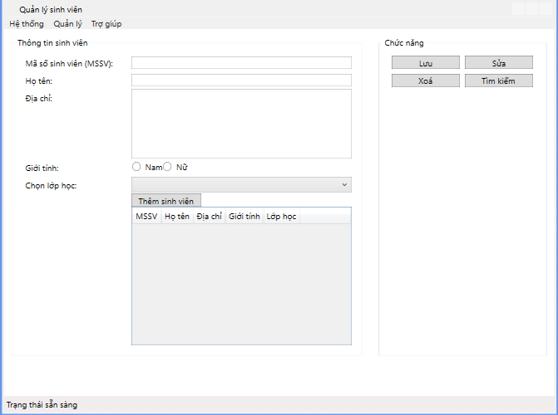
<Window x:Class="WPF_QLSV_13112025.MainWindow"
xmlns="http://schemas.microsoft.com/winfx/2006/xaml/presentation"
xmlns:x="http://schemas.microsoft.com/winfx/2006/xaml"
xmlns:d="http://schemas.microsoft.com/expression/blend/2008"
xmlns:mc="http://schemas.openxmlformats.org/markup-compatibility/2006"
xmlns:local="clr-namespace:WPF_QLSV_13112025"
mc:Ignorable="d"
Title="Quản lý sinh viên" Height="600" Width="800">

<DockPanel>
<Menu DockPanel.Dock="Top">
<MenuItem Header="Hệ thống"/>
<MenuItem Header="Quản lý"/>
<MenuItem Header="Trợ giúp"/>
</Menu>

<StatusBar DockPanel.Dock="Bottom">
Trạng thái sẵn sàng
</StatusBar>
<Grid VerticalAlignment="Top">
<Grid.ColumnDefinitions>
<ColumnDefinition Width="2*">
</ColumnDefinition>
<ColumnDefinition Width="*">
</ColumnDefinition>
</Grid.ColumnDefinitions>
<Grid Margin="10" Grid.Column="0">
<GroupBox Header="Thông tin sinh viên">
<Grid Margin="10">
<Grid.ColumnDefinitions>
<ColumnDefinition Width="*"/>
<ColumnDefinition Width="2*"/>
</Grid.ColumnDefinitions>
<Grid.RowDefinitions>
<RowDefinition Height="Auto"/>
<RowDefinition Height="Auto"/>
<RowDefinition Height="Auto"/>
<RowDefinition Height="Auto"/>
<RowDefinition Height="Auto"/>
<RowDefinition Height="Auto"/>
<RowDefinition Height="*"/>
</Grid.RowDefinitions>
<Label Content="Mã số sinh viên (MSSV):" Grid.Row="0" Grid.Column="0"/>
<TextBox TextWrapping="Wrap" VerticalAlignment="Center" Grid.Row="0" Grid.Column="1"/>
<Label Content="Họ tên:" Grid.Row="1" Grid.Column="0"/>
<TextBox TextWrapping="Wrap" VerticalAlignment="Center" Grid.Row="1" Grid.Column="1" />
<Label Content="Địa chỉ:" Grid.Row="2" Grid.Column="0"/>
<TextBox TextWrapping="Wrap" VerticalAlignment="Center" Grid.Row="2" Height="100" Grid.Column="1" />
<Label Content="Giới tính:" Grid.Row="3" Grid.Column="0"/>
<WrapPanel Grid.Column="1" Grid.Row="3" VerticalAlignment="Center" >
<RadioButton Content="Nam" />
<RadioButton Content="Nữ" />
</WrapPanel>
<Label Content="Chọn lớp học:" Grid.Row="4" Grid.Column="0"/>
<ComboBox VerticalAlignment="Center" Grid.Row="4" Grid.Column="1">
<ComboBoxItem Content="Trí tuệ nhân tạo" Selected="True"/>
<ComboBoxItem Content="Toán học"/>
</ComboBox>
<Button Grid.Row="5" Grid.Column="1" Width="100" HorizontalAlignment="Left">Thêm sinh viên</Button>
<Grid Grid.Row="6" Grid.Column="1" Height="200">
<DataGrid>
<DataGrid.Columns>
<DataGridTextColumn Header="MSSV"/>
<DataGridTextColumn Header="Họ tên"/>
<DataGridTextColumn Header="Địa chỉ"/>
<DataGridTextColumn Header="Giới tính"/>
<DataGridTextColumn Header="Lớp học"/>
</DataGrid.Columns>
</DataGrid>
</Grid>
</Grid>
</GroupBox>
</Grid>
<Grid Margin="10" Grid.Column="1">
<GroupBox Header="Chức năng">
<WrapPanel Margin="10">
<Button Content="Lưu" Margin="3" Width="100"/>
<Button Content="Sửa" Margin="3" Width="100"/>
<Button Content="Xoá" Margin="3" Width="100"/>
<Button Content="Tìm kiếm" Margin="3" Width="100"/>
</WrapPanel>
</GroupBox>

</Grid>
</Grid>

</DockPanel>

</Window>

