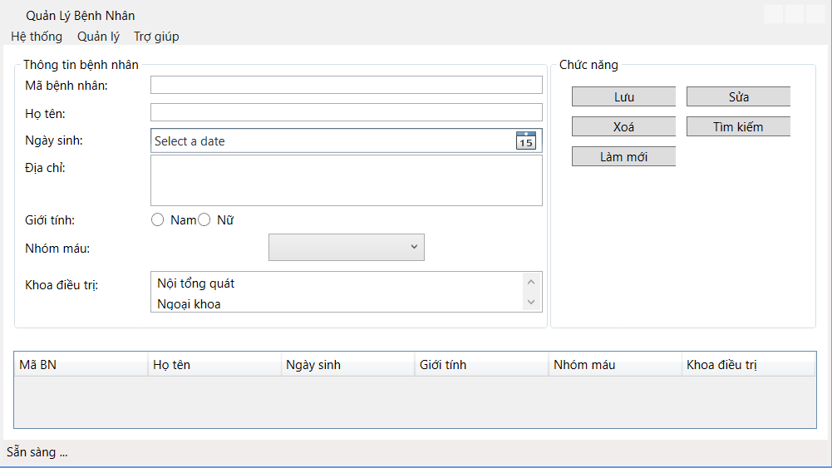
<Window x:Class="WPF_QLBN_15112025.MainWindow"
xmlns="http://schemas.microsoft.com/winfx/2006/xaml/presentation"
xmlns:x="http://schemas.microsoft.com/winfx/2006/xaml"
xmlns:d="http://schemas.microsoft.com/expression/blend/2008"
xmlns:mc="http://schemas.openxmlformats.org/markup-compatibility/2006"
xmlns:local="clr-namespace:WPF_QLBN_15112025"
mc:Ignorable="d"
Title="Quản Lý Bệnh Nhân" Height="450" Width="800">
<DockPanel>
<Menu DockPanel.Dock="Top">
<MenuItem Header="Hệ thống"/>
<MenuItem Header="Quản lý"/>
<MenuItem Header="Trợ giúp"/>
</Menu>
<StatusBar DockPanel.Dock="Bottom">
Sẵn sàng ...
</StatusBar>
<Grid>
<Grid.RowDefinitions>
<RowDefinition Height="3*"/>
<RowDefinition Height="*" />
</Grid.RowDefinitions>
<Grid Margin="10" Grid.Row="0">
<Grid.ColumnDefinitions>
<ColumnDefinition Width="2*"/>
<ColumnDefinition Width="*"/>
</Grid.ColumnDefinitions>
<GroupBox Header="Thông tin bệnh nhân" Grid.Column="0">
<Grid>
<Grid.RowDefinitions>
<RowDefinition Height="Auto"/>
<RowDefinition Height="Auto"/>
<RowDefinition Height="Auto"/>
<RowDefinition Height="Auto"/>
<RowDefinition Height="Auto"/>
<RowDefinition Height="Auto"/>
<RowDefinition Height="Auto"/>
</Grid.RowDefinitions>
<Grid.ColumnDefinitions>
<ColumnDefinition Width="*"/>
<ColumnDefinition Width="3*" />
</Grid.ColumnDefinitions>
<Label Content="Mã bệnh nhân:" VerticalAlignment="Center" Grid.Column="0" Grid.Row="0"/>
<TextBox VerticalAlignment="Center" Grid.Column="1" Grid.Row="0" />
<Label Content="Họ tên:" VerticalAlignment="Center" Grid.Column="0" Grid.Row="1"/>
<TextBox VerticalAlignment="Center" Grid.Column="1" Grid.Row="1" />
<Label Content="Ngày sinh:" VerticalAlignment="Center" Grid.Column="0" Grid.Row="2"/>
<DatePicker VerticalAlignment="Center" Grid.Column="1" Grid.Row="2" />
<Label Content="Địa chỉ:" VerticalAlignment="Top" Grid.Column="0" Grid.Row="3"/>
<TextBox VerticalAlignment="Center" Grid.Column="1" Height="50" Grid.Row="3"/>
<Label Content="Giới tính:" VerticalAlignment="Top" Grid.Column="0" Grid.Row="4"/>
<WrapPanel Grid.Column="1" VerticalAlignment="Center" Grid.Row="4">
<RadioButton Content="Nam" />
<RadioButton Content="Nữ" />
</WrapPanel>
<Label Content="Nhóm máu:" Grid.Column="0" Grid.Row="5" VerticalAlignment="Center" />
<ComboBox Grid.Column="1" Grid.Row="5" HorizontalAlignment="Center" Width="150">
<ComboBoxItem Content="A" />
<ComboBoxItem Content="B" />
<ComboBoxItem Content="O" />
<ComboBoxItem Content="AB" />
</ComboBox>
<Label Content="Khoa điều trị:" Margin="0 10 0 0" Grid.Column="0" Grid.Row="6"/>
<ListView Grid.Column="1" Margin="0 10 0 0" Grid.Row="6" Height="40">
<ListViewItem Content="Nội tổng quát" />
<ListViewItem Content="Ngoại khoa" />
<ListViewItem Content="Tim mạch" />
<ListViewItem Content="Nhị khoa" />
</ListView>
</Grid>
</GroupBox>
<GroupBox Grid.Column="1" Header="Chức năng">
<WrapPanel Margin="10">
<Button Content="Lưu" Margin="5" Width="100"/>
<Button Content="Sửa" Margin="5" Width="100" />
<Button Content="Xoá" Margin="5" Width="100" />
<Button Content="Tìm kiếm" Margin="5" Width="100" />
<Button Content="Làm mới" Margin="5" Width="100" />
</WrapPanel>
</GroupBox>
</Grid>
<DataGrid Margin="10" Grid.Row="1" >
<DataGrid.Columns >
<DataGridTextColumn Header="Mã BN" Width="*"/>
<DataGridTextColumn Header="Họ tên" Width="*"/>
<DataGridTextColumn Header="Ngày sinh" Width="*"/>
<DataGridTextColumn Header="Giới tính" Width="*"/>
<DataGridTextColumn Header="Nhóm máu" Width="*"/>
<DataGridTextColumn Header="Khoa điều trị" Width="*"/>
</DataGrid.Columns>
</DataGrid>
</Grid>
</DockPanel>
</Window>

