HF32F 18.4x10.2x15.3

SRD 19.1x15.5x15.3

SRA 15.5X12.3X14.0

JQC 19.0X15.2X15.5

HK4100F 15.5X10.5X11.0 RELAY ĐÓNG CẮT NHANH

**RELAY SLA-12VDC-SL-A**

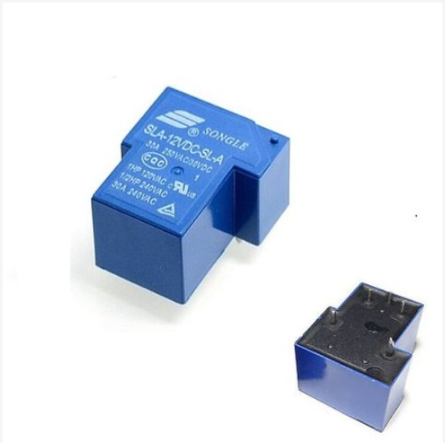

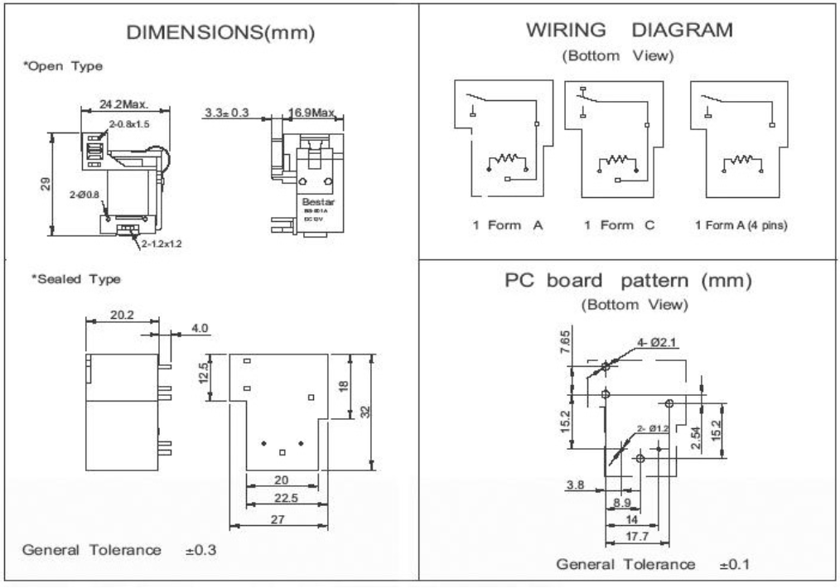

### Relay HK4100F-DC9V-SHG

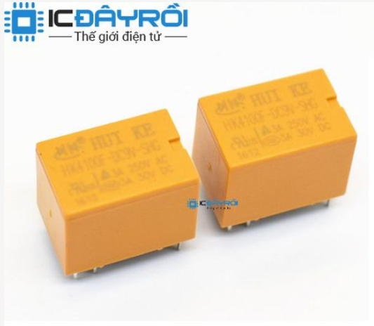

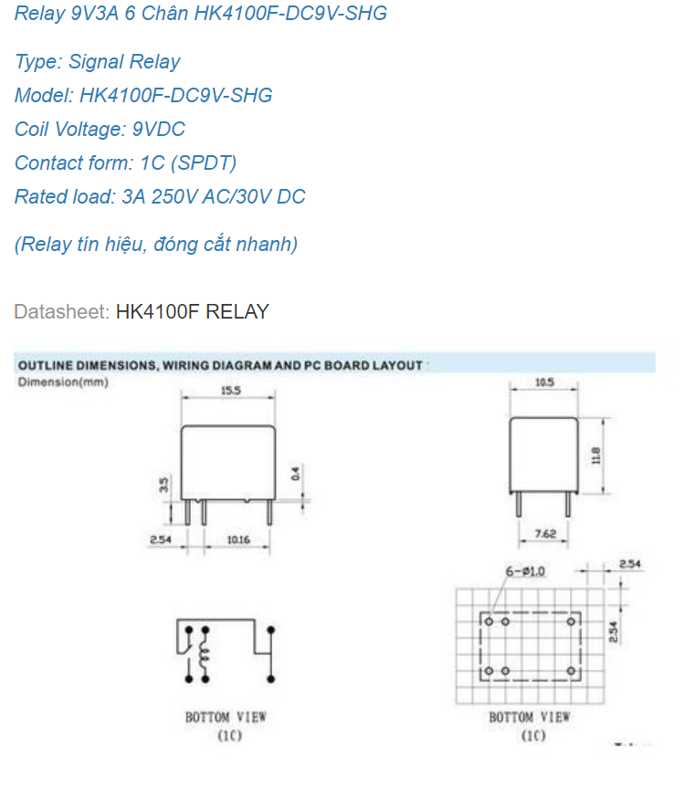

### Relay JQC-3FF-005-1ZS

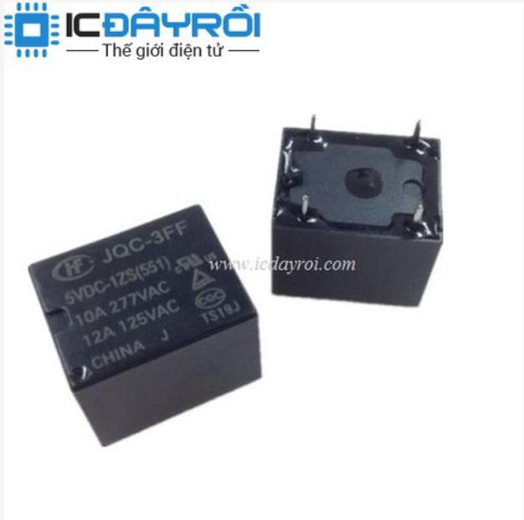

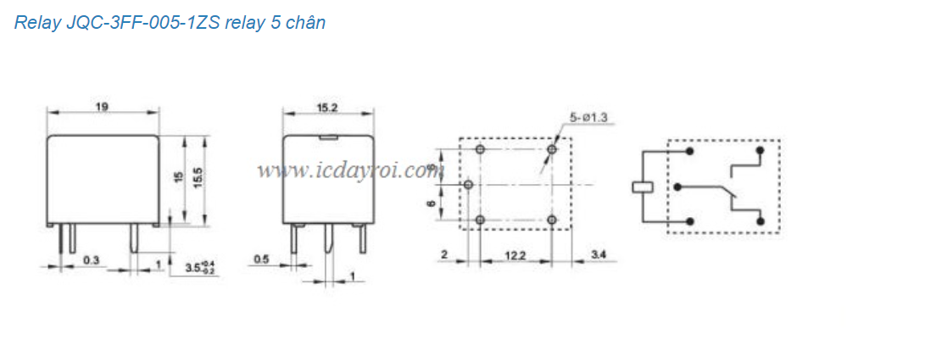

### Relay SRA-05VDC-CL

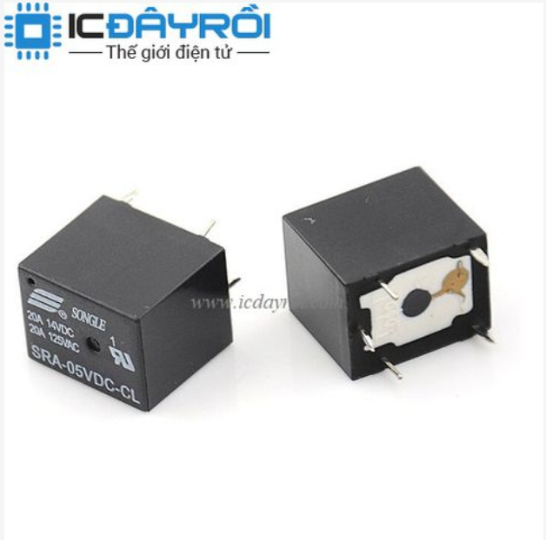

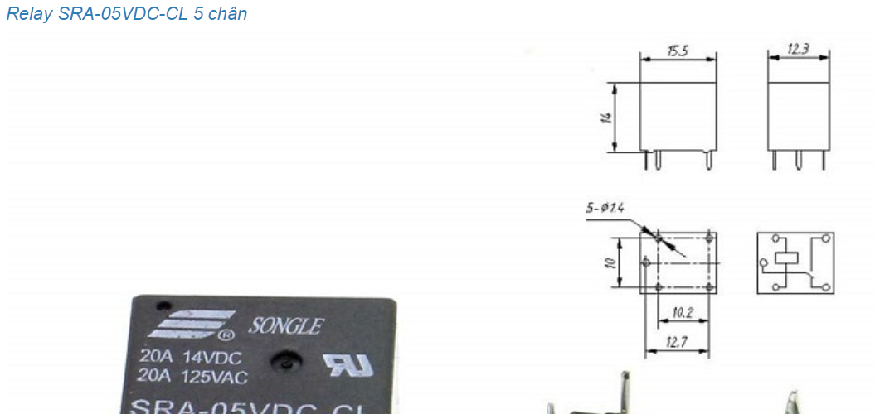

### Relay SRD-24VDC-SL-C

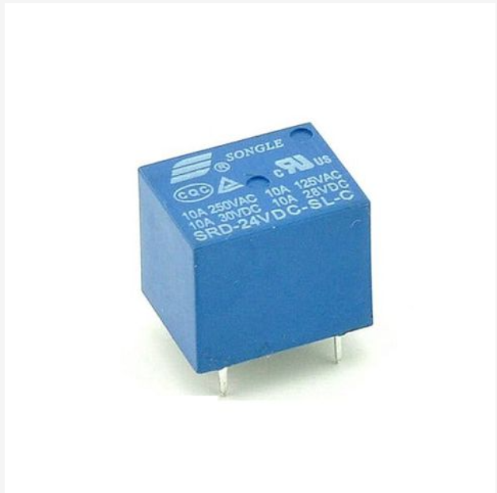

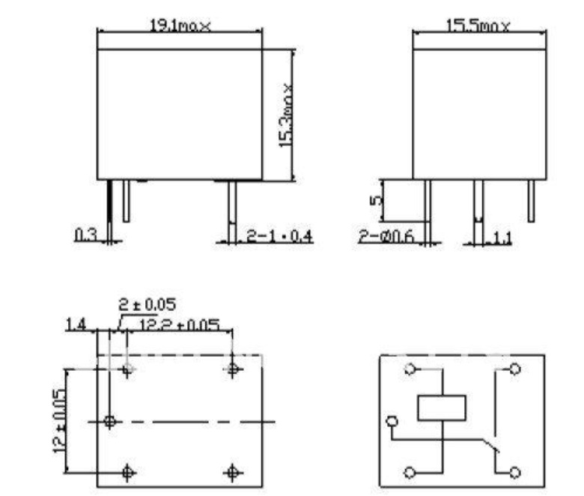

### Relay SLC-12VDC-SL-C

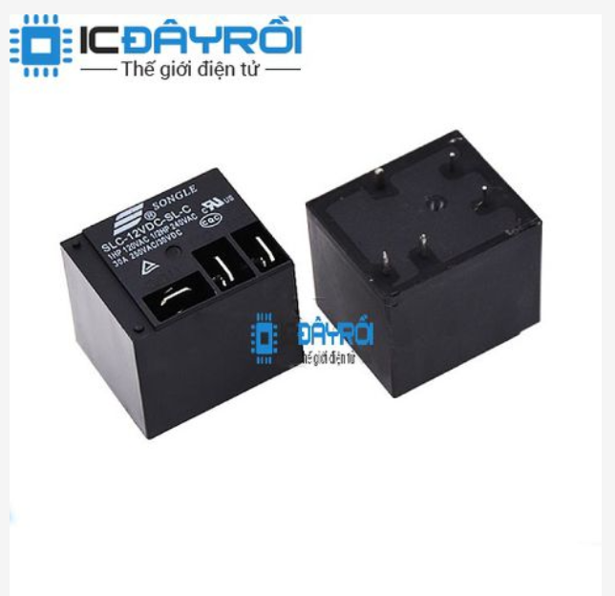

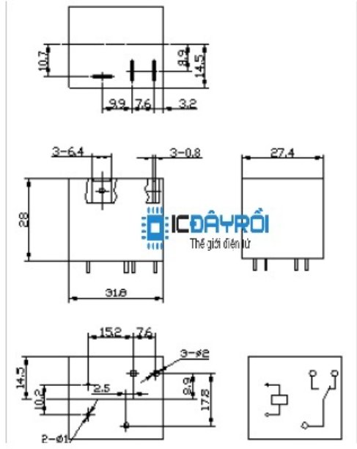

### Relay omron G3MB-202P-5VDC

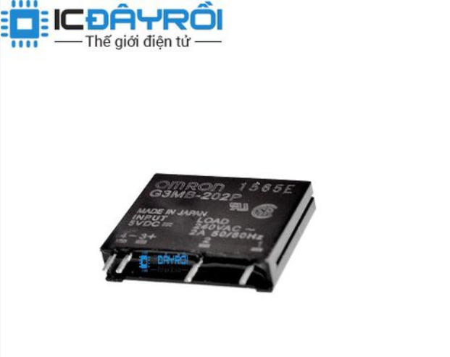

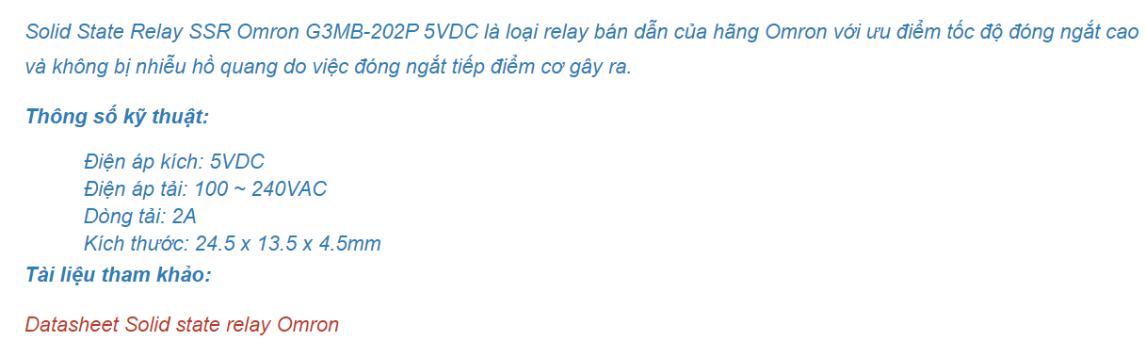

### Relay SMI-05VDC-SL-2C

