Web URL: <http://a6546f4b806bf416a8f401f8b09fd38f-1784447714.us-west-2.elb.amazonaws.com/>

Docker hub

CircleCI Dashboard

Kubectl get pods

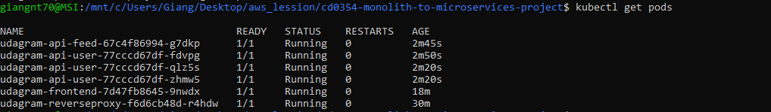

Kubectl describe services

Kubectl describe hpa  
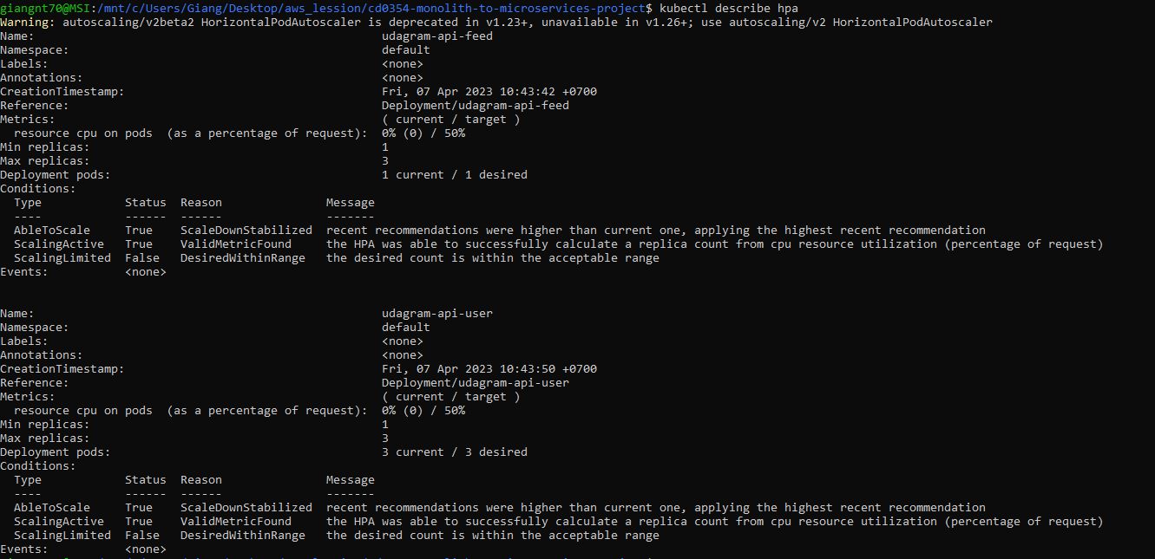  
kubectl get service udagram-reverseproxy



kubectl get service publicreverseproxy



kubectl get deployment udagram-frontend

  
kubectl logs -f udagram-api-feed-67c4f86994-g7dkp

