17th November 2022

Document Version 0.1

Robot Project
  - FCS

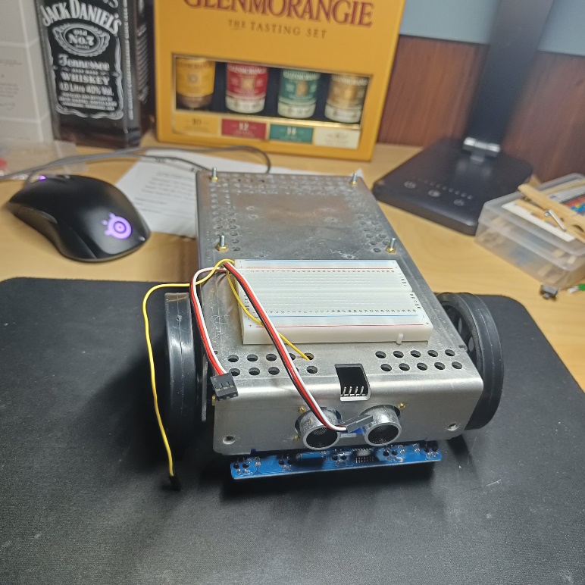

Teacher:
René, Bakx
Students:
- Minh Nhat Nguyen
- Luka Aerts

Table of Contents
1. Introduction 1
2. Phase 1 2
2.1 Configuration 2
2.2 Servo control 2
2.3 Ultrasonic sensor configuration 2
2.4 Adjusting servo’s 3
2.5 Diagrams 3
3. Phase 2 5
3.1 P Controller 5
3.2 PD Controller 5
3.3 Diagrams 6
4. Phase 3 8
5. conclusion 8
6. Sources 8

Introduction
This report is written to give context to the robot project. It will give the needed explanation to each phase of the project and all the steps needed to complete it. Since this project is made by a team that’s 2/3rd of the normal group size some parts of the project may be missing or may be less refined.

Phase 1

2.1 Configuration

To start of the project one has to configure all the ports, timers and clocks. Without doing this nothing is initialized and it is impossible to get the servo and the ultrasonic sensor to work.

2.2 Servo control

One of the first things that need to be done is the coding of the wheels, so in fact it’s the configuration of the servo’s controlling the wheels. This is done by altering the Timer registers.
The servo makes use of Timer 2 (TIM2), this being the first thing that has to be enabled. After having enabled TIM2 one has to choose and set a pre-scaler value, and set the PWM duty cycle. It is important not to forget to reset these values again.
After “setting” the servo one has to enable the output compare preload timer on two channels (one for each servo). In this case channel 2 and 4 were chosen. After this one has to det the PWM mode to mode 1 on timer 2. Then one has to enable the compare output channel on 2 and 4. After this the counter timer 2 gets enabled.

Ultrasonic sensor configuration

After getting the servo’s to work properly it is time to start configuring the ultrasonic sensor.
To start of one has to enable Timer 3 and 4 (TIM3, TIM4) since these are the timers that will be used to control the ultrasonic sensor. TIM3 will be used for the output timer configuration and TIM4 for the input timer configuration.
The first few steps of configuring the ultrasonic sensor are similar to the servo’s configuration. These steps being the setting of the pre-scaler, PWM duty cycle and the reset value.
After those steps it is it is important to make sure the sensor receives a pulse of a certain value (10us). And after that one has to enable output compare preload timer 3 in channel 2. And set PWM mode to 1. Finally one has to enable counter timer 2. After this the output timer configuration is set properly.

For the input timer configuration the first few steps are the same. The difference is the facts that TIM4 gets used now.
One has to configure TIM4 to input mode and make sure it reads both rising and falling edge. Also the capture channel has to be enabled and an interrupt is created.
When this interrupt is triggered the servo’s get adjusted accordingly to the situation.

Adjusting servo’s

After the ultrasonic sensor detects an object in its path an interrupt gets triggered that calls upon a function to adjust the servo’s.
The servo gets adjusted by checking what the distance is to the object. If the distance is within a dangerous range, in this case around 10 cm, the servo’s spin in a way that makes the robot turn 90 degrees.
If the ultrasonic sensor detects an object but it is not it the danger zone yet the robot will proceed to move forward until the danger zone is reached and the robot has to turn.

Diagrams

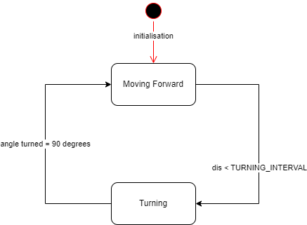
Figure 1: Phase 1 state-diagram
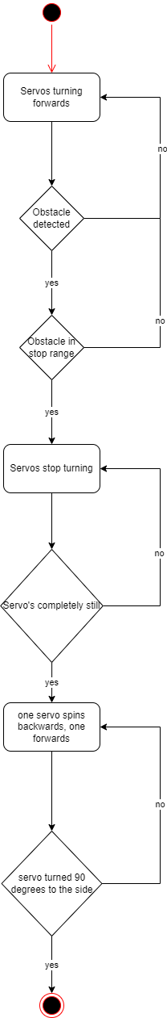
Figure 2: Phase 1 flowchart

Phase 2

3.1 P Controller

To start off phase 2 the first thing that had to be done was taking a look at the PID controllers that were designed at the start of the semester. The best one in our possession was chosen as the skeleton for the controller that had to be made.
The decision was made to not complicate things right away, what is meant by this is that to start off only the P part of the PID would be implemented. The P only looks at the current error, so it does not take future or previous errors into account. By starting with only P the controller would start off by looking at the current error and just driving until the stopping distance had been reached.

Parameter Increased | Rise Time | Overshoot | Settling Time | Steady-State Error | Stability
K_{p} | Decrease | Increase | Small Change | Decrease | Degrade
Table 1: P controller impact

3.2 PD Controller

After successfully implementing the P part of the PID controller it was time to add the D part. It should be noted that the I part of the controller has and will not be implemented into the controller. This is due to the fact that from tests and research it showed that a PD controller works just fine and the I part does not necessarily improve the controller.
The D takes future errors into account, this slows the response time of the system but helps with overshoot. The PD controller has all the needed functionality to accommodate for all the needs/requirements that the Robot might have. It will now start slowing down at a certain distance

Parameter Increased | Rise Time | Overshoot | Settling Time | Steady-State Error | Stability
K_{p} | Decrease | Increase | Small Change | Decrease | Degrade
K_{i} | Decrease | Increase | Increase | Decrease Significantly | Degrade
K_{d} | Minor Decrease | Minor Decrease | Minor Decrease | No Effect | Improve (for small K_{d})
Table 2: PID controller impact

3.3 Mapping

One of the things that had to be done to implement the PD controller was creating a mapping function. This function gets used in the “ControlServo” function. What the MAP function does is that it makes sure that the range stays within the correct values. Without this function the car would be way les accurate.

3.4 PD/Execution

In the my_PD function the PD controllers actual functionalities get implemented. As mentioned before it takes the current error and previous Errors into account. It combines these values with the sensor value to get a certain value for speed.
What happens is that after the set delay has passed, the PD begins to calculate the optimal current speed. So first off it gets the sensor value, with this value and the setpoint it calculates the current error. The PD controller acquires the derivative by subtracting the previous error from the current error.
When all the correct values have been acquired the “execute_PD” function gets called and this function performs the calculation that gives the the “control_servo” function mentioned in Phase 1 the correct amount of power.

3.5 Diagrams
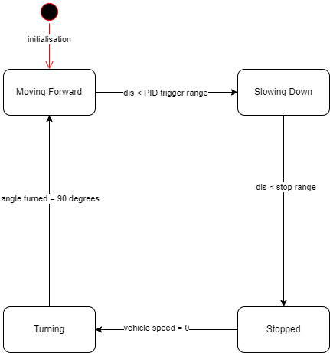
Figure 3: Phase 2 Statemachine

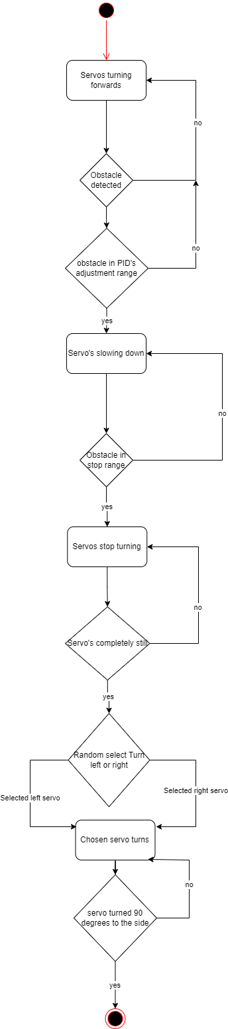
Figure 4: Phase 2 flowchart

Phase 3

conclusion

Sources

https://www.thorlabs.com/newgrouppage9.cfm?objectgroup_id=9013

