Bài 5.4:

#include <stdio.h>
#include <conio.h>
int main ()
{
int n,i,dem1,dem2;
float a[10],b[10],c[10];
printf ("HOANG TRUNG DUNG - MSSV:20150664\n");
do
{
printf ("Nhap 0<n<=10:");
scanf ("%d",&n);
} while (!(0<n<=10));
for (i=0;i<n;i++)
{
printf ("a[%d]=",i+1);
scanf ("%f",&a[i]);
}
for (i=0,dem1=0,dem2=0;i<n; i++)
{
if (a[i]>0)
{
b[dem1]=a[i];
dem1++;
}
if (a[i]<0)
{
c[dem2]=a[i];
dem2++;
}
}
printf ("\nb:");
for (i=0;i<dem1;i++)
{
printf ("b[%d]=%.2f ",i+1,b[i]);
}
printf ("\nc:");
for (i=0;i<dem2;i++)
{
printf ("c[%d]=%.2f ",i+1,c[i]);
}
getch ();
}

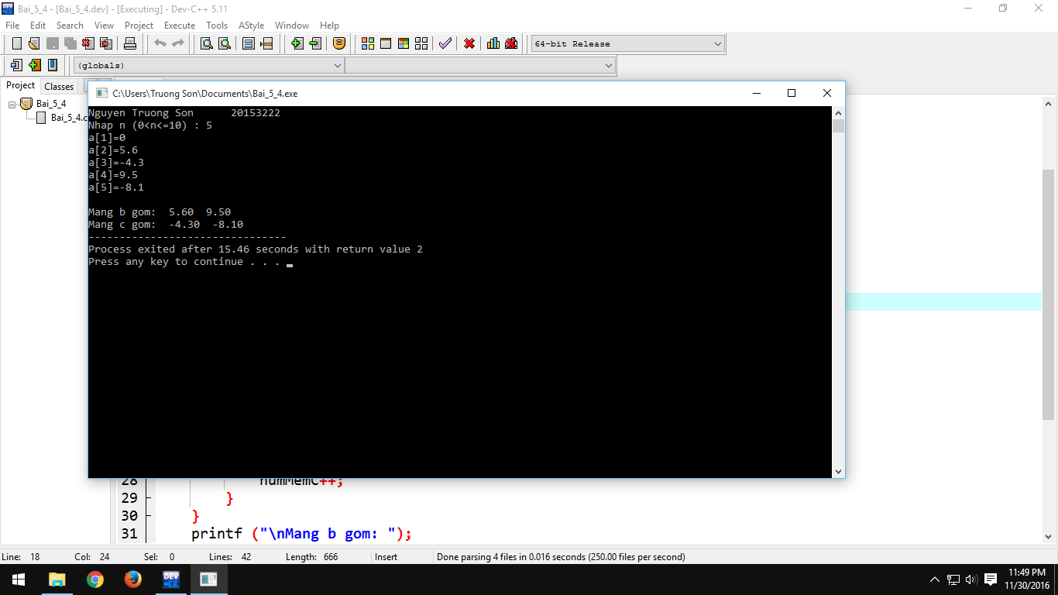

Bài 5.5:

#include <stdio.h>
#include <conio.h>
#include <string.h>
int main ()
{
char name1[50];
printf ("Nguyen Truong Son 20153222 \n");
printf ("Ten cua ban la gi ? : ");
fflush(stdin);
gets(name1);
printf ("DEV-C xin chao ban:");
printf ("%s",name1);
getch();
}

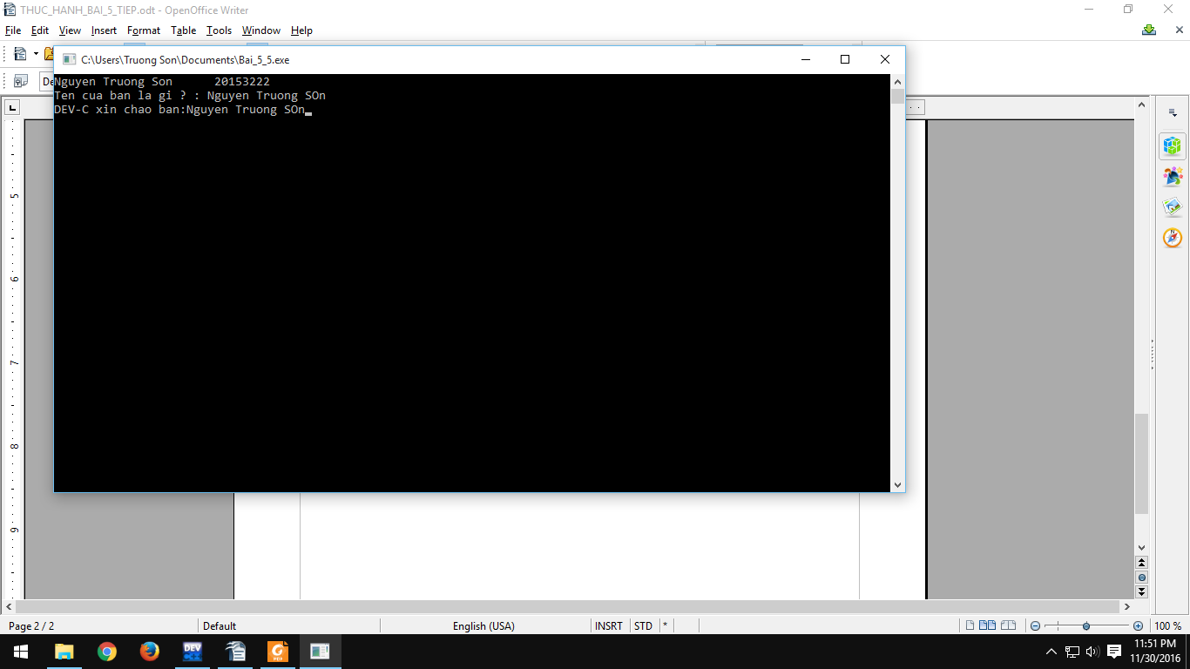

Bài 5.6:

#include <stdio.h>
#include <conio.h>
#include <string.h>
int main ()
{
char namE[30][30],temp[30];
int i,n,j;
printf ("Nguyen Truong Son 20153222 \n");
do
{
printf ("Nhap 0<n<10:");
scanf ("%d",&n);
} while (!(0<n<=10));

for (i=0;i<n;i++)
{
printf ("Ten cua ban thu %d la:",i+1);
fflush(stdin);
gets(namE[i]);
}

for (i=0;i<n;i++)
{
for(j=i+1;j<n;j++)
{
if (strcmp(namE[i],namE[j])>0)
{
strcpy(temp,namE[j]);
strcpy(namE[j],namE[i]);
strcpy(namE[i],temp);
}
}
}
for (i=0;i<n;i++)
{
printf ("%s\n",namE[i]);
}

}

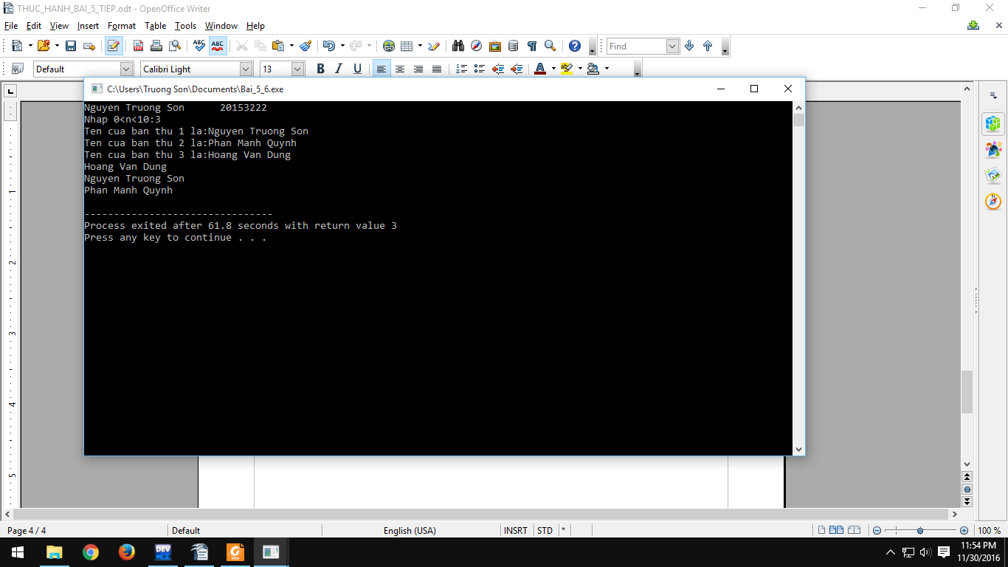

Bài 5.7:

#include <stdio.h>
#include <conio.h>
#include <string.h>
int main ()
{
char s1[30],s2[30],s12[30],s22[30];
printf ("Nguyen Truong Son 20153222 \n");
printf ("Nhap s1: ");
fflush(stdin);
gets(s1);
printf ("Nhap s2: ");
fflush(stdin);
gets(s2);
printf ("\nDo dai xau s1 = %d, Do dai xau s2 = %d",strlen(s1),strlen(s2));
strcpy(s12,s1);
strcpy(s22,s2);
strcpy(s12,s22);
printf ("\nDung \"strcpy(s1,s2)\" : s1= %s, s2= %s",s12,s22);
printf ("\nDung \"strcmp(s1,s2)\" : strcmp(s1,s2) = %d, strcmp(s2,s1) = %d",strcmp(s1,s2),strcmp(s2,s1));
strcat(s1,s2);
printf ("\nDung \"strcat(s1,s2)\" : s1= %s, s2= %s",s1,s2);

}

