VIETNAM GENERAL CONFEDERATION OF LABOR
TON DUC THANG UNIVERSITY
FACULTY OF INFORMATION TECHNOLOGY



Dinh Quoc Cuong – 523H0008
Nguyen Cao Hau – 523H0025
Nguyen Tran Trong Phuc – 523H0080

FINAL PROJECT

GAME DEVELOPMENT

LAST HOPE

HO CHI MINH CITY, 2025

VIETNAM GENERAL CONFEDERATION OF LABOR
TON DUC THANG UNIVERSITY
FACULTY OF INFORMATION TECHNOLOGY



Dinh Quoc Cuong – 523H0008
Nguyen Cao Hau – 523H0025
Nguyen Tran Trong Phuc – 523H0080

FINAL PROJECT

GAME DEVELOPMENT

LAST HOPE

Advised by
Mr. Vu Dinh Hong

HO CHI MINH CITY, 2025

ACKNOWLEDGEMENT
First and foremost, we would like to extend my deepest gratitude to Mr. Vu Dinh Hong for his unwavering support and enthusiastic guidance throughout every stage of researching and writing this term paper for the “Game Development” course.
We also wish to thank the Faculty of Information Technology at Ton Duc Thang University for providing us with the opportunity, resources, and an encouraging environment to pursue our studies and research in this subject. The faculty’s willingness to share invaluable knowledge and experiences has greatly benefited not only the completion of this paper but also our overall learning and practical growth at the university.
Finally, we are grateful to all our lecturers for their insightful instruction and support. Although we have done my best, we recognize there are still areas where our understanding and analysis could improve. We warmly welcome any feedback or suggestions from my professors and peers, which will help us refine this work and perform even better in future research and assignments.
Thank you all sincerely!
Ho Chi Minh city, 21st November 2025.
Author
(Signature and full name)
Cuong
Dinh Quoc Cuong
Hau
Nguyen Cao Hau
Phuc
Nguyen Tran Trong Phuc

DECLARATION OF AUTHORSHIP
We hereby declare that this is our own project and is guided by Mr. Vu Dinh Hong; The content research and results contained herein are central and have not been published in any form before. The data in the tables for analysis, comments and evaluation are collected by the main author from different sources, which are clearly stated in the reference section.
In addition, the project also uses some comments, assessments as well as data of other authors, other organizations with citations and annotated sources.
If something wrong happens, we’ll take full responsibility for the content of my project. Ton Duc Thang University is not related to the infringing rights, the copyrights that we give during the implementation process (if any).
Ho Chi Minh city, 21st November 2025
Author
(Signature and full name)
Cuong
Dinh Quoc Cuong
Hau
Nguyen Cao Hau
Phuc
Nguyen Tran Trong Phuc

TABLE OF CONTENT
ACKNOWLEDGEMENT 2
DECLARATION OF AUTHORSHIP 3
TABLE OF CONTENT 4
CHAPTER 1. PROJECT OVERVIEW 7
CHAPTER 2. THEORETICAL BACKGROUND 8
2.1 Unity and the Component-Based Architecture 8
2.2 Game Loop and Object Lifecycle Management 8
2.3 Grid-Based Building System 9
2.4 Resource and Logistics System 9
2.5 Object-Oriented Design and Software Patterns 10
2.6 Enemy AI and Wave-Based Gameplay 10
2.7 Game Data Persistence and Serialization 11
CHAPTER 3. ANALYSIS AND DESIGN 11
3.1 Player and Camera System 11
3.2 Grid and Building System 12
3.3 Building, Placement, and Preview System 12
3.4 Resource and Logistics System 13
3.5 Upgrading, Repairing, and Selling Buildings 14
3.6 Object Selection and UI System 14
3.7 Enemy and Wave System 15
3.8 Game Flow and System UI 16
3.9 Save/Load System Architecture 16
CHAPTER 4. SYSTEM IMPLEMENTATION 17
4.1 Tools and Development Environment 17
4.2 Installation and Integration Workflow 17
4.3 System Screenshots and Demonstrations 20
CHAPTER 5. ACHIEVED RESULTS AND LIMITATIONS 25
5.1 Achieved Results and Completed Features 25
5.2 Limitations and Future Improvements 28
CHAPTER 6. CONCLUSION 28
REFERENCES 31

TABLE OF IMAGES
Image 1: Main game screen interface……………………………………………...20
Image 2: Grid-based game map and cell system…………………………………...20
Image 3: Build mode interface and Building placeable spot………………………21
Image 4: Building non-placeable spot……………………………………………..21
Image 5: Drill and conveyor transport system……………………………………..22
Image 6: Building Information Panel………………………………………………22
Image 7: Multi-Building Selection Panel…………………………………………..23
Image 8: Enemy attacking base in wave…………………………………………...23
Image 9: Building upgrade panel…………………………………………………..24
Image 10: Game Over screen………………………………………………………24
Image 11: Victory screen…………………………………………………………..25

PROJECT OVERVIEW
Topic: Developing a 2D Tower-Defense Resource-Management Grid-Based Game using Unity.
- The player controls a character on a grid-based map and protects the Core (main base) from waves of enemies.
- The main gameplay systems include:
- Building structures: walls, ore-drilling machines, conveyor belts for resource transport, core, etc.
- Resource extraction & distribution: using drills and conveyors to deliver ore back to the Core.
- Spending resources to construct, upgrade, repair, and sell structures.
- Multiple enemy types (Basic, Fast, Tank, Ranged) with different target priorities, spawning in waves.
- Pause, win/lose system, UI information, and multi-selection to manage multiple structures at once.
Main objectives of the project:
- Build fully functional core gameplay systems, including:
- Grid-based placement system.
- Resource system + logistics using conveyors.
- Health, upgrade, repair, and selling systems for structures.
- Multiple enemy types with increasing difficulty over time.
- Maintain clean and extensible source code architecture, allowing future additions such as more resource types, turrets, or troops.

THEORETICAL BACKGROUND
This section presents the key theoretical concepts, architectural principles, and technologies applied in the development of the 2D tower-defense resource-management game using Unity. These foundations provide the basis for building extensible gameplay systems, maintaining clean code structure, and ensuring stable game behavior.

Unity and the Component-Based Architecture
Unity adopts a component-based design model in which every entity in the game world is represented as a GameObject containing multiple Components. Instead of using large monolithic classes, each behavior is implemented as an independent script.
In this project, functionality is separated into specialized components such as BuildingBase, CoreBuilding, ConveyorBuilding, EnemyBasic, and WaveManager, enabling modularity, reusability, and ease of maintenance. This design also supports extending the system with new building types, enemy types, or gameplay mechanics without modifying existing logic.

Game Loop and Object Lifecycle Management
Unity provides a predefined execution order that governs the lifecycle of every object in the game:
- Awake – initializes object references
- Start – runs once at the beginning of the game
- Update – executes every frame for UI, selection, and general logic
- FixedUpdate – executes at a fixed time step for physics and enemy movement
- OnDestroy – handles cleanup when an object is removed
This lifecycle model allows the project to separate physics-related behaviors (handled in FixedUpdate) from player interactions, user interface, and building placement logic (handled in Update), contributing to more predictable and stable gameplay.

Grid-Based Building System
The game uses a grid-based environment where all structures must be placed on discrete cells. The GridManager, already available in the project, provides essential functionality:
- Converting coordinates between World Space and Grid Cell
- Tracking occupied and unoccupied cells
- Validating placement through CanPlaceBuilding
- Managing building size and anchor positions
All structure types inherit from BuildingBase, which defines properties such as Vector2Int size and anchor cell, ensuring consistent placement logic across walls, conveyors, drills, turrets, and other future buildings.

Resource and Logistics System
The resource system is centered on two core concepts:
- ResourceType – defining the type of resource (currently only Ore)
- ResourceStack – pairing a resource type with a numerical amount
A logistics framework is built through the IResourceSink interface, which allows various buildings (e.g., conveyors, storage cores) to receive resources without coupling specific building types together.
The system operates as follows:
- OreBuilding (Drill) periodically generates ore.
- ConveyorBuilding transports ore step-by-step along a conveyor path.
- CoreBuilding acts as the central storage unit, collecting all transported resources.
This modular design allows additional resource types, advanced logistics, or automated systems to be added in the future with minimal changes to existing code.

Object-Oriented Design and Software Patterns
Object-oriented programming principles are applied extensively throughout the project:
- Inheritance:
- BuildingBase → CoreBuilding, OreBuilding, ConveyorBuilding, walls, turrets, etc.
- EnemyBasic → FastEnemy, TankEnemy, RangedEnemy.
This hierarchy promotes code reuse and simplifies the creation of new entity types.
- Singleton Pattern:
Global managers such as GridManager, CoreBuilding.Instance, and GameFlowManager.Instance adopt the Singleton pattern, ensuring universal access and maintaining a single authoritative instance during gameplay.
- Interface-Based Design:
The use of IResourceSink abstracts resource-handling logic from specific building implementations, improving modularity and supporting scalability.

Enemy AI and Wave-Based Gameplay
The enemy system relies on a wave-based spawning mechanism consisting of configurable parameters such as spawn count, spawn interval, and difficulty scaling per wave.
Different enemy types exhibit distinct behaviors and targeting priorities:
- Basic Enemy – prioritizes attacking the Core and switches to structures when blocked
- Fast Enemy – targets resource-related buildings to disrupt player economy
- Tank Enemy – slow movement but high durability, functioning as a front-line threat
- Ranged Enemy – searches for defensive structures and attacks from a distance
This diversity in enemy behavior forms the foundation for strategic planning, balancing, and player progression.

Game Data Persistence and Serialization
The game adopts a simplified state-persistence model focused on rebuilding the strategic state of the base rather than reproducing every moment of real-time combat. To reduce complexity and avoid inconsistencies during restoration, only core progression data is saved, while transient elements such as enemy positions and active projectiles are intentionally excluded.
The Save System stores:
- Structural state (buildings, levels, health, stored resources).
- Player progression (wave number and difficulty scaling).
- Resource economy state (Core ore amount, drill storage, conveyor carried items).
Real-time simulation objects such as moving enemies and active bullets are recreated automatically after loading, ensuring simplicity, stability, and performance efficiency.
This approach aligns with common practices in tower-defense and strategy games where the persistent state centers on strategic layout rather than frame-accurate reconstruction of combat.

ANALYSIS AND DESIGN
Overall Architecture: The system is structured into the following major groups:

Player and Camera System
The player and camera are designed to provide intuitive control and continuous visibility of the game environment:
- PlayerClickMover handles left-mouse click movement, allowing the character to move within predefined map bounds.
- The Camera is a child of the player object, ensuring it always follows the player's position smoothly.

Grid and Building System
A grid-based map forms the foundation of all placement and construction mechanics.
- GridManager:
- Maintains map size, cell dimensions, and boundary checks.
- Provides collision checks for building placement and ensures no overlap.
- BuildingBase:
The parent class for all structures, containing:
- size, AnchorCell
- maxHealth, currentHealth
- buildCostOre
- Virtual methods: OnPlaced(), TakeDamage(), Heal(), OnDestroyed()
All building types inherit from this base class to ensure consistent behavior and extensibility.

Building, Placement, and Preview System
The construction workflow is implemented through BuildingPlacer, which manages build mode and visual previews.
Key features:
- Toggle Build Mode using B.
- Select building type using numeric keys 1–4 or custom hotkeys.
- Generate a ghost preview by disabling scripts/colliders and enabling SpriteRenderers.
- Preview coloring: green for valid placement, red for invalid placement.
Special placement rules:
- OreBuilding (drill) can only be placed on OreNodes.
- Other buildings cannot overlap ore cells.
Additional features:
- Rotate conveyors with R, preserving last used direction.
- Right-click-drag to build walls or conveyors in a straight line.

Resource and Logistics System
This system provides ore extraction, transportation, and storage.
CoreBuilding
- Stores oreAmount.
- Provides AddOre(int) and TrySpendOre(int) for resource spending.
OreBuilding (Drill)
- Determines current upgrade level.
- Generates ore periodically, affected by drill level.
- Contains local storage: storedOre / maxStorage.
- Provides APIs:
- TakeOre(int)
- TakeAllOre()
IO and Conveyor Logistics
OreBuildingResourceIO
- Acts as a resource source for conveyors, providing ResourceStack objects.
ConveyorBuilding (inherits BuildingBase, implements IResourceSink)
- Holds at most one item stack (carriedItem)
- Contains direction (Right/Up/Left/Down) and a movement interval.
- CanAccept(ResourceStack) ensures valid resource intake.
- TryMoveForward() moves items to the next IResourceSink.
DrillToConveyorOutput
- Periodically checks whether the drill has ore.
- Scans adjacent cells in priority order (Left → Up → Right → Down).
- If a valid conveyor is found, transfers ore to it.

Upgrading, Repairing, and Selling Buildings
BuildingUpgrade
- Contains multiple levels with ore costs.
- Provides CanUpgrade(), UpgradeCost, and TryUpgrade()
- Buildings read their level to scale performance (e.g., drill output).
BuildingRepairSell
- RepairCost calculated from build cost, repair factor, and HP lost
- SellRefund returned proportionally to build cost.
- TryRepairFull() heals the building if the core has enough ore
- TrySell() refunds ore, then destroys the building.
- The Core cannot be sold (logic enforced externally).

Object Selection and UI System
Single Selection
- Right-click selects a building.
- BuildingInfoUI displays:
- Building nam
- Current/max H
- Level and upgrade cost
- Resource data (Core ore amount, drill stored ore, conveyor carried ore)
Selection Highlight
- BuildingSelectionHighlight uses a transparent cyan overlay on selected structures.
Multi-Selection
Implemented via MultiBuildingSelectionUI:
- Left-click drag to draw a selection rectangle on canvas
- Convert Screen → Canvas → World coordinates
- Use physics OverlapAreaAll to gather buildings in the region.
- UI displays:
- Building type(s) selected
- Count
- Total upgrade/repair/sell values
- Buttons:
- Upgrade All
- Repair All
- Sell All (excluding Core)

Enemy and Wave System
EnemyBasic
- Attributes: moveSpeed, maxHealth, damagePerHit, attackInterval, scanRadius.
- Default target is the Core.
- If obstructed by a building, switches target to break the obstacle.
- Damage feedback includes color flash, shrink animation, and death sound.
Enemy Variants
- FastEnemy: high speed, low HP; prioritizes resource structures.
- TankEnemy: slow, high HP, heavy damage; similar logic to Basic.
- RangedEnemy: maintains distance (shootRange) and fires projectiles; targets defense buildings.
EnemyProjectile
- Moves toward the target along a fixed direction.
- Damages buildings tagged Defense, Core, Wall, Resource, or Building.
EnemySpawner
- Each spawner holds a list of enemies for the wave.
- StartSpawningWave() spawns enemies at intervals and applies stat multipliers.
WaveManager
- Uses predefined WaveConfig for early game.
- From a certain wave onward, switches to endless mode:
- Procedurally generates enemy compositions
- Increases enemy stats per wave.
- Adjusts quantities and spawn intervals.
- UI displays “Wave N” or countdown text.

Game Flow and System UI
GameFlowManager
Handles:
- Loss condition: Core destroyed → show Game Over panel → pause time.
- Win condition: Enemy Core destroyed → show Win panel → display survival stats.
- Pause/Resume:
- Triggered by ESC or UI.
- Uses Time.timeScale = 0 during pause.
- Integrates with the Settings Overlay.

Save/Load System Architecture
SaveData Contains:
- Core ore amount
- Core status
- Player position
- Current wave and progression scaling
- List of buildings (type, position, rotation, health, level)
- Drill stored ore
- Conveyor carried resource
- Enemy core status (if applicable)
Reconstruction Logic:
- Rebuild all base structures
- Restore ore economy
- Reset wave manager to the correct progression level
- Re-spawn enemies naturally via wave logic (not from saved data)

SYSTEM IMPLEMENTATION

Tools and Development Environment
- Engine: Unity 6.2 (6000.2.6f2), 2D template using the Built-in Render Pipeline.
- Programming Language: C#.
- Version Control: Git and GitHub for source-code management, collaboration, and rollback safety.
- User Interface: Implemented with Unity’s Canvas (Screen Space – Overlay), TextMeshProUGUI, Button, and Image components.

Installation and Integration Workflow
- Grid System and Basic Structure Setup
- A GridManager is created to manage grid coordinates, cell occupancy, and placement validation.
- Core gameplay prefabs such as Core, Wall, Turret placeholder, and OreNode are initialized.
- Every structure is assigned the BuildingBase component, defining size, maximum health, and ore construction cost.
- This ensures consistent foundational behavior across all building types.
- Build Mode System
- A BuildingPlacer object is added to manage all construction interactions.
- Build options are configured in the Inspector, mapping hotkeys to building types (Wall, Turret, Drill, Conveyor).
- Visual preview objects (“ghost previews”) are implemented to show valid or invalid placement.
- Rules such as restricting drills to OreNodes and deducting ore on construction are enforced to maintain gameplay constraints.
- Resource Extraction and Conveyor Logistics
- Drills are configured with OreBuilding and OreBuildingResourceIO to generate and output ore.
- Conveyors use ConveyorBuilding and the IResourceSink interface to receive and transport resources.
- The Core is equipped with a resource-sink script to accept ore delivered by conveyors.
- DrillToConveyorOutput automatically transfers ore from drills to adjacent conveyors, establishing a continuous logistics chain.
- Upgrading, Repairing, and Selling Systems
- Structures that support progression are assigned BuildingUpgrade and BuildingRepairSell components
- These systems manage upgrade levels, repair calculations, and refund logic for selling structures.
- The user interface is expanded—via BuildingInfoUI and MultiBuildingSelectionUI—to display upgrade costs, repair costs, and sell values.
- Multi-Selection and Building Highlighting
- A SelectionBox (UI Image) is added to the Canvas to support drag-based area selection.
- MultiBuildingSelectionUI handles displaying selected structures and provides batch operations (Upgrade All, Repair All, Sell All).
- All building prefabs include the BuildingSelectionHighlight component to visually indicate selection using overlay effects.
- Enemy and Wave System Integration
- Four EnemySpawner objects are positioned at the map boundaries to spawn enemies from all directions.
- Prefabs for Basic, Fast, Tank, and Ranged enemy types are connected to both the spawners and the WaveManager.
- Standardized tags (Core, Resource, Defense, Wall) are assigned to ensure correct targeting behavior.
- Colliders and triggers are adjusted to guarantee that enemies detect and damage structures through the BuildingBase system.
- Game Flow and System-Level UI
- A GameFlowManager is introduced to control game states such as pause/resume, wave announcements, and end-game conditions.
- UI panels for Game Over, Victory, Pause Menu, and wave indicators are linked to the manager.
- Event bindings are implemented so that:
- Destroying the player’s Core triggers the Game Over state, and destroying the enemy Core triggers the Victory state.
- This ensures proper transitions between gameplay phases and a coherent user experience.

System Screenshots and Demonstrations
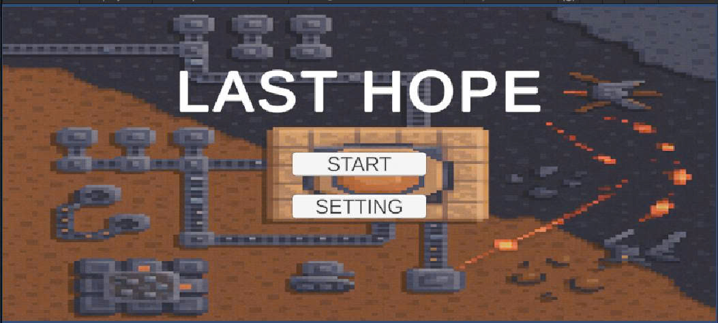
Image 1: Main game screen interface
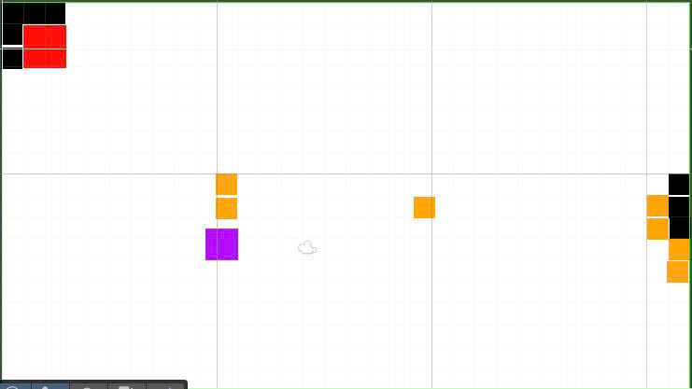
Image 2: Grid-based game map and cell system
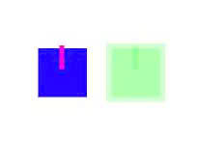
Image 3: Build mode interface and Building placeable spot
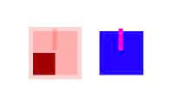
Image 4: Building non-placeable spot


Image 5: Drill and conveyor transport system
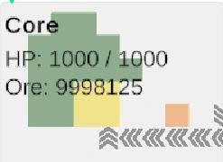
Image 6: Building Information Panel
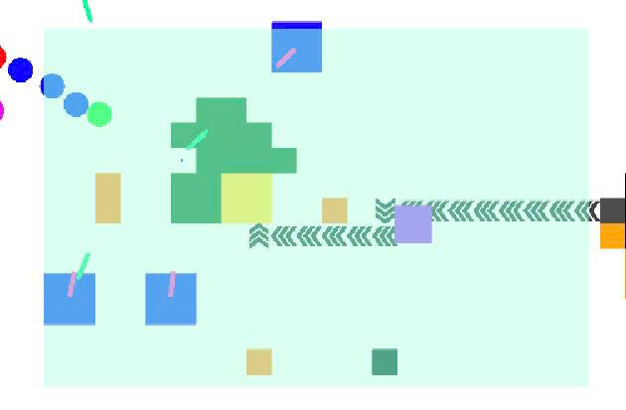
Image 7: Multi-Building Selection Panel
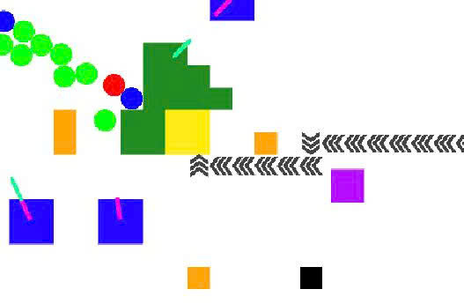
Image 8: Enemy attacking base in wave
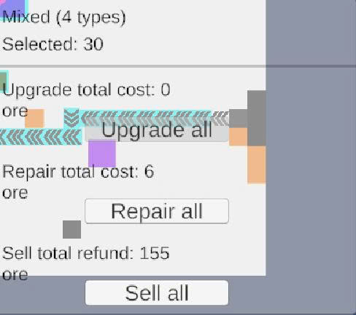
Image 9: Building upgrade panel
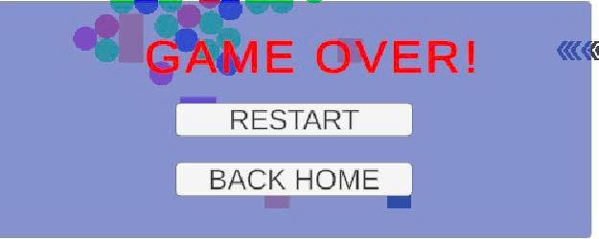
Image 10: Game Over screen
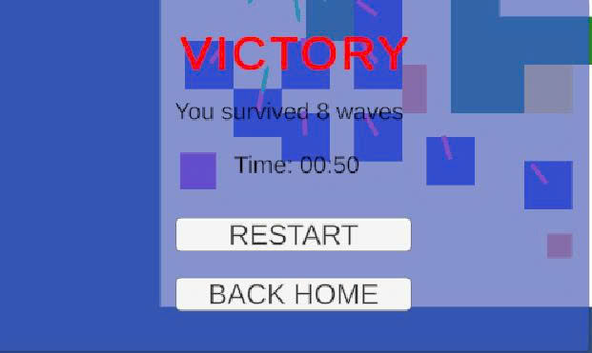
Image 11: Victory screen

ACHIEVED RESULTS AND LIMITATIONS

Achieved Results and Completed Features
- Core Gameplay Systems
- Grid-Based Building System
- Clear placement preview with green/red validation indicators.
- Drills can only be placed on ore nodes and cannot be built outside map boundaries.
- Conveyors can be rotated; walls and conveyors can be built in continuous lines through right-click dragging.
- Resource and Logistics System
- Drills autonomously extract ore, store it internally, and scale storage with upgrade level.
- Conveyors transport ore one cell at a time in the correct direction.
- The full Drill → Conveyor → Core pipeline operates reliably, including testing for jam conditions when outputs are blocked.
- Upgrade / Repair / Sell Mechanics
- All structures possess health, upgrade levels, repair cost, and sell refund based on buildCostOre.
- The Core can be repaired but cannot be sold.
- Repair and refund calculations dynamically adjust according to health percentage and cost factors (e.g., 50% of build cost).
- Information UI and Multi-Selection
- Building Info Panel includes:
- Building name, health, level, upgrade cost.
- Ore amounts in the Core, drills, and conveyors.
- Multi-Selection System includes:
- Drag-box to select multiple buildings simultaneously.
- Summary panel showing total count, cumulative upgrade/repair cost, and expected refund from selling.
- Fully functional Upgrade All, Repair All, and Sell All actions.
- Enemy and Wave System
- Multiple enemy types implemented: Basic, Fast, Tank, Ranged, each with distinct behaviors.
- Wave Manager produces:
- Mixed enemy compositions.
- Scaling difficulty over time.
- Multiple spawn gates and synchronized wave notifications with sound effects.
- Simplified Save/Load System:
- Successfully implemented base-state persistence:
- All buildings rebuilt with correct health, level, and resource data.
- Conveyor and drill inventories restored.
- Wave number and progression preserved.
- Real-time states intentionally excluded:
- Enemies and projectiles are reset after loading.
- Ensures stable, predictable loading suitable for strategy-based gameplay.
- Game Flow / UX
- Lose condition when the player’s Core is destroyed; win condition when the Enemy Core is destroyed.
- Clear win/lose screens with survival time and wave count.
- Pause/Resume supported via ESC key, including an intuitive pause menu and settings overlay.
- Technical Experience and Achievements
- Successfully resolved numerous challenging issues during development:
- Drill alignment problems with terrain.
- Conveyor sprite scaling and preview inconsistencies.
- Preventing buildings from overlapping ore nodes.
- Coordinate mismatch in drag selection (Screen → Canvas → World).
- Player movement conflicting with drag-selection input.
- Selection highlight covering building sprites unintentionally.
- Established a maintainable codebase using singletons and interfaces:
- New resource types can be added easily.
- New buildings can be integrated by implementing IResourceSink or related interfaces.
- Successfully consolidated both personal code and teammate-provided code into a unified, functional project.

Limitations and Future Improvements
Due to project scope and deadline constraints, several aspects remain incomplete or require refinement:
- Turret Combat Incomplete
- Only a Single Resource Type (Ore)
- No Player-Controlled Military Units
- No Save/Load System
- Enemy/Wave Testing Incomplete
- Save System does not preserve real-time battle states:
- Active enemies and bullets are not saved.
- After loading, combat resets to a clean state and waves respawn normally.
- This is an intentional design choice to avoid complexity.

CONCLUSION
The development of the 2D tower-defense and resource-management game successfully demonstrates the application of modular software architecture, component-based design, and real-time strategy mechanics within the Unity engine. Across the project, multiple gameplay systems—grid-based construction, automated resource logistics, multi-type enemy AI, wave progression, building upgrades, multi-selection, and game flow control—were fully integrated into a cohesive and functional prototype.
The use of Unity’s component-based model and object-oriented programming principles enabled the design of reusable, maintainable systems that can be extended with new buildings, resource types, or enemy behaviors without major restructuring. The careful separation between core structures such as GridManager, BuildingBase, WaveManager, and UI controllers helped ensure clean logic boundaries and facilitated parallel development among team members.
A notable achievement of the project is the implementation of a Save/Load System that preserves the strategic state of the game. The system stores essential progression data—building placements, health values, resource inventories, conveyor and drill states, Core resource count, and the current wave index—allowing players to resume their session at a later time. To maintain simplicity, stability, and avoid inconsistencies, the system intentionally does not save transient real-time entities such as active enemies and projectiles. These objects are naturally reconstructed through wave logic after loading, reflecting a practical and effective design choice suitable for the project’s scope.
Throughout development, the team addressed numerous technical challenges involving coordinate conversion, UI interaction conflicts, placement validation, resource flow reliability, and enemy behavior tuning. These problem-solving efforts contributed significantly to the stability and refinement of the final game experience. The project not only demonstrates technical proficiency in Unity and C#, but also highlights skills in debugging, optimization, collaborative version control, and system-level design.
While the final product meets the core objectives, several features remain open for future improvement. Potential extensions include a more advanced turret combat system, additional resource types and processing chains, player-controlled combat units, deeper wave balancing, and an expanded progression loop. These enhancements can be integrated seamlessly due to the modularity of the existing architecture.
In conclusion, the project achieves its primary goals and establishes a strong, extensible foundation for future game development. It successfully delivers a functional gameplay prototype with meaningful strategic depth, robust system interactions, and a well-structured codebase—demonstrating both practical implementation capabilities and thoughtful design decisions throughout the development process.

REFERENCES

This report is based on team discussions, practical experience, and internal project requirements.
[1]. Matt Smith, Chico Queiroz, [2015], Unity 5.x Cookbook, Packt Publishing, Birmingham.
[2]. Jeremy Gibson Bond, [2014], Introduction to Game Design, Prototyping, and Development: From Concept to Playable Game with Unity and C#, Addison-Wesley Professional, 2nd edition, United States.
[3]. Ray Barrera, Aung Sithu Kyaw, Clifford Peters, Thet Naing Swe, [2015], Unity AI Game Programming, Packt Publishing, 2nd edition, Birmingham.
[4]. Ryan Henson Creighton, [2010], Unity 3D Game Development by Example: Beginner's Guide, Packt Publishing, Birmingham.
[5]. Ian Millington, John Funge, [2009], Artificial Intelligence for Games, Morgan Kaufmann, Burlington.

