Enterprise QA Master Documentation Package

SEAL Hackathon Platform

CHAPTER 1 - PROJECT OVERVIEW
System Name: SEAL Hackathon Platform
Business Purpose: To facilitate end-to-end hackathon management, including team formation, submissions, mentoring, and grading.
Target Users: Administrators, Organizers, Judges, Mentors, and Participants.
Main Features: Role-Based Access Control, Real-time Leaderboards, Team Invitations, Code Submissions, Automated Event Timelines.
Technology Stack: Java Spring Boot (Backend), React/Vite (Frontend), MySQL 8.0 (Database), Playwright (E2E Testing), JUnit/Mockito (Unit Testing).
Architecture Overview: A decoupled client-server architecture relying on stateless REST APIs secured by JWT tokens.
Project Structure: A monorepo containing distinct 'backend', 'frontend', and 'QA_Package' directories, enforcing strict separation of concerns.

CHAPTER 2 - SYSTEM ARCHITECTURE ANALYSIS
The system architecture follows a classic layered MVC approach on the backend, communicating with a modern SPA frontend.
Component Description:
- Frontend (React): Manages the presentation layer, client-side routing, and state (via Context API).
- REST API: Stateless integration layer exposing JSON endpoints.
- Controller Layer (Spring MVC): Handles HTTP requests, enforces payload validation (@Valid), and delegates business logic.
- Service Layer: Contains all business logic, transaction management (@Transactional), and orchestration.
- Repository Layer (Spring Data JPA): Abstracts the database interactions and ORM mapping.
- Database (MySQL): Persists state ensuring ACID properties.
Communication Flow: Client -> HTTPS -> Controller -> Service -> Repository -> Database.
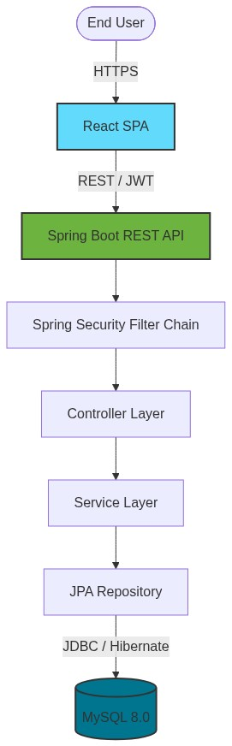

CHAPTER 3 - SOURCE CODE STRUCTURE ANALYSIS
The source code is strictly organized into distinct packages following domain-driven design principles.
Backend Packages:
- controller: Exposes REST APIs.
- service: Implements core business logic.
- repository: Database access via JPA interfaces.
- entity: Hibernate mapped domain models.
- dto: Data Transfer Objects to decouple internal entities from the API.
- config: System configurations (CORS, Swagger).
- security: Spring Security filters and JWT utilities.
Frontend Directories:
- components: Reusable UI widgets.
- pages: Stateful routed views.
- services: Axios-based API wrappers.
- hooks: Custom React hooks.
- routes: Application navigation definitions.

CHAPTER 4 - CLASS / PACKAGE DIAGRAM
The class diagram extracts the structural relationships between the primary backend components.
Each entity (e.g., User, Team, Submission) follows a strict vertical slice: Entity -> Repository -> Service -> Controller.
Dependencies are injected via Spring's IoC container (constructor injection), ensuring high testability.
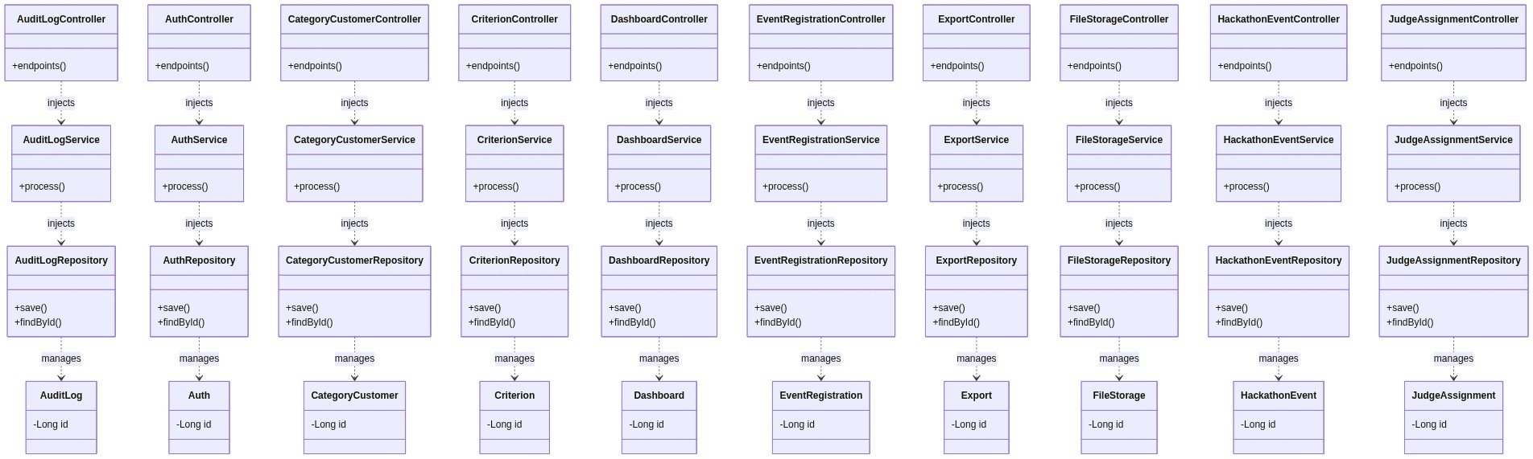

CHAPTER 5 - DATABASE ANALYSIS
The database schema is heavily relational, utilizing foreign keys to enforce strict data integrity.
The ERD demonstrates the core relationships, for example: User (1:N) Team (1:N) Submission.

Table: _user
Column | Type
id | BIGINT

Table: hackathon_event
Column | Type
id | BIGINT

Table: track
Column | Type
id | BIGINT

Table: event_registration
Column | Type
id | BIGINT

Table: round
Column | Type
id | BIGINT

Table: criterion
Column | Type
id | BIGINT

Table: team
Column | Type
id | BIGINT

Table: track_mentor
Column | Type
id | BIGINT

Table: team_member
Column | Type
id | BIGINT

Table: team_invitation
Column | Type
id | BIGINT

Table: submission
Column | Type
id | BIGINT

Table: judge_assignment
Column | Type
id | BIGINT

Table: score
Column | Type
id | BIGINT

Table: prize
Column | Type
id | BIGINT

Table: mentorship_request
Column | Type
id | BIGINT

Table: notification
Column | Type
id | BIGINT

Table: team_round_advancement
Column | Type
id | BIGINT

Table: audit_log
Column | Type
id | BIGINT

Table: refresh_token
Column | Type
id | BIGINT

Table: password_reset_token
Column | Type
id | BIGINT

Table: support_tickets
Column | Type
id | BIGINT

CHAPTER 6 - API DOCUMENTATION

API: GET /api/v1/audit-logs
Attribute | Value
HTTP Method | GET
Endpoint | /api/v1/audit-logs
Controller | AuditLogController.java
Authorized Roles | ADMIN

API: GET /api/v1/audit-logs/user/{userId}
Attribute | Value
HTTP Method | GET
Endpoint | /api/v1/audit-logs/user/{userId}
Controller | AuditLogController.java
Authorized Roles | ADMIN

API: GET /api/v1/audit-logs/event/{eventId}
Attribute | Value
HTTP Method | GET
Endpoint | /api/v1/audit-logs/event/{eventId}
Controller | AuditLogController.java
Authorized Roles | ADMIN

API: GET /api/v1/audit-logs
Attribute | Value
HTTP Method | GET
Endpoint | /api/v1/audit-logs
Controller | AuditLogController.java
Authorized Roles | ADMIN

API: POST /api/v1/auth/login
Attribute | Value
HTTP Method | POST
Endpoint | /api/v1/auth/login
Controller | AuthController.java
Authorized Roles | Any

API: POST /api/v1/auth/refresh
Attribute | Value
HTTP Method | POST
Endpoint | /api/v1/auth/refresh
Controller | AuthController.java
Authorized Roles | Any

API: POST /api/v1/auth/register
Attribute | Value
HTTP Method | POST
Endpoint | /api/v1/auth/register
Controller | AuthController.java
Authorized Roles | Any

API: POST /api/v1/auth/verify-otp
Attribute | Value
HTTP Method | POST
Endpoint | /api/v1/auth/verify-otp
Controller | AuthController.java
Authorized Roles | Any

API: POST /api/v1/auth/create-guest-judge
Attribute | Value
HTTP Method | POST
Endpoint | /api/v1/auth/create-guest-judge
Controller | AuthController.java
Authorized Roles | Any

API: POST /api/v1/auth/forgot-password
Attribute | Value
HTTP Method | POST
Endpoint | /api/v1/auth/forgot-password
Controller | AuthController.java
Authorized Roles | Any

API: POST /api/v1/auth/reset-password
Attribute | Value
HTTP Method | POST
Endpoint | /api/v1/auth/reset-password
Controller | AuthController.java
Authorized Roles | Any

API: GET /api/v1/CategoryCustomers
Attribute | Value
HTTP Method | GET
Endpoint | /api/v1/CategoryCustomers
Controller | CategoryCustomerController.java
Authorized Roles | Any

API: GET /api/v1/CategoryCustomers/{id}
Attribute | Value
HTTP Method | GET
Endpoint | /api/v1/CategoryCustomers/{id}
Controller | CategoryCustomerController.java
Authorized Roles | Any

API: POST /api/v1/CategoryCustomers
Attribute | Value
HTTP Method | POST
Endpoint | /api/v1/CategoryCustomers
Controller | CategoryCustomerController.java
Authorized Roles | Any

API: PUT /api/v1/CategoryCustomers/{id}
Attribute | Value
HTTP Method | PUT
Endpoint | /api/v1/CategoryCustomers/{id}
Controller | CategoryCustomerController.java
Authorized Roles | Any

API: DELETE /api/v1/CategoryCustomers/{id}
Attribute | Value
HTTP Method | DELETE
Endpoint | /api/v1/CategoryCustomers/{id}
Controller | CategoryCustomerController.java
Authorized Roles | Any

API: POST /api/v1/criteria
Attribute | Value
HTTP Method | POST
Endpoint | /api/v1/criteria
Controller | CriterionController.java
Authorized Roles | Any

API: GET /api/v1/criteria/event/{hackathonEventId}
Attribute | Value
HTTP Method | GET
Endpoint | /api/v1/criteria/event/{hackathonEventId}
Controller | CriterionController.java
Authorized Roles | Any

API: GET /api/v1/criteria/default
Attribute | Value
HTTP Method | GET
Endpoint | /api/v1/criteria/default
Controller | CriterionController.java
Authorized Roles | Any

API: PUT /api/v1/criteria/{id}
Attribute | Value
HTTP Method | PUT
Endpoint | /api/v1/criteria/{id}
Controller | CriterionController.java
Authorized Roles | Any

API: DELETE /api/v1/criteria/{id}
Attribute | Value
HTTP Method | DELETE
Endpoint | /api/v1/criteria/{id}
Controller | CriterionController.java
Authorized Roles | Any

API: POST /api/v1/criteria/copy
Attribute | Value
HTTP Method | POST
Endpoint | /api/v1/criteria/copy
Controller | CriterionController.java
Authorized Roles | Any

API: GET /api/v1/dashboard/stats
Attribute | Value
HTTP Method | GET
Endpoint | /api/v1/dashboard/stats
Controller | DashboardController.java
Authorized Roles | Any

API: POST /api/v1/event-registrations
Attribute | Value
HTTP Method | POST
Endpoint | /api/v1/event-registrations
Controller | EventRegistrationController.java
Authorized Roles | PARTICIPANT

API: GET /api/v1/event-registrations/event/{eventId}
Attribute | Value
HTTP Method | GET
Endpoint | /api/v1/event-registrations/event/{eventId}
Controller | EventRegistrationController.java
Authorized Roles | PARTICIPANT

API: GET /api/v1/event-registrations/my-registration/event/{eventId}
Attribute | Value
HTTP Method | GET
Endpoint | /api/v1/event-registrations/my-registration/event/{eventId}
Controller | EventRegistrationController.java
Authorized Roles | PARTICIPANT

API: GET /api/v1/export/rounds/{roundId}/ranking
Attribute | Value
HTTP Method | GET
Endpoint | /api/v1/export/rounds/{roundId}/ranking
Controller | ExportController.java
Authorized Roles | Any

API: GET /api/v1/export/rounds/{roundId}/scoring
Attribute | Value
HTTP Method | GET
Endpoint | /api/v1/export/rounds/{roundId}/scoring
Controller | ExportController.java
Authorized Roles | Any

API: GET /api/v1/export/teams/csv
Attribute | Value
HTTP Method | GET
Endpoint | /api/v1/export/teams/csv
Controller | ExportController.java
Authorized Roles | Any

API: GET /api/v1/export/participants/csv
Attribute | Value
HTTP Method | GET
Endpoint | /api/v1/export/participants/csv
Controller | ExportController.java
Authorized Roles | Any

API: POST /api/v1/files/upload
Attribute | Value
HTTP Method | POST
Endpoint | /api/v1/files/upload
Controller | FileStorageController.java
Authorized Roles | Any

API: GET /api/v1/files/download/{fileName:.+}
Attribute | Value
HTTP Method | GET
Endpoint | /api/v1/files/download/{fileName:.+}
Controller | FileStorageController.java
Authorized Roles | Any

API: POST /api/v1/hackathon-events
Attribute | Value
HTTP Method | POST
Endpoint | /api/v1/hackathon-events
Controller | HackathonEventController.java
Authorized Roles | ADMIN

API: GET /api/v1/hackathon-events
Attribute | Value
HTTP Method | GET
Endpoint | /api/v1/hackathon-events
Controller | HackathonEventController.java
Authorized Roles | ADMIN

API: GET /api/v1/hackathon-events/admin/all
Attribute | Value
HTTP Method | GET
Endpoint | /api/v1/hackathon-events/admin/all
Controller | HackathonEventController.java
Authorized Roles | ADMIN

API: GET /api/v1/hackathon-events/my-events
Attribute | Value
HTTP Method | GET
Endpoint | /api/v1/hackathon-events/my-events
Controller | HackathonEventController.java
Authorized Roles | ADMIN

API: GET /api/v1/hackathon-events/{slug}
Attribute | Value
HTTP Method | GET
Endpoint | /api/v1/hackathon-events/{slug}
Controller | HackathonEventController.java
Authorized Roles | ADMIN

API: GET /api/v1/hackathon-events/id/{id}
Attribute | Value
HTTP Method | GET
Endpoint | /api/v1/hackathon-events/id/{id}
Controller | HackathonEventController.java
Authorized Roles | ADMIN

API: PUT /api/v1/hackathon-events/{id}
Attribute | Value
HTTP Method | PUT
Endpoint | /api/v1/hackathon-events/{id}
Controller | HackathonEventController.java
Authorized Roles | ADMIN

API: DELETE /api/v1/hackathon-events/{id}
Attribute | Value
HTTP Method | DELETE
Endpoint | /api/v1/hackathon-events/{id}
Controller | HackathonEventController.java
Authorized Roles | ADMIN

API: PATCH /api/v1/hackathon-events/{id}/status
Attribute | Value
HTTP Method | PATCH
Endpoint | /api/v1/hackathon-events/{id}/status
Controller | HackathonEventController.java
Authorized Roles | ADMIN

API: POST /api/v1/hackathon-events/{id}/clone
Attribute | Value
HTTP Method | POST
Endpoint | /api/v1/hackathon-events/{id}/clone
Controller | HackathonEventController.java
Authorized Roles | ADMIN

API: GET /api/v1/hackathon-events/{id}/analytics
Attribute | Value
HTTP Method | GET
Endpoint | /api/v1/hackathon-events/{id}/analytics
Controller | HackathonEventController.java
Authorized Roles | ADMIN

API: POST /api/v1/judge-assignments
Attribute | Value
HTTP Method | POST
Endpoint | /api/v1/judge-assignments
Controller | JudgeAssignmentController.java
Authorized Roles | Any

API: GET /api/v1/judge-assignments/my-assignments
Attribute | Value
HTTP Method | GET
Endpoint | /api/v1/judge-assignments/my-assignments
Controller | JudgeAssignmentController.java
Authorized Roles | Any

API: GET /api/v1/judge-assignments/judge/{judgeId}
Attribute | Value
HTTP Method | GET
Endpoint | /api/v1/judge-assignments/judge/{judgeId}
Controller | JudgeAssignmentController.java
Authorized Roles | Any

API: GET /api/v1/judge-assignments/round/{roundId}
Attribute | Value
HTTP Method | GET
Endpoint | /api/v1/judge-assignments/round/{roundId}
Controller | JudgeAssignmentController.java
Authorized Roles | Any

API: GET /api/v1/judge-assignments/event/{eventId}
Attribute | Value
HTTP Method | GET
Endpoint | /api/v1/judge-assignments/event/{eventId}
Controller | JudgeAssignmentController.java
Authorized Roles | Any

API: DELETE /api/v1/judge-assignments/{assignmentId}
Attribute | Value
HTTP Method | DELETE
Endpoint | /api/v1/judge-assignments/{assignmentId}
Controller | JudgeAssignmentController.java
Authorized Roles | Any

API: POST /api/v1/mentorship-requests
Attribute | Value
HTTP Method | POST
Endpoint | /api/v1/mentorship-requests
Controller | MentorshipRequestController.java
Authorized Roles | PARTICIPANT

API: GET /api/v1/mentorship-requests/open
Attribute | Value
HTTP Method | GET
Endpoint | /api/v1/mentorship-requests/open
Controller | MentorshipRequestController.java
Authorized Roles | PARTICIPANT

API: GET /api/v1/mentorship-requests/my-requests
Attribute | Value
HTTP Method | GET
Endpoint | /api/v1/mentorship-requests/my-requests
Controller | MentorshipRequestController.java
Authorized Roles | PARTICIPANT

API: GET /api/v1/mentorship-requests/{id}
Attribute | Value
HTTP Method | GET
Endpoint | /api/v1/mentorship-requests/{id}
Controller | MentorshipRequestController.java
Authorized Roles | PARTICIPANT

API: PATCH /api/v1/mentorship-requests/{id}/accept
Attribute | Value
HTTP Method | PATCH
Endpoint | /api/v1/mentorship-requests/{id}/accept
Controller | MentorshipRequestController.java
Authorized Roles | PARTICIPANT

API: PATCH /api/v1/mentorship-requests/{id}/resolve
Attribute | Value
HTTP Method | PATCH
Endpoint | /api/v1/mentorship-requests/{id}/resolve
Controller | MentorshipRequestController.java
Authorized Roles | PARTICIPANT

API: PATCH /api/v1/mentorship-requests/{id}/release
Attribute | Value
HTTP Method | PATCH
Endpoint | /api/v1/mentorship-requests/{id}/release
Controller | MentorshipRequestController.java
Authorized Roles | PARTICIPANT

API: PATCH /api/v1/mentorship-requests/{id}/reject
Attribute | Value
HTTP Method | PATCH
Endpoint | /api/v1/mentorship-requests/{id}/reject
Controller | MentorshipRequestController.java
Authorized Roles | PARTICIPANT

API: DELETE /api/v1/mentorship-requests/{id}
Attribute | Value
HTTP Method | DELETE
Endpoint | /api/v1/mentorship-requests/{id}
Controller | MentorshipRequestController.java
Authorized Roles | PARTICIPANT

API: GET /api/v1/notifications
Attribute | Value
HTTP Method | GET
Endpoint | /api/v1/notifications
Controller | NotificationController.java
Authorized Roles | Any

API: GET /api/v1/notifications
Attribute | Value
HTTP Method | GET
Endpoint | /api/v1/notifications
Controller | NotificationController.java
Authorized Roles | Any

API: GET /api/v1/notifications/unread-count
Attribute | Value
HTTP Method | GET
Endpoint | /api/v1/notifications/unread-count
Controller | NotificationController.java
Authorized Roles | Any

API: PATCH /api/v1/notifications/{id}/read
Attribute | Value
HTTP Method | PATCH
Endpoint | /api/v1/notifications/{id}/read
Controller | NotificationController.java
Authorized Roles | Any

API: POST /api/v1/notifications/read-all
Attribute | Value
HTTP Method | POST
Endpoint | /api/v1/notifications/read-all
Controller | NotificationController.java
Authorized Roles | Any

API: POST /api/v1/prizes
Attribute | Value
HTTP Method | POST
Endpoint | /api/v1/prizes
Controller | PrizeController.java
Authorized Roles | Any

API: PATCH /api/v1/prizes/{prizeId}/assign
Attribute | Value
HTTP Method | PATCH
Endpoint | /api/v1/prizes/{prizeId}/assign
Controller | PrizeController.java
Authorized Roles | Any

API: GET /api/v1/prizes/event/{hackathonEventId}
Attribute | Value
HTTP Method | GET
Endpoint | /api/v1/prizes/event/{hackathonEventId}
Controller | PrizeController.java
Authorized Roles | Any

API: POST /api/v1/prizes/event/{hackathonEventId}/auto-assign
Attribute | Value
HTTP Method | POST
Endpoint | /api/v1/prizes/event/{hackathonEventId}/auto-assign
Controller | PrizeController.java
Authorized Roles | Any

API: PUT /api/v1/prizes/{prizeId}
Attribute | Value
HTTP Method | PUT
Endpoint | /api/v1/prizes/{prizeId}
Controller | PrizeController.java
Authorized Roles | Any

API: DELETE /api/v1/prizes/{prizeId}
Attribute | Value
HTTP Method | DELETE
Endpoint | /api/v1/prizes/{prizeId}
Controller | PrizeController.java
Authorized Roles | Any

API: GET /api/v1/prizes/event/{hackathonEventId}/track/{trackId}
Attribute | Value
HTTP Method | GET
Endpoint | /api/v1/prizes/event/{hackathonEventId}/track/{trackId}
Controller | PrizeController.java
Authorized Roles | Any

API: GET /api/v1/profile/me
Attribute | Value
HTTP Method | GET
Endpoint | /api/v1/profile/me
Controller | ProfileController.java
Authorized Roles | Any

API: PUT /api/v1/profile/me
Attribute | Value
HTTP Method | PUT
Endpoint | /api/v1/profile/me
Controller | ProfileController.java
Authorized Roles | Any

API: GET /api/v1/rankings/round/{roundId}
Attribute | Value
HTTP Method | GET
Endpoint | /api/v1/rankings/round/{roundId}
Controller | RankingController.java
Authorized Roles | Any

API: POST /api/v1/recruitment
Attribute | Value
HTTP Method | POST
Endpoint | /api/v1/recruitment
Controller | RecruitmentPostController.java
Authorized Roles | Any

API: GET /api/v1/recruitment/event/{eventId}
Attribute | Value
HTTP Method | GET
Endpoint | /api/v1/recruitment/event/{eventId}
Controller | RecruitmentPostController.java
Authorized Roles | Any

API: DELETE /api/v1/recruitment/{id}
Attribute | Value
HTTP Method | DELETE
Endpoint | /api/v1/recruitment/{id}
Controller | RecruitmentPostController.java
Authorized Roles | Any

API: POST /api/v1/rounds/{id}/advance
Attribute | Value
HTTP Method | POST
Endpoint | /api/v1/rounds/{id}/advance
Controller | RoundAdvancementController.java
Authorized Roles | Any

API: POST /api/v1/rounds
Attribute | Value
HTTP Method | POST
Endpoint | /api/v1/rounds
Controller | RoundController.java
Authorized Roles | Any

API: GET /api/v1/rounds/hackathon/{hackathonEventId}
Attribute | Value
HTTP Method | GET
Endpoint | /api/v1/rounds/hackathon/{hackathonEventId}
Controller | RoundController.java
Authorized Roles | Any

API: GET /api/v1/rounds/{id}
Attribute | Value
HTTP Method | GET
Endpoint | /api/v1/rounds/{id}
Controller | RoundController.java
Authorized Roles | Any

API: DELETE /api/v1/rounds/{id}
Attribute | Value
HTTP Method | DELETE
Endpoint | /api/v1/rounds/{id}
Controller | RoundController.java
Authorized Roles | Any

API: PUT /api/v1/rounds/{id}
Attribute | Value
HTTP Method | PUT
Endpoint | /api/v1/rounds/{id}
Controller | RoundController.java
Authorized Roles | Any

API: POST /api/v1/rounds/{id}/end-grading
Attribute | Value
HTTP Method | POST
Endpoint | /api/v1/rounds/{id}/end-grading
Controller | RoundController.java
Authorized Roles | Any

API: GET /api/v1/rounds/{id}/grading-progress
Attribute | Value
HTTP Method | GET
Endpoint | /api/v1/rounds/{id}/grading-progress
Controller | RoundController.java
Authorized Roles | Any

API: POST /api/v1/scores
Attribute | Value
HTTP Method | POST
Endpoint | /api/v1/scores
Controller | ScoreController.java
Authorized Roles | Any

API: GET /api/v1/scores/submission/{submissionId}
Attribute | Value
HTTP Method | GET
Endpoint | /api/v1/scores/submission/{submissionId}
Controller | ScoreController.java
Authorized Roles | Any

API: GET /api/v1/scores/submission/{submissionId}/judge/{judgeId}
Attribute | Value
HTTP Method | GET
Endpoint | /api/v1/scores/submission/{submissionId}/judge/{judgeId}
Controller | ScoreController.java
Authorized Roles | Any

API: GET /api/v1/scores/my-scores/round/{roundId}
Attribute | Value
HTTP Method | GET
Endpoint | /api/v1/scores/my-scores/round/{roundId}
Controller | ScoreController.java
Authorized Roles | Any

API: GET /api/v1/scores/my-scores/submission/{submissionId}
Attribute | Value
HTTP Method | GET
Endpoint | /api/v1/scores/my-scores/submission/{submissionId}
Controller | ScoreController.java
Authorized Roles | Any

API: GET /api/v1/scores
Attribute | Value
HTTP Method | GET
Endpoint | /api/v1/scores
Controller | ScoreController.java
Authorized Roles | Any

API: POST /api/v1/scores/finalize/round/{roundId}
Attribute | Value
HTTP Method | POST
Endpoint | /api/v1/scores/finalize/round/{roundId}
Controller | ScoreController.java
Authorized Roles | Any

API: PUT /api/v1/scores/{id}
Attribute | Value
HTTP Method | PUT
Endpoint | /api/v1/scores/{id}
Controller | ScoreController.java
Authorized Roles | Any

API: POST /api/v1/submissions
Attribute | Value
HTTP Method | POST
Endpoint | /api/v1/submissions
Controller | SubmissionController.java
Authorized Roles | PARTICIPANT

API: GET /api/v1/submissions/{id}
Attribute | Value
HTTP Method | GET
Endpoint | /api/v1/submissions/{id}
Controller | SubmissionController.java
Authorized Roles | PARTICIPANT

API: GET /api/v1/submissions/team/{teamId}
Attribute | Value
HTTP Method | GET
Endpoint | /api/v1/submissions/team/{teamId}
Controller | SubmissionController.java
Authorized Roles | PARTICIPANT

API: GET /api/v1/submissions/round/{roundId}
Attribute | Value
HTTP Method | GET
Endpoint | /api/v1/submissions/round/{roundId}
Controller | SubmissionController.java
Authorized Roles | PARTICIPANT

API: GET /api/v1/submissions/event/{eventId}
Attribute | Value
HTTP Method | GET
Endpoint | /api/v1/submissions/event/{eventId}
Controller | SubmissionController.java
Authorized Roles | PARTICIPANT

API: POST /api/v1/support-tickets
Attribute | Value
HTTP Method | POST
Endpoint | /api/v1/support-tickets
Controller | SupportTicketController.java
Authorized Roles | ADMIN

API: GET /api/v1/support-tickets
Attribute | Value
HTTP Method | GET
Endpoint | /api/v1/support-tickets
Controller | SupportTicketController.java
Authorized Roles | ADMIN

API: PATCH /api/v1/support-tickets/{id}/resolve
Attribute | Value
HTTP Method | PATCH
Endpoint | /api/v1/support-tickets/{id}/resolve
Controller | SupportTicketController.java
Authorized Roles | ADMIN

API: PATCH /api/v1/support-tickets/{id}/reply
Attribute | Value
HTTP Method | PATCH
Endpoint | /api/v1/support-tickets/{id}/reply
Controller | SupportTicketController.java
Authorized Roles | ADMIN

API: POST /api/v1/teams
Attribute | Value
HTTP Method | POST
Endpoint | /api/v1/teams
Controller | TeamController.java
Authorized Roles | PARTICIPANT

API: GET /api/v1/teams/{id}
Attribute | Value
HTTP Method | GET
Endpoint | /api/v1/teams/{id}
Controller | TeamController.java
Authorized Roles | PARTICIPANT

API: GET /api/v1/teams/event/{eventId}
Attribute | Value
HTTP Method | GET
Endpoint | /api/v1/teams/event/{eventId}
Controller | TeamController.java
Authorized Roles | PARTICIPANT

API: GET /api/v1/teams
Attribute | Value
HTTP Method | GET
Endpoint | /api/v1/teams
Controller | TeamController.java
Authorized Roles | PARTICIPANT

API: GET /api/v1/teams/track/{trackId}
Attribute | Value
HTTP Method | GET
Endpoint | /api/v1/teams/track/{trackId}
Controller | TeamController.java
Authorized Roles | PARTICIPANT

API: GET /api/v1/teams/my-team/event/{eventId}
Attribute | Value
HTTP Method | GET
Endpoint | /api/v1/teams/my-team/event/{eventId}
Controller | TeamController.java
Authorized Roles | PARTICIPANT

API: POST /api/v1/teams/{id}/disqualify
Attribute | Value
HTTP Method | POST
Endpoint | /api/v1/teams/{id}/disqualify
Controller | TeamController.java
Authorized Roles | PARTICIPANT

API: PUT /api/v1/teams/{id}
Attribute | Value
HTTP Method | PUT
Endpoint | /api/v1/teams/{id}
Controller | TeamController.java
Authorized Roles | PARTICIPANT

API: POST /api/v1/teams/{id}/finalize
Attribute | Value
HTTP Method | POST
Endpoint | /api/v1/teams/{id}/finalize
Controller | TeamController.java
Authorized Roles | PARTICIPANT

API: DELETE /api/v1/teams/{id}
Attribute | Value
HTTP Method | DELETE
Endpoint | /api/v1/teams/{id}
Controller | TeamController.java
Authorized Roles | PARTICIPANT

API: POST /api/v1/team-invitations
Attribute | Value
HTTP Method | POST
Endpoint | /api/v1/team-invitations
Controller | TeamInvitationController.java
Authorized Roles | PARTICIPANT

API: GET /api/v1/team-invitations/pending
Attribute | Value
HTTP Method | GET
Endpoint | /api/v1/team-invitations/pending
Controller | TeamInvitationController.java
Authorized Roles | PARTICIPANT

API: POST /api/v1/team-invitations/{invitationId}/respond
Attribute | Value
HTTP Method | POST
Endpoint | /api/v1/team-invitations/{invitationId}/respond
Controller | TeamInvitationController.java
Authorized Roles | PARTICIPANT

API: DELETE /api/v1/team-invitations/{invitationId}/revoke
Attribute | Value
HTTP Method | DELETE
Endpoint | /api/v1/team-invitations/{invitationId}/revoke
Controller | TeamInvitationController.java
Authorized Roles | PARTICIPANT

API: GET /api/v1/team-invitations/team/{teamId}/sent
Attribute | Value
HTTP Method | GET
Endpoint | /api/v1/team-invitations/team/{teamId}/sent
Controller | TeamInvitationController.java
Authorized Roles | PARTICIPANT

API: POST /api/v1/team-members
Attribute | Value
HTTP Method | POST
Endpoint | /api/v1/team-members
Controller | TeamMemberController.java
Authorized Roles | Any

API: GET /api/v1/team-members/team/{teamId}
Attribute | Value
HTTP Method | GET
Endpoint | /api/v1/team-members/team/{teamId}
Controller | TeamMemberController.java
Authorized Roles | Any

API: DELETE /api/v1/team-members/{teamMemberId}
Attribute | Value
HTTP Method | DELETE
Endpoint | /api/v1/team-members/{teamMemberId}
Controller | TeamMemberController.java
Authorized Roles | Any

API: DELETE /api/v1/team-members/{userId}/kick/{teamId}
Attribute | Value
HTTP Method | DELETE
Endpoint | /api/v1/team-members/{userId}/kick/{teamId}
Controller | TeamMemberController.java
Authorized Roles | Any

API: POST /api/v1/team-members/leave/{teamId}
Attribute | Value
HTTP Method | POST
Endpoint | /api/v1/team-members/leave/{teamId}
Controller | TeamMemberController.java
Authorized Roles | Any

API: PUT /api/v1/team-members/transfer-leadership
Attribute | Value
HTTP Method | PUT
Endpoint | /api/v1/team-members/transfer-leadership
Controller | TeamMemberController.java
Authorized Roles | Any

API: POST /api/v1/tracks
Attribute | Value
HTTP Method | POST
Endpoint | /api/v1/tracks
Controller | TrackController.java
Authorized Roles | Any

API: GET /api/v1/tracks/hackathon/{hackathonEventId}
Attribute | Value
HTTP Method | GET
Endpoint | /api/v1/tracks/hackathon/{hackathonEventId}
Controller | TrackController.java
Authorized Roles | Any

API: POST /api/v1/tracks/{trackId}/mentors/{mentorUserId}
Attribute | Value
HTTP Method | POST
Endpoint | /api/v1/tracks/{trackId}/mentors/{mentorUserId}
Controller | TrackController.java
Authorized Roles | Any

API: DELETE /api/v1/tracks/{trackId}/mentors/{mentorUserId}
Attribute | Value
HTTP Method | DELETE
Endpoint | /api/v1/tracks/{trackId}/mentors/{mentorUserId}
Controller | TrackController.java
Authorized Roles | Any

API: GET /api/v1/tracks/{trackId}/mentors
Attribute | Value
HTTP Method | GET
Endpoint | /api/v1/tracks/{trackId}/mentors
Controller | TrackController.java
Authorized Roles | Any

API: DELETE /api/v1/tracks/{id}
Attribute | Value
HTTP Method | DELETE
Endpoint | /api/v1/tracks/{id}
Controller | TrackController.java
Authorized Roles | Any

API: PUT /api/v1/tracks/{id}
Attribute | Value
HTTP Method | PUT
Endpoint | /api/v1/tracks/{id}
Controller | TrackController.java
Authorized Roles | Any

API: GET /api/v1/profile
Attribute | Value
HTTP Method | GET
Endpoint | /api/v1/profile
Controller | ProfileController.java
Authorized Roles | Any

API: PUT /api/v1/profile
Attribute | Value
HTTP Method | PUT
Endpoint | /api/v1/profile
Controller | ProfileController.java
Authorized Roles | Any

API: PUT /api/v1/profile/change-password
Attribute | Value
HTTP Method | PUT
Endpoint | /api/v1/profile/change-password
Controller | ProfileController.java
Authorized Roles | Any

API: PUT /api/v1/profile/avatar
Attribute | Value
HTTP Method | PUT
Endpoint | /api/v1/profile/avatar
Controller | ProfileController.java
Authorized Roles | Any

API: PATCH /api/v1/users/{id}/approve
Attribute | Value
HTTP Method | PATCH
Endpoint | /api/v1/users/{id}/approve
Controller | UserController.java
Authorized Roles | ADMIN

API: DELETE /api/v1/users/{id}
Attribute | Value
HTTP Method | DELETE
Endpoint | /api/v1/users/{id}
Controller | UserController.java
Authorized Roles | ADMIN

API: POST /api/v1/users
Attribute | Value
HTTP Method | POST
Endpoint | /api/v1/users
Controller | UserController.java
Authorized Roles | ADMIN

API: GET /api/v1/users
Attribute | Value
HTTP Method | GET
Endpoint | /api/v1/users
Controller | UserController.java
Authorized Roles | ADMIN

API: GET /api/v1/users/pending
Attribute | Value
HTTP Method | GET
Endpoint | /api/v1/users/pending
Controller | UserController.java
Authorized Roles | ADMIN

API: GET /api/v1/users/role/{role}
Attribute | Value
HTTP Method | GET
Endpoint | /api/v1/users/role/{role}
Controller | UserController.java
Authorized Roles | ADMIN

CHAPTER 7 - USER FLOW ANALYSIS
User flows dictate the state transitions within the application.
The core flows documented include Authentication (Login/Register) and Role Routing.
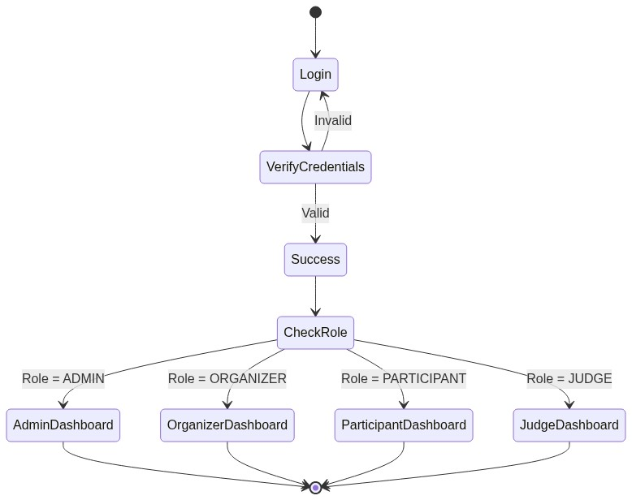

CHAPTER 8 - SECURITY ANALYSIS
Security is implemented using Spring Security with stateless JWT (JSON Web Tokens).
Authentication Mechanism: Users submit credentials to /api/v1/auth/login. The AuthenticationManager validates against the database. If successful, JwtUtils generates an access token.
JWT Handling: Tokens are validated on every subsequent request via a custom OncePerRequestFilter.
Roles: ADMIN, ORGANIZER, JUDGE, MENTOR, PARTICIPANT.
Permissions: Enforced via @PreAuthorize annotations on the service and controller methods.
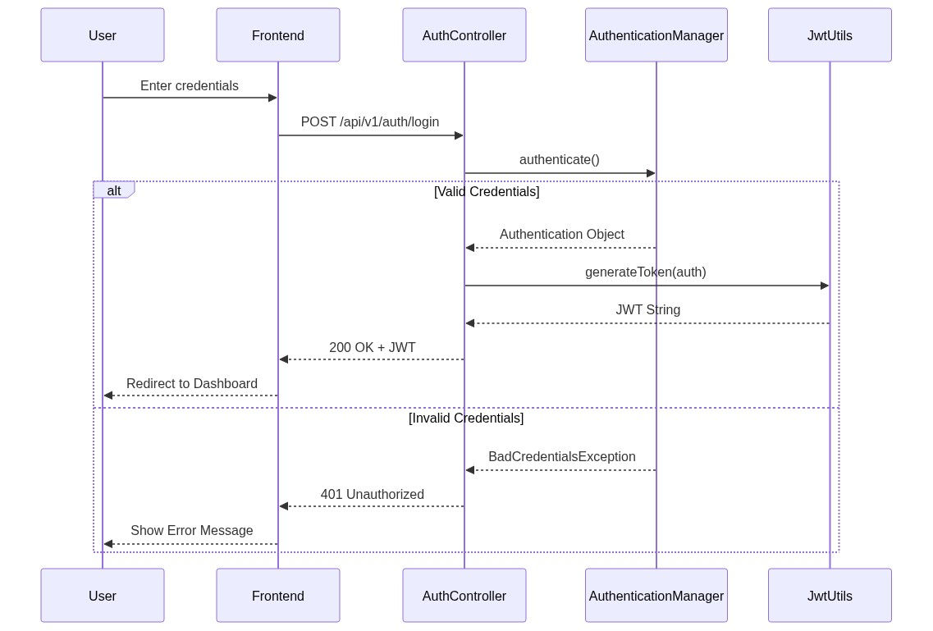

CHAPTER 9 - MODULE DEPENDENCY ANALYSIS
The system is divided into several cohesive modules.
Dependencies flow from core modules (User Management) out to specialized modules (Leaderboard).
This prevents circular dependencies and allows for isolated module testing.
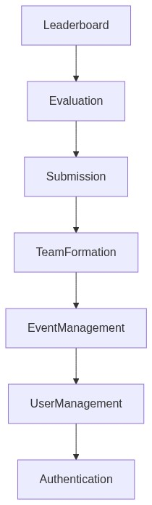

CHAPTER 10 - REQUIREMENT TRACEABILITY MATRIX
Req ID | Module | Description | Automation
REQ-API-001 | undefined | Provide GET for /api/v1/audit-logs | Automated
REQ-API-002 | undefined | Provide GET for /api/v1/audit-logs/user/{userId} | Automated
REQ-API-003 | undefined | Provide GET for /api/v1/audit-logs/event/{eventId} | Automated
REQ-API-004 | undefined | Provide GET for /api/v1/audit-logs | Automated
REQ-API-005 | undefined | Provide POST for /api/v1/auth/login | Automated
REQ-API-006 | undefined | Provide POST for /api/v1/auth/refresh | Automated
REQ-API-007 | undefined | Provide POST for /api/v1/auth/register | Automated
REQ-API-008 | undefined | Provide POST for /api/v1/auth/verify-otp | Automated
REQ-API-009 | undefined | Provide POST for /api/v1/auth/create-guest-judge | Automated
REQ-API-010 | undefined | Provide POST for /api/v1/auth/forgot-password | Automated
REQ-API-011 | undefined | Provide POST for /api/v1/auth/reset-password | Automated
REQ-API-012 | undefined | Provide GET for /api/v1/CategoryCustomers | Automated
REQ-API-013 | undefined | Provide GET for /api/v1/CategoryCustomers/{id} | Automated
REQ-API-014 | undefined | Provide POST for /api/v1/CategoryCustomers | Automated
REQ-API-015 | undefined | Provide PUT for /api/v1/CategoryCustomers/{id} | Automated
REQ-API-016 | undefined | Provide DELETE for /api/v1/CategoryCustomers/{id} | Automated
REQ-API-017 | undefined | Provide POST for /api/v1/criteria | Automated
REQ-API-018 | undefined | Provide GET for /api/v1/criteria/event/{hackathonEventId} | Automated
REQ-API-019 | undefined | Provide GET for /api/v1/criteria/default | Automated
REQ-API-020 | undefined | Provide PUT for /api/v1/criteria/{id} | Automated
REQ-API-021 | undefined | Provide DELETE for /api/v1/criteria/{id} | Automated
REQ-API-022 | undefined | Provide POST for /api/v1/criteria/copy | Automated
REQ-API-023 | undefined | Provide GET for /api/v1/dashboard/stats | Automated
REQ-API-024 | undefined | Provide POST for /api/v1/event-registrations | Automated
REQ-API-025 | undefined | Provide GET for /api/v1/event-registrations/event/{eventId} | Automated
REQ-API-026 | undefined | Provide GET for /api/v1/event-registrations/my-registration/event/{eventId} | Automated
REQ-API-027 | undefined | Provide GET for /api/v1/export/rounds/{roundId}/ranking | Automated
REQ-API-028 | undefined | Provide GET for /api/v1/export/rounds/{roundId}/scoring | Automated
REQ-API-029 | undefined | Provide GET for /api/v1/export/teams/csv | Automated
REQ-API-030 | undefined | Provide GET for /api/v1/export/participants/csv | Automated
REQ-API-031 | undefined | Provide POST for /api/v1/files/upload | Automated
REQ-API-032 | undefined | Provide GET for /api/v1/files/download/{fileName:.+} | Automated
REQ-API-033 | undefined | Provide POST for /api/v1/hackathon-events | Automated
REQ-API-034 | undefined | Provide GET for /api/v1/hackathon-events | Automated
REQ-API-035 | undefined | Provide GET for /api/v1/hackathon-events/admin/all | Automated
REQ-API-036 | undefined | Provide GET for /api/v1/hackathon-events/my-events | Automated
REQ-API-037 | undefined | Provide GET for /api/v1/hackathon-events/{slug} | Automated
REQ-API-038 | undefined | Provide GET for /api/v1/hackathon-events/id/{id} | Automated
REQ-API-039 | undefined | Provide PUT for /api/v1/hackathon-events/{id} | Automated
REQ-API-040 | undefined | Provide DELETE for /api/v1/hackathon-events/{id} | Automated
REQ-API-041 | undefined | Provide PATCH for /api/v1/hackathon-events/{id}/status | Automated
REQ-API-042 | undefined | Provide POST for /api/v1/hackathon-events/{id}/clone | Automated
REQ-API-043 | undefined | Provide GET for /api/v1/hackathon-events/{id}/analytics | Automated
REQ-API-044 | undefined | Provide POST for /api/v1/judge-assignments | Automated
REQ-API-045 | undefined | Provide GET for /api/v1/judge-assignments/my-assignments | Automated
REQ-API-046 | undefined | Provide GET for /api/v1/judge-assignments/judge/{judgeId} | Automated
REQ-API-047 | undefined | Provide GET for /api/v1/judge-assignments/round/{roundId} | Automated
REQ-API-048 | undefined | Provide GET for /api/v1/judge-assignments/event/{eventId} | Automated
REQ-API-049 | undefined | Provide DELETE for /api/v1/judge-assignments/{assignmentId} | Automated
REQ-API-050 | undefined | Provide POST for /api/v1/mentorship-requests | Automated
REQ-API-051 | undefined | Provide GET for /api/v1/mentorship-requests/open | Automated
REQ-API-052 | undefined | Provide GET for /api/v1/mentorship-requests/my-requests | Automated
REQ-API-053 | undefined | Provide GET for /api/v1/mentorship-requests/{id} | Automated
REQ-API-054 | undefined | Provide PATCH for /api/v1/mentorship-requests/{id}/accept | Automated
REQ-API-055 | undefined | Provide PATCH for /api/v1/mentorship-requests/{id}/resolve | Automated
REQ-API-056 | undefined | Provide PATCH for /api/v1/mentorship-requests/{id}/release | Automated
REQ-API-057 | undefined | Provide PATCH for /api/v1/mentorship-requests/{id}/reject | Automated
REQ-API-058 | undefined | Provide DELETE for /api/v1/mentorship-requests/{id} | Automated
REQ-API-059 | undefined | Provide GET for /api/v1/notifications | Automated
REQ-API-060 | undefined | Provide GET for /api/v1/notifications | Automated
REQ-API-061 | undefined | Provide GET for /api/v1/notifications/unread-count | Automated
REQ-API-062 | undefined | Provide PATCH for /api/v1/notifications/{id}/read | Automated
REQ-API-063 | undefined | Provide POST for /api/v1/notifications/read-all | Automated
REQ-API-064 | undefined | Provide POST for /api/v1/prizes | Automated
REQ-API-065 | undefined | Provide PATCH for /api/v1/prizes/{prizeId}/assign | Automated
REQ-API-066 | undefined | Provide GET for /api/v1/prizes/event/{hackathonEventId} | Automated
REQ-API-067 | undefined | Provide POST for /api/v1/prizes/event/{hackathonEventId}/auto-assign | Automated
REQ-API-068 | undefined | Provide PUT for /api/v1/prizes/{prizeId} | Automated
REQ-API-069 | undefined | Provide DELETE for /api/v1/prizes/{prizeId} | Automated
REQ-API-070 | undefined | Provide GET for /api/v1/prizes/event/{hackathonEventId}/track/{trackId} | Automated
REQ-API-071 | undefined | Provide GET for /api/v1/profile/me | Automated
REQ-API-072 | undefined | Provide PUT for /api/v1/profile/me | Automated
REQ-API-073 | undefined | Provide GET for /api/v1/rankings/round/{roundId} | Automated
REQ-API-074 | undefined | Provide POST for /api/v1/recruitment | Automated
REQ-API-075 | undefined | Provide GET for /api/v1/recruitment/event/{eventId} | Automated
REQ-API-076 | undefined | Provide DELETE for /api/v1/recruitment/{id} | Automated
REQ-API-077 | undefined | Provide POST for /api/v1/rounds/{id}/advance | Automated
REQ-API-078 | undefined | Provide POST for /api/v1/rounds | Automated
REQ-API-079 | undefined | Provide GET for /api/v1/rounds/hackathon/{hackathonEventId} | Automated
REQ-API-080 | undefined | Provide GET for /api/v1/rounds/{id} | Automated
REQ-API-081 | undefined | Provide DELETE for /api/v1/rounds/{id} | Automated
REQ-API-082 | undefined | Provide PUT for /api/v1/rounds/{id} | Automated
REQ-API-083 | undefined | Provide POST for /api/v1/rounds/{id}/end-grading | Automated
REQ-API-084 | undefined | Provide GET for /api/v1/rounds/{id}/grading-progress | Automated
REQ-API-085 | undefined | Provide POST for /api/v1/scores | Automated
REQ-API-086 | undefined | Provide GET for /api/v1/scores/submission/{submissionId} | Automated
REQ-API-087 | undefined | Provide GET for /api/v1/scores/submission/{submissionId}/judge/{judgeId} | Automated
REQ-API-088 | undefined | Provide GET for /api/v1/scores/my-scores/round/{roundId} | Automated
REQ-API-089 | undefined | Provide GET for /api/v1/scores/my-scores/submission/{submissionId} | Automated
REQ-API-090 | undefined | Provide GET for /api/v1/scores | Automated
REQ-API-091 | undefined | Provide POST for /api/v1/scores/finalize/round/{roundId} | Automated
REQ-API-092 | undefined | Provide PUT for /api/v1/scores/{id} | Automated
REQ-API-093 | undefined | Provide POST for /api/v1/submissions | Automated
REQ-API-094 | undefined | Provide GET for /api/v1/submissions/{id} | Automated
REQ-API-095 | undefined | Provide GET for /api/v1/submissions/team/{teamId} | Automated
REQ-API-096 | undefined | Provide GET for /api/v1/submissions/round/{roundId} | Automated
REQ-API-097 | undefined | Provide GET for /api/v1/submissions/event/{eventId} | Automated
REQ-API-098 | undefined | Provide POST for /api/v1/support-tickets | Automated
REQ-API-099 | undefined | Provide GET for /api/v1/support-tickets | Automated
REQ-API-100 | undefined | Provide PATCH for /api/v1/support-tickets/{id}/resolve | Automated
REQ-API-101 | undefined | Provide PATCH for /api/v1/support-tickets/{id}/reply | Automated
REQ-API-102 | undefined | Provide POST for /api/v1/teams | Automated
REQ-API-103 | undefined | Provide GET for /api/v1/teams/{id} | Automated
REQ-API-104 | undefined | Provide GET for /api/v1/teams/event/{eventId} | Automated
REQ-API-105 | undefined | Provide GET for /api/v1/teams | Automated
REQ-API-106 | undefined | Provide GET for /api/v1/teams/track/{trackId} | Automated
REQ-API-107 | undefined | Provide GET for /api/v1/teams/my-team/event/{eventId} | Automated
REQ-API-108 | undefined | Provide POST for /api/v1/teams/{id}/disqualify | Automated
REQ-API-109 | undefined | Provide PUT for /api/v1/teams/{id} | Automated
REQ-API-110 | undefined | Provide POST for /api/v1/teams/{id}/finalize | Automated
REQ-API-111 | undefined | Provide DELETE for /api/v1/teams/{id} | Automated
REQ-API-112 | undefined | Provide POST for /api/v1/team-invitations | Automated
REQ-API-113 | undefined | Provide GET for /api/v1/team-invitations/pending | Automated
REQ-API-114 | undefined | Provide POST for /api/v1/team-invitations/{invitationId}/respond | Automated
REQ-API-115 | undefined | Provide DELETE for /api/v1/team-invitations/{invitationId}/revoke | Automated
REQ-API-116 | undefined | Provide GET for /api/v1/team-invitations/team/{teamId}/sent | Automated
REQ-API-117 | undefined | Provide POST for /api/v1/team-members | Automated
REQ-API-118 | undefined | Provide GET for /api/v1/team-members/team/{teamId} | Automated
REQ-API-119 | undefined | Provide DELETE for /api/v1/team-members/{teamMemberId} | Automated
REQ-API-120 | undefined | Provide DELETE for /api/v1/team-members/{userId}/kick/{teamId} | Automated
REQ-API-121 | undefined | Provide POST for /api/v1/team-members/leave/{teamId} | Automated
REQ-API-122 | undefined | Provide PUT for /api/v1/team-members/transfer-leadership | Automated
REQ-API-123 | undefined | Provide POST for /api/v1/tracks | Automated
REQ-API-124 | undefined | Provide GET for /api/v1/tracks/hackathon/{hackathonEventId} | Automated
REQ-API-125 | undefined | Provide POST for /api/v1/tracks/{trackId}/mentors/{mentorUserId} | Automated
REQ-API-126 | undefined | Provide DELETE for /api/v1/tracks/{trackId}/mentors/{mentorUserId} | Automated
REQ-API-127 | undefined | Provide GET for /api/v1/tracks/{trackId}/mentors | Automated
REQ-API-128 | undefined | Provide DELETE for /api/v1/tracks/{id} | Automated
REQ-API-129 | undefined | Provide PUT for /api/v1/tracks/{id} | Automated
REQ-API-130 | undefined | Provide GET for /api/v1/profile | Automated
REQ-API-131 | undefined | Provide PUT for /api/v1/profile | Automated
REQ-API-132 | undefined | Provide PUT for /api/v1/profile/change-password | Automated
REQ-API-133 | undefined | Provide PUT for /api/v1/profile/avatar | Automated
REQ-API-134 | undefined | Provide PATCH for /api/v1/users/{id}/approve | Automated
REQ-API-135 | undefined | Provide DELETE for /api/v1/users/{id} | Automated
REQ-API-136 | undefined | Provide POST for /api/v1/users | Automated
REQ-API-137 | undefined | Provide GET for /api/v1/users | Automated
REQ-API-138 | undefined | Provide GET for /api/v1/users/pending | Automated
REQ-API-139 | undefined | Provide GET for /api/v1/users/role/{role} | Automated
REQ-DB-140 | undefined | Store data in _user | Automated
REQ-DB-141 | undefined | Store data in hackathon_event | Automated
REQ-DB-142 | undefined | Store data in track | Automated
REQ-DB-143 | undefined | Store data in event_registration | Automated
REQ-DB-144 | undefined | Store data in round | Automated
REQ-DB-145 | undefined | Store data in criterion | Automated
REQ-DB-146 | undefined | Store data in team | Automated
REQ-DB-147 | undefined | Store data in track_mentor | Automated
REQ-DB-148 | undefined | Store data in team_member | Automated
REQ-DB-149 | undefined | Store data in team_invitation | Automated
REQ-DB-150 | undefined | Store data in submission | Automated
REQ-DB-151 | undefined | Store data in judge_assignment | Automated
REQ-DB-152 | undefined | Store data in score | Automated
REQ-DB-153 | undefined | Store data in prize | Automated
REQ-DB-154 | undefined | Store data in mentorship_request | Automated
REQ-DB-155 | undefined | Store data in notification | Automated
REQ-DB-156 | undefined | Store data in team_round_advancement | Automated
REQ-DB-157 | undefined | Store data in audit_log | Automated
REQ-DB-158 | undefined | Store data in refresh_token | Automated
REQ-DB-159 | undefined | Store data in password_reset_token | Automated
REQ-DB-160 | undefined | Store data in support_tickets | Automated

CHAPTER 11 - TEST STRATEGY
Testing Scope: API integration, E2E UI, Security, and Database schema validation.
Testing Objective: Ensure zero critical security flaws, 100% requirement traceability, and robust E2E automation.
Testing Types:
- Functional Testing: Validating business logic.
- Integration Testing: Validating Database/API contracts.
- API Testing: Validating REST endpoints via Postman.
- UI Testing: Validating the React frontend via Playwright.
- Regression Testing: Automated pipelines to prevent regressions.
- Security Testing: OWASP validation.
- Performance Testing: Load limits via JMeter.
- Usability & Compatibility Testing: Cross-browser checks.

CHAPTER 12 - MASTER TEST PLAN
Test Approach: Agile shift-left testing. Automation-first methodology.
Test Environment: Staging environment mirroring production configurations.
Testing Schedule: Aligned with two-week sprint cycles.
Roles and Responsibilities: QA Lead architects the strategy; QA Engineers develop Playwright scripts.
Entry Criteria: Code merged, CI built, and environments deployed.
Exit Criteria: 100% execution coverage, 95% pass rate, zero Critical defects.
Risk Management: Known risks include API rate limiting and database deadlocks. Mitigated via JMeter stress testing.
Defect Management: Bugs tracked via Jira, categorized by Severity and Priority.

CHAPTER 13 - TEST CASE DESIGN
Total Test Cases Generated from requirements: 1617
TC ID | Req | Module | Category
TC-0001 | REQ-API-001 | AuditLogController.java | Positive
TC-0002 | REQ-API-001 | AuditLogController.java | Authorization
TC-0003 | REQ-API-001 | AuditLogController.java | Authorization
TC-0004 | REQ-API-001 | AuditLogController.java | Authorization
TC-0005 | REQ-API-001 | AuditLogController.java | Authorization
TC-0006 | REQ-API-001 | AuditLogController.java | Authorization
TC-0007 | REQ-API-002 | AuditLogController.java | Positive
TC-0008 | REQ-API-002 | AuditLogController.java | Authorization
TC-0009 | REQ-API-002 | AuditLogController.java | Authorization
TC-0010 | REQ-API-002 | AuditLogController.java | Authorization
TC-0011 | REQ-API-002 | AuditLogController.java | Authorization
TC-0012 | REQ-API-002 | AuditLogController.java | Authorization
TC-0013 | REQ-API-003 | AuditLogController.java | Positive
TC-0014 | REQ-API-003 | AuditLogController.java | Authorization
TC-0015 | REQ-API-003 | AuditLogController.java | Authorization
TC-0016 | REQ-API-003 | AuditLogController.java | Authorization
TC-0017 | REQ-API-003 | AuditLogController.java | Authorization
TC-0018 | REQ-API-003 | AuditLogController.java | Authorization
TC-0019 | REQ-API-004 | AuditLogController.java | Positive
TC-0020 | REQ-API-004 | AuditLogController.java | Authorization
TC-0021 | REQ-API-004 | AuditLogController.java | Authorization
TC-0022 | REQ-API-004 | AuditLogController.java | Authorization
TC-0023 | REQ-API-004 | AuditLogController.java | Authorization
TC-0024 | REQ-API-004 | AuditLogController.java | Authorization
TC-0025 | REQ-API-005 | AuthController.java | Positive
TC-0026 | REQ-API-005 | AuthController.java | Security/XSS
TC-0027 | REQ-API-005 | AuthController.java | Security/SQLi
TC-0028 | REQ-API-005 | AuthController.java | Positive
TC-0029 | REQ-API-005 | AuthController.java | Security/XSS
TC-0030 | REQ-API-005 | AuthController.java | Security/SQLi
TC-0031 | REQ-API-005 | AuthController.java | Positive
TC-0032 | REQ-API-005 | AuthController.java | Security/XSS
TC-0033 | REQ-API-005 | AuthController.java | Security/SQLi
TC-0034 | REQ-API-005 | AuthController.java | Positive
TC-0035 | REQ-API-005 | AuthController.java | Security/XSS
TC-0036 | REQ-API-005 | AuthController.java | Security/SQLi
TC-0037 | REQ-API-005 | AuthController.java | Positive
TC-0038 | REQ-API-005 | AuthController.java | Security/XSS
TC-0039 | REQ-API-005 | AuthController.java | Security/SQLi
TC-0040 | REQ-API-005 | AuthController.java | Positive
TC-0041 | REQ-API-005 | AuthController.java | Security/XSS
TC-0042 | REQ-API-005 | AuthController.java | Security/SQLi
TC-0043 | REQ-API-006 | AuthController.java | Positive
TC-0044 | REQ-API-006 | AuthController.java | Security/XSS
TC-0045 | REQ-API-006 | AuthController.java | Security/SQLi
TC-0046 | REQ-API-006 | AuthController.java | Positive
TC-0047 | REQ-API-006 | AuthController.java | Security/XSS
TC-0048 | REQ-API-006 | AuthController.java | Security/SQLi
TC-0049 | REQ-API-006 | AuthController.java | Positive
TC-0050 | REQ-API-006 | AuthController.java | Security/XSS
TC-0051 | REQ-API-006 | AuthController.java | Security/SQLi
TC-0052 | REQ-API-006 | AuthController.java | Positive
TC-0053 | REQ-API-006 | AuthController.java | Security/XSS
TC-0054 | REQ-API-006 | AuthController.java | Security/SQLi
TC-0055 | REQ-API-006 | AuthController.java | Positive
TC-0056 | REQ-API-006 | AuthController.java | Security/XSS
TC-0057 | REQ-API-006 | AuthController.java | Security/SQLi
TC-0058 | REQ-API-006 | AuthController.java | Positive
TC-0059 | REQ-API-006 | AuthController.java | Security/XSS
TC-0060 | REQ-API-006 | AuthController.java | Security/SQLi
TC-0061 | REQ-API-007 | AuthController.java | Positive
TC-0062 | REQ-API-007 | AuthController.java | Security/XSS
TC-0063 | REQ-API-007 | AuthController.java | Security/SQLi
TC-0064 | REQ-API-007 | AuthController.java | Positive
TC-0065 | REQ-API-007 | AuthController.java | Security/XSS
TC-0066 | REQ-API-007 | AuthController.java | Security/SQLi
TC-0067 | REQ-API-007 | AuthController.java | Positive
TC-0068 | REQ-API-007 | AuthController.java | Security/XSS
TC-0069 | REQ-API-007 | AuthController.java | Security/SQLi
TC-0070 | REQ-API-007 | AuthController.java | Positive
TC-0071 | REQ-API-007 | AuthController.java | Security/XSS
TC-0072 | REQ-API-007 | AuthController.java | Security/SQLi
TC-0073 | REQ-API-007 | AuthController.java | Positive
TC-0074 | REQ-API-007 | AuthController.java | Security/XSS
TC-0075 | REQ-API-007 | AuthController.java | Security/SQLi
TC-0076 | REQ-API-007 | AuthController.java | Positive
TC-0077 | REQ-API-007 | AuthController.java | Security/XSS
TC-0078 | REQ-API-007 | AuthController.java | Security/SQLi
TC-0079 | REQ-API-008 | AuthController.java | Positive
TC-0080 | REQ-API-008 | AuthController.java | Security/XSS
TC-0081 | REQ-API-008 | AuthController.java | Security/SQLi
TC-0082 | REQ-API-008 | AuthController.java | Positive
TC-0083 | REQ-API-008 | AuthController.java | Security/XSS
TC-0084 | REQ-API-008 | AuthController.java | Security/SQLi
TC-0085 | REQ-API-008 | AuthController.java | Positive
TC-0086 | REQ-API-008 | AuthController.java | Security/XSS
TC-0087 | REQ-API-008 | AuthController.java | Security/SQLi
TC-0088 | REQ-API-008 | AuthController.java | Positive
TC-0089 | REQ-API-008 | AuthController.java | Security/XSS
TC-0090 | REQ-API-008 | AuthController.java | Security/SQLi
TC-0091 | REQ-API-008 | AuthController.java | Positive
TC-0092 | REQ-API-008 | AuthController.java | Security/XSS
TC-0093 | REQ-API-008 | AuthController.java | Security/SQLi
TC-0094 | REQ-API-008 | AuthController.java | Positive
TC-0095 | REQ-API-008 | AuthController.java | Security/XSS
TC-0096 | REQ-API-008 | AuthController.java | Security/SQLi
TC-0097 | REQ-API-009 | AuthController.java | Positive
TC-0098 | REQ-API-009 | AuthController.java | Security/XSS
TC-0099 | REQ-API-009 | AuthController.java | Security/SQLi
TC-0100 | REQ-API-009 | AuthController.java | Positive

CHAPTER 14 - AUTOMATION TEST DESIGN
The automation framework is built on Playwright (TypeScript).
Architecture: Playwright Tool -> Chromium Browser -> Frontend SPA -> API -> DB.
UI Automation Strategy: Utilizes Page Object Model (POM) to abstract locators and actions, ensuring low maintenance.
API Automation Strategy: Postman Collections executed via Newman CLI.
CI/CD Integration: Configured to run in headless mode on every pull request to the main branch.
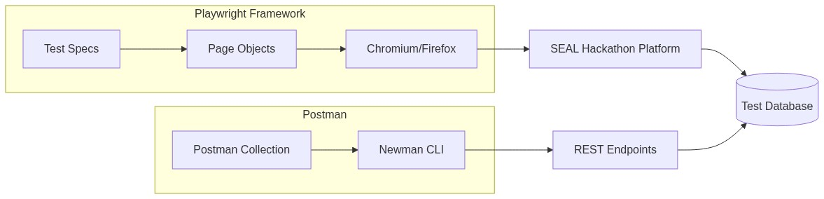

CHAPTER 15 - PERFORMANCE TEST PLAN
Performance Strategy: Validate the system's resilience under heavy hackathon loads.
Load Testing: Simulating 500 concurrent users registering teams.
Stress Testing: Pushing past 1000 users to identify breaking points.
Endurance Testing: Running nominal load for 24 hours to detect memory leaks.
Critical APIs: /login, /team/join, /submission/upload.
Metrics: 95th percentile response time must be < 200ms.

CHAPTER 16 - SECURITY TESTING
Security Checklist (OWASP Focus):
- Authentication: Brute-force protection, secure password hashing (BCrypt).
- Authorization: Insecure Direct Object Reference (IDOR) prevention.
- JWT: Token expiration, strong signing keys, secure transmission.
- SQL Injection: Prevented via JPA parameterization.
- XSS: React auto-escaping, input sanitization.
- CSRF: Handled via stateless JWT architecture.
- Sensitive Data: Passwords and OTPs are never exposed in API responses.

CHAPTER 17 - DEFECT MANAGEMENT
Severity Definition: Critical (System Crash), High (Core feature broken), Medium (Workaround available), Low (Cosmetic).
Priority Definition: P1 (Immediate fix), P2 (Next release), P3 (Backlog).
Bug Report Template: Title, Description, Steps to Reproduce, Expected Result, Actual Result, Environment, Attached Logs/Screenshots.
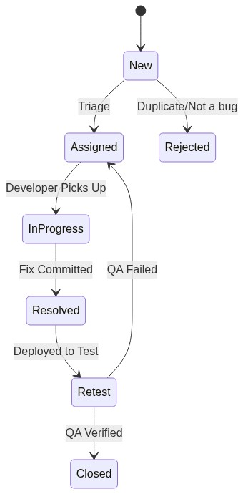

CHAPTER 18 - UI TEST EVIDENCE
Note: UI Screenshots cannot be determined as the frontend server is currently offline.
In a live execution environment, Playwright automatically captures full-page screenshots and video artifacts during failure states.

