SOFTWARE REQUIREMENTS
SPECIFICATION (SRS)
SEAL Hackathon Management System
Version 1.0
Course | Software Requirements Engineering
Team name | Assumption: team name not provided in backend or supplied project metadata.
Members | Assumption: member list and student IDs were not present in the backend source code.
Instructor | Assumption: instructor name not provided in backend or supplied metadata.
Submission date | 02 / 07 / 2026
Document status | Draft for review / backend-derived SRS

Revision History
Track every version of this document. This completed version was generated from the SRS template and backend implementation.
Version | Date | Author | Changes summary | Reviewer
0.1 | 02 / 07 / 2026 | Codex / BA reverse-engineering | Initial template completion from backend source, OpenAPI, JPA entities, SQL schema, and project documentation. | Project team
0.2 | 02 / 07 / 2026 | Codex / Requirements engineering | Added traceability, diagrams, data dictionary, business rules, and NFRs. | Project team
1.0 | 02 / 07 / 2026 | Project team | Ready for university review after team confirms assumptions and metadata. | Instructor / reviewer

Table of Contents
- 1. Introduction
- 1.1 Purpose
- 1.2 Document conventions
- 1.3 Intended audience and reading suggestions
- 1.4 Product scope
- 1.5 Definitions, acronyms, and abbreviations
- 1.6 References
- 2. Overall Description
- 2.1 Product perspective
- 2.2 Product functions
- 2.3 User classes and characteristics
- 2.4 Operating environment
- 2.5 Design and implementation constraints
- 2.6 Assumptions and dependencies
- 3. External Interface Requirements
- 3.1 User interfaces
- 3.2 Hardware interfaces
- 3.3 Software interfaces
- 3.4 Communications interfaces
- 4. System Features (Functional Requirements)
- 5. Data Requirements
- 6. Non-Functional Requirements
- 7. Business Rules
- 8. Other Models and Diagrams
- 9. Prioritization and Traceability
- 10. Validation and Change Management
- Appendix A - Glossary
- Appendix B - Analysis Models (full-size diagrams)
- Appendix C - Issues List

1. Introduction

1.1 Purpose
This SRS describes the functional and non-functional requirements for version 1.0 of SEAL Hackathon Management System, a web-based platform for managing hackathon events, participant registration, team formation, submissions, judging, rankings, mentorship, notifications, exports, and administration. The document is completed from the supplied Word template and the backend implementation located at C:\Source_Code\SWP\SWP391-Project\backend.
The backend implementation is treated as the source of truth for system behavior. Items not inferable from backend code are explicitly marked as assumptions.

1.2 Document conventions
- Requirement IDs are bolded in tables and use the format FR-MODULE-NN or NFR-MODULE-NN.
- The word 'shall' indicates a mandatory requirement; 'should' indicates a desirable requirement; 'may' indicates an optional capability.
- Priority values are High, Medium, or Low and are assigned per requirement.
- Acceptance criteria use Given / When / Then phrasing.
- Source identifies the backend class, controller, DTO, schema, or explicit assumption used to derive the requirement.

1.3 Intended audience and reading suggestions
Audience | Suggested reading path
Project sponsor / instructor | Sections 1, 2, 7, 8, and 9 for scope, rules, diagrams, and traceability.
Backend developers | Sections 3, 4, 5, and 7 for interfaces, functional behavior, data, and rules.
Frontend developers / UX designers | Sections 2.3, 3.1, 4, 6.3, and Appendix B personas/diagrams.
QA / testers | Sections 4, 7, 9, and 10 for acceptance criteria, rules, traceability, and validation plan.
Future maintainers | Sections 2.4, 2.5, 5, 6.5, and Appendix C for environment, constraints, data model, and open issues.

1.4 Product scope
The product scope is a hackathon management backend and related web application workflow. It supports account onboarding, event configuration, team collaboration, submissions, judging, ranking, prizes, mentorship, real-time notifications, audit logging, and administrative reporting.

In scope
- Account registration, OTP verification, admin approval, JWT login, refresh tokens, password reset, and Google OAuth2 login.
- Role-based access for ADMIN, ORGANIZER, JUDGE, GUEST_JUDGE, MENTOR, PARTICIPANT, and public visitors.
- Hackathon events, tracks, rounds, criteria, lifecycle status, registration windows, team size rules, and soft deletion.
- Participant event registration, team creation, invitations, team membership, leadership transfer, finalization, and disqualification.
- Project submission, versioned resubmission, judge assignment, scoring, finalization, ranking, advancement, and prize assignment.
- Mentorship requests, notifications with SSE push, dashboard statistics, CSV exports, audit logs, and CategoryCustomer CRUD endpoints.

Out of scope (NOT delivered in v1.0)
- Payment, ticketing, venue check-in hardware, and physical event logistics; no backend modules implement these functions.
- Built-in file storage for project artifacts; submissions store repository/demo/report URLs rather than binary uploads.
- Chat, video conferencing, or real-time collaboration beyond one-way Server-Sent Events notifications.
- Native mobile application APIs beyond the REST/JSON endpoints already exposed.
- A complete data-retention or privacy-erasure workflow; the backend includes soft delete for events and deactivation for users but not a full compliance lifecycle.

1.5 Definitions, acronyms, and abbreviations
Term / Acronym | Definition
API | Application Programming Interface exposed by the Spring Boot backend.
BR | Business Rule: domain constraint or computation that influences functional requirements.
DTO | Data Transfer Object used for request and response payloads.
ERD | Entity-Relationship Diagram showing persistent data entities and relationships.
FR | Functional Requirement: behavior the system shall provide.
Guest Judge | Temporary external evaluator account created by an admin or organizer.
JWT | JSON Web Token used as stateless bearer authentication.
MoSCoW | Prioritization method: Must, Should, Could, Won't.
NFR | Non-Functional Requirement: measurable quality requirement.
OTP | One-Time Password used for email verification and password reset.
Round | Competition stage within a hackathon event.
SRS | Software Requirements Specification.
SSE | Server-Sent Events, used for one-way real-time notifications.
Track | Competition category inside a hackathon event.

1.6 References
- Wiegers, K. & Beatty, J. (2013). Software Requirements (3rd ed.). Microsoft Press.
- IEEE Std 830-1998 - Recommended Practice for Software Requirements Specifications.
- ISO/IEC/IEEE 29148:2018 - Systems and software engineering - Requirements engineering.
- Backend source code: C:\Source_Code\SWP\SWP391-Project\backend
- SQL schema source: C:\Source_Code\SWP\SWP391-Project\database.sql
- OpenAPI metadata: C:\Source_Code\SWP\SWP391-Project\backend\openapi.json
- Assumption: stakeholder interview notes, final team roster, instructor name, and frontend wireframes were not supplied with the backend.

2. Overall Description

2.1 Product perspective
SEAL Hackathon Management System is a self-contained web platform with a Spring Boot REST backend, SQL Server persistence, an SPA frontend, email delivery, Google OAuth2 login, and Server-Sent Events notification streaming. The context diagram is included below and repeated full-size in Appendix B.
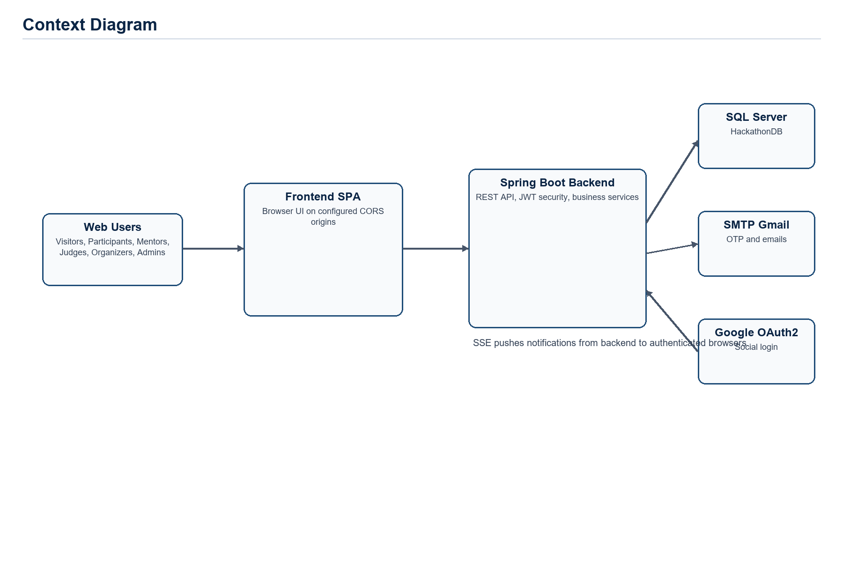
Figure 1. Context diagram.

2.2 Product functions
- Manage account lifecycle: registration, OTP verification, approval, login, refresh, password reset, OAuth2, profile, and role-specific access.
- Configure hackathon events: lifecycle status, registration windows, team size limits, tracks, rounds, criteria, and prizes.
- Support participation: event registration, teams, member invitations, leadership transfer, finalization, project details, and submissions.
- Support evaluation: judge assignment, scoring by criteria, score finalization, rankings, advancement, prize assignment, and exports.
- Support collaboration and operations: mentorship requests, notifications, dashboards, audit logs, and administrative user management.

2.3 User classes and characteristics
User class | Characteristics | Frequency of use | Privilege | Key features for this class
Visitor | Unauthenticated browser user viewing public event, track, prize, team, category, and ranking data. | Occasional | Public read-only | Browse events, view event details and rankings.
Participant | FPT/student participant with profile, event registration, team membership, and project submission responsibilities. | High during registration and rounds | Authenticated PARTICIPANT | Register, create/join teams, invite/respond, submit, request mentorship, notifications.
Team Leader | Participant who owns team workflow decisions. | High | Participant plus leader flag | Invite members, finalize team, submit project, request mentorship, transfer leadership.
Mentor | Advisor who supports teams via mentorship requests and may be assigned to tracks. | Medium | Authenticated MENTOR | View open requests, accept/resolve/reject requests, receive notifications.
Judge | Internal evaluator assigned to rounds/tracks; may mentor only where no conflict exists. | High during scoring | Authenticated JUDGE | View assigned submissions, score, update own scores, see rankings.
Guest Judge | Temporary external evaluator created by organizer/admin; cannot mentor. | Medium | Authenticated GUEST_JUDGE | View assigned submissions, score, update own scores.
Organizer | Event operator responsible for setup, judges, teams, exports, and event lifecycle. | High | Authenticated ORGANIZER | Manage own events, tracks, rounds, criteria, judges, mentors, exports, dashboard, disqualification.
Admin | System superuser responsible for users, audit, and cross-event operations. | Medium | Authenticated ADMIN | Approve/create/deactivate users, manage events, review audit logs, exports, full administration.

2.4 Operating environment
- Client: browser-based SPA; configured local CORS origins are http://localhost:5173 and http://localhost:5174.
- Server: Java 21, Spring Boot 3.2.5, Spring Web, Spring Security, Spring Data JPA, Spring Validation, Spring Mail, Spring Retry, Spring OAuth2 Client, SpringDoc OpenAPI.
- Database: Microsoft SQL Server, JDBC URL configured for localhost:1433 and database HackathonDB; Hibernate ddl-auto is none.
- Security: BCrypt password hashing, stateless JWT bearer tokens, method-level @PreAuthorize authorization, Google OAuth2 login.
- Third-party services: Gmail SMTP on smtp.gmail.com:587 with TLS; Google OAuth2 profile and email scope.

2.5 Design and implementation constraints
- The backend is constrained to Java 21 and Spring Boot 3.2.5 by pom.xml.
- The persistence model is constrained to SQL Server and the expected HackathonDB schema because spring.jpa.hibernate.ddl-auto=none.
- REST payloads use JSON DTOs and validation annotations; generated API documentation is exposed through SpringDoc OpenAPI.
- Authentication is stateless; server-side HTTP sessions are disabled and API security depends on JWT validation plus database reloading of user authorities.
- The SSE stream accepts a token query parameter because browser EventSource cannot send custom Authorization headers.
- Assumption: production deployment shall externalize database, SMTP, JWT, and OAuth secrets instead of storing secrets in application.properties.

2.6 Assumptions and dependencies
ID | Type | Statement | Risk if false
A-01 | Assumption | Project/team metadata not present in backend should be filled by the team before submission. | Low
A-02 | Assumption | Frontend screen names are inferred from backend workflows because final wireframes were not supplied. | Medium
A-03 | Assumption | Production non-functional targets are university-project targets unless stakeholders specify stricter values. | Medium
D-01 | Dependency | SQL Server HackathonDB schema must exist and match database.sql/JPA entities. | High
D-02 | Dependency | SMTP email service must be available for OTP, approval, and notification email workflows. | Medium
D-03 | Dependency | Google OAuth2 client configuration must be valid for OAuth login. | Medium
D-04 | Dependency | Frontend must pass JWT bearer tokens or SSE token query parameters for authenticated workflows. | High

3. External Interface Requirements

3.1 User interfaces
The backend does not include final wireframe files. The following logical UI screens are inferred from implemented API workflows and should be reflected in frontend wireframes.
Screen ID | Screen name | Purpose / key elements
UI-01 | Login / OAuth / Password Reset | Username/password login, Google OAuth redirect, forgot/reset password OTP flow.
UI-02 | Registration and OTP Verification | Participant registration form, OTP input, verification status messages.
UI-03 | Public Event Catalog | Event list, event details by slug, tracks, prizes, teams, and public ranking.
UI-04 | Participant Profile | Profile fields, student ID, school, GitHub, avatar, change password.
UI-05 | Event Registration | Register button, eligibility status, registration window status.
UI-06 | Team Workspace | Create team, project name/description, members, finalize, leave/kick/transfer leadership.
UI-07 | Team Invitations | Invite by email, pending invitations, accept/decline, sent invitations, revoke.
UI-08 | Submission Workspace | Repository URL, demo URL, report URL, submission version, round window state.
UI-09 | Judge Scoring Console | Assigned submissions, criteria, score fields, comments, update/finalization state.
UI-10 | Mentorship Requests | Create request, open request queue, accept, resolve with answer, reject with reason.
UI-11 | Organizer/Admin Management | Events, tracks, rounds, criteria, judges, mentors, prizes, disqualification, exports.
UI-12 | Notifications and Dashboard | SSE notification feed, unread count, dashboard stats and criterion variance.

3.2 Hardware interfaces
None applicable. The backend implementation does not integrate with printers, scanners, sensors, payment terminals, or other hardware devices.

3.3 Software interfaces
System | Purpose of integration | Data exchanged / API contract
Frontend SPA | User-facing UI consumes backend REST and SSE endpoints. | JSON request/response bodies, JWT bearer tokens, SSE events.
Microsoft SQL Server | Persistent data storage for accounts, events, teams, submissions, scores, notifications, and audit logs. | JDBC SQL Server driver; database HackathonDB; schema defined by database.sql.
Gmail SMTP | Send OTP, account approval, and email notifications. | SMTP over TLS, email address/subject/body.
Google OAuth2 | Authenticate via Google account and import profile data. | OAuth2 profile/email scope, redirect with issued JWT/refresh token.
SpringDoc OpenAPI | Expose machine-readable API documentation. | OpenAPI JSON under /v3/api-docs and Swagger UI.

3.4 Communications interfaces
- REST API: HTTP(S) endpoints under /api/v1/* with JSON payloads and standard HTTP status codes.
- Authentication: Authorization: Bearer <JWT> header for protected endpoints; SSE stream may use token query parameter.
- Real-time notifications: text/event-stream Server-Sent Events on /api/v1/notifications/stream.
- Database: SQL Server JDBC over the configured database connection.
- Email: SMTP with TLS on port 587.
- CSV exports: text/csv responses with UTF-8 BOM for ranking, anonymized scoring, team, and participant data.
- Assumption: production deployment shall use HTTPS/TLS for browser-to-backend communication.

4. System Features (Functional Requirements)

4.1 Feature: Authentication and Account Lifecycle

4.1.1 Description and priority
This feature group covers authentication and account lifecycle. Overall priority is High because it is directly implemented by REST controllers and service workflows.

4.1.2 Stimulus / response sequences
- Happy path: authorized actor submits a valid request -> controller validates input -> service applies business rules -> repository persists/retrieves data -> API returns ApiResponse or domain response.
- Alternative flow: optional fields omitted or existing records found -> service applies defaults, partial updates, or idempotent behavior where implemented.
- Error flow: invalid role, status, duplicate, date, score, ownership, or lifecycle condition -> GlobalExceptionHandler returns a structured error response with HTTP 400/401/403/404/409 as applicable.

4.1.3 Functional requirements (detailed)
ID | FR-AUTH-01
Title | Participant self-registration
Description | The system shall allow a visitor to register a participant account with a unique username, unique email, password, and optional FPT student ID. The account shall be created as PARTICIPANT, unapproved, and unverified.
Priority | High
Source | AuthController; AuthServiceImpl.register; RegisterRequest
Dependencies | None
Acceptance criteria | Given a new visitor with unique identity data, When registration is submitted, Then the system stores a participant account, hashes the password, creates a six-digit OTP, and emails it.

ID | FR-AUTH-02
Title | Email OTP verification
Description | The system shall verify an account email using the OTP code generated during registration.
Priority | High
Source | AuthController; AuthServiceImpl.verifyOtp
Dependencies | FR-AUTH-01
Acceptance criteria | Given an unverified user and a non-expired matching OTP, When verification is requested, Then the system marks the user verified and clears the OTP fields.

ID | FR-AUTH-03
Title | Login and token issuance
Description | The system shall authenticate only verified and approved users and return an access token plus refresh token.
Priority | High
Source | AuthServiceImpl.login; JwtTokenProvider; RefreshTokenService
Dependencies | FR-AUTH-02; FR-USER-01
Acceptance criteria | Given a verified and approved user with valid credentials, When the user logs in, Then the system returns JWT access and refresh tokens; Given an unverified or unapproved user, Then login is rejected.

ID | FR-AUTH-04
Title | Refresh access token
Description | The system shall issue a new access token when a valid unexpired refresh token is supplied.
Priority | High
Source | AuthServiceImpl.refreshToken; RefreshTokenService
Dependencies | FR-AUTH-03
Acceptance criteria | Given a stored refresh token that has not expired, When refresh is requested, Then the system returns a new access token and keeps the same refresh token.

ID | FR-AUTH-05
Title | Password reset by email OTP
Description | The system shall support password reset by sending a six-digit OTP to the registered email and accepting a new password of at least six characters.
Priority | High
Source | AuthServiceImpl.forgotPassword; AuthServiceImpl.resetPassword
Dependencies | FR-AUTH-01
Acceptance criteria | Given a registered email and a valid reset OTP, When the user submits a new password, Then the system stores the BCrypt hash and clears the OTP.

ID | FR-AUTH-06
Title | Guest judge account creation
Description | The system shall allow ADMIN or ORGANIZER users to create temporary GUEST_JUDGE accounts that are automatically verified and approved.
Priority | Medium
Source | AuthController.createGuestJudge; AuthServiceImpl.createGuestJudge
Dependencies | FR-AUTH-03
Acceptance criteria | Given an organizer supplies unique guest judge credentials, When creation succeeds, Then the system stores a temporary GUEST_JUDGE account and logs the action.

ID | FR-AUTH-07
Title | Google OAuth2 login
Description | The system shall support Google OAuth2 login and create a new PARTICIPANT account from Google profile data when no account exists.
Priority | Medium
Source | OAuth2AuthenticationSuccessHandler; SecurityConfig
Dependencies | Google OAuth2 dependency
Acceptance criteria | Given Google returns an email profile, When OAuth2 login succeeds and the account is approved and active, Then the system redirects to the frontend with access and refresh tokens.

4.2 Feature: User Profile and Administration

4.2.1 Description and priority
This feature group covers user profile and administration. Overall priority is High because it is directly implemented by REST controllers and service workflows.

4.2.2 Stimulus / response sequences
- Happy path: authorized actor submits a valid request -> controller validates input -> service applies business rules -> repository persists/retrieves data -> API returns ApiResponse or domain response.
- Alternative flow: optional fields omitted or existing records found -> service applies defaults, partial updates, or idempotent behavior where implemented.
- Error flow: invalid role, status, duplicate, date, score, ownership, or lifecycle condition -> GlobalExceptionHandler returns a structured error response with HTTP 400/401/403/404/409 as applicable.

4.2.3 Functional requirements (detailed)
ID | FR-USER-01
Title | Approve pending users
Description | The system shall allow ADMIN users to approve pending user accounts and email the approved user.
Priority | High
Source | UserController.approveUser; UserServiceImpl.approveUser
Dependencies | FR-AUTH-01
Acceptance criteria | Given an unapproved user, When an admin approves the user, Then the account becomes approved, an audit log is recorded, and an approval email is sent asynchronously.

ID | FR-USER-02
Title | Administrative user creation
Description | The system shall allow ADMIN users to create users with a selected role as approved and verified accounts.
Priority | Medium
Source | UserController.createUser; UserServiceImpl.createUser
Dependencies | FR-AUTH-03
Acceptance criteria | Given unique username, email, and optional student ID, When an admin creates a user, Then the system stores the account with the requested role and logs the action.

ID | FR-USER-03
Title | User listing and filtering
Description | The system shall provide approved-user, pending-user, and role-based user lists according to controller authorization.
Priority | Medium
Source | UserController; UserRepository
Dependencies | FR-AUTH-03
Acceptance criteria | Given an authorized user requests a permitted list, When the endpoint is called, Then the system returns the matching page or collection of user responses.

ID | FR-USER-04
Title | Deactivate users
Description | The system shall allow ADMIN users to deactivate accounts instead of physically deleting them.
Priority | Medium
Source | UserController.delete; UserServiceImpl.deactivateUser
Dependencies | FR-AUTH-03
Acceptance criteria | Given an existing active user, When an admin deactivates the user, Then the system sets isActive to false and records an audit log.

ID | FR-USER-05
Title | Profile retrieval and update
Description | The system shall allow authenticated users to view and update profile fields including full name, phone, bio, student ID, school, GitHub URL, and avatar where supported.
Priority | High
Source | ProfileController; User ProfileController; UserServiceImpl.updateProfile
Dependencies | FR-AUTH-03
Acceptance criteria | Given an authenticated user, When profile data is submitted, Then the system persists allowed fields; Given the user is in a finalized team, Then identity fields cannot be changed.

ID | FR-USER-06
Title | Change password
Description | The system shall allow authenticated users to change password only after validating the old password.
Priority | High
Source | ProfileController.changePassword; UserServiceImpl.changePassword
Dependencies | FR-AUTH-03
Acceptance criteria | Given the correct old password and a valid new password, When change password is requested, Then the system stores the new BCrypt hash and logs the action.

4.3 Feature: Hackathon Event Configuration

4.3.1 Description and priority
This feature group covers hackathon event configuration. Overall priority is High because it is directly implemented by REST controllers and service workflows.

4.3.2 Stimulus / response sequences
- Happy path: authorized actor submits a valid request -> controller validates input -> service applies business rules -> repository persists/retrieves data -> API returns ApiResponse or domain response.
- Alternative flow: optional fields omitted or existing records found -> service applies defaults, partial updates, or idempotent behavior where implemented.
- Error flow: invalid role, status, duplicate, date, score, ownership, or lifecycle condition -> GlobalExceptionHandler returns a structured error response with HTTP 400/401/403/404/409 as applicable.

4.3.3 Functional requirements (detailed)
ID | FR-EVENT-01
Title | Create hackathon events
Description | The system shall allow ADMIN or ORGANIZER users to create hackathon events with generated unique slug, valid event time range, registration window, team size limits, and default DRAFT status.
Priority | High
Source | HackathonEventController.create; HackathonEventServiceImpl.createHackathonEvent
Dependencies | FR-AUTH-03
Acceptance criteria | Given valid event data and min team size not greater than max size, When the event is created, Then the system stores the event as DRAFT, generates a unique slug, seeds default criteria, and logs creation.

ID | FR-EVENT-02
Title | Browse public events
Description | The system shall expose public browsing for non-deleted PUBLISHED, IN_PROGRESS, and COMPLETED hackathon events.
Priority | High
Source | HackathonEventController.getAll; SecurityConfig
Dependencies | None
Acceptance criteria | Given any visitor, When public event listing or event detail by slug is requested, Then the system returns visible event information without requiring authentication.

ID | FR-EVENT-03
Title | Organizer event views
Description | The system shall allow ADMIN or ORGANIZER users to list all events and list events owned by the current organizer.
Priority | Medium
Source | HackathonEventController.admin/all; my-events
Dependencies | FR-AUTH-03
Acceptance criteria | Given an organizer is authenticated, When my-events is requested, Then the system returns events where organizer_id matches that user.

ID | FR-EVENT-04
Title | Update hackathon event details
Description | The system shall allow only the event owner or ADMIN to update events while they are in DRAFT or PUBLISHED status.
Priority | High
Source | HackathonEventServiceImpl.updateHackathonEvent
Dependencies | FR-EVENT-01
Acceptance criteria | Given an owner or admin edits a DRAFT/PUBLISHED event with valid times, When update is requested, Then the system persists changed fields and logs the update.

ID | FR-EVENT-05
Title | Manage event lifecycle status
Description | The system shall enforce event status transitions DRAFT -> PUBLISHED -> IN_PROGRESS -> COMPLETED, with CANCELLED reachable from non-terminal states.
Priority | High
Source | HackathonStatus; HackathonEventServiceImpl.updateHackathonEventStatus
Dependencies | FR-EVENT-01
Acceptance criteria | Given a valid next status, When an owner or admin changes status, Then the system persists the status, sends publication/completion notifications where applicable, and disqualifies undersized teams when moving to IN_PROGRESS.

ID | FR-EVENT-06
Title | Soft-delete events
Description | The system shall soft-delete only events that are not PUBLISHED, IN_PROGRESS, or COMPLETED.
Priority | Medium
Source | HackathonEventServiceImpl.deleteHackathonEvent
Dependencies | FR-EVENT-01
Acceptance criteria | Given an owner or admin deletes an allowed event, When deletion succeeds, Then the system sets isDeleted to true and logs the change.

4.4 Feature: Tracks, Rounds, and Criteria

4.4.1 Description and priority
This feature group covers tracks, rounds, and criteria. Overall priority is High because it is directly implemented by REST controllers and service workflows.

4.4.2 Stimulus / response sequences
- Happy path: authorized actor submits a valid request -> controller validates input -> service applies business rules -> repository persists/retrieves data -> API returns ApiResponse or domain response.
- Alternative flow: optional fields omitted or existing records found -> service applies defaults, partial updates, or idempotent behavior where implemented.
- Error flow: invalid role, status, duplicate, date, score, ownership, or lifecycle condition -> GlobalExceptionHandler returns a structured error response with HTTP 400/401/403/404/409 as applicable.

4.4.3 Functional requirements (detailed)
ID | FR-CONFIG-01
Title | Manage tracks
Description | The system shall allow ADMIN or ORGANIZER users to create tracks for a hackathon and allow public retrieval of tracks by event.
Priority | High
Source | TrackController; TrackServiceImpl
Dependencies | FR-EVENT-01
Acceptance criteria | Given a valid event ID and track name, When a track is created, Then it is associated with the hackathon event and returned in track listings.

ID | FR-CONFIG-02
Title | Assign mentors to tracks
Description | The system shall allow ADMIN or ORGANIZER users to assign and remove MENTOR users from tracks while preventing duplicate assignment and guest judge mentoring.
Priority | Medium
Source | TrackServiceImpl.assignMentor
Dependencies | FR-CONFIG-01; FR-USER-02
Acceptance criteria | Given a MENTOR user and a track, When assignment is requested, Then the system stores a TrackMentor record and logs the action.

ID | FR-CONFIG-03
Title | Manage rounds
Description | The system shall allow ADMIN or ORGANIZER users to create rounds for an event with start/end time and advancement slots, defaulting slots to 2 when not positive.
Priority | High
Source | RoundController; RoundServiceImpl
Dependencies | FR-EVENT-01
Acceptance criteria | Given valid round data, When round creation succeeds, Then the round is associated with the event and appears in the event round list.

ID | FR-CONFIG-04
Title | Manage scoring criteria
Description | The system shall allow ADMIN or ORGANIZER users to create, update, delete, and copy criteria while keeping event criterion weights at or below 100 percent.
Priority | High
Source | CriterionController; CriterionServiceImpl
Dependencies | FR-EVENT-01
Acceptance criteria | Given criteria have no existing scores and total weight remains <= 100, When an organizer updates criteria, Then the system saves the change; Given existing scores, Then update/delete is rejected.

4.5 Feature: Registration, Teams, and Invitations

4.5.1 Description and priority
This feature group covers registration, teams, and invitations. Overall priority is High because it is directly implemented by REST controllers and service workflows.

4.5.2 Stimulus / response sequences
- Happy path: authorized actor submits a valid request -> controller validates input -> service applies business rules -> repository persists/retrieves data -> API returns ApiResponse or domain response.
- Alternative flow: optional fields omitted or existing records found -> service applies defaults, partial updates, or idempotent behavior where implemented.
- Error flow: invalid role, status, duplicate, date, score, ownership, or lifecycle condition -> GlobalExceptionHandler returns a structured error response with HTTP 400/401/403/404/409 as applicable.

4.5.3 Functional requirements (detailed)
ID | FR-REG-01
Title | Register for event
Description | The system shall allow PARTICIPANT users to register for PUBLISHED events only during the registration window after email verification, approval, and profile completion.
Priority | High
Source | EventRegistrationController; EventRegistrationService
Dependencies | FR-AUTH-02; FR-USER-01; FR-EVENT-05
Acceptance criteria | Given an eligible participant and an open PUBLISHED event, When registration is requested, Then the system creates a REGISTERED event_registration record; Given a duplicate registration, Then it is rejected.

ID | FR-TEAM-01
Title | Create team
Description | The system shall allow a PARTICIPANT to create one ACTIVE team per event during the PUBLISHED registration phase after registration and profile completion.
Priority | High
Source | TeamController.create; TeamServiceImpl.createTeam
Dependencies | FR-REG-01; FR-CONFIG-01
Acceptance criteria | Given a registered participant not already in an event team, When team creation is submitted with a valid track, Then the system creates the team and makes the creator leader.

ID | FR-TEAM-02
Title | Retrieve teams
Description | The system shall return teams by ID, event, track, all teams for admin/organizer, and the current participant's team for an event.
Priority | Medium
Source | TeamController
Dependencies | FR-TEAM-01
Acceptance criteria | Given a permitted caller, When a team retrieval endpoint is called, Then the system returns team data including members, track, status, and final score where available.

ID | FR-TEAM-03
Title | Update team details
Description | The system shall allow a team leader, ADMIN, or ORGANIZER to update team name, project details, and track while applying track and finalization restrictions.
Priority | Medium
Source | TeamServiceImpl.updateTeam
Dependencies | FR-TEAM-01
Acceptance criteria | Given the caller is a leader or admin/organizer, When a valid team update is submitted, Then the system persists changes; Given a finalized team track change by a non-admin, Then it is rejected.

ID | FR-TEAM-04
Title | Finalize team
Description | The system shall allow only the team leader to finalize a team when the team size is within event min/max limits.
Priority | High
Source | TeamServiceImpl.finalizeTeam
Dependencies | FR-TEAM-01
Acceptance criteria | Given a leader and a team that satisfies size rules, When finalization is requested, Then the team status becomes FINALIZED and an audit log is recorded.

ID | FR-TEAM-05
Title | Disqualify team
Description | The system shall allow ADMIN or ORGANIZER users to disqualify a team with a reason, timestamp, disqualifier, audit log, and notifications to members.
Priority | High
Source | TeamServiceImpl.disqualifyTeam
Dependencies | FR-TEAM-01
Acceptance criteria | Given an active or finalized team, When disqualification is requested by admin/organizer, Then the team status becomes DISQUALIFIED and all members receive notifications.

ID | FR-TEAM-06
Title | Delete non-finalized team
Description | The system shall allow ADMIN or ORGANIZER users to delete non-finalized teams after deleting associated mentorship requests, invitations, and submissions.
Priority | Low
Source | TeamServiceImpl.deleteTeam
Dependencies | FR-TEAM-01
Acceptance criteria | Given a non-finalized team, When deletion is requested, Then related team artifacts are removed and the team is deleted; Given a finalized team, Then deletion is rejected.

ID | FR-MEMBER-01
Title | Add and remove team members
Description | The system shall support team member addition and removal during the PUBLISHED registration phase while enforcing max size, one-team-per-event, and finalized-team min size rules.
Priority | High
Source | TeamMemberController; TeamMemberServiceImpl
Dependencies | FR-TEAM-01
Acceptance criteria | Given registration is open and the member is eligible, When a member is added, Then the system stores the team_member record; Given the team is full, Then addition is rejected.

ID | FR-MEMBER-02
Title | Kick or leave team
Description | The system shall allow leaders/admins to kick members and non-leader members to leave teams during registration, subject to finalized-team min size rules.
Priority | Medium
Source | TeamMemberServiceImpl.kickMember; leaveTeam
Dependencies | FR-MEMBER-01
Acceptance criteria | Given a non-leader member is in a team during registration, When leave is requested, Then the membership is removed; Given a leader tries to leave, Then the system requires leadership transfer first.

ID | FR-MEMBER-03
Title | Transfer team leadership
Description | The system shall allow the current team leader to transfer leadership to another team member during registration.
Priority | Medium
Source | TeamMemberServiceImpl.transferLeadership
Dependencies | FR-TEAM-01
Acceptance criteria | Given the caller is the current leader and the target is a team member, When transfer is requested, Then the old leader flag is cleared and the new leader flag is set.

ID | FR-INV-01
Title | Invite team member
Description | The system shall allow team leaders to invite registered users by email during registration while preventing duplicate invitations, full teams, and invitees already in another team for the event.
Priority | High
Source | TeamInvitationService.inviteMember
Dependencies | FR-TEAM-01; FR-REG-01
Acceptance criteria | Given a leader invites an eligible user by email, When the invitation is created, Then the system stores a PENDING invitation and sends a notification.

ID | FR-INV-02
Title | Respond to team invitation
Description | The system shall allow the invited user to accept or decline a pending invitation during registration after verification, approval, profile completion, and event registration.
Priority | High
Source | TeamInvitationService.respondToInvitation
Dependencies | FR-INV-01
Acceptance criteria | Given an eligible invitee accepts a pending invitation, When the response is submitted, Then the system adds the user to the team, marks the invitation ACCEPTED, notifies the leader, and cancels other pending invitations for the same event.

ID | FR-INV-03
Title | View and revoke invitations
Description | The system shall let participants view their pending invitations, leaders view sent invitations for their team, and leaders revoke pending invitations.
Priority | Medium
Source | TeamInvitationController; TeamInvitationService
Dependencies | FR-INV-01
Acceptance criteria | Given a leader revokes a pending invitation, When revoke is requested, Then the invitation becomes CANCELLED and the invitee receives a notification if a user account exists.

4.6 Feature: Submission, Judging, Scoring, Ranking, and Advancement

4.6.1 Description and priority
This feature group covers submission, judging, scoring, ranking, and advancement. Overall priority is High because it is directly implemented by REST controllers and service workflows.

4.6.2 Stimulus / response sequences
- Happy path: authorized actor submits a valid request -> controller validates input -> service applies business rules -> repository persists/retrieves data -> API returns ApiResponse or domain response.
- Alternative flow: optional fields omitted or existing records found -> service applies defaults, partial updates, or idempotent behavior where implemented.
- Error flow: invalid role, status, duplicate, date, score, ownership, or lifecycle condition -> GlobalExceptionHandler returns a structured error response with HTTP 400/401/403/404/409 as applicable.

4.6.3 Functional requirements (detailed)
ID | FR-SUB-01
Title | Submit or update project
Description | The system shall allow only a finalized team's leader to submit or update repository, demo, and report URLs during the round window.
Priority | High
Source | SubmissionController; SubmissionServiceImpl.createSubmission
Dependencies | FR-TEAM-04; FR-CONFIG-03
Acceptance criteria | Given the team is finalized, not disqualified, has minimum size, and the caller is leader, When a submission is made during the round, Then the system creates version 1 or increments the version for updates.

ID | FR-SUB-02
Title | View submissions with role restrictions
Description | The system shall return submissions by team, round, event, or ID while restricting participants to their own team and judges to assigned round/track submissions.
Priority | High
Source | SubmissionServiceImpl retrieval methods
Dependencies | FR-SUB-01
Acceptance criteria | Given a judge assigned to a track, When round submissions are requested, Then the system returns only submissions in assigned tracks; Given an unassigned judge, Then access is denied.

ID | FR-JUDGE-01
Title | Assign judges
Description | The system shall allow ADMIN or ORGANIZER users to assign JUDGE or GUEST_JUDGE users to all tracks or a specific track in a round.
Priority | High
Source | JudgeAssignmentController; JudgeAssignmentService
Dependencies | FR-CONFIG-01; FR-CONFIG-03
Acceptance criteria | Given a judge and a valid round/track, When assignment is requested, Then the system stores the assignment; Given the judge mentors the same track, Then assignment is rejected as a conflict of interest.

ID | FR-SCORE-01
Title | Save and update scores
Description | The system shall allow assigned judges to save scores per criterion and allow score updates by the owner judge or admin/organizer until finalized or frozen.
Priority | High
Source | ScoreController; ScoreServiceImpl
Dependencies | FR-JUDGE-01; FR-SUB-01; FR-CONFIG-04
Acceptance criteria | Given an assigned judge submits scores within each criterion max score, When save is requested, Then scores are created or updated; Given finalized scores or advanced round, Then changes are rejected.

ID | FR-SCORE-02
Title | Finalize scores
Description | The system shall allow ADMIN or ORGANIZER users to finalize all scores for a round.
Priority | High
Source | ScoreServiceImpl.finalizeScores; ScoreRepository
Dependencies | FR-SCORE-01
Acceptance criteria | Given an organizer finalizes a round, When finalization is requested, Then all scores for the round are marked finalized and an audit log is recorded.

ID | FR-RANK-01
Title | Compute rankings
Description | The system shall compute public rankings per round from finalized scores only, excluding disqualified teams and assigning rank per track.
Priority | High
Source | RankingController; RankingService
Dependencies | FR-SCORE-02
Acceptance criteria | Given finalized score data exists, When ranking is requested, Then each team's final score equals the average of per-judge weighted scores rounded to two decimals and ranks are sorted within each track.

ID | FR-ADV-01
Title | Advance teams between rounds
Description | The system shall allow ADMIN or ORGANIZER users to advance ranked, non-disqualified teams after a round ends, with advancement slots applied per track and duplicate advancement blocked.
Priority | High
Source | RoundAdvancementController; RoundAdvancementService
Dependencies | FR-RANK-01; FR-CONFIG-03
Acceptance criteria | Given a completed round with rankings and a next round, When advancement is requested, Then eligible teams are advanced to the next round; Given no next round, Then the event is marked COMPLETED and final scores are populated.

ID | FR-PRIZE-01
Title | Manage prizes
Description | The system shall allow ADMIN or ORGANIZER users to create, update, delete, and list prizes by event and track while enforcing unique rank per track.
Priority | Medium
Source | PrizeController; PrizeServiceImpl
Dependencies | FR-EVENT-01; FR-CONFIG-01
Acceptance criteria | Given a prize rank already exists for the same event and track, When another prize with the same rank is created or updated, Then the system rejects the request.

ID | FR-PRIZE-02
Title | Assign prizes to teams
Description | The system shall support manual and automatic assignment of prizes to ranked teams, enforcing track match and one prize per team per event.
Priority | Medium
Source | PrizeServiceImpl.assignPrizeToTeam; autoAssignPrizes
Dependencies | FR-PRIZE-01; FR-RANK-01
Acceptance criteria | Given track rankings and configured prizes, When auto-assign is requested, Then prizes are assigned by ascending rank within each track without awarding the same team twice.

4.7 Feature: Mentorship and Notifications

4.7.1 Description and priority
This feature group covers mentorship and notifications. Overall priority is High because it is directly implemented by REST controllers and service workflows.

4.7.2 Stimulus / response sequences
- Happy path: authorized actor submits a valid request -> controller validates input -> service applies business rules -> repository persists/retrieves data -> API returns ApiResponse or domain response.
- Alternative flow: optional fields omitted or existing records found -> service applies defaults, partial updates, or idempotent behavior where implemented.
- Error flow: invalid role, status, duplicate, date, score, ownership, or lifecycle condition -> GlobalExceptionHandler returns a structured error response with HTTP 400/401/403/404/409 as applicable.

4.7.3 Functional requirements (detailed)
ID | FR-MENTOR-01
Title | Request mentorship
Description | The system shall allow only team leaders to create OPEN mentorship requests and notify all MENTOR users.
Priority | Medium
Source | MentorshipRequestService.createRequest
Dependencies | FR-TEAM-01
Acceptance criteria | Given a team leader submits a mentorship title and description, When the request is created, Then the system stores an OPEN request and sends notifications to mentors.

ID | FR-MENTOR-02
Title | Accept, resolve, reject, and cancel mentorship
Description | The system shall allow mentors or internal judges to accept open requests, assigned mentors or team leaders to resolve them, mentors to reject open requests, and leaders/admins/organizers to cancel requests.
Priority | Medium
Source | MentorshipRequestController; MentorshipRequestService
Dependencies | FR-MENTOR-01
Acceptance criteria | Given an OPEN request, When a MENTOR accepts it, Then status becomes IN_PROGRESS; Given the assigned mentor resolves it with an answer, Then status becomes RESOLVED and the leader is notified.

ID | FR-NOTIF-01
Title | Manage notifications
Description | The system shall let authenticated users list notifications, get unread count, mark one notification read, and mark all notifications read.
Priority | High
Source | NotificationController; NotificationService
Dependencies | FR-AUTH-03
Acceptance criteria | Given a notification belongs to the current user, When mark-as-read is requested, Then the system marks it read; Given a different user's notification, Then the update is rejected.

ID | FR-NOTIF-02
Title | Push real-time notifications
Description | The system shall push notification and unread-count events to online users through Server-Sent Events.
Priority | Medium
Source | SseEmitterService; NotificationService.createNotification
Dependencies | FR-NOTIF-01
Acceptance criteria | Given a user has an active SSE stream, When a notification is created for that user, Then the backend sends NOTIFICATION and UNREAD_COUNT events over the open stream.

4.8 Feature: Reporting, Export, Audit, and Legacy Category

4.8.1 Description and priority
This feature group covers reporting, export, audit, and legacy category. Overall priority is High because it is directly implemented by REST controllers and service workflows.

4.8.2 Stimulus / response sequences
- Happy path: authorized actor submits a valid request -> controller validates input -> service applies business rules -> repository persists/retrieves data -> API returns ApiResponse or domain response.
- Alternative flow: optional fields omitted or existing records found -> service applies defaults, partial updates, or idempotent behavior where implemented.
- Error flow: invalid role, status, duplicate, date, score, ownership, or lifecycle condition -> GlobalExceptionHandler returns a structured error response with HTTP 400/401/403/404/409 as applicable.

4.8.3 Functional requirements (detailed)
ID | FR-DASH-01
Title | Dashboard statistics
Description | The system shall provide event dashboard statistics including active teams, submissions received, open mentorship requests, days remaining, and criterion score variance.
Priority | Medium
Source | DashboardController; DashboardServiceImpl
Dependencies | FR-EVENT-01
Acceptance criteria | Given a hackathon event ID, When dashboard stats are requested by an authenticated caller, Then the system returns counts and variance data computed from finalized scores.

ID | FR-EXPORT-01
Title | CSV exports
Description | The system shall allow ADMIN or ORGANIZER users to export rankings, anonymized scoring, teams, and participants as UTF-8 BOM CSV files.
Priority | Medium
Source | ExportController; ExportService
Dependencies | FR-RANK-01; FR-SCORE-01
Acceptance criteria | Given an organizer requests a ranking CSV for a valid round, When export is requested, Then the system returns text/csv bytes and records an audit action.

ID | FR-AUDIT-01
Title | Audit logging and review
Description | The system shall record audit actions for significant administrative and workflow operations and allow ADMIN users to review audit logs.
Priority | High
Source | AuditLogController; AuditLogServiceImpl
Dependencies | FR-AUTH-03
Acceptance criteria | Given an admin requests audit logs, When the endpoint is called, Then the system returns logs ordered by creation time with user, action, details, and timestamp.

ID | FR-CAT-01
Title | Category customer maintenance
Description | The system shall expose CategoryCustomer CRUD endpoints, with public read access and ADMIN write access, while enforcing unique customer code and DTO validation.
Priority | Low
Source | CategoryCustomerController; CategoryCustomerServiceImpl
Dependencies | FR-AUTH-03 for write operations
Acceptance criteria | Given an admin submits a unique code and valid required fields, When a category customer is created, Then the system stores the record; Given a duplicate code, Then creation or update is rejected.

5. Data Requirements

5.1 Logical data model (ERD)
The logical data model is derived from JPA entities and database.sql. The ERD below shows major entities and relationships. A full-size copy is provided in Appendix B.
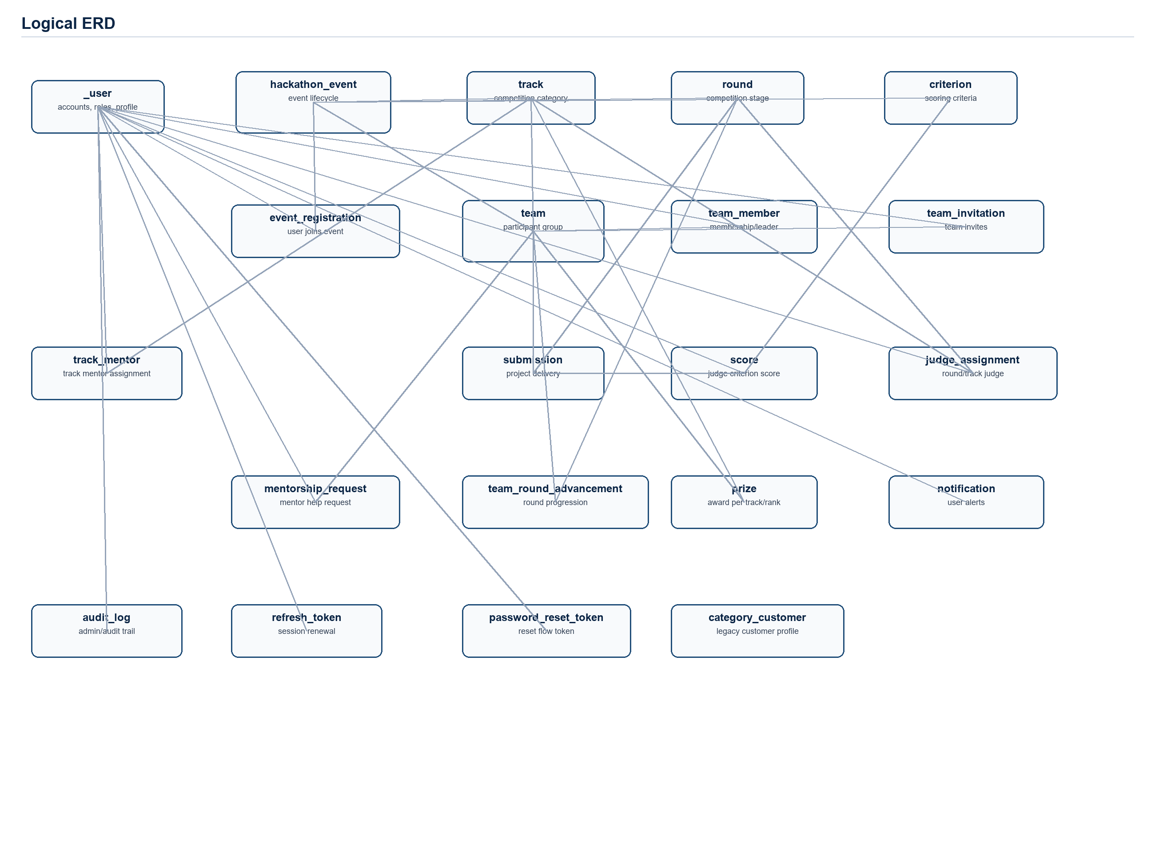
Figure 2. Logical ERD.

5.2 Data dictionary
Entity | Attribute | Type | Length / Range | Constraint / Notes
_user | id | BIGINT | as defined by type | PK; identity
_user | username | NVARCHAR | 255 | not null; unique
_user | password | NVARCHAR | 255 | not null
_user | email | NVARCHAR | 255 | not null; unique
_user | role | NVARCHAR | 50 | nullable / no explicit constraint
_user | fpt_student_id | NVARCHAR | 255 | nullable / no explicit constraint
_user | school_name | NVARCHAR | 255 | nullable / no explicit constraint
_user | approved | BIT | as defined by type | default 0
_user | is_verified | BIT | as defined by type | default 0
_user | otp_code | VARCHAR | 10 | nullable / no explicit constraint
_user | otp_expiry | DATETIME | as defined by type | nullable / no explicit constraint
_user | skills | NVARCHAR | MAX | nullable / no explicit constraint
_user | github_url | NVARCHAR | 255 | nullable / no explicit constraint
_user | full_name | NVARCHAR | 255 | nullable / no explicit constraint
_user | phone | NVARCHAR | 50 | nullable / no explicit constraint
_user | bio | NVARCHAR | MAX | nullable / no explicit constraint
_user | avatar_url | NVARCHAR | 255 | nullable / no explicit constraint
_user | is_temporary | BIT | as defined by type | not null; default 0
audit_log | id | BIGINT | as defined by type | PK; identity
audit_log | user_id | BIGINT | as defined by type | FK -> _user.id
audit_log | action | NVARCHAR | 255 | not null
audit_log | details | NVARCHAR | MAX | nullable / no explicit constraint
audit_log | created_at | DATETIME | as defined by type | default GETDATE()
audit_log | entity_type | NVARCHAR | 255 | nullable / no explicit constraint
audit_log | entity_id | BIGINT | as defined by type | nullable / no explicit constraint
audit_log | old_value | NVARCHAR | MAX | nullable / no explicit constraint
audit_log | new_value | NVARCHAR | MAX | nullable / no explicit constraint
category_customer | id | BIGINT | as defined by type | PK; identity; from JPA entity
category_customer | date_of_birth | DATE | as defined by type | not null; from JPA entity
category_customer | modified_date | DATE | as defined by type | not null; from JPA entity
category_customer | address | NVARCHAR | 255 | not null; from JPA entity
category_customer | code | NVARCHAR | 255 | not null; unique; from JPA entity
category_customer | email | NVARCHAR | 255 | not null; email validation in DTO; from JPA entity
category_customer | identification | NVARCHAR | 255 | not null; from JPA entity
category_customer | name | NVARCHAR | 255 | not null; from JPA entity
category_customer | phone | NVARCHAR | 255 | not null; from JPA entity
category_customer | zip_code | NVARCHAR | 255 | not null; from JPA entity
criterion | id | BIGINT | as defined by type | PK; identity
criterion | name | NVARCHAR | 255 | not null
criterion | description | NVARCHAR | MAX | nullable / no explicit constraint
criterion | max_score | INT | as defined by type | not null
criterion | weight | INT | as defined by type | not null; default 1
criterion | hackathon_event_id | BIGINT | as defined by type | FK -> hackathon_event.id
event_registration | id | BIGINT | as defined by type | PK; identity
event_registration | event_id | BIGINT | as defined by type | not null; FK -> hackathon_event.id; unique group: event_id, user_id
event_registration | user_id | BIGINT | as defined by type | not null; FK -> _user.id; unique group: event_id, user_id
event_registration | status | NVARCHAR | 50 | default 'REGISTERED'
event_registration | registered_at | DATETIME | as defined by type | default GETDATE()
hackathon_event | id | BIGINT | as defined by type | PK; identity
hackathon_event | name | NVARCHAR | 255 | not null
hackathon_event | slug | NVARCHAR | 255 | not null; unique
hackathon_event | description | NVARCHAR | MAX | nullable / no explicit constraint
hackathon_event | status | NVARCHAR | 50 | not null; default 'DRAFT'
hackathon_event | registration_start | DATETIME | as defined by type | nullable / no explicit constraint
hackathon_event | registration_end | DATETIME | as defined by type | nullable / no explicit constraint
hackathon_event | start_time | DATETIME | as defined by type | not null
hackathon_event | max_team_size | INT | as defined by type | default 5
hackathon_event | min_team_size | INT | as defined by type | default 2
hackathon_event | rules | NVARCHAR | MAX | nullable / no explicit constraint
hackathon_event | image_url | NVARCHAR | 255 | nullable / no explicit constraint
hackathon_event | organizer_id | BIGINT | as defined by type | FK -> _user.id
hackathon_event | created_at | DATETIME | as defined by type | default GETDATE()
hackathon_event | updated_at | DATETIME | as defined by type | default GETDATE()
hackathon_event | is_deleted | BIT | as defined by type | default 0
judge_assignment | id | BIGINT | as defined by type | PK; identity
judge_assignment | judge_id | BIGINT | as defined by type | not null; FK -> _user.id; unique group: judge_id, round_id, track_id
judge_assignment | round_id | BIGINT | as defined by type | not null; FK -> round.id; unique group: judge_id, round_id, track_id
judge_assignment | track_id | BIGINT | as defined by type | FK -> track.id; unique group: judge_id, round_id, track_id
judge_assignment | assigned_by_organizer_id | BIGINT | as defined by type | FK -> _user.id
judge_assignment | status | NVARCHAR | 50 | default 'ASSIGNED'
judge_assignment | assigned_at | DATETIME | as defined by type | default GETDATE()
mentorship_request | id | BIGINT | as defined by type | PK; identity
mentorship_request | team_id | BIGINT | as defined by type | not null; FK -> team.id
mentorship_request | mentor_id | BIGINT | as defined by type | FK -> _user.id
mentorship_request | title | NVARCHAR | 255 | not null
mentorship_request | description | NVARCHAR | MAX | nullable / no explicit constraint
mentorship_request | status | NVARCHAR | 50 | default 'OPEN'
mentorship_request | created_at | DATETIME | as defined by type | default GETDATE()
mentorship_request | resolved_at | DATETIME | as defined by type | nullable / no explicit constraint
notification | id | BIGINT | as defined by type | PK; identity
notification | user_id | BIGINT | as defined by type | not null; FK -> _user.id
notification | title | NVARCHAR | 255 | not null
notification | message | NVARCHAR | MAX | nullable / no explicit constraint
notification | is_read | BIT | as defined by type | default 0
notification | type | NVARCHAR | 255 | not null; default 'INFO'
notification | reference_type | NVARCHAR | 255 | nullable / no explicit constraint
notification | reference_id | BIGINT | as defined by type | nullable / no explicit constraint
notification | created_at | DATETIME | as defined by type | default GETDATE()
password_reset_token | id | BIGINT | as defined by type | PK; identity
password_reset_token | token | NVARCHAR | 255 | not null; unique
password_reset_token | user_id | BIGINT | as defined by type | not null; FK -> _user.id
password_reset_token | expiry_date | DATETIME | as defined by type | not null
password_reset_token | created_at | DATETIME | as defined by type | default GETDATE()
prize | id | BIGINT | as defined by type | PK; identity
prize | name | NVARCHAR | 255 | not null
prize | description | NVARCHAR | MAX | nullable / no explicit constraint
prize | hackathon_event_id | BIGINT | as defined by type | not null; FK -> hackathon_event.id
prize | track_id | BIGINT | as defined by type | FK -> track.id
prize | winning_team_id | BIGINT | as defined by type | FK -> team.id
prize | rank | INT | as defined by type | nullable / no explicit constraint
refresh_token | id | BIGINT | as defined by type | PK; identity
refresh_token | token | NVARCHAR | 255 | not null; unique
refresh_token | user_id | BIGINT | as defined by type | not null; FK -> _user.id
refresh_token | expiry_date | DATETIME | as defined by type | not null
refresh_token | created_at | DATETIME | as defined by type | default GETDATE()
round | id | BIGINT | as defined by type | PK; identity
round | name | NVARCHAR | 255 | not null
round | description | NVARCHAR | MAX | nullable / no explicit constraint
round | start_time | DATETIME | as defined by type | not null
round | hackathon_event_id | BIGINT | as defined by type | FK -> hackathon_event.id
round | submission_deadline | DATETIME | as defined by type | nullable / no explicit constraint
round | advancement_slots | INT | as defined by type | nullable / no explicit constraint
round | round_order | INT | as defined by type | not null; default 1
score | id | BIGINT | as defined by type | PK; identity
score | judge_id | BIGINT | as defined by type | not null; FK -> _user.id; unique group: judge_id, submission_id, criterion_id
score | submission_id | BIGINT | as defined by type | not null; FK -> submission.id; unique group: judge_id, submission_id, criterion_id
score | criterion_id | BIGINT | as defined by type | not null; FK -> criterion.id; unique group: judge_id, submission_id, criterion_id
score | score_value | INT | as defined by type | not null
score | comment | NVARCHAR | MAX | nullable / no explicit constraint
score | scored_at | DATETIME | as defined by type | default GETDATE()
score | is_finalized | BIT | as defined by type | not null; default 0
submission | id | BIGINT | as defined by type | PK; identity
submission | team_id | BIGINT | as defined by type | not null; FK -> team.id
submission | round_id | BIGINT | as defined by type | not null; FK -> round.id
submission | repository_url | NVARCHAR | 255 | nullable / no explicit constraint
submission | demo_url | NVARCHAR | 255 | nullable / no explicit constraint
submission | report_url | NVARCHAR | 255 | nullable / no explicit constraint
submission | version | INT | as defined by type | default 1
submission | submitted_at | DATETIME | as defined by type | default GETDATE()
team | id | BIGINT | as defined by type | PK; identity
team | name | NVARCHAR | 255 | not null; unique group: name, event_id
team | project_name | NVARCHAR | 255 | nullable / no explicit constraint
team | project_description | NVARCHAR | MAX | nullable / no explicit constraint
team | track_id | BIGINT | as defined by type | FK -> track.id
team | event_id | BIGINT | as defined by type | not null; FK -> hackathon_event.id; unique group: name, event_id
team | status | NVARCHAR | 50 | default 'ACTIVE'
team | created_at | DATETIME | as defined by type | default GETDATE()
team | disqualification_reason | NVARCHAR | MAX | nullable / no explicit constraint
team | disqualified_at | DATETIME | as defined by type | nullable / no explicit constraint
team | disqualified_by | BIGINT | as defined by type | FK -> _user.id
team | final_score | DECIMAL | 5,2 | default NULL
team_invitation | id | BIGINT | as defined by type | PK; identity
team_invitation | team_id | BIGINT | as defined by type | not null; FK -> team.id
team_invitation | inviter_id | BIGINT | as defined by type | not null; FK -> _user.id
team_invitation | invitee_email | NVARCHAR | 255 | not null
team_invitation | status | NVARCHAR | 50 | default 'PENDING'
team_invitation | created_at | DATETIME | as defined by type | default GETDATE()
team_invitation | expires_at | DATETIME | as defined by type | nullable / no explicit constraint
team_member | id | BIGINT | as defined by type | PK; identity
team_member | team_id | BIGINT | as defined by type | not null; FK -> team.id
team_member | user_id | BIGINT | as defined by type | not null; FK -> _user.id
team_member | is_leader | BIT | as defined by type | default 0
team_round_advancement | id | BIGINT | as defined by type | PK; identity
team_round_advancement | team_id | BIGINT | as defined by type | not null; FK -> team.id; unique group: team_id, from_round_id, to_round_id
team_round_advancement | from_round_id | BIGINT | as defined by type | not null; FK -> round.id; unique group: team_id, from_round_id, to_round_id
team_round_advancement | to_round_id | BIGINT | as defined by type | not null; FK -> round.id; unique group: team_id, from_round_id, to_round_id
team_round_advancement | advanced_by | BIGINT | as defined by type | not null; FK -> _user.id
team_round_advancement | advanced_at | DATETIME | as defined by type | not null; default GETDATE()
track | id | BIGINT | as defined by type | PK; identity
track | name | NVARCHAR | 255 | not null
track | description | NVARCHAR | MAX | nullable / no explicit constraint
track | hackathon_event_id | BIGINT | as defined by type | FK -> hackathon_event.id
track_mentor | id | BIGINT | as defined by type | PK; identity
track_mentor | track_id | BIGINT | as defined by type | not null; FK -> track.id; unique group: track_id, user_id
track_mentor | user_id | BIGINT | as defined by type | not null; FK -> _user.id; unique group: track_id, user_id
track_mentor | event_id | BIGINT | as defined by type | not null; FK -> hackathon_event.id
track_mentor | assigned_by | BIGINT | as defined by type | FK -> _user.id
track_mentor | assigned_at | DATETIME | as defined by type | not null; default GETDATE()

5.3 Data integrity, retention, and privacy
- Integrity: SQL primary keys, foreign keys, unique constraints, and service-layer validation enforce identity, event/team membership, assignment, score, advancement, and prize consistency.
- Integrity: database.sql defines unique constraints for user username/email, event slug, event registration per event/user, team name per event, track mentor per track/user, judge assignment per judge/round/track, score per judge/submission/criterion, and team advancement per team/from/to round.
- Retention: events are soft-deleted with is_deleted; users are deactivated with isActive in the entity/service; other domain records are retained unless explicitly deleted by service workflows. Assumption: no complete legal retention schedule is implemented.
- Privacy: passwords are BCrypt-hashed; JWTs contain username and role claim; profile, student ID, email, phone, GitHub URL, and category customer data are PII and should be protected by access control.
- Privacy: CSV exports may contain participant PII; export endpoints are restricted to ADMIN/ORGANIZER roles.
- Assumption: production deployments shall move secrets out of application.properties and enforce HTTPS for transport confidentiality.

6. Non-Functional Requirements
The backend contains some quality mechanisms directly, such as stateless JWT, role authorization, BCrypt, async notification processing, and retry. Quantitative targets below are measurable project requirements; where no code enforces a value today, the source is marked as an assumption.

6.1 Performance
ID | NFR-PERF-01
Quality attribute | Performance
Scale (what we measure) | API response time for normal JSON endpoints
Meter (how we measure) | Measure p95 latency under 100 concurrent users against representative auth, event, team, submission, and scoring workflows.
Target (desired) | p95 <= 2 seconds
Must-level (minimum) | p95 <= 5 seconds

6.2 Security
ID | NFR-SEC-01
Quality attribute | Security
Scale (what we measure) | Unauthorized access attempts to protected endpoints
Meter (how we measure) | Automated security tests shall exercise public, authenticated, and role-protected endpoints.
Target (desired) | 100% protected endpoints require valid JWT and proper role.
Must-level (minimum) | No protected business endpoint is accessible without authentication or required role.

6.3 Usability
ID | NFR-USE-01
Quality attribute | Usability
Scale (what we measure) | Completion rate for core participant workflow
Meter (how we measure) | Prototype/user test: register, verify, register event, create/finalize team, submit project.
Target (desired) | >= 90% first-time users complete without assistance within 15 minutes.
Must-level (minimum) | >= 75% complete without assistance within 25 minutes.

6.4 Reliability and availability
ID | NFR-REL-01
Quality attribute | Reliability and availability
Scale (what we measure) | Successful notification delivery or durable persistence
Meter (how we measure) | Observe notification creation plus async retry logs for completion notifications.
Target (desired) | >= 99% notifications persisted; retry attempts recover transient delivery failures within 3 attempts.
Must-level (minimum) | Notifications are persisted even when SSE recipient is offline.

6.5 Maintainability
ID | NFR-MAINT-01
Quality attribute | Maintainability
Scale (what we measure) | Requirement-to-code traceability coverage
Meter (how we measure) | Traceability matrix review against controllers/services/entities.
Target (desired) | 100% high-priority FRs map to source classes and at least one endpoint or workflow.
Must-level (minimum) | All implemented public backend features appear in Section 4 or Appendix C.

6.6 Portability
ID | NFR-PORT-01
Quality attribute | Portability
Scale (what we measure) | Environment setup reproducibility
Meter (how we measure) | Run backend with documented Java, Maven, SQL Server, and property configuration.
Target (desired) | Setup succeeds on Windows developer machine and one CI/Linux-equivalent environment with externalized secrets.
Must-level (minimum) | Setup succeeds on Windows developer machine with Java 21 and SQL Server.

7. Business Rules
Business rules are extracted from service logic, validation annotations, status enums, SQL constraints, and security annotations.
ID | Type | Rule statement | Linked FR(s)
BR-01 | Constraint | Only verified and approved accounts are enabled for login and authenticated API use. | FR-AUTH-02, FR-AUTH-03, FR-USER-01
BR-02 | Constraint | Username, email, and nonblank FPT student ID must be unique. | FR-AUTH-01, FR-USER-02, FR-USER-05
BR-03 | Constraint | Registration and password reset OTP codes are six digits and expire after five minutes. | FR-AUTH-02, FR-AUTH-05
BR-04 | Constraint | Guest judges are temporary, auto-approved accounts and cannot be assigned as mentors. | FR-AUTH-06, FR-CONFIG-02, FR-JUDGE-01
BR-05 | Constraint | Valid event lifecycle transitions are DRAFT -> PUBLISHED -> IN_PROGRESS -> COMPLETED, with CANCELLED as a terminal path from non-terminal states. | FR-EVENT-05
BR-06 | Constraint | Publishing an event requires registration start/end values and registration end after registration start. | FR-EVENT-05
BR-07 | Constraint | Event end must be after start; registration must end before event start; min team size cannot exceed max team size. | FR-EVENT-01, FR-EVENT-04
BR-08 | Action Enabler | Only the event organizer or an admin can update status, update details, or delete the event. | FR-EVENT-04, FR-EVENT-05, FR-EVENT-06
BR-09 | Constraint | Participants can register for an event only when it is PUBLISHED and inside the registration window. | FR-REG-01
BR-10 | Constraint | A participant can belong to only one team per hackathon event. | FR-TEAM-01, FR-MEMBER-01, FR-INV-02
BR-11 | Constraint | Team membership modifications and invitations are allowed only during the PUBLISHED registration phase. | FR-MEMBER-01, FR-MEMBER-02, FR-MEMBER-03, FR-INV-01, FR-INV-02
BR-12 | Constraint | Finalized teams must respect event min/max team size; finalized teams cannot be deleted and cannot fall below min size except admin force cases implemented for some actions. | FR-TEAM-04, FR-TEAM-06, FR-MEMBER-01, FR-MEMBER-02
BR-13 | Action Enabler | Only team leaders can finalize teams, invite members, submit projects, request mentorship, and transfer leadership. | FR-TEAM-04, FR-INV-01, FR-SUB-01, FR-MENTOR-01, FR-MEMBER-03
BR-14 | Constraint | Submissions require a finalized, non-disqualified team, minimum team size, leader ownership, and an active round submission window. | FR-SUB-01
BR-15 | Constraint | Judges must be assigned to the round or track to view/score submissions, and a user mentoring a track cannot judge the same track. | FR-JUDGE-01, FR-SUB-02, FR-SCORE-01
BR-16 | Constraint | Scores must be between zero and the criterion max score; criteria weights per event may not exceed 100 percent and cannot be modified after scoring starts. | FR-CONFIG-04, FR-SCORE-01
BR-17 | Constraint | Scores cannot be changed after finalization or after teams have advanced from the round. | FR-SCORE-01, FR-SCORE-02, FR-ADV-01
BR-18 | Computation | Rankings use only finalized scores, exclude disqualified teams, compute each judge's weighted average, average across judges, and rank within each track. | FR-RANK-01
BR-19 | Constraint | Round advancement can occur only after the round ends, only once per source round, and only for eligible non-disqualified ranked teams up to the slot limit per track. | FR-ADV-01
BR-20 | Constraint | Prizes must have unique rank per event/track, match the winning team's track, and a team may receive only one prize in an event. | FR-PRIZE-01, FR-PRIZE-02
BR-21 | Constraint | Users may mark only their own notifications as read. | FR-NOTIF-01
BR-22 | Constraint | Audit-log review endpoints are restricted to ADMIN users. | FR-AUDIT-01
BR-23 | Constraint | CategoryCustomer codes must be unique. | FR-CAT-01

8. Other Models and Diagrams
This section summarizes the analysis models. Full-size copies are included in Appendix B.

8.1 Context diagram

Figure 3. Backend system context.
The system is centered on a Spring Boot backend consumed by a frontend SPA. It persists to SQL Server and integrates with Gmail SMTP and Google OAuth2.

8.2 Use case diagram
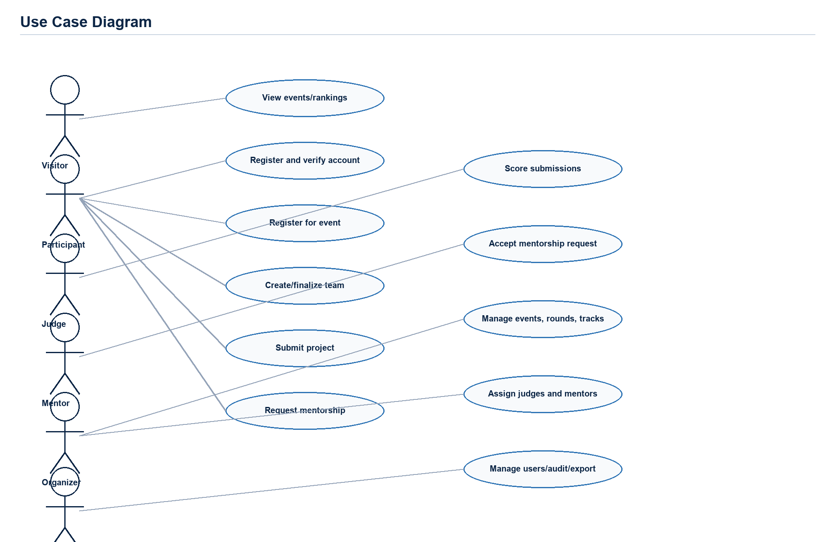
Figure 4. Actor/use case overview.
The major actors are visitor, participant/team leader, judge, guest judge, mentor, organizer, and admin. Use cases align to the implemented controller modules.

8.3 Sequence / activity diagram (key flow)
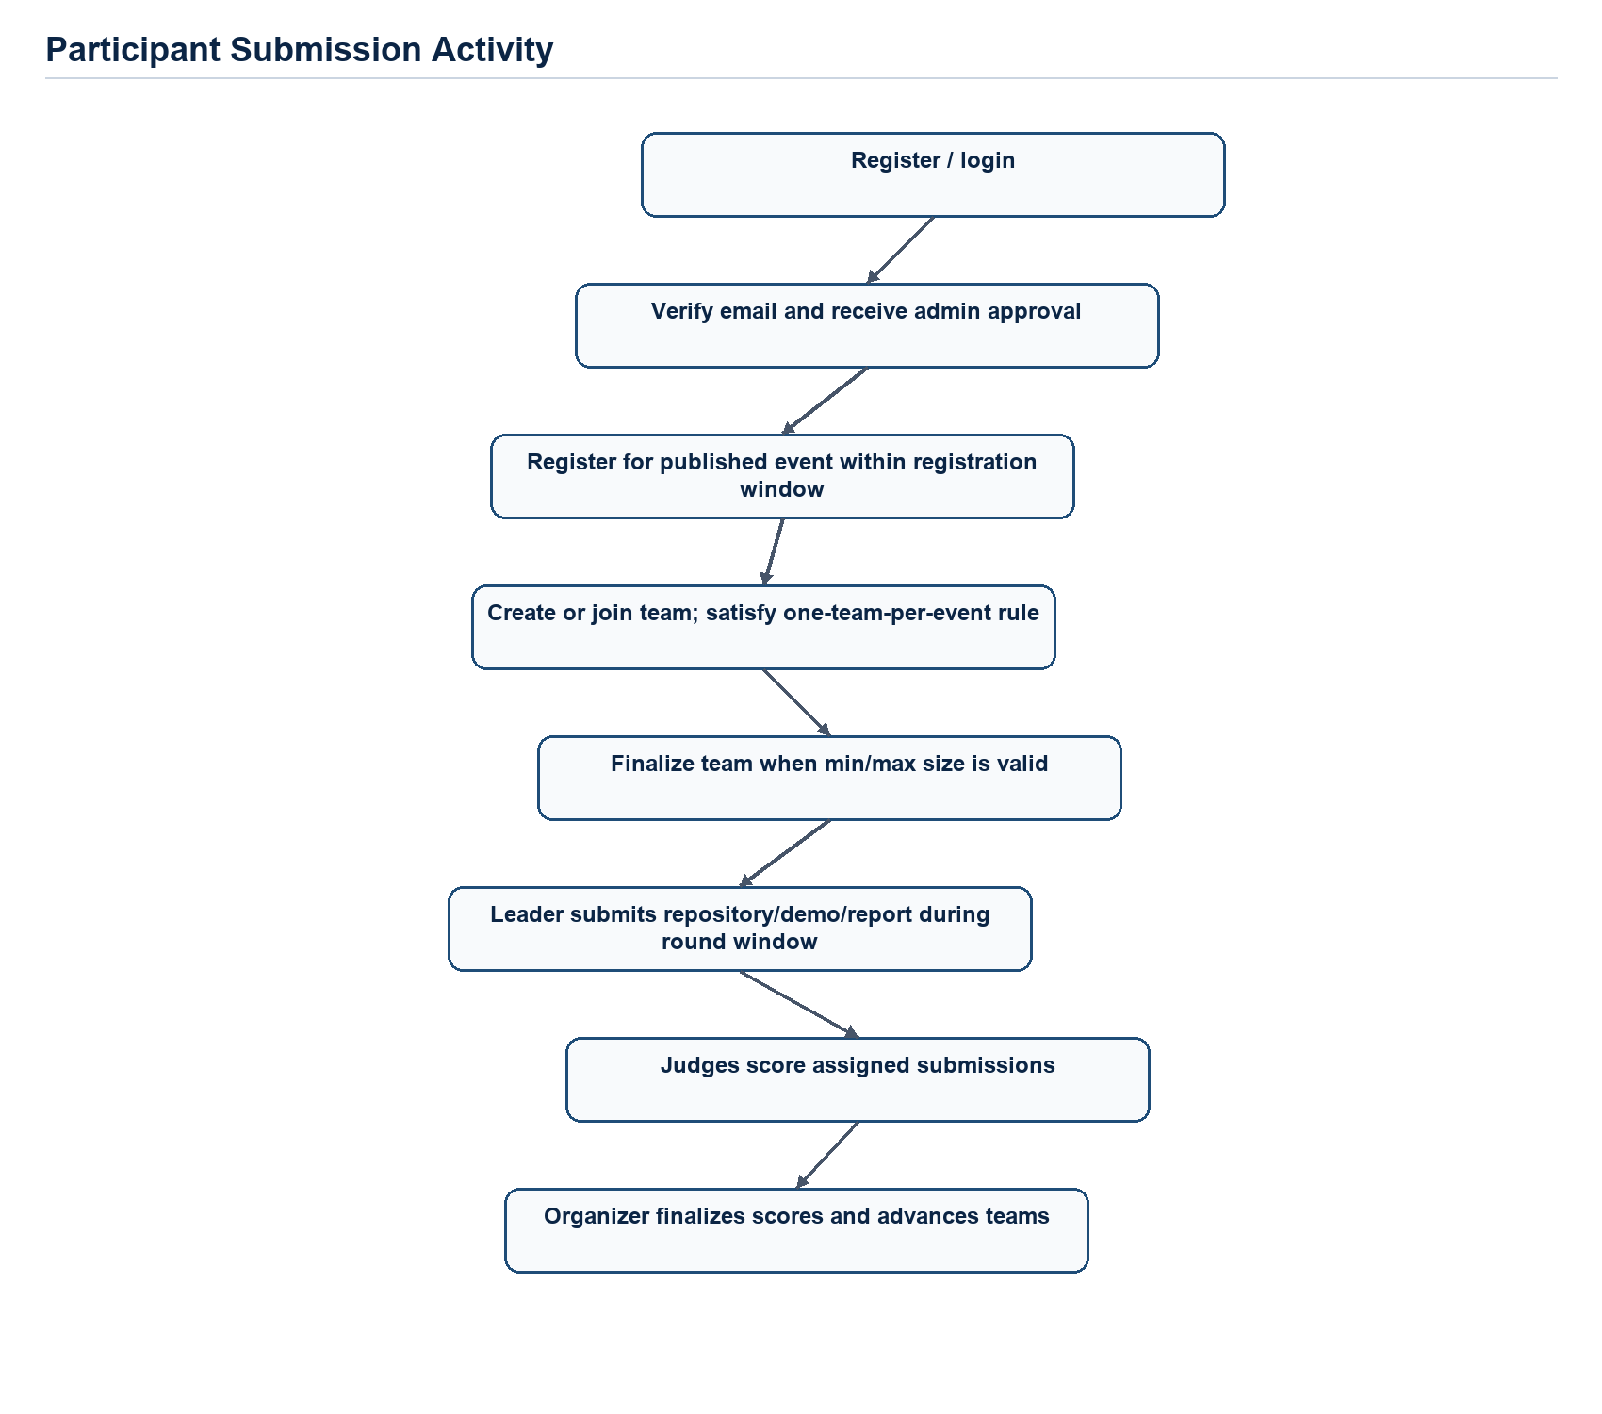
Figure 5. Participant submission and evaluation activity.
The key participant flow moves from registration and approval through team finalization and submission, then into judge scoring and organizer advancement.

8.4 State diagram (if applicable)
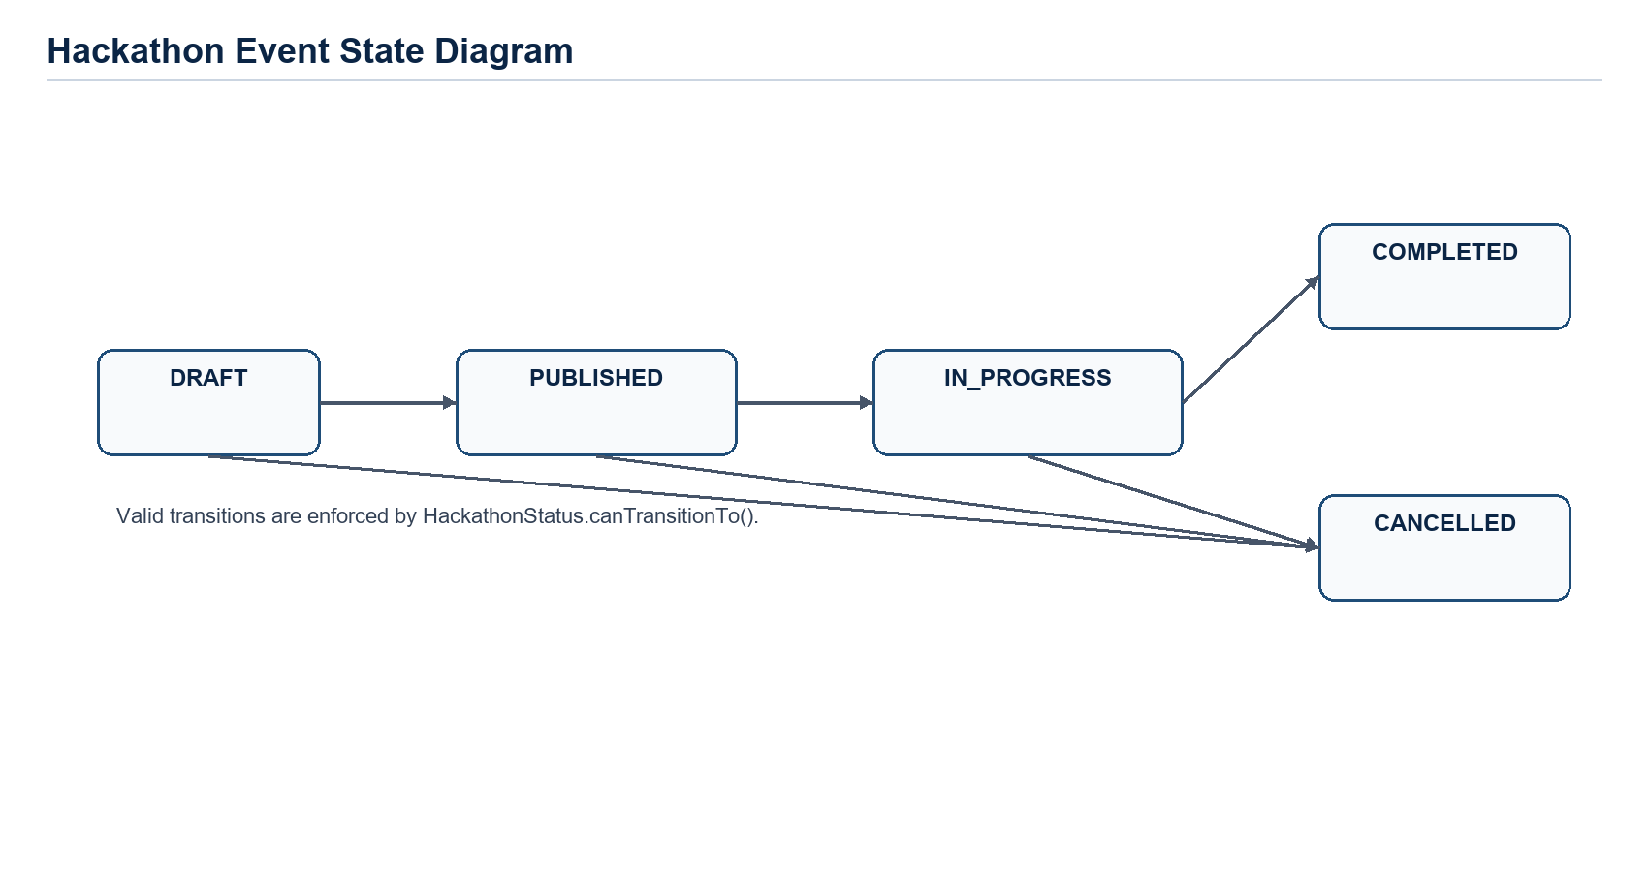
Figure 6. Hackathon event lifecycle state diagram.
The lifecycle is implemented by HackathonStatus and enforced by updateHackathonEventStatus. COMPLETED and CANCELLED are terminal states.

8.5 Component diagram
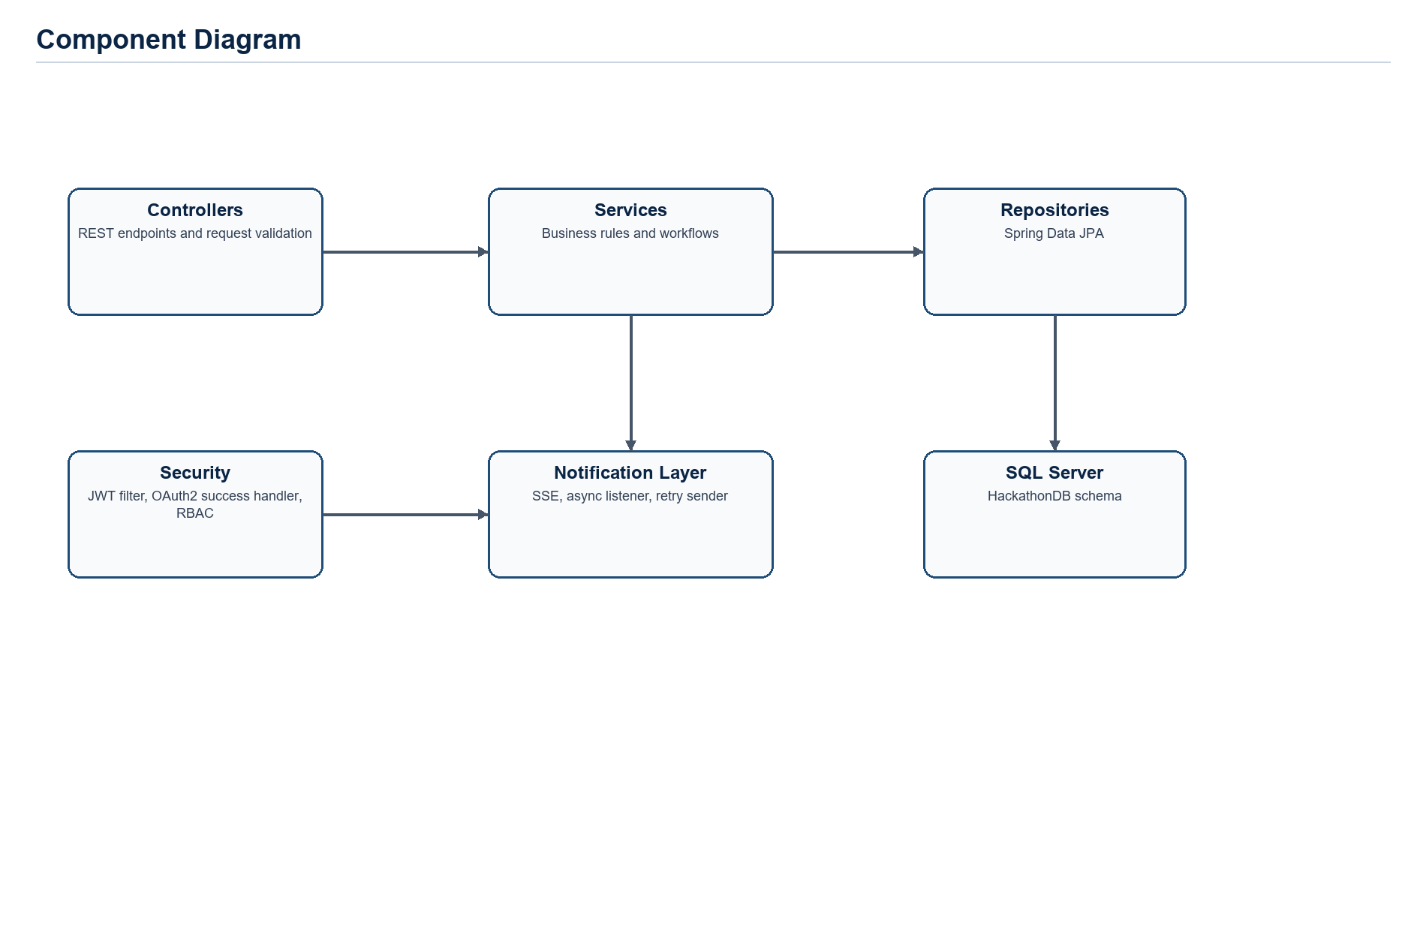
Figure 7. Component diagram.

8.6 Deployment diagram
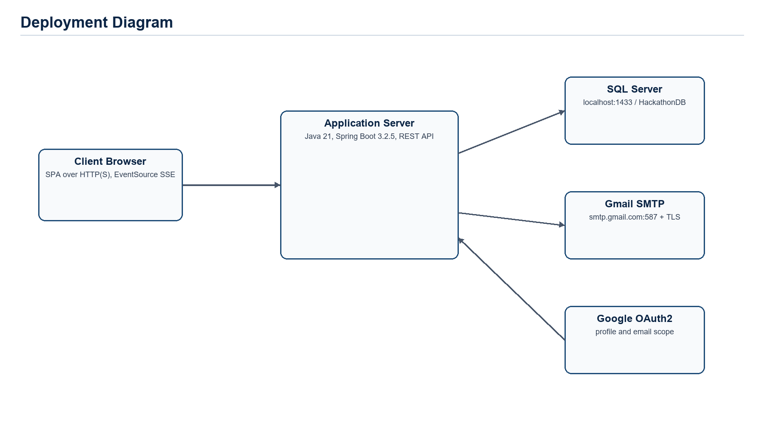
Figure 8. Deployment diagram.

9. Prioritization and Traceability

9.1 Prioritization (MoSCoW)
Bucket | Requirements (IDs) | Justification
Must have | FR-AUTH-01, FR-AUTH-02, FR-AUTH-03, FR-AUTH-04, FR-AUTH-05, FR-USER-01, FR-USER-05, FR-USER-06, FR-EVENT-01, FR-EVENT-02, FR-EVENT-04, FR-EVENT-05, FR-CONFIG-01, FR-CONFIG-03, FR-CONFIG-04, FR-REG-01, FR-TEAM-01, FR-TEAM-04, FR-TEAM-05, FR-MEMBER-01, FR-INV-01, FR-INV-02, FR-SUB-01, FR-SUB-02, FR-JUDGE-01, FR-SCORE-01, FR-SCORE-02, FR-RANK-01, FR-ADV-01, FR-NOTIF-01, FR-AUDIT-01 | Core account, event, team, submission, judging, ranking, notification, and audit workflows required for a working hackathon platform.
Should have | FR-AUTH-06, FR-AUTH-07, FR-USER-02, FR-USER-03, FR-USER-04, FR-EVENT-03, FR-EVENT-06, FR-CONFIG-02, FR-TEAM-02, FR-TEAM-03, FR-MEMBER-02, FR-MEMBER-03, FR-INV-03, FR-PRIZE-01, FR-PRIZE-02, FR-MENTOR-01, FR-MENTOR-02, FR-NOTIF-02, FR-DASH-01, FR-EXPORT-01 | Important operational features such as guest judges, exports, mentorship management, dashboards, prizes, and OAuth2 that improve completeness.
Could have | FR-TEAM-06, FR-CAT-01 | Implemented but lower-priority supporting or legacy features.
Won't have (this release) | Payments, hardware check-in, native mobile app, binary uploads, chat/video, full data-erasure workflow | No backend implementation found for these features.

9.2 Traceability matrix
BR ID | FR ID | FR title | Priority | Test case ID
BR-01 | FR-AUTH-02 | Email OTP verification | High | TC-AUTH-02
BR-01 | FR-AUTH-03 | Login and token issuance | High | TC-AUTH-03
BR-01 | FR-USER-01 | Approve pending users | High | TC-USER-01
BR-02 | FR-AUTH-01 | Participant self-registration | High | TC-AUTH-01
BR-02 | FR-USER-02 | Administrative user creation | Medium | TC-USER-02
BR-02 | FR-USER-05 | Profile retrieval and update | High | TC-USER-05
BR-03 | FR-AUTH-02 | Email OTP verification | High | TC-AUTH-02
BR-03 | FR-AUTH-05 | Password reset by email OTP | High | TC-AUTH-05
BR-04 | FR-AUTH-06 | Guest judge account creation | Medium | TC-AUTH-06
BR-04 | FR-CONFIG-02 | Assign mentors to tracks | Medium | TC-CONFIG-02
BR-04 | FR-JUDGE-01 | Assign judges | High | TC-JUDGE-01
BR-05 | FR-EVENT-05 | Manage event lifecycle status | High | TC-EVENT-05
BR-06 | FR-EVENT-05 | Manage event lifecycle status | High | TC-EVENT-05
BR-07 | FR-EVENT-01 | Create hackathon events | High | TC-EVENT-01
BR-07 | FR-EVENT-04 | Update hackathon event details | High | TC-EVENT-04
BR-08 | FR-EVENT-04 | Update hackathon event details | High | TC-EVENT-04
BR-08 | FR-EVENT-05 | Manage event lifecycle status | High | TC-EVENT-05
BR-08 | FR-EVENT-06 | Soft-delete events | Medium | TC-EVENT-06
BR-09 | FR-REG-01 | Register for event | High | TC-REG-01
BR-10 | FR-TEAM-01 | Create team | High | TC-TEAM-01
BR-10 | FR-MEMBER-01 | Add and remove team members | High | TC-MEMBER-01
BR-10 | FR-INV-02 | Respond to team invitation | High | TC-INV-02
BR-11 | FR-MEMBER-01 | Add and remove team members | High | TC-MEMBER-01
BR-11 | FR-MEMBER-02 | Kick or leave team | Medium | TC-MEMBER-02
BR-11 | FR-MEMBER-03 | Transfer team leadership | Medium | TC-MEMBER-03
BR-12 | FR-TEAM-04 | Finalize team | High | TC-TEAM-04
BR-12 | FR-TEAM-06 | Delete non-finalized team | Low | TC-TEAM-06
BR-12 | FR-MEMBER-01 | Add and remove team members | High | TC-MEMBER-01
BR-13 | FR-TEAM-04 | Finalize team | High | TC-TEAM-04
BR-13 | FR-INV-01 | Invite team member | High | TC-INV-01
BR-13 | FR-SUB-01 | Submit or update project | High | TC-SUB-01
BR-14 | FR-SUB-01 | Submit or update project | High | TC-SUB-01
BR-15 | FR-JUDGE-01 | Assign judges | High | TC-JUDGE-01
BR-15 | FR-SUB-02 | View submissions with role restrictions | High | TC-SUB-02
BR-15 | FR-SCORE-01 | Save and update scores | High | TC-SCORE-01
BR-16 | FR-CONFIG-04 | Manage scoring criteria | High | TC-CONFIG-04
BR-16 | FR-SCORE-01 | Save and update scores | High | TC-SCORE-01
BR-17 | FR-SCORE-01 | Save and update scores | High | TC-SCORE-01
BR-17 | FR-SCORE-02 | Finalize scores | High | TC-SCORE-02
BR-17 | FR-ADV-01 | Advance teams between rounds | High | TC-ADV-01
BR-18 | FR-RANK-01 | Compute rankings | High | TC-RANK-01
BR-19 | FR-ADV-01 | Advance teams between rounds | High | TC-ADV-01
BR-20 | FR-PRIZE-01 | Manage prizes | Medium | TC-PRIZE-01
BR-20 | FR-PRIZE-02 | Assign prizes to teams | Medium | TC-PRIZE-02
BR-21 | FR-NOTIF-01 | Manage notifications | High | TC-NOTIF-01
BR-22 | FR-AUDIT-01 | Audit logging and review | High | TC-AUDIT-01
BR-23 | FR-CAT-01 | Category customer maintenance | Low | TC-CAT-01

Endpoint/entity traceability details are provided below to satisfy BR -> FR -> API Endpoint -> Entity -> Test Case traceability.
FR ID | API endpoint(s) | Primary entity/entity set | Source class | Test case ID
FR-AUTH-01 | /api/v1/auth/register | _user | AuthController; AuthServiceImpl.register; RegisterRequest | TC-AUTH-01
FR-AUTH-03 | /api/v1/auth/login | _user, refresh_token | AuthServiceImpl.login; JwtTokenProvider; RefreshTokenService | TC-AUTH-03
FR-EVENT-01 | /api/v1/hackathon-events | hackathon_event, criterion | HackathonEventController.create; HackathonEventServiceImpl.createHackathonEvent | TC-EVENT-01
FR-REG-01 | /api/v1/event-registrations | event_registration | EventRegistrationController; EventRegistrationService | TC-REG-01
FR-TEAM-01 | /api/v1/teams | team, team_member | TeamController.create; TeamServiceImpl.createTeam | TC-TEAM-01
FR-INV-02 | /api/v1/team-invitations/{id}/respond | team_invitation, team_member | TeamInvitationService.respondToInvitation | TC-INV-02
FR-SUB-01 | /api/v1/submissions | submission | SubmissionController; SubmissionServiceImpl.createSubmission | TC-SUB-01
FR-JUDGE-01 | /api/v1/judge-assignments | judge_assignment, track_mentor | JudgeAssignmentController; JudgeAssignmentService | TC-JUDGE-01
FR-SCORE-01 | /api/v1/scores | score, submission, criterion | ScoreController; ScoreServiceImpl | TC-SCORE-01
FR-RANK-01 | /api/v1/rankings/round/{roundId} | score, submission, team | RankingController; RankingService | TC-RANK-01
FR-ADV-01 | /api/v1/rounds/{id}/advance | team_round_advancement, round, team | RoundAdvancementController; RoundAdvancementService | TC-ADV-01
FR-PRIZE-02 | /api/v1/prizes/{id}/assign; /api/v1/prizes/event/{eventId}/auto-assign | prize, team | PrizeServiceImpl.assignPrizeToTeam; autoAssignPrizes | TC-PRIZE-02
FR-MENTOR-02 | /api/v1/mentorship-requests/{id}/accept|resolve|reject | mentorship_request | MentorshipRequestController; MentorshipRequestService | TC-MENTOR-02
FR-NOTIF-01 | /api/v1/notifications | notification | NotificationController; NotificationService | TC-NOTIF-01
FR-EXPORT-01 | /api/v1/export/* | round, score, team, _user | ExportController; ExportService | TC-EXPORT-01
FR-AUDIT-01 | /api/v1/audit-logs | audit_log | AuditLogController; AuditLogServiceImpl | TC-AUDIT-01

10. Validation and Change Management

10.1 Validation plan
Feature area | Validation technique | Evidence / expected result
Authentication and authorization | Automated API tests and role matrix review | Public endpoints accessible; protected endpoints reject unauthenticated or wrong-role users.
Event lifecycle | State-transition tests | Only valid transitions accepted; publish/start/complete side effects occur.
Team workflows | Acceptance tests from FR criteria | One-team rule, team size, invitation, finalization, and disqualification rules hold.
Submission/scoring/ranking | Integration tests with seeded data | Submissions are versioned; assigned judges score; rankings match weighted computation.
Notifications | SSE/manual tests and async retry log review | Stored notifications appear in API; online users receive SSE updates.
Data model | Schema review and referential-integrity tests | SQL FKs/unique constraints and service validation prevent inconsistent data.
SRS review | Peer inspection checklist | Every template section has content, placeholders are removed, and assumptions are listed.

- Inspection: peer review this SRS against the original Word template and backend implementation.
- Prototype testing: validate inferred UI screens with frontend workflows once wireframes are available.
- Acceptance testing: convert each FR's Given/When/Then criteria into API or UI test cases.

10.2 Change management process
Change requests shall follow Wiegers' seven-step impact analysis: understand the change, check feasibility, identify affected components, estimate effort, assess risk, obtain change-control approval, and update the SRS plus traceability matrix. Each accepted change must identify affected FRs, BRs, endpoints, entities, tests, and diagrams.

10.3 Change log
CR ID | Date | Change requested | Decision | Impact / affected items
CR-000 | 02 / 07 / 2026 | Complete SRS template from backend implementation. | Accepted | All sections, FRs, BRs, data dictionary, diagrams, traceability, and assumptions.
CR-001 | Pending | Confirm team name, members, instructor, and frontend wireframes. | Open | Cover page metadata, UI section, Appendix B personas/wireframes.

Appendix A - Glossary
Term | Definition
Advancement | Moving top ranked non-disqualified teams from one round to the next.
API | Application Programming Interface exposed by the Spring Boot backend.
Audit Log | Persistent record of administrative or workflow changes.
BR | Business Rule: domain constraint or computation that influences functional requirements.
DTO | Data Transfer Object used for request and response payloads.
ERD | Entity-Relationship Diagram showing persistent data entities and relationships.
Finalized Team | Team status indicating roster/project readiness and eligibility to submit.
FR | Functional Requirement: behavior the system shall provide.
Guest Judge | Temporary external evaluator account created by an admin or organizer.
JWT | JSON Web Token used as stateless bearer authentication.
MoSCoW | Prioritization method: Must, Should, Could, Won't.
NFR | Non-Functional Requirement: measurable quality requirement.
OTP | One-Time Password used for email verification and password reset.
Ranking | Per-track ordering of teams by finalized weighted average score.
Round | Competition stage within a hackathon event.
SRS | Software Requirements Specification.
SSE | Server-Sent Events, used for one-way real-time notifications.
Track | Competition category inside a hackathon event.

Appendix B - Analysis Models (full-size diagrams)
This appendix includes full-size diagrams referenced in the SRS and personas inferred from backend user classes.

Appendix Figure B-1. Context diagram.

Appendix Figure B-2. Use case diagram.

Appendix Figure B-3. Activity diagram.

Appendix Figure B-4. Hackathon state diagram.

Appendix Figure B-5. Component diagram.

Appendix Figure B-6. Deployment diagram.

Appendix Figure B-7. ERD.

Personas
Persona | Goal | Main system needs
Participant / Team Leader | Join a hackathon and submit a project with teammates. | Registration, team creation, invitations, finalization, submissions, notifications.
Organizer | Run an event from setup to judging and reporting. | Event lifecycle, tracks, rounds, criteria, judge/mentor assignment, dashboards, exports.
Judge / Guest Judge | Evaluate assigned submissions fairly. | Assignment list, submission access, criteria scoring, score update, rankings.
Mentor | Help teams resolve blockers. | Open request queue, accept/resolve/reject requests, notifications.
Admin | Control platform users and audit operations. | Approval, user creation/deactivation, audit logs, system-wide administration.

Appendix C - Issues List
ID | Open issue / question | Raised by | Status
ISS-001 | Team name, member names/student IDs, and instructor name were not present in backend or supplied metadata. | SRS generation | Open
ISS-002 | Frontend wireframes were not available; logical screens were inferred from backend endpoints. | SRS generation | Open
ISS-003 | Production hosting, HTTPS certificate, domain, and performance sizing are not specified in backend configuration. | SRS generation | Open
ISS-004 | Data retention and privacy-erasure policy is not implemented beyond event soft delete and user deactivation. | SRS generation | Open
ISS-005 | CategoryCustomer module appears to be outside the hackathon core domain and is absent from database.sql; confirm whether it is required for v1.0. | SRS generation | Open

