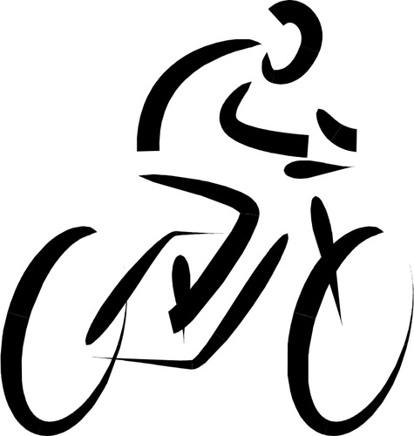

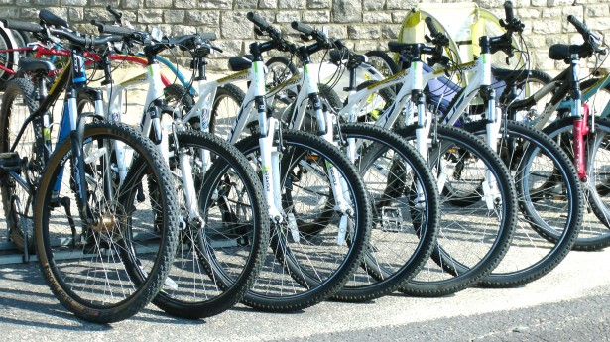boat Bellows Bicycle Barn

With summer quickly approaching, now is the perfect time to get back in the biking spirit! Bicycles are a great way to get around town without having to worry about parking or gas. And these days, bike enthusiasts have more choices than ever. From traditional bikes to mountain bikes, racers, collapsible bikes, and even electric-motor assisted bikes, your choices are practically endless! We even offer bicycle rentals for those just starting out.

The fun never ends when you’re on a bike. Whether it’s taking in the sights and sounds of the great outdoors on your full-suspension mountain bike or the freedom you feel from exploring a city and being able to stop anywhere you like, you’re never freer than when you’re riding a bike!

# [Bicycle Advantages](http://wikipedia.org/wiki/Bicycle)

* Low maintenance
* No expensive fuel
* Great for the environment
* Good way to stay in shape
* Lightweight and easy to store

# Popular Builds

* Commuter Bicycles
* Touring Bicycles
* Cyclo-Cross Bicycles
* Freight Bicycles
* Mountain Bicycles
* Racing Bicycles
* Cruiser Bicycles
* Motorized Bicycles

# Rental Prices

* City Bikes
  + Hourly - $7
  + Daily - $25
  + Weekly - $80
* Mountain Bikes
  + Daily - $40
  + 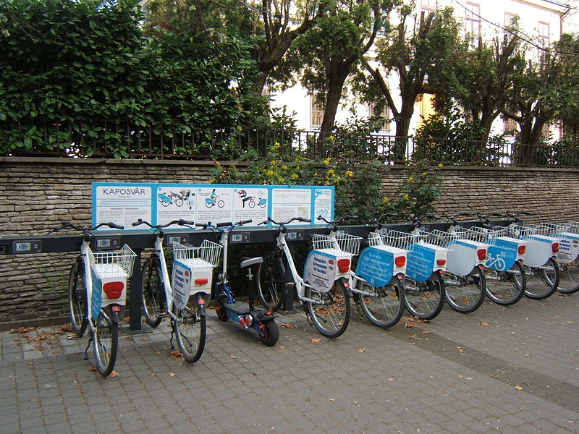Weekly - $110

# Affordable Pricing

Whether you’re looking to invest in a bike for commuting to work, buying a child’s first bicycle, or even building a custom mountain bike capable of climbing the most rugged trails, we offer great deals and affordable pricing plans for every type of customer. There’s never been a better time to own a bike!

# Contact Us

Bellows Bicycle Barn

1234 Main St.

Page, AZ 86040