 | MINISTRY OF EDUCATION AND TRAINING

FPT UNIVERSITY
SAP341/PRM393 Project Document
MINI SOCIAL (MSC)

[Group name]
Group Members | [Member 1 name][Roll No.][Student code]  [Member 2 name][Roll No.]< Student code >  [Member 3 name][Roll No.]< Student code >  [Member 4 name][Roll No.]< Student code >  [Member 5 name][Roll No.]< Student code >
Lecture | [Lecturer name]

- Hanoi, November 2026 -

Table of Contents

Acknowledgement 3
Definition and Acronyms 3
I. Project Introduction 4
1. Overview 4
2. Product Background 4
3. Existing Solutions 4
4. Project Scope & Limitations 4
II. Software Requirement Specification 5
1. Requirement Overview 5
2. Functional Specifications 5
2. Non-Functional Requirements 7
3. Requirement Appendix 7
III. Software Design Description 7
1. System Design 7
2. Database Design 7
IV. Software Testing Documentation 7
1. Scope of Testing 7
2. Test Strategy 8
3. Test Cases 8
4. Test Reports 8

Acknowledgement
We thank our lecturer and our teammates for supporting the Mini Social project.

Definition and Acronyms
Key terms used in this report:
Acronym | Definition
API | Application Programming Interface
BR | Business Rule
CRUD | Create, Read, Update and Delete
ERD | Entity Relationship Diagram
GUI | Graphical User Interface
LAN | Local Area Network
PRM393 | Mobile Programming Project Course
REST | Representational State Transfer
SDD | Software Design Description
SRS | Software Requirement Specification
UAT | User Acceptance Testing
UC | Use Case
UML | Unified Modeling Language

I. Project Introduction

1. Overview

1.1 Project Information
Item | Information
Project | Mini Social (MSC) — Android text-only social network
Frontend | Flutter + Riverpod
Backend | Node.js REST API
Database | MongoDB Community Server on a team laptop
Connectivity | Android phones communicate with one shared API over Wi-Fi/LAN

1.2 Project Team
No. | Member | Task / Screen
1 | [Member 1] | SCR01 Home Feed; SCR02 Post Detail; SCR03 Notifications
2 | [Member 2] | SCR04 Post Editor; SCR05 My Posts; SCR06 Post Insights
3 | [Member 3] | SCR07 Comments; SCR08 Liked Posts; SCR09 Saved Posts
4 | [Member 4] | SCR10 Search; SCR11 Friend Requests; SCR12 Friend List
5 | [Member 5] | SCR13 Profile; SCR14 Edit Profile; SCR15 Account Settings
— | Shared | SCR16 Login; SCR17 Register (not counted for individual quota)

2. Product Background
Mini Social lets people publish short text updates and connect with friends using one shared backend.

3. Existing Solutions
Facebook-style apps provide familiar examples of feeds, likes and friendships. Mini Social implements a simpler text-only scope.

4. Project Scope & Limitations
In scope | Out of scope
Phone registration/login; text posts; likes, comments, saves | Email/OTP, media upload, stories, chat, Share/Repost
Search, friend requests, notifications, profile | Public cloud deployment, advanced analytics
17 screens; 5 members × 3 screens + shared authentication | Independent offline-only data on one phone

II. Software Requirement Specification

1. Requirement Overview
A user accesses the Android app. The shared Node.js service reads and updates MongoDB on the team laptop.

1.1 Context Diagram
[Insert Context Diagram diagram image here.]
PlantUML source — Context Diagram (render and insert the diagram above):
@startuml
left to right direction
actor User
rectangle "Mini Social System" as MS
User --> MS : Register / Log in
User --> MS : Posts / Friends / Profile
@enduml

1.2 Main Business Process
[Insert Main Business Process (Swimlane) diagram image here.]
PlantUML source — Main Business Process (Swimlane) (render and insert the diagram above):
@startuml
title Mini Social - Main Business Process
|User|
start
:Open Mini Social;
if (Has an account?) then (No)
:Register;
endif
:Log in;
|Mini Social System|
:Validate account;
:Show Home Feed;
|User|
if (Choose activity) then (Posts)
:View or manage posts;
elseif (Friends)
:Search or manage friends;
else (Profile)
:View or update profile;
endif
|Mini Social System|
:Process action and update shared data;
:Show result;
stop
@enduml
Step | Main activity
1 | User opens Mini Social and registers/logs in if needed.
2 | System validates the account and opens Home Feed.
3 | User selects post, friend or profile activity.
4 | System processes the request and displays the result.

2. Functional Specifications
Features are grouped below as in the FPT template. Tabs, bottom sheets and editor modes are parts of their parent screens.

2.1 Use Case Overview
UC | Function | Screen
UC01 | Register | SCR17
UC02 | Login | SCR16
UC03 | Logout | SCR15
UC04 | View Feed | SCR01
UC05 | View Post Detail | SCR02
UC06 | Create Post | SCR04
UC07 | Edit Post | SCR04
UC08 | Delete Post | SCR05
UC09 | View My Posts | SCR05
UC10 | Like / Unlike Post | SCR01, SCR02, SCR08
UC11 | Add Comment | SCR07
UC12 | Delete Own Comment | SCR07
UC13 | View Liked Posts | SCR08
UC14 | Save / Unsave | SCR01, SCR02, SCR09
UC15 | View Saved Posts | SCR09
UC16 | Search Users / Posts | SCR10
UC17 | Send Friend Request | SCR10
UC18 | Accept / Decline Request | SCR11
UC19 | View Friend List | SCR12
UC20 | View Profile | SCR13
UC21 | Edit Profile | SCR14
UC22 | View Notifications | SCR03
UC23 | Mark Notification Read | SCR03
UC24 | View Post Likes | SCR02 (sheet)
UC25 | View Post Insights | SCR06
UC26 | View / Cancel Sent Request | SCR11 (tab)
UC27 | Change Password | SCR15

2.2 Feed and Notifications (Member 1)

2.2.1 Feed and Notifications Functions

2.2.1.1 Home Feed (SCR01)
Browse recent text posts.

a. UI Specifications
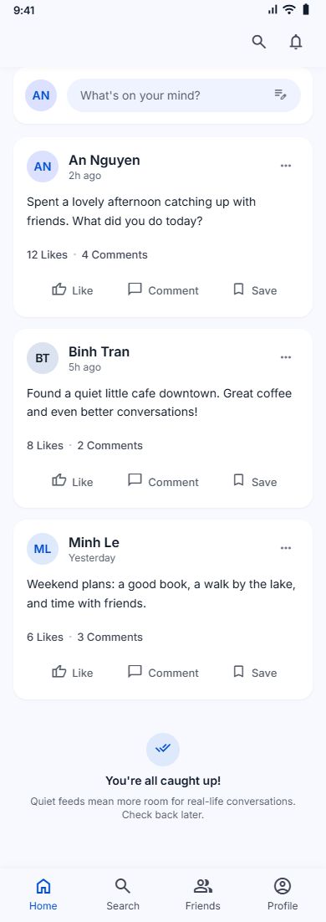
UI component | Description
Post cards | Author, time, text and counts
Like / Comment / Save | Interact with a post
Top actions | Create Post or open Notifications

b. Use Case Specification
Item | Specification
Use Case(s) | UC04, UC10, UC14
Actor / Precondition | User / Signed in
Main flow | Open Home → load posts → read or interact.

c. Business Rules
Rule | Description
BR | Only authenticated users can view posts.

2.2.1.2 Post Detail (SCR02)
Read one full post and open related interactions.

a. UI Specifications
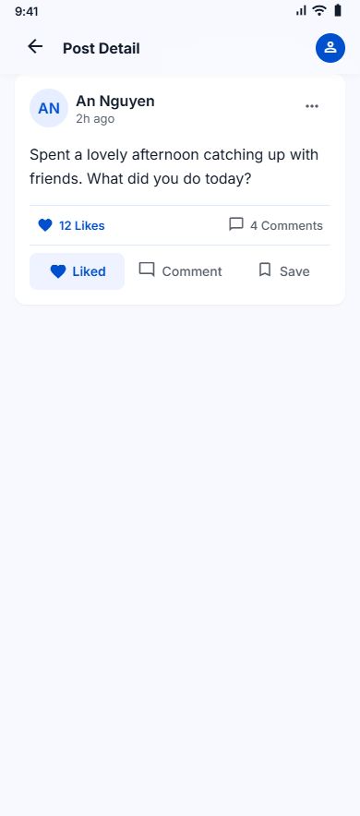
UI component | Description
Post detail | Full text, author and time
Actions | Like, Comment, Save
Likes count | Opens user-list bottom sheet

b. Use Case Specification
Item | Specification
Use Case(s) | UC05, UC24
Actor / Precondition | User / Signed in
Main flow | Select post → load detail → show content.

c. Business Rules
Rule | Description
BR | Deleted posts are unavailable.

2.2.1.3 Notifications (SCR03)
See recent activity and mark messages read.

a. UI Specifications
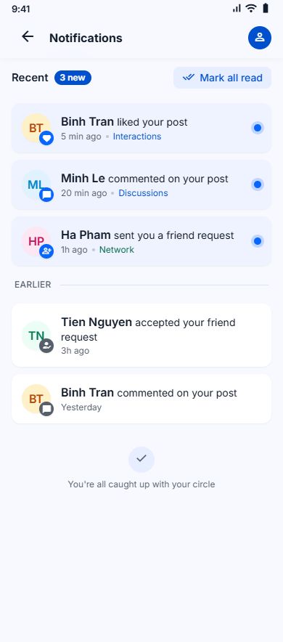
UI component | Description
Notification list | Actor, activity, time, read state
Open item | Navigate to related content
Mark all read | Clear unread states

b. Use Case Specification
Item | Specification
Use Case(s) | UC22, UC23
Actor / Precondition | User / Signed in
Main flow | Open Notifications → load list → select or mark read.

c. Business Rules
Rule | Description
BR | Notifications are visible only to their recipient.

2.3 Post Management (Member 2)

2.3.1 Post Management Functions

2.3.1.1 Post Editor (SCR04)
Create or edit a text post on the same page.

a. UI Specifications
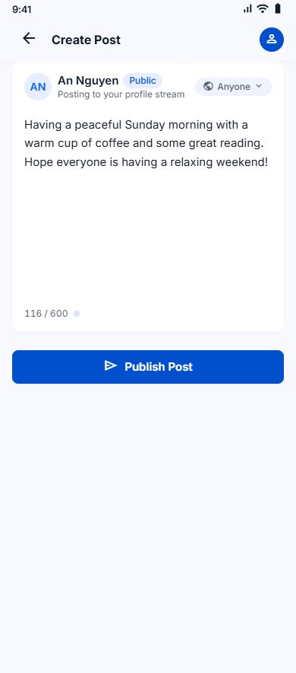
UI component | Description
Plain-text editor | Multiline post content
Create mode | Publish Post
Edit mode | Save Changes for own post

b. Use Case Specification
Item | Specification
Use Case(s) | UC06, UC07
Actor / Precondition | User / Signed in
Main flow | Open editor → enter text → save.

c. Business Rules
Rule | Description
BR | Post content cannot be blank; only author can edit.

2.3.1.2 My Posts (SCR05)
Manage posts written by the current user.

a. UI Specifications
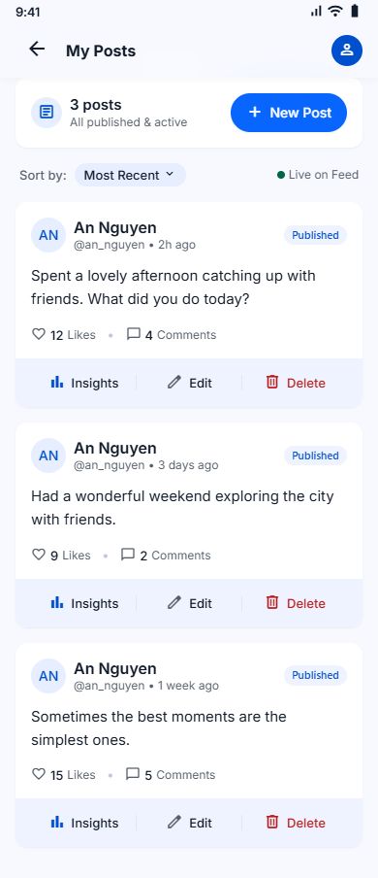
UI component | Description
Own post list | Show content, date and counts
Manage | Create, Edit and Delete
Insights | Open SCR06

b. Use Case Specification
Item | Specification
Use Case(s) | UC08, UC09
Actor / Precondition | User / Signed in
Main flow | Open My Posts → choose Manage action.

c. Business Rules
Rule | Description
BR | Only author may delete a post; confirm deletion.

2.3.1.3 Post Insights (SCR06)
View simple engagement totals on own posts.

a. UI Specifications
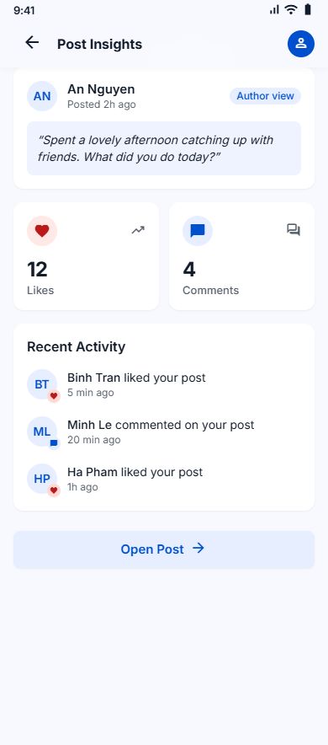
UI component | Description
Post excerpt | Identify selected post
Totals | Likes and Comments
Recent activity | Related notifications, if any

b. Use Case Specification
Item | Specification
Use Case(s) | UC25
Actor / Precondition | User / Signed in
Main flow | Select Insights → load totals → display.

c. Business Rules
Rule | Description
BR | Insights show only data for the author’s own post.

2.4 Interactions (Member 3)

2.4.1 Interactions Functions

2.4.1.1 Comments (SCR07)
Read and add comments on one post.

a. UI Specifications
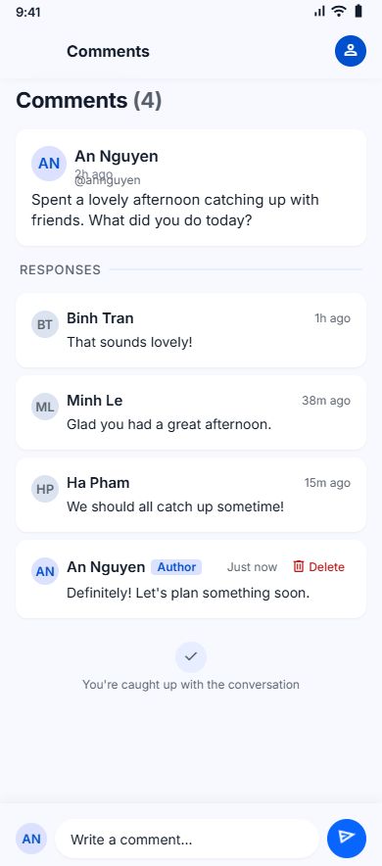
UI component | Description
Comments | Author, text and time
Composer | Write comment and Send
Delete | Remove own comment

b. Use Case Specification
Item | Specification
Use Case(s) | UC11, UC12
Actor / Precondition | User / Signed in
Main flow | Open Comments → add or delete own comment.

c. Business Rules
Rule | Description
BR | Only comment author may delete; blank text rejected.

2.4.1.2 Liked Posts (SCR08)
Find posts previously liked by the user.

a. UI Specifications
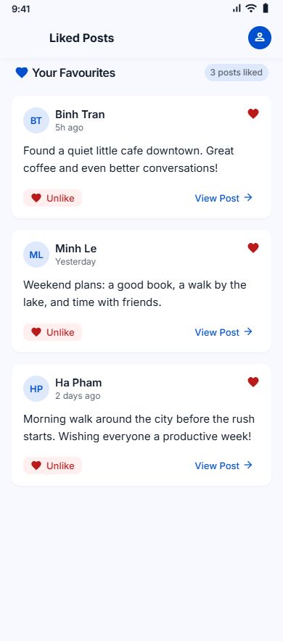
UI component | Description
Liked list | Posts liked by current user
Unlike | Remove a like
View Post | Open SCR02

b. Use Case Specification
Item | Specification
Use Case(s) | UC10, UC13
Actor / Precondition | User / Signed in
Main flow | Open Liked Posts → unlike or open post.

c. Business Rules
Rule | Description
BR | One user can like each post at most once.

2.4.1.3 Saved Posts (SCR09)
Read and remove saved posts.

a. UI Specifications
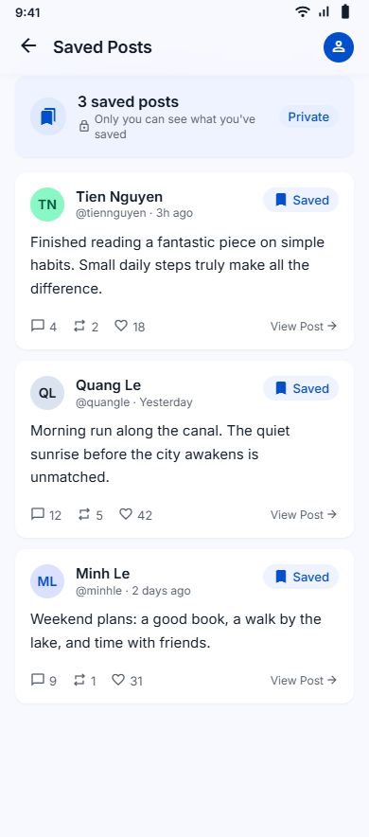
UI component | Description
Saved list | Saved posts for current user
Unsave | Remove bookmark
View Post | Open SCR02

b. Use Case Specification
Item | Specification
Use Case(s) | UC14, UC15
Actor / Precondition | User / Signed in
Main flow | Open Saved Posts → unsave or open post.

c. Business Rules
Rule | Description
BR | Saving the same post twice is not allowed.

2.5 Search and Friends (Member 4)

2.5.1 Search and Friends Functions

2.5.1.1 Search (SCR10)
Find users or posts, with results on the same page.

a. UI Specifications
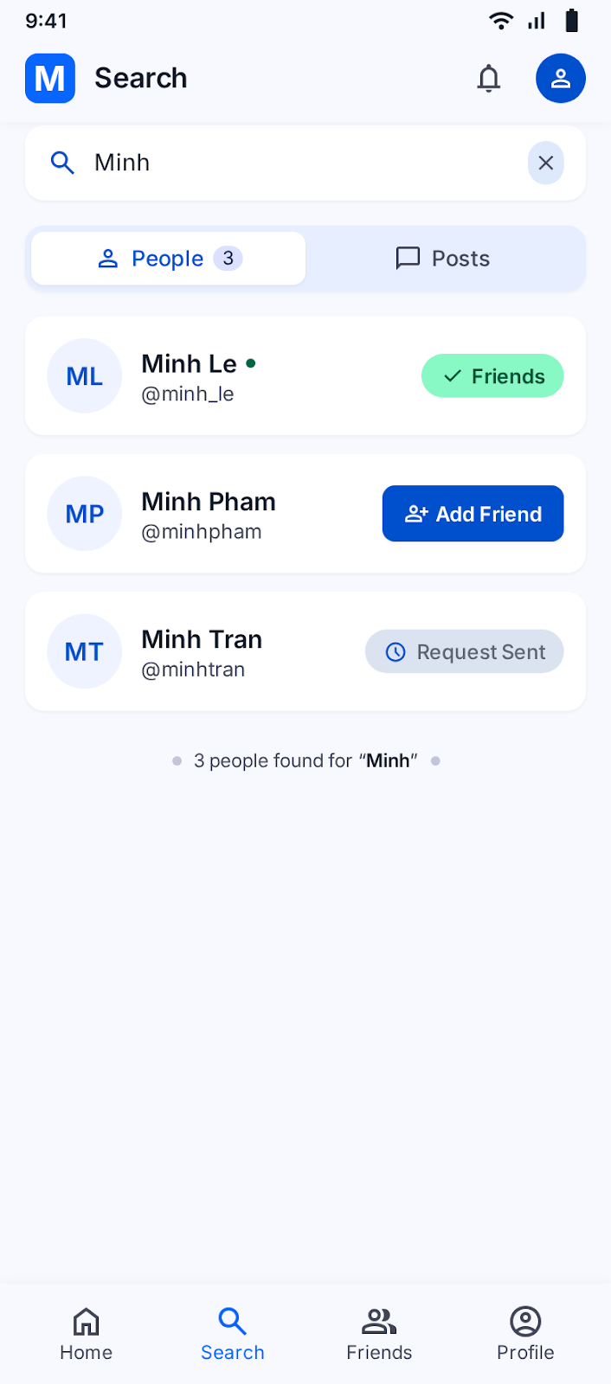
UI component | Description
Search box | Enter a keyword
People / Posts | Switch result type in same screen
User result | Open profile or Add Friend

b. Use Case Specification
Item | Specification
Use Case(s) | UC16, UC17
Actor / Precondition | User / Signed in
Main flow | Enter keyword → view results → choose action.

c. Business Rules
Rule | Description
BR | Cannot send a friend request to self or existing friend.

2.5.1.2 Friend Requests (SCR11)
Manage received and sent requests using tabs.

a. UI Specifications
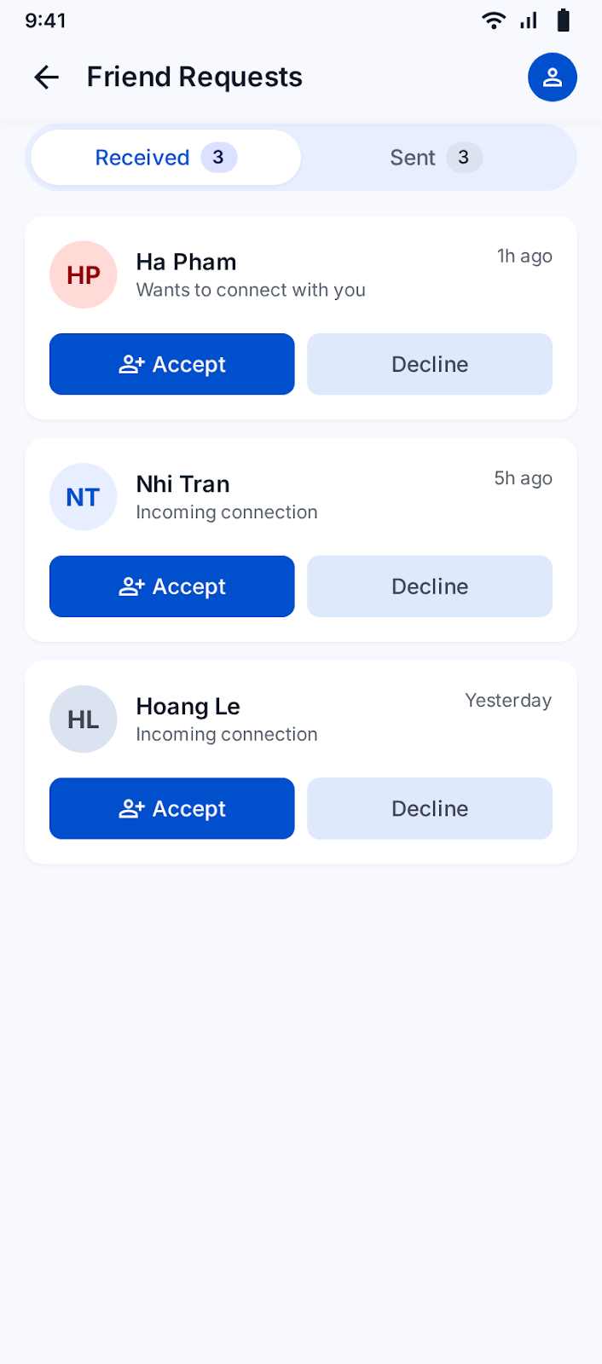
UI component | Description
Received tab | Accept or Decline pending requests
Sent tab | See pending requests and Cancel
Status | Show current request state

b. Use Case Specification
Item | Specification
Use Case(s) | UC18, UC26
Actor / Precondition | User / Signed in
Main flow | Choose tab → accept, decline or cancel.

c. Business Rules
Rule | Description
BR | Only request participants may change pending requests.

2.5.1.3 Friend List (SCR12)
View accepted friends and open profiles.

a. UI Specifications
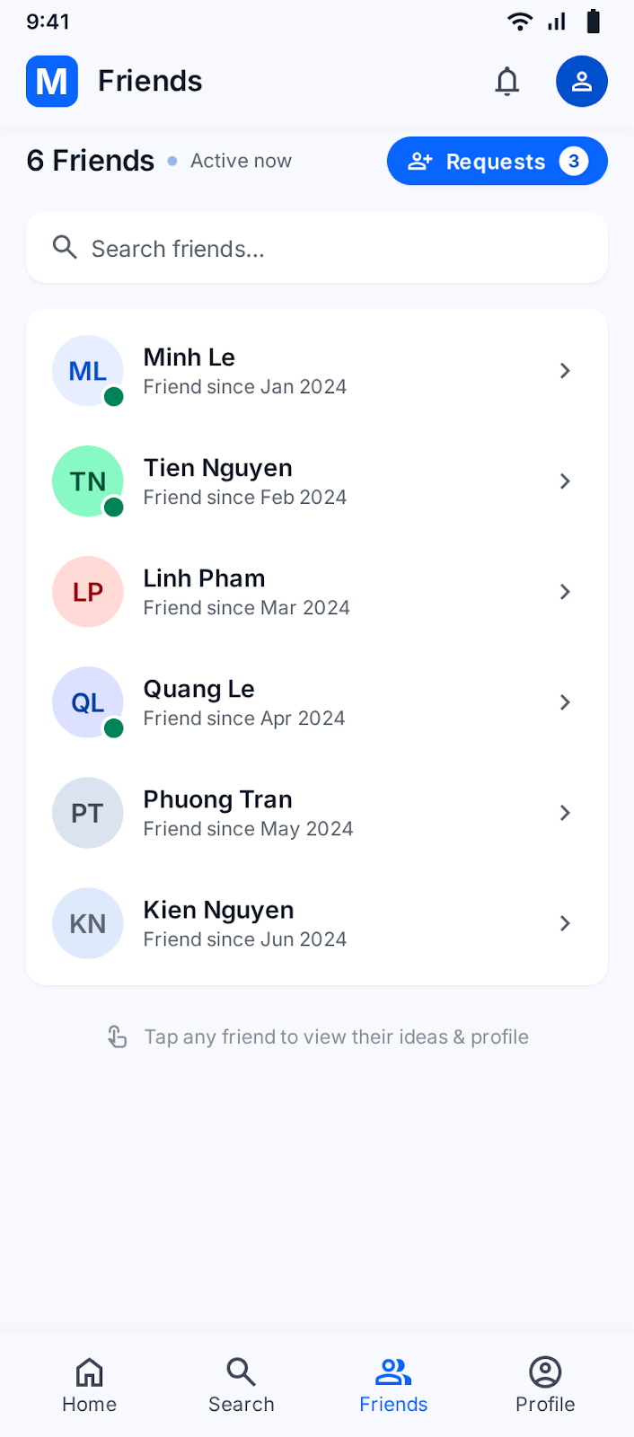
UI component | Description
Friends list | Accepted friends only
Friend row | Open a user profile
Requests button | Open SCR11

b. Use Case Specification
Item | Specification
Use Case(s) | UC19
Actor / Precondition | User / Signed in
Main flow | Open Friends → list accepted users → choose one.

c. Business Rules
Rule | Description
BR | Only accepted friendships appear in the list.

2.6 Profile and Account (Member 5)

2.6.1 Profile and Account Functions

2.6.1.1 Profile (SCR13)
View account identity or another user profile.

a. UI Specifications
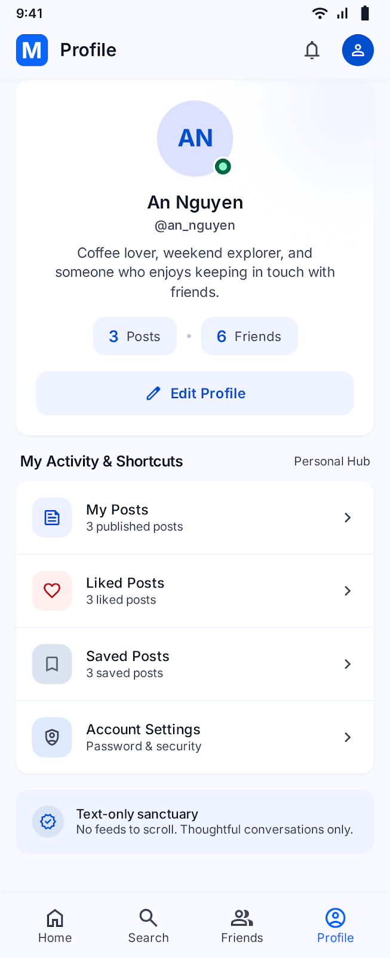
UI component | Description
Identity | Name, initials and bio
Own profile | Edit Profile and personal shortcuts
Other user | Relationship-aware action

b. Use Case Specification
Item | Specification
Use Case(s) | UC20
Actor / Precondition | User / Signed in
Main flow | Open Profile → display details → choose shortcut.

c. Business Rules
Rule | Description
BR | Own editing controls are restricted to the owner.

2.6.1.2 Edit Profile (SCR14)
Update display name and biography.

a. UI Specifications
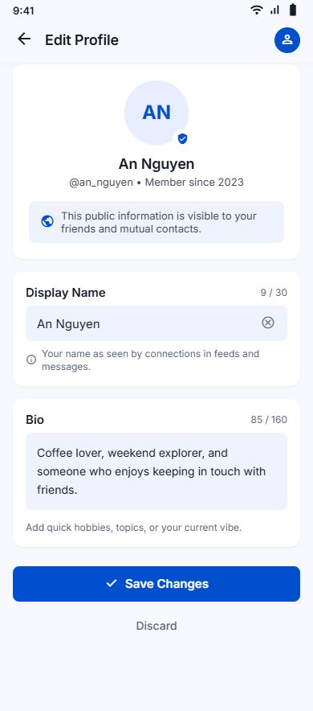
UI component | Description
Display Name | Required field
Bio | Optional multiline field
Save Changes | Update own profile

b. Use Case Specification
Item | Specification
Use Case(s) | UC21
Actor / Precondition | User / Signed in
Main flow | Edit Name or Bio → save → refresh profile.

c. Business Rules
Rule | Description
BR | Only user may update own profile.

2.6.1.3 Account Settings (SCR15)
Change password and log out from one page.

a. UI Specifications
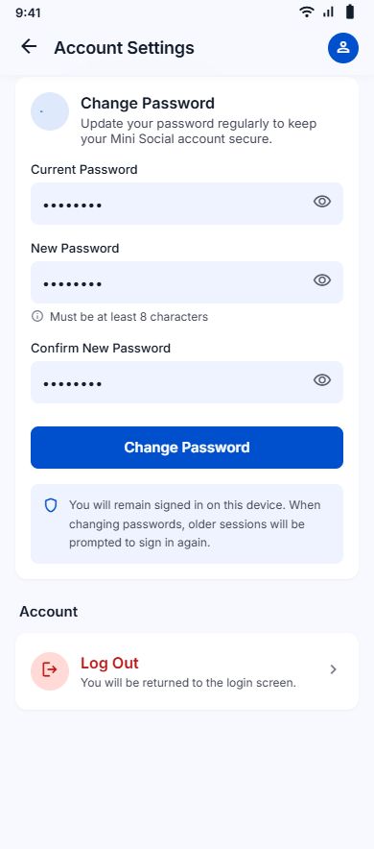
UI component | Description
Password form | Current, New, Confirm New
Change Password | Update credentials
Log Out | End session

b. Use Case Specification
Item | Specification
Use Case(s) | UC03, UC27
Actor / Precondition | User / Signed in
Main flow | Enter password details and submit, or log out.

c. Business Rules
Rule | Description
BR | Verify current password before changing credentials.

2.7 Authentication (Shared)

2.7.1 Authentication Functions

2.7.1.1 Login (SCR16)
Sign in with phone and password.

a. UI Specifications
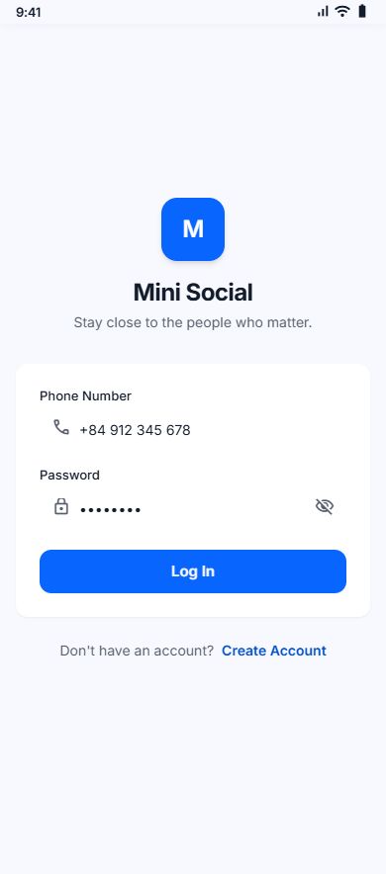
UI component | Description
Phone Number | Required
Password | Required and masked
Log In | Authenticate and open Home

b. Use Case Specification
Item | Specification
Use Case(s) | UC02
Actor / Precondition | Guest / Not signed in
Main flow | Enter phone and password → log in.

c. Business Rules
Rule | Description
BR | Reject invalid credentials without exposing password data.

2.7.1.2 Register (SCR17)
Create an account with phone-based credentials.

a. UI Specifications
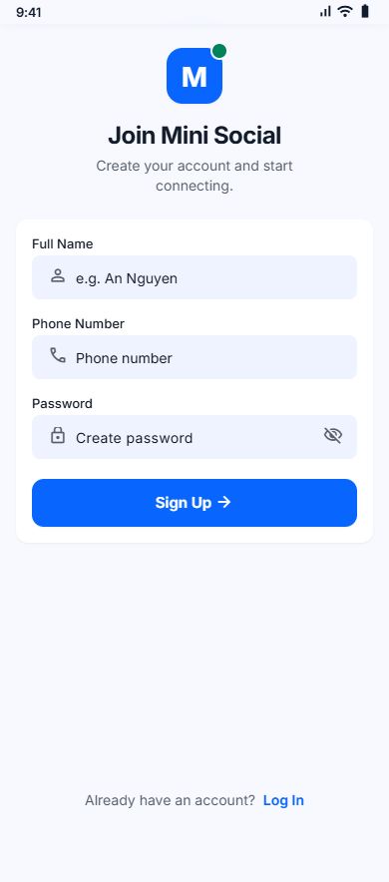
UI component | Description
Name | Required
Phone Number | Required and unique
Password | Required and masked

b. Use Case Specification
Item | Specification
Use Case(s) | UC01
Actor / Precondition | Guest / Not signed in
Main flow | Enter fields → register → open Login/Home.

c. Business Rules
Rule | Description
BR | Phone must be unique; store a secure password hash.

2. Non-Functional Requirements

2.1 External Interfaces
Flutter calls the Node.js API over reachable local Wi-Fi/LAN. Mobile devices never connect directly to MongoDB.

2.2 Quality Attributes
Attribute | Requirement
Security | Authenticated requests; hashed passwords; server-side permission checks.
Reliability | Show clear messages when local server is unreachable.
Usability | Consistent navigation and accessible text-only forms.
Performance | Use bounded result lists and indexed queries.

3. Requirement Appendix

3.1 Business Rules
ID | Common rule
BR01 | Phone number is unique for each account.
BR02 | Only the author may edit/delete their posts and comments.
BR03 | Users cannot like/save the same post twice.
BR04 | Friend requests cannot target self or duplicate an active friendship.
BR05 | Only the receiver can accept/decline; only the sender can cancel.
BR06 | Notifications and saved posts belong to the signed-in user.

3.2 Common Requirements
All screens use the same navigation and API session. Account data is shared across phones.

3.3 Application Messages List
Message | When shown
Please enter the required information. | A required field is empty.
Unable to connect. Please try again. | The local backend is not reachable.
Request already exists. | Duplicate friend request.
Changes saved successfully. | An update succeeds.

3.4 Other Requirements
The demonstration requires the laptop server and Android devices to use the same accessible Wi-Fi/LAN.

III. Software Design Description

1. System Design

1.1 System Architecture
[Insert System Architecture diagram image here.]
PlantUML source — System Architecture (render and insert the diagram above):
@startuml
left to right direction
node "Android Device" {
component "Flutter + Riverpod" as APP
}
node "Team Laptop (Local Wi-Fi/LAN)" {
component "Node.js REST API" as API
database "MongoDB Community Server" as DB
}
APP --> API : HTTP requests
API --> DB : Database operations
@enduml
Flutter manages screens and Riverpod state. Node.js implements REST APIs. MongoDB stores shared data on the laptop.

1.2 Package Diagram
[Insert Package Diagram diagram image here.]
PlantUML source — Package Diagram (render and insert the diagram above):
@startuml
package "Flutter App" {
[Authentication]
[Feed and Posts]
[Interactions]
[Search and Friends]
[Profile and Settings]
[API Repository]
}
package "Node.js Backend" {
[Routes]
[Services]
[MongoDB Access]
}
[Authentication] --> [API Repository]
[Feed and Posts] --> [API Repository]
[Interactions] --> [API Repository]
[Search and Friends] --> [API Repository]
[Profile and Settings] --> [API Repository]
[API Repository] --> [Routes]
[Routes] --> [Services]
[Services] --> [MongoDB Access]
@enduml

2. Database Design
MongoDB uses seven collections. References use ObjectId values; indexes enforce important uniqueness rules.
[Insert MongoDB Relationship Diagram diagram image here.]
PlantUML source — MongoDB Relationship Diagram (render and insert the diagram above):
@startuml
hide methods
skinparam classAttributeIconSize 0
class users
class posts
class comments
class post_likes
class saved_posts
class friend_requests
class notifications
users "1" -- "many" posts : authorId
users "1" -- "many" comments : authorId
posts "1" -- "many" comments : postId
users "1" -- "many" post_likes : userId
posts "1" -- "many" post_likes : postId
users "1" -- "many" saved_posts : userId
posts "1" -- "many" saved_posts : postId
users "1" -- "many" friend_requests : senderId / receiverId
users "1" -- "many" notifications : receiverId / actorId
@enduml

2.1 users
Fields | Indexes / notes
_id; displayName; displayNameLower; phone; passwordHash; passwordSalt; passwordIterations; bio; tokenVersion; createdAt; updatedAt | Unique phone; search displayNameLower

2.2 posts
Fields | Indexes / notes
_id; authorId; content; contentLower; createdAt; updatedAt; isDeleted | Index authorId, createdAt; search contentLower

2.3 comments
Fields | Indexes / notes
_id; postId; authorId; content; createdAt | Index postId, createdAt

2.4 post_likes
Fields | Indexes / notes
_id; postId; userId; createdAt | Unique (postId,userId)

2.5 saved_posts
Fields | Indexes / notes
_id; postId; userId; createdAt | Unique (postId,userId)

2.6 friend_requests
Fields | Indexes / notes
_id (pair key); senderId; receiverId; status; createdAt; respondedAt | Unique relationship pair; index recipient/status

2.7 notifications
Fields | Indexes / notes
_id; receiverId; actorId; type; targetType; targetId; isRead; createdAt | Index receiverId, isRead, createdAt

IV. Software Testing Documentation

1. Scope of Testing
Test registration, text posts, interactions, search, friendships and profile functions using the local API and shared MongoDB.

2. Test Strategy

2.1 Testing Types
Type | Purpose
Unit | Validate field checks and core service rules.
Integration | Check Flutter → API → MongoDB communication.
System | Verify complete user journeys across screens.

2.2 Test Levels
Developers perform unit and integration tests. The team performs manual system tests on two Android devices.

2.3 Supporting Tools
Flutter test tools, Node.js test tools, REST client and MongoDB Compass (as available).

3. Test Cases
ID | Test action | Expected result
TC01 | Register with valid phone | Account created
TC02 | Login with valid credentials | Home opens
TC03 | Publish a text post | Post appears in Feed
TC04 | Edit or delete own post | Changes applied
TC05 | Like and save a post | State updates once
TC06 | Add and delete own comment | Comment state updates
TC07 | Search people and posts | Matching results shown on SCR10
TC08 | Send / accept friend request | Friend appears on both friend lists
TC09 | Decline / cancel request | Pending request disappears
TC10 | Edit profile / change password | Updates persisted and validated
TC11 | Read notifications | Read state changes
TC12 | Use second Android device | Shared backend data visible

4. Test Reports
Execution status: Not yet recorded. Complete the table after testing on actual Android devices.
Test group | Executed | Passed | Failed
Authentication | Pending | — | —
Posts / Interactions | Pending | — | —
Search / Friends | Pending | — | —
Profile / Notifications | Pending | — | —

