PHENIKAA UNIVERSITY
PHENIKAA SCHOOL OF COMPUTING


WEEKLY REPORT
TOPIC: ELECTRONICS E-COMMERCE WEBSITE

Course Class : | Software Architecture-1-2-25 (N01)
Instructor : | M.Sc. Vũ Quang Dũng
Group : | 16
Group Members : | Nguyễn Tuấn Thiền - 23010571  Đặng Việt Anh – 23010689

Mục lục:
Lab 08
1 INTRODUCTION 3
1.1 Lab Overview 3
1.2 Objectives 3
2 DEPLOYMENT VIEW 3
2.1 Goal and Detailed Explanation of the Diagram 3
2.2 UML Deployment Diagram for Microservices Architecture 4
2.3 Node Descriptions 5
2.4 Communication Paths 6
3 QUALITY ATTRIBUTE ANALYSIS (ATAM) 7
3.1 Define Scenarios 7
3.2 Evaluate Architectures against Scenarios 8
3.3 Identify Trade-offs 9
4 COMPARISON OF ARCHITECTURES 9
5 CONCLUSION 9
6 APPENDIX 10
6.1 Scenario Template 10
6.2 Code-to-Deployment Mapping (docker-compose.microservices.yml) 10

1 INTRODUCTION

1.1 Lab Overview
This lab focuses on architecture documentation and quality attribute evaluation for the ElectroShop e-commerce system. Instead of implementing new features, the lab requires documenting the physical deployment view using a UML Deployment Diagram and evaluating architectural decisions with a simplified Architecture Trade-off Analysis Method (ATAM). The evaluation concentrates on two key quality attributes: Scalability and Availability. The system is implemented as a Laravel-based microservices architecture supported by an API Gateway and a message broker.

1.2 Objectives
- Create a UML Deployment Diagram to visualize the physical setup of the architecture (Deployment View).
- Conduct a simplified ATAM analysis focusing on Scalability and Availability.
- Compare Monolithic (Layered) versus Microservices architecture with respect to the chosen quality attributes.
- State clear architectural trade-offs and justify why the chosen architecture is appropriate for the project.

2 DEPLOYMENT VIEW

2.1 Goal and Detailed Explanation of the Diagram
Goal: Model the physical allocation of software artifacts to execution environments and show the network communication paths between them.
The UML Deployment Diagram in this report represents the microservices deployment defined in the project’s docker-compose.microservices.yml. Clients access the system through a Load Balancer and an API Gateway (Kong). Core business capabilities are split into services such as Catalog Service, Order Service, User Service, and Notification Service. Persistent storage follows a database-per-service approach using separate MySQL instances (catalog, order, user). Redis provides caching, and RabbitMQ enables asynchronous messaging for event-driven flows (for example, publishing an order event and consuming it for notifications). The diagram uses standard UML conventions: 3D boxes for nodes, artifact symbols for deployable units, database symbols for data stores, and dashed arrows for communication associations with labeled protocols.
Implementation note: In the provided docker-compose.microservices.yml, clients can access Kong directly via exposed ports in local development. The Load Balancer is documented as a logical production component (Nginx/Cloud LB) as required by Lab 08 and can be added in front of Kong for horizontal scaling.

2.2 UML Deployment Diagram for Microservices Architecture
Figure 1 presents the UML Deployment Diagram of ElectroShop, showing nodes, artifacts, and key communication paths.
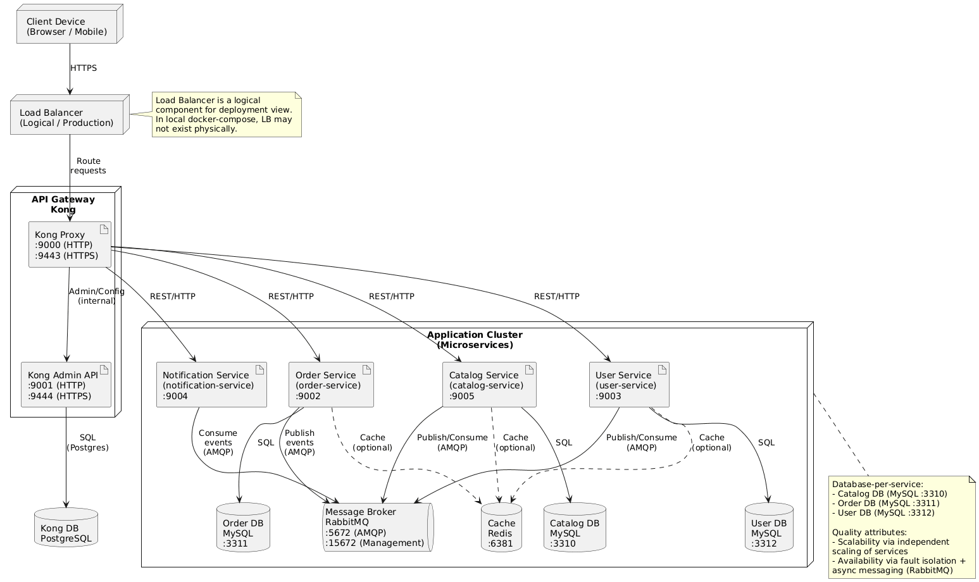
Figure 1: UML Deployment Diagram for ElectroShop Microservices

2.3 Node Descriptions
The deployment architecture consists of the following key nodes and hosted artifacts.
Node | Hosted Artifacts | Rationale
Client Device | Web Browser / Mobile App | End-user device that initiates HTTP/HTTPS requests to access the system.
Load Balancer (Logical / Production) | Load Balancer Service (logical component) | Distributes incoming traffic to the API Gateway/application services to improve availability and scalability. In local docker-compose, this may not exist physically.
API Gateway (Kong) | Kong Proxy (:9000 HTTP, :9443 HTTPS)  Kong Admin API (:9001 HTTP, :9444 HTTPS) | Single entry point that routes requests to microservices and enforces gateway policies (routing, rate limiting, auth, etc.).
Kong DB (PostgreSQL) | Postgres database for Kong configuration | Stores Kong configuration/state for the API Gateway.
Application Cluster (Microservices) | Catalog Service (:9005)  Order Service (:9002)  User Service (:9003)  Notification Service (:9004) | Independently deployable services; supports independent scaling and fault isolation.
Message Broker (RabbitMQ) | RabbitMQ (:5672 AMQP, :15672 Management) | Enables asynchronous, event-driven communication to improve resilience and decouple services.
Cache (Redis) (Optional) | Redis (:6381) | Provides caching to reduce database load and improve response time for read-heavy operations.
Databases (DB-per-service) | Catalog DB (MySQL :3310)  Order DB (MySQL :3311)  User DB (MySQL :3312) | Each service owns its data store (database-per-service pattern), improving autonomy and limiting cross-service coupling.

2.4 Communication Paths
The following table summarizes the primary communication protocols and patterns between nodes.
From → To | Protocol | Purpose
Client Device → Load Balancer | HTTPS | User requests (browse products, view cart, checkout).
Load Balancer → API Gateway | HTTP/HTTPS | Routes requests to appropriate services and applies gateway policies.
API Gateway → Catalog/User/Order Services | HTTP/REST | Synchronous operations requiring immediate response (read product detail, authenticate user, place order).
Order Service → RabbitMQ | AMQP | Publishes domain events such as order created.
RabbitMQ → Notification Service | AMQP | Asynchronous consumption of events to send email notifications without blocking checkout.
Services → Redis | TCP (Redis protocol) | Caching and shared ephemeral state to reduce DB load.
Services → Service Databases | MySQL protocol | Read and write service-owned data (database per service).

3 QUALITY ATTRIBUTE ANALYSIS (ATAM)

3.1 Define Scenarios
The analysis focuses on two architecturally significant requirements. Scalability is evaluated under a demand surge, and availability is evaluated under a partial service failure.
Scalability Scenario (SS1): During a flash sale, the system must handle a sudden 10x spike in concurrent users searching products and placing orders while keeping request latency acceptable (e.g., p95 < 2 seconds).
Availability Scenario (AS1): The Notification Service fails completely for 1 hour. The system must still allow users to place orders successfully, and notifications should be delivered after recovery without losing events.

3.2 Evaluate Architectures against Scenarios
Table 1 compares the Monolithic (Layered) and Microservices architectures against the scenarios.

Scenario | Monolithic (Layered) Approach | Microservices Approach
SS1 | Must scale the entire application as one unit. If only catalog or order processing becomes a bottleneck, the whole system still needs scaling. A shared database can become a single bottleneck under heavy read and write load. Vertical scaling is common and has limits. | Services can scale independently. Catalog can scale for read-heavy traffic while Order scales for write-heavy checkout. Caching reduces load on service databases. The gateway and load balancer enable horizontal scaling across instances.
AS1 | If notifications are implemented inside the same process, a failure in the notification module can reduce overall availability or degrade the entire app. If synchronous sending is used, checkout may be blocked. | Order processing is decoupled from notification delivery via RabbitMQ. Order Service publishes an event and completes the request. Notification Service consumes events when available. The broker buffers messages, improving fault isolation and recovery.

3.3 Identify Trade-offs
Trade-off statement: The microservices architecture improves scalability and availability by isolating failures and enabling independent scaling, at the cost of higher operational complexity. Compared to a monolithic architecture, ElectroShop requires additional infrastructure such as an API gateway, multiple databases, and a message broker. This increases deployment and monitoring effort, but it allows the system to remain responsive during traffic spikes and to continue processing orders even when non-critical services, such as notifications, are temporarily unavailable.

4 COMPARISON OF ARCHITECTURES
The monolithic architecture is simpler to develop and deploy because it packages all modules into a single application and typically uses one shared database. This reduces infrastructure overhead and can be appropriate for small teams or early prototypes. However, it scales as a single unit and provides limited fault isolation.
The microservices architecture used by ElectroShop aligns with business capability boundaries and supports event-driven integration. It enables independent scaling of services and reduces the impact of partial failures. The main cost is the need to manage inter-service communication, service discovery and observability, as well as data consistency across service-owned databases.

5 CONCLUSION
This report documented the UML Deployment View of the ElectroShop Laravel microservices system and evaluated its architecture using a simplified ATAM. Based on the scalability and availability scenarios, microservices with an API gateway and RabbitMQ provide stronger support for traffic spikes and fault isolation than a monolithic layered design. The resulting trade-off is higher operational complexity, which is justified for an e-commerce system expected to grow in features and user demand.

6 APPENDIX

6.1 Scenario Template
The following table rewrites SS1 and AS1 using the Lecture 08 scenario template (Source, Stimulus, Artifact, Environment, Response).
Element | SS1 (Scalability) | AS1 (Availability / Fault Isolation)
Source | 10,000 concurrent users | Deployment error / Notification Service down
Stimulus | Users search product catalog and place orders | Customer places an order while Notification Service is unavailable
Artifact | API Gateway, Catalog Service, Order Service, Redis cache, service databases | Order Service, RabbitMQ broker, Notification Service
Environment | Flash sale / Black Friday promotion window | Normal operations, partial service failure lasting 1 hour
Response | System maintains acceptable latency (e.g., p95 < 2 seconds) by scaling hot services independently and using cache | Order is confirmed successfully; events are buffered in RabbitMQ and notifications are delivered after recovery

6.2 Code-to-Deployment Mapping
Key services visible in the project docker-compose.microservices.yml are summarized below to show traceability between the report and the source code.
Service / Component | Role | Local Ports (host:container)
kong | API Gateway / entry point | 9000:8000, 9001:8001, 9443:8443, 9444:8444
catalog-service | Product catalog microservice | 9005:9005
order-service | Order placement microservice | 9002:9002
user-service | User / auth microservice | 9003:9003
notification-service | Asynchronous email notification consumer | 9004:9004
rabbitmq | Message broker (AMQP) | 5672:5672, 15672:15672
redis | Cache / ephemeral state | 6381:6379
mysql-catalog | Catalog database (DB-per-service) | 3310:3306
mysql-order | Order database (DB-per-service) | 3311:3306
mysql-user | User database (DB-per-service) | 3312:3306

