PHENIKAA UNIVERSITY
PHENIKAA SCHOOL OF COMPUTING


WEEKLY REPORT
TOPIC: ELECTRONICS E-COMMERCE WEBSITE

Course Class : | Software Architecture-1-2-25 (N01)
Instructor : | M.Sc. Vũ Quang Dũng
Group : | 16
Group Members : | Nguyễn Tuấn Thiền - 23010571  Đặng Việt Anh – 23010689
Mục lục:
Lab 02
1. Abstract/Summary 3
2. Lab Specific Section: Layered Architecture Design 3
2.1 Activity Practice 1: Defining Layers and Responsibilities 3
2.1.1 Data Flow Definition 4
2.2 Activity Practice 2: Component Identification (Product Catalog) 5
2.2.1 Identify Components 5
2.2.2 Define Interfaces 6
2.3 Activity Practice 3: UML Component Diagram Modeling 8
2.3.1 UML Component Diagram: Product Catalog Feature 8
2.3.2 Complete Layered Architecture Diagram 10
3. Architectural Analysis and Trade-offs 11
3.1 Trade-offs of the Layered Pattern 11
3.2 Analyzing ASRs: Layered Architecture Evaluation 11
4. Conclusion and Reflection 12
5. References 12

1. Abstract/Summary

This lab focuses on designing the Layered Architecture for the Electronics E-Commerce application, representing the system's static structure and component relationships. This is a crucial step before implementation in Lab 3.
Lab Objectives:
- Understand the principles and constraints of the Layered Architecture Pattern
- Define the four main layers and their responsibilities
- Identify the key components within each layer for the Product Catalog feature
- Model the logical view using UML Component Diagrams

2. Lab Specific Section: Layered Architecture Design

2.1 Activity Practice 1: Defining Layers and Responsibilities
Goal: Formally define the four layers and their roles within the Electronics E-Commerce monolithic structure.
The Layered Pattern Rule: A layer can only interact with the layer directly below it (strict downward dependency).
Table 2.1: Four Standard Layers Definition
Layer | Purpose/Responsibility | Output/Artifact
1. Presentation Layer (UI/Web) | Handles HTTP requests, authentication, session management, and rendering the user interface (views). | Controllers: ProductController, CategoryController, OrderController, CartController, UserController
2. Business Logic Layer (Service/Domain) | Contains the core business rules, validation logic, and transaction management. Orchestrates data access. | Services: ProductService, CategoryService, OrderService, CartService, UserService
3. Persistence Layer (Data Access) | Responsible for mapping business objects to database entities and executing CRUD operations. | Repositories/DAOs: ProductRepository, CategoryRepository, OrderRepository
4. Data Layer (Database) | The physical database storage system (MySQL). | Database Schema: products, categories, orders, users, carts, reviews tables

2.1.1 Data Flow Definition
The typical request flow for a customer viewing a product detail page follows this sequence:
Client Request -> Layer 1 -> Layer 2 -> Layer 3 -> Layer 4 -> Layer 3 -> Layer 2 -> Layer 1 -> Client Response
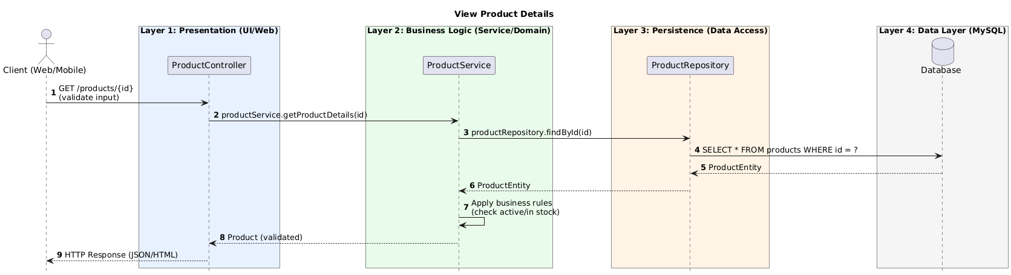
Figure 2.1: Request Flow Diagram - View Product Details

Table 2.2: Detailed Request Flow Steps
Step | From | To | Action/Description
1 | Client (Browser) | ProductController | HTTP GET /products/{id} to view product details
2 | ProductController | ProductService | Call: productService.getProductDetails(productId)
3 | ProductService | ProductRepository | Call: productRepository.findById(productId)
4 | ProductRepository | Database | Query product by id and return Product entity/data
5 | ProductRepository | ProductService | Return Product entity/data to service
6 | ProductService | ProductController | Return Product details DTO/model for response rendering
7 | ProductController | Client (Browser) | Return HTTP 200 with product details page/JSON response

2.2 Activity Practice 2: Component Identification (Product Catalog)
Goal: Break down the Product Catalog feature into concrete components that reside in the top three layers.

2.2.1 Identify Components
For the feature 'View Product Details', the following software components are identified:
Table 2.3: Component Identification for Product Catalog
Layer | Component Name | Responsibility
Layer 1 (Presentation) | ProductController | Receives HTTP request like GET /products/{id}. Validates input parameters. Calls the Business Logic Layer. Returns HTTP response (JSON/HTML).
Layer 2 (Business Logic) | ProductService | Receives the product ID from Controller. Enforces business rules (e.g., check if product is active/in stock). Calls the Persistence Layer. Returns validated Product object.
Layer 3 (Persistence) | ProductRepository | Translates the request into a database query (e.g., SELECT * FROM products WHERE id = ?). Executes CRUD operations. Returns raw ProductEntity data.

2.2.2 Define Interfaces
The primary interfaces (method signatures) provided by each layer:
Table 2.4: Interface Definitions
Note: This table lists only the primary method signatures; additional methods can be documented as optional APIs.
Interface | Method Signature | Description
IProductService (for Layer 1) | Product getProductDetails(String productId) | Returns a validated Product object with all business rules applied
IProductService | List<Product> getAllProducts() | Returns all active products in the catalog
IProductService | List<Product> searchProducts(String keyword) | Search products by keyword in name or description
IProductRepository (for Layer 2) | ProductEntity findById(String productId) | Returns raw database entity for a product
IProductRepository | List<ProductEntity> findAll() | Returns all product entities from database
IProductRepository | void save(ProductEntity entity) | Persists a product entity to database

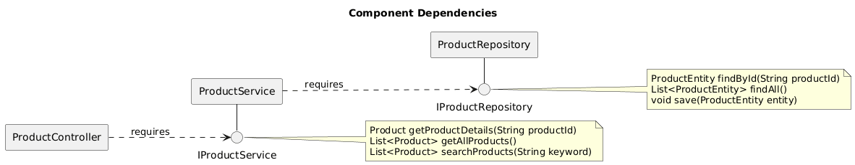
Figure 2.2: Component Dependencies with Interface Notation (Lollipop/Socket)

2.5 Mapping Source Code Structure to Layered Architecture
This section maps the folder structure in the provided source code (Web.zip) to the four-layer architecture used in this report. The purpose is to show how the logical design aligns with implementation artifacts in the project.
Table 2.5: Folder-to-Layer Mapping
Layer | Implementation folders/files in Web.zip | Notes
Presentation | app/Lab03/Controllers/  app/app/Http/Controllers/ | Controllers handle HTTP requests and call services (Lab03) or directly call Models (other features).
Business Logic | app/Lab03/Services/ | Service encapsulates business rules and orchestrates repository calls.
Persistence | app/Lab03/Repositories/ | Repository hides data access and exposes interfaces to services.
Data | database/migrations/  (database) | Migrations define schema; database stores persistent data.

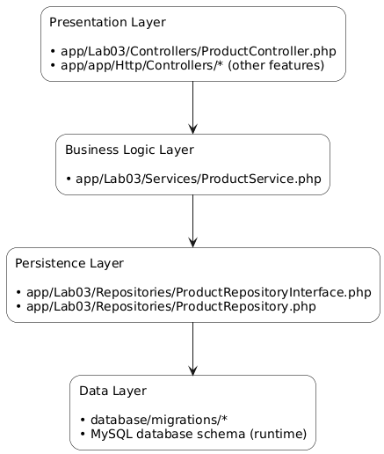
Figure 2.3: Mapping folder structure to the 4-layer architecture

2.3 Activity Practice 3: UML Component Diagram Modeling
Goal: Create a visual model of the Layered Architecture using UML Component Diagrams.

2.3.1 UML Component Diagram: Product Catalog Feature
The following diagram shows the layered structure for the Product Catalog feature with all interface notations:
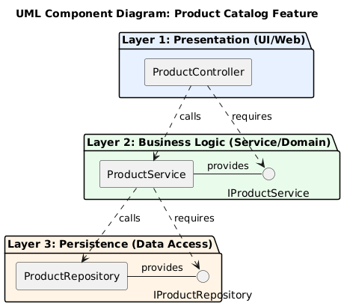
Figure 2.4: UML Component Diagram - Product Catalog Feature
Diagram Elements Explanation:
- Three large stacked rectangles represent Presentation, Business Logic, and Persistence layers
- UML Component shapes (rectangle with two small rectangles) for ProductController, ProductService, ProductRepository
- Provided Interface (Lollipop): Circle on a line attached to ProductService labeled IProductService
- Required Interface (Socket): Semi-circle attached to ProductController that plugs into IProductService
- Strict Dependency: All arrows point strictly downward (Layer 1 -> Layer 2 -> Layer 3)

2.3.2 Complete Layered Architecture Diagram
The complete architecture showing all major features of the Electronics E-Commerce system:
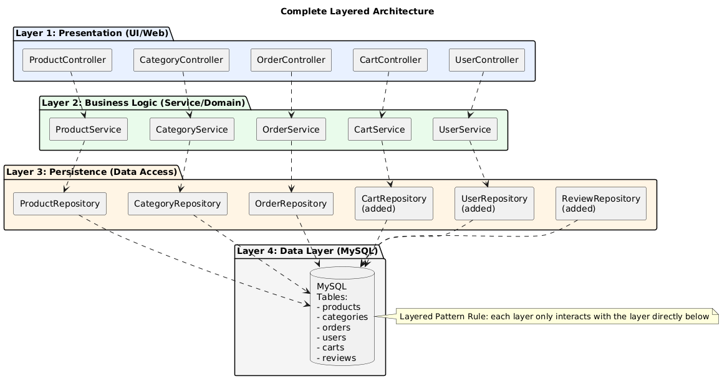
Figure 2.5: Complete Layered Architecture - Electronics E-Commerce System

3. Architectural Analysis and Trade-offs

3.1 Trade-offs of the Layered Pattern
Table 3.1: Layered Architecture Trade-offs
Advantages (Pro) | Disadvantages (Con)
Simplicity: Easy to understand and develop rapidly for small teams. | Scaling Inefficiency: If only the Catalog needs capacity, you must scale the entire monolithic application.
Testability: Each layer can be tested in isolation by mocking the layer below. | Deployment Coupling: A change in any layer requires redeploying the whole system.
Maintainability: Changes in one layer do not affect other layers if interfaces are preserved. | Performance Overhead: Each layer adds latency due to data transformation between layers.

3.2 Analyzing ASRs: Layered Architecture Evaluation
Evaluating how the Layered Architecture addresses the ASRs identified in Lab 1:
Table 3.2: ASR Evaluation for Layered Architecture
ASR | Layered Architecture Support | Rating | Future Action
ASR-1: Scalability | Fails easily. Must scale entire monolith even if only one feature needs capacity. | WEAK | Consider Microservices
ASR-2: Security | Good support. Security logic enforced centrally in Business Logic Layer. | GOOD | Maintain current approach
ASR-3: Modifiability | Good support. Strict layer dependencies enable isolated changes. Payment can be changed without affecting Products. | GOOD | Maintain current approach

Conclusion: The Layered Monolith is a good starting point for rapid development, but it is fundamentally weak against our critical Scalability ASR. Future iterations may need to evolve toward Microservices architecture.
4. Conclusion and Reflection
This lab successfully designed the Layered Architecture for the Electronics E-Commerce system following all requirements from Lab 2 and Lecture 2.
Key Deliverables Completed:
- Document 1: Table defining the purpose and output artifacts for all four layers (Presentation, Business Logic, Persistence, Data)
- Document 2: Complete UML Component Diagrams showing components, interfaces (lollipop/socket), and strict downward dependency flow
- Request Flow diagram tracing data movement through all layers
Key Learnings:
- Strict Downward Dependency: Components must only depend on the layer immediately below, ensuring maintainability
- Interface-Based Design: Lollipop (provided) and Socket (required) notations clearly define component contracts
- Separation of Concerns: Each layer focuses on its specialized task without knowledge of other layers' internals
- Trade-off Awareness: Layered architecture provides simplicity but sacrifices scalability

5. References
- Lab 2: Layered Architecture Design (Logical View) - Course Materials
- Lecture 2: The Layered Architecture Pattern - Software Architecture Course
- Lab 1 Report: Requirements Elicitation, ASRs, and Use Case Modeling

