**PIP & Photo Collage Maker**

**With Photo Editor**

**Created: 01/10/2020  
By: Kessi Infotech**

**Email:**[**kessiinfotech@gmail.com**](mailto:youremail@yourdomain.com)

Thank you for purchasing our app. If you have any questions that are beyond the scope of this help file, please feel free to contact via email. Thanks you so much!

\_\_\_\_\_\_\_\_\_\_\_\_\_\_\_\_\_\_\_\_\_\_\_\_\_\_\_\_\_\_\_\_\_\_\_\_\_\_\_\_\_\_\_\_\_\_\_\_\_\_\_\_\_\_\_\_\_\_\_\_\_\_\_\_\_\_\_\_\_\_\_\_\_\_\_\_\_\_\_\_\_\_

**Step 1** : **Which Android Studio version is needed?**

Latest Android Studio version is recommended.

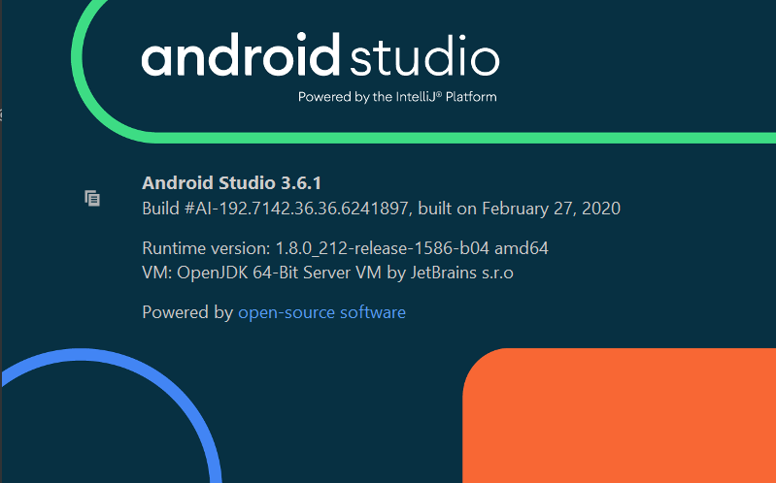

**Step 2** : **How to Open The Project in Android Studio?**

1. Unzip Project Folder.

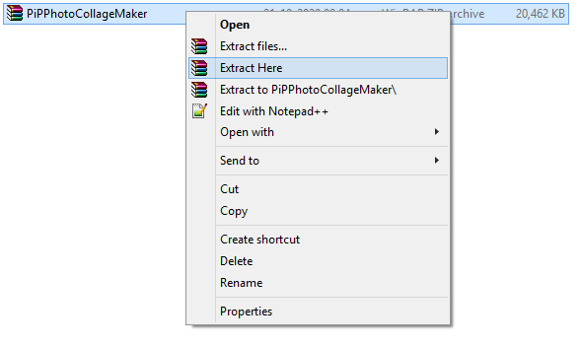

Screenshot_3.png

2. Open Android Studio > Open an Existing Android Studio Project > Select Your Project > ok.

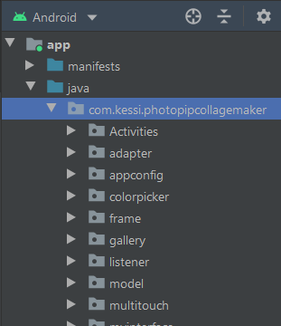

3. Wait for Gradle Process.

4. Click on Run and install.

**Step 3** : **How to change the package name?**

You can change it easily from Android Studio. Here are the steps:

1. In the Project pane, click on the little gear icon. Uncheck/Deselect the Compact Empty Middle Packages option.

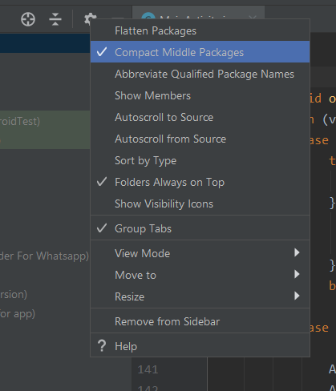

2. Your package directory will now be broken up in individual directories.

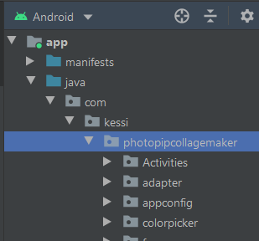

3. Individually select each directory you want to rename, and: Right-click it Select Refactor Click on Rename In the Pop-up dialog.

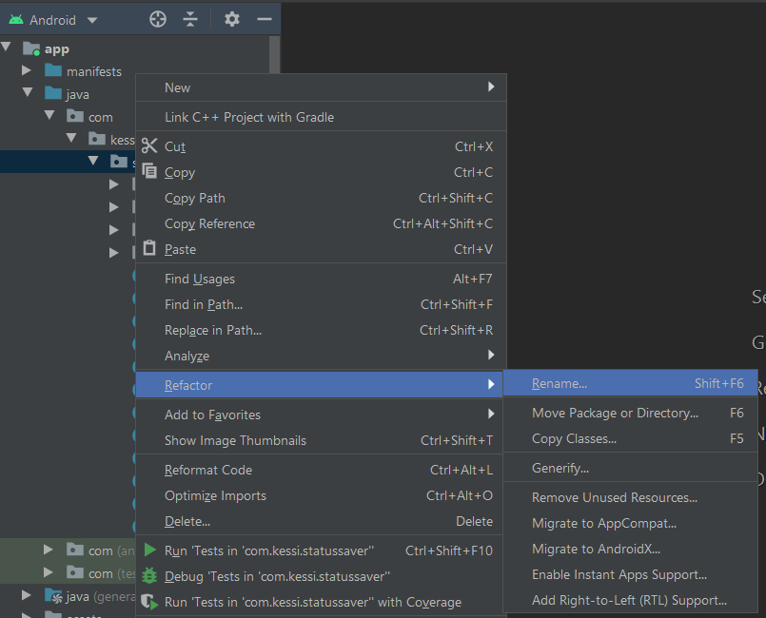

4. Click on Rename Package instead of Rename Directory Enter the new name and hit Refactor Allow a minute to let Android Studio update all changes.

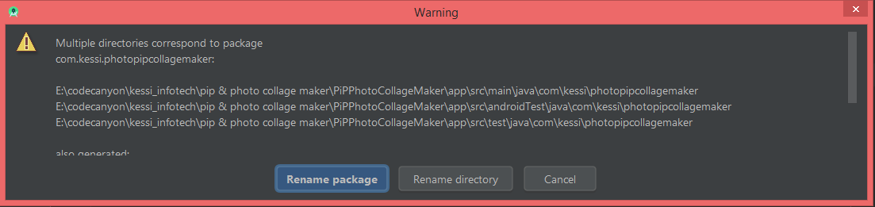

5. Now open your build.gradle (Usually 'app' or 'mobile'). Update the applicationId to your Package Name and Sync Gradle, if it hasn't already been updated automatically.

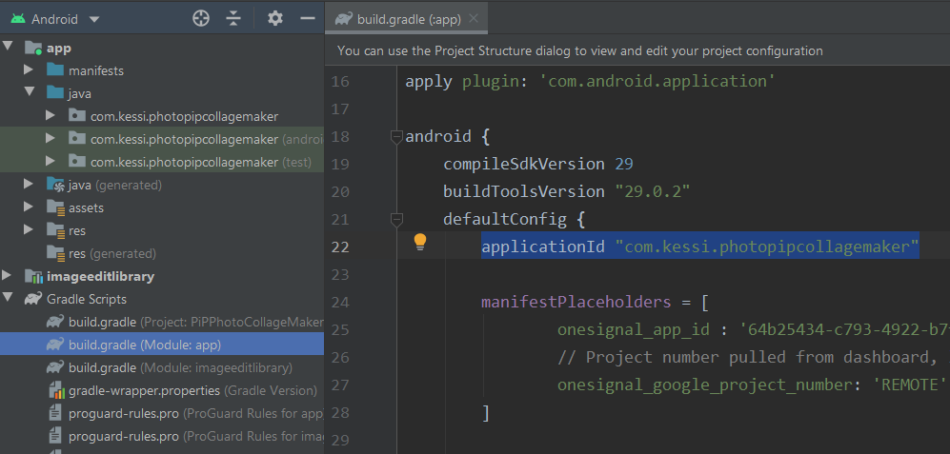

NOTE: When renaming com in Android Studio, it might give a warning. In such case, select Rename All.

**Step 4** : **How to change app name?**

1. Open Android Studio > PIP & Photo Collage Maker > res > values > strings.xml.

2. Enter your app name inside "app\_name" string tag:

<string name="app\_name"> PIP & Photo Collage Maker </string>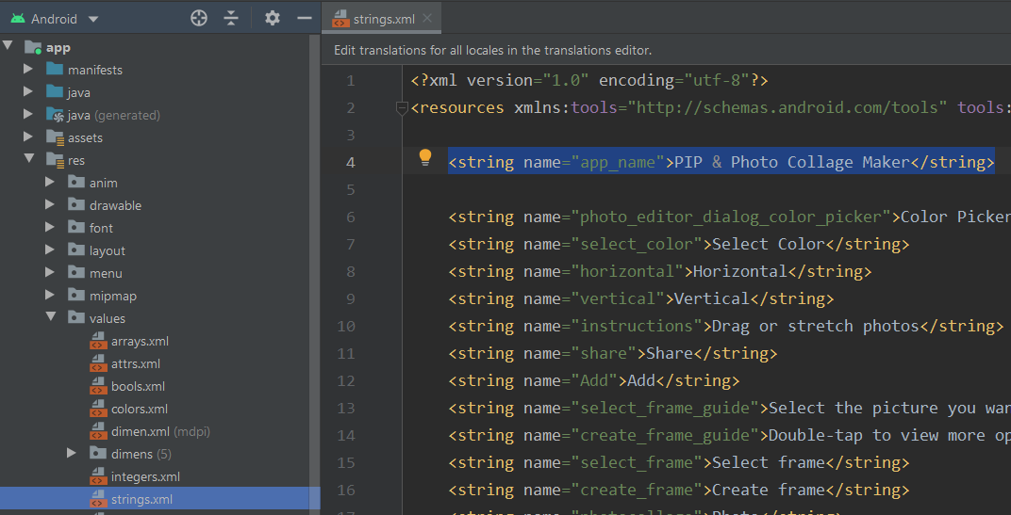

**Step 5** : **How to Change Application Icon?**

1. Open Android Studio > app > res >.

2. Replace your icon with ic\_launcher.png and paste in all mipmap folders.

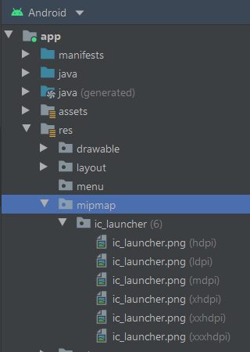

**Step 6 : How to change admob id's?**

**1.** Open Android Studio > PIP & Photo Collage Maker > res > values > strings.xml.

**2.** Enter your admob app id inside "admob\_app\_id" string tag:  
<string name="admob\_app\_id"> ca-app-pub-3940256099942544~6300978111 </string>

**3.** Enter your admob banner id inside "banner\_id" string tag:  
<string name="banner\_id"> ca-app-pub-3940256099942544/6300978111 </string>

**4.** Enter your admob interstitial id inside "admob\_interstitial\_id" string tag:  
<string name="admob\_interstitial\_id"> ca-app-pub-3940256099942544/1033173712 </string>

**Step 7 : How to change AppLovin(MAX) ad id's?**

**1.** Open Android Studio > PIP & Photo Collage Maker > res > values > strings.xml.

**2.** Enter your AppLovin ad banner id inside " max\_banner" string tag:  
<string name=" max\_banner ">xxxxxxxxxxxxxxxx</string>

**3.** Enter your AppLovin ad interstitial id inside " max\_interstitial " string tag:  
<string name=" max\_interstitial ">xxxxxxxxxxxxxxxx</string>

**Note : Login with Applovin account and follow this below link for fb bidding ads with AppLovin(MAX)**

<https://dash.applovin.com/documentation/mediation/android/mediation-setup/facebook>

**Step 8 : How to enable/disable AppLovin ad & admob ad?**

1.Open Android Studio > PIP & Photo Collage Maker and goto the AdManager.Java

2.For display Applovin ads make isLoadFbAd = true

3.For display Admob ads make isLoadFbAd = false

**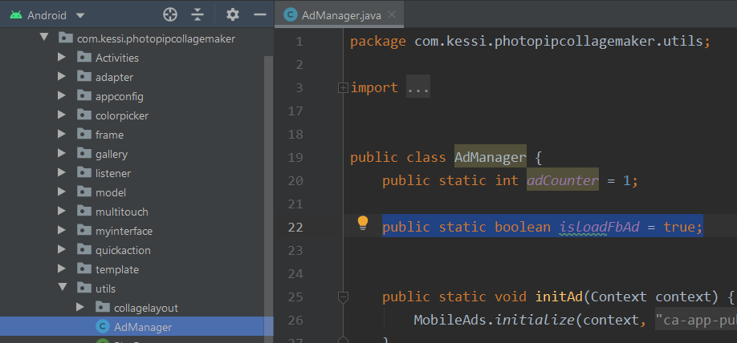**

**Step 9 : How to setup Onesignal?**

**1.** Open Onesignal website from here & login.

[**https://onesignal.com/**](https://onesignal.com/)

**2.** Click on NEW APP/WEBSITE button.

**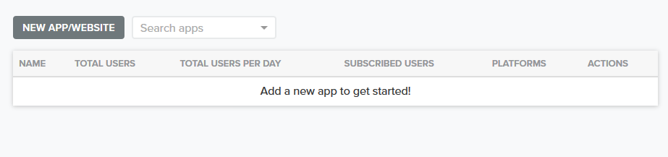**

**3.** Insert app name, select google android and click on next button.

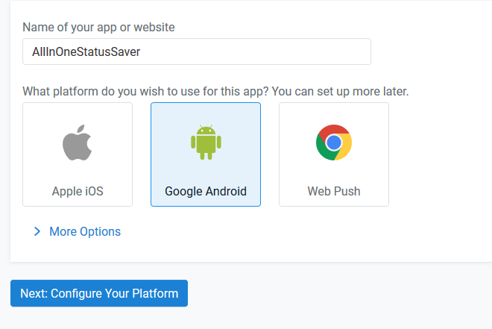

**4.** Now open firebase console website from here.

<https://console.firebase.google.com/>

**5.** Click on "Add Project" button.

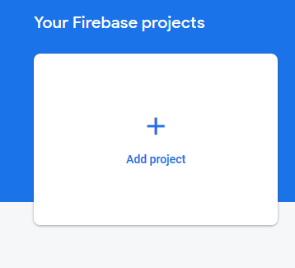

**6.** Enter project name & Click on "Continue" button.

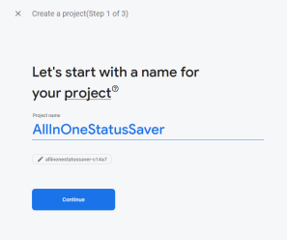

**7.** Again Click on "Continue" button.

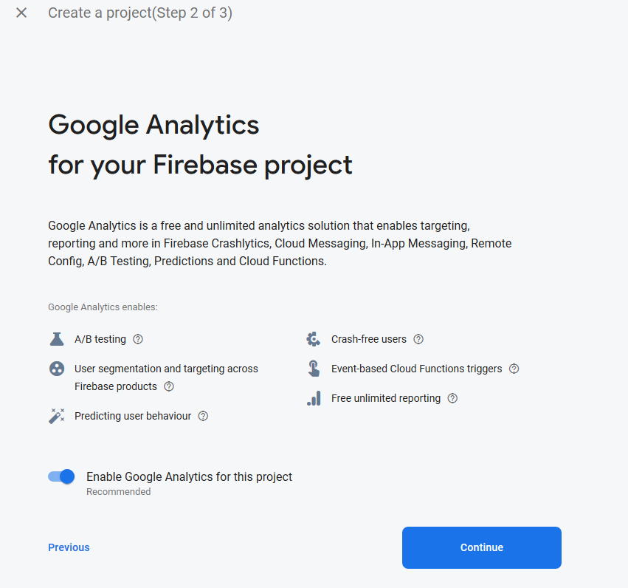

**8.** Select location and check mark all options then Click on "Create Project" button.

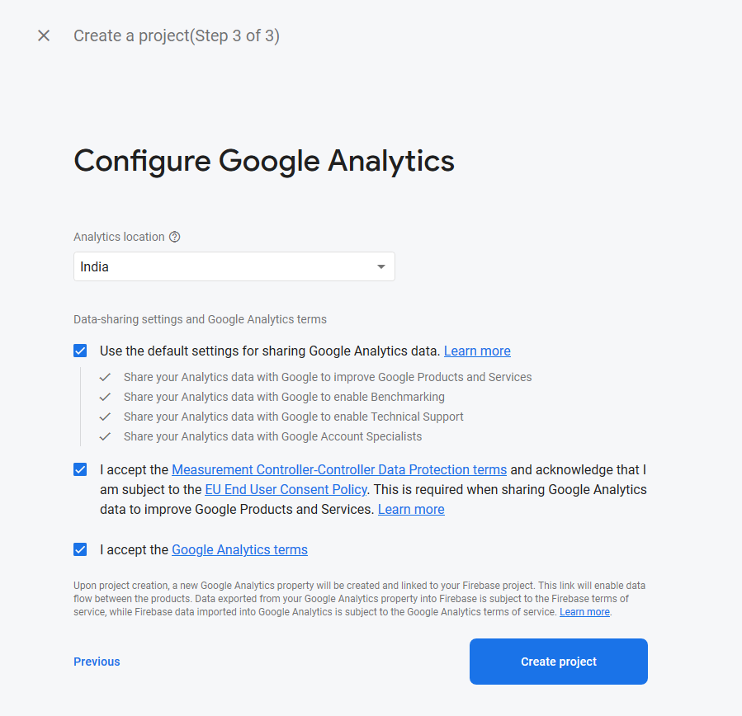

**9.** Click on "Continue" button.

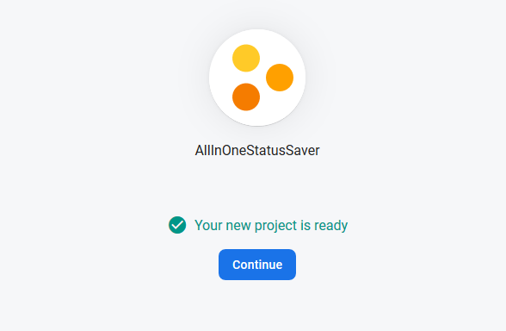

**10.** Click on "Settings/Project settings" button.

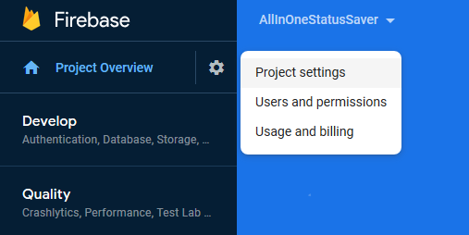

**11.** Copy Sever key & Sender ID One By One.

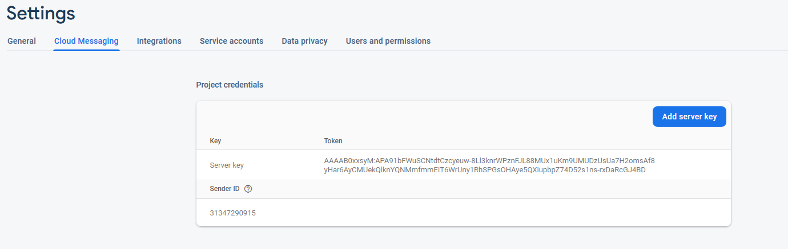

**12.** Come back to the Onesignal.com and paste Sever key & Sender ID here and click on "Next" button.

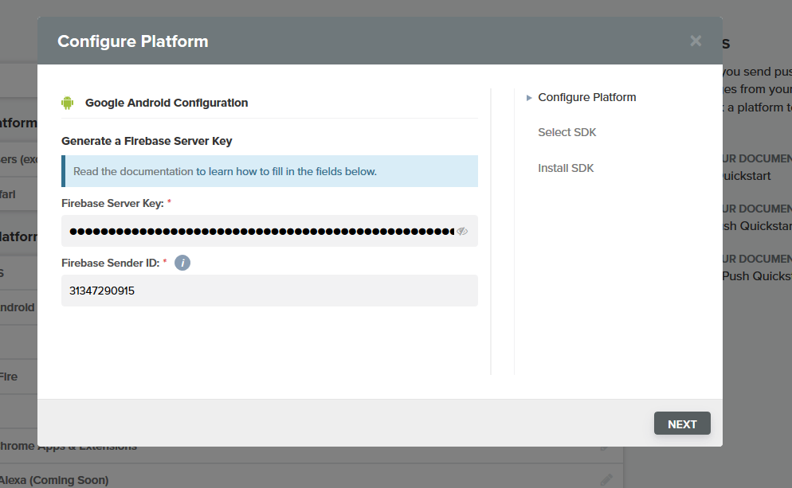

**13.** Select your target sdk as "Native Android" and Click on "Next" button

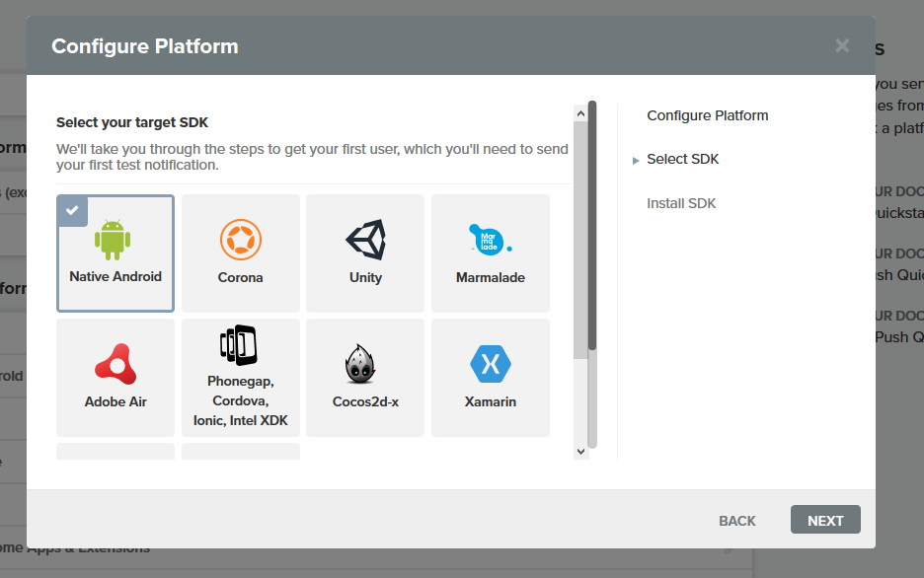

**14.** Click on "SAVE" button.

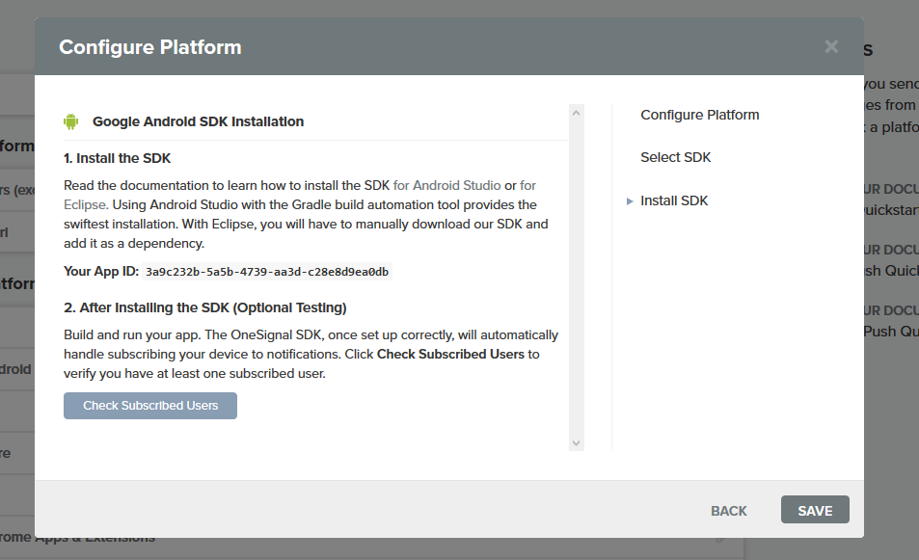

**15.** Go to Settings/Keys&IDs and copy "ONESIGNAL APP ID".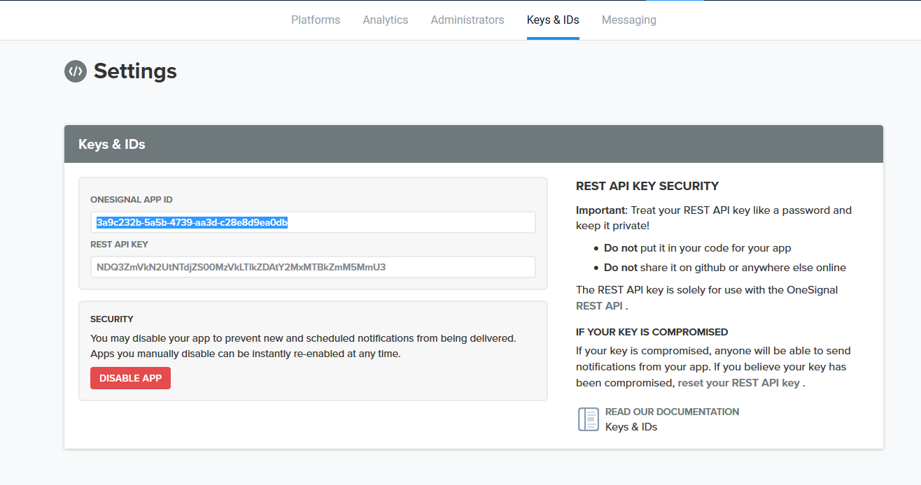

**16.** Open Android Studio > PIP & Photo Collage Maker and open build.gradle then paste your ONESIGNAL APP ID here.

onesignal\_app\_id: ' 64b25434-c793-4922-b7f4-a66efef26ba7 '

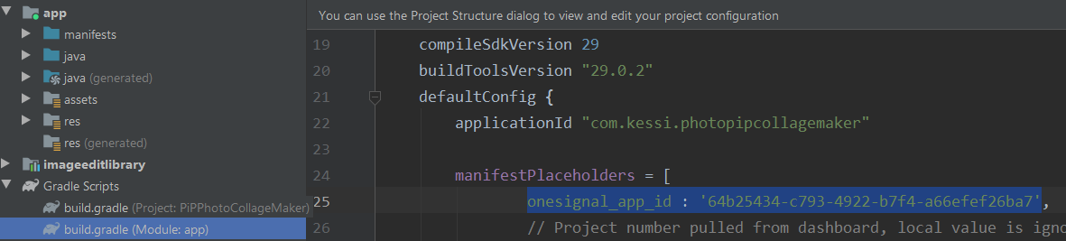

**Thank you so much for purchasing this Android App. As I said at the beginning, I'd be glad to help you if you have any questions relating to this Android App. No guarantees, but I'll do my best to assist. If you have a more general question relating to the app please send mail us on "kessiinfotech@gmail.com"**