CALENDAR
CALENDAR WEB APPLICATION
Use Case Specifications

Project Code: TCS
Document Code: SRS_CAL_WEBAPP_MasterPage _v0.1

Ha Noi

Record of change

*A - Added M - Modified D - Deleted
Effective Date | Changed Items | A*  M, D | Change Description | New Version
06-Nov-08 |  | A | First created | 1.0
11-Nov-08 |  | M | Changes after first review from CIE | 1.1

SIGNATURE PAGE

ORIGINATOR: 29-Oct-08
Team leader

REVIEWERS: 06-Nov-08
PTL

06-Nov-08

APPROVAL:

TABLE OF CONTENTS
1 Introduction 5
1.1 Purpose 5
1.2 Scope 5
1.3 Definitions, Acronyms, and Abbreviations 5
1.4 References 5
2 HIGH LEVEL REQUIREMENTS 6
2.1 Business Essence 6
2.2 High level use case 7
2.3 Use cases diagrams 8
3 Specific Requirements 10
3.1 Functionality 10
3.2 Data field valid conditions 76
4 Non Functional Specification 78
4.1 Usability 78
4.2 Reliability 78
4.2.1 Availability 78
4.2.2 System Dependencies 78
4.2.3 Bugs and Defect Rates 78
4.3 In SDC process, there are four bug severities. Each severity has a weighted value as in table below: 78
4.4 Performance 80
4.5 Supportability 80

Introduction

Purpose
CIE-PDB Use Case Specifications document is the complete and comprehensive description of software requirement. This system is a window form based application, which performs various functions on the CIE pricing data and Admin functions.
This document will be the basic for further analysis and design model.

Scope
The scope of this project:
+ Planning, Studying requirement, Designing, Coding and Testing.
+ Deploying the system.

Definitions, Acronyms, and Abbreviations
No | Abbreviations | Description
1
2

References
EXAMPLE Standard 07-08.pdf
EXAMPLE CIE Pricing Database.xls
Project Brief.doc

HIGH LEVEL REQUIREMENTS

Business Essence
Main functions of system are listed as following:
+ View price list
+ Create/Update price list
+ Generate review schedule
+ Archive price list
+ View/Print audit log
+ Maintain static data
+ Authenticate user

High level use case
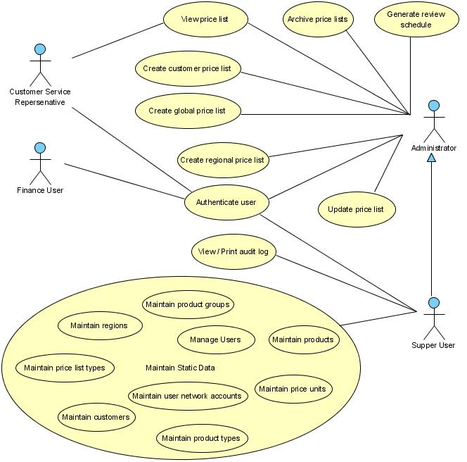
High-level use case

Use cases diagrams

Actor description
# | Actor | Description
1 | Finance user | Can log in the system
2 | Customer service representative | Can view price list only
3 | Administrator | Can view price list, create/update price list, generate review schedule, archive price list
4 | Super user | is inherited roles from administrator roles, allowed to maintain the static data and view/print audit log

Use case description
# | Code | Name | Brief Description
1 | UC01 | Maintain price units | Allows user to maintain Price Units
2 | UC02 | Maintain product types | Allows user to maintain Product Types
3 | UC03 | Maintain product groups | Allows user to maintain Product Groups
4 | UC04 | Maintain products | Allows user to maintain Products
5 | UC05 | Maintain price list types | Allows user to maintain Price List Types
6 | UC06 | Maintain regions | Allows user to maintain regions
7 | UC07 | Maintain customers | Allows user to maintain Customers
8 | UC08 | View price list | Allows user to search and view global price list, regional price list and customer price list
9 | UC09 | Create global price list | Allows user to create global price list
10 | UC10 | Create regional price list | Allows user to create regional price list
11 | UC11 | Create customer price list | Allows user to create customer price list
12 | UC12 | Update price list | Allows user to update global price list, regional price list and customer price list
13 | UC13 | Generate review schedule | Allows user to generate review schedule and mark any price list as reviewed
14 | UC14 | Archive price lists | Allows user to archive price lists that are not currently.
15 | UC15 | Maintain user network accounts | Allows administrator to maintain list of user account
16 | UC16 | View/print audit log | Allows user to view and print out audit log
17 | UC17 | Authenticate user | System verifies permissions of user

Screens

Screen flow
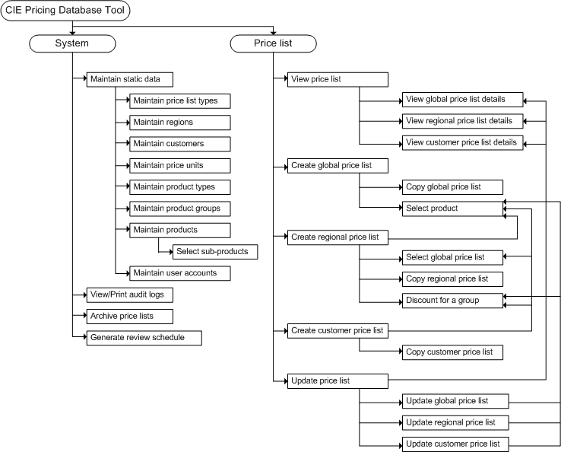

Screen description
# | Screen name | Brief Description
1 | Maintain price units | Allows user to maintain Price Units
2 | Maintain product types | Allows user to maintain Product Types
3 | Maintain product groups | Allows user to maintain Product Groups
4 | Maintain products | Allows user to maintain Products
5 | Maintain price list types | Allows user to maintain price list types
6 | Maintain regions | Allows user to maintain regions
7 | Maintain customers | Allows user to maintain customers
8 | Select sub-products | Allows user to select sub-products of a product
9 | Maintain user accounts | Allows administrator to maintain list of user accounts
10 | View/print audit log | Allows user to view and print out audit log
11 | Archive price lists | Allows user to archive price lists that are not currently.
12 | Generate review schedule | Allows user to generate review schedule and mark any price list as reviewed
13 | View price list | Allows user to search price lists
14 | View global price list details | Allows user to view details of a global price list
15 | View regional price list details | Allows user to view details of a regional price list
16 | View customer price list details | Allows user to view details of a customer price list
17 | Create global price list | Allows user to create a global price list
18 | Copy global price list | Allows user to create a global price list by copying from another price list
19 | Select product | Allows user to select products to add to price list
20 | Create regional price list | Allows user to create regional price list
21 | Select global price list | Allows user to select a global price list which is applied to a specific price list
22 | Copy regional price list | Allows user to create a regional price list by copying from another price list
23 | Discount for a product group | Allows user to adjust the price for a group of products
24 | Create customer price list | Allows user to create customer price list
25 | Copy customer price list | Allows user to create a customer price list by copying from another price list
26 | Update price list | Allows user to search for a price list to be updated
27 | Update global price list | Allows user to update a global price list
28 | Update regional price list | Allows user to update a regional price list
29 | Update customer price list | Allows user to update a customer price list

Specific Requirements

Functionality

UC01: Maintain price units
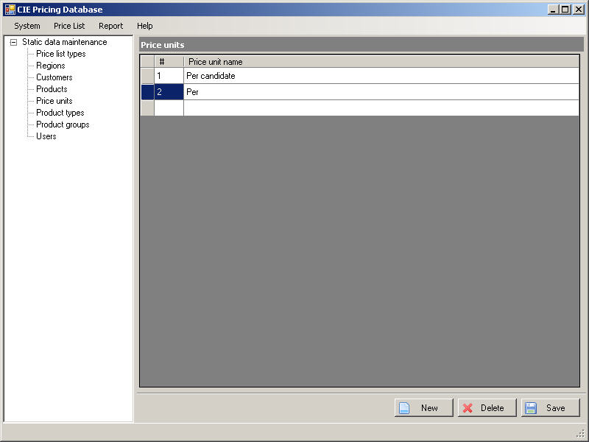
Figure 1. “Maintain price unit” screen

UC01: Maintain price units
Goal in Context |  |  | This use case allows the actor to display list of price units.  The actor can then select a single price unit for updating or deleting.  The actor can insert a single price unit into list.
Pre-Condition |  |  | The actor has successfully logged into the system and has Super User role.
Post-Condition |  |  | The tool shall bring back data that is appropriate to the actor’s request
Step | Subject  (Actor) | Verb  (Event) |  | Object  (Entity) | Response
Main Success Scenario
Pre-Condition |  | The actor has successfully logged into the system and has Super User role.
1. | Super User | Select |  | “Maintain Static Data” menu item on “System” menu | “Maintain static data” screen is opened on application window.
2. | Super User | Select |  | ‘Price units’ in the left menu tree on screen | System displays the list of price units with the first of list row is focused
3. | Super User | Click |  | “New” button | If a blank row has not created  Then  System creates a new row and focuses on “Price unit name” cell.  Else  System focuses on “Price unit name” cell inside blank row at the end of list.
4. | Super User | Input |  | Cells | Input data into “Price unit name” cell (see 3.2. Data field valid conditions).  Actor cannot leave a row until all valid conditions of fields on that row are satisfied.
5. | Super User | Select |  | Row | System focuses on selected row.
6. | Super User | Click |  | Button “Delete” | System displays a confirmation message box: “Do you want to delete this record?” with “Yes/No” options.
6a. | Super User | Click |  | Button “Yes” | If there is a product associated with this price unit then system display a message box “This price unit has Products associated with it. System can not implement this action.”  Else system deletes selected price unit from list.
6b. | Super User | Click |  | Button “No” | System closes the confirmation message box and returns to the price unit screen.
7. | Super User | Click |  | Button “Save” | System checks empty condition on field “Price unit name” of each updated row or added row. If the field is empty then displays message “Price unit name can not be empty.”  Else  System checks duplicate data, if the name already exists then displays message “Price unit name can not be duplicated.”  If validation process is completed successfully without any warning message then system saves the list into database.

UC02: Maintain product types
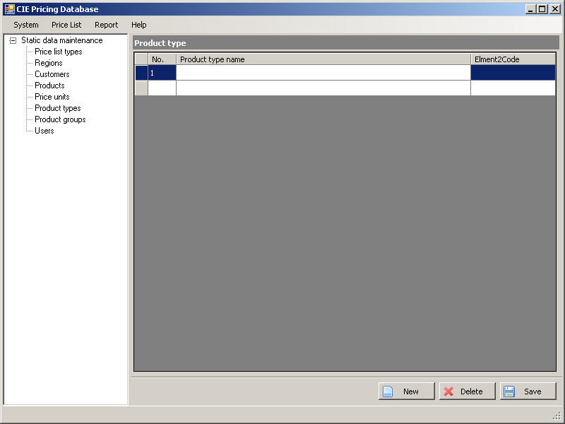
Figure 03: “Maintain Product Type” screen
UC02: Maintain product types
Goal in Context |  |  | This use case allows the actor to display list of product types.  The actor can then select a single product type for updating or deleting.  The actor can insert a single product type into list.
Pre-Condition |  |  | The actor has successfully logged into the system and has Super User role.
Post-Condition |  |  | The tool shall bring back data that is appropriate to the actor’s request
Step | Subject  (Actor) | Verb  (Event) |  | Object  (Entity) | Response
Main Success Scenario
Pre-Condition |  | The actor has successfully logged into the system and has Super User role.
1. | Super User | Select |  | “Maintain Static Data” menu item on “System” menu | “Maintain static data” screen is opened on application window.
2. | Super User | Select |  | ‘Product types’ in the left menu tree on screen | System displays the list of product types.
3. | Super User | Click |  | “New” button | If a blank row has not created  Then  System creates a new row and focuses on “Product type name” cell.  Else  System focuses on “Product type name” cell inside blank row at the end of list.
4. | Super User | Input |  | Cells | Input data into cells: “Product type name”, “Element2Code” (see 3.2. Data field valid conditions).  Actor cannot leave a row until all valid conditions of fields on that row are satisfied.
5. | Super User | Select |  | Row | System focuses on selected row.
6. | Super User | Click |  | Button “Delete” | System displays a confirmation message box: “Do you want to delete this record?” with “Yes/No” options.
6a. | Super User | Click |  | Button “Yes” | If there is a product associated with this product type then system display a message box “This product type has Products associated with it. System can not implement this action.”  Else  System deletes selected product type from list.
6b. | Super User | Click |  | Button “No” | System closes confirmation message box and returns to product type screen.
7. | Super User | Click |  | Button “Save” | System checks empty condition on field “Product type name” of each updated row or new row. If the field is empty then displays message “Product type name can not be empty.”  Else  System checks duplicate data, if the name already exists then displays message “product type name can not be duplicated.”  If validation process is completed successfully without any warning message then system saves the list into database.

UC03: Maintain product groups
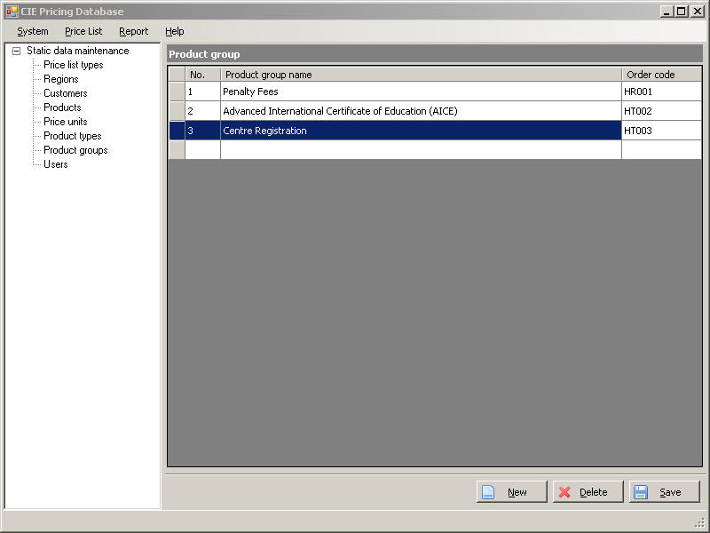
Figure 04: “Maintain product group” screen

UC03: Maintain product groups
Goal in Context |  |  | This use case allows the actor to display Product Groups list.  The actor can then select a single product group for updating or deleting.  The actor can insert a single product group into list.
Pre-Condition |  |  | The actor has successfully logged into the system and has Super User role.
Post-Condition |  |  | The tool shall bring back data that is appropriate to the actor’s request
Step | Subject  (Actor) | Verb  (Event) |  | Object  (Entity) | Response
Main Success Scenario
Pre-Condition |  | The actor has successfully logged into the system and has Super User role.
1. | Super User | Select |  | “Maintain Static Data” menu item on “System” menu | “Maintain static data” screen is opened on application window.
2. | Super User | Select |  | ‘Product group’ in the left menu tree on screen | System displays the list of product group.
3. | Super User | Click |  | “New” button | If a blank row has not created  Then  System creates a new row and focuses on “Product group name” cell.  Else  System focuses on “Product group name” cell inside blank row at the end of list.
4. | Super User | Input |  | Cells | Input data into cells: “Product group name”, “Order code” (see 3.2. Data field valid conditions).  Actor cannot leave a row until all valid conditions of fields on that row are satisfied.
5. | Super User | Select |  | Row | System focuses on selected row.
6. | Super User | Click |  | Button “Delete” | System displays a confirmation message box: “Do you want to delete this record?” with “Yes/No” options.
6a. | Super User | Click |  | Button “Yes” | If there is any product associated with this product group then system display a message box “This product group has Products associated with it. System can not implement this action.”  Else  System deletes selected product group from list.
6b. | Super User | Click |  | Button “No” | System closes the confirmation message box and returns to the “Maintain product groups” screen.
7. | Super User | Click |  | Button “Save” | System checks empty condition on fields “Product group name” and “Order code” of each updated row or added row. If the field is empty then displays message “Product group name can not be empty.” Or “Order code can not be empty.”  Else  System checks duplicate data, if the name already exists then displays message “Product group name can not be duplicated.”  If validation process is completed successfully without any warning message then system saves the list into database.

UC04: Maintain products
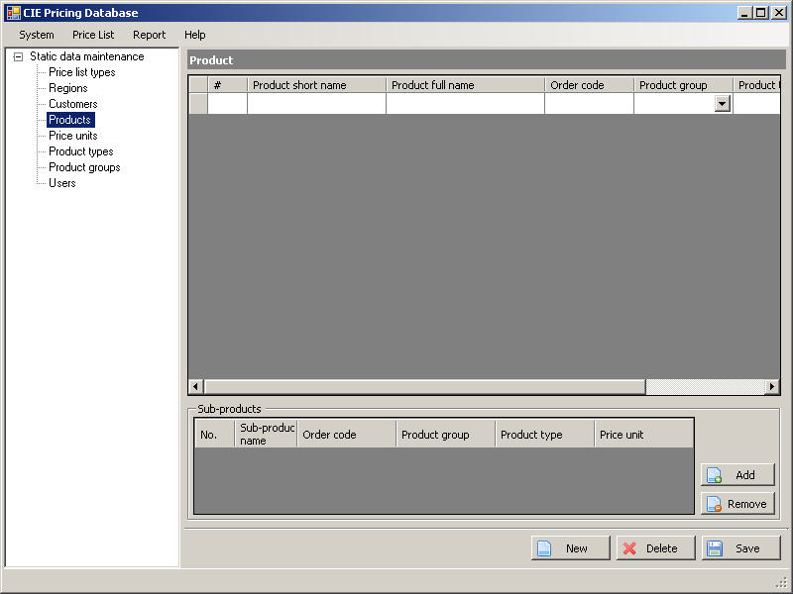
Figure 05a: “Maintain products” screen
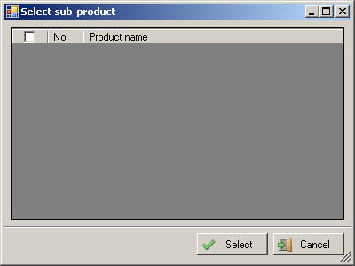
Figure 05b: “Select sub-products” screen

UC04: Maintain products
Goal in Context |  |  | This use case allows the actor to display list of product.  The actor can then select a single product for updating or deleting.  The actor can insert a single product into list.
Pre-Condition |  |  | The actor has successfully logged into the system and has Super User role.
Post-Condition |  |  | The tool shall bring back data that is appropriate to the actor’s request
Step | Subject  (Actor) | Verb  (Event) |  | Object  (Entity) | Response
Main Success Scenario
Pre-Condition |  | The actor has successfully logged into the system and has Super User role.
1. | Super User | Select |  | “Maintain Static Data” menu item on “System” menu | “Maintain static data” screen is opened on application window.
2. | Super User | Select |  | ‘Product’ in the left menu tree on screen | System displays the list of products with the first row of list focused
3. | Super User | Click |  | “New” button | If a blank row has not created  Then  System creates a new row and focuses on “Product name” cell.  Else  System focuses on “Product name” cell inside blank row at the end of list.
4. | Super User | Input |  | Cells | Input data into “Product short name”, “Product full name”, “Order code” cells, selected value in “Product group”, “Product type”, “Price unit” cells (see 3.2. Data field valid conditions).  Actor cannot leave a row until all valid conditions of fields on that row are satisfied.
5. | Super User | Select |  | Row | System focuses on selected row.
6. | Super User | Click |  | Button “Delete” | System displays a confirmation message box: “Do you want to delete this record?” with “Yes/No” options.
6a. | Super User | Click |  | Button “Yes” | If there is any price list associated with this product then system display a message box “This product has price list associated with it. System can not implement this action.”  Else, system deletes selected product from list.
6b. | Super User | Click |  | Button “No” | System closes the confirmation message box and returns to the “Maintain products” screen.
7. | Super User | Click |  | Button “Add” | “Select sub-product” screen is showed on application window.
7a. | Super User | Click |  | “Select” button | - Actor select products they want to add to sub-product list.  - Actor select “Select” button.  - All selected products will be copied to list of sub-products on “Maintain Product” screen.  System closes the message box.
7b. | Super User | Click |  | “Cancel” button | System closes the message box.
8. | Super User | Select |  | A row in sub-product list | System focuses on the selected row.
8a. | Super User | Select |  | “Remove” button | System displays message box “Do you want remove this Sub-Product?” with “Yes/No” options.
8b. | Super User | Select |  | “Yes” button | Selected sub-product will be removed from list.
8c. | Super User | Select |  | “No” button | Cancel action removing a sub-product
9. | Super User | Click |  | Button “Save” | System checks empty condition on fields “Product short name”, “Product full name”, “Order code”, “Product group”, “Product type”, “Price unit” of each updated row or added row. If any field is empty then displays message:  “Product short name can not be empty.”  Or “Product full name can not be empty.”  Or “Order code can not be empty.”  Or “Product group has to be selected.”  Or “Product type has to be selected.”  Or “Price unit has to be selected.”  Else  System checks duplicate data, if the “Product full name” already exists then displays message “Product full name can not be duplicated.”  If validation process is completed successfully without any warning message then system saves the list into database.

UC05: Maintain price list types
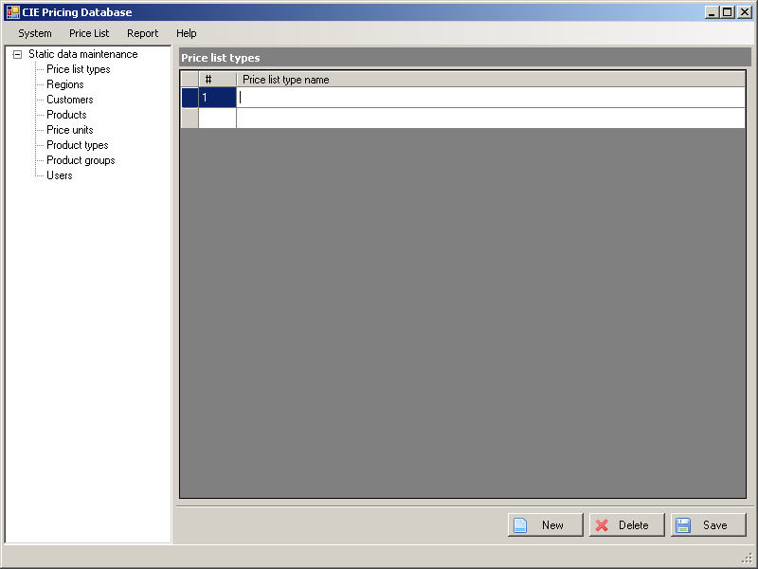
Figure 06: “Maintain price list types” screen

UC05: Maintain price list types
Goal in Context |  |  | This use case allows the actor to display price list type list.  The actor can then select a single price list type for updating or deleting.  The actor can insert a single price list type into list.
Pre-Condition |  |  | The actor has successfully logged into the system and has Super User role.
Post-Condition |  |  | The tool shall bring back data that is appropriate to the actor’s request
Step | Subject  (Actor) | Verb  (Event) |  | Object  (Entity) | Response
Main Success Scenario
Pre-Condition |  | The actor has successfully logged into the system and has Super User role.
1. | Super User | Select |  | “Maintain Static Data” menu item on “System” menu | “Maintain static data” screen is opened on application window.
2. | Super User | Select |  | ‘Price list type’ in the left menu tree on screen | System displays the list of price list type.
3. | Super User | Click |  | “New” button | If a blank row has not created  Then  System creates a new row and focuses on “Price list type name” cell.  Else  System focuses on “Price list type name” cell inside blank row at the end of list.
4. | Super User | Input |  | Cells | Input data into cell: “Price list type name” (see 3.2. Data field valid conditions).  Actor cannot leave a row until all valid conditions of fields on that row are satisfied.
5. | Super User | Select |  | Row | System focuses on the selected row.
6. | Super User | Click |  | “Delete” button | System displays a confirmation message box: “Do you want to delete this record?” with “Yes/No” options.
6a. | Super User | Click |  | “Yes” button | If there is any price list associated with this price list type then system display a message box “This price list type has price lists associated with it. System can not implement this action.”  Else  System deletes the selected price list type from list.
6b. | Super User | Click |  | “No” button | System closes the confirmation message box and returns to the “Maintain price list types” screen.
7. | Super User | Click |  | “Save” button | System checks empty condition on field “Price list type name” of each updated row or added row. If the field is empty then displays message “Price list type name can not be empty.”  Else  System checks duplicate data, if the “Price list type name” already exists then displays message “Price list type name can not be duplicated.”  If validation process is completed successfully without any warning message then system saves the list into database.

UC06: Maintain regions
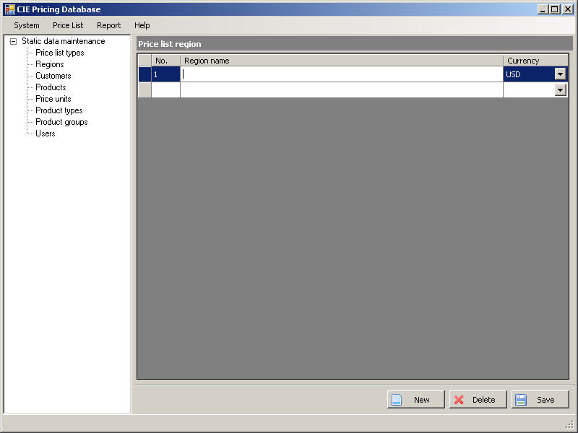
Figure 07: “Maintain regions” screen

UC06: Maintain regions
Goal in Context |  |  | This use case allows the actor to display region list.  The actor can then select a single price list region for updating or deleting.  The actor can insert a single price list region into list.
Pre-Condition |  |  | The actor has successfully logged into the system and has Super User role.
Post-Condition |  |  | The tool shall bring back data that is appropriate to the actor’s request
Step | Subject  (Actor) | Verb  (Event) |  | Object  (Entity) | Response
Main Success Scenario
Pre-Condition |  | The actor has successfully logged into the system and has Super User role.
1. | Super User | Select |  | “Maintain Static Data” menu item on “System” menu | “Maintain static data” screen is opened on application window.
2. | Super User | Select |  | ‘Regions’ in the left menu tree on screen | System displays the list of regions.
3. | Super User | Click |  | “New” button | If a blank row has not created  Then  System creates a new row and focuses on “Region name” cell.  Else  System focuses on “Region name” cell inside blank row at the end of list.
4. | Super User | Input |  | Cells | Input data into cell “Region name” and select “Currency” (see 3.2. Data field valid conditions).  Actor cannot leave a row until all valid conditions of fields on that row are satisfied.
5. | Super User | Select |  | Row | System focuses on the selected row.
6. | Super User | Click |  | Button “Delete” | System displays a confirmation message box: “Do you want to delete this record?” with “Yes/No” options.
6a. | Super User | Click |  | Button “Yes” | If there is any customer or price list associated with this region then system display a message box “This region has customer and/or price list associated with it. System can not implement this action.”  Else  System deletes selected price list region from list.
6b. | Super User | Click |  | Button “No” | System closes the confirmation message box and returns to the “Maintain regions” screen.
7. | Super User | Click |  | Button “Save” | System checks empty condition on field “Region name” of each updated row or added row. If the field is empty then displays message “Region name can not be empty.”  Else  System checks duplicate data, if the “Region name” already exists then displays message “Region name can not be duplicated.”  If validation process is completed successfully without any warning message then system saves the list into database.

UC07: Maintain customers
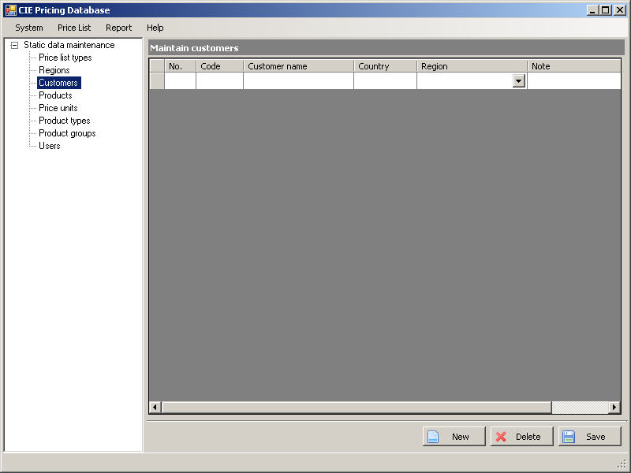
Figure 10: “Maintain customers” screen

UC07: Maintain customers
Goal in Context |  |  | This use case allows the actor to display customer list.  The actor can then select a single customer for updating or deleting.  The actor can insert a single customer into list.
Pre-Condition |  |  | The actor has successfully logged into the system and has Super User role.
Post-Condition |  |  | The tool shall bring back data that is appropriate to the actor’s request
Step | Subject  (Actor) | Verb  (Event) |  | Object  (Entity) | Response
Main Success Scenario
Pre-Condition |  | The actor has successfully logged into the system and has Super User role.
1. | Super User | Select |  | “Maintain Static Data” menu item on “System” menu | “Maintain static data” screen is opened on application window.
2. | Super User | Select |  | ‘Customers’ in the left menu tree on screen | System displays the list of customers.
3. | Super User | Click |  | “New” button | If a blank row has not created  Then  System creates a new row and focuses on “Customer code” cell.  Else  System focuses on “Customer code” cell inside blank row at the end of list.
4. | Super User | Input |  | Cells | Actor gives input data into cells “Customer code”, “Customer name”, “Country”, “Note” and select “Region” (see 3.2. Data field valid conditions).  Actor cannot leave a row until all valid conditions of fields on that row are satisfied.
5. | Super User | Select |  | Row | System focuses on the selected row.
6. | Super User | Click |  | Button “Delete” | System displays a confirmation message box: “Do you want to delete this record?” with “Yes/No” options.
6a. | Super User | Click |  | Button “Yes” | If there is any price list associated with this customer  Then  System display a message box “This customer has price list associated with it. System can not implement this action.”  Else  System deletes selected customer from list.
6b. | Super User | Click |  | Button “No” | System closes confirmation message box and returns to “Maintain customers” screen.
7. | Super User | Click |  | Button “Save” | System checks empty condition on fields “Customer code”, “Customer name”, “Region” of each updated row or added row. If any field is empty then displays message:  “Customer code can not be empty.”  Or “Customer name can not be empty.”  Or “Region has to be selected.”  Else  System checks duplicate data, if the “Customer code” or “Customer name” already exists then displays message:  “Customer code can not be duplicated.”  Or “Customer name can not be duplicated”  If validation process is completed successfully without any warning message then system saves the list into database.

UC08: View price list
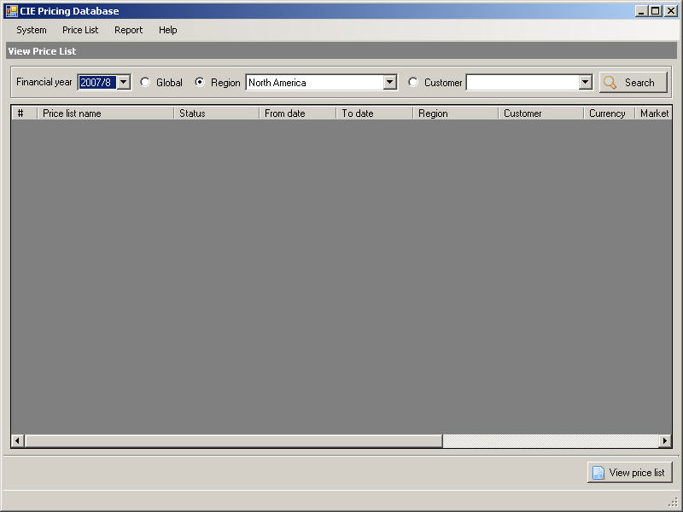
Figure 9a: “View price list” screen
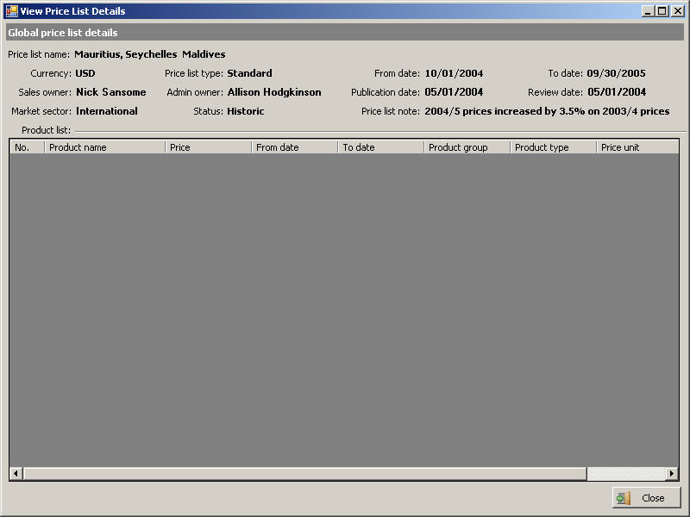
Figure 9b: “View global price list details” screen
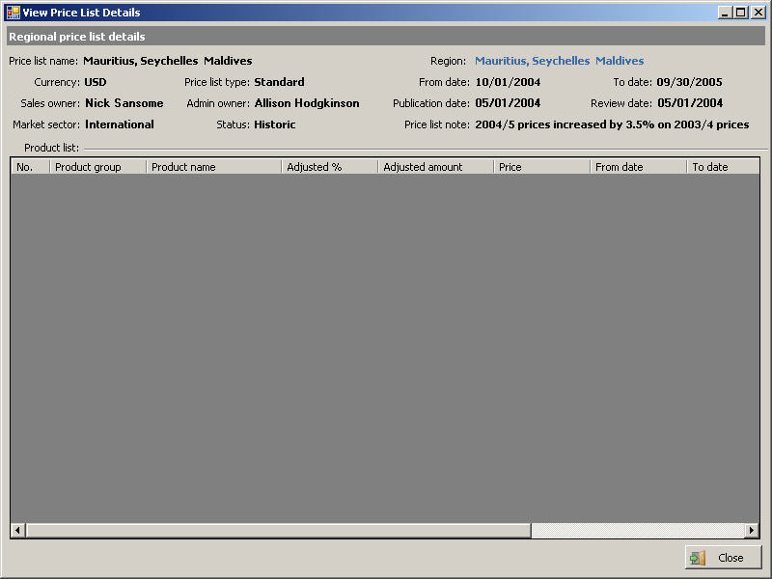
Figure 9c. “View regional price list details” screen
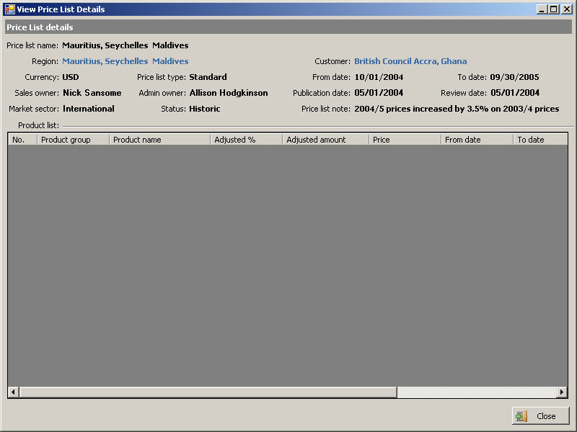
Figure 9d. “View customer price list details” screen

UC08: View price list
Goal in Context |  |  | The actor can query price lists by inputting query options. They can select a price list and view details also.
Pre-Condition |  |  | The actor has successfully logged into the system and has Customer service representative role or Administrator role or Super User role.
Post-Condition |  |  | The tool shall bring back data that is appropriate to the actor’s request
Step | Subject  (Actor) | Verb  (Event) |  | Object  (Entity) | Response
1. | Customer service representative  or  Administrator  or  Super User | Select |  | “Price List/View Price List” menu item | The system displays the screen without any price list. Button “View price list” is disabled.  (see Figure 9a: View Price List)
2. | Customer service representative  or  Administrator  or  Super User | Input |  | Query selection: Combo boxes/Radio boxes | Actor can select financial year from “Financial year” combo box.  If actor selects “Global” radio button then “Region” combo box and “Customer” combo box are disabled.  If actor selects “Region” radio button then “Region” combo box is enabled and “Customer” combo box is disabled. Actor can select region from “Region” combo box.  If user selects “customer” radio button then “Region” combo box and “Customer” combo box are enabled. Actor can select region from “region” combo box and select customer from “Customer” combo box.
3. | Customer service representative  or  Administrator  or  Super User | Select |  | ‘Search’ button | System returns results and displays in following columns:  - No.  - Price list name  - Status  - From date  - To date  - Currency  - Region  - Customer  - Sale owner  - Market sector  - Publication date  - Review date  - Price list note
4. | Customer service representative  or  Administrator  or  Super User | Select |  | Single row in result list | System focus and change background color of selected row. Actor can then perform more functions.  System enables button “View price list”.
5. | Customer service representative  or  Administrator  or  Super User | Select |  | “View price list” button | System displays details of selected price list on a popup window.  If “Global” radio is selected then “View global price list details” screen will be showed (see Figure 9b: “View global price list details” screen).  If “Region” radio is selected then “View regional price list details” screen will be showed (see Figure 9c: “View regional price list details” screen).  If “Customer” radio is selected then “View customer price list details” screen will be showed (see Figure 9d: “View customer price list details” screen).

UC09: Create global price list
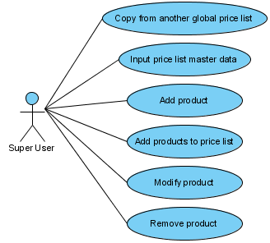
Figure 9. UC09 Create global price list

UC09A. Create global price list
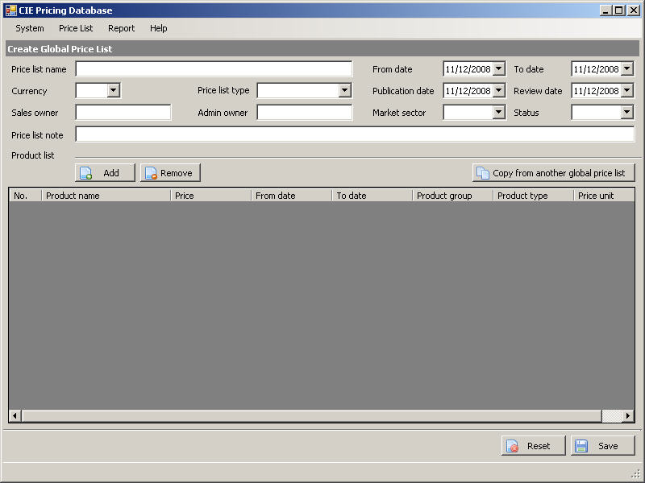
Figure 09a: “Create Global Price List” screen

UC09: Create global price list
Goal in Context |  |  | Actor can create new price list by copying data from another price list and replace some data fields if needed.  Actor can insert a product to product list.  Actor can remove product from product list.  Actor can also modify properties of a product.
Pre-Condition |  |  | The actor has successfully logged into the system and has Administrator role or Super User role.
Post-Condition |  |  | The tool shall bring back data that is appropriate to the actor’s request
Step | Subject  (Actor) | Verb  (Event) |  | Object  (Entity) | Response
1. | Administrator  or  Super User | Select |  | “Price list/Create global price list” menu item | The system displays “Create global price list” screen (see Figure 9a: “Create Global Price List” screen).  List of products contains following columns:  - No.  - Product Group: products are grouped by product group name  - Product name  - Price  - From date  - To date  - Product type  - Price unit  - Product price note
2. | Administrator  or  Super User | Input/Select |  | Fields/Combo boxes | Actor can input data to “Price list name”, “Sales owner”, “Admin owner”, “Price list note”, “From date”, “To date”, “Publication date”, “Review date” fields.  Actor can select:  - Currency from “Currency” combo box  - Price list type from “Price list type” combo box  - Market sector from “Market sector” combo box  - Status from “Status” combo box
3. | Administrator  or  Super User | Select |  | “Add” button | User can add products into product list by select “Add” button. “Select product” screen will be displayed (see UC09C. Select products).  List of selected products from “Select products” screen will be inserted into list of products in price list.  If the duplication exists then selected products, which are duplicated, will not be added to the list of products.  With each added product, price is set to 0, “From date” and “To date” are set to null value.
4. | Administrator  or  Super User | Select |  | “Copy from another global price list” button | This function could help actor to copy data from another price list.  System displays “Select global price list to copy” screen (see UC09B. Select global price list to copy).  All data of selected price list will be copied into fields and list on “Create global price list” screen. After copying data, “Currency” combo box is disabled.
5. | Administrator  or  Super User | Select |  | A row in product list | System focuses and change background color of the selected row.
5a. | Administrator  or  Super User | Select |  | “Remove” button | System remove selected product from list.
5b. | Administrator  or  Super User | Input |  | Cell in selected row | Actor can change value in cells:  - “Product name”  - “From date”  - “To date”  - “Price”  Actor cannot leave a row until all valid conditions of fields on that row are satisfied (see 3.2. Data field valid conditions).
6. | Administrator  or  Super User | Select |  | “Reset” button | System clears all value of fields, combo boxes and product list. “Currency” combo box is enabled
7. | Administrator  or  Super User | Select |  | “Save” button | System checks valid conditions on fields (see 3.2. Data field valid conditions).  If validation process is completed successfully without any warning message then system saves the price list.

UC09B. Select global price list to copy
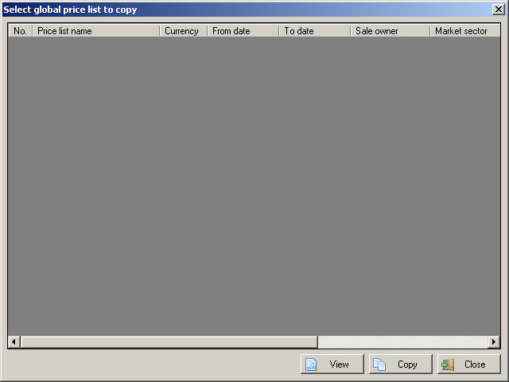
Figure 09b: “Select global price list to copy” screen

UC09B. Select global price list to copy
Goal in Context |  |  | This use case allows actor to select a global price list.
Pre-Condition |  |  | The actor has successfully logged into the system and has Administrator role or Super User role.
Post-Condition |  |  | The tool shall bring back data that is appropriate to the actor’s request
Step | Subject  (Actor) | Verb  (Event) |  | Object  (Entity) | Response
Main Success Scenario
Pre-Condition |  | The actor has successfully logged into the system and has Administrator role or Super User role.
1. | Administrator  or  Super User | Select |  | “Copy from another global price list” button | “Select global price list to copy” screen is showed.  System loads list of global price list into a grid.  If the list has at least one row  Then  First row of list is focused. “View price list” button and “Copy” button are enabled.  Else  “View price list” button and “Copy” button are disabled.
2. | Administrator  or  Super User | Click |  | “View price list” button | System displays “View global price list details” screen showing the details of selected global price list (see more details from UC08. View price list).
3. | Administrator  or  Super User | Click |  | “Copy” button | Details of selected price list are copied.
4. | Administrator  or  Super User | Click |  | “Close” button | System closes screen.

UC09C. Select products
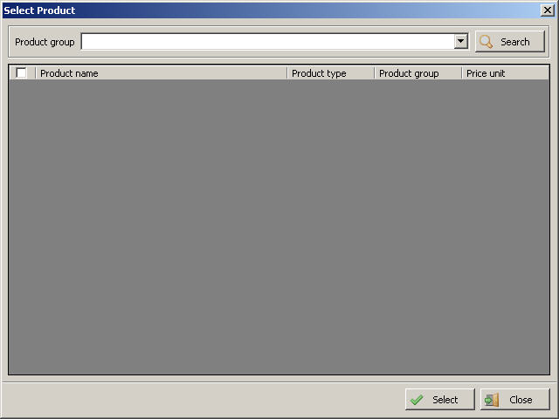
Figure 09c: “Select products” screen

UC09C. Select products
Goal in Context |  |  | This use case allows actor to select products to add to a price list.
Pre-Condition |  |  | The actor has successfully logged into the system and has Administrator role or Super User role.
Post-Condition |  |  | The tool shall bring back data that is appropriate to the actor’s request
Step | Subject  (Actor) | Verb  (Event) |  | Object  (Entity) | Response
Main Success Scenario
Pre-Condition |  | The actor has successfully logged into the system and has Administrator role or Super User role.
1. | Administrator  or  Super User | Select |  | “Add product” button | “Select products” screen is showed.  System loads list of product groups into “Product group” combo box.
2. | Administrator  or  Super User | Select |  | “Product group” combo box | Actor can select a product group from “Product group” combo box.
3. | Administrator  or  Super User | Click |  | “Search” button | If actor selects first option of “Product group” combo box valued “All” then system will display list of all products  If actor selects a specific product group from “Product group” combo box, system will display a list of products belonging to selected product group.  If the list has at least one row  Then  “Select” button is enabled.  Else  “Select” button is disabled.
4. | Administrator  or  Super User | Select |  | Checkboxes | Actor can select products by checking on checkboxes at the first cell of each row in list.  Actor can also click on check box on header of list to select all or deselect all of products in list.
5. | Administrator  or  Super User | Click |  | “Select” button | Selected products are copied.
6. | Administrator  or  Super User | Click |  | “Close” button | System closes screen.

UC10: Create regional price list
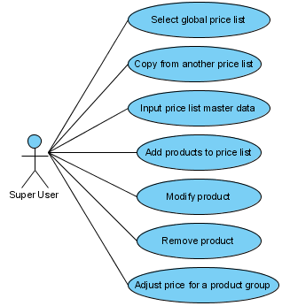
Figure 10. UC10 Create regional price list

UC10A. Create regional price list

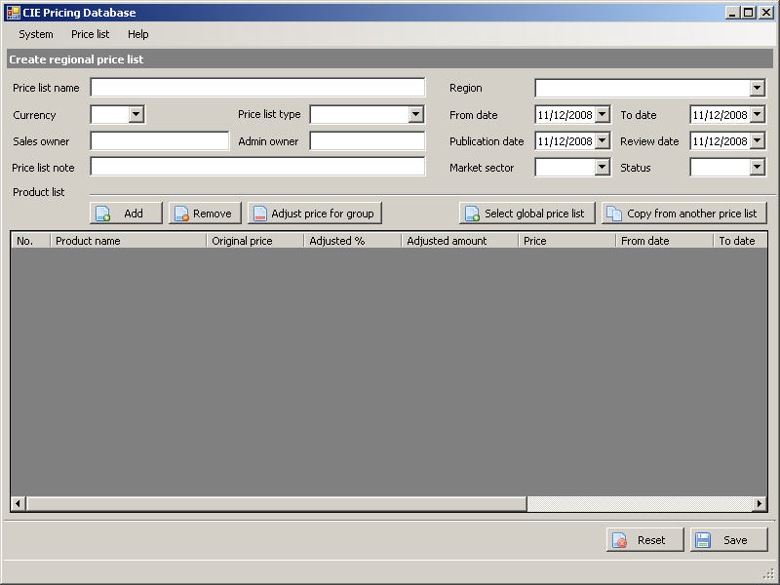
Figure 10a: “Create Regional Price List” screen

UC10: Create regional price list
Goal in Context |  |  | Actor can create new price list by copying data from another price list and replace some data fields if needed.  Actor can insert a product to product list.  Actor can remove product from product list.  Actor can also modify properties of a product.  Actor can adjust price of a group of products.
Pre-Condition |  |  | The actor has successfully logged into the system and has Administrator role or Super User role.
Post-Condition |  |  | The tool shall bring back data that is appropriate to the actor’s request
Step | Subject  (Actor) | Verb  (Event) |  | Object  (Entity) | Response
1. | Administrator  or  Super User | Select |  | “Price list/Create regional price list” menu item | The system displays “Create regional price list” screen (see Figure 10a: “Create regional Price List” screen).  “Currency” combo box is disable.  List of products contains following columns:  - No.  - Product Group: products are grouped by product group name  - Product name  - Original price  - Adjusted %  - Adjusted amount  - Price  - From date  - To date  - Product type  - Price unit  - Product price note
2. | Administrator  or  Super User | Input/Select |  | Fields/Combo boxes | Actor can input data to “Price list name”, “Sales owner”, “Admin owner”, “Price list note”, “From date”, “To date”, “Publication date”, “Review date” fields.  Actor can select:  - Region from “Region” combo box  - Price list type from “Price list type” combo box  - Market sector from “Market sector” combo box  - Status from “Status” combo box  When value of “Region” combo box is changed, value of “Currency” combo box is set to the currency of selected region.
3. | Administrator  or  Super User | Select |  | “Add” button | User can add products into product list by select “Add” button. “Select product” screen will be displayed (see UC09C. Select products).  List of selected products from “Select products” screen will be inserted into list of products in price list.  If the duplication exists then selected products, which are duplicated, will not be added to the list of products.  With each added product, price is set to 0, “From date” and “To date” are assigned to null value.
4. | Administrator  or  Super User | Select |  | “Select global price list” button | This function could help actor to copy data from a global price list.  System displays “Select global price list to copy” screen (see UC09B. Select global price list to copy).  System removes globally products existed from product list on “Create regional price list” screen.  All product of selected global price list will be copied into product list on “Create regional price list” screen.
5. | Administrator  or  Super User | Select |  | “Copy from another price list” button | This function could help actor to copy data from another price list.  System displays “Select regional price list to copy” screen (see UC10C. Select regional price list to copy).  All data of selected price list will be copied into fields and list on “Create regional price list” screen.
6. | Administrator  or  Super User | Select |  | “Adjust price for product group” button | This function could help actor to adjust price of a group of products.  System displays “Adjust price for a product group” screen (see UC10B. Adjust price for a product group).  Prices of products in product list belonging to selected product group are updated.
7. | Administrator  or  Super User | Select |  | A row in product list | System focuses and change background color of selected row.
8a. | Administrator  or  Super User | Select |  | “Remove” button | System remove selected product from list.
8b. | Administrator  or  Super User | Input |  | Cell in selected row | Actor can change value in cells:  - “Product name”  - “From date”  - “To date”  - “Adjusted %”  - “Adjusted amount”  - “Price”  Actor cannot leave a row until all valid conditions of fields on that row are satisfied (see 3.2. Data field valid conditions).
9. | Administrator  or  Super User | Select |  | “Reset” button | System clears all value of fields, combo boxes and product list.
10. | Administrator  or  Super User | Select |  | “Save” button | System checks valid conditions on fields (see 3.2. Data field valid conditions).  If validation process is completed successfully without any warning message then system saves the price list.

UC10B. Adjust price for a product group
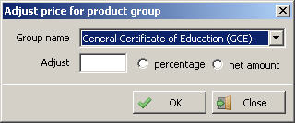
Figure 10b: “Adjust price for a product group” screen

UC10B. Adjust price for a product group
Goal in Context |  |  | This use case allows actor to adjust price of a product group.
Pre-Condition |  |  | The actor has successfully logged into the system and has Administrator role or Super User role.
Post-Condition |  |  | The tool shall bring back data that is appropriate to the actor’s request
Step | Subject  (Actor) | Verb  (Event) |  | Object  (Entity) | Response
Main Success Scenario
Pre-Condition |  | The actor has successfully logged into the system and has Administrator role or Super User role.
1. | Administrator  or  Super User | Select |  | “Adjust price for product group” button | “Adjust price for product group” screen is showed.  System loads list of product groups into “Product group” combo box.
2. | Administrator  or  Super User | Select |  | Fields/combo boxes | Actor can select a product group from “Product group” combo box.  Actor can input a value to be adjusted into “Adjust” field.  Actor can select type of adjusting by check on “Percentage” or “Amount” radio button.
3. | Administrator  or  Super User | Click |  | “OK” button | System keeps values inputted.
4. | Administrator  or  Super User | Click |  | “Close” button | System closes screen.

UC10C. Select regional price list to copy
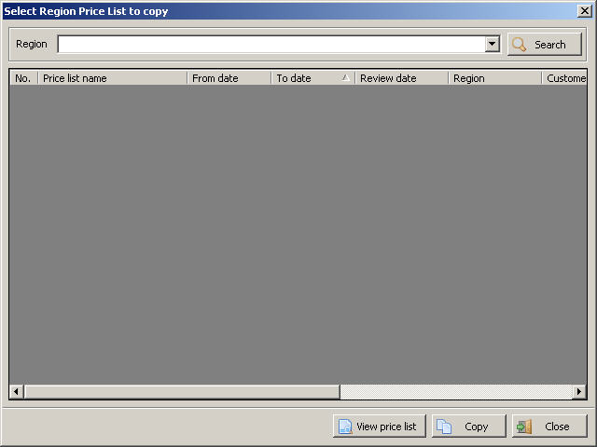
Figure 10c: “Select regional price list to copy” screen

UC10C. Select regional price list to copy
Goal in Context |  |  | This use case allows actor to copy data from another price list.
Pre-Condition |  |  | The actor has successfully logged into the system and has Administrator role or Super User role.
Post-Condition |  |  | The tool shall bring back data that is appropriate to the actor’s request
Step | Subject  (Actor) | Verb  (Event) |  | Object  (Entity) | Response
Main Success Scenario
Pre-Condition |  | The actor has successfully logged into the system and has Administrator role or Super User role.
1. | Administrator  or  Super User | Select |  | “Copy price list” button | “Select regional price list to copy” screen is showed.  System loads list of region into “Region” combo box.
2. | Administrator  or  Super User | Select |  | “Region” combo box | Actor can select a region from “Region” combo box.
3 | Administrator  or  Super User | Click |  | “Search” button | System loads list of price list belonging to selected region into a grid.  If the list has at least one row  Then  First row of list is focused. “View price list” button and “Copy” button are enabled.  Else  “View price list” button and “Copy” button are disabled.
4. | Administrator  or  Super User | Select |  | Row on list | System focuses and changes background color of selected row.
5. | Administrator  or  Super User | Click |  | “View price list” button | System displays “View regional price list details” screen showing the details of selected price list (see more details from UC08. View price list).
6. | Administrator  or  Super User | Click |  | “Copy” button | Details of selected price list are copied.
7. | Administrator  or  Super User | Click |  | “Close” button | System closes screen.

UC11: Create customer price list
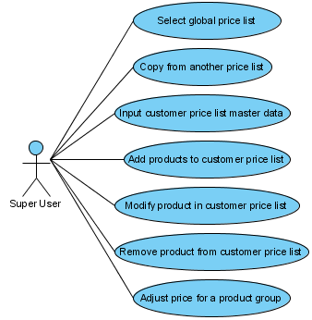
Figure 11. UC11 Create customer price list

UC11A. Create customer price list

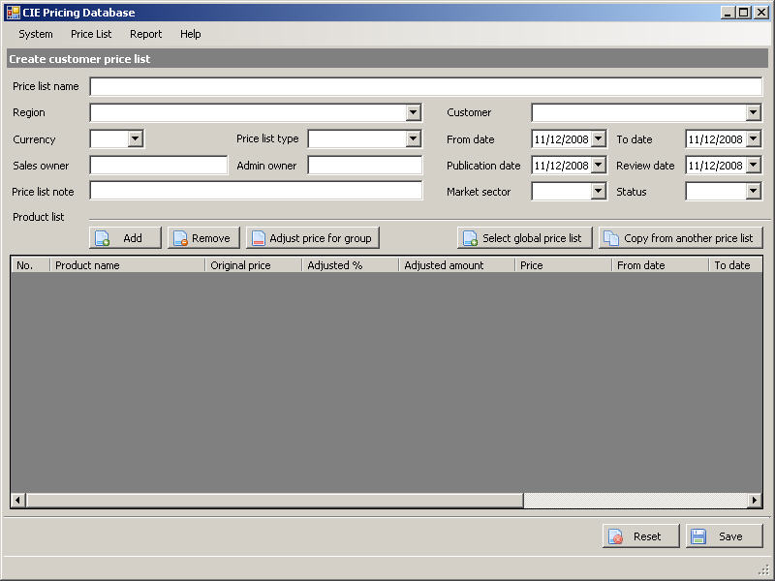
Figure 11a: “Create Customer Price List” screen

UC11: Create customer price list
Goal in Context |  |  | Actor can create new price list by copying data from another price list and replace some data fields if needed.  Actor can insert a product to product list.  Actor can remove product from product list.  Actor can also modify properties of a product.  Actor can adjust price of a group of products.
Pre-Condition |  |  | The actor has successfully logged into the system and has Administrator role or Super User role.
Post-Condition |  |  | The tool shall bring back data that is appropriate to the actor’s request
Step | Subject  (Actor) | Verb  (Event) |  | Object  (Entity) | Response
1. | Administrator  or  Super User | Select |  | “Price list/Create customer price list” menu item | The system displays “Create customer price list” screen (see Figure 10a: “Create customer Price List” screen).  “Currency” combo box is disabled.  List of products contains following columns:  - No.  - Product Group: products are grouped by product group name  - Product name  - Original price  - Adjusted %  - Adjusted amount  - Price  - From date  - To date  - Product type  - Price unit  - Product price note
2. | Administrator  or  Super User | Input/Select |  | Fields/Combo boxes | Actor can input data to “Price list name”, “Sales owner”, “Admin owner”, “Price list note”, “From date”, “To date”, “Publication date”, “Review date” fields.  Actor can select:  - Region from “Region” combo box  - Customer from “Customer” combo box  - Price list type from “Price list type” combo box  - Market sector from “Market sector” combo box  - Status from “Status” combo box  When value of “Region” combo box is changed, value of “Currency” combo box is set to the currency of selected region and list of customers belonging to selected is loaded to “Customer” combo box.
3. | Administrator  or  Super User | Select |  | “Add” button | User can add products into product list by select “Add” button. “Select product” screen will be displayed (see UC09C. Select products).  List of selected products from “Select products” screen will be inserted into list of products in price list.  If the duplication exists then selected products, which are duplicated, will not be added to the list of products.  With each added product, price is set to 0, “From date” and “To date” are assigned to null value.
4. | Administrator  or  Super User | Select |  | “Select global price list” button | This function could help actor to copy data from a global price list.  System displays “Select global price list to copy” screen (see UC09B. Select global price list to copy).  System removes globally products existed in product list on “Create customer price list” screen.  All product of selected global price list will be copied into product list on “Create customer price list” screen.
5. | Administrator  or  Super User | Select |  | “Copy from another price list” button | This function could help actor to copy data from another price list.  System displays “Select customer price list to copy” screen (see UC11B. Select customer price list to copy).  All data of selected price list will be copied into fields and list on “Create customer price list” screen.
6. | Administrator  or  Super User | Select |  | “Adjust price for product group” button | This function could help actor to adjust price of a group of products.  System displays “Adjust price for a product group” screen (see UC10B. Adjust price for a product group).  Prices of products in product list belonging to selected product group are updated.
7. | Administrator  or  Super User | Select |  | A row in product list | System focuses and change background color of selected row.
8a. | Administrator  or  Super User | Select |  | “Remove” button | System remove selected product from list.
8b. | Administrator  or  Super User | Input |  | Cell in selected row | Actor can change value in cells:  - “Product name”  - “From date”  - “To date”  - “Adjusted %”  - “Adjusted amount”  - “Price”  Actor cannot leave a row until all valid conditions of fields on that row are satisfied (see 3.2. Data field valid conditions).
9. | Administrator  or  Super User | Select |  | “Reset” button | System clears all value of fields, combo boxes and product list.
10. | Administrator  or  Super User | Select |  | “Save” button | System checks valid conditions on fields (see 3.2. Data field valid conditions).  If validation process is completed successfully without any warning message then system saves the price list.

UC11B. Select customer price list to copy
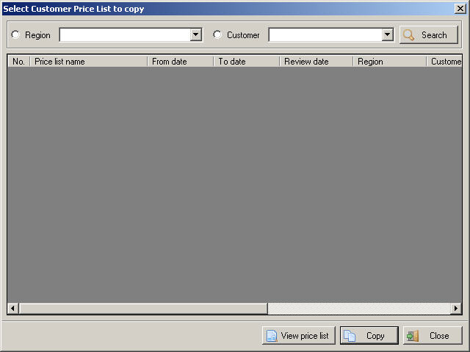
Figure 11b: “Select customer price list to copy” screen

UC11B. Select customer price list to copy
Goal in Context |  |  | This use case allows actor to copy data from another price list.
Pre-Condition |  |  | The actor has successfully logged into the system and has Administrator role or Super User role.
Post-Condition |  |  | The tool shall bring back data that is appropriate to the actor’s request
Step | Subject  (Actor) | Verb  (Event) |  | Object  (Entity) | Response
Main Success Scenario
Pre-Condition |  | The actor has successfully logged into the system and has Administrator role or Super User role.
1. | Administrator  or  Super User | Select |  | “Copy price list” button | “Select customer price list to copy” screen is showed.  System loads list of region into “Region” combo box.  By default, “Region” radio button is selected.
2. | Administrator  or  Super User | Select |  | Combo boxes | If actor selects “Region” radio button then “Region” combo box is enabled and “Customer” combo box is disabled. Actor can select region from “Region” combo box.  If user selects “Customer” radio button then “Region” combo box and “Customer” combo box are enabled. Actor can select region from “region” combo box and select customer from “Customer” combo box. When value of “Region” combo box is changed, list of customers belonging to selected region is loaded into “Customer” combo box.
3 | Administrator  or  Super User | Click |  | “Search” button | System loads list of price list depend on query selected by actor.  If the list has at least one row  Then  First row of list is focused. “View price list” button and “Copy” button are enabled.  Else  “View price list” button and “Copy” button are disabled.
4. | Administrator  or  Super User | Select |  | Row on list | System focuses and changes background color of selected row.
5. | Administrator  or  Super User | Click |  | “View price list” button | System displays “View customer price list details” screen showing the details of selected price list (see more details from UC08. View price list).
6. | Administrator  or  Super User | Click |  | “Copy” button | Details of selected price list are copied.
7. | Administrator  or  Super User | Click |  | “Close” button | System closes screen.

UC12: Update price list
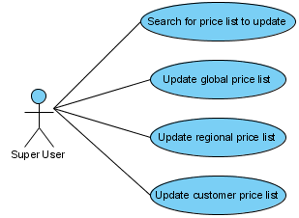
UC12. Update price list
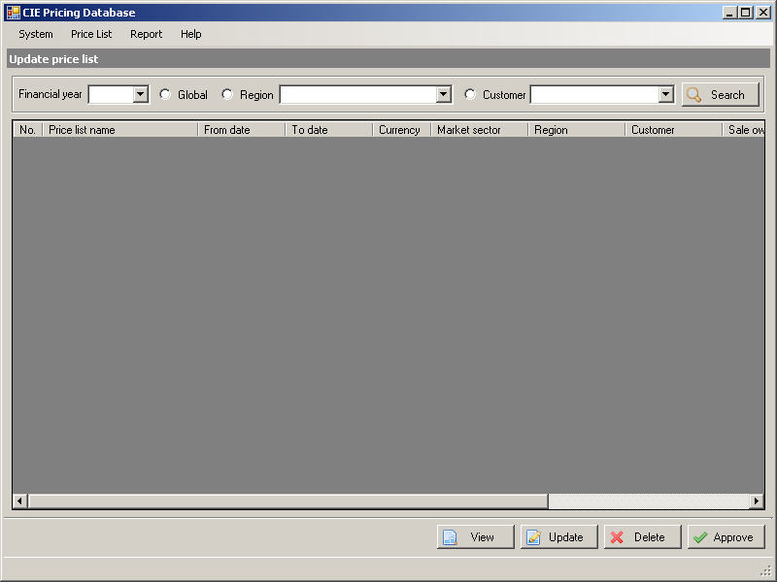
Figure 13a: “Update price list search” screen.
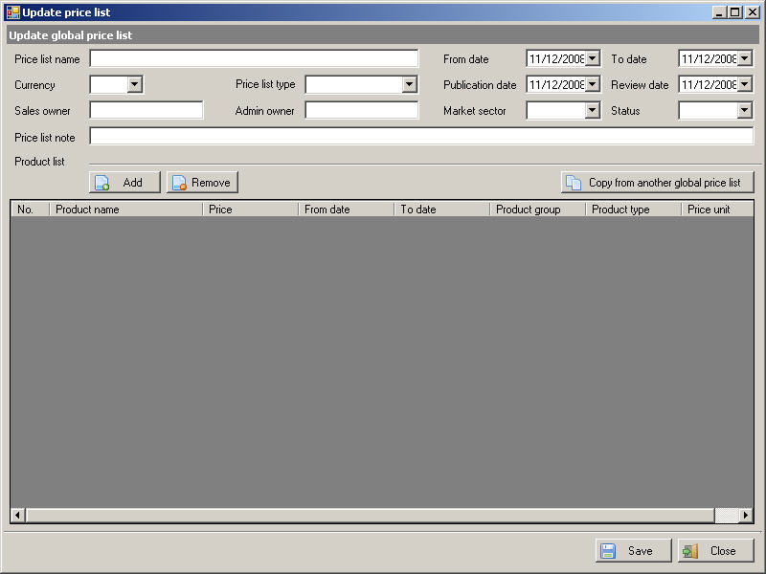
Figure 12b: “Update global price list” screen.
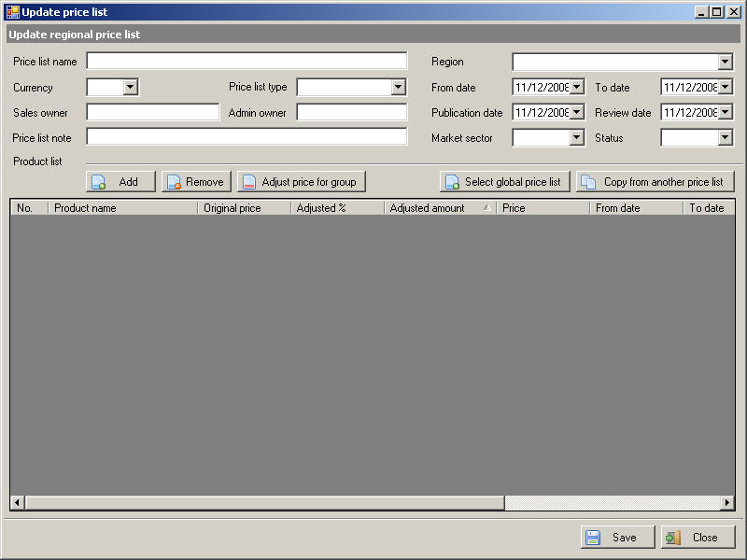
Figure 12c: “Update regional price list” screen.
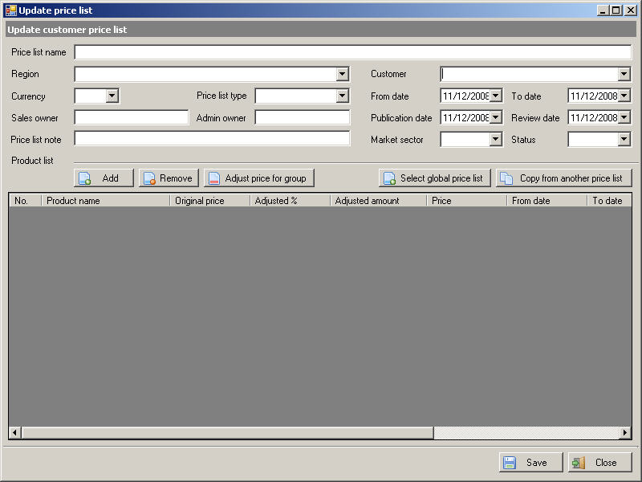
Figure 12d. “Update customer price list” screen.

UC12: Update price list
Goal in Context |  |  | Actor can query price lists by inputting query options. Actor can select a price list and update selected price list. Only price lists, which haven’t have “Approved” or “Historic” status, can be updated.
Pre-Condition |  |  | Actor has successfully logged into the system and has Customer service representative role or Administrator role or Super User role.
Post-Condition |  |  | The tool shall bring back data that is appropriate to the actor’s request
Step | Subject  (Actor) | Verb  (Event) |  | Object  (Entity) | Response
1. | Customer service representative  or  Administrator  or  Super User | Select |  | “Price List/Update price list” menu item | System displays “Update price list” screen without any price list. “View price list” button, “Update” button, “Delete” button, “Approve” button are disabled.  (see Figure 12a: Update price list)
2. | Customer service representative  or  Administrator  or  Super User | Input |  | Query selection: Combo boxes/Radio boxes | Actor can select financial year from “Financial year” combo box.  If actor selects “Global” radio button then “Region” combo box and “Customer” combo box are disabled.  If actor selects “Region” radio button then “Region” combo box is enabled and “Customer” combo box is disabled. Actor can select region from “Region” combo box.  If user selects “customer” radio button then “Region” combo box and “Customer” combo box are enabled. Actor can select region from “region” combo box and select customer from “Customer” combo box.
3. | Customer service representative  or  Administrator  or  Super User | Select |  | ‘Search’ button | System returns results and displays in following columns:  - No.  - Price list name  - Status  - From date  - To date  - Currency  - Region  - Customer  - Sale owner  - Market sector  - Publication date  - Review date  - Price list note  Only price lists, which have not have “Approved” or ”Historic” status, are returned.
4. | Customer service representative  or  Administrator  or  Super User | Select |  | Single row in result list | System focus and change background color of selected row. Actor can then perform more functions.  “View price list” button, “Update” button, “Delete” button, “Approve” button are enabled.
5a. | Customer service representative  or  Administrator  or  Super User | Select |  | “View price list” button | System displays details of selected price list on a popup window.  If “Global” radio is selected then “View global price list details” screen will be showed (see UC08. View price list).  If “Region” radio is selected then “View regional price list details” screen will be showed (see UC08. View price list).  If “Customer” radio is selected then “View customer price list details” screen will be showed (see UC08. View price list).
5b. | Administrator  or  Super User | Select |  | “Delete” button | System displays message box “Do you want to delete selected price list?” with “Yes/No” options.
5b.i. | Administrator  or  Super User | Select |  | “OK” button | System deletes selected price list, reloads list of price list, closes message box and focus on “Update price list” screen.
5b.ii. | Administrator  or  Super User | Select |  | “No” button | System closes message box and focus on “Update price list” screen
5c. | Administrator  or  Super User | Select |  | “Approve” button | System displays message box “Do you want to approve selected price list?” with “Yes/No” options.
5c.i. | Administrator  or  Super User | Select |  | “OK” button | System applies status of selected price list to “Approved”, reloads the list of price list, closes message box and focus on “Update price list” screen.
5c.ii. | Administrator  or  Super User | Select |  | “No” button | System closes message box and focus on “Update price list” screen
5d. | Administrator  or  Super User | Select |  | ‘Update” button | If Global radio button is checked then system displays “Update global price list” screen (see Figure 12b: Update global price list for Global). This use case is similarly to UC09. Create global price list. At the time screen opened, data of selected price list is loaded into fields and product list in “Create global price list” screen. By default, “Currency” combo-box is disabled.  If Region radio button is checked then system displays “Update regional price list” screen (see Figure 12c: Update regional price list). This use case is similarly to UC10. Create regional price list. At the time screen opened, data of selected price list is loaded into fields and product list in “Create regional price list” screen. By default, “Region” combo box and “Currency” combo-box are disabled.  If Customer radio button is checked then system display “Update customer price list” screen (see Figure 12d: Update customer price list). This use case is similarly to UC11. Create customer price list. At the time screen opened, data of selected price list is loaded into fields and product list in “Create regional price list” screen. By default, “Region” combo box, “Customer” combo box and “Currency” combo-box are disabled.

UC13: Generate review schedule
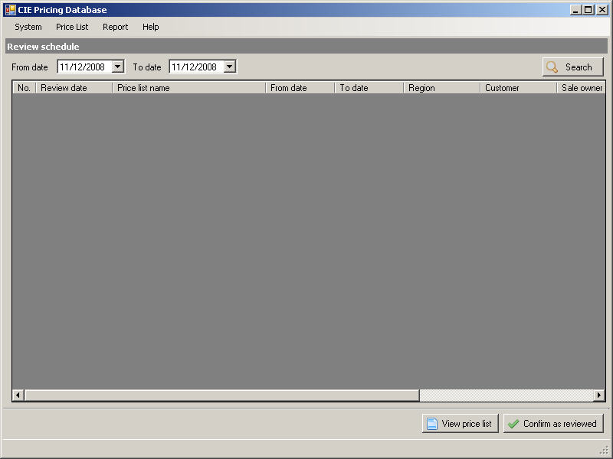
Figure 13. “Review schedule” screen

UC13: Generate review schedule
Goal in Context |  | The actor can query all the price lists that have review date in the range between ‘From date’ and ‘To date’. They can select a single price list and view details. They can also confirm a price list as reviewed.
Pre-Condition |  | The actor has successfully logged into the system and has Administrator role or Super User role.
Post-Condition |  | The tool shall bring back data that is appropriate to the actor’s request
Step | Subject  (Actor) | Verb  (Event) |  | Object  (Entity) |  | Response
Main Success Scenario
Pre-Condition |  | The actor has successfully logged into the system and has Administrator role or Super User role
1. | Administrator  or  Super User | Select |  | ‘Review schedule’ in the “Report” menu |  | System displays the screen without any price lists that have to be reviewed.
2 | Administrator  or  Super User | Type |  | Query selection:  From date  and  To date |  | The screen displays actor query selections.
3 | Administrator  or  Super User | Select |  | ‘Search’ option to run query |  | System will search for all price lists which have review date between the specified date range, with status equals Under Reviewed. Then system returns result showing following columns:  - Serial number  - Review date  - Price list name  - Region  - Customer  - From date  - To date  - Sale owner  - Market sector  - Currency  - Publication date  System will disable buttons “View price list” and “Confirm as reviewed”.
4 | Administrator  or  Super User | Select |  | Single row in result list |  | System focuses and changes background color of selected row. Actor can then perform more functions.
5a | Administrator  or  Super User | Select |  | “View price list” button |  | The system will display details of selected price list on a popup window.  See more in “UC09: View Price List”
5b | Administrator  or  Super User | Select |  | Button “Confirm as reviewed” |  | System prompts a message: “Are you sure you want to mark this price list as reviewed?”  Actor has to confirm updating data action with two options:  ‘Yes’ (mark price list as reviewed)  Or  ‘No’ (do not mark)  (see variation 5.b.i, 5.b.ii)
Variation Scenario
# | Subject  (Actor) |  | Verb (Event) |  | Object  (Entity) | Response
5b.i | Administrator  or  Super User |  | Select |  | Button “Yes” | System marks price list as reviewed, removes selected price list from list and takes actor back to screen.
5b.ii | Administrator  or  Super User |  | Select |  | Button “No” | System takes actor back to screen.

UC14: Archive price lists
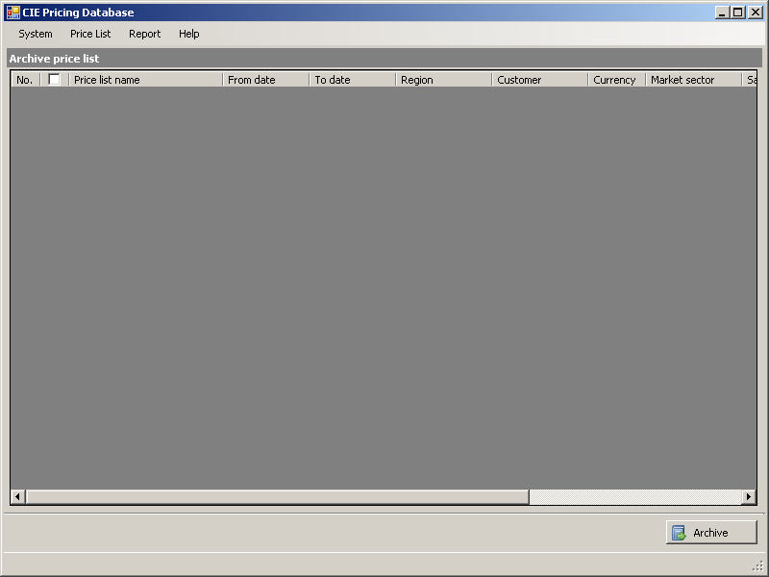
Figure 14: “Archive price lists” screen

UC14: Archive price lists
Goal in Context |  |  | The actor can view list of price lists which have value “Historic” in status. Actor can also select and archive price lists from the list.
Pre-Condition |  |  | The actor has successfully logged into the system and has Super User role.
Post-Condition |  |  | The tool shall bring back data that is appropriate to the actor’s request
Step | Subject  (Actor) | Verb  (Event) |  | Object  (Entity) | Response
1. | Super User | Select |  | “System/Archive price list” menu item | System displays the screen with a list that contains historic price lists. Button “Archive” is disabled (see Figure 14: Archive price lists).
2. | Super User | Select |  | Check boxes | Actor can select price lists to be archived by check on corresponding check boxes. placed.
3. | Super User | Select |  | “Archive” button | System moves all selected price lists to archive tables and refreshes the list.

UC15: Maintain user network accounts
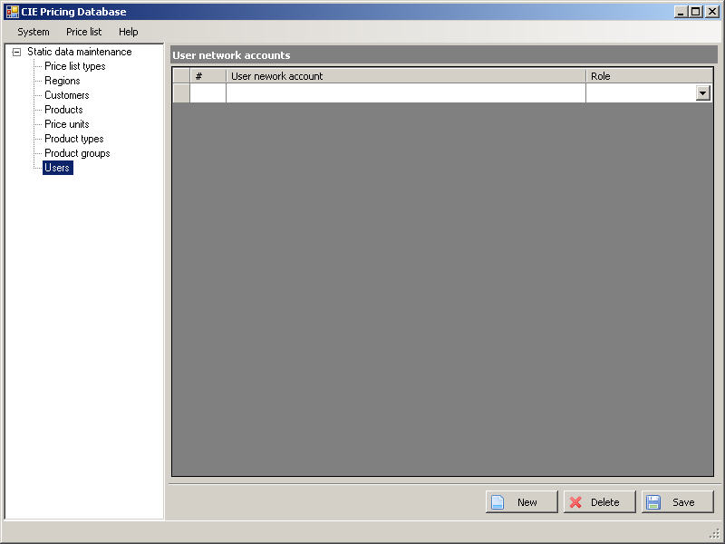
Figure 16: “Maintain user accounts” screen

UC15: Maintain user network accounts
Goal in Context |  |  | This use case allows actor to display list of user network accounts.  Actor can select a single user account for updating role or deleting.  Actor can add a new user network account into list.
Pre-Condition |  |  | Actor has successfully logged into the system and has Super User role.
Post-Condition |  |  | The tool shall bring back data that is appropriate to the actor’s request
Step | Subject  (Actor) | Verb  (Event) |  | Object  (Entity) | Response
Main Success Scenario
Pre-Condition |  | The actor has successfully logged into the system and has Super User role.
1. | Super User | Select |  | “Maintain static data” menu item on “System” menu | “Maintain static data” screen is opened on application window.
2. | Super User | Select |  | ‘Users’ in the left menu tree on screen | System displays “Maintain user network accounts” screen with a list of user accounts.
3. | Super User | Click |  | “New” button | If a blank row has not created  Then  System creates a new row and focuses on “User network account” cell.  Else  System focuses on “User network account” cell inside blank row at the end of list.
4. | Super User | Input |  | Cells | Actor can input Active Directory account name into “User network account” cell. Actor can also select role from “Role” combo box cell.  Actor cannot leave a row until all valid conditions of fields on that row are satisfied (see 3.2. Data field valid conditions).
5. | Super User | Select |  | Row | System focuses on the selected row.
6. | Super User | Click |  | Button “Delete” | System displays a confirmation message box: “Do you want to delete this record?” with “Yes/No” options.
6a. | Super User | Click |  | Button “Yes” | System deletes selected user network account from list.
6b. | Super User | Click |  | Button “No” | System closes confirmation message box and returns to “Maintain user network accounts” screen.
7. | Super User | Click |  | Button “Save” | With each updated row or added row, system checks the existing of “User network account” in Active Directory. If account does not exist then system displays message:  “Given network account name does not exist in Active Directory.”  Else  System checks duplicate data, if a “User network account” already exists in the list then displays message “User network account can not be duplicated.”  If validation process is completed successfully without any warning message then system saves the list into database.

UC16: View/print audit log
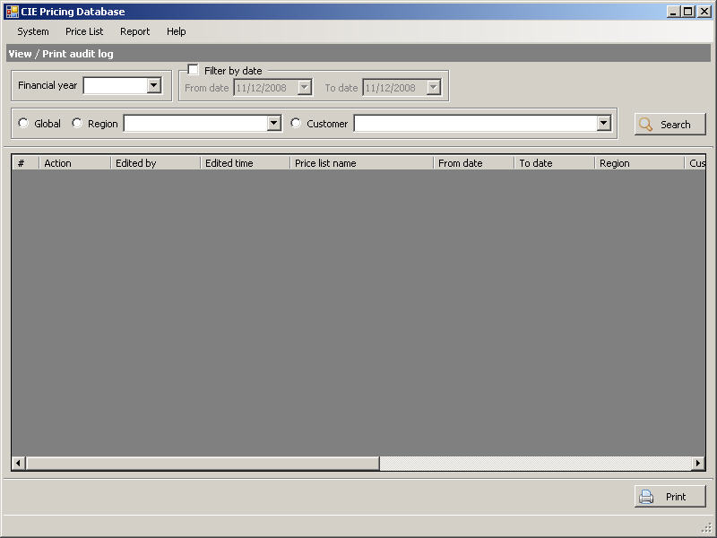
Figure 16: “View/print audit log” screen

UC16: View/print audit log
Goal in Context |  |  | The actor can track data changes in price list.
Pre-Condition |  |  | The actor has successfully logged into the system and has Super User role.
Post-Condition |  |  | The tool shall bring back data that is appropriate to the actor’s request
Step | Subject  (Actor) | Verb  (Event) |  | Object  (Entity) | Response
1. | Super User | Select |  | “System/View/print audit log” menu | System displays the “View/Print audit log” screen (see Figure 16: View/print audit log screen).  “View” button is disabled  “Filter by date” check box is unchecked.  “From date” and “To date” control are disabled.  “Global” radio button is checked.  “Region” and “Customer” combo box are disabled.  “Print” button is disabled.
2. | Super User | Input/Select |  | Field/Combo box/Radio box | Actor can select financial year from “Financial year” combo box.  Actor can check on “Filter by date” check box to enable and give input to “From date”, “To date” fields.  If actor selects “Global” radio button then “Region” combo box and “Customer” combo box are disabled.  If actor selects “Region” radio button then “Region” combo box is enabled and “Customer” combo box is disabled. Actor can select region from “Region” combo box.  If user selects “customer” radio button then “Region” combo box and “Customer” combo box are enabled. Actor can select region from “region” combo box and select customer from “Customer” combo box.
3. | Super User | Select |  | ‘Search’ button | Screen displays results based on query created by actor with following columns:  - No.  - Action  - Edited by  - Edited time  - Price list name  - From date  - To date  - Region  - Customer  - Sale owner  - Currency  - Note  System enables “Print” button.
4. | Super User | Select |  | Button “Print” | System prints out audit logs from result list.

UC17: Authenticate user
As the first task of running CIE Pricing Database Tool, system checks for the existing of user account, which is used to log in to operation system, in Active Directory.
System displays a message box “You do not have permission to use this application.” in any case of following:
- Account does not exist in Active Directory
- Account does exist but it has not assigned to any role belonging to CIE Pricing Database Tool
Otherwise, system displays main form with menu items based on the role assigned to user account.

Data field valid conditions
# | Field Name | Mandatory | Type | Condition | Error message
1 | Price unit name | Y | Text | Max length is 128
 |  |  |  | Value should not be empty | “Price unit name should not be empty.”
2 | Product type name | Y | Text | Max length is 128
 |  |  |  | Value should not be empty | “Product type name should not be empty.”
3 | Product group name | Y | Text | Max length is 128
 |  |  |  | Value should not be empty | “Product group name should not be empty.”
4 | Order code | Y | Text | Max length is 6
 |  |  |  | Value should not be empty | “Order code should not be empty.”
5 | Region name | Y | Text | Max length is 128
 |  |  |  | Value should not be empty | “Region name should not be empty.”
6 | Customer code | Y | Text | Max length is 5
 |  |  |  | Value should not be empty | “Customer code should not be empty.”
7 | Customer name | Y | Text | Max length is 128
 |  |  |  | Value should not be empty | “Customer name should not be empty.”
8 | Country | N | Text | Max length is 64
9 | Customer note | N | Text | Max length is 255
10 | Price list type name | Y | Text | Max length is 128
 |  |  |  | Value should not be empty | “Price list type name should not be empty.”
11 | Product short name | Y | Text | Max length is 64
 |  |  |  | Value should not be empty | “Product short name should not be empty.”
12 | Product full name | Y | Text | Max length is 128
 |  |  |  | Value should not be empty | “Product full name should not be empty.”
13 | Price list name | Y | Text | Max length is 128
 |  |  |  | Value should not be empty | “Price list name should not be empty.”
14 | Sale owner | Y | Text | Max length is 64
 |  |  |  | Value should not be empty | “Sale owner should not be empty.”
15 | Admin owner | Y | Text | Max length is 64
 |  |  |  | Value should not be empty | “Admin owner should not be empty.”
16 | Price list note | N | Text | Max length is 256
17 | Price list start date | Y | Date | Value should be earlier than “price list end date”
18 | Price list end date | Y | Date | Value should be later than “price list start date”
19 | Price list publication date | Y | Date | Value should be earlier than “price list start date”
20 | Price list review date | Y | Date | Value should be earlier than “price list publication date”
21 | Price adjusted | Y | Number
22 | Product price | Y | Number | Max length is 12
23 | Product from date | Y | Date | Value is in range of “Start date” and “End date” of price list
24 | Product to date | Y | Date | Value is in range of “Start date” and “End date” of price list and later than “Product from date”
25 | User network account | Y | Text | Max length is 64
 |  |  |  | Value should not be empty | “User network account should not be empty.”

Non Functional Specification

Usability

Look and feel
The user interface is illustrated in the form of a prototype. The general guideline includes the following rules:
- The system must conform to standard look and feel of Windows.

Screen Styles
Screen styles refer to facilities that are allowed within the following requirements:
- Screen style is consistent across the system.

Reliability
End-user's screens must display suitable user-friendly error message (stack dump should not be displayed)

Availability

System Dependencies

- Database back-end: MS SQL Server 2005

Bugs and Defect Rates

No specific requirements have been stated. The defect rate objectives can be derived from standards and norms of HVN SDC quality management system.

In SDC process, there are four bug severities. Each severity has a weighted value as in table below:

No | Bug severity | Weighted value | Description
1 | Critical | 10 | A major issue where a large piece of functionality or major system component is completely broken  There is no workaround and testing cannot be continued
2 | High | 5 | Major functionality or major system component does not work, works incorrectly or is documented incorrectly  Security issue
3 | Medium | 3 | Minor functionality does not work, works incorrectly or is documented incorrectly
4 | Cosmetic | 1 | Very minor defect, no way to affect the functionality of the product

Defect rate is measured per Weighted defect / Use case point (in short form: Wdef / UCP). One use case point is 20 person-days.
SDC norm of defect rate is 5.5 wdef / UCP.

Performance

Response time

- 1 second for screen data to be validated.
- Moving between pages/screens should have maximum timing of 3 seconds.

Throughput

There’s no specific requirement.

Volume

The system will be required to handle 5 years of historic data (which currently equates to around 10,000 prices.

There are expected to be 5 to 10 system users.

Supportability

As standard, all predefined values (amounts, dropdown values) must be easy to maintain, i.e. change/update and delete/add (where applicable).

Error Log

All log messages must include a standard-format timestamp (YYYY-MM-DD-HH:MM:SS).

