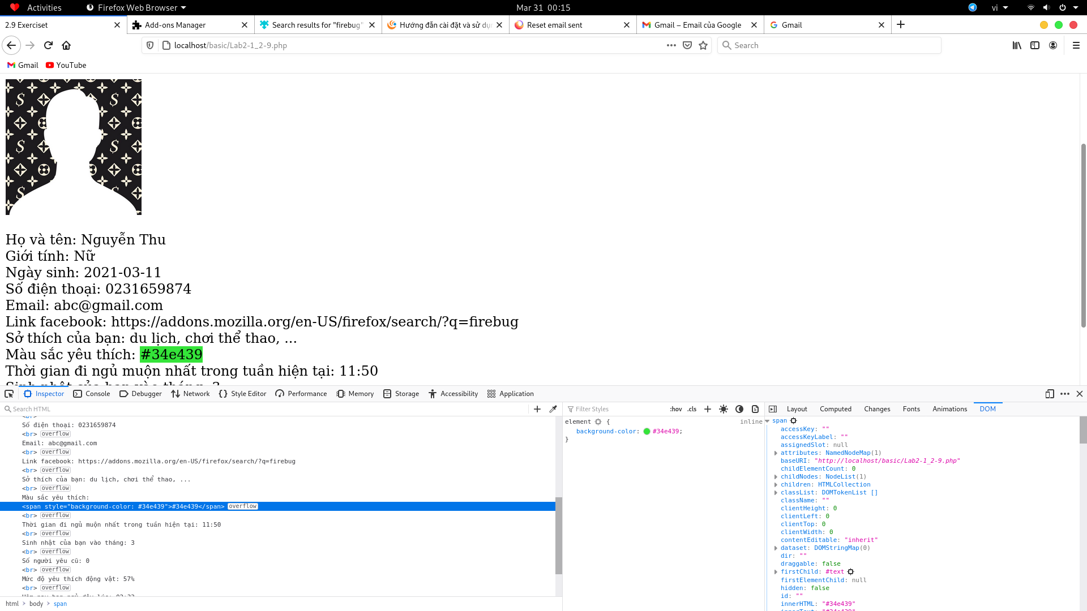
DOM Imspect FireFox file.php

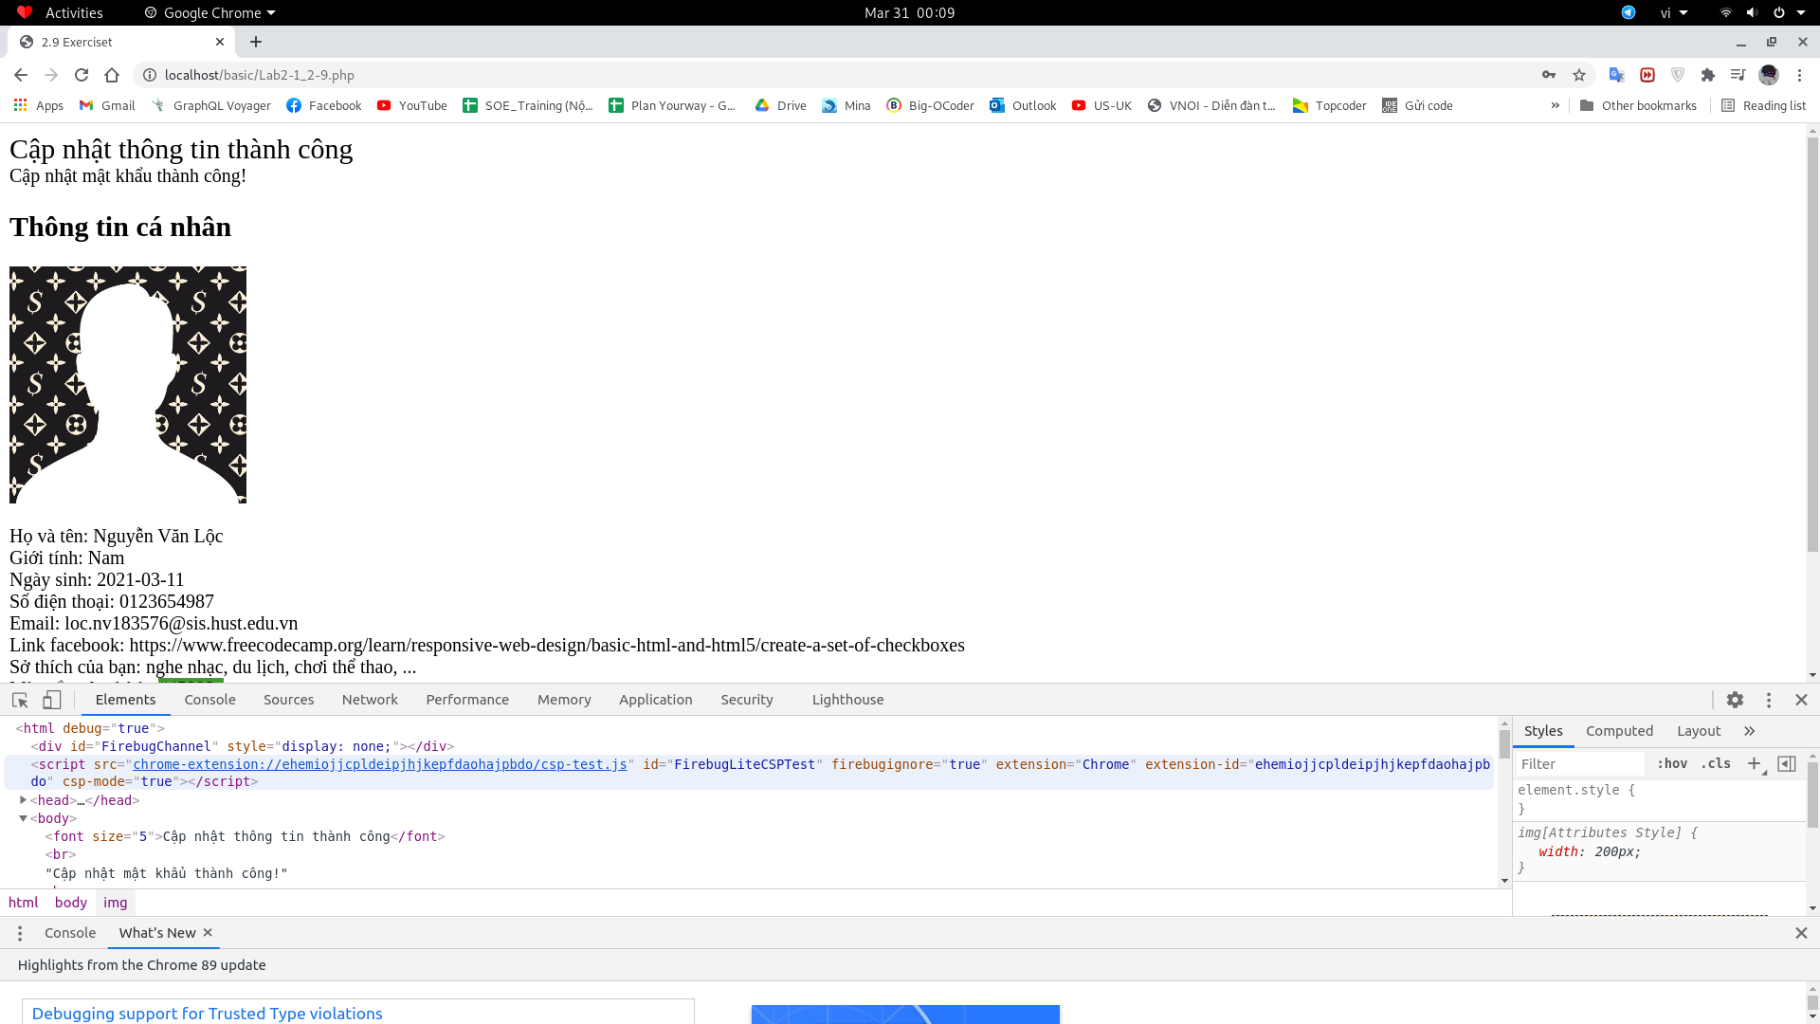
Firebug Lite Chorme file.php

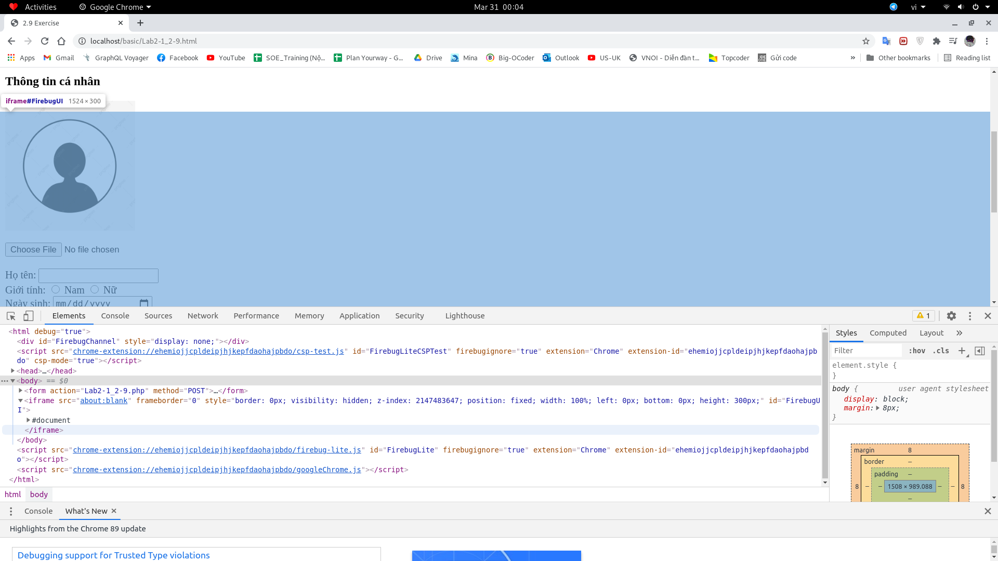
Firebug Lite Chorme file.html

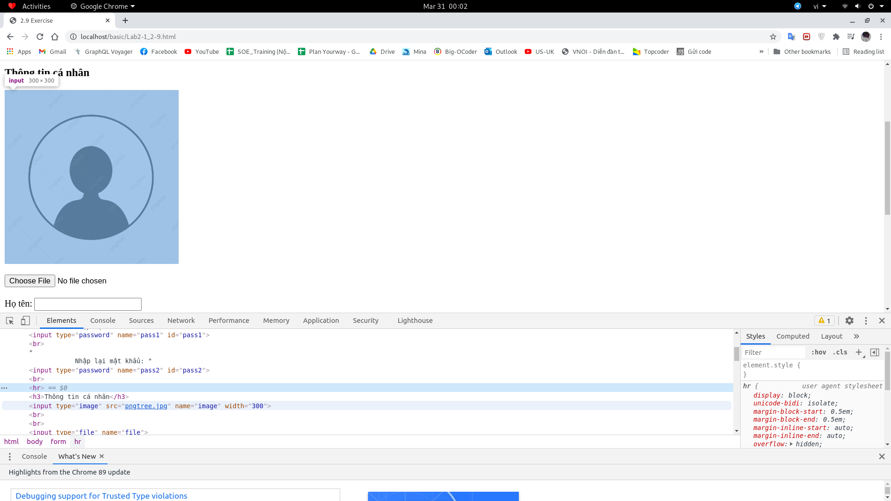
DOM Inspect Chorme file.html

