Taxi Near mobile app

Setup & Guideline

|  |  |
| --- | --- |
|  |  |

Setup & Install

1. **Requirement**

|  |  |
| --- | --- |
| **Tool** | Android studio v3.0 or newer |
| **Jdk** | Version 1.7 or newer |
| **Device** | Android Phone v4.0 or newer |

**II. Customize**

**A. Customization**

* **How to edit app name?**

Go to “app/res/values/main_config.xml” file then change value of “app_name” key.

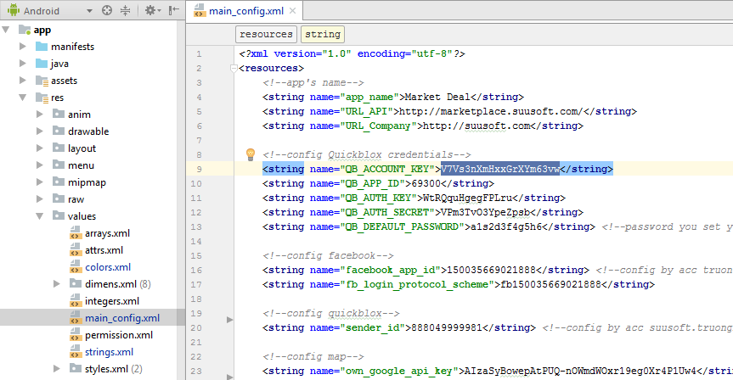

* **How to edit app Icon?**

In left menu you will need to search “ic_launcher.png” files in all “app/res/mipmap-xxxx” folders and replace them by your app icon.

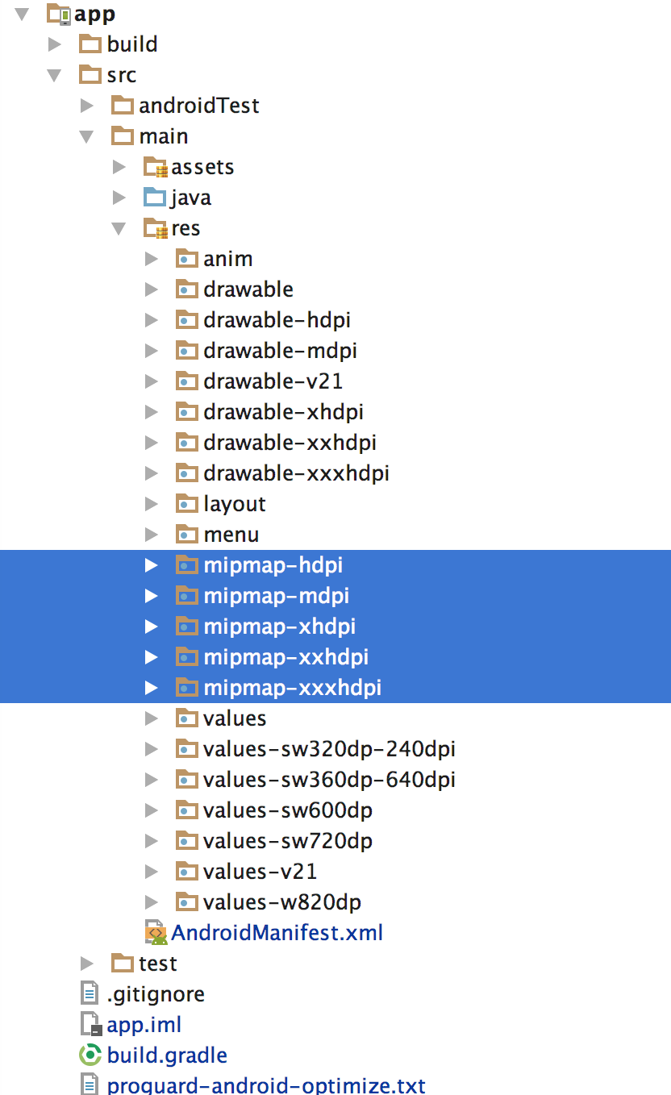

* **How to edit images?**

You can find and edit any image in all “app/res/drawable-xxxx” folders. Make your image for all folder drawable-xxx

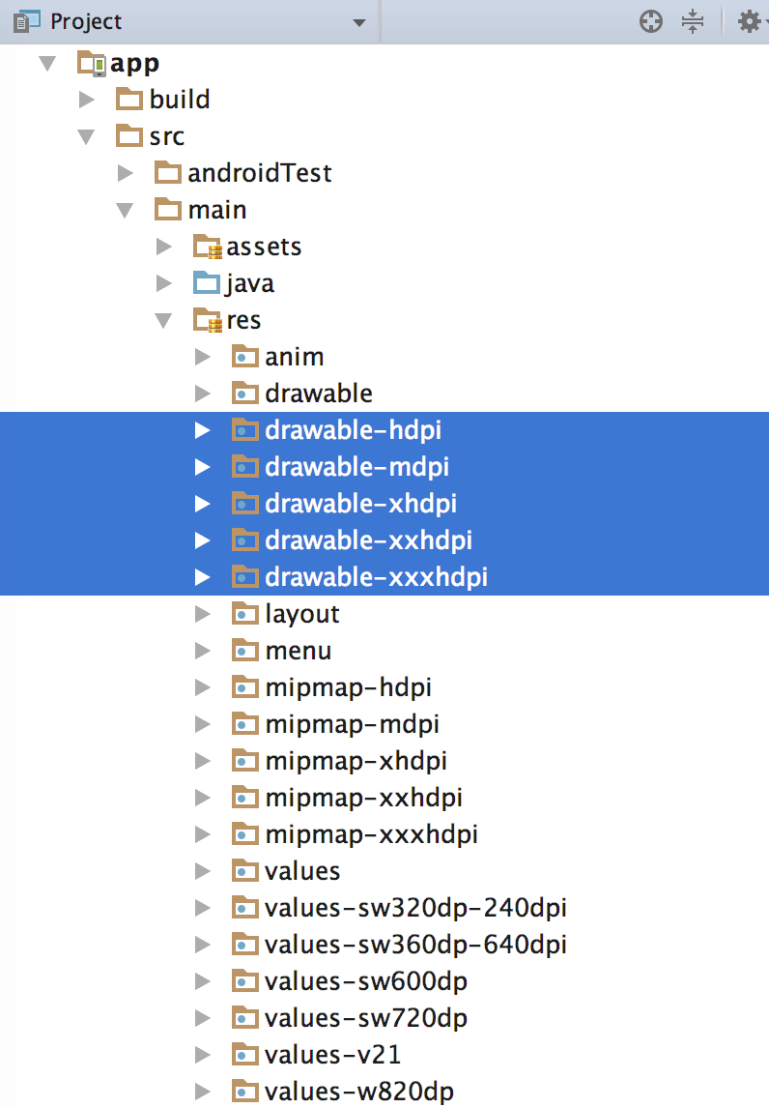

* **How to edit layouts?**

You can find and edit any layout in “app/res/layout” folder.

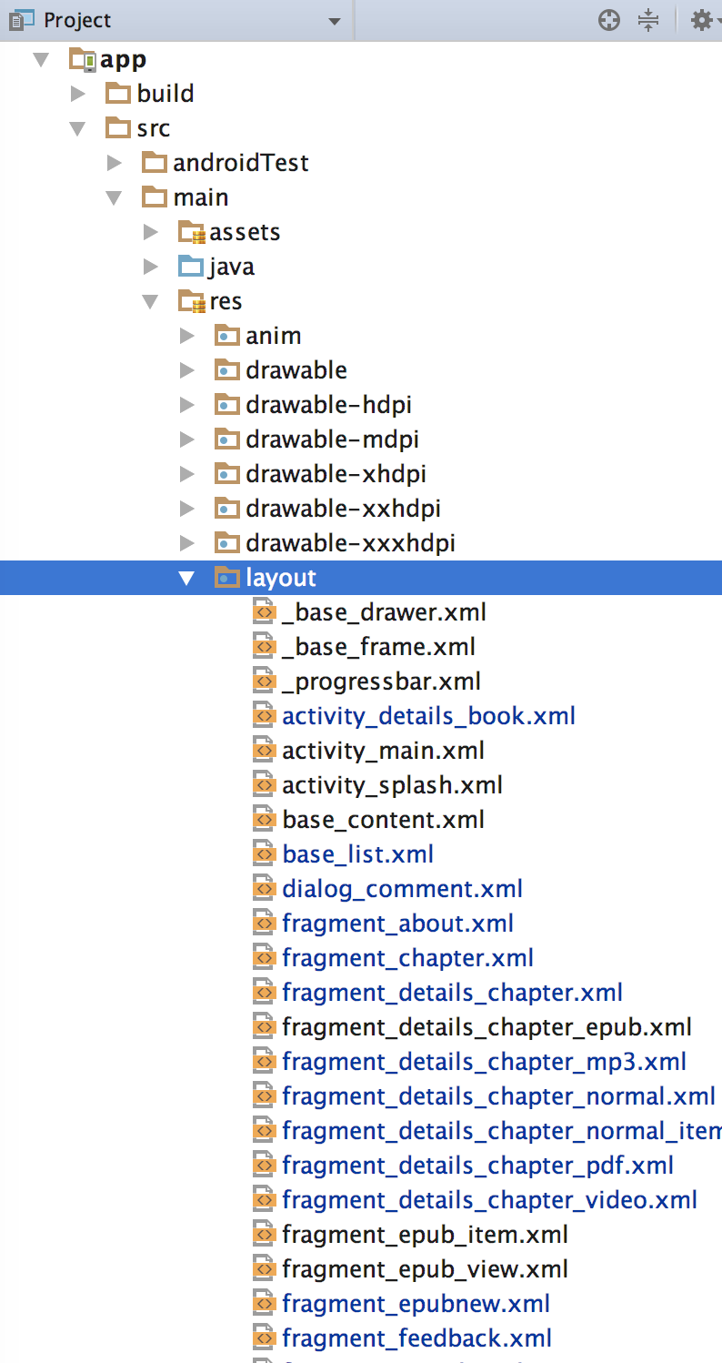

* **How to edit colors?**

You can find and edit any color in “app/res/values/colors.xml”

* **NOTE**:

- The <!-- main color --> is app theme, you can edit and make a new theme

- The <!—base color --> we do not recommended you edit it

- Other colors you can edit

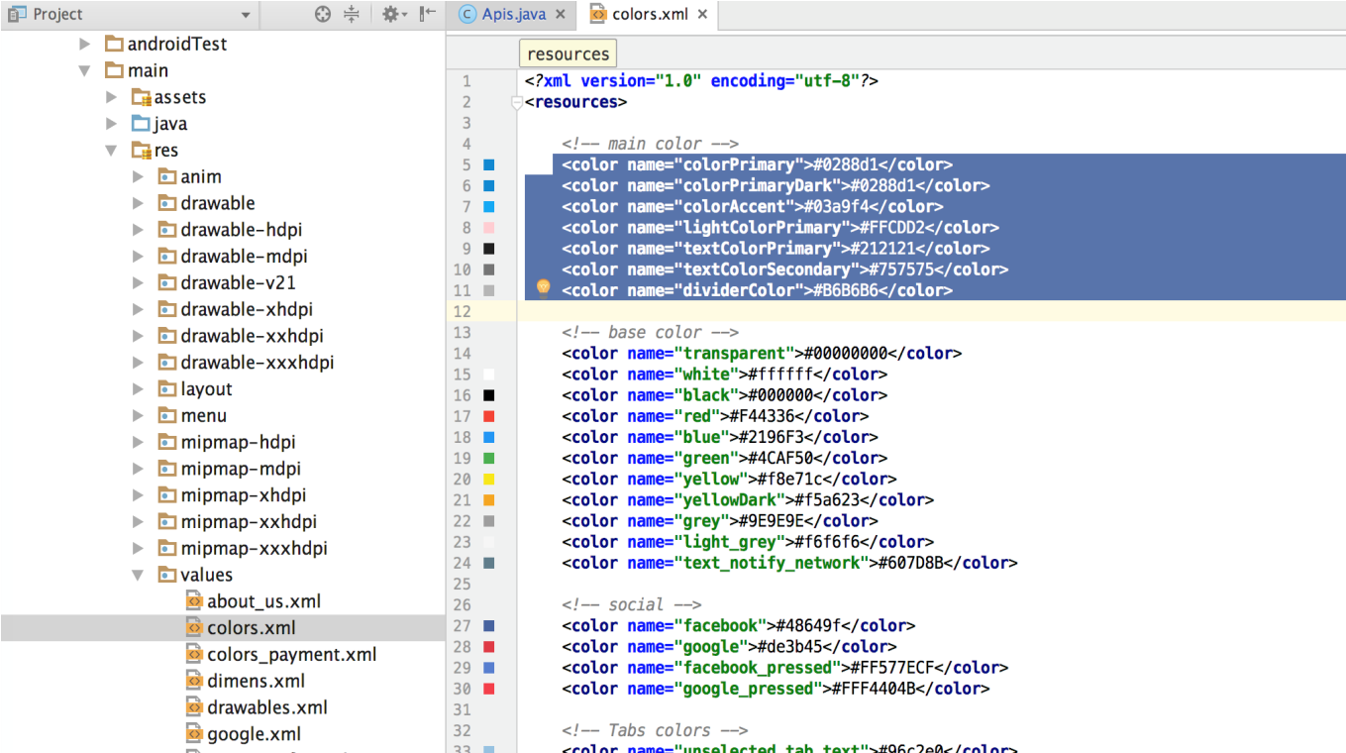

* **How to edit file language when you want to multi-language on app?**
* **Step 1:** Right click on res folder and create new resource file

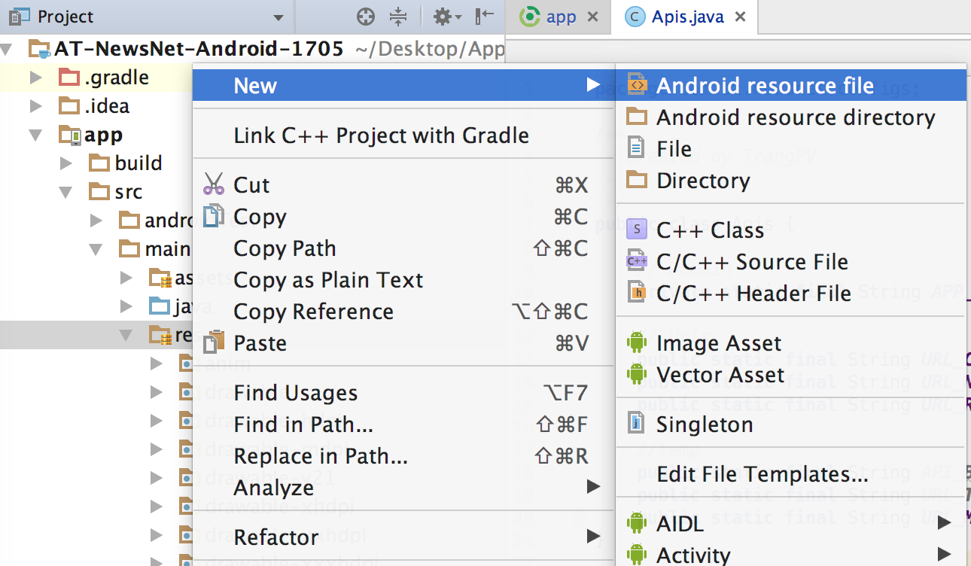

* **Step 2:**

Select locale 🡪 click next

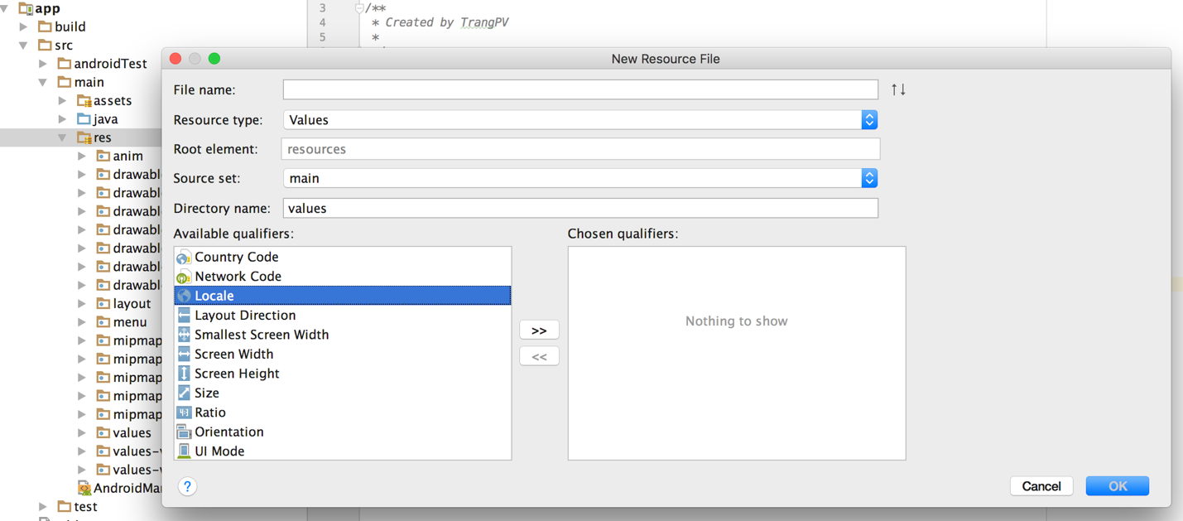

After select locale it will be as below. Now you can choose your country 🡪 Put a file name is “strings” and click OK. It will be generated a foler with name “values-countrycode” in res folder

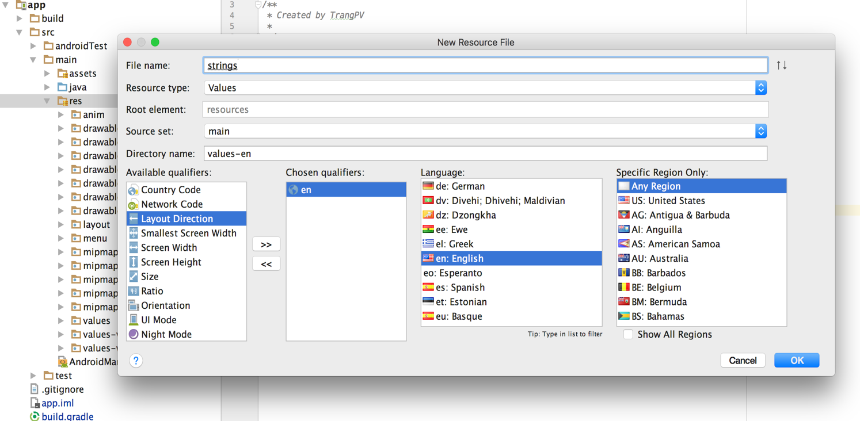

* **Step 3**: Now open strings.xml file in “values” folder 🡪 copy all content in this 🡪 paste to file that you have created.
* **Step 4:** Finally, we can translate text

**B. Configure for app**

Go to “main_config.xml” file as screenshot below.



**Now we see the keys. Please look at description below**

**+** The “*app_name*” : Change for your app name

**+** The “*URL_API*”: After you install the backend successfully, please get your backend link and put it here. Note: Copy right link same as our format.

**+** The “*QB_ACCOUNT_KEY ; QB_APP_ID ; QB_AUTH_KEY ; QB_AUTH_SECRET ; QB_DEFAULT_PASSWORD*” : These are the keys you can configure for the app to use the chat function. In Section C I will guide you to take these key.

**C. Configure chat function for app (use Quickblox SDK)**

This app uses QuickBlox as a chat solution, you need to have a QuickBlox account to configure it.

If you do not have a QuickBlox account yet, go to page : <http://admin.quickblox.com/register> Once you have an account you create an app at <http://admin.quickblox.com/apps/new> .

Once you have successfully created the app on QuickBlox, go to <https://admin.quickblox.com/account/settings> to get the configuration information.

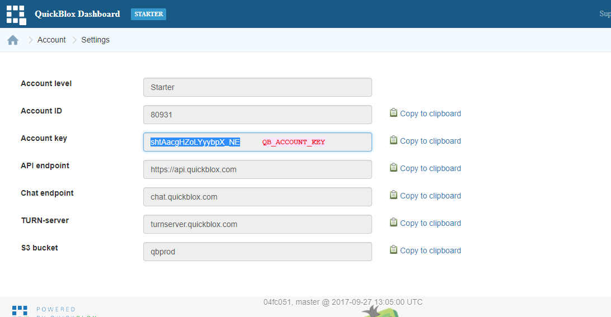

You go to the Application menu and select the application you just created to configure.

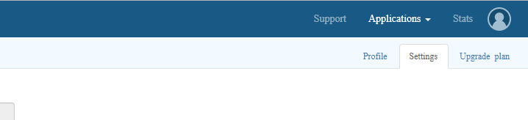

You will see the parameters in the image below.

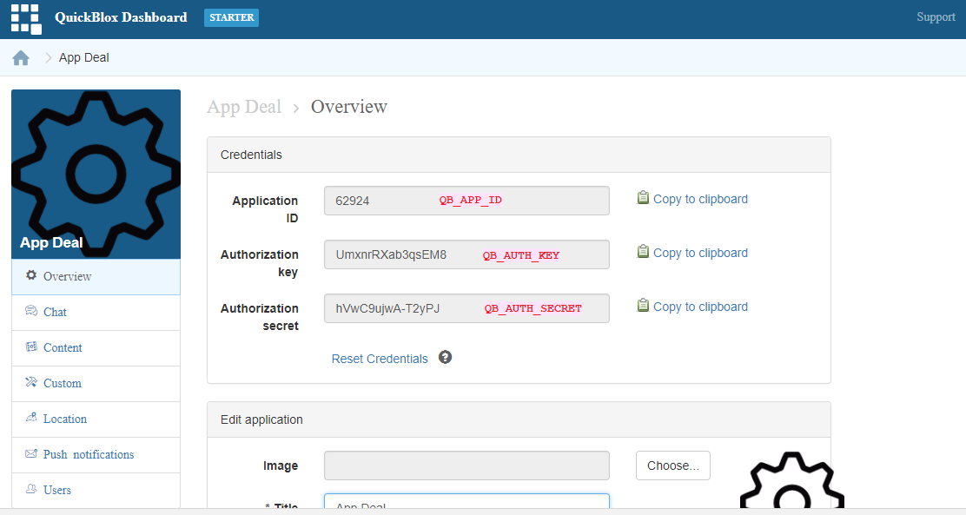

You replace the newly acquired key to the appropriate place in the file “main_config.xml”



**D. Configure Push function in App**

* **Step 1:**

You go to <https://console.firebase.google.com> , open your project -> choose Project settings -> CLOUD MESSAGING

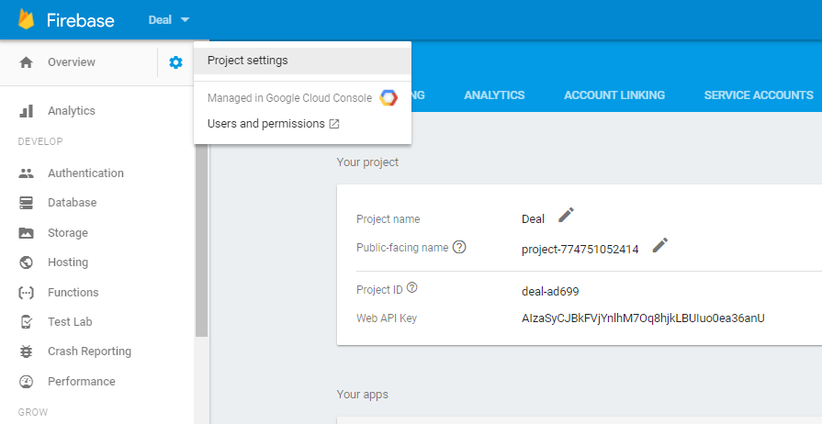

You get Google Api Key and Sender_id :

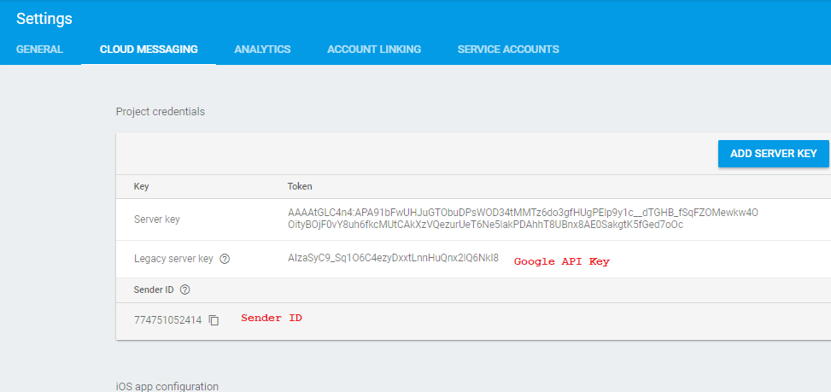

* **Step 2:**

You go to <https://admin.quickblox.com/apps> and choose app created, click Push notification -> Settings -> Google Cloud Messaging (GCM) Api Key:

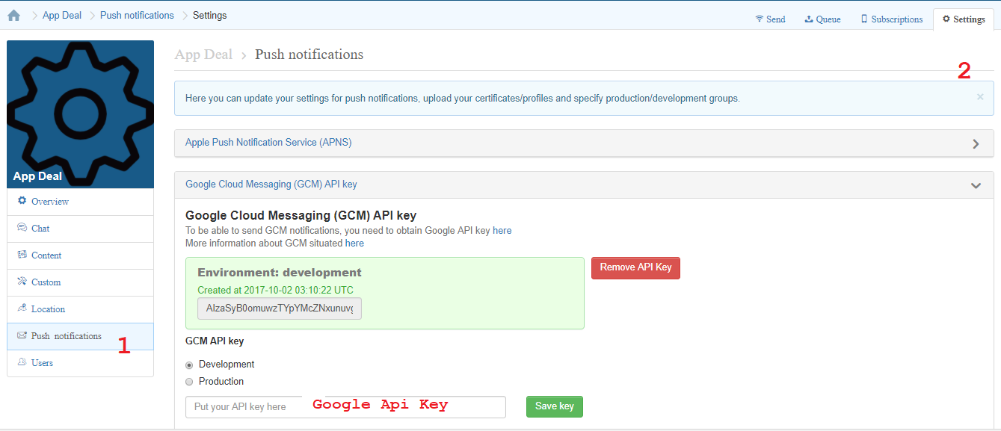

You paste Google Api Key and click Save key.

* **Step 3:**

You go to “main_config.xml” change sender_id is getted on Step 1:

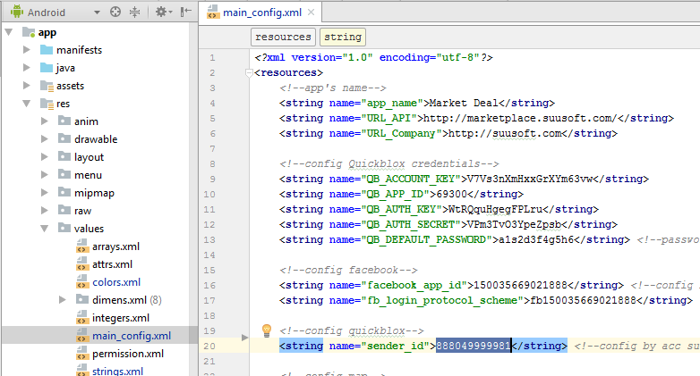

**E. Get key Distance**

You go to <https://developers.google.com/maps/documentation/distance-matrix/get-api-key>

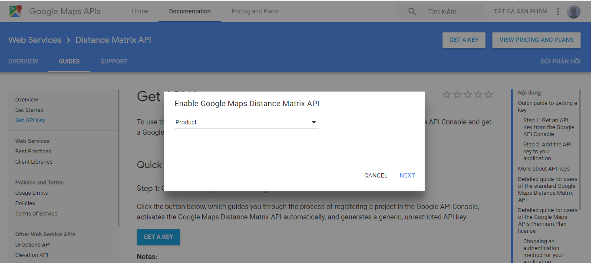

You login with your account config, click button GET A KEY -> choose Project contain my app, to Next. The key distance will appear and you just need to copy it.

Then go to backend page, select Settings and paste key to Google API Key, finally save it.

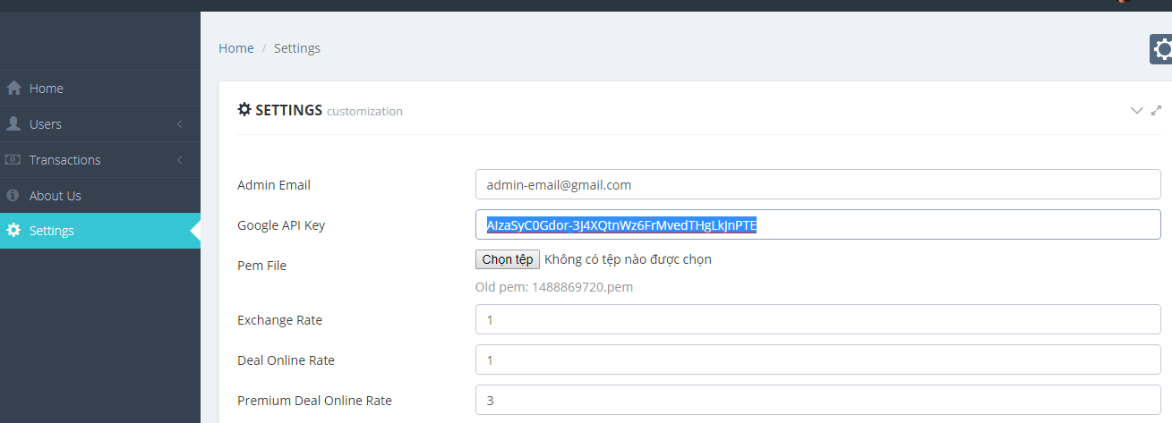

Congratulation!!!

You have configured successfully.

Now Let’s try building and run it

Customer support & customization

We have full team of developers that will help you to fix issues related to development, deployment.

Please contact with us via:

# General support:

1. Skype: suusoft
2. Email : [suusoft@gmail.com](mailto:support@suusoft.com)
3. Whatsapp: