Taxi Near Backend

Setup & Guideline

|  |  |
| --- | --- |
|  |  |

Setup & Install

1. **Requirement**

|  |  |
| --- | --- |
| PHP Version | 7.1 or newer |
| **Recommended Host** | Host Gator or a good host |
|  |  |

**II. Installation**

**Step 1:** Upload backend source code to your host and unzip.

**Step 2:** Go to your host, create a mysql database and go to phpmyadmin. Import db file to your db name which you have just created.

You can find the db file in root_folder/common/data/db.sql

**Step 3:** Open file root_folder/common/config/main-local.php to config. As like screenshot

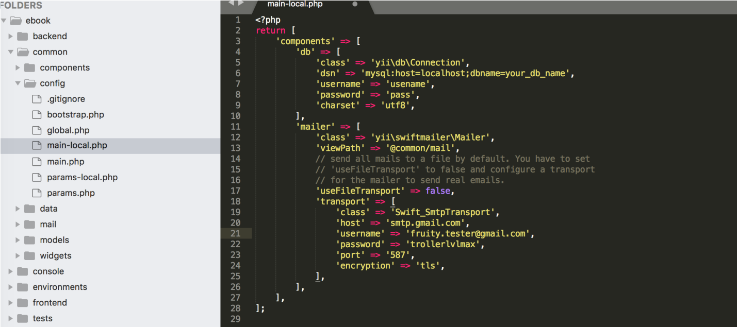

Now we have to put the username, password and database name in this.

**Step 4:** Set permission for folder.

In Cpanel browser to your folder which contain the source code. And follow these steps:

1. Browse to root_folder -> backend/runtime -> right click -> change permissions -> set permissions is 777.
2. Same action with root/backend/web/assets
3. Same action with root/backend/web/upload

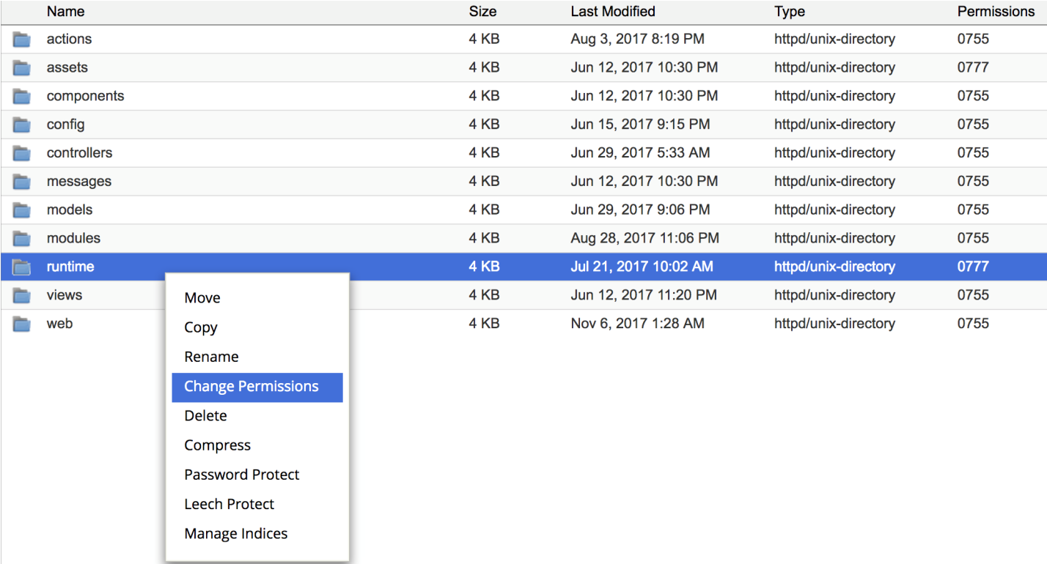

**Step 5:** Go to browser and try run. Open with link on address bar: your_host_address/root_folder

If a login is show then we have successfully!

You can login with account:

**User name:** admin

**Password:** 123456

Now to connect to app you will get api link and put into config file on app source code. Look at the guide for app

Api link: <http://your_host_address/root>_folder/

**III Guide for Backend**

1. View User

From Menu left, you click to Users -> Users

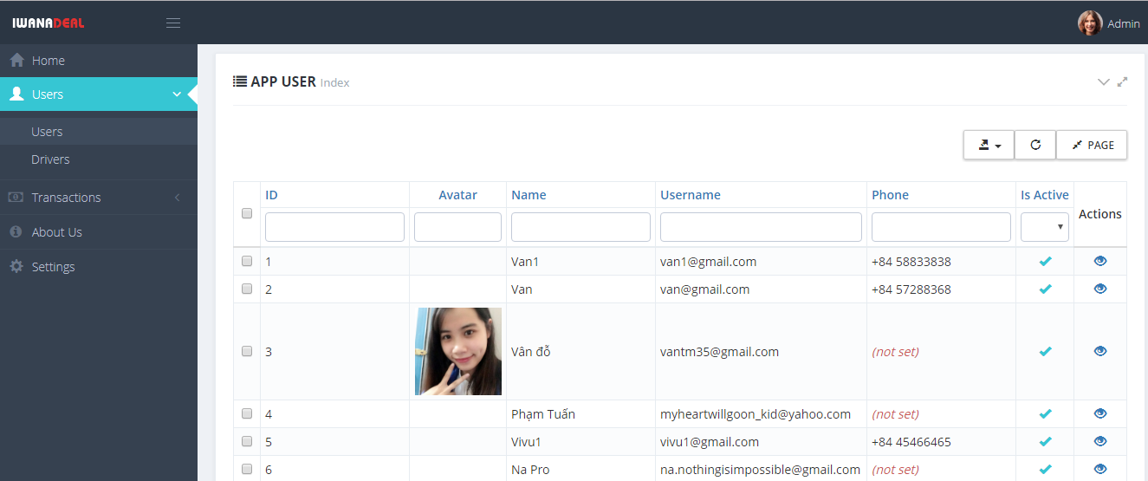

At here you can view user about.

1. View Transactions

From Menu left, you click to Transactions -> Transactions

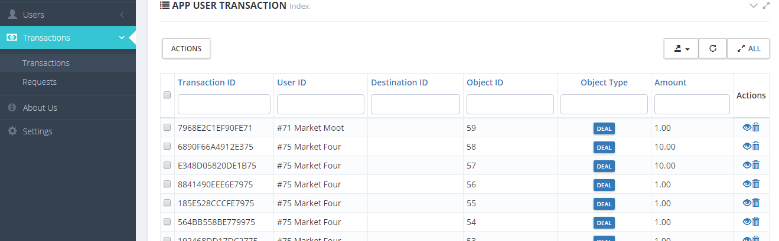

At here you can view, delete Transaction.

------ DONE -------------

Now you can open the app and connect to backend by a link. Please look at the app document

If you have any question feel free contact us.