**Project PRU221m**

**TOWER DEFENSE**

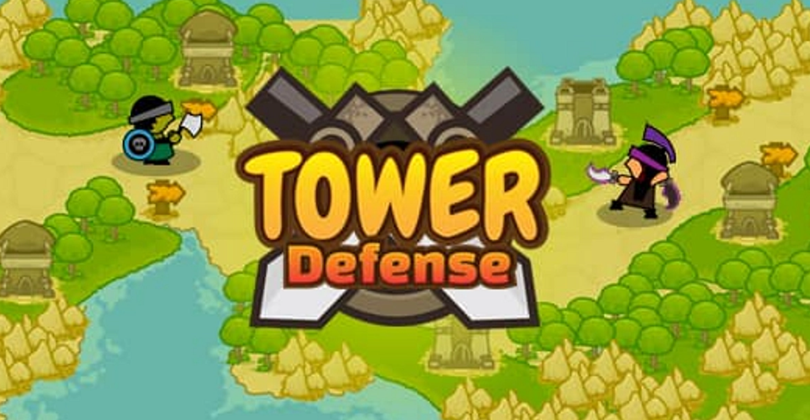

|  |  |  |
| --- | --- | --- |
| **Teacher:** Thuybt26  **Members:** | | |
| Nguyen Van Tien | : | HE163008 (Leader) |
| Nguyen Tran Quoc Anh | : | HE163282 |
| Le Minh Dung | : | HE160721 |
| Do Son Tung | : | HE150203 |
| Tran Van Tuan | : | HE151203 |

**HaNoi 06/2023**

Contents:

1. Understand the solution 4

2. Design a solution 4

2.1. Audio 4

2.1.1. Audio Controller 4

2.2. Gameplay 5

2.2.1. Tower 5

2.2.2. Build Manager 6

2.2.3. Plot 7

2.2.4. Turret 9

2.2.5. Slow Turret 11

2.2.6. Menu 13

2.2.7. LevelManager 14

2.2.8. Bullet 15

2.2.9. EnemyController 17

2.2.10. EnemyMovement 19

2.2.11. EnemySpawner 21

2.3 Player Setting 23

2.4. Save Load 23

2.5 Resources 23

2.6 How many code have done / all script : 10/20 23

3. Write test case 24

|  |  |
| --- | --- |
| **Iteration 1** | |
| Nguyen Van Tien | Understand the game |
| Nguyen Tran Quoc Anh | Find sprite and prefab, template |
| Le Minh Dung | Build the base of project |
| Do Son Tung | Find about third party for the game |
| Tran Van Tuan | Understand the game |

|  |  |
| --- | --- |
| **Iteration 2** |  |
| Nguyen Van Tien | Putting all together |
| Nguyen Tran Quoc Anh | Code Player Settings |
| Le Minh Dung | Code, Design UI |
| Do Son Tung | Code Object pool |
| Tran Van Tuan | Code Tower controller |

|  |  |
| --- | --- |
| **Iteration 3** |  |
| Nguyen Van Tien | Test |
| Nguyen Tran Quoc Anh | Test |
| Le Minh Dung | Fix bug |
| Do Son Tung | Fix bug |
| Tran Van Tuan | Fix bug |

# **Understand the solution**

Implement a game called Tower Defense. In the game, the player chose the tile to place the tower.There are four kinds of tower with different powers and you must combine them wisely to kill all the monsters.There are lots of kinds of monster with their leader and bosses. The monster will spawn in many ways to your castle. You can also upgrade your tower to get to a new level of strength. When the game finishes because the player ran out of health the player discovers whether or not they just achieved a new high score.

# **Design a solution**

## **2.1. Audio**

### **2.1.1. Audio Controller**

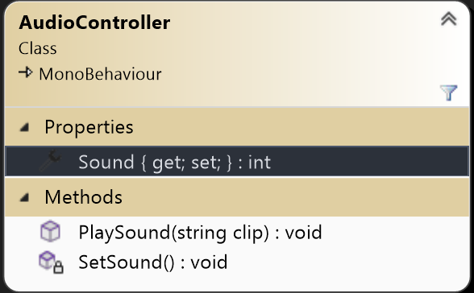

|  |  |
| --- | --- |
| **Properties** | **Usage** |
| Sound | Save Sound value |
| Methods | Usage |
| SetSound | Enable/Disable game sound |
| PlaySound | Play sound based on a string parameter |

## **2.2. Gameplay**

### **2.2.1. Tower**

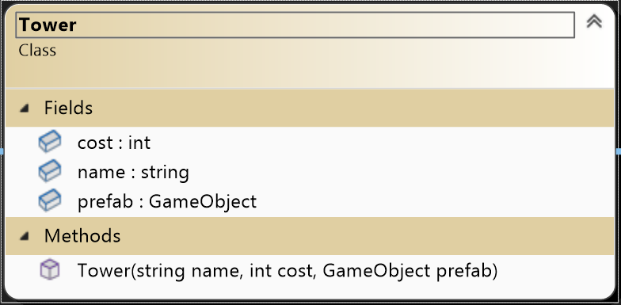

|  |  |
| --- | --- |
| **Fields** | **Usage** |
| Cost | The cost of the tower |
| Name | Name of the tower |
| prefab | GameObject to build |
| Methods | Usage |
| Tower | Constructor |

## **2.2.2. Build Manager**

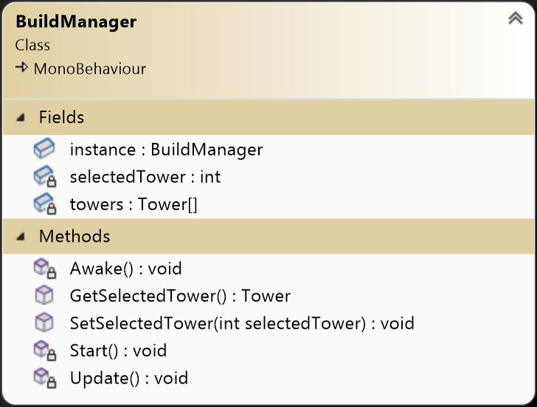

|  |  |
| --- | --- |
| **Fields** | **Usage** |
| instance | Singleton Pattern |
| selectedTower | Index of the tower going to be built |
| towers | Array of builtable tower |
| Methods | Usage |
| Awake | Singleton Pattern |
| GetSelectedTower | Return Tower object being selected |
| SetSelectedTower | Set the selectedTower variable to a index |

## **Plot**

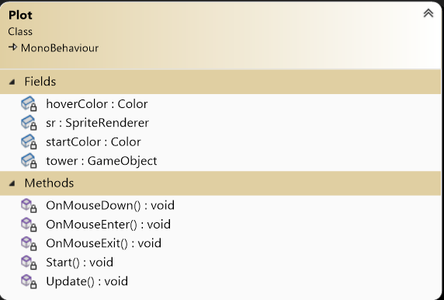

|  |  |
| --- | --- |
| **Fields** | **Usage** |
| Hover Color | Color to change when hover mouse |
| Sr | SpriteRender of the plot |
| Start Color | Color of the Plot when game start |
| Tower | The tower is built on plot |
| Methods | Usage |
| OnMouseDown | Handler plot interaction when press the plot |
| OnMouseEnter | Change color when mouse enter plot |
| OnMouseExit | Change color when mouse exit plot |
| **Start** | **Init the color of plot** |

## **Turret**

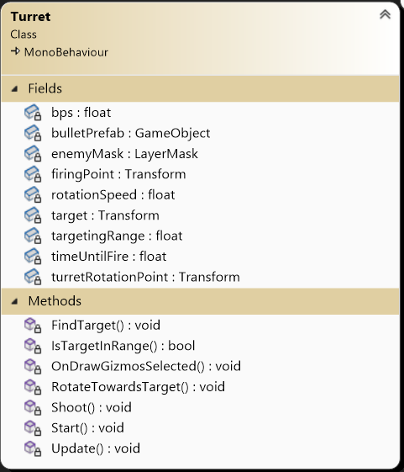

|  |  |
| --- | --- |
| **Fields** | **Usage** |
| bps | Number of bullet per second |
| BulletPrefab | The prefab of the bullet |
| enemyMask | The layer of the enemy to target |
| firingPoint | The position of the bullet to spawn |
| rotationSpeed | The speed that the head of the turret to spin |
| target | The target that the turret is going to hit |
| targetingRange | The range of the turret can shot |
| timeUntilFire | Time between shoot |
| turretRotationPoint | The point that the gun spin around |
| Methods | Usage |
| FindTarget | Find the target to shoot |
| IsTargetInRange | Check if target is in range |
| OnDrawGizmosSelected | Draw the range of turret |
| RotateTowardsTarget | Rotate the gun to the target |
| Shoot | Shoot the bullet |
| Update | Update the target |

## **Slow Turret**

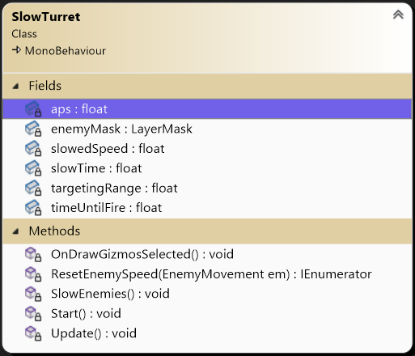

|  |  |
| --- | --- |
| **Fields** | **Usage** |
| aps | Attack per second |
| enemyMask | The layer of the enemy to target |
| slowedSpeed | Speed of enemy is slow to |
| slowTime | The duration the enemy is slow |
| targetingRange | The range of the turret can slow |
| timeUntilFire | Time between slow |
| Methods | Usage |
| SlowEnemies | Slow enemies |
| ResetEnemySpeed | Reset the speed of the enemy |
| OnDrawGizmosSelected | Draw the range of turret |
| Update | Update the slow |

## **Menu**

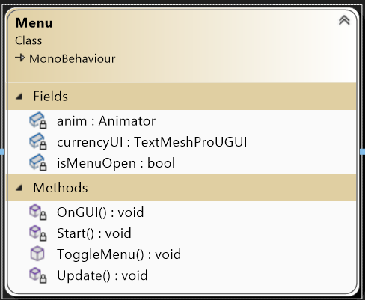

|  |  |
| --- | --- |
| **Fields** | **Usage** |
| anim | Animator of the menu |
| currencyUI | UI currency |
| isMenuOpen | Check if Menu is open |
| Methods | Usage |
| OnGUI | Change currency text UI |
| ToggleMenu | Change Menu state |

## **LevelManager**

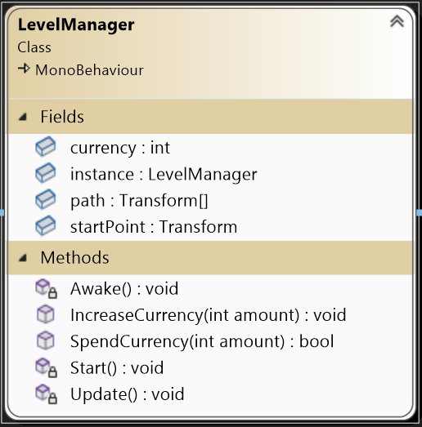

|  |  |
| --- | --- |
| **Fields** | **Usage** |
| Currency | currency of player |
| instance | Singleton pattern |
| path | Enemy’s path |
| startPoint | Enemy spawn point |
| Methods | Usage |
| Awake | Singleton pattern |
| IncreaseCurrency | Increase the currency of player |
| SpendCurrency | Decrease the currency of player |
| Start | Start currency |

## **Bullet**

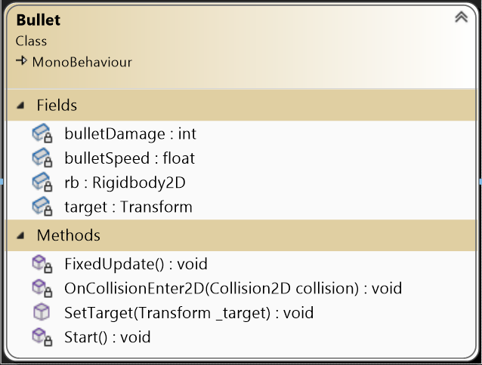

|  |  |
| --- | --- |
| **Fields** | **Usage** |
| bulletDamage | Damage of bullet |
| bulletSpeed | Speed of bullet |
| rb | Rigidbody of the bullet |
| target | Target of bullet |
| Methods | Usage |
| FixedUpdate | Update position of bullet |
| OnCollisionEnter2D | When bullet collide with enemy |
| SetTarget | Set the target for bullet |

## **EnemyController**

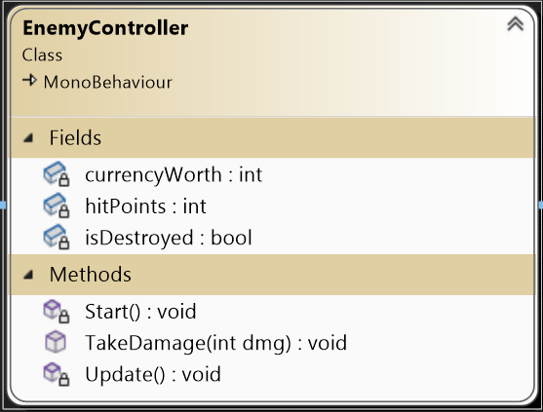

|  |  |
| --- | --- |
| **Fields** | **Usage** |
| currencyWorth | Worth when kill enemy |
| hitPoints | HIt need to kill the enemy |
| isDestroyed | Check enemy is destroy |
| Methods | Usage |
| TakeDamage | The enemy take damage |

## **EnemyMovement**

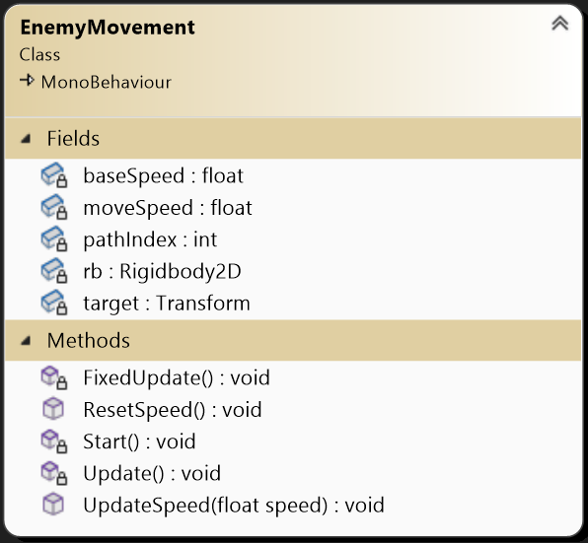

|  |  |
| --- | --- |
| **Fields** | **Usage** |
| baseSpeed | Base speed of Enemy |
| moveSpeed | Move speed of Enemy |
| pathIndex | Index of the path to travel to |
| rb | Rigidbody of Enemy |
| target | Target to move to |
| Methods | Usage |
| FixedUpdate | Update the position of Enemy |
| ResetSpeed | Reset the speed of the enemy |
| Start | Init speed and target |
| Update | Update the target |
| UpdateSpeed | Update new speed for the enemy |

## **EnemySpawner**

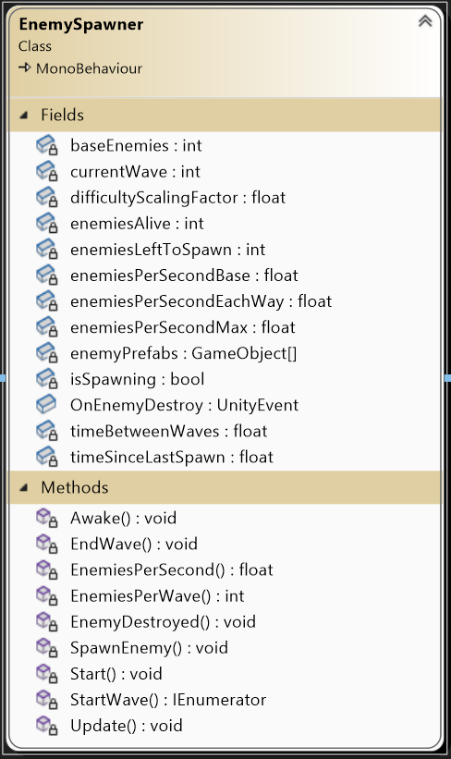

|  |  |
| --- | --- |
| **Fields** | **Usage** |
| baseEnemies | Base number of enemies |
| currentWave | The current wave number |
| difficultyScalingFactor | How the game become more difficult each round |
| enemiesAlive | The number of enemies left alive |
| enemiesLeftToSpawn | The number of enemies not yet spawn |
| enemiesPerSecond | The base number of enemies to spawn per second |
| enemiesPerSecondMax | The maximum number of enemies allowed to spawn per second |
| enemiesPrefabs | Enemy prefabs |
| eps | The number of enemies to spawn per second after calculation |
| isSpawning | Flag to check if the enemies wave has finished spawning |
| OnEnemyDestroy | Trigger an event when an enemy is destroyed |
| timeBetweenWaves | Time between enemies spawning waves |
| timeSinceLastSpawn | Time since the last enemy has been spawned |
| Methods | Use for |
| Awake | Init event listener |
| EndWave | End a enemy wave |
| EnemiesPerSecond | Count enemies per second scaling with waves |
| EnemiesPerWave | Count enemies per wave scaling with waves |
| EnemyDestroyed | Reduce number of enemies currently alive |
| SpawnEnemy | Spawn a random enemies |
| Start | Start spawn enemies |
| StartWave | Spawn a wave of many enemies |
| Update | Update the state |

## **Player Setting**

2.3.1. Player setting

## **2.4. Save Load**

## **2.5. Resources**

2.5.1. Sprite

2.5.2. Audio

## **2.6. How many code have done / all script :** 10/20

## **Write test case**

* **Test Case 1: Click new game button**
  + Step1: Click new game button on the screen
  + Expected Result: Redirect to the map and start the gameplay.
* **Test Case 2**: Increase game speed by 2 times
  + Step 1: Enter new game
  + Step 2: Once started the game, click the double arrow button on the top right of the screen to increase the speed of the game to x2.
  + Expected Result: Increase the gameplay pace 2 times.
* **Test Case 3**: Increase game speed by 4 times
  + Step 1: Enter new game
  + Step 2: Once inside the game, click the double arrow button on the top right of the screen twice to increase the speed of the game to x4.
  + Expected Result: Increase the gameplay pace 4 times.
* **Test Case 4**: Reset game speed by 4 times
  + Step 1: Enter new game
  + Step 2: Once inside the game, click the double arrow button on the top right of the screen thrice.
  + Expected Result: Gameplay pace speed up by x2, then x4, then reset back to normal.
* **Test Case 5**: Click pause button
  + Step 1: Click the pause button on the right corner of the screen.
  + Expected Result: The pause screen appears and displays 4 buttons including ”Home”, ”Restart”, “Continue”, and “Save and Quit”.
* **Test case 6**: Click the “Home” button during pausing the game.
  + Step 1: Click the pause button on the right corner.
  + Step 2: Click the “Home” button
  + Expected Result: Redirect to the main screen
* **Test case 7**: Click the “Restart” button during pausing the game.
  + Step 1: Click the pause button on the right corner.
  + Step 2: Click the “Restart” button
  + Expected Result: Restart everything from the beginning.
* **Test case 8**: Click the “Continue” button during pausing the game.
  + Step 1: Click the pause button on the right corner.
  + Step 2: Click the “Continue” button
  + Expected Result: Continue the game.
* **Test case 9**: Click the “Save and Quit” button during pausing the game.
  + Step 1: Click the pause button on the right corner.
  + Step 2: Click the “Save and Quit” button
  + Expected Result: Save the progress and redirect to Home screen.
* **Test case 10**: Build defense tower
  + Step 1: Click the rounded position on the screen.
  + Step 2: Choose one of four types of towers
  + Expected Result: the tower displayed on the map
* **Test case 11**: Upgrade defense tower
  + Step 1: Click the tower that you want to upgrade.
  + Step 2: Click the button with the upward arrow.
  + Expected Result: If you have enough money, then you’ll be able to upgrade the tower.
* **Test case 12**: Destroy defense tower
  + Step 1: Click the tower that you want to destroy.
  + Step 2: Click the destroy button.
  + Expected Result: The tower gets destroyed and money returned to the player.
* **Test case 13**: Lose all HP point and click Home button
  + Step 1: The player loses all of his/her HP points, then the defeat announcement appears on the screen.
  + Step 2: Click Home button
  + Expected Result: The defeat scene appears and displays 2 buttons “Home” and “Retry”. Players choose the Home button and redirect to the main screen.
* **Test case 14**: Lose all HP point and click Retry button
  + Step 1: The player loses all of his/her HP points, then the defeat announcement appears on the screen.
  + Step 2: Click Retry button
  + Expected Result: The defeat scene appears and displays 2 buttons “Home” and “Retry”. Players choose the Retry button and the game starts from the beginning.