**ASSIGNMENT 2 FRONT SHEET**



|  |  |  |  |
| --- | --- | --- | --- |
| **Qualification** | **BTEC Level 5 HND Diploma in Computing** | | |
| **Unit number and title** | Unit 13:Computing Research Project | | |
| **Submission date** |  | **Date Received 1st submission** |  |
| **Re-submission Date** |  | **Date Received 2nd submission** |  |
| **Student Name** | Nguyen Van Tung | **Student ID** | BH00299 |
| **Class** | IT0503 | **Assessor name** | Nguyen Thanh Trieu |
| **Student declaration**  I certify that the assignment submission is entirely my own work and I fully understand the consequences of plagiarism. I understand that making a false declaration is a form of malpractice. | | | |
|  | | **Student’s signature** | Tung |

**Grading grid**

|  |  |  |  |
| --- | --- | --- | --- |
| P6 | P7 | M4 | D3 |
|  |  |  |  |

1

|  |  |  |
| --- | --- | --- |
| ❒ **Summative Feedback:**  **Resubmission Feedback:** | | |
| **Grade:** | **Assessor Signature:** | **Date:** |
| **Internal Verifier’s Comments:** | | |
| **Signature & Date:** | | |

Contents

**A. Introduction 5**

**B. Content 6**

**I. Reflect on the effectiveness of research methods applied for meeting the objectives of the computing research project. (P6) 6**

**1. Impact of research proposal 6**

**2. Impact of Sequential Research Process 7**

**3. Research methods used 8**

**II. Consider alternative research methodologies and lessons learnt in view of the outcomes (P7) 27**

**1. Mistakes during your research process: 27**

**2. Alternative research methodologies and improvement in future research: 28**

**C. Conclusion 36**

**D. References 37**

**Table Of Figures**

Figure 1: Result survey 12

Figure 2: Result survey 12

Figure 3: Result survey 13

Figure 4: Result survey 13

Figure 5: Result survey 14

Figure 6: Result survey 14

Figure 7: Result survey 15

Figure 8: Result survey 15

Figure 9: Result survey 16

Figure 10: Result survey 16

# A. Introduction

In an era fueled by digital interconnectedness, user data privacy is a crucial problem in the information technology environment. There is a great deal of concern about how to secure sensitive data because of the frequency of data breaches and the impact they have on user privacy. This article critically examines "the most common cyber threats and vulnerabilities associated with big data environments and how organizations can effectively mitigate them". This study intends to contribute to the expanding field of information security by elucidating the intricacies of data vulnerabilities and offering workable mitigation strategies.

The digital world is expanding, and with it, so are the complexity of dangers pertaining to user data. Data breaches can have a wide range of consequences, from identity theft and illegal access to potentially manipulating sensitive data. This essay seeks to clarify the various facets of these negative consequences by thoroughly examining the impacts on individuals, businesses, and the framework of our globalized society as a whole.

A interdisciplinary approach combining qualitative and quantitative methodologies is set to be used in the study. Our objective is to provide a narrative through extensive literature research, surveys, and in-depth interviews that not only accounts for the frequency of data vulnerabilities but also captures the nuanced experiences and viewpoints of users. The project hopes to bridge this knowledge gap by focusing on the experiences of individuals engaging with the digital environment and statistical understanding.

The primary objective of this research goes beyond simply enumerating the negative impacts; it also suggests workable strategies for mitigating them. The study makes an effort to provide a roadmap for enhancing data protection procedures by utilizing best practices, state-of-the-art technology, and insights from the integration of qualitative and quantitative data. Its main objective is to support the development of long-term solutions that safeguard user data in a rapidly evolving technological landscape.

We really hope that the knowledge we offer here will improve academic debate and empower stakeholders from a range of sectors to take proactive steps to address and mitigate the negative impacts on user data as we embark on this voyage of discovery into the field of data security. Together, we want to open the door for a more robust and safe digital future.

# B. Content

# I. Reflect on the effectiveness of research methods applied for meeting the objectives of the computing research project. (P6)

In the first class, the research approaches were carefully applied to produce a thorough and well-written research study. The essential subject at the heart of this laborious endeavor is "the most common cyber threats and vulnerabilities associated with big data environments and how organizations can effectively mitigate them". This study aims to clarify the many levels of implications that affect consumers and stakeholders in the data security domain.

The study design, which calls for a comprehensive inquiry, is consistent with the approach that was covered in the first session. The study uses a combination of qualitative and quantitative methodologies in an effort to fully capture the breadth and depth of the negative impacts on user data. These strategies have allowed the project to progress in a transparent manner while emphasizing methodological integrity.

Throughout the journey, thorough explanations have been included to help make sense of the many ramifications that both users and stakeholders must deal with. The consequences of vulnerabilities and data breaches have been made evident, emphasizing the far-reaching implications on individuals as well as the companies that keep their data. The intricate nature of these consequences has been carefully dissected, offering a thorough understanding of the current issues.

This research project essentially serves as an example of the need of using the taught methodologies in addition to resolving data security challenges in our digital environment. The project aims to produce effective preventative measures and contribute significantly to the present information security discourse by demonstrating the practical repercussions and difficulties associated with bad impacts on user data.

### 1. Impact of research proposal

* **Clarity of Research Objectives:** Having a well-structured research proposal makes it easier to define the objectives of the study precisely. This clarity is necessary to guide the research process, ensure that the analysis of the negative impacts on user data is the main emphasis, and provide workable limitations.
* **Resource Allocation:** A compelling research proposal helps with efficient resource allocation. It clarifies for researchers and other interested parties the study's characteristics, procedures, and potential resource requirements. Consequently, better staffing, budgeting, and planning are made feasible.
* **Effective Stakeholder Engagement:** Effective stakeholder inclusion may be possible in a well-designed research study. It is possible to win over legislators, businesses, and individuals who see the need of preserving user data by demonstrating how critical it is to resolve detrimental consequences on user data.
* **Ethical Issues:** Ethical considerations are vital when exploiting user data in research. A well-written proposal addresses ethical concerns in a clear and concise manner, ensuring that the study is conducted ethically, with participants' best interests in mind, and in compliance with legal and ethical requirements.
* **Contributions to Knowledge Base:** A research proposal lays the groundwork for contributing to the corpus of existing knowledge. By clearly stating the study topic, hypothesis, and objectives, it paves the way for generating new insights and adding substantial information to the academic and industrial discourse on data security.
* **Policy Implications:** A carefully considered suggestion may have an effect on how policies are formulated. Lawmakers may amend or modify cybersecurity and data protection policies if the report highlights significant issues or offers workable solutions to minimize negative consequences.
* **Educational Value:** The proposal itself could be useful for teaching even before the full research study is completed. It provides a clear synopsis of the research question and clarifies the objectives, approach, and potential outcomes of the investigation. This instructive information can be beneficial to academic and business audiences.
* **Practical Applications:** It also has an impact in real-world situations. This research proposal can help customers, businesses, and the larger digital ecosystem by describing practices that successfully minimize negative effects on user data. These techniques are applicable in practical situations.
* **Clarity of Research Objectives:** Having a well-structured research proposal makes it easier to define the objectives of the study precisely. This clarity is crucial for steering the research process, ensuring that the analysis of the negative impacts on user data is the main focus, and proposing workable limitations.
* **Resource Allocation:** A compelling research proposal helps with efficient resource allocation. It clarifies for researchers and other interested parties the study's characteristics, procedures, and potential resource requirements. Consequently, better staffing, budgeting, and planning are made feasible.
* **Long-Term Relevance:** Successful research projects may have long-term implications. Even when the present study project is completed, the recommendation could still have an impact since it might inspire more research, discussions, and initiatives aimed at enhancing data security.

In summary, a research proposal will have a big impact on this topic; it will have an impact on everything from the specificity of the study's objectives to potential real-world uses and long-term improvements in knowledge and policy development.

### 2. Impact of Sequential Research Process

The implications and results that arise from carrying out research in a methodical, step-by-step fashion are referred to as the effect of a sequential research process. A sequence of stages is involved in sequential research procedures, each of which builds on the one before it. Here are a few major effects of this kind of study process:

* **Systematic Progression:** A step-by-step approach to research guarantees an organized and methodical development of the investigation. Scholars proceed logically via discrete stages, including literature evaluation, research design, data gathering, analysis, and interpretation. This aids in keeping the study focused and clear throughout.
* **Accumulation of Knowledge:** The progressive accumulation of information is made possible by the sequential character of study. Each stage builds on the knowledge acquired in previous stages to further the overall comprehension of the study topic. This advances the creation of a thorough body of information about the topic.
* **Methodological Rigor:** Research methodology is something that needs to be carefully considered in sequential research procedures. To guarantee methodological rigor, careful preparation and execution are needed at every stage of the process. This improves the validity and reliability of the study's conclusions.
* **Refinement of Research Questions:** Research questions can be adjusted and refined as the study moves on in a stepwise manner, taking into account the knowledge that has been gathered thus far. Through this iterative approach, researchers can improve the accuracy and applicability of their findings.
* **Resource Optimization:** Researchers can maximize their use of resources—financial and time—by adhering to a methodical procedure. Every stage is carried out with a specific goal in mind, and modifications can be made depending on the results of earlier stages, preventing wasteful spending.
* **Minimization of Errors:** Research is sequential, which makes it possible to find and fix flaws or restrictions at every round. Frequent reviews and assessments guarantee that any problems are dealt with quickly, which raises the standard of the study as a whole.
* **Facilitation of Collaboration:** Researchers with varying levels of experience frequently collaborate during sequential research procedures. The organized method makes this cooperation easier, with each team member contributing to different stages of the study according to their expertise and experience.
* **Informed Decision-Making:** Researchers and stakeholders receive the knowledge they need to make well-informed judgments through the sequential process. This is important for a number of reasons, including study design, result interpretation, and suggestion formulation.
* **Communication and Dissemination:** Using a methodical approach makes it easier to communicate and distribute study findings in an efficient manner. When researchers organize their work logically, it becomes simpler for others to comprehend the background, procedures, and conclusions of the study.
* **Practical Application:** Research findings are frequently applied in real-world settings as a result of the sequential research process. Researchers may help put research into practice by identifying potential real-world applications for the findings as the project develops.

In conclusion, the quality, depth, and application of research are significantly impacted by a sequential research method. It guarantees a deliberate and thorough approach, resulting in a deeper comprehension of the study subject and its ramifications.

### 3. Research methods used

**a. Secondary research Source:**

Data Security:

**Link:** [**https://www.imperva.com/learn/data-security/data-security/**](https://www.imperva.com/learn/data-security/data-security/)

Threat Intelligence in the 5G security era:

**Link:** [**https://s.net.vn/Nx1P**](https://s.net.vn/Nx1P)

Common cyber security threats and how to deal with them:

**Link:** [**https://www.futurelearn.com/info/blog/how-to-deal-with-cyber-security-threats**](https://www.futurelearn.com/info/blog/how-to-deal-with-cyber-security-threats)

**The reason I choose these sources:**

Consideration has been paid to the reliability and validity of the sources that were selected for this meticulous information-sourcing project on data security and prevention. The selection criteria are based on the following core concepts:

* **Association with Reputable Organizations:** The websites of prestigious organizations, governmental authorities, and educational institutions have been prioritized. These entities often adhere to stringent protocols, ensuring the precision and thoroughness of the information they offer.
* **Track Record of Trustworthiness:** The reliability of an established source is based on their track record. To improve the accuracy of the data utilized in the project, preference should be given to platforms that have a history of supplying accurate and thoroughly researched data.
* **Pertinence to the Subject:** One important consideration when choosing sources is how closely the information relates to the research question. The sources that are chosen are based on the sections or articles that address assault methods, their objectives, defenses, and outcomes. This ensures that the data are perfectly aligned with the study's primary goal.
* **Particularized Knowledge:** Sources offering expert analysis and opinions are given precedence. Websites pertaining to information technology, academic institutions, security companies, and tech companies interested in enhancing security protocols are included in this. Using the opinions of experts improves the depth and quality of the knowledge acquired.
* **Authorship and Transparency:** Transparency in authorship and content creation is thought to be a vital component of dependability. When the information is derived from sources that explicitly disclose the identities of their authors, methodologies, and data collection techniques, it becomes more transparent and trustworthy.
* **Publication Standards:** The adherence of sources to rigorous publication criteria is a crucial consideration. Platforms that follow established procedures for gathering, processing, and reporting data improve the overall reliability of the data used in the research.
* **Diversity in viewpoints:** A variety of perspectives have been offered in an effort to recognize the complexity of the research problem. Acquiring information from sources associated with several businesses and industries provides a comprehensive understanding of the intricate issues that data breaches bring.

In other words, the reliability and authenticity of the data supporting this research effort are largely dependent on the meticulous selection of sources based on expertise, applicability, and reputation. This methodical approach ensures that the project is grounded in trustworthy and validated facts, hence fostering confidence in the outcomes produced.

**Things I learned from secondary research:**

* **Background Information:** A topic's core information is obtained through secondary research. It aids in your comprehension of the important ideas, historical background, and current theories pertaining to your field of study.
* **Literature Review:** On your subject, you are able to locate and study pertinent literature. This include academic books, papers, essays, and other publications that add to the corpus of knowledge already known in your subject.
* **Trends and Patterns:** You can find patterns and trends in the data that already exists by conducting secondary research. These can include long-term trends, regional patterns, or other recurrent themes that are pertinent to your study subject.
* **Statistical Information:** Data and statistical information can be obtained from a variety of sources, including industry publications, scholarly journals, and government reports. Economic indicators, market trends, demographics, and other information may be included in this data.
* **Comparison of Studies:** Reviewing several research on a subject allows you to contrast approaches, results, and conclusions. This aids in comprehending the consistency or variances in findings between various research.
* **Expert Opinions:** Experts in the subject frequently provide their ideas and insights to secondary research.

This might give you a more comprehensive understanding of the topic and assist you in comprehending the many points of view.

* **Identification of Research Gaps:** Secondary research might help you find areas that require more investigation or gaps in the body of knowledge. This might help you formulate your study goals and queries.
* **Policy and Regulatory Insights:** Secondary research may provide information about current laws, rules, or policies that are pertinent to your field of study, depending on your topic.
* **Historical Context:** Secondary research may provide you insights into the historical background of your subject, enabling you to comprehend how it has changed over time and what influences have shaped it.
* **Case Studies:** Case studies, which offer practical illustrations and applications of ideas or theories, are frequently a part of secondary research. Examining case studies might provide useful information about your field of study.
* **Identification of Key Stakeholders:** You can name important parties, groups, or people connected to or impacted by the subject. It is helpful to comprehend these stakeholders' points of view while determining the context of your study.
* **Data Limitations and Critiques:** You can find any limitations in the data that is currently available and criticisms of earlier studies by conducting secondary research. Contextualizing and interpreting study findings requires an understanding of these constraints.

When taken as a whole, these lessons offer a more thorough grasp of the subtleties of data security and form the cornerstone for creating workable solutions that reduce negative impacts on user data.

**Advantages and Disadvantages of Secondary Research**

|  |  |
| --- | --- |
| **PROS** | **CONS** |
| Because secondary research makes use of already-existing data, it is typically less expensive because it eliminates the need for considerable data collecting and related costs. | Secondary data can range widely in quality and dependability, thus researchers need to assess the sources' veracity and correctness carefully. |
| Compared to original research, secondary research saves time because the data is already available and can be analyzed quickly. | Because of their limited control over the data gathering process, researchers may encounter problems with data completeness, relevance, or fit for their particular study aims. |
| Research may be greatly aided by the abundance of data and information provided in secondary sources, which can span a wide range of subjects and historical periods. | Findings from secondary data may not be as accurate or applicable in the present study environment since they are out-of-date. |
| By comparing historical data, secondary research makes it possible to look at patterns, trends, and changes across time. | There may be situations where important data is not readily available to the public, making it difficult to find thorough and pertinent information. |
| Researchers don't need to physically be there or make attempts to collect data because they can obtain data from different geographic places. | Using secondary sources requires careful citation to ensure full credit is given to the original authors and to prevent plagiarism. |
| Before beginning primary research, researchers can improve their research questions and find knowledge gaps with the aid of secondary research. | In order to obtain significant insights, researchers must synthesis information from several sources because secondary data may not be detailed enough for the study aims. |
|  | The initial intent and prejudice of the source that provided the secondary data may have an impact on the data's objectivity and impartiality, which may have an impact on the study's conclusions. |

**b. Quantitative research**

**The result of quantitative research:**

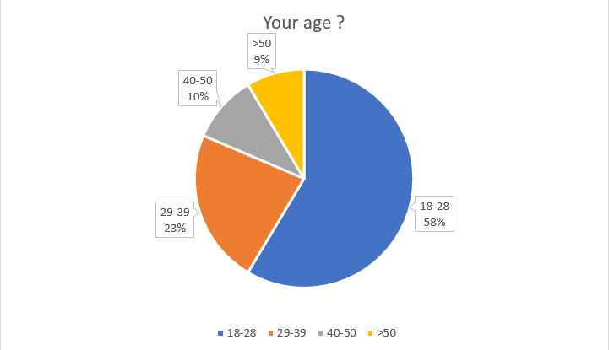

Figure : Result survey

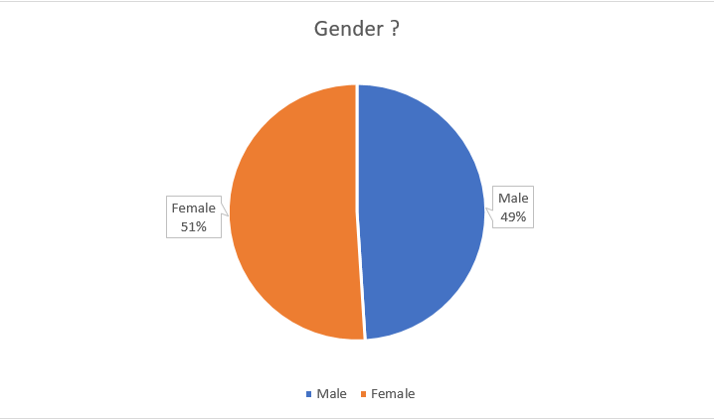

Figure : Result survey

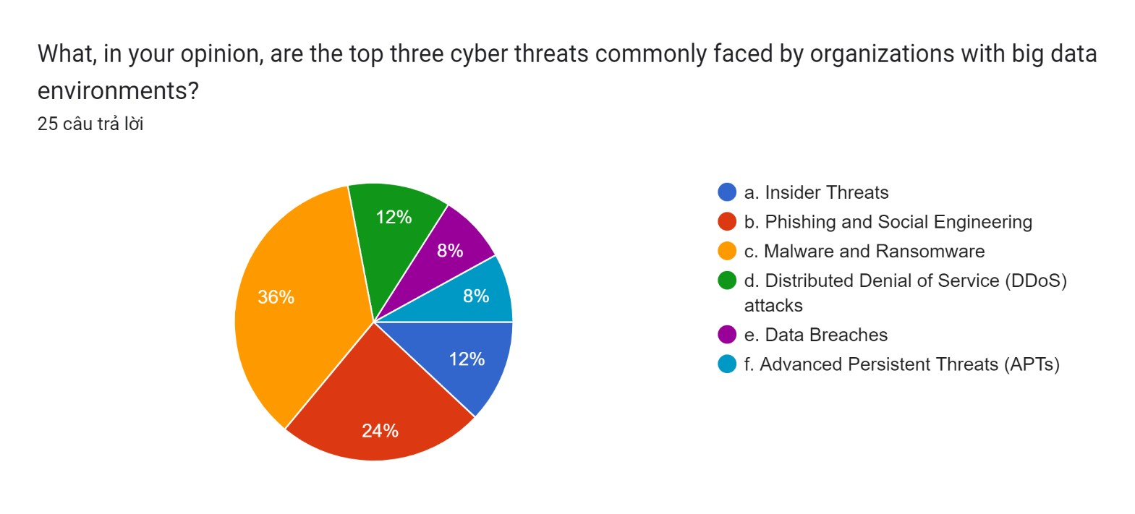

Figure : Result survey

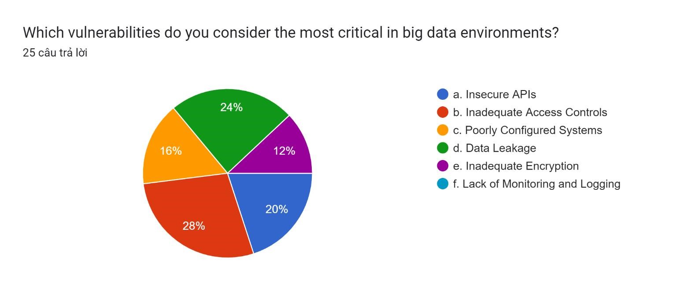

Figure : Result survey

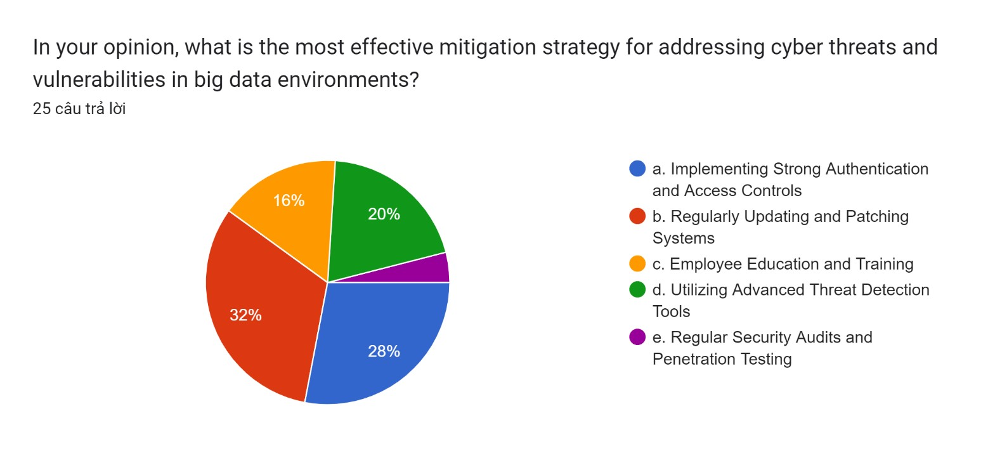

Figure : Result survey

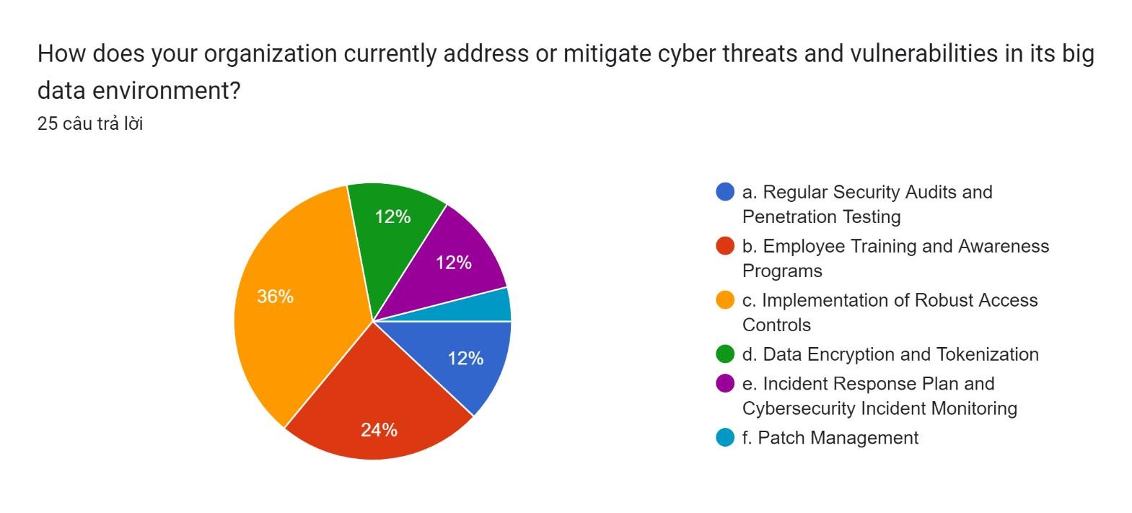

Figure : Result survey

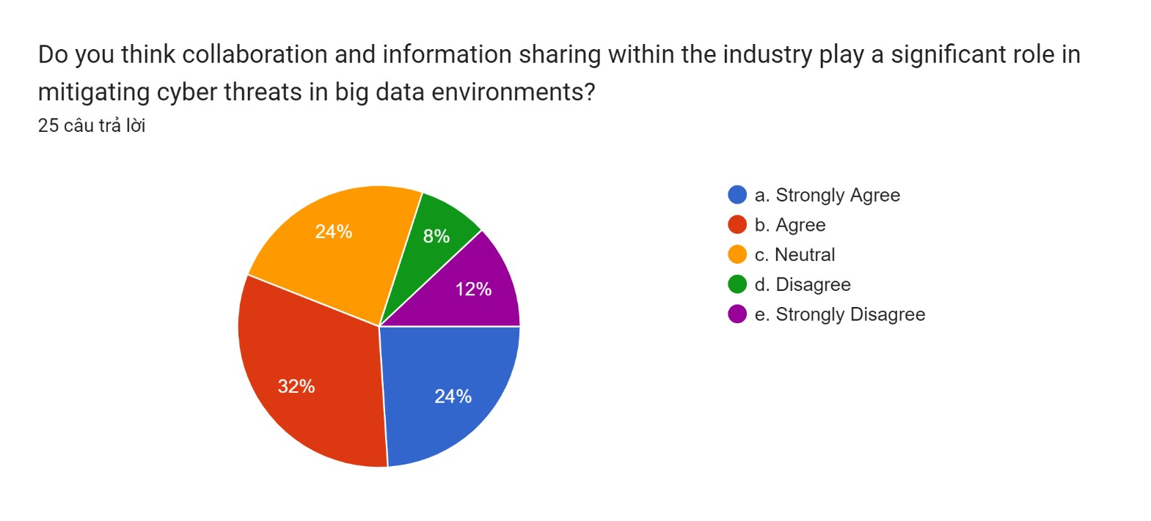

Figure : Result survey

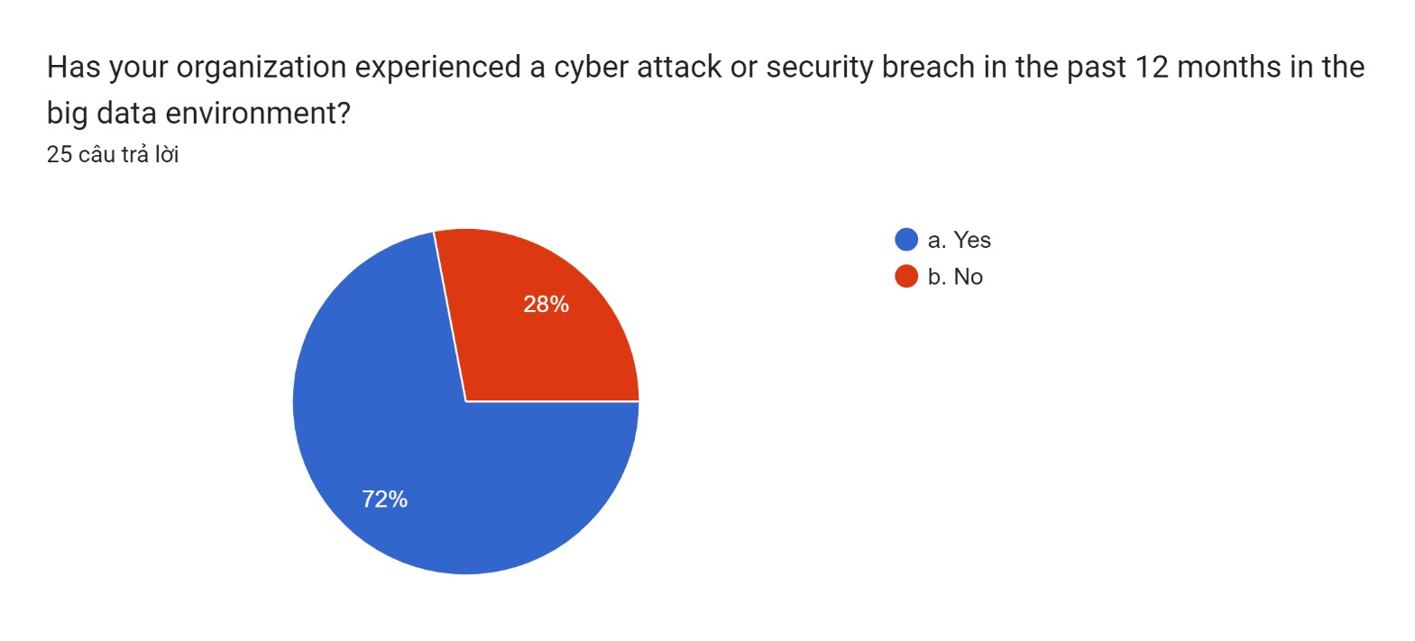

Figure : Result survey

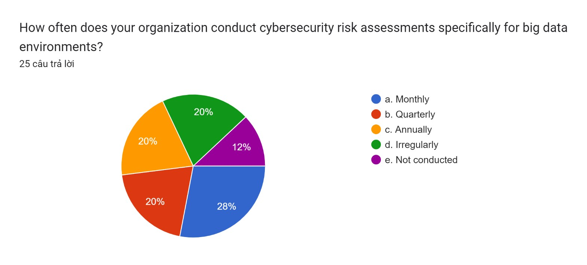

Figure : Result survey

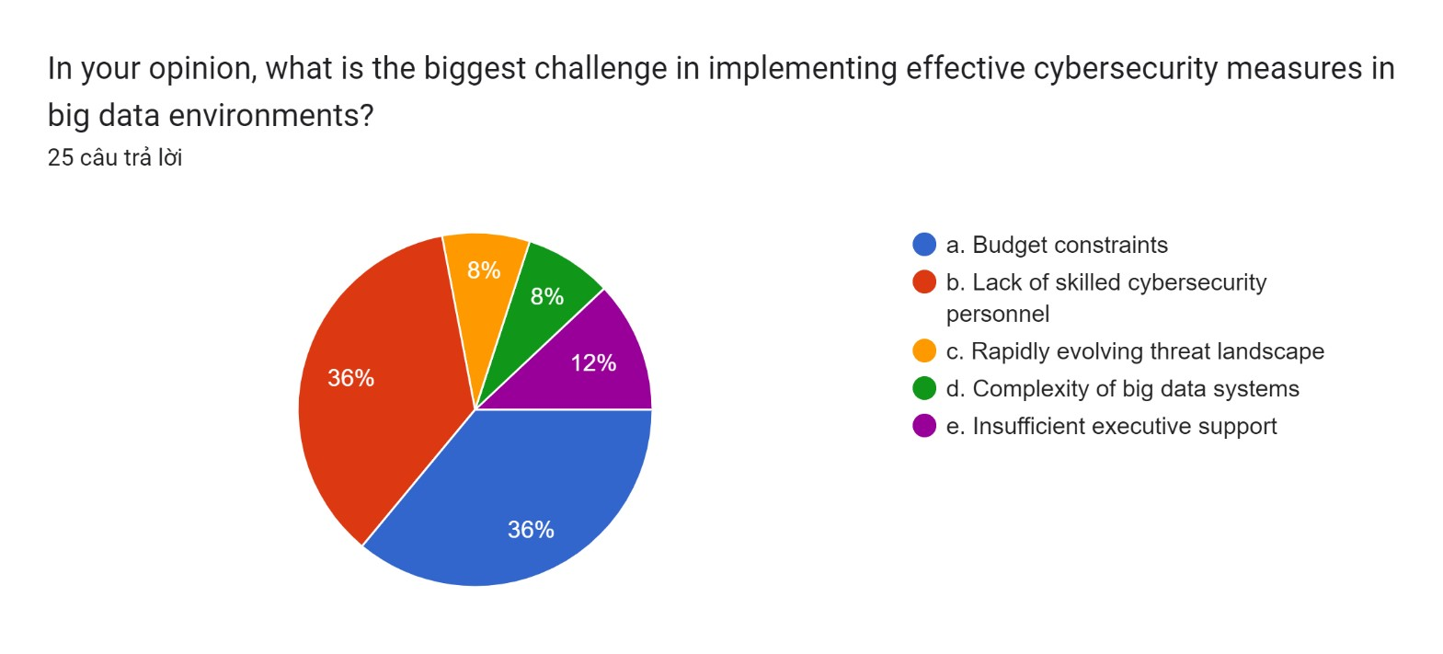

Figure : Result survey

**Things I learned from quantitative research:**

* **Descriptive Statistics:** Descriptive statistics are produced by quantitative research, and they offer a summary and description of a dataset's key characteristics. Measures including mean, median, mode, range, and standard deviation are among those found in these statistics.
* **Patterns and Trends:** The data may be analyzed quantitatively to find trends and patterns. This might entail looking at the relationships between data, tracking changes over time, or finding connections between various elements.
* **Causality Relationships:** It is possible to investigate the causal links between variables using quantitative research. Researchers can determine whether changes in one variable are related to changes in another by using statistical techniques like regression analysis.
* **Generalization to a Population:** The goal of quantitative research is frequently to extrapolate findings from a sample to a larger population. With a given degree of confidence, researchers can extrapolate results from the sample to the broader population by applying statistical procedures.
* **Validation of Hypotheses:** Through quantitative research, theories may be tested by researchers. An concept or hypothesis is supported or refuted by the analysis of the gathered data, which offers empirical evidence in favor of or against the offered hypotheses.
* **Reliability and Validity:** Evaluation of the validity and reliability of the study's instruments and measurements is made possible by quantitative research. While validity evaluates if a measurement is measuring what it is supposed to measure, reliability shows how consistently measurements are made.
* **Comparisons Between Groups:** Using statistical tests, researchers may compare groups or circumstances. This makes it possible to distinguish between groups—such as experimental and control groups in an experiment or various demographic categories—and to identify their differences or similarities.
* **Prediction and Forecasting:** Researchers can create models and equations for forecasting and prediction through the use of quantitative research. This is especially helpful in the social sciences, economics, and finance.
* **Quantification of Relationships:** Relationships between variables are numerically represented in quantitative research. It can be used to measure the magnitude of the effect in experimental research or the direction and intensity of connections.
* **Data Visualization:** Data visualizations such as graphs, charts, and other visual aids are frequently used in quantitative research. This can help simplify complicated relationships and provide a better comprehension of the results.
* **Statistical Significance:** It is possible for researchers to ascertain the statistical significance of differences or associations they detect. This makes it easier to discern between results that are probably the result of coincidence and those that are probably true over a larger population.
* **Survey and Questionnaire Analysis:** Questionnaires and surveys are commonly used in quantitative research. Numerical insights into the attitudes, actions, and preferences of participants can be obtained through the analysis of closed-ended question replies.

The capacity of quantitative research to offer accurate and quantifiable insights into a broad range of phenomena makes it valuable. For a more thorough understanding, it is crucial to be aware of its limits and think about fusing quantitative and qualitative methods with findings.

**Advantages and Disadvantages of Quantitative Research**

|  |  |
| --- | --- |
| **Pros** | **Cons** |
| **Objectivity**: Quantitative research uses statistical analysis and organized data gathering techniques to reduce researcher bias and strive for impartiality. | **Limited Context**: It could not take into consideration the social dynamics and context that affect attitudes and behaviors. |
| **Replicability**: Because they provide standardized instruments and defined methodology, quantitative investigations are very reproducible and may be repeated by other researchers. | **Difficulty in Questionnaire Design**: It might be difficult to create successful surveys and questionnaires that will yield accurate and trustworthy data. |
| **Efficiency**: When gathering data on several factors at once and investigating huge populations, it is frequently more effective. | **Rigidity**: Because quantitative research is based on predefined variables and survey questions, it may not be able to explore phenomena that are not expected. |
| **Data Precision**: Because quantitative research offers accurate measurements, it is a good option for investigating cause-and-effect relationships and evaluating hypotheses. | **Potential for Oversimplification**: Because quantitative research reduces complicated topics to numerical data, it may oversimplify them. |
| **Generalizability**: Random sampling and statistical inference make it easier to extrapolate findings from quantitative research to bigger populations. | **Lack of Depth**: Quantitative study might not be able to fully convey the breadth and depth of human experience or reveal hidden motives. |

**c. Qualitative research**

**The result of qualitative research:**

**Interview 1**

|  |
| --- |
| **Name: Nguyen Quang Phi Hung**  **Age: 21**  **Occupation: Student**  **Company: FPT BTEC** |
| **A:** Which are the main online dangers that large data settings usually have to deal with?  **B:** Because big data settings hold and process vast volumes of valuable and sensitive data, they are appealing targets for cyber attacks. Data breaches, malware and ransomware, phishing, and social engineering are some of the main cyberthreats connected to big data settings.  **A:** Which prevalent vulnerabilities in large data settings might be exploited by hostile actors?  **B:** A succinct summary of typical weaknesses in big data settings that malevolent actors might take advantage of: Weak Authentication, Insufficient Access Controls, Unencrypted Data...  **A:** What are the typical big data environment vulnerabilities that require immediate attention from enterprises, based on your experience? Could you give instances or particular situations that highlight these weaknesses and the possible outcomes?  **B:** Inadequate access controls provide a serious vulnerability. For example, we experienced an event where an unauthorized user obtained administrator capabilities due to a misconfiguration in access permissions, which may have resulted in data tampering and illegal access to vital systems. |

**Interview 2**

|  |
| --- |
| **Name: Nguyen Ngoc Duy**  **Age: 22**  **Occupation: Staff**  **Company: Google** |
| **A:** Could you give concrete instances or examples of cyberthreats that you have seen or experienced in contexts with big data?  **B:** Of course. Phishing emails have been known to target our staff in an effort to get access credentials to our big data systems. Furthermore, a previous worker previously took advantage of their lingering access to steal private information from our huge data repositories.  **A:** Which frequent weaknesses in big data settings, in your opinion, do enterprises need to address right away?  **B:** Two main issues are inadequate access restrictions and improperly setup systems. In big data contexts, inadequately protected APIs and inadequate encryption methods also provide serious dangers.    **A:** What are the typical big data environment vulnerabilities that require immediate attention from enterprises, based on your experience? Could you give instances or particular situations that highlight these weaknesses and the possible outcomes?  **B:** Two main issues are inadequate access restrictions and improperly setup systems. In big data contexts, inadequately protected APIs and inadequate encryption methods also provide serious dangers. |

**Interview 3**

|  |
| --- |
| **Name: Nguyen Ba Duc**  **Age: 25**  **Occupation: Staff**  **Company: Google** |
| **A:** Which major vulnerabilities in big data settings do you think enterprises need to address right away?  **B:** Critical vulnerabilities include data leaks caused by subpar encryption techniques, insecure APIs, and insufficient access restrictions. These make companies more vulnerable to possible data breaches and illegal access to private data.  **A:** What tactics or best practices, in your opinion, can businesses use to successfully reduce cyberthreats and vulnerabilities in their big data environments?  **B:** Essentials include frequent security training for staff members and stringent access controls. Furthermore, security may be substantially improved by encrypting data while it is in transit and at rest and by continuously monitoring for strange activity. It is equally crucial to keep software and systems updated with the newest updates.  **A:** In light of big data, how do you see the future of cyber threats? What steps should businesses take to remain ahead of these changing threats?  **B:** Cyber threats in big data environments are probably going to grow more advanced and focused in the future. Employers should prioritize proactive threat hunting, make investments in cutting-edge technology for threat detection, and encourage a cybersecurity-aware culture among staff members. To stay ahead of the game, regular knowledge exchange and keeping up with new threats are essential. |

**Interview 4**

|  |
| --- |
| **Name: Ngo Xuan Duy**  **Age: 24**  **Occupation: Staff**  **Company: FPT** |
| **A:** Based on your experience, which major vulnerabilities in big data settings ought to be addressed first by organizations?  **B:** Important vulnerabilities include inadequate authentication procedures and insecure APIs. Serious hazards are also posed by inadequate data encryption and improperly designed systems. Improving the security posture should be the first priority when it comes to fixing these vulnerabilities.  **A:** What tactics or best practices would you suggest using to help businesses in their big data environments effectively reduce cyber risks and vulnerabilities?  **B:** It is essential to put in place a robust access control policy. To find and fix flaws, regular security audits and vulnerability assessments are essential. Important precautions include encrypting critical data, keeping an eye on user activity, and regularly educating staff members about cybersecurity.  **A:** In the context of big data, how do you envision the future of cyber threats changing, and what proactive measures should enterprises take to lessen these changing dangers?  **B:** Future cyberthreats are probably going to get more complex, focusing more on IoT devices and utilizing AI to drive assaults. To keep current on new threats and mitigation techniques, organizations must engage with the cybersecurity community, invest in sophisticated threat detection systems, and regularly undertake threat simulations. |

**Interview 5**

|  |
| --- |
| **Name: Nguyen Duc Phat**  **Age: 22**  **Occupation: Student**  **Company: FPT BTEC** |
| **A:** Which big data ecosystem vulnerabilities do you think are the most important, and how do these vulnerabilities impact the security of an organization?  **B:** Among the most common vulnerabilities are inadequately designed access controls and insecure authentication methods. These have the potential to seriously jeopardize an organization's security and the privacy of sensitive data by causing unwanted access and data breaches.  **A:** What tactics or best practices, in your opinion, can businesses use to successfully reduce cyberthreats and vulnerabilities in their big data environments?  **B:** Essential tactics include putting in place thorough access rules, conducting frequent security audits, and encrypting data. Effectively reducing cyber risks also requires having a strong incident response strategy in place, training staff on cybersecurity, and keeping up with the most recent security updates.  **A:** In the context of big data, how do you anticipate cyber risks developing in the future? What proactive steps could enterprises take to counter these growing dangers?  **B:** Future cyberattacks are probably going to target big data system weaknesses by taking use of AI and machine learning capabilities. To proactively counter these new threats, organizations should make investments in AI-driven security solutions, carry out in-depth vulnerability assessments, and promote cooperation and information sharing within the cybersecurity community. |

**Things I learned from qualitative research:**

* **In-Depth Understanding:** Qualitative research enables a thorough and comprehensive comprehension of a certain phenomena. To better understand the complexity of human experiences, researchers might investigate participant viewpoints, meanings, and context.
* **Contextual Factors:** The significance of context is emphasized in qualitative research. It aids in the comprehension of how historical, social, cultural, and environmental elements affect the topic being studied by researchers.
* **Participant Perspectives:** The viewpoints of participants are the main subject of qualitative research. Researchers can record the opinions and voices of study participants by using techniques including focus groups, interviews, and participant observation.
* **Emergent Themes:** Qualitative research allows themes and patterns to emerge from the data rather than testing preconceived notions. It is possible for researchers to find recurrent notions, thoughts, or experiences that might not have been expected.
* **Rich Descriptions:** The topic under study is richly and thoroughly described via qualitative investigation. This level of descriptive detail aids in capturing the variety and complexity of human experience and behavior.
* **Cultural Insights:** Investigating cultural subtleties and variances is a good fit for qualitative research methods. It enables researchers to discover how cultural elements influence relationships, behaviors, and beliefs within a certain community.
* **Process-Oriented Understanding:** A common focus of qualitative research is on processes and how things develop over time. Scholars have the ability to examine the dynamic characteristics of social phenomena and examine the progressions of experiences or occurrences.
* **Interpersonal Dynamics:** Investigating interpersonal dynamics and relationships is a useful use of qualitative approaches. Scholars have the ability to investigate how people connect with one another and how these interactions impact their lives.
* **Theory Development:** By creating fresh conceptions and frameworks from observable patterns and themes, qualitative research advances theory development. It can assist researchers in developing theories for more study.
* **Subjectivity and Reflexivity:** Qualitative research acknowledges the investigator's influence in molding the investigation. Reflexivity is a common practice among researchers, who examine how their personal prejudices and worldviews may affect how they perceive the evidence.
* **Flexibility in Data Collection:** Because qualitative research methods are adaptable, researchers may modify their strategy in response to new information. This adaptability comes be very handy when studying dynamic and intricate events.
* **Applicability to Real-World Contexts:** Qualitative research findings are frequently immediately relevant to real-world situations. Gained insights can provide a greater knowledge of the needs and experiences of individuals or groups, which can drive policies, initiatives, or practices.
* **Case Studies:** Case studies, which offer in-depth analyses of certain situations, are frequently used in qualitative research. These instances can provide in-depth understanding of unusual or complicated circumstances.

Investigating the subjective and context-dependent facets of social processes and human behavior is a useful use of qualitative research. It enhances quantitative methodologies, and the combination of the two might result in a deeper comprehension of a study subject.

**Advantages and Disadvantages**

|  |  |
| --- | --- |
| **Pros** | **Cons** |
| **Exploratory Research:** When there is minimal information available about a topic, it is especially helpful for theory creation, hypothesis generating, and exploratory study. | **Subjectivity:** The trustworthiness of the results of qualitative research might be impacted by the bias and interpretation of the researchers. |
| **Rich Data:** Nuanced interpretations might result from the rich and extensive information that qualitative data frequently give, including context and human histories. | **Time-Consuming:** Because in-depth interviews, coding, and theme analysis are required for qualitative data analysis, it might take a while to gather and process the data. |
| **Contextual Insights:** When it comes to revealing underlying meanings and social dynamics, qualitative research is particularly good at capturing the environment in which actions or events occur. | **Limited Generalizability:** Qualitative research often yields context-specific findings that might be difficult to generalize to wider groups. |
| **In-Depth Understanding:** Through qualitative inquiry, complex phenomena may be fully understood holistically. | **Difficulty in Data Management:** Large amounts of qualitative data can be difficult to manage and analyze, necessitating the use of efficient data management techniques. |
| **Flexibility:** Because qualitative approaches are adaptive and flexible, researchers may change their strategy when new information comes to light while doing their study. | **Resource-Intensive:** More resources, such as experienced researchers and transcribing services, are frequently needed for qualitative research, which might |

**d. The relationship between Primary and Secondary Research**

* **Definition: Primary Research:** entails getting authentic data directly from sources or persons. Surveys, interviews, observations, and experiments are examples of common methodologies.
* **Secondary Research:** entails the examination of previously gathered information from sources such as literature, statistics, and other sources. Academic journals, books, papers, and information from government or business sources might all fall under this category.
* **Complementary Roles:** In the research process, primary and secondary research complement one other. In order to assist researchers grasp the background of their issue, uncover gaps in knowledge, and develop research questions, secondary research frequently offers a foundation of previously held information. After that, primary research fills in certain gaps or aims by gathering fresh, unique data.
* **Informing Research Design:** The design of a primary research project can benefit from secondary research. Researchers may improve the quality of their research questions, select suitable procedures, and pinpoint possible factors for further study by conducting a thorough evaluation of the body of current literature.
* **Identifying Research Gaps:** Contradictory discoveries or gaps in knowledge might be identified through secondary research. Researchers can use this identification of gaps in the literature to inform the design of primary research studies that fill up these gaps.
* **Literature Review:** By use of the literature review procedure, primary and secondary research are intimately related. Before beginning their own investigation, researchers perform a thorough analysis of the body of existing literature (secondary research) to ascertain the status of knowledge at the time (primary research).
* **Validating Findings:** By contrasting primary research findings with extant literature, they might be contextualized or verified. When a main study's findings support or refute preexisting knowledge, researchers can make stronger inferences.
* **Cost and Time Considerations:** Because secondary research involves the analysis of pre-existing data, it is frequently faster and less expensive than primary research. However, when particular, customized data is needed and the amount of current information is insufficient, primary research becomes necessary.
* **Iterative Process:** There is frequently an iterative interaction between primary and secondary research. Researchers may revisit secondary research after primary research yields fresh information and insights in order to improve their comprehension, modify their methodology, or corroborate their results.
* **Triangulation:** Principal and secondary data are frequently combined by researchers in order to strengthen the validity of their conclusions. By cross-checking data from several sources, this strategy—known as triangulation—increases the overall trustworthiness of the study.
* **Practical Example:** For instance, a researcher looking to understand customer preferences for a new product may start by reviewing industry data, market studies that have already been done, and literature on consumer behavior. They may make particular research inquiries and identify knowledge gaps based on this review. After that, the researcher would carry out primary research—such as surveys or interviews—to get firsthand information from customers.

In the research process, primary and secondary research are connected phases. While primary research produces fresh, targeted insights, secondary research establishes the framework and context. The study findings gain greater depth and credibility when both methodologies are integrated.

## II. Consider alternative research methodologies and lessons learnt in view of the outcomes (P7)

### 1. Mistakes during your research process:

**a. Secondary Research**

* **Excessive Dependency on Secondary Data:** There were times when I might have relied too much on secondary sources. This may have led to a different direction for my research because these sources might have had personal prejudices. I had to consider if my research objectives were in line with the initial environment in which the data were acquired.
* **Not Checking the Credibility of Sources:** In my haste to gather data, I might not have verified the validity of each source I used for secondary research. This could have led to inaccurate outcomes.
* **Outdated Information:** There's a chance the information gathered from secondary sources was outdated. Relying on older data might lead to incorrect conclusions in fields where changes happen quickly, like technology.
* **Absence of Critical Evaluation:** If the quality and dependability of sources are not rigorously evaluated, information that is biased or inaccurate may be provided. Assessing the reliability of each source is essential to maintaining the study's integrity.

**b. Primary Research**

* **Disregarding Ethical Considerations:** I conducted my interviews with great care to ensure that informed consent was obtained and privacy was maintained. I am conscious, however, that it can be more challenging to preserve respondents' privacy when conducting online surveys, and that some respondents might not have felt comfortable sharing critical information.
* **Badly Designed Surveys and Interviews:** Looking back, there were a couple questions I should have asked differently throughout the surveys and interviews. It's probable that unclear or perplexing questions led to inaccurate data and misunderstandings. I'll be more cautious and meticulous in my future research by taking these potential risks into account.
* **Biases in Data Collection:** I could have unintentionally introduced bias into my primary research by misphrasing my survey questions or by selection bias during the interview selection procedure. Looking back, I see that several of my survey questions may have been more direct and less suggestive.
* **Restricted Sample Size or Scope:** My initial study used a relatively small sample size. This might have skewed the results because it couldn't have been entirely representative of the larger population I was studying.
* **Inadequate Pilot Testing:** If pilot testing are not conducted before the actual data collection, unexpected issues with survey tools, interviews, or experiments may surface. Pilot testing makes it easier to identify and fix problems early on.

**c. Reflection on the result of the research**

Evaluating the results of my investigation on the most prevalent cyberthreats and vulnerabilities connected to big data settings, as well as the best ways for businesses to mitigate them. My comprehension of the subject area has increased as a result of my extensive secondary research, which yielded a wealth of data, opinions, and ideas. This process made clear how crucial it is to carefully evaluate the reliability and quality of information sources. It became evident that I needed to use caution to ensure that the foundation for my research was solid and trustworthy.

Primary research has yielded firsthand insights, particularly via the use of surveys and interviews. It became evident how human the problem is when experts were consulted and information about public attitudes and behaviors about personal data was obtained. I've learned how important it is to craft succinct, thoughtful questions while navigating the nuances of moral dilemmas in data collection.

Finding opportunities for improvement is a crucial part of this self-examination process. I am aware that increasing sample size and preserving variety will increase the survey's robustness. It's possible that interviews using a more methodical approach and in-depth analysis through follow-up questions yielded richer insights. The takeaway from secondary research is the constant need to cross-reference sources to ensure the data is correct and current.

Not only have I increased my understanding and sharpened my research skills, but I have also contributed to raising awareness of a significant global issue. The knowledge I've gained will undoubtedly affect how I approach projects going forward, allowing me to apply these wise lessons and refine the areas that need improvement. I eagerly anticipate the opportunity to make a significant contribution to the constantly changing field of information security through ongoing research initiatives.

### 2. Alternative research methodologies and improvement in future research:

**a. Experimental research**

As part of a scientific research methodology, experimental research modifies one or more independent factors and observes how it affects a dependent variable while accounting for any confounding variables. Establishing cause-and-effect links between variables via methodical and thorough examination is the main objective of experimental research.

**Key characteristics of experimental research include:**

* **Manipulation of Variables:** One or more independent variables are purposefully manipulated by the researcher in experimental research. It is thought that these variables have an impact on the dependent variable.
* **Controlled Environment:** To reduce the impact of extraneous variables—factors other than the independent variable that might affect the results—the researcher meticulously manages the experimental setup. Establishing a cause-and-effect link requires this control.
* **Random Assignment:** In experimental research, subjects are frequently randomized at random to various experimental setups. In order to maintain group comparability, random assignment helps guarantee that participant differences are dispersed equally throughout the experimental groups.
* **Measurement of Variables:** The response or outcome that is anticipated to change as a result of adjusting the independent variable is the dependent variable, which is measured by the researcher. Since the measurement is usually quantitative, statistical analysis is possible.
* **Comparison Groups:** Comparison groups are frequently used in experimental research. While the control group is not given any therapy or modification, the experimental group is. This enables researchers to assess if the independent variable had a substantial impact by comparing the results.
* **Replication:** Replicable studies are those in which additional researchers can carry out the same experiment and get comparable outcomes. The reliability and generalizability of findings are strengthened by replication.
* **Validity and Reliability:** The two main goals of experimental research are external validity (the degree to which the results may be applied to different populations or environments) and internal validity (the degree to which the study correctly represents a cause-and-effect connection). Furthermore, consistency and reproducibility of the outcomes are guaranteed by dependability.
* **Hypothesis Testing:** It is common practice in experimental research to develop and test hypotheses. Based on the modification of the independent variable, the researcher develops predictions about the predicted results, which are then tested by statistical analysis of the data.
* **Ethical Considerations:** In order to protect participants' welfare and get their informed permission, researchers carrying out experimental studies are required to abide by ethical standards. While designing and carrying out research involving humans or animals, ethical issues are crucial.

**Pros and cons:**

|  |  |
| --- | --- |
| **PROS** | **CONS** |
| **Establishing Cause-and-Effect Relationships:** Specifically, experimental research is ideal for determining the cause-and-effect connections between variables. Researchers can determine causal linkages by changing the independent variable and monitoring how it affects the dependent variable while accounting for other variables. | **Artificiality of Settings:** The artificiality or contrivance of experimental settings may restrict the applicability of findings in real-world contexts. In a controlled situation, participants could act differently than they would in their natural environments. |
| **Control Over Variables:** There is a great deal of control over the research setting while conducting experimental research. By reducing the impact of unrelated factors, this control improves the study's internal validity. | **Ethical Concerns:** Ethics issues might arise from experimental research, particularly when the study requires manipulation or deceit. Informed permission must be sought, and participants' rights must be upheld, according to researchers. |
| **Random Assignment:** In order to guarantee that participant individual variations are dispersed equally among experimental groups, random assignment is used in experimental investigations. This enhances the validity of the results and helps to make the groups more comparable. | **Difficulty in Manipulating Some Variables:** In an experimental context, it might be difficult or immoral to change some factors. For the purpose of the experiment, it might not be morally permissible to expose subjects to certain dangers or situations. |
| **Replicability:** Designs for experimental inquiry are frequently repeatable. The general dependability of the results can be increased by having many researchers carry out the same experiment to confirm or refute the findings. | **Experimenter Bias:** Consciously or unintentionally, the experimenter's presence might bring bias into the research. This might have an effect on participant behavior as well as the gathering and analysis of data. |
| **Quantitative Data:** Most experimental research yields quantitative data, which makes thorough statistical analysis easier. This enables researchers to compare groups objectively and get accurate results. | **Demand Characteristics:** According to their understanding of the goal of the study or the researcher's expectations, participants in experimental studies may change how they behave, which might result in demand characteristics that can affect the outcomes. |
| **Hypothesis Testing:** Hypotheses are developed and put to the test in experimental study. Researchers may more methodically explore and evaluate the correlations between variables with the use of this organized technique. | **Limited Exploration of Complex Phenomena:** Using experimental research to study intricate social, cultural, or contextual factors might not be the best idea. It could be difficult to fully capture some facets of human experience and behavior in a controlled laboratory context. |
| **Generalizability:** Experimental research can have high external validity when it is well-designed and carried out, which allows results to be extrapolated to different populations or environments. This is especially true if a variety of samples and circumstances are used in the study. | **Resource Intensive:** Resources for experimental research can be few, including staff, funds, and time. Organizing controlled settings, finding subjects, and carrying out research might demand a large financial investment. |
|  | **Limited External Validity:** Experiments may have a high degree of internal validity but a low level of external validity. Results obtained in a controlled laboratory environment do not necessarily translate to intricate real-world circumstances. |

**b. Case study**

A case study is a type of research methodology that entails a thorough and extensive analysis of a particular occurrence or case, usually in relation to its actual environment. Gaining a thorough grasp of the intricacies, dynamics, and distinctive characteristics of the selected case is the aim of a case study. Numerous disciplines, including psychology, sociology, business, education, health, and the social sciences, frequently employ this technique.

**Key characteristics of a case study include:**

* **Focus on a Single Case:** A case study usually focuses on examining a specific person, group, occasion, establishment, or circumstance. Depth is more important than width.
* **Real-Life Context:** Researchers can analyze cases in their real-life context by conducting case studies in a naturalistic environment. It is thought that knowledge of this background is necessary to appreciate the subtleties and complexity of the case.
* **In-Depth Data Collection:** Researchers get rich, comprehensive case data using a variety of techniques. Interviews, observations, paperwork, surveys, historical materials, and/or a mix of these methods may be used for this.
* **Longitudinal or Retrospective Approach:** Case studies can be carried out using a retrospective technique, in which past data is examined to comprehend the evolution of the case, or a longitudinal method, in which data is gathered over an extended period of time.
* **Holistic Perspective:** Case studies take into account many aspects of the case in order to present a comprehensive viewpoint. Examining potential relevant social, psychological, economic, cultural, and environmental elements is part of this process.
* **Detailed Description and Analysis:** Scholars present a thorough analysis of the case, including its history, significant incidents, participants, and pertinent background data. Interpreting the data in order to make inferences and provide insights is the analysis.
* **Development of Themes and Patterns:** Researchers want to find reoccurring themes, patterns, or trends in the case via analysis. This may aid in the creation of ideas or frameworks that might be used in comparable circumstances.
* **Rich and Qualitative Data:** Gathering qualitative information for case studies frequently entails gathering narratives, quotations, and descriptions. A deeper knowledge of the subjective experiences and viewpoints of the parties concerned is made possible by this qualitative approach.
* **Applicability to Real-World Problems:** Case studies are very helpful for examining real-world issues and offering answers tailored to the specific setting. A case study's conclusions can have a useful and relevant impact on theory, policy, or practice.
* **Subject to Interpretation:** Case studies are interpretive in nature due to the qualitative character of the material. To increase the validity and trustworthiness of their conclusions, researchers need to be open and honest about their procedures and presumptions.

**Pros and cons**

|  |  |
| --- | --- |
| **PROS** | **CONS** |
| **Rich and In-Depth Data:** Case studies make it possible to gather extensive and detailed information on a particular case. The intricacies, specifics, and subtleties of the matter under inquiry can be explored by researchers. | **Limited Generalizability:** The restricted generalizability of case studies is one of its primary drawbacks. Generalizing conclusions from a particular example can be difficult, and its findings might not apply to other people or situations. |
| **Contextual Understanding:** Case studies are carried out in actual settings and offer a comprehensive and contextual knowledge of the phenomena. Investigating the complexities of social, cultural, and organizational processes will benefit most from this. | **Subjectivity and Bias:** Case studies are vulnerable to the subjectivity and prejudice of researchers, especially when interpreting data. The analysis and findings may be influenced by the personal opinions and assumptions of the researchers. |
| **Holistic Perspective:** Case studies use a multifaceted approach by examining many facets of the case. This entails looking at a variety of elements, parties involved, and potential influencing factors. | **Time-Consuming:** Case studies need a lot of time. A single example may need a lot of time to gather and analyze extensive data from, which makes case studies less appropriate for research projects with tight deadlines. |
| **Applicability to Real-World Problems:** Case studies are excellent for addressing real-world issues and providing workable answers. The results can guide the formulation of policies, initiatives, or decisions in certain situations. | **Resource Intensive:** In terms of time, labor, and money, case studies might need a lot of resources. This can be a drawback, particularly for resource-constrained researchers. |
| **Theory Development:** By producing insights, patterns, or themes that can be extrapolated or incorporated into larger theoretical frameworks, case studies aid in the development of theory. They can add to or refute preexisting notions. | **Difficulty in Replication:** Because every situation is different, it might be difficult to replicate case studies. Replicability is a drawback for case studies even if it might be an advantage in particular study approaches. |
| **Flexibility in Data Collection:** Case studies provide data collecting techniques some flexibility.  To get thorough data, researchers might combine observations, interviews, records, and other sources. | **Ethical Concerns:** Ethical issues might come up, particularly when vulnerable populations or delicate subjects are being studied. Ethics-related issues, such as informed permission and confidentiality, must come first for researchers. |
| **Useful for Exploratory Research:** When conducting exploratory study to better understand a phenomena in its natural setting, case studies are very helpful. They can be applied to formulate theories or pinpoint areas that require more research. | **Difficulty in Causation Inference:** In case studies, establishing causality can be difficult. Even if they offer a thorough grasp of relationships, more study designs could be necessary to show a cause-and-effect link. |
| **Illustrative and Engaging:** A broad audience may easily understand case studies due to their engaging and illustrative nature. They frequently include in-depth explanations, quotations, and real-world examples to improve the readability of study results. | **Potential for Selective Reporting:** It might be tempting for researchers to just publish data that supports their assumptions or theories. This may affect the study's credibility and objectivity. |

**c. Improvement in Future Case Studies**

* **Clearly Define Objectives and Research Questions:** Express the case study's goals and research questions in a clear and concise manner. This guarantees a targeted and intentional inquiry, supporting the direction of the research procedure and analysis.
* **Use Multiple Sources of Data:** Make use of a range of data sources, such as observations, documents, interviews, and historical records. Enhancing the validity and dependability of the results is the process of triangulating data from many sources.
* **Ensure Rigorous Data Collection:** Employ meticulous data gathering techniques, being mindful of specifics, and reducing biases. To improve transparency and replicability, thoroughly record the data collection processes.
* **Apply Systematic Data Analysis:** When analyzing data, follow transparent and methodical procedures. Make careful to take a thorough and well-documented approach when using any qualitative analysis approaches, such as content analysis or theme analysis.
* **Consider the Use of Mixed Methods:** To offer a more thorough knowledge of the situation, use a mixed methods approach that integrates qualitative and quantitative data. Qualitative discoveries can be supported by quantitative data and vice versa.
* **Address Researcher Bias:** Recognize and deal with any potential bias in the research. Give a clear explanation of the background, viewpoints, and any prejudices of the researcher that could affect the study. Adopt reflexivity to improve openness regarding the researcher's contribution to the study's design.
* **Ensure Ethical Considerations:** Give ethical issues first priority when doing case study research. Get participants' informed permission, maintain participant anonymity, and take into account the study's possible effects on people or communities.
* **Enhance Generalizability Through Transferability:** Aim for transferability while acknowledging the case studies' intrinsic restricted generalizability. To assist readers in determining if the findings are applicable to comparable circumstances, include thorough explanations of the case background, participants, and methods.
* **Involve Stakeholders:** Include pertinent parties in the case study procedure. Their viewpoints can offer insightful information and help create a more comprehensive picture of the situation. Involving stakeholders can also improve the results' application and relevance.
* **Use Theory to Guide the Study:** Use pre-existing frameworks or ideas to direct the case study. This aids in organizing the study, offers a foundation for analysis, and advances the creation of knowledge that may be used broadly.
* **Transparent Reporting:** Make sure the case study is reported in an open manner. Provide the methodology, data gathering processes, and data analysis methods in an understandable manner. Give thorough details about the case's background to aid with comprehension and interpretation.
* **Peer Review and Validation:** Seek peer review to confirm the methodology and conclusions of the research. Interacting with other researchers can aid in locating any blind spots, strengthen the rigor of the investigation, and raise the case study's general caliber.
* **Continuous Learning and Adaptation:** Adopt a mindset of constant learning and adjustment. Researchers who use case studies should be willing to adjust their strategy in response to criticism, unexpected results, or modifications to the study's environment.
* **Promote Transparency and Open Science:** Adopt open science and transparency policies. When feasible, distribute research materials, analytic codes, and datasets. This promotes cooperation, permits examination, and advances our understanding.

**d. Lessons learned in view of the outcome**

* **Dynamic Nature of Cyber Threats:** Cyberthreats are always changing. Understanding the dynamic nature of cyber threats in big data settings is one of the most important lessons to be learned. Organizations must continually upgrade their cybersecurity defenses against new threats.
* **Importance of Comprehensive Risk Assessment:** It is essential to carry out a complete risk assessment. In addition to identifying common threats, organizations should evaluate their own vulnerabilities and the possible consequences of an assault on their big data infrastructure. Strategies of mitigation that are effective are built on this understanding.
* **Need for Multi-Layered Defense Strategies:** Depending just on one line of defense is not enough. In order to address numerous cybersecurity concerns, the case study may emphasize the significance of putting in place multi-layered protection tactics that incorporate technologies like intrusion detection systems, firewalls, encryption, and access restrictions.
* **Human Factors in Cybersecurity:** Individuals are important to cybersecurity. The case study could emphasize how crucial it is to create a security-conscious company culture, train employees, and implement awareness programs in order to reduce human-related vulnerabilities like insider threats and phishing schemes.
* **Integration of Technologies:** Technology integration is frequently necessary for effective cybersecurity. The case study may highlight the necessity of a comprehensive strategy in which various cybersecurity techniques and technologies function in unison to offer large data environments complete protection.
* **Regular Security Audits and Assessments:** It's crucial to conduct regular security audits and evaluations. In order to find flaws and proactively fix such problems, the case study may emphasize the importance of routine assessments of the security posture, including vulnerability assessments and penetration testing.
* **Incident Response Planning:** Planning for incident reaction is essential. The case study could highlight how important it is for businesses to have clear incident response procedures in place so they can react quickly to cybersecurity incidents and lessen the damage they do to their big data infrastructure.
* **Collaboration and Information Sharing:** Cybersecurity initiatives may be strengthened by industry collaboration and information exchange. The case study could highlight the advantages of companies exchanging best practices, lessons learned, and threat intelligence in order to bolster cybersecurity defenses as a whole.
* **Adherence to Compliance and Regulatory Standards:** Respecting legal requirements and compliance requirements is essential. The case study may emphasize how crucial it is to match cybersecurity procedures with industry norms and guidelines in order to maintain legal compliance and reduce any threats to the law and finances.
* **Investment in Cybersecurity:** It's imperative to invest enough on cybersecurity. The case study may emphasize how important it is to set aside funds for cybersecurity precautions, such as staff development, technological advancements, and continuing upkeep and monitoring.
* **User Education and Awareness:** It is essential to teach people about cybersecurity best practices. In order to enable people working for the company to identify and address such hazards, the case study could highlight the necessity of continual user education and awareness initiatives.
* **Continuous Monitoring and Adaptation:** Cybersecurity is a continuous endeavor. The case study may emphasize the value of ongoing observation, incident analysis, and a readiness to modify cybersecurity plans in response to changing organizational structures and threats.

# C. Conclusion

I pledge to address my weaknesses in future research initiatives. I admit my shortcomings. I want to approach next reports with more assurance, applying the knowledge I've gained and alternative research techniques to consistently raise the standard of my work. This research paper is a great resource for anybody who wants to learn more about the difficulties that come with producing a research report. After carefully considering how successfully the project's aims were achieved through the use of applied research methodologies (P6), I am ready to use new tactics and leverage the insights I obtained from the positive outcomes (P7) to raise the standard of my next research projects.

# D. References

[1]. Crockett, E. (2023) What is Big Data Security? Challenges &amp; Solutions, Datamation. Available at: <https://www.datamation.com/big-data/big-data-security/>(Accessed: 20 November 2023).

[2]. Coos, P. byAndrada (2022) Top 5 internal data security threats and how to deal with them, Endpoint Protector Blog. Available at: [https://www.endpointprotector.com/blog/top-5-internal-data-security-threatsand-how-to-deal-with-them/](https://www.endpointprotector.com/blog/top-5-internal-data-security-threats-and-how-to-deal-with-them/)  (Accessed: 20 November 2023).

[3]. Lizaveta, A. (2023) Big Data Security Concerns for 2023 and beyond, *instinctools. Available at: <https://www.instinctools.com/blog/big-data-security-concerns/> (Accessed: 20 November 2023).

[4]. Mimecast (no date) Cyber threats and vulnerabilities, Mimecast. Available at: <https://www.mimecast.com/content/cyber-threats/>(Accessed: 20 November 2023).

[5]. Bhat, A. (2023) Experimental research: Types of designs, QuestionPro. Available at: [https://www.questionpro.com/blog/experimentalresearch/#:~:text=Experimental%20research%20is%20a%20study,%2C%20for%20example%2C%20are %20experimental.](https://www.questionpro.com/blog/experimental-research/#:~:text=Experimental%20research%20is%20a%20study,%2C%20for%20example%2C%20are%20experimental) (Accessed: 20 November 2023).

[6]. (No date) Case study methodology of qualitative research: Key attributes and ... Available at: <https://journals.sagepub.com/doi/full/10.1177/0038022920970318>(Accessed: 20 November 2023).