CAPSTONE PROJECT REPORT

Report 3 Software Requirement Specification
BMWMS – Building Material Warehouse Management System
Version 1.1 | Source baseline: commit 9d60a49 (2026-09-19) | 20 September 2026

I. Record of Changes
Date | Action | In charge | Change description
17/09/2026 | A | BA Junior | Initial SRS based on BMWMS source code and database script
20/09/2026 | M | Business Analyst | Updated Report 3 from BMWMS source code commit 9d60a49; verified UI source paths, roles and code traceability.

2. Definition and Acronyms
Acronym | Definition
BMWMS | Building Material Warehouse Management System
PO | Purchase Order
SO | Sales Order
Inbound Order | Warehouse receiving order
Outbound Order | Warehouse issuing order
TO | Transfer Order
FIFO | First In First Out
FEFO | First Expired First Out
KPI | Key Performance Indicator
UC | Use Case
API | Application Programming Interface

II. Software Requirement Specification

1. Overall Requirements

1.1 Context Diagram
BMWMS supports the management of warehouse master data, procurement, receiving, inventory, sales fulfilment, stock transfer, stocktake and reporting. Users interact with the web application. The web application communicates with the BMWMS API, which applies business rules and persists data in SQL Server.
[DIAGRAM NOTE] BMWMS_01_Context_Diagram.drawio – System boundary, human actors, supplier email service and SQL Server

1.2 Main Business Flow
BF-ID | Flow name | Primary actors | Trigger | End condition
BF-01 | Secure Access and User Administration | System Admin; Warehouse Manager; Warehouse Staff; Purchasing Staff; Sales Staff | User requires access to the system. | User is authenticated and reaches the permitted workspace.
BF-02 | Maintain Warehouse and Master Data | System Admin; Warehouse Manager; Warehouse Staff; Purchasing Staff; Sales Staff | A master record must be created or updated. | The valid master record is available for operational transactions.
BF-03 | Purchase and Receive Goods | System Admin; Warehouse Manager; Warehouse Staff; Purchasing Staff; Sales Staff | A purchasing need is identified. | PO is completed or closed with a documented remainder.
BF-04 | Sell and Issue Goods | System Admin; Warehouse Manager; Warehouse Staff; Purchasing Staff; Sales Staff | A customer order is accepted. | Goods are issued and inventory is updated.
BF-05 | Transfer Stock Between Warehouses | System Admin; Warehouse Manager; Warehouse Staff; Purchasing Staff; Sales Staff | Stock must be moved between warehouse locations. | Transfer is completed and both warehouse balances are updated.
BF-06 | Count and Reconcile Inventory | System Admin; Warehouse Manager; Warehouse Staff; Purchasing Staff; Sales Staff | A scheduled or ad-hoc stocktake is required. | Stocktake is approved and inventory variance is recorded.
[DIAGRAM NOTE] BMWMS_BF-01_Secure_Access_and_User_Administration.drawio – Swimlane business flow for Secure Access and User Administration
[DIAGRAM NOTE] BMWMS_BF-02_Maintain_Warehouse_and_Master_Data.drawio – Swimlane business flow for Maintain Warehouse and Master Data
[DIAGRAM NOTE] BMWMS_BF-03_Purchase_and_Receive_Goods.drawio – Swimlane business flow for Purchase and Receive Goods
[DIAGRAM NOTE] BMWMS_BF-04_Sell_and_Issue_Goods.drawio – Swimlane business flow for Sell and Issue Goods
[DIAGRAM NOTE] BMWMS_BF-05_Transfer_Stock_Between_Warehouses.drawio – Swimlane business flow for Transfer Stock Between Warehouses
[DIAGRAM NOTE] BMWMS_BF-06_Count_and_Reconcile_Inventory.drawio – Swimlane business flow for Count and Reconcile Inventory

1.3 Conceptual Data Model

3.1 Entity Relationship Diagram
The conceptual model is centered on products, inventory, orders and warehouse locations. Purchase Orders are connected to Inbound Orders; Sales Orders are connected to Outbound Orders; Transfer Orders connect source and destination warehouses. Stocktake sessions record count results and variance adjustments.
[DIAGRAM NOTE] BMWMS_08_ERD.drawio – Crow-foot conceptual ERD derived from the repository entities and BMWMS database script

3.2 Entity Descriptions
Entity | Purpose | Key business attributes
User | Stores system users and their assigned role. | UserId, Username, Email, RoleId, Status
Entity | Purpose | Key business attributes
Role | Defines the role code used by API and Web authorization. | RoleId, RoleCode, RoleName
Entity | Purpose | Key business attributes
Warehouse | Represents a warehouse managed by the system. | WarehouseId, WarehouseCode, WarehouseName, Status
Entity | Purpose | Key business attributes
StorageLocation | Represents a physical storage location. | StorageLocationId, LocationCode, WarehouseId
Entity | Purpose | Key business attributes
Product | Represents a material/item stored or transacted. | ProductId, ProductCode, ProductName, ProductGroupId, UnitOfMeasureId, RotationMethod
Entity | Purpose | Key business attributes
ProductLot | Stores lot and expiry information for a product. | ProductLotId, ProductId, LotNumber, ExpiryDate
Entity | Purpose | Key business attributes
Inventory | Stores quantity by product, location and lot. | InventoryId, ProductId, StorageLocationId, ProductLotId, OnHandQuantity, ReservedQuantity
Entity | Purpose | Key business attributes
Supplier | Represents a supplier for purchase transactions. | SupplierId, SupplierCode, SupplierName, Email, Status
Entity | Purpose | Key business attributes
PurchaseOrder | Represents a purchase request sent to supplier. | PurchaseOrderId, PurchaseOrderNumber, SupplierId, Status, ExpectedDeliveryDate
Entity | Purpose | Key business attributes
InboundOrder | Represents one receiving attempt linked to a PO or another source. | InboundOrderId, PurchaseOrderId, WarehouseId, Status
Entity | Purpose | Key business attributes
SalesOrder | Represents a customer sales order. | SalesOrderId, SalesOrderNumber, CustomerId, Status
Entity | Purpose | Key business attributes
OutboundOrder | Represents warehouse issuing work for a sales order. | OutboundOrderId, SalesOrderId, WarehouseId, Status
Entity | Purpose | Key business attributes
TransferOrder | Represents a stock movement between warehouses. | TransferOrderId, SourceWarehouseId, DestinationWarehouseId, Status
Entity | Purpose | Key business attributes
StocktakeSession | Represents a stocktake session and its approval lifecycle. | StocktakeSessionId, WarehouseId, Status, AssignedToUserId

3.3 Data Business Rules
Rule | Description
BR-01 | Product code, supplier code, warehouse code and PO number are unique.
BR-02 | A PO starts in DRAFT and can be sent only when supplier email exists.
BR-03 | Sending PO email successfully changes PO status to CONFIRMED.
BR-04 | Only completed GOOD receipts count as accepted PO quantity.
BR-05 | A PO with a completed but incomplete delivery enters PENDING_RECEIPT_REVIEW.
BR-06 | A product cannot be duplicated in one PO, Sales Order or relevant order detail.
BR-07 | Inventory is identified by product, storage location and product lot.
BR-08 | Only authorized roles can create, approve or process operational transactions.

1.4 User Requirements

4.1 Actors
ID | Actor | Description
A01 | System Administrator | Manages users, roles, master data and system-wide operations.
A02 | Warehouse Manager | Manages warehouse operations, approval and stocktake.
A03 | Warehouse Staff | Performs receiving, putaway, picking, issuing and counting.
A04 | Purchasing Staff | Creates and sends Purchase Orders and manages suppliers.
A05 | Sales Staff | Creates and manages customer Sales Orders.
A06 | Accountant | Views purchase/order information and reports.
A07 | Director | Views business information and reports.
A08 | Supplier | External recipient of PO emails; does not directly access the system.

4.2 Use Cases
ID | Use Case | Feature | Description
UC-001 | Login to system | Authentication and Profile | Enables an authorized actor to complete the business transaction.
UC-002 | Logout from system | Authentication and Profile | Enables an authorized actor to complete the business transaction.
UC-003 | Forgot password | Authentication and Profile | Enables an authorized actor to complete the business transaction.
UC-004 | Reset password | Authentication and Profile | Enables an authorized actor to complete the business transaction.
UC-005 | View or update personal information | Authentication and Profile | Enables an authorized actor to complete the business transaction.
UC-006 | Change password | Authentication and Profile | Enables an authorized actor to complete the business transaction.
UC-007 | View user list | User and Role Management | Enables an authorized actor to complete the business transaction.
UC-008 | Create user | User and Role Management | Enables an authorized actor to complete the business transaction.
UC-009 | View user details | User and Role Management | Enables an authorized actor to complete the business transaction.
UC-010 | Edit user | User and Role Management | Enables an authorized actor to complete the business transaction.
UC-011 | Assign role to user | User and Role Management | Enables an authorized actor to complete the business transaction.
UC-012 | View user operation history | User and Role Management | Enables an authorized actor to complete the business transaction.
UC-013 | View role list | User and Role Management | Enables an authorized actor to complete the business transaction.
UC-014 | Manage product group/category | Master Data Management | Enables an authorized actor to complete the business transaction.
UC-015 | Manage product | Master Data Management | Enables an authorized actor to complete the business transaction.
UC-016 | View product details | Master Data Management | Enables an authorized actor to complete the business transaction.
UC-017 | Manage product attributes | Master Data Management | Enables an authorized actor to complete the business transaction.
UC-018 | Manage units of measure | Master Data Management | Enables an authorized actor to complete the business transaction.
UC-019 | Manage suppliers | Master Data Management | Enables an authorized actor to complete the business transaction.
UC-020 | View supplier details | Master Data Management | Enables an authorized actor to complete the business transaction.
UC-021 | View supplier inbound history | Master Data Management | Enables an authorized actor to complete the business transaction.
UC-022 | Manage customers | Master Data Management | Enables an authorized actor to complete the business transaction.
UC-023 | Manage warehouses | Warehouse and Storage | Enables an authorized actor to complete the business transaction.
UC-024 | View warehouse details | Warehouse and Storage | Enables an authorized actor to complete the business transaction.
UC-025 | Manage storage locations | Warehouse and Storage | Enables an authorized actor to complete the business transaction.
UC-026 | View warehouse tasks | Warehouse and Storage | Enables an authorized actor to complete the business transaction.
UC-027 | Create Purchase Order | Purchase Order | Enables an authorized actor to complete the business transaction.
UC-028 | View Purchase Order list | Purchase Order | Enables an authorized actor to complete the business transaction.
UC-029 | View Purchase Order details | Purchase Order | Enables an authorized actor to complete the business transaction.
UC-030 | Send Purchase Order to supplier | Purchase Order | Enables an authorized actor to complete the business transaction.
UC-031 | Cancel Purchase Order | Purchase Order | Enables an authorized actor to complete the business transaction.
UC-032 | Continue partial PO receipt | Purchase Order | Enables an authorized actor to complete the business transaction.
UC-033 | Close PO with remainder | Purchase Order | Enables an authorized actor to complete the business transaction.
UC-034 | View inbound order list | Inbound | Enables an authorized actor to complete the business transaction.
UC-035 | Create inbound order | Inbound | Enables an authorized actor to complete the business transaction.
UC-036 | View inbound order details | Inbound | Enables an authorized actor to complete the business transaction.
UC-037 | Edit inbound order | Inbound | Enables an authorized actor to complete the business transaction.
UC-038 | Confirm inbound order | Inbound | Enables an authorized actor to complete the business transaction.
UC-039 | Assign inbound processing | Inbound | Enables an authorized actor to complete the business transaction.
UC-040 | Receive goods | Inbound | Enables an authorized actor to complete the business transaction.
UC-041 | Record lot and condition | Inbound | Enables an authorized actor to complete the business transaction.
UC-042 | Put away goods | Inbound | Enables an authorized actor to complete the business transaction.
UC-043 | Process customer return receipt | Inbound | Enables an authorized actor to complete the business transaction.
UC-044 | Create Sales Order | Sales Order | Enables an authorized actor to complete the business transaction.
UC-045 | View Sales Order list | Sales Order | Enables an authorized actor to complete the business transaction.
UC-046 | View Sales Order details | Sales Order | Enables an authorized actor to complete the business transaction.
UC-047 | Create outbound order | Outbound | Enables an authorized actor to complete the business transaction.
UC-048 | View outbound order list | Outbound | Enables an authorized actor to complete the business transaction.
UC-049 | View outbound order details | Outbound | Enables an authorized actor to complete the business transaction.
UC-050 | Edit outbound order | Outbound | Enables an authorized actor to complete the business transaction.
UC-051 | Approve outbound order | Outbound | Enables an authorized actor to complete the business transaction.
UC-052 | Start outbound processing | Outbound | Enables an authorized actor to complete the business transaction.
UC-053 | Pick goods | Outbound | Enables an authorized actor to complete the business transaction.
UC-054 | Complete outbound order | Outbound | Enables an authorized actor to complete the business transaction.
UC-055 | Cancel outbound order | Outbound | Enables an authorized actor to complete the business transaction.
UC-056 | Close sales remainder | Outbound | Enables an authorized actor to complete the business transaction.
UC-057 | Create transfer order | Transfer Order | Enables an authorized actor to complete the business transaction.
UC-058 | View transfer order list | Transfer Order | Enables an authorized actor to complete the business transaction.
UC-059 | View transfer order details | Transfer Order | Enables an authorized actor to complete the business transaction.
UC-060 | Approve transfer order | Transfer Order | Enables an authorized actor to complete the business transaction.
UC-061 | Confirm transfer execution | Transfer Order | Enables an authorized actor to complete the business transaction.
UC-062 | Complete transfer order | Transfer Order | Enables an authorized actor to complete the business transaction.
UC-063 | View inventory dashboard | Inventory | Enables an authorized actor to complete the business transaction.
UC-064 | Search inventory | Inventory | Enables an authorized actor to complete the business transaction.
UC-065 | View inventory by location | Inventory | Enables an authorized actor to complete the business transaction.
UC-066 | View inventory by lot/expiry | Inventory | Enables an authorized actor to complete the business transaction.
UC-067 | View inventory transaction history | Inventory | Enables an authorized actor to complete the business transaction.
UC-068 | Create stocktake session | Stocktake | Enables an authorized actor to complete the business transaction.
UC-069 | View stocktake list | Stocktake | Enables an authorized actor to complete the business transaction.
UC-070 | View stocktake details | Stocktake | Enables an authorized actor to complete the business transaction.
UC-071 | Start stocktake | Stocktake | Enables an authorized actor to complete the business transaction.
UC-072 | Assign stocktake | Stocktake | Enables an authorized actor to complete the business transaction.
UC-073 | Enter count results | Stocktake | Enables an authorized actor to complete the business transaction.
UC-074 | Record unexpected items | Stocktake | Enables an authorized actor to complete the business transaction.
UC-075 | Submit stocktake result | Stocktake | Enables an authorized actor to complete the business transaction.
UC-076 | Approve stocktake result | Stocktake | Enables an authorized actor to complete the business transaction.
UC-077 | Reject stocktake result | Stocktake | Enables an authorized actor to complete the business transaction.
UC-078 | View general dashboard | Dashboard and Reports | Enables an authorized actor to complete the business transaction.
UC-079 | View inventory dashboard | Dashboard and Reports | Enables an authorized actor to complete the business transaction.
UC-080 | Inventory report | Dashboard and Reports | Enables an authorized actor to complete the business transaction.
UC-081 | Inbound report | Dashboard and Reports | Enables an authorized actor to complete the business transaction.
UC-082 | Outbound report | Dashboard and Reports | Enables an authorized actor to complete the business transaction.
UC-083 | Inbound-outbound-stock report | Dashboard and Reports | Enables an authorized actor to complete the business transaction.
UC-084 | Product statistics | Dashboard and Reports | Enables an authorized actor to complete the business transaction.
UC-085 | Supplier statistics | Dashboard and Reports | Enables an authorized actor to complete the business transaction.
UC-086 | Stocktake statistics | Dashboard and Reports | Enables an authorized actor to complete the business transaction.
UC-087 | Warehouse KPI report | Dashboard and Reports | Enables an authorized actor to complete the business transaction.
UC-088 | Low-stock alert | Dashboard and Reports | Enables an authorized actor to complete the business transaction.
UC-089 | Expiring-lot alert | Dashboard and Reports | Enables an authorized actor to complete the business transaction.
UC-090 | Overdue-order alert | Dashboard and Reports | Enables an authorized actor to complete the business transaction.
UC-091 | Export report to Excel | Dashboard and Reports | Enables an authorized actor to complete the business transaction.

4.3 Use Case Diagrams
[DIAGRAM NOTE] BMWMS_UC_Authentication_and_Profile.drawio – Use-case diagram for Authentication and Profile
[DIAGRAM NOTE] BMWMS_UC_User_and_Role_Management.drawio – Use-case diagram for User and Role Management
[DIAGRAM NOTE] BMWMS_UC_Master_Data_Management.drawio – Use-case diagram for Master Data Management
[DIAGRAM NOTE] BMWMS_UC_Warehouse_and_Storage.drawio – Use-case diagram for Warehouse and Storage
[DIAGRAM NOTE] BMWMS_UC_Purchase_Order.drawio – Use-case diagram for Purchase Order
[DIAGRAM NOTE] BMWMS_UC_Inbound.drawio – Use-case diagram for Inbound
[DIAGRAM NOTE] BMWMS_UC_Sales_Order.drawio – Use-case diagram for Sales Order
[DIAGRAM NOTE] BMWMS_UC_Outbound.drawio – Use-case diagram for Outbound
[DIAGRAM NOTE] BMWMS_UC_Transfer_Order.drawio – Use-case diagram for Transfer Order
[DIAGRAM NOTE] BMWMS_UC_Inventory.drawio – Use-case diagram for Inventory
[DIAGRAM NOTE] BMWMS_UC_Stocktake.drawio – Use-case diagram for Stocktake
[DIAGRAM NOTE] BMWMS_UC_Dashboard_and_Reports.drawio – Use-case diagram for Dashboard and Reports
The use-case diagrams are delivered as separate draw.io files. The SRS records the diagram name so that the document remains editable and diagrams can be updated independently.

4.4 Permission Matrix
Legend: ✓ = permitted; V = view-only; — = not permitted.
Roles: SA = System Administrator; WM = Warehouse Manager; WS = Warehouse Staff; PS = Purchasing Staff; SS = Sales Staff; AC = Accountant; DR = Director.
UC ID | Use Case | SA | WM | WS | PS | SS | AC | DR
UC-001 | Login to system | ✓ | ✓ | ✓ | ✓ | ✓ | ✓ | ✓
UC-002 | Logout from system | ✓ | ✓ | ✓ | ✓ | ✓ | ✓ | ✓
UC-003 | Forgot password | ✓ | ✓ | ✓ | ✓ | ✓ | ✓ | ✓
UC-004 | Reset password | ✓ | ✓ | ✓ | ✓ | ✓ | ✓ | ✓
UC-005 | View or update personal information | ✓ | ✓ | ✓ | ✓ | ✓ | ✓ | ✓
UC-006 | Change password | ✓ | ✓ | ✓ | ✓ | ✓ | ✓ | ✓
UC-007 | View user list | ✓ | — | — | — | — | — | —
UC-008 | Create user | ✓ | — | — | — | — | — | —
UC-009 | View user details | ✓ | — | — | — | — | — | —
UC-010 | Edit user | ✓ | — | — | — | — | — | —
UC-011 | Assign role to user | ✓ | — | — | — | — | — | —
UC-012 | View user operation history | ✓ | — | — | — | — | — | —
UC-013 | View role list | ✓ | — | — | — | — | — | —
UC-014 | Manage product group/category | ✓ | ✓ | V | V | V | — | —
UC-015 | Manage product | ✓ | ✓ | V | V | V | — | —
UC-016 | View product details | ✓ | ✓ | ✓ | ✓ | ✓ | V | V
UC-017 | Manage product attributes | ✓ | ✓ | — | — | — | — | —
UC-018 | Manage units of measure | ✓ | ✓ | V | V | V | — | —
UC-019 | Manage suppliers | ✓ | V | — | ✓ | — | — | —
UC-020 | View supplier details | ✓ | ✓ | V | ✓ | — | V | —
UC-021 | View supplier inbound history | ✓ | ✓ | V | ✓ | — | V | V
UC-022 | Manage customers | ✓ | V | — | — | ✓ | — | —
UC-023 | Manage warehouses | ✓ | ✓ | V | — | — | — | —
UC-024 | View warehouse details | ✓ | ✓ | ✓ | V | V | V | V
UC-025 | Manage storage locations | ✓ | ✓ | V | — | — | — | —
UC-026 | View warehouse tasks | V | ✓ | ✓ | — | — | — | —
UC-027 | Create Purchase Order | — | V | — | ✓ | — | — | —
UC-028 | View Purchase Order list | V | ✓ | V | ✓ | — | V | V
UC-029 | View Purchase Order details | V | ✓ | V | ✓ | — | V | V
UC-030 | Send Purchase Order to supplier | — | ✓ | — | ✓ | — | — | —
UC-031 | Cancel Purchase Order | — | ✓ | — | ✓ | — | — | —
UC-032 | Continue partial PO receipt | — | ✓ | V | ✓ | — | — | —
UC-033 | Close PO with remainder | — | ✓ | — | ✓ | — | — | —
UC-034 | View inbound order list | V | ✓ | ✓ | V | — | V | V
UC-035 | Create inbound order | — | ✓ | ✓ | V | — | — | —
UC-036 | View inbound order details | V | ✓ | ✓ | V | — | V | V
UC-037 | Edit inbound order | — | ✓ | ✓ | — | — | — | —
UC-038 | Confirm inbound order | — | ✓ | — | — | — | — | —
UC-039 | Assign inbound processing | — | ✓ | — | — | — | — | —
UC-040 | Receive goods | — | V | ✓ | — | — | — | —
UC-041 | Record lot and condition | — | V | ✓ | — | — | — | —
UC-042 | Put away goods | — | V | ✓ | — | — | — | —
UC-043 | Process customer return receipt | — | ✓ | ✓ | — | V | — | —
UC-044 | Create Sales Order | — | V | — | — | ✓ | — | —
UC-045 | View Sales Order list | V | V | V | — | ✓ | V | V
UC-046 | View Sales Order details | V | V | V | — | ✓ | V | V
UC-047 | Create outbound order | — | ✓ | — | — | ✓ | — | —
UC-048 | View outbound order list | V | ✓ | ✓ | — | ✓ | V | V
UC-049 | View outbound order details | V | ✓ | ✓ | — | ✓ | V | V
UC-050 | Edit outbound order | — | ✓ | ✓ | — | ✓ | — | —
UC-051 | Approve outbound order | — | ✓ | — | — | — | — | —
UC-052 | Start outbound processing | — | ✓ | ✓ | — | — | — | —
UC-053 | Pick goods | — | V | ✓ | — | — | — | —
UC-054 | Complete outbound order | — | ✓ | ✓ | — | — | — | —
UC-055 | Cancel outbound order | — | ✓ | — | — | ✓ | — | —
UC-056 | Close sales remainder | — | ✓ | — | — | ✓ | — | —
UC-057 | Create transfer order | — | ✓ | ✓ | — | — | — | —
UC-058 | View transfer order list | V | ✓ | ✓ | — | — | V | V
UC-059 | View transfer order details | V | ✓ | ✓ | — | — | V | V
UC-060 | Approve transfer order | — | ✓ | — | — | — | — | —
UC-061 | Confirm transfer execution | — | ✓ | ✓ | — | — | — | —
UC-062 | Complete transfer order | — | ✓ | ✓ | — | — | — | —
UC-063 | View inventory dashboard | V | ✓ | ✓ | V | V | V | V
UC-064 | Search inventory | V | ✓ | ✓ | V | V | V | V
UC-065 | View inventory by location | V | ✓ | ✓ | V | V | V | V
UC-066 | View inventory by lot/expiry | V | ✓ | ✓ | V | V | V | V
UC-067 | View inventory transaction history | V | ✓ | ✓ | V | V | V | V
UC-068 | Create stocktake session | — | ✓ | — | — | — | — | —
UC-069 | View stocktake list | V | ✓ | ✓ | — | — | V | V
UC-070 | View stocktake details | V | ✓ | ✓ | — | — | V | V
UC-071 | Start stocktake | — | ✓ | — | — | — | — | —
UC-072 | Assign stocktake | — | ✓ | — | — | — | — | —
UC-073 | Enter count results | — | V | ✓ | — | — | — | —
UC-074 | Record unexpected items | — | V | ✓ | — | — | — | —
UC-075 | Submit stocktake result | — | V | ✓ | — | — | — | —
UC-076 | Approve stocktake result | — | ✓ | — | — | — | — | —
UC-077 | Reject stocktake result | — | ✓ | — | — | — | — | —
UC-078 | View general dashboard | ✓ | ✓ | V | V | V | ✓ | ✓
UC-079 | View inventory dashboard | ✓ | ✓ | V | V | V | ✓ | ✓
UC-080 | Inventory report | ✓ | ✓ | V | V | V | ✓ | ✓
UC-081 | Inbound report | ✓ | ✓ | V | V | — | ✓ | ✓
UC-082 | Outbound report | ✓ | ✓ | V | — | V | ✓ | ✓
UC-083 | Inbound-outbound-stock report | ✓ | ✓ | V | V | V | ✓ | ✓
UC-084 | Product statistics | ✓ | ✓ | V | V | V | ✓ | ✓
UC-085 | Supplier statistics | ✓ | ✓ | — | V | — | ✓ | ✓
UC-086 | Stocktake statistics | ✓ | ✓ | V | — | — | ✓ | ✓
UC-087 | Warehouse KPI report | ✓ | ✓ | V | — | — | ✓ | ✓
UC-088 | Low-stock alert | ✓ | ✓ | ✓ | V | V | V | V
UC-089 | Expiring-lot alert | ✓ | ✓ | ✓ | V | V | V | V
UC-090 | Overdue-order alert | ✓ | ✓ | V | V | V | V | V
UC-091 | Export report to Excel | ✓ | ✓ | — | — | — | ✓ | ✓

1.5 System Functionalities

5.1 Screen Inventory
The BMWMS Web project contains 87 Razor Page files under BMWMS.Web/Pages. The API contains 27 controller files, with business rules implemented in the Business and Repository layers. The screens, field names and actions in this report are derived from those source files at commit 9d60a49.
[DIAGRAM NOTE] BMWMS_09_Screen_Flow.drawio – High-level navigation and screen flow of the Web application

5.2 External API Inventory
API / integration | Purpose | Direction
BMWMS API | Provides business operations for the Web application. | Web → API
SMTP / Email service | Sends PO and partial-receipt emails to suppliers. | API → External service
SQL Server | Persists operational and reporting data. | API ↔ Database

5.3 Background Job Inventory
No standalone scheduler or background worker was identified in the latest source snapshot. The current implementation performs status changes and inventory updates during API transactions; scheduled automation is therefore documented as out of the current implementation scope.

2. Use Case Specifications

5.4 Source Code Traceability
This report is based on the BMWMS source repository at commit 9d60a49 (2026-09-19). The 91 use cases are mapped to the current Razor Pages and API behavior. Vietnamese labels in the Field Description tables are retained exactly as shown in the user interface.
Code area | Repository path | Evidence read from source | Use in Report 3
Web UI | BMWMS.Web/Pages/**/*.cshtml | Razor Pages define screen routes, labels, inputs, tables and actions. | UI wireframes, Field Description and screen-to-UC mapping.
Web services | BMWMS.Web/Services/*ApiService.cs | The web layer calls the corresponding API service for each module. | Secondary actors and screen action behavior.
API | BMWMS.API/Controllers/**/*.cs | Controllers expose endpoints and role guards through Authorize attributes. | Normal flow, exceptions and authorization rules.
Business layer | BMWMS.Business/Services, Interfaces, DTOs | Business services contain validation, status transitions and transaction rules. | Postconditions, alternative flows and business rules.
Persistence | BMWMS.Repository/Entities, Repositories, Migrations | Entity relationships, repositories and migrations describe stored data and constraints. | Conceptual data model and data-related preconditions.
Database scripts | docs/*.sql and seed scripts | Schema patches and seed scripts document quantity, reservation, stocktake and workflow rules. | Inventory, inbound, outbound, transfer and stocktake constraints.

Roles detected in source code
The source code contains seven role codes. The permission matrix and use-case actors therefore follow the implemented role definitions.
Role code | Role name in code | Observed responsibility
SYSTEM_ADMIN | System Administrator | System-wide administration, users, roles and configuration.
WAREHOUSE_MANAGER | Warehouse Manager | Warehouse approval, master data and operational supervision.
WAREHOUSE_STAFF | Warehouse Staff | Receiving, put-away, picking, transfer execution and stocktake work.
PURCHASING_STAFF | Purchasing Staff | Supplier and Purchase Order operations.
SALES_STAFF | Sales Staff | Customer and Sales Order operations.
ACCOUNTANT | Accountant | Read access to purchasing, order and report information.
DIRECTOR | Director | Read access to management information and reports.
UI naming convention: every value in the Field Name column is retained exactly as displayed on the BMWMS user interface. Vietnamese UI labels are not translated in this English document.
Each use case below contains a code-derived wireframe, field description and complete use case specification. Wireframes are simplified representations of the corresponding Razor Pages and are intended for requirements communication, not final visual design.

2.1 Authentication and Profile

UC-001 Login to system
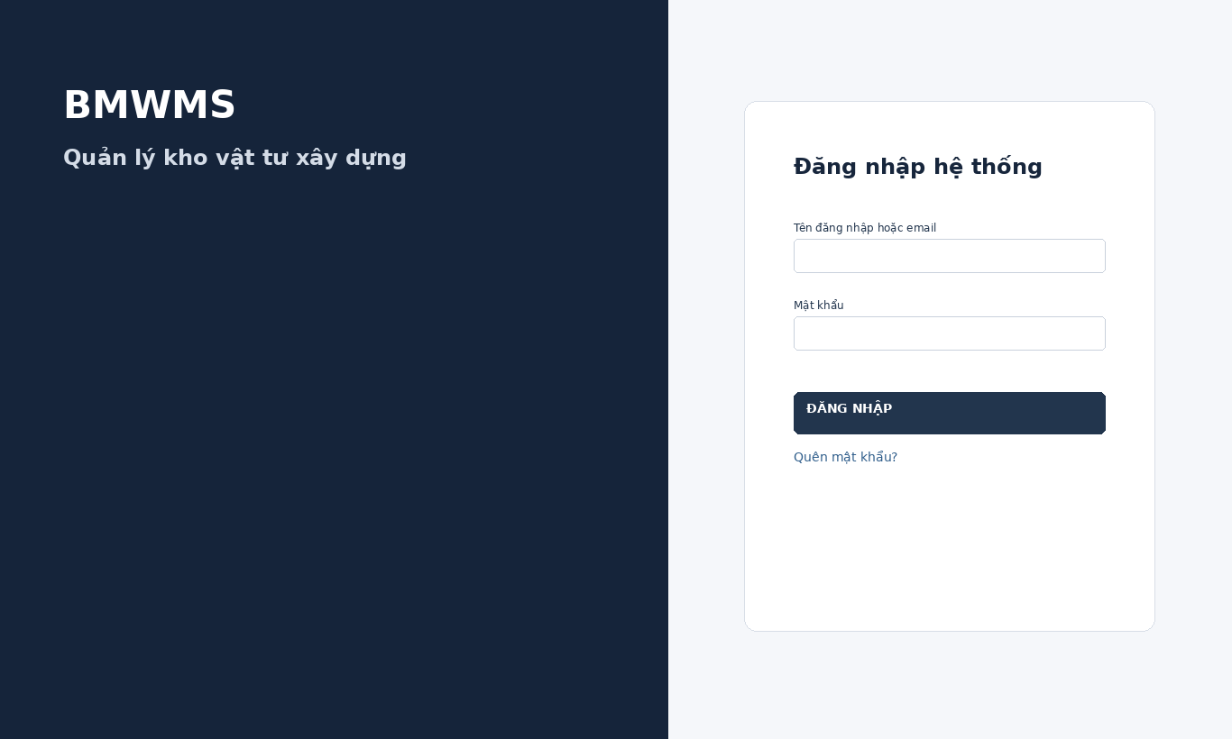
Figure UC-001: Wireframe for Login to system. Source: BMWMS.Web/Pages/Auth/Login.cshtml

Field Description
Field Name | Field Type | Description
Tên đăng nhập hoặc email | Text box | Required text box.
Mật khẩu | Password input | Required masked input.
Hiện/Ẩn mật khẩu | Checkbox / Toggle | Button toggles password visibility without changing its value.
Quên mật khẩu? | Link | Link opens the password recovery screen.
Đăng nhập | Button | Button submits credentials; account is locked for 15 minutes after five consecutive failed attempts.

Use Case Specification
Use Case ID | UC-001 | Use Case Name | Login to system
Primary Actors | All users | Secondary Actors | BMWMS API; SQL Server database; Email service for password recovery
Description | As a registered user, I want to sign in so that I can access functions permitted for my role.
Preconditions | The user account exists and is not inactive. No authenticated session is required.
Postconditions | A valid authenticated session is created and the user is redirected to the permitted workspace.
Normal Sequence/Flow | 1. User opens the Login screen.  2. System displays Username or email and Password.  3. User enters credentials and selects Login.  4. System validates the credentials and account status.  5. System creates the authenticated session.  6. System redirects the user to the permitted dashboard.
Alternative Sequences/Flows | A1. User selects Forgot password; system opens the recovery screen.  A2. User toggles Show/hide password; system changes only the visual display of the password field.
Exception Flows | E1. Required or formatted data is invalid: system shows field-level validation and does not save.  E2. Actor is not authorized: system denies the operation.  E3. Record status changed or is not eligible: system reloads the latest data and disables the action.  E4. API/database/email service is unavailable: system shows an error and keeps the previous consistent state.
Business Rules | Authentication is role-based. Five consecutive invalid attempts lock the account for 15 minutes. Password recovery uses the registered email.

UC-002 Logout from system
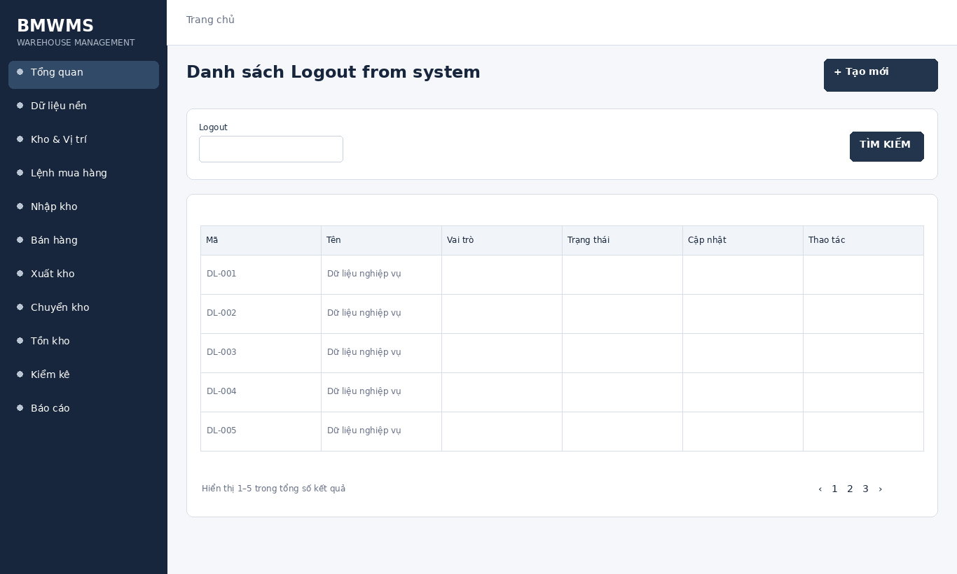
Figure UC-002: Wireframe for Logout from system. Source: BMWMS.Web/Pages/Auth/Logout.cshtml

Field Description
Field Name | Field Type | Description
Logout | Button | Button ends the current authenticated session and returns to Login.

Use Case Specification
Use Case ID | UC-002 | Use Case Name | Logout from system
Primary Actors | All users | Secondary Actors | BMWMS API; SQL Server database; Email service for password recovery
Description | As an authenticated user, I want to sign out so that my session cannot be reused.
Preconditions | The user has an authenticated session.
Postconditions | The session is invalidated and the Login screen is displayed.
Normal Sequence/Flow | 1. User opens the account menu.  2. User selects Logout.  3. System invalidates the current session and authentication cookie.  4. System redirects to Login.
Alternative Sequences/Flows | A1. The session has already expired; system redirects directly to Login.
Exception Flows | E1. Required or formatted data is invalid: system shows field-level validation and does not save.  E2. Actor is not authorized: system denies the operation.  E3. Record status changed or is not eligible: system reloads the latest data and disables the action.  E4. API/database/email service is unavailable: system shows an error and keeps the previous consistent state.
Business Rules | Authentication is role-based. Five consecutive invalid attempts lock the account for 15 minutes. Password recovery uses the registered email.

UC-003 Forgot password
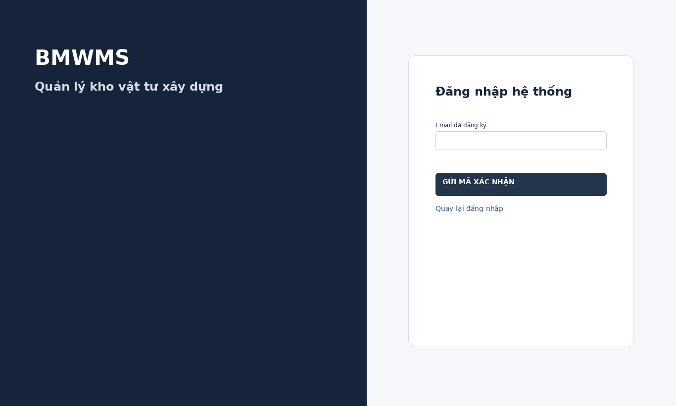
Figure UC-003: Wireframe for Forgot password. Source: BMWMS.Web/Pages/Auth/ForgotPassword.cshtml

Field Description
Field Name | Field Type | Description
Địa chỉ email | Email input | Required email input with placeholder "Enter your email address".
Gửi mã xác nhận | Button | Button validates the email format and requests a recovery code.

Use Case Specification
Use Case ID | UC-003 | Use Case Name | Forgot password
Primary Actors | All users | Secondary Actors | BMWMS API; SQL Server database; Email service for password recovery
Description | As a user, I want to request a password-recovery verification code through my registered email so that I can create a new password.
Preconditions | The user can access the email address associated with the account. No authenticated session is required.
Postconditions | A valid recovery request/code is sent when the account is eligible; the response does not reveal whether an email is registered.
Normal Sequence/Flow | 1. User selects Forgot password.  2. System displays the recovery form.  3. User enters the email address and selects Send verification code.  4. System validates the email format.  5. System creates a time-limited recovery code/request.  6. System sends the recovery information to the registered email.  7. System displays a neutral confirmation and opens the reset-password step.
Alternative Sequences/Flows | A1. User requests another code; system invalidates the previous unused code and sends a new one.
Exception Flows | E1. Email format is invalid: system shows a validation message.  E2. Email service is unavailable: system shows a neutral error and does not expose account existence.  E3. Too many requests: system temporarily rejects the request.
Business Rules | Authentication is role-based. Five consecutive invalid attempts lock the account for 15 minutes. Password recovery uses the registered email.

UC-004 Reset password
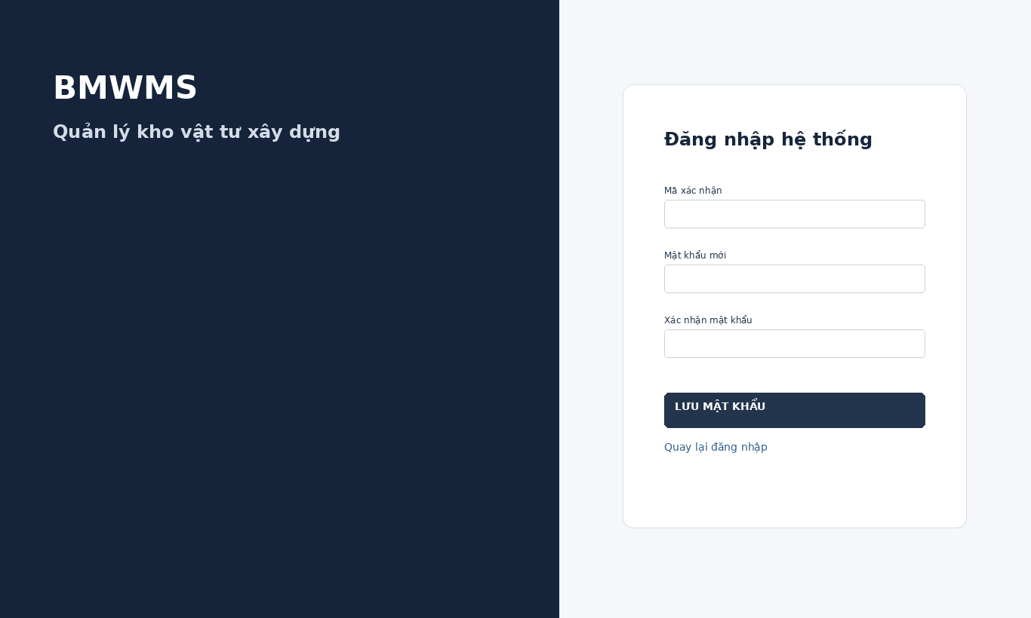
Figure UC-004: Wireframe for Reset password. Source: BMWMS.Web/Pages/Auth/ResetPassword.cshtml

Field Description
Field Name | Field Type | Description
Mã xác nhận | Display field | Required code received through the registered email.
Mật khẩu mới | Password input | Required masked input that must satisfy the password policy.
Xác nhận mật khẩu | Password input | Required masked input; must match New password.
Lưu | Button | Button validates the code and updates the password.

Use Case Specification
Use Case ID | UC-004 | Use Case Name | Reset password
Primary Actors | All users | Secondary Actors | BMWMS API; SQL Server database; Email service for password recovery
Description | As a user with a valid recovery code, I want to set a new password so that I can regain access to my account.
Preconditions | A valid, unused and unexpired recovery code exists.
Postconditions | The password is updated, the recovery code is invalidated and the user can return to Login.
Normal Sequence/Flow | 1. User enters the verification code.  2. User enters New password and Confirm password.  3. User selects Save.  4. System validates the code, password policy and matching confirmation.  5. System updates the password and invalidates the recovery code.  6. System displays success and returns to Login.
Alternative Sequences/Flows | A1. User requests a new code; system returns to Forgot password.
Exception Flows | E1. Code is invalid, expired or used: system rejects the reset.  E2. Password does not satisfy policy: system shows a field-level error.  E3. Password confirmation does not match: system returns to password entry.
Business Rules | Authentication is role-based. Five consecutive invalid attempts lock the account for 15 minutes. Password recovery uses the registered email.

UC-005 View or update personal information
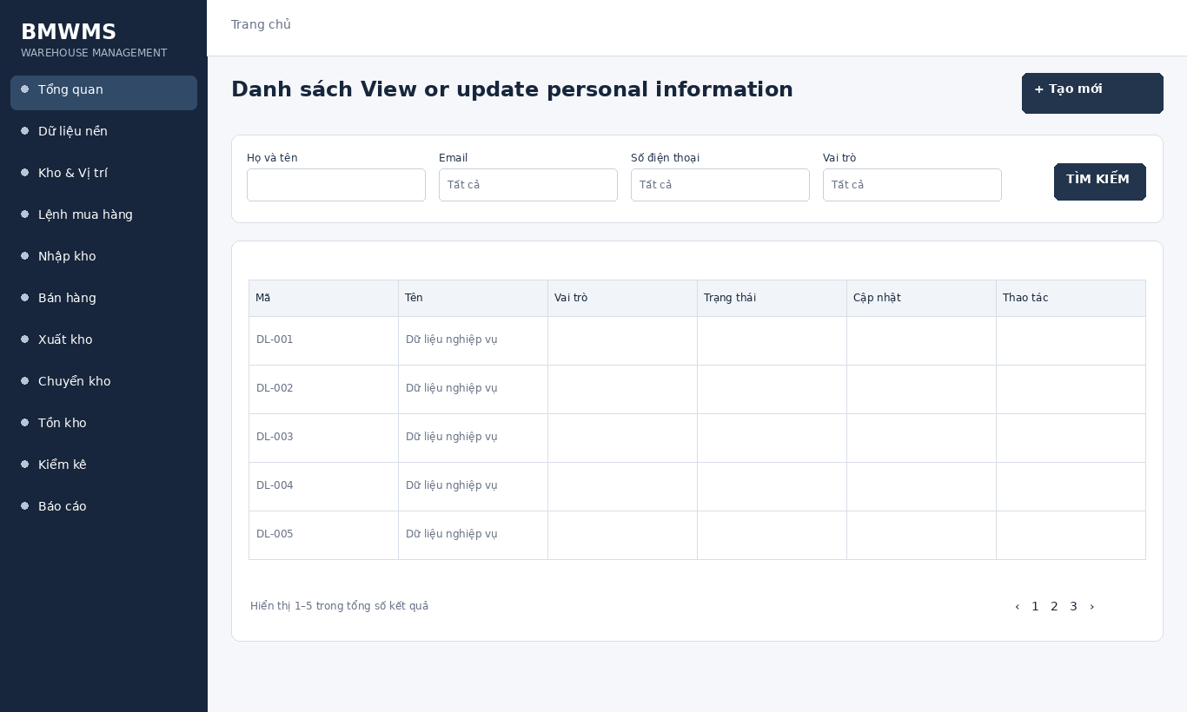
Figure UC-005: Wireframe for View or update personal information. Source: BMWMS.Web/Pages/Admin/Profile.cshtml

Field Description
Field Name | Field Type | Description
Họ và tên | Text box | Editable text box.
Email | Email input | Editable email input.
Số điện thoại | Text box | Editable text box.
Vai trò | Read-only field | Read-only current role.
Tên đăng nhập | Read-only field | Read-only login name.
Lần đăng nhập gần nhất | Read-only field | Read-only timestamp.
Trạng thái | Read-only field | Read-only account status.
Kho | Read-only field | Read-only assigned warehouse.
Cập nhật thông tin | Button | Button saves editable profile fields.

Use Case Specification
Use Case ID | UC-005 | Use Case Name | View or update personal information
Primary Actors | All users | Secondary Actors | BMWMS API; SQL Server database; Email service for password recovery
Description | As an authenticated user, I want to view and update my profile so that my contact information remains accurate.
Preconditions | The user is authenticated.
Postconditions | Editable profile fields are updated; role, username, status and warehouse remain system-controlled.
Normal Sequence/Flow | 1. User opens Profile.  2. System displays profile and recent activity.  3. User edits Full name, Email or Phone number.  4. User selects Update profile.  5. System validates and saves the changes.  6. System displays the updated profile.
Alternative Sequences/Flows | A1. User selects Cancel; system discards unsaved changes.
Exception Flows | E1. Required or formatted data is invalid: system shows field-level validation and does not save.  E2. Actor is not authorized: system denies the operation.  E3. Record status changed or is not eligible: system reloads the latest data and disables the action.  E4. API/database/email service is unavailable: system shows an error and keeps the previous consistent state.
Business Rules | Authentication is role-based. Five consecutive invalid attempts lock the account for 15 minutes. Password recovery uses the registered email.

UC-006 Change password
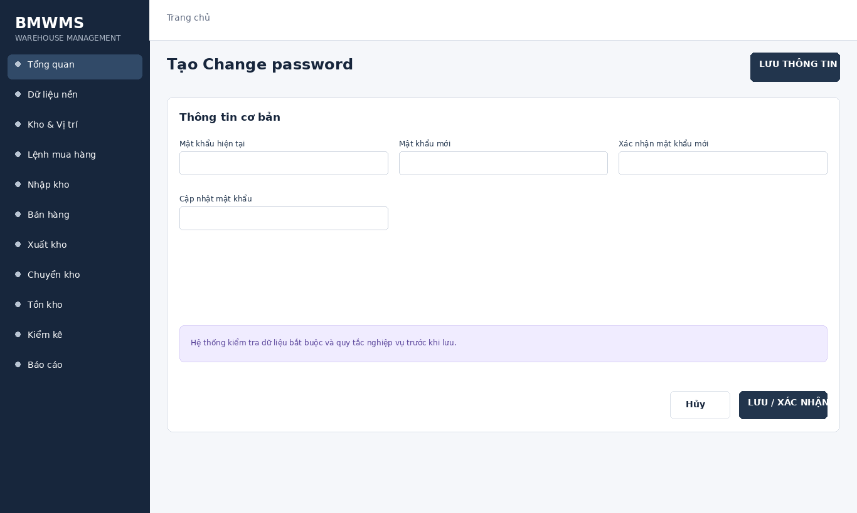
Figure UC-006: Wireframe for Change password. Source: BMWMS.Web/Pages/Admin/Profile.cshtml

Field Description
Field Name | Field Type | Description
Mật khẩu hiện tại | Password input | Required masked input.
Mật khẩu mới | Password input | Required masked input that must satisfy the password policy.
Xác nhận mật khẩu mới | Password input | Required masked input; must match New password.
Cập nhật mật khẩu | Button | Button submits the password change.

Use Case Specification
Use Case ID | UC-006 | Use Case Name | Change password
Primary Actors | All users | Secondary Actors | BMWMS API; SQL Server database; Email service for password recovery
Description | As an authenticated user, I want to change my password so that I can maintain account security.
Preconditions | The user is authenticated and knows the current password.
Postconditions | The new password replaces the old password successfully.
Normal Sequence/Flow | 1. User opens Change password.  2. User enters Current password, New password and Confirm new password.  3. User selects Update password.  4. System validates the current password and password policy.  5. System updates the password and displays success.
Alternative Sequences/Flows | A1. User cancels; system returns to Profile without changes.
Exception Flows | E1. Current password is incorrect.  E2. New password does not satisfy policy.  E3. Confirmation does not match New password.
Business Rules | Authentication is role-based. Five consecutive invalid attempts lock the account for 15 minutes. Password recovery uses the registered email.

2.2 User and Role Management

UC-007 View user list
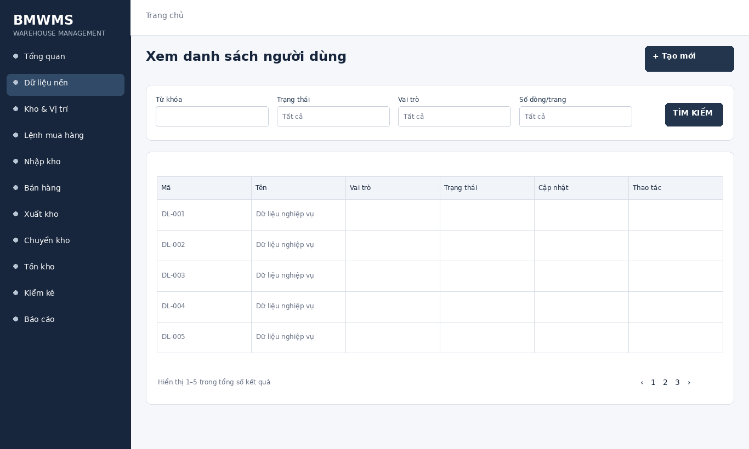
Figure UC-007: Wireframe for View user list. Source: BMWMS.Web/Pages/Admin/Users/Index.cshtml

Field Description
Field Name | Field Type | Description
Từ khóa | Text box | Text box. Search by user code, full name or username; optional.
Trạng thái | Dropdown | Dropdown. All statuses, Active, Locked, Inactive; default All statuses.
Vai trò | Dropdown | Dropdown. All roles, Sys Admin, WH Manager, WH Staff, Purchasing, Sales Staff; default All roles.
Số dòng/trang | Dropdown | Dropdown: 10, 20, 50, 100; default 20.

Use Case Specification
Use Case ID | UC-007 | Use Case Name | View user list
Primary Actors | System Administrator | Secondary Actors | BMWMS API; SQL Server database
Description | As an authorized system administrator, I want to perform view user list so that the related warehouse activity is completed and traceable.
Preconditions | The actor is authenticated and authorized. Required master data and source transaction exist and are active.
Postconditions | The view user list result is saved or displayed successfully. Related statuses and inventory balances remain consistent.
Normal Sequence/Flow | 1. Actor opens the View user list screen.  2. System displays the available filters and current records.  3. Actor enters optional filter criteria.  4. Actor selects Filter/Search/View.  5. System validates the criteria and returns matching data.  6. Actor reviews the result or opens a record for more detail.
Alternative Sequences/Flows | A1. Actor leaves all filters blank; system displays the default paged result.  A2. No record matches; system displays an empty list without changing data.
Exception Flows | E1. Required or formatted data is invalid: system shows field-level validation and does not save.  E2. Actor is not authorized: system denies the operation.  E3. Record status changed or is not eligible: system reloads the latest data and disables the action.  E4. API/database/email service is unavailable: system shows an error and keeps the previous consistent state.
Business Rules | Username and email must be unique. Only System Administrator can create users or assign roles.

UC-008 Create user
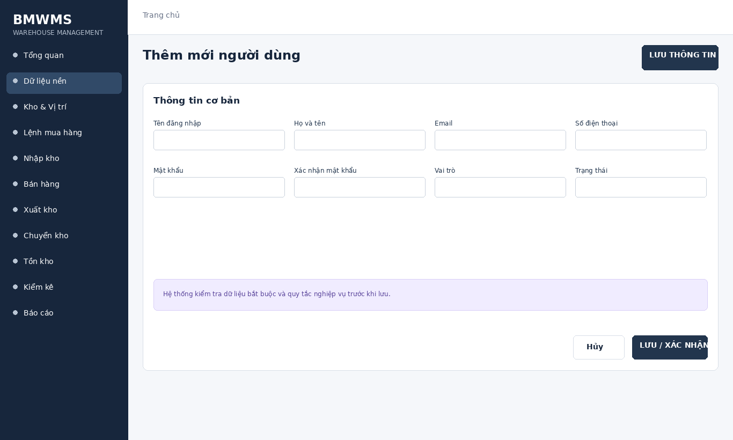
Figure UC-008: Wireframe for Create user. Source: BMWMS.Web/Pages/Admin/Users/Create.cshtml

Field Description
Field Name | Field Type | Description
Tên đăng nhập | Text box | Text box; required; unique login name.
Họ và tên | Text box | Text box; required.
Email | Email input | Email input; required and validated.
Số điện thoại | Text box | Text box; optional.
Mật khẩu | Password input | Password input; required for a new account.
Xác nhận mật khẩu | Password input | Password input; must match Password.
Vai trò | Dropdown | Dropdown: Sales Staff, WH Staff, Purchasing, WH Manager, System Administrator; required.
Trạng thái | Dropdown | Dropdown: Active or Locked; default Active.

Use Case Specification
Use Case ID | UC-008 | Use Case Name | Create user
Primary Actors | System Administrator | Secondary Actors | BMWMS API; SQL Server database
Description | As an authorized system administrator, I want to perform create user so that the related warehouse activity is completed and traceable.
Preconditions | The actor is authenticated and authorized. Required master data and source transaction exist and are active.
Postconditions | The create user result is saved or displayed successfully. Related statuses and inventory balances remain consistent.
Normal Sequence/Flow | 1. Actor opens the relevant list or detail screen.  2. System displays the current data and actions permitted for the actor.  3. Actor selects Create.  4. System displays the required input fields or confirmation.  5. Actor enters/reviews the information and confirms.  6. System validates mandatory fields, quantities, authorization and current status.  7. System saves the transaction, updates the status and displays the result.
Alternative Sequences/Flows | A1. Actor cancels before confirmation; system returns to the previous screen without saving.  A2. Actor corrects invalid data and resubmits; system continues from the validation step.
Exception Flows | E1. Required or formatted data is invalid: system shows field-level validation and does not save.  E2. Actor is not authorized: system denies the operation.  E3. Record status changed or is not eligible: system reloads the latest data and disables the action.  E4. API/database/email service is unavailable: system shows an error and keeps the previous consistent state.
Business Rules | Username and email must be unique. Only System Administrator can create users or assign roles.

UC-009 View user details
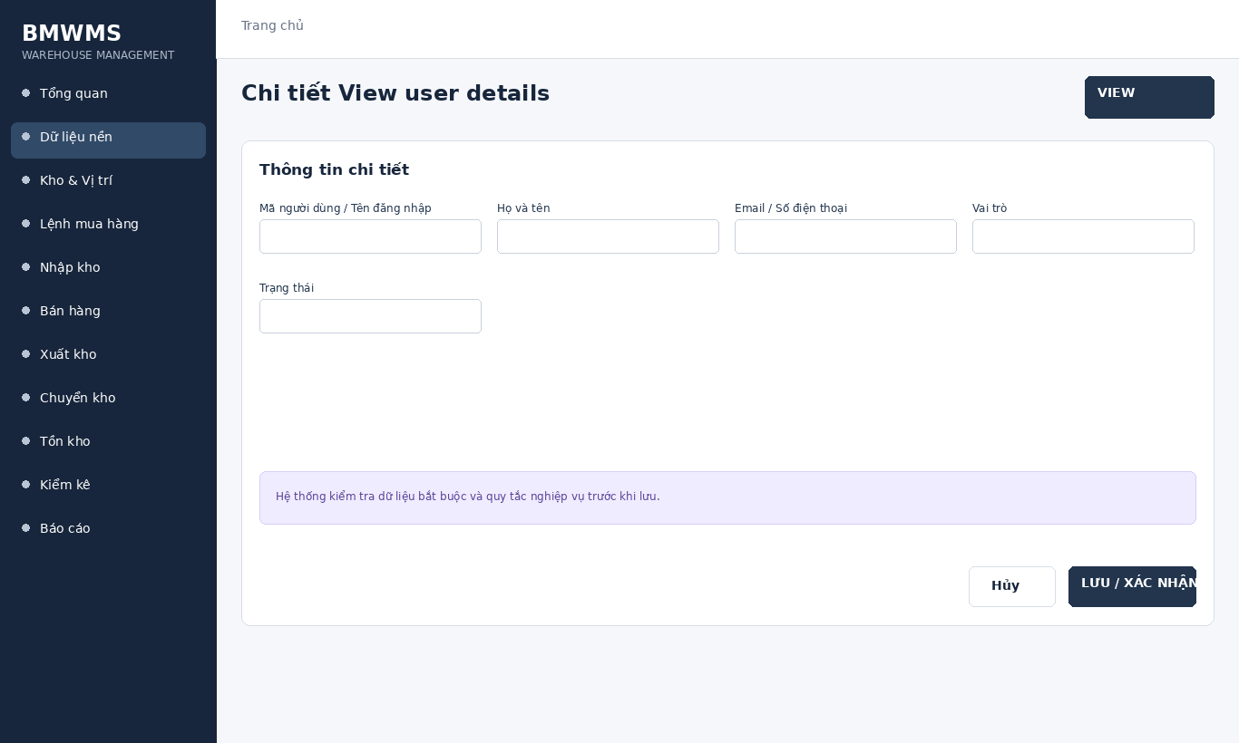
Figure UC-009: Wireframe for View user details. Source: BMWMS.Web/Pages/Admin/Users/Detail.cshtml

Field Description
Field Name | Field Type | Description
Mã người dùng / Tên đăng nhập | Read-only field | Read-only account identifier.
Họ và tên | Read-only field | User display name.
Email / Số điện thoại | Display field | User contact information.
Vai trò | Dropdown | Current role or role selector when assigning access.
Trạng thái | Display field | Active, Locked or Inactive.

Use Case Specification
Use Case ID | UC-009 | Use Case Name | View user details
Primary Actors | System Administrator | Secondary Actors | BMWMS API; SQL Server database
Description | As an authorized system administrator, I want to perform view user details so that the related warehouse activity is completed and traceable.
Preconditions | The actor is authenticated and authorized. Required master data and source transaction exist and are active.
Postconditions | The view user details result is saved or displayed successfully. Related statuses and inventory balances remain consistent.
Normal Sequence/Flow | 1. Actor opens the View user details screen.  2. System displays the available filters and current records.  3. Actor enters optional filter criteria.  4. Actor selects Filter/Search/View.  5. System validates the criteria and returns matching data.  6. Actor reviews the result or opens a record for more detail.
Alternative Sequences/Flows | A1. Actor leaves all filters blank; system displays the default paged result.  A2. No record matches; system displays an empty list without changing data.
Exception Flows | E1. Required or formatted data is invalid: system shows field-level validation and does not save.  E2. Actor is not authorized: system denies the operation.  E3. Record status changed or is not eligible: system reloads the latest data and disables the action.  E4. API/database/email service is unavailable: system shows an error and keeps the previous consistent state.
Business Rules | Username and email must be unique. Only System Administrator can create users or assign roles.

UC-010 Edit user
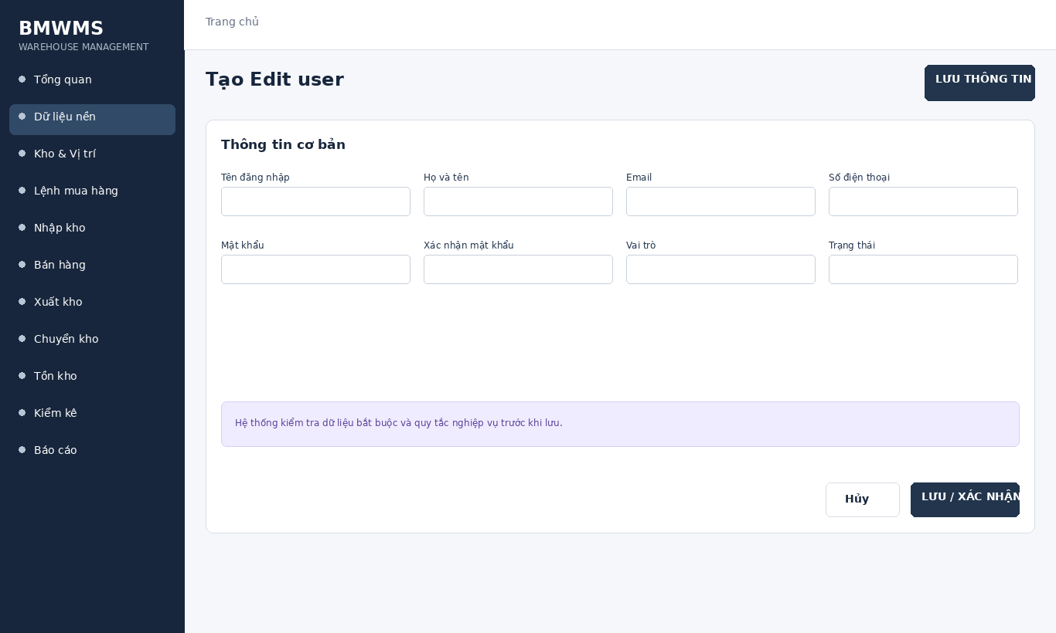
Figure UC-010: Wireframe for Edit user. Source: BMWMS.Web/Pages/Admin/Users/Create.cshtml

Field Description
Field Name | Field Type | Description
Tên đăng nhập | Text box | Text box; required; unique login name.
Họ và tên | Text box | Text box; required.
Email | Email input | Email input; required and validated.
Số điện thoại | Text box | Text box; optional.
Mật khẩu | Password input | Password input; required for a new account.
Xác nhận mật khẩu | Password input | Password input; must match Password.
Vai trò | Dropdown | Dropdown: Sales Staff, WH Staff, Purchasing, WH Manager, System Administrator; required.
Trạng thái | Dropdown | Dropdown: Active or Locked; default Active.

Use Case Specification
Use Case ID | UC-010 | Use Case Name | Edit user
Primary Actors | System Administrator | Secondary Actors | BMWMS API; SQL Server database
Description | As an authorized system administrator, I want to perform edit user so that the related warehouse activity is completed and traceable.
Preconditions | The actor is authenticated and authorized. Required master data and source transaction exist and are active.
Postconditions | The edit user result is saved or displayed successfully. Related statuses and inventory balances remain consistent.
Normal Sequence/Flow | 1. Actor opens the relevant list or detail screen.  2. System displays the current data and actions permitted for the actor.  3. Actor selects Edit.  4. System displays the required input fields or confirmation.  5. Actor enters/reviews the information and confirms.  6. System validates mandatory fields, quantities, authorization and current status.  7. System saves the transaction, updates the status and displays the result.
Alternative Sequences/Flows | A1. Actor cancels before confirmation; system returns to the previous screen without saving.  A2. Actor corrects invalid data and resubmits; system continues from the validation step.
Exception Flows | E1. Required or formatted data is invalid: system shows field-level validation and does not save.  E2. Actor is not authorized: system denies the operation.  E3. Record status changed or is not eligible: system reloads the latest data and disables the action.  E4. API/database/email service is unavailable: system shows an error and keeps the previous consistent state.
Business Rules | Username and email must be unique. Only System Administrator can create users or assign roles.

UC-011 Assign role to user
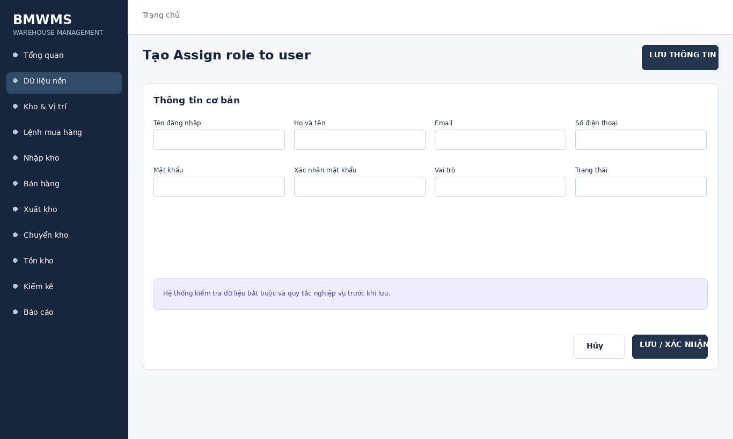
Figure UC-011: Wireframe for Assign role to user. Source: BMWMS.Web/Pages/Admin/Users/Create.cshtml

Field Description
Field Name | Field Type | Description
Tên đăng nhập | Text box | Text box; required; unique login name.
Họ và tên | Text box | Text box; required.
Email | Email input | Email input; required and validated.
Số điện thoại | Text box | Text box; optional.
Mật khẩu | Password input | Password input; required for a new account.
Xác nhận mật khẩu | Password input | Password input; must match Password.
Vai trò | Dropdown | Dropdown: Sales Staff, WH Staff, Purchasing, WH Manager, System Administrator; required.
Trạng thái | Dropdown | Dropdown: Active or Locked; default Active.

Use Case Specification
Use Case ID | UC-011 | Use Case Name | Assign role to user
Primary Actors | System Administrator | Secondary Actors | BMWMS API; SQL Server database
Description | As an authorized system administrator, I want to perform assign role to user so that the related warehouse activity is completed and traceable.
Preconditions | The actor is authenticated and authorized. Required master data and source transaction exist and are active.
Postconditions | The assign role to user result is saved or displayed successfully. Related statuses and inventory balances remain consistent.
Normal Sequence/Flow | 1. Actor opens the relevant list or detail screen.  2. System displays the current data and actions permitted for the actor.  3. Actor selects Assign.  4. System displays the required input fields or confirmation.  5. Actor enters/reviews the information and confirms.  6. System validates mandatory fields, quantities, authorization and current status.  7. System saves the transaction, updates the status and displays the result.
Alternative Sequences/Flows | A1. Actor cancels before confirmation; system returns to the previous screen without saving.  A2. Actor corrects invalid data and resubmits; system continues from the validation step.
Exception Flows | E1. Required or formatted data is invalid: system shows field-level validation and does not save.  E2. Actor is not authorized: system denies the operation.  E3. Record status changed or is not eligible: system reloads the latest data and disables the action.  E4. API/database/email service is unavailable: system shows an error and keeps the previous consistent state.
Business Rules | Username and email must be unique. Only System Administrator can create users or assign roles.

UC-012 View user operation history
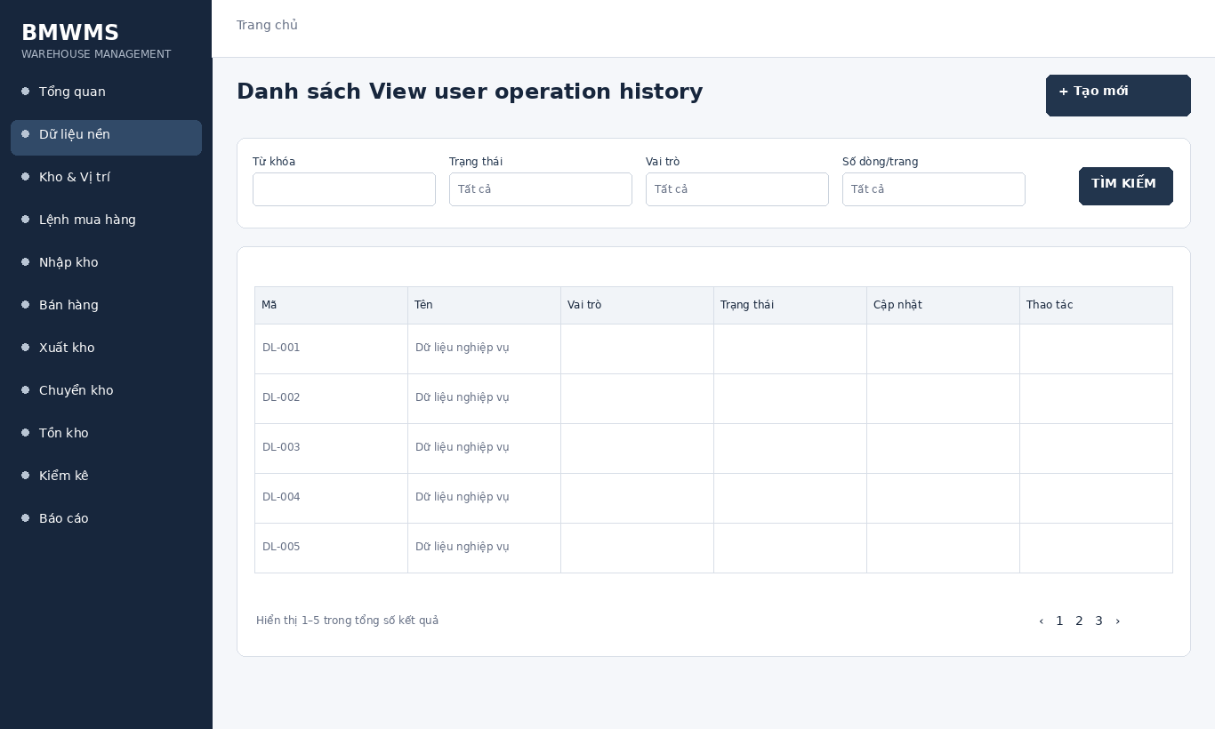
Figure UC-012: Wireframe for View user operation history. Source: BMWMS.Web/Pages/Admin/Users/Index.cshtml

Field Description
Field Name | Field Type | Description
Từ khóa | Text box | Text box. Search by user code, full name or username; optional.
Trạng thái | Dropdown | Dropdown. All statuses, Active, Locked, Inactive; default All statuses.
Vai trò | Dropdown | Dropdown. All roles, Sys Admin, WH Manager, WH Staff, Purchasing, Sales Staff; default All roles.
Số dòng/trang | Dropdown | Dropdown: 10, 20, 50, 100; default 20.

Use Case Specification
Use Case ID | UC-012 | Use Case Name | View user operation history
Primary Actors | System Administrator | Secondary Actors | BMWMS API; SQL Server database
Description | As an authorized system administrator, I want to perform view user operation history so that the related warehouse activity is completed and traceable.
Preconditions | The actor is authenticated and authorized. Required master data and source transaction exist and are active.
Postconditions | The view user operation history result is saved or displayed successfully. Related statuses and inventory balances remain consistent.
Normal Sequence/Flow | 1. Actor opens the View user operation history screen.  2. System displays the available filters and current records.  3. Actor enters optional filter criteria.  4. Actor selects Filter/Search/View.  5. System validates the criteria and returns matching data.  6. Actor reviews the result or opens a record for more detail.
Alternative Sequences/Flows | A1. Actor leaves all filters blank; system displays the default paged result.  A2. No record matches; system displays an empty list without changing data.
Exception Flows | E1. Required or formatted data is invalid: system shows field-level validation and does not save.  E2. Actor is not authorized: system denies the operation.  E3. Record status changed or is not eligible: system reloads the latest data and disables the action.  E4. API/database/email service is unavailable: system shows an error and keeps the previous consistent state.
Business Rules | Username and email must be unique. Only System Administrator can create users or assign roles.

UC-013 View role list
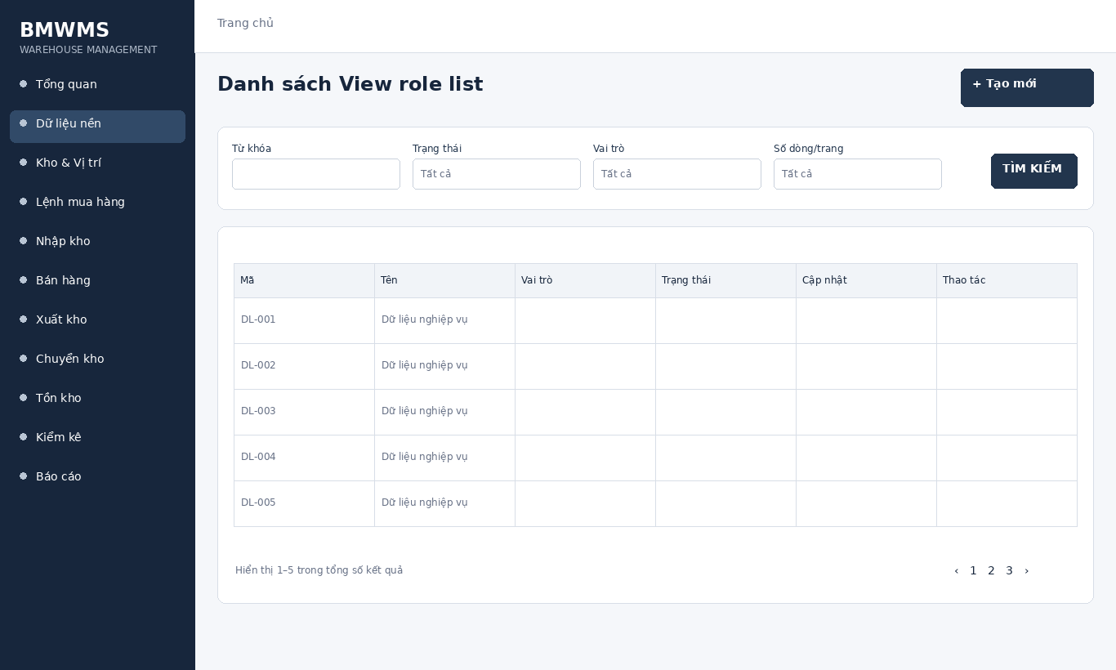
Figure UC-013: Wireframe for View role list. Source: BMWMS.Web/Pages/Admin/Users/Index.cshtml

Field Description
Field Name | Field Type | Description
Từ khóa | Text box | Text box. Search by user code, full name or username; optional.
Trạng thái | Dropdown | Dropdown. All statuses, Active, Locked, Inactive; default All statuses.
Vai trò | Dropdown | Dropdown. All roles, Sys Admin, WH Manager, WH Staff, Purchasing, Sales Staff; default All roles.
Số dòng/trang | Dropdown | Dropdown: 10, 20, 50, 100; default 20.

Use Case Specification
Use Case ID | UC-013 | Use Case Name | View role list
Primary Actors | System Administrator | Secondary Actors | BMWMS API; SQL Server database
Description | As an authorized system administrator, I want to perform view role list so that the related warehouse activity is completed and traceable.
Preconditions | The actor is authenticated and authorized. Required master data and source transaction exist and are active.
Postconditions | The view role list result is saved or displayed successfully. Related statuses and inventory balances remain consistent.
Normal Sequence/Flow | 1. Actor opens the View role list screen.  2. System displays the available filters and current records.  3. Actor enters optional filter criteria.  4. Actor selects Filter/Search/View.  5. System validates the criteria and returns matching data.  6. Actor reviews the result or opens a record for more detail.
Alternative Sequences/Flows | A1. Actor leaves all filters blank; system displays the default paged result.  A2. No record matches; system displays an empty list without changing data.
Exception Flows | E1. Required or formatted data is invalid: system shows field-level validation and does not save.  E2. Actor is not authorized: system denies the operation.  E3. Record status changed or is not eligible: system reloads the latest data and disables the action.  E4. API/database/email service is unavailable: system shows an error and keeps the previous consistent state.
Business Rules | Username and email must be unique. Only System Administrator can create users or assign roles.

2.3 Master Data Management

UC-014 Manage product group/category
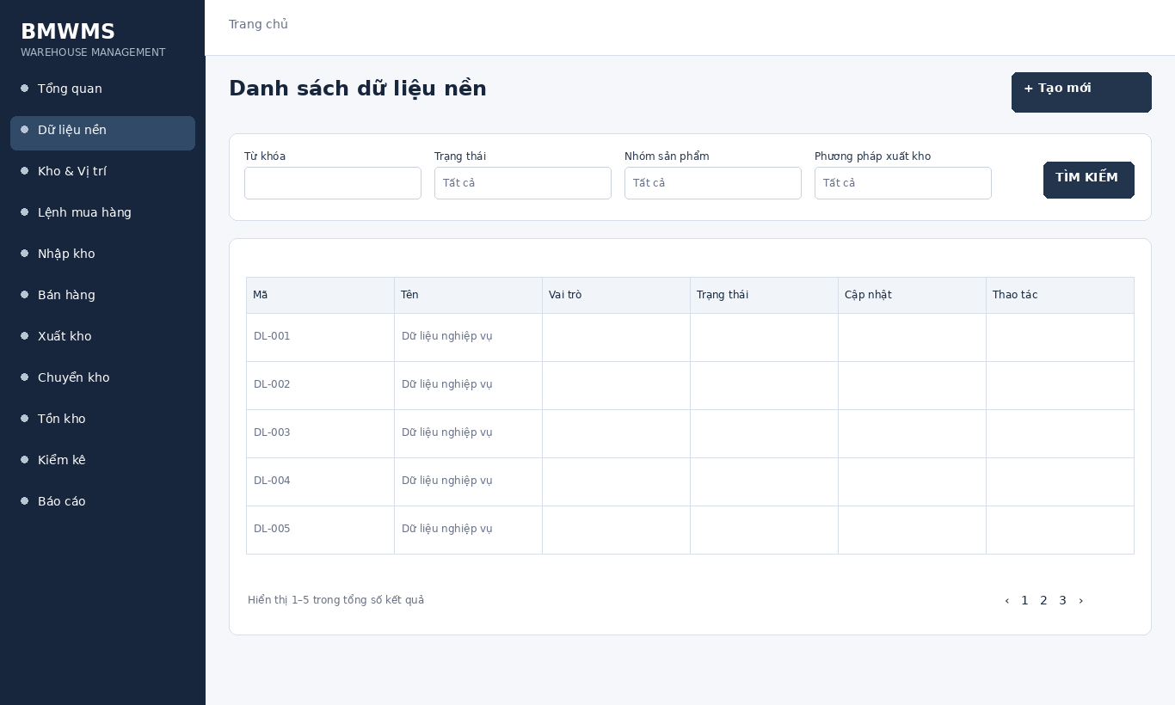
Figure UC-014: Wireframe for Manage product group/category. Source: BMWMS.Web/Pages/Products/Index.cshtml

Field Description
Field Name | Field Type | Description
Từ khóa | Text box | Text box. Search by code or name; optional.
Trạng thái | Dropdown | Dropdown. All statuses, Active, Inactive; default All statuses.
Nhóm sản phẩm | Dropdown | Dropdown used on product list; default All product groups.
Phương pháp xuất kho | Dropdown | Dropdown: All, FIFO, FEFO; default All.
Số dòng/trang | Dropdown | Dropdown: 10, 20, 50, 100.

Use Case Specification
Use Case ID | UC-014 | Use Case Name | Manage product group/category
Primary Actors | System Administrator; authorized staff | Secondary Actors | BMWMS API; SQL Server database
Description | As an authorized system administrator, I want to perform manage product group/category so that the related warehouse activity is completed and traceable.
Preconditions | The actor is authenticated and authorized. Required master data and source transaction exist and are active.
Postconditions | The manage product group/category result is saved or displayed successfully. Related statuses and inventory balances remain consistent.
Normal Sequence/Flow | 1. Actor opens the relevant list or detail screen.  2. System displays the current data and actions permitted for the actor.  3. Actor selects Manage.  4. System displays the required input fields or confirmation.  5. Actor enters/reviews the information and confirms.  6. System validates mandatory fields, quantities, authorization and current status.  7. System saves the transaction, updates the status and displays the result.
Alternative Sequences/Flows | A1. Actor cancels before confirmation; system returns to the previous screen without saving.  A2. Actor corrects invalid data and resubmits; system continues from the validation step.
Exception Flows | E1. Required or formatted data is invalid: system shows field-level validation and does not save.  E2. Actor is not authorized: system denies the operation.  E3. Record status changed or is not eligible: system reloads the latest data and disables the action.  E4. API/database/email service is unavailable: system shows an error and keeps the previous consistent state.
Business Rules | Codes are unique. Inactive master data cannot be selected for new transactions. Product rotation is FIFO or FEFO.

UC-015 Manage product
Figure UC-015: Wireframe for Manage product. Source: BMWMS.Web/Pages/Products/Index.cshtml

Field Description
Field Name | Field Type | Description
Từ khóa | Text box | Text box. Search by code or name; optional.
Trạng thái | Dropdown | Dropdown. All statuses, Active, Inactive; default All statuses.
Nhóm sản phẩm | Dropdown | Dropdown used on product list; default All product groups.
Phương pháp xuất kho | Dropdown | Dropdown: All, FIFO, FEFO; default All.
Số dòng/trang | Dropdown | Dropdown: 10, 20, 50, 100.

Use Case Specification
Use Case ID | UC-015 | Use Case Name | Manage product
Primary Actors | System Administrator; authorized staff | Secondary Actors | BMWMS API; SQL Server database
Description | As an authorized system administrator, I want to perform manage product so that the related warehouse activity is completed and traceable.
Preconditions | The actor is authenticated and authorized. Required master data and source transaction exist and are active.
Postconditions | The manage product result is saved or displayed successfully. Related statuses and inventory balances remain consistent.
Normal Sequence/Flow | 1. Actor opens the relevant list or detail screen.  2. System displays the current data and actions permitted for the actor.  3. Actor selects Manage.  4. System displays the required input fields or confirmation.  5. Actor enters/reviews the information and confirms.  6. System validates mandatory fields, quantities, authorization and current status.  7. System saves the transaction, updates the status and displays the result.
Alternative Sequences/Flows | A1. Actor cancels before confirmation; system returns to the previous screen without saving.  A2. Actor corrects invalid data and resubmits; system continues from the validation step.
Exception Flows | E1. Required or formatted data is invalid: system shows field-level validation and does not save.  E2. Actor is not authorized: system denies the operation.  E3. Record status changed or is not eligible: system reloads the latest data and disables the action.  E4. API/database/email service is unavailable: system shows an error and keeps the previous consistent state.
Business Rules | Codes are unique. Inactive master data cannot be selected for new transactions. Product rotation is FIFO or FEFO.

UC-016 View product details
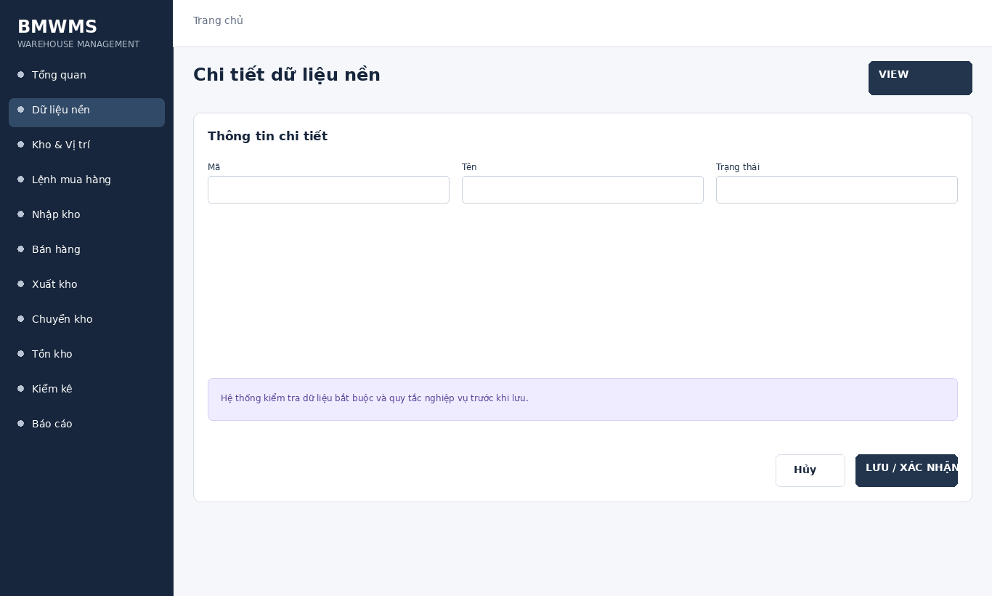
Figure UC-016: Wireframe for View product details. Source: BMWMS.Web/Pages/Products/Details.cshtml

Field Description
Field Name | Field Type | Description
Mã | Read-only field | Read-only master-data code.
Tên | Read-only field | Master-data display name.
Trạng thái | Display field | Active or Inactive.

Use Case Specification
Use Case ID | UC-016 | Use Case Name | View product details
Primary Actors | System Administrator; authorized staff | Secondary Actors | BMWMS API; SQL Server database
Description | As an authorized system administrator, I want to perform view product details so that the related warehouse activity is completed and traceable.
Preconditions | The actor is authenticated and authorized. Required master data and source transaction exist and are active.
Postconditions | The view product details result is saved or displayed successfully. Related statuses and inventory balances remain consistent.
Normal Sequence/Flow | 1. Actor opens the View product details screen.  2. System displays the available filters and current records.  3. Actor enters optional filter criteria.  4. Actor selects Filter/Search/View.  5. System validates the criteria and returns matching data.  6. Actor reviews the result or opens a record for more detail.
Alternative Sequences/Flows | A1. Actor leaves all filters blank; system displays the default paged result.  A2. No record matches; system displays an empty list without changing data.
Exception Flows | E1. Required or formatted data is invalid: system shows field-level validation and does not save.  E2. Actor is not authorized: system denies the operation.  E3. Record status changed or is not eligible: system reloads the latest data and disables the action.  E4. API/database/email service is unavailable: system shows an error and keeps the previous consistent state.
Business Rules | Codes are unique. Inactive master data cannot be selected for new transactions. Product rotation is FIFO or FEFO.

UC-017 Manage product attributes
Figure UC-017: Wireframe for Manage product attributes. Source: BMWMS.Web/Pages/Products/Index.cshtml

Field Description
Field Name | Field Type | Description
Từ khóa | Text box | Text box. Search by code or name; optional.
Trạng thái | Dropdown | Dropdown. All statuses, Active, Inactive; default All statuses.
Nhóm sản phẩm | Dropdown | Dropdown used on product list; default All product groups.
Phương pháp xuất kho | Dropdown | Dropdown: All, FIFO, FEFO; default All.
Số dòng/trang | Dropdown | Dropdown: 10, 20, 50, 100.

Use Case Specification
Use Case ID | UC-017 | Use Case Name | Manage product attributes
Primary Actors | System Administrator; authorized staff | Secondary Actors | BMWMS API; SQL Server database
Description | As an authorized system administrator, I want to perform manage product attributes so that the related warehouse activity is completed and traceable.
Preconditions | The actor is authenticated and authorized. Required master data and source transaction exist and are active.
Postconditions | The manage product attributes result is saved or displayed successfully. Related statuses and inventory balances remain consistent.
Normal Sequence/Flow | 1. Actor opens the relevant list or detail screen.  2. System displays the current data and actions permitted for the actor.  3. Actor selects Manage.  4. System displays the required input fields or confirmation.  5. Actor enters/reviews the information and confirms.  6. System validates mandatory fields, quantities, authorization and current status.  7. System saves the transaction, updates the status and displays the result.
Alternative Sequences/Flows | A1. Actor cancels before confirmation; system returns to the previous screen without saving.  A2. Actor corrects invalid data and resubmits; system continues from the validation step.
Exception Flows | E1. Required or formatted data is invalid: system shows field-level validation and does not save.  E2. Actor is not authorized: system denies the operation.  E3. Record status changed or is not eligible: system reloads the latest data and disables the action.  E4. API/database/email service is unavailable: system shows an error and keeps the previous consistent state.
Business Rules | Codes are unique. Inactive master data cannot be selected for new transactions. Product rotation is FIFO or FEFO.

UC-018 Manage units of measure
Figure UC-018: Wireframe for Manage units of measure. Source: BMWMS.Web/Pages/Products/Index.cshtml

Field Description
Field Name | Field Type | Description
Từ khóa | Text box | Text box. Search by code or name; optional.
Trạng thái | Dropdown | Dropdown. All statuses, Active, Inactive; default All statuses.
Nhóm sản phẩm | Dropdown | Dropdown used on product list; default All product groups.
Phương pháp xuất kho | Dropdown | Dropdown: All, FIFO, FEFO; default All.
Số dòng/trang | Dropdown | Dropdown: 10, 20, 50, 100.

Use Case Specification
Use Case ID | UC-018 | Use Case Name | Manage units of measure
Primary Actors | System Administrator; authorized staff | Secondary Actors | BMWMS API; SQL Server database
Description | As an authorized system administrator, I want to perform manage units of measure so that the related warehouse activity is completed and traceable.
Preconditions | The actor is authenticated and authorized. Required master data and source transaction exist and are active.
Postconditions | The manage units of measure result is saved or displayed successfully. Related statuses and inventory balances remain consistent.
Normal Sequence/Flow | 1. Actor opens the relevant list or detail screen.  2. System displays the current data and actions permitted for the actor.  3. Actor selects Manage.  4. System displays the required input fields or confirmation.  5. Actor enters/reviews the information and confirms.  6. System validates mandatory fields, quantities, authorization and current status.  7. System saves the transaction, updates the status and displays the result.
Alternative Sequences/Flows | A1. Actor cancels before confirmation; system returns to the previous screen without saving.  A2. Actor corrects invalid data and resubmits; system continues from the validation step.
Exception Flows | E1. Required or formatted data is invalid: system shows field-level validation and does not save.  E2. Actor is not authorized: system denies the operation.  E3. Record status changed or is not eligible: system reloads the latest data and disables the action.  E4. API/database/email service is unavailable: system shows an error and keeps the previous consistent state.
Business Rules | Codes are unique. Inactive master data cannot be selected for new transactions. Product rotation is FIFO or FEFO.

UC-019 Manage suppliers
Figure UC-019: Wireframe for Manage suppliers. Source: BMWMS.Web/Pages/Products/Index.cshtml

Field Description
Field Name | Field Type | Description
Từ khóa | Text box | Text box. Search by code or name; optional.
Trạng thái | Dropdown | Dropdown. All statuses, Active, Inactive; default All statuses.
Nhóm sản phẩm | Dropdown | Dropdown used on product list; default All product groups.
Phương pháp xuất kho | Dropdown | Dropdown: All, FIFO, FEFO; default All.
Số dòng/trang | Dropdown | Dropdown: 10, 20, 50, 100.

Use Case Specification
Use Case ID | UC-019 | Use Case Name | Manage suppliers
Primary Actors | System Administrator; authorized staff | Secondary Actors | BMWMS API; SQL Server database
Description | As an authorized system administrator, I want to perform manage suppliers so that the related warehouse activity is completed and traceable.
Preconditions | The actor is authenticated and authorized. Required master data and source transaction exist and are active.
Postconditions | The manage suppliers result is saved or displayed successfully. Related statuses and inventory balances remain consistent.
Normal Sequence/Flow | 1. Actor opens the relevant list or detail screen.  2. System displays the current data and actions permitted for the actor.  3. Actor selects Manage.  4. System displays the required input fields or confirmation.  5. Actor enters/reviews the information and confirms.  6. System validates mandatory fields, quantities, authorization and current status.  7. System saves the transaction, updates the status and displays the result.
Alternative Sequences/Flows | A1. Actor cancels before confirmation; system returns to the previous screen without saving.  A2. Actor corrects invalid data and resubmits; system continues from the validation step.
Exception Flows | E1. Required or formatted data is invalid: system shows field-level validation and does not save.  E2. Actor is not authorized: system denies the operation.  E3. Record status changed or is not eligible: system reloads the latest data and disables the action.  E4. API/database/email service is unavailable: system shows an error and keeps the previous consistent state.
Business Rules | Codes are unique. Inactive master data cannot be selected for new transactions. Product rotation is FIFO or FEFO.

UC-020 View supplier details
Figure UC-020: Wireframe for View supplier details. Source: BMWMS.Web/Pages/Products/Details.cshtml

Field Description
Field Name | Field Type | Description
Mã | Read-only field | Read-only master-data code.
Tên | Read-only field | Master-data display name.
Trạng thái | Display field | Active or Inactive.

Use Case Specification
Use Case ID | UC-020 | Use Case Name | View supplier details
Primary Actors | System Administrator; authorized staff | Secondary Actors | BMWMS API; SQL Server database
Description | As an authorized system administrator, I want to perform view supplier details so that the related warehouse activity is completed and traceable.
Preconditions | The actor is authenticated and authorized. Required master data and source transaction exist and are active.
Postconditions | The view supplier details result is saved or displayed successfully. Related statuses and inventory balances remain consistent.
Normal Sequence/Flow | 1. Actor opens the View supplier details screen.  2. System displays the available filters and current records.  3. Actor enters optional filter criteria.  4. Actor selects Filter/Search/View.  5. System validates the criteria and returns matching data.  6. Actor reviews the result or opens a record for more detail.
Alternative Sequences/Flows | A1. Actor leaves all filters blank; system displays the default paged result.  A2. No record matches; system displays an empty list without changing data.
Exception Flows | E1. Required or formatted data is invalid: system shows field-level validation and does not save.  E2. Actor is not authorized: system denies the operation.  E3. Record status changed or is not eligible: system reloads the latest data and disables the action.  E4. API/database/email service is unavailable: system shows an error and keeps the previous consistent state.
Business Rules | Codes are unique. Inactive master data cannot be selected for new transactions. Product rotation is FIFO or FEFO.

UC-021 View supplier inbound history
Figure UC-021: Wireframe for View supplier inbound history. Source: BMWMS.Web/Pages/Products/Index.cshtml

Field Description
Field Name | Field Type | Description
Từ khóa | Text box | Text box. Search by code or name; optional.
Trạng thái | Dropdown | Dropdown. All statuses, Active, Inactive; default All statuses.
Nhóm sản phẩm | Dropdown | Dropdown used on product list; default All product groups.
Phương pháp xuất kho | Dropdown | Dropdown: All, FIFO, FEFO; default All.
Số dòng/trang | Dropdown | Dropdown: 10, 20, 50, 100.

Use Case Specification
Use Case ID | UC-021 | Use Case Name | View supplier inbound history
Primary Actors | System Administrator; authorized staff | Secondary Actors | BMWMS API; SQL Server database
Description | As an authorized system administrator, I want to perform view supplier inbound history so that the related warehouse activity is completed and traceable.
Preconditions | The actor is authenticated and authorized. Required master data and source transaction exist and are active.
Postconditions | The view supplier inbound history result is saved or displayed successfully. Related statuses and inventory balances remain consistent.
Normal Sequence/Flow | 1. Actor opens the View supplier inbound history screen.  2. System displays the available filters and current records.  3. Actor enters optional filter criteria.  4. Actor selects Filter/Search/View.  5. System validates the criteria and returns matching data.  6. Actor reviews the result or opens a record for more detail.
Alternative Sequences/Flows | A1. Actor leaves all filters blank; system displays the default paged result.  A2. No record matches; system displays an empty list without changing data.
Exception Flows | E1. Required or formatted data is invalid: system shows field-level validation and does not save.  E2. Actor is not authorized: system denies the operation.  E3. Record status changed or is not eligible: system reloads the latest data and disables the action.  E4. API/database/email service is unavailable: system shows an error and keeps the previous consistent state.
Business Rules | Codes are unique. Inactive master data cannot be selected for new transactions. Product rotation is FIFO or FEFO.

UC-022 Manage customers
Figure UC-022: Wireframe for Manage customers. Source: BMWMS.Web/Pages/Products/Index.cshtml

Field Description
Field Name | Field Type | Description
Từ khóa | Text box | Text box. Search by code or name; optional.
Trạng thái | Dropdown | Dropdown. All statuses, Active, Inactive; default All statuses.
Nhóm sản phẩm | Dropdown | Dropdown used on product list; default All product groups.
Phương pháp xuất kho | Dropdown | Dropdown: All, FIFO, FEFO; default All.
Số dòng/trang | Dropdown | Dropdown: 10, 20, 50, 100.

Use Case Specification
Use Case ID | UC-022 | Use Case Name | Manage customers
Primary Actors | System Administrator; authorized staff | Secondary Actors | BMWMS API; SQL Server database
Description | As an authorized system administrator, I want to perform manage customers so that the related warehouse activity is completed and traceable.
Preconditions | The actor is authenticated and authorized. Required master data and source transaction exist and are active.
Postconditions | The manage customers result is saved or displayed successfully. Related statuses and inventory balances remain consistent.
Normal Sequence/Flow | 1. Actor opens the relevant list or detail screen.  2. System displays the current data and actions permitted for the actor.  3. Actor selects Manage.  4. System displays the required input fields or confirmation.  5. Actor enters/reviews the information and confirms.  6. System validates mandatory fields, quantities, authorization and current status.  7. System saves the transaction, updates the status and displays the result.
Alternative Sequences/Flows | A1. Actor cancels before confirmation; system returns to the previous screen without saving.  A2. Actor corrects invalid data and resubmits; system continues from the validation step.
Exception Flows | E1. Required or formatted data is invalid: system shows field-level validation and does not save.  E2. Actor is not authorized: system denies the operation.  E3. Record status changed or is not eligible: system reloads the latest data and disables the action.  E4. API/database/email service is unavailable: system shows an error and keeps the previous consistent state.
Business Rules | Codes are unique. Inactive master data cannot be selected for new transactions. Product rotation is FIFO or FEFO.

2.4 Warehouse and Storage

UC-023 Manage warehouses
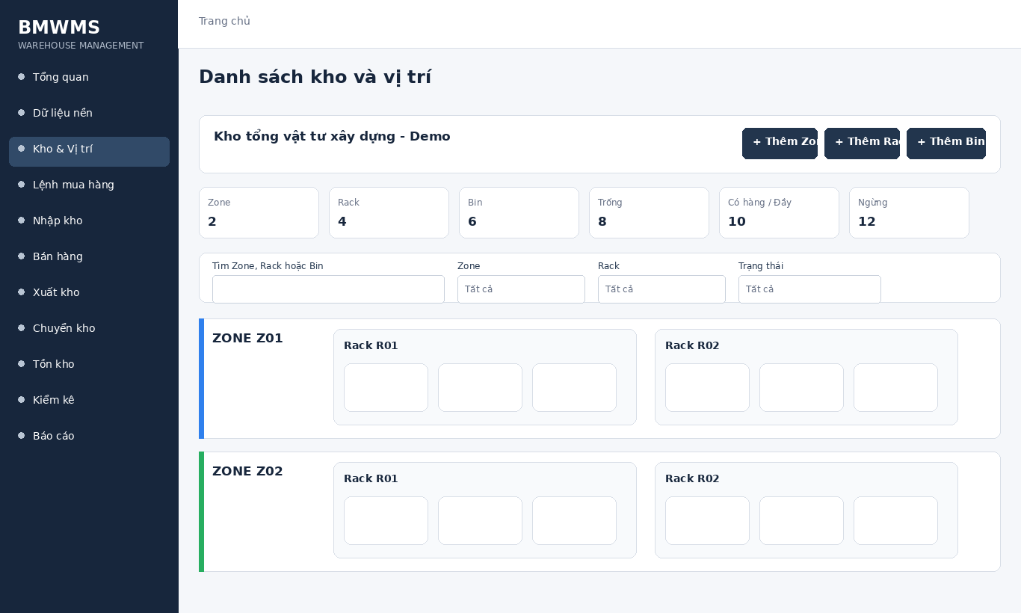
Figure UC-023: Wireframe for Manage warehouses. Source: BMWMS.Web/Pages/Warehouse/Index.cshtml

Field Description
Field Name | Field Type | Description
Từ khóa | Search box | Search box for Zone, Rack or Bin code/name; optional.
Zone | Dropdown | Dropdown containing active zones; default All Zones.
Rack | Dropdown | Dependent dropdown filtered by Zone; default All Racks.
Trạng thái Bin | Dropdown | Dropdown: All, Empty, Occupied, Full, Capacity unknown, Inactive, Locked.
Chế độ xem | Button | Buttons to switch between Map and List.

Use Case Specification
Use Case ID | UC-023 | Use Case Name | Manage warehouses
Primary Actors | System Administrator; Warehouse Manager | Secondary Actors | BMWMS API; SQL Server database
Description | As an authorized system administrator, I want to perform manage warehouses so that the related warehouse activity is completed and traceable.
Preconditions | The actor is authenticated and authorized. Required master data and source transaction exist and are active.
Postconditions | The manage warehouses result is saved or displayed successfully. Related statuses and inventory balances remain consistent.
Normal Sequence/Flow | 1. Actor opens the relevant list or detail screen.  2. System displays the current data and actions permitted for the actor.  3. Actor selects Manage.  4. System displays the required input fields or confirmation.  5. Actor enters/reviews the information and confirms.  6. System validates mandatory fields, quantities, authorization and current status.  7. System saves the transaction, updates the status and displays the result.
Alternative Sequences/Flows | A1. Actor cancels before confirmation; system returns to the previous screen without saving.  A2. Actor corrects invalid data and resubmits; system continues from the validation step.
Exception Flows | E1. Required or formatted data is invalid: system shows field-level validation and does not save.  E2. Actor is not authorized: system denies the operation.  E3. Record status changed or is not eligible: system reloads the latest data and disables the action.  E4. API/database/email service is unavailable: system shows an error and keeps the previous consistent state.
Business Rules | The hierarchy is Warehouse - Zone - Rack - Bin. A child location requires an active parent.

UC-024 View warehouse details
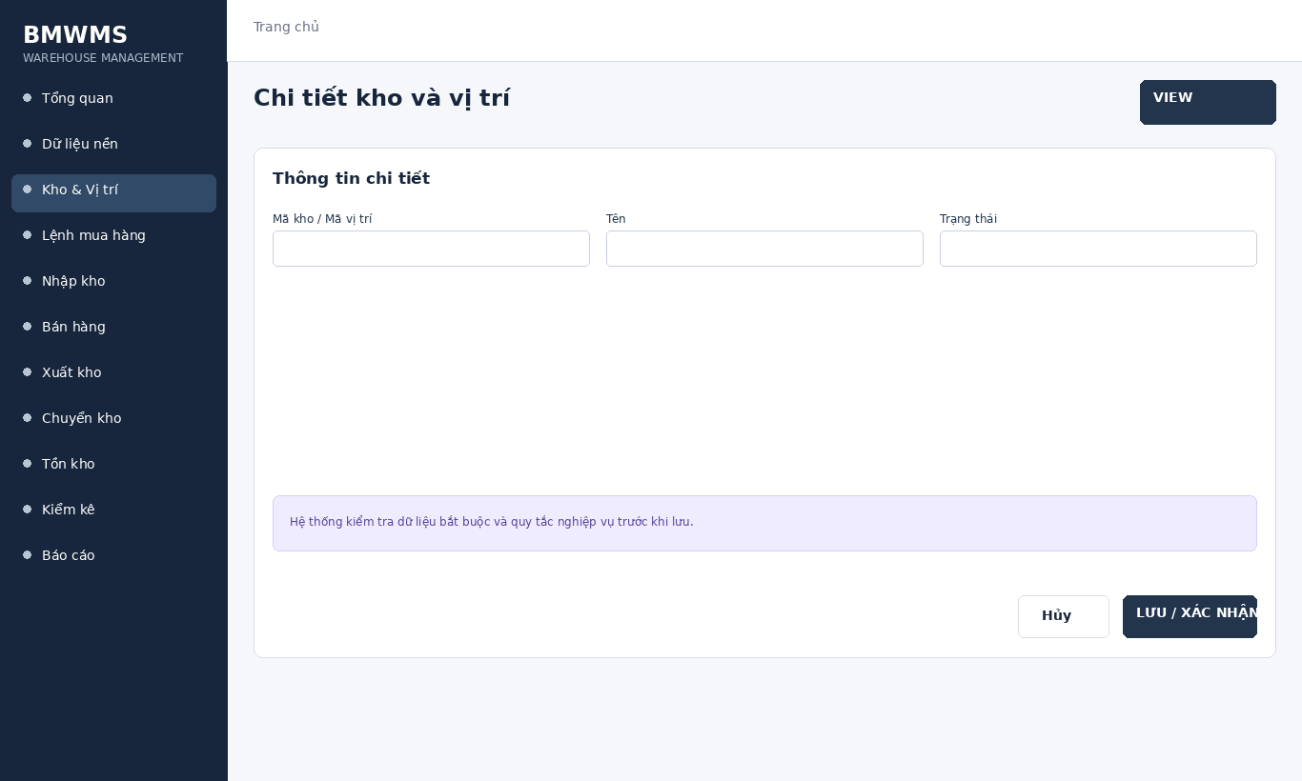
Figure UC-024: Wireframe for View warehouse details. Source: BMWMS.Web/Pages/Warehouse/Details.cshtml

Field Description
Field Name | Field Type | Description
Mã kho / Mã vị trí | Read-only field | Read-only identifier.
Tên | Display field | Warehouse or location name.
Trạng thái | Display field | Operational status of the warehouse/location.

Use Case Specification
Use Case ID | UC-024 | Use Case Name | View warehouse details
Primary Actors | System Administrator; Warehouse Manager | Secondary Actors | BMWMS API; SQL Server database
Description | As an authorized system administrator, I want to perform view warehouse details so that the related warehouse activity is completed and traceable.
Preconditions | The actor is authenticated and authorized. Required master data and source transaction exist and are active.
Postconditions | The view warehouse details result is saved or displayed successfully. Related statuses and inventory balances remain consistent.
Normal Sequence/Flow | 1. Actor opens the View warehouse details screen.  2. System displays the available filters and current records.  3. Actor enters optional filter criteria.  4. Actor selects Filter/Search/View.  5. System validates the criteria and returns matching data.  6. Actor reviews the result or opens a record for more detail.
Alternative Sequences/Flows | A1. Actor leaves all filters blank; system displays the default paged result.  A2. No record matches; system displays an empty list without changing data.
Exception Flows | E1. Required or formatted data is invalid: system shows field-level validation and does not save.  E2. Actor is not authorized: system denies the operation.  E3. Record status changed or is not eligible: system reloads the latest data and disables the action.  E4. API/database/email service is unavailable: system shows an error and keeps the previous consistent state.
Business Rules | The hierarchy is Warehouse - Zone - Rack - Bin. A child location requires an active parent.

UC-025 Manage storage locations
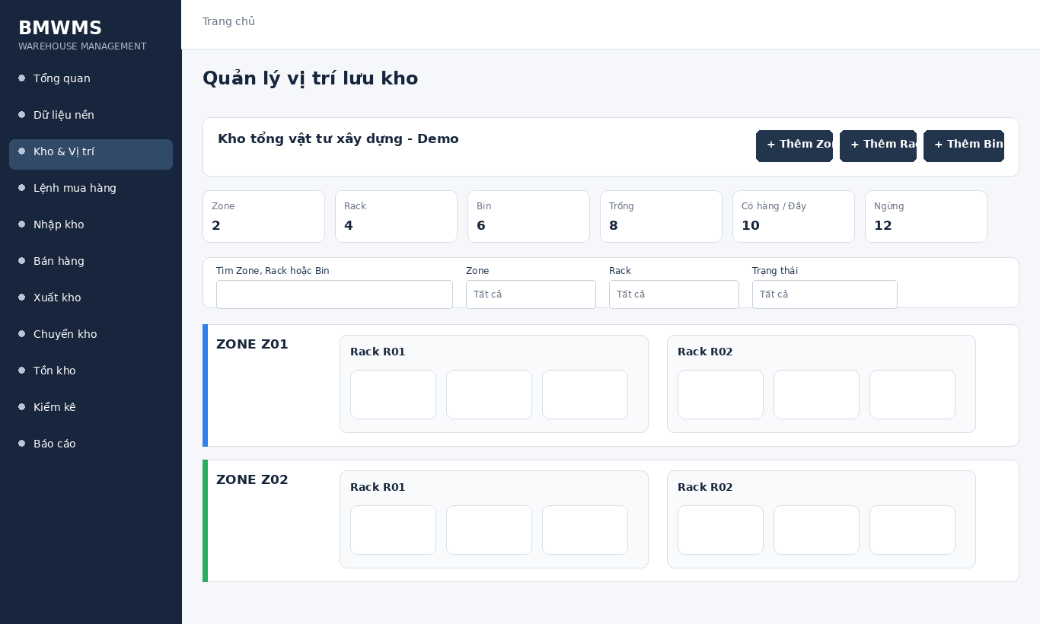
Figure UC-025: Wireframe for Manage storage locations. Source: BMWMS.Web/Pages/Warehouse/Index.cshtml

Field Description
Field Name | Field Type | Description
Từ khóa | Search box | Search box for Zone, Rack or Bin code/name; optional.
Zone | Dropdown | Dropdown containing active zones; default All Zones.
Rack | Dropdown | Dependent dropdown filtered by Zone; default All Racks.
Trạng thái Bin | Dropdown | Dropdown: All, Empty, Occupied, Full, Capacity unknown, Inactive, Locked.
Chế độ xem | Button | Buttons to switch between Map and List.

Use Case Specification
Use Case ID | UC-025 | Use Case Name | Manage storage locations
Primary Actors | System Administrator; Warehouse Manager | Secondary Actors | BMWMS API; SQL Server database
Description | As an authorized system administrator, I want to perform manage storage locations so that the related warehouse activity is completed and traceable.
Preconditions | The actor is authenticated and authorized. Required master data and source transaction exist and are active.
Postconditions | The manage storage locations result is saved or displayed successfully. Related statuses and inventory balances remain consistent.
Normal Sequence/Flow | 1. Actor opens the relevant list or detail screen.  2. System displays the current data and actions permitted for the actor.  3. Actor selects Manage.  4. System displays the required input fields or confirmation.  5. Actor enters/reviews the information and confirms.  6. System validates mandatory fields, quantities, authorization and current status.  7. System saves the transaction, updates the status and displays the result.
Alternative Sequences/Flows | A1. Actor cancels before confirmation; system returns to the previous screen without saving.  A2. Actor corrects invalid data and resubmits; system continues from the validation step.
Exception Flows | E1. Required or formatted data is invalid: system shows field-level validation and does not save.  E2. Actor is not authorized: system denies the operation.  E3. Record status changed or is not eligible: system reloads the latest data and disables the action.  E4. API/database/email service is unavailable: system shows an error and keeps the previous consistent state.
Business Rules | The hierarchy is Warehouse - Zone - Rack - Bin. A child location requires an active parent.

UC-026 View warehouse tasks
Figure UC-026: Wireframe for View warehouse tasks. Source: BMWMS.Web/Pages/Warehouse/Index.cshtml

Field Description
Field Name | Field Type | Description
Từ khóa | Search box | Search box for Zone, Rack or Bin code/name; optional.
Zone | Dropdown | Dropdown containing active zones; default All Zones.
Rack | Dropdown | Dependent dropdown filtered by Zone; default All Racks.
Trạng thái Bin | Dropdown | Dropdown: All, Empty, Occupied, Full, Capacity unknown, Inactive, Locked.
Chế độ xem | Button | Buttons to switch between Map and List.

Use Case Specification
Use Case ID | UC-026 | Use Case Name | View warehouse tasks
Primary Actors | System Administrator; Warehouse Manager | Secondary Actors | BMWMS API; SQL Server database
Description | As an authorized system administrator, I want to perform view warehouse tasks so that the related warehouse activity is completed and traceable.
Preconditions | The actor is authenticated and authorized. Required master data and source transaction exist and are active.
Postconditions | The view warehouse tasks result is saved or displayed successfully. Related statuses and inventory balances remain consistent.
Normal Sequence/Flow | 1. Actor opens the View warehouse tasks screen.  2. System displays the available filters and current records.  3. Actor enters optional filter criteria.  4. Actor selects Filter/Search/View.  5. System validates the criteria and returns matching data.  6. Actor reviews the result or opens a record for more detail.
Alternative Sequences/Flows | A1. Actor leaves all filters blank; system displays the default paged result.  A2. No record matches; system displays an empty list without changing data.
Exception Flows | E1. Required or formatted data is invalid: system shows field-level validation and does not save.  E2. Actor is not authorized: system denies the operation.  E3. Record status changed or is not eligible: system reloads the latest data and disables the action.  E4. API/database/email service is unavailable: system shows an error and keeps the previous consistent state.
Business Rules | The hierarchy is Warehouse - Zone - Rack - Bin. A child location requires an active parent.

2.5 Purchase Order

UC-027 Create Purchase Order
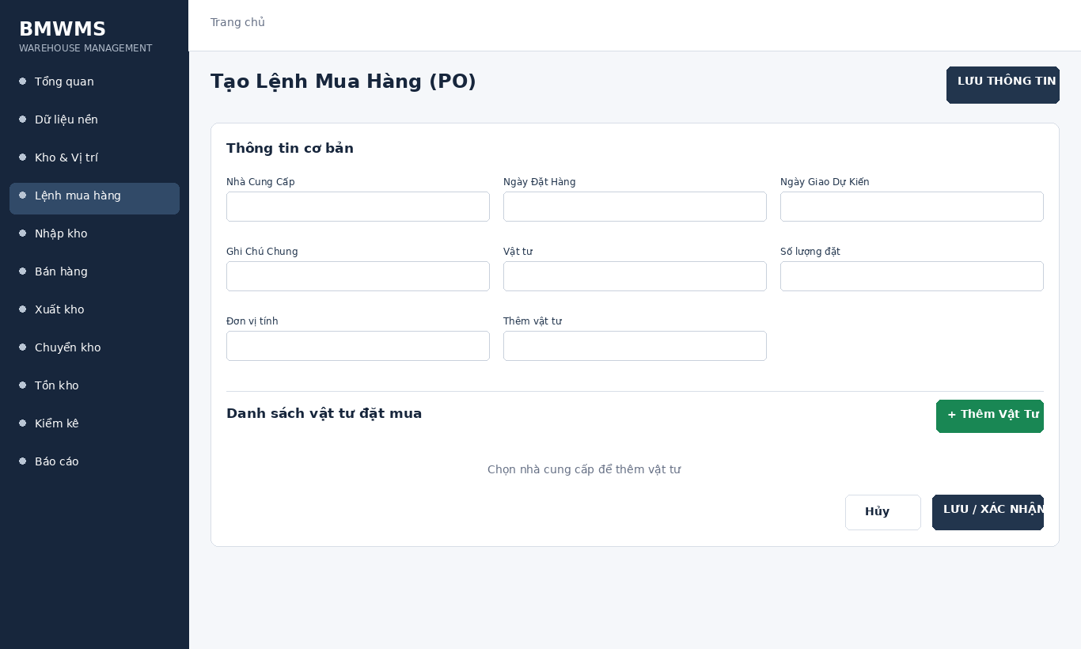
Figure UC-027: Wireframe for Create Purchase Order. Source: BMWMS.Web/Pages/PurchaseOrders/Create.cshtml

Field Description
Field Name | Field Type | Description
Nhà Cung Cấp | Dropdown | Dropdown of active suppliers; required.
Ngày Đặt Hàng | Date picker | Date input; required; default current date.
Ngày Giao Dự Kiến | Date picker | Date input; required; cannot be earlier than Order date.
Ghi Chú Chung | Text area | Multiline text; optional.
Vật tư | Dropdown | Product selector restricted by supplier where configured.
Số lượng đặt | Number input | Positive numeric input; required for each line.
Đơn vị tính | Dropdown | Displayed from the selected product.
Thêm vật tư | Button | Button adds a new product line; duplicated products are not allowed.

Use Case Specification
Use Case ID | UC-027 | Use Case Name | Create Purchase Order
Primary Actors | Purchasing Staff; Warehouse Manager | Secondary Actors | BMWMS API; SQL Server database
Description | As an authorized purchasing staff, I want to perform create purchase order so that the related warehouse activity is completed and traceable.
Preconditions | The actor is authenticated and authorized. Required master data and source transaction exist and are active.
Postconditions | The create purchase order result is saved or displayed successfully. Related statuses and inventory balances remain consistent.
Normal Sequence/Flow | 1. Actor opens the relevant list or detail screen.  2. System displays the current data and actions permitted for the actor.  3. Actor selects Create.  4. System displays the required input fields or confirmation.  5. Actor enters/reviews the information and confirms.  6. System validates mandatory fields, quantities, authorization and current status.  7. System saves the transaction, updates the status and displays the result.
Alternative Sequences/Flows | A1. Actor cancels before confirmation; system returns to the previous screen without saving.  A2. Actor corrects invalid data and resubmits; system continues from the validation step.
Exception Flows | E1. Required or formatted data is invalid: system shows field-level validation and does not save.  E2. Actor is not authorized: system denies the operation.  E3. Record status changed or is not eligible: system reloads the latest data and disables the action.  E4. API/database/email service is unavailable: system shows an error and keeps the previous consistent state.
Business Rules | A PO is created in DRAFT. Sending to the supplier changes it to CONFIRMED. Only DRAFT can be cancelled. Incomplete receipt may be continued or closed with remainder.

UC-028 View Purchase Order list
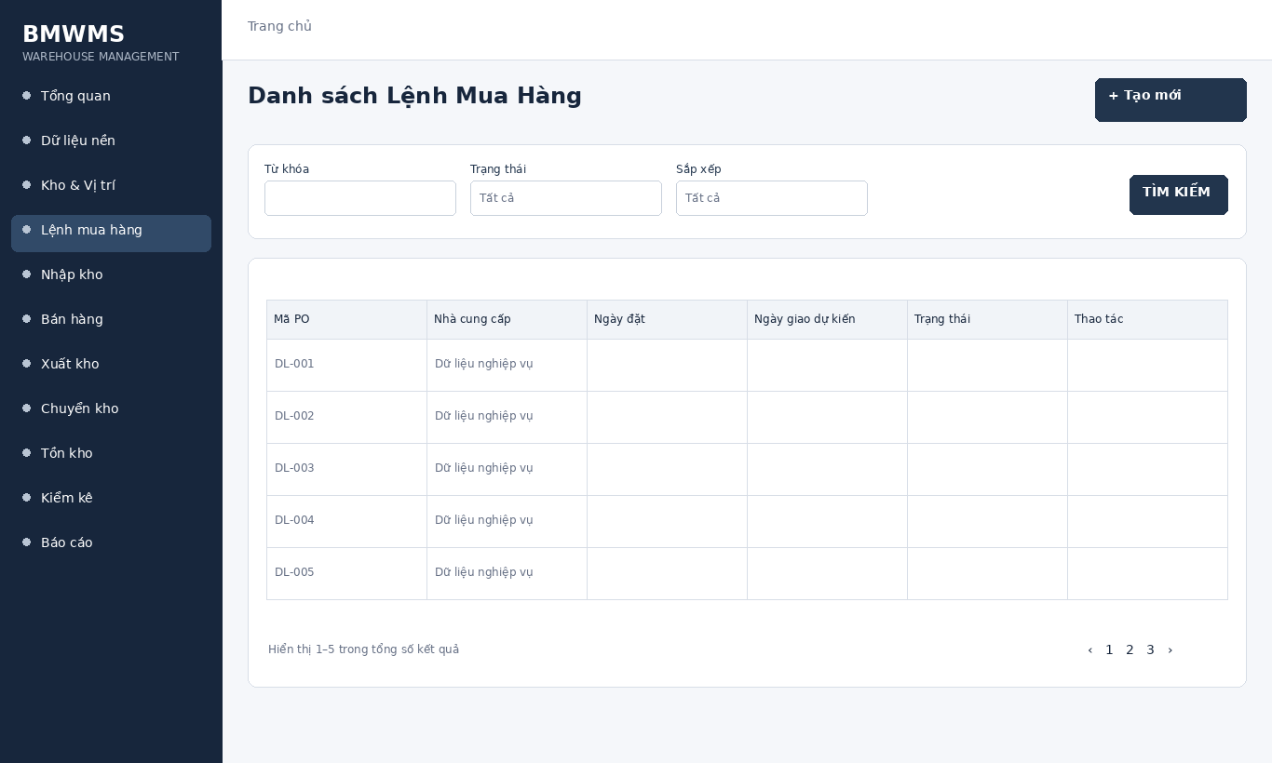
Figure UC-028: Wireframe for View Purchase Order list. Source: BMWMS.Web/Pages/PurchaseOrders/Index.cshtml

Field Description
Field Name | Field Type | Description
Từ khóa | Text box | Text box. Search by PO number or supplier; optional.
Trạng thái | Dropdown | Dropdown: All, Draft, Confirmed, Pending receipt review, Partially received, Completed, Cancelled.
Sắp xếp | Dropdown | Dropdown: Newest or Oldest; default Newest.

Use Case Specification
Use Case ID | UC-028 | Use Case Name | View Purchase Order list
Primary Actors | Purchasing Staff; Warehouse Manager | Secondary Actors | BMWMS API; SQL Server database
Description | As an authorized purchasing staff, I want to perform view purchase order list so that the related warehouse activity is completed and traceable.
Preconditions | The actor is authenticated and authorized. Required master data and source transaction exist and are active.
Postconditions | The view purchase order list result is saved or displayed successfully. Related statuses and inventory balances remain consistent.
Normal Sequence/Flow | 1. Actor opens the View Purchase Order list screen.  2. System displays the available filters and current records.  3. Actor enters optional filter criteria.  4. Actor selects Filter/Search/View.  5. System validates the criteria and returns matching data.  6. Actor reviews the result or opens a record for more detail.
Alternative Sequences/Flows | A1. Actor leaves all filters blank; system displays the default paged result.  A2. No record matches; system displays an empty list without changing data.
Exception Flows | E1. Required or formatted data is invalid: system shows field-level validation and does not save.  E2. Actor is not authorized: system denies the operation.  E3. Record status changed or is not eligible: system reloads the latest data and disables the action.  E4. API/database/email service is unavailable: system shows an error and keeps the previous consistent state.
Business Rules | A PO is created in DRAFT. Sending to the supplier changes it to CONFIRMED. Only DRAFT can be cancelled. Incomplete receipt may be continued or closed with remainder.

UC-029 View Purchase Order details
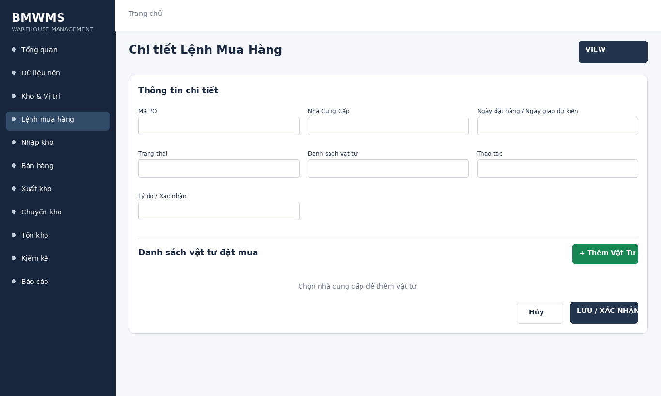
Figure UC-029: Wireframe for View Purchase Order details. Source: BMWMS.Web/Pages/PurchaseOrders/Detail.cshtml

Field Description
Field Name | Field Type | Description
Mã PO | Read-only field | Read-only system-generated purchase-order number.
Nhà Cung Cấp | Read-only field | Read-only supplier linked to the PO.
Ngày đặt hàng / Ngày giao dự kiến | Read-only field | Read-only transaction dates.
Trạng thái | Read-only field | Read-only current PO lifecycle status.
Danh sách vật tư | Display field | Product, ordered quantity, accepted quantity and remaining quantity.
Thao tác | Read-only field | Send, Cancel, Continue receipt or Close remainder; displayed according to role and status.
Lý do / Xác nhận | Display field | Required by actions that change or close the transaction.

Use Case Specification
Use Case ID | UC-029 | Use Case Name | View Purchase Order details
Primary Actors | Purchasing Staff; Warehouse Manager | Secondary Actors | BMWMS API; SQL Server database
Description | As an authorized purchasing staff, I want to perform view purchase order details so that the related warehouse activity is completed and traceable.
Preconditions | The actor is authenticated and authorized. Required master data and source transaction exist and are active.
Postconditions | The view purchase order details result is saved or displayed successfully. Related statuses and inventory balances remain consistent.
Normal Sequence/Flow | 1. Actor opens the View Purchase Order details screen.  2. System displays the available filters and current records.  3. Actor enters optional filter criteria.  4. Actor selects Filter/Search/View.  5. System validates the criteria and returns matching data.  6. Actor reviews the result or opens a record for more detail.
Alternative Sequences/Flows | A1. Actor leaves all filters blank; system displays the default paged result.  A2. No record matches; system displays an empty list without changing data.
Exception Flows | E1. Required or formatted data is invalid: system shows field-level validation and does not save.  E2. Actor is not authorized: system denies the operation.  E3. Record status changed or is not eligible: system reloads the latest data and disables the action.  E4. API/database/email service is unavailable: system shows an error and keeps the previous consistent state.
Business Rules | A PO is created in DRAFT. Sending to the supplier changes it to CONFIRMED. Only DRAFT can be cancelled. Incomplete receipt may be continued or closed with remainder.

UC-030 Send Purchase Order to supplier
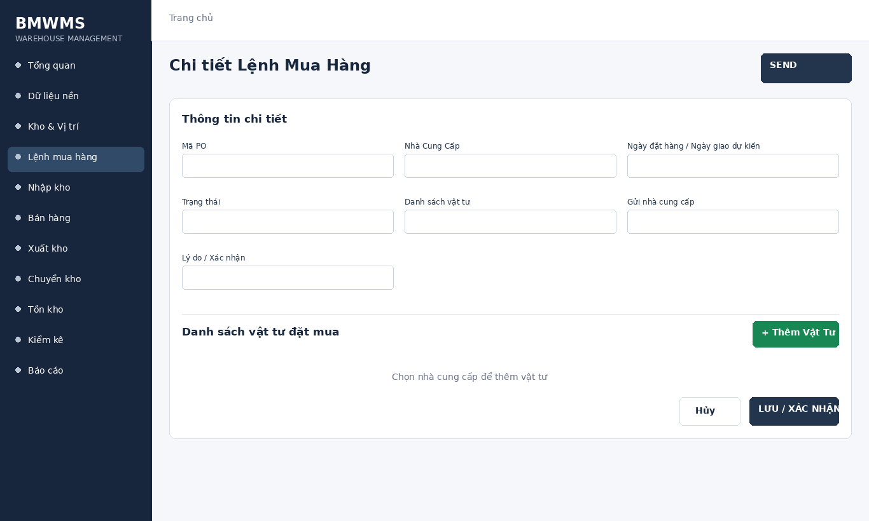
Figure UC-030: Wireframe for Send Purchase Order to supplier. Source: BMWMS.Web/Pages/PurchaseOrders/Detail.cshtml

Field Description
Field Name | Field Type | Description
Mã PO | Read-only field | Read-only system-generated purchase-order number.
Nhà Cung Cấp | Read-only field | Read-only supplier linked to the PO.
Ngày đặt hàng / Ngày giao dự kiến | Read-only field | Read-only transaction dates.
Trạng thái | Read-only field | Read-only current PO lifecycle status.
Danh sách vật tư | Display field | Product, ordered quantity, accepted quantity and remaining quantity.
Gửi nhà cung cấp | Read-only field | Send, Cancel, Continue receipt or Close remainder; displayed according to role and status.
Lý do / Xác nhận | Display field | Required by actions that change or close the transaction.

Use Case Specification
Use Case ID | UC-030 | Use Case Name | Send Purchase Order to supplier
Primary Actors | Purchasing Staff; Warehouse Manager | Secondary Actors | BMWMS API; SQL Server database; Email service
Description | As an authorized purchasing staff, I want to perform send purchase order to supplier so that the related warehouse activity is completed and traceable.
Preconditions | The actor is authenticated and authorized. Required master data and source transaction exist and are active.
Postconditions | The send purchase order to supplier result is saved or displayed successfully. Related statuses and inventory balances remain consistent.
Normal Sequence/Flow | 1. Actor opens the relevant list or detail screen.  2. System displays the current data and actions permitted for the actor.  3. Actor selects Send.  4. System displays the required input fields or confirmation.  5. Actor enters/reviews the information and confirms.  6. System validates mandatory fields, quantities, authorization and current status.  7. System saves the transaction, updates the status and displays the result.
Alternative Sequences/Flows | A1. Actor cancels before confirmation; system returns to the previous screen without saving.  A2. Actor corrects invalid data and resubmits; system continues from the validation step.
Exception Flows | E1. Required or formatted data is invalid: system shows field-level validation and does not save.  E2. Actor is not authorized: system denies the operation.  E3. Record status changed or is not eligible: system reloads the latest data and disables the action.  E4. API/database/email service is unavailable: system shows an error and keeps the previous consistent state.
Business Rules | A PO is created in DRAFT. Sending to the supplier changes it to CONFIRMED. Only DRAFT can be cancelled. Incomplete receipt may be continued or closed with remainder.

UC-031 Cancel Purchase Order
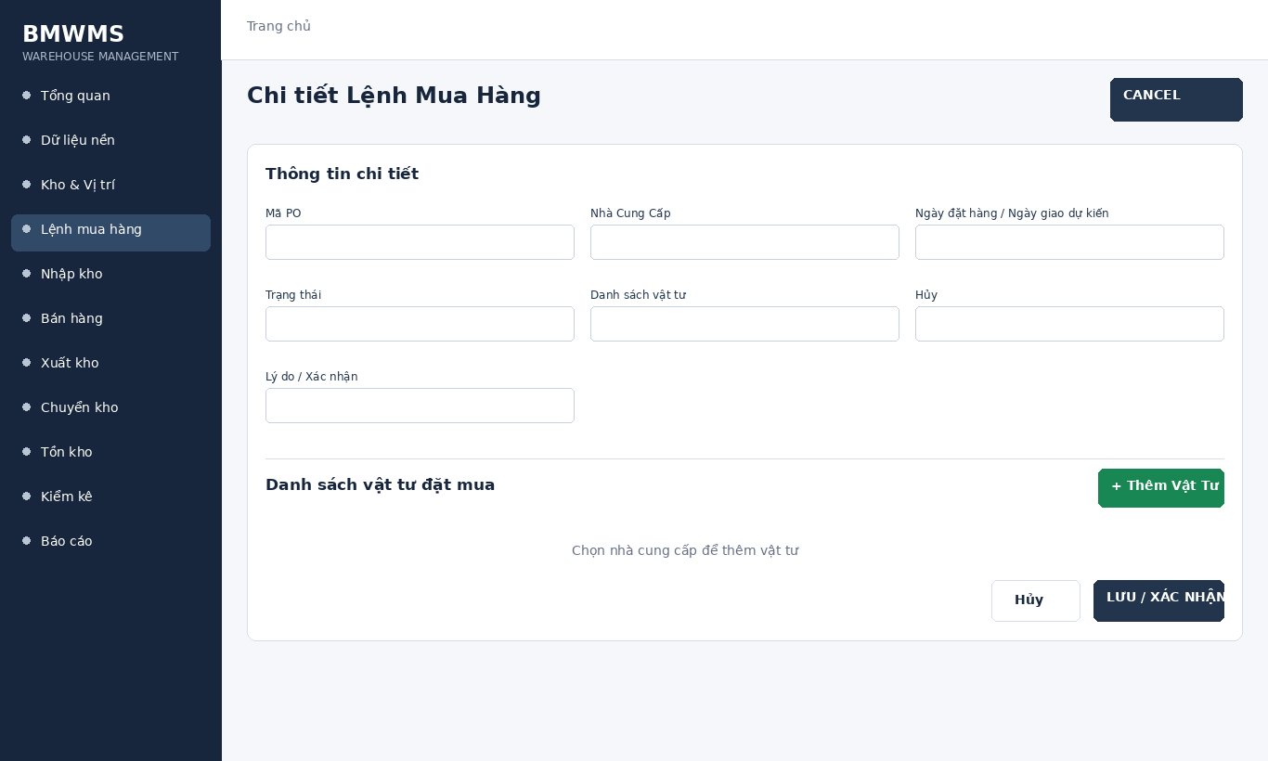
Figure UC-031: Wireframe for Cancel Purchase Order. Source: BMWMS.Web/Pages/PurchaseOrders/Detail.cshtml

Field Description
Field Name | Field Type | Description
Mã PO | Read-only field | Read-only system-generated purchase-order number.
Nhà Cung Cấp | Read-only field | Read-only supplier linked to the PO.
Ngày đặt hàng / Ngày giao dự kiến | Read-only field | Read-only transaction dates.
Trạng thái | Read-only field | Read-only current PO lifecycle status.
Danh sách vật tư | Display field | Product, ordered quantity, accepted quantity and remaining quantity.
Hủy | Read-only field | Send, Cancel, Continue receipt or Close remainder; displayed according to role and status.
Lý do / Xác nhận | Display field | Required by actions that change or close the transaction.

Use Case Specification
Use Case ID | UC-031 | Use Case Name | Cancel Purchase Order
Primary Actors | Purchasing Staff; Warehouse Manager | Secondary Actors | BMWMS API; SQL Server database
Description | As an authorized purchasing staff, I want to perform cancel purchase order so that the related warehouse activity is completed and traceable.
Preconditions | The actor is authenticated and authorized. Required master data and source transaction exist and are active.
Postconditions | The cancel purchase order result is saved or displayed successfully. Related statuses and inventory balances remain consistent.
Normal Sequence/Flow | 1. Actor opens the relevant list or detail screen.  2. System displays the current data and actions permitted for the actor.  3. Actor selects Cancel.  4. System displays the required input fields or confirmation.  5. Actor enters/reviews the information and confirms.  6. System validates mandatory fields, quantities, authorization and current status.  7. System saves the transaction, updates the status and displays the result.
Alternative Sequences/Flows | A1. Actor cancels before confirmation; system returns to the previous screen without saving.  A2. Actor corrects invalid data and resubmits; system continues from the validation step.
Exception Flows | E1. Required or formatted data is invalid: system shows field-level validation and does not save.  E2. Actor is not authorized: system denies the operation.  E3. Record status changed or is not eligible: system reloads the latest data and disables the action.  E4. API/database/email service is unavailable: system shows an error and keeps the previous consistent state.
Business Rules | A PO is created in DRAFT. Sending to the supplier changes it to CONFIRMED. Only DRAFT can be cancelled. Incomplete receipt may be continued or closed with remainder.

UC-032 Continue partial PO receipt
Figure UC-032: Wireframe for Continue partial PO receipt. Source: BMWMS.Web/Pages/PurchaseOrders/Index.cshtml

Field Description
Field Name | Field Type | Description
Từ khóa | Text box | Text box. Search by PO number or supplier; optional.
Trạng thái | Dropdown | Dropdown: All, Draft, Confirmed, Pending receipt review, Partially received, Completed, Cancelled.
Sắp xếp | Dropdown | Dropdown: Newest or Oldest; default Newest.

Use Case Specification
Use Case ID | UC-032 | Use Case Name | Continue partial PO receipt
Primary Actors | Purchasing Staff; Warehouse Manager | Secondary Actors | BMWMS API; SQL Server database
Description | As an authorized purchasing staff, I want to perform continue partial po receipt so that the related warehouse activity is completed and traceable.
Preconditions | The actor is authenticated and authorized. Required master data and source transaction exist and are active.
Postconditions | The continue partial po receipt result is saved or displayed successfully. Related statuses and inventory balances remain consistent.
Normal Sequence/Flow | 1. Actor opens the relevant list or detail screen.  2. System displays the current data and actions permitted for the actor.  3. Actor selects Continue.  4. System displays the required input fields or confirmation.  5. Actor enters/reviews the information and confirms.  6. System validates mandatory fields, quantities, authorization and current status.  7. System saves the transaction, updates the status and displays the result.
Alternative Sequences/Flows | A1. Actor cancels before confirmation; system returns to the previous screen without saving.  A2. Actor corrects invalid data and resubmits; system continues from the validation step.
Exception Flows | E1. Required or formatted data is invalid: system shows field-level validation and does not save.  E2. Actor is not authorized: system denies the operation.  E3. Record status changed or is not eligible: system reloads the latest data and disables the action.  E4. API/database/email service is unavailable: system shows an error and keeps the previous consistent state.
Business Rules | A PO is created in DRAFT. Sending to the supplier changes it to CONFIRMED. Only DRAFT can be cancelled. Incomplete receipt may be continued or closed with remainder.

UC-033 Close PO with remainder
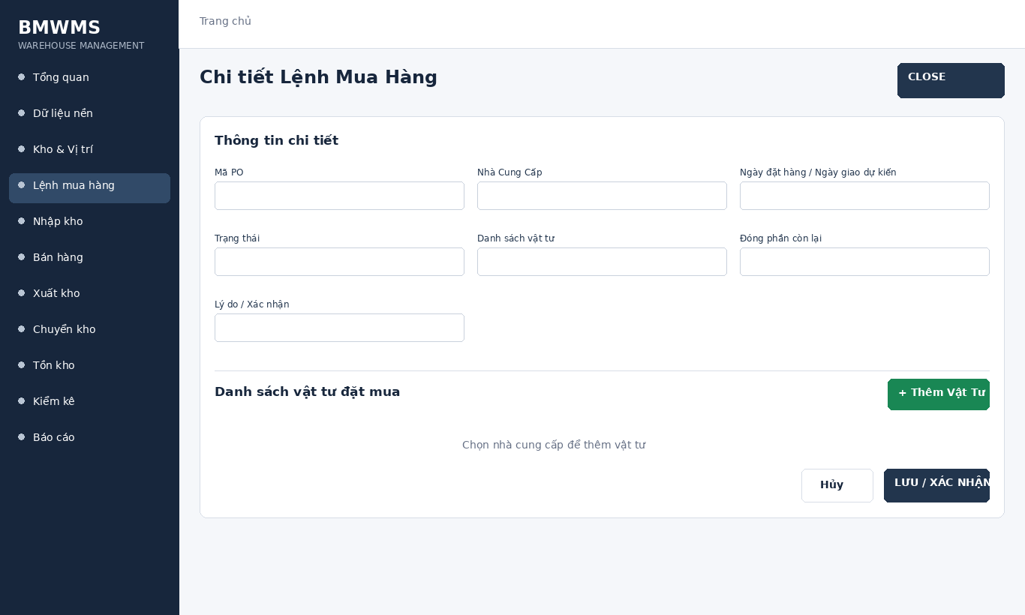
Figure UC-033: Wireframe for Close PO with remainder. Source: BMWMS.Web/Pages/PurchaseOrders/Detail.cshtml

Field Description
Field Name | Field Type | Description
Mã PO | Read-only field | Read-only system-generated purchase-order number.
Nhà Cung Cấp | Read-only field | Read-only supplier linked to the PO.
Ngày đặt hàng / Ngày giao dự kiến | Read-only field | Read-only transaction dates.
Trạng thái | Read-only field | Read-only current PO lifecycle status.
Danh sách vật tư | Display field | Product, ordered quantity, accepted quantity and remaining quantity.
Đóng phần còn lại | Read-only field | Send, Cancel, Continue receipt or Close remainder; displayed according to role and status.
Lý do / Xác nhận | Display field | Required by actions that change or close the transaction.

Use Case Specification
Use Case ID | UC-033 | Use Case Name | Close PO with remainder
Primary Actors | Purchasing Staff; Warehouse Manager | Secondary Actors | BMWMS API; SQL Server database
Description | As an authorized purchasing staff, I want to perform close po with remainder so that the related warehouse activity is completed and traceable.
Preconditions | The actor is authenticated and authorized. Required master data and source transaction exist and are active.
Postconditions | The close po with remainder result is saved or displayed successfully. Related statuses and inventory balances remain consistent.
Normal Sequence/Flow | 1. Actor opens the relevant list or detail screen.  2. System displays the current data and actions permitted for the actor.  3. Actor selects Close.  4. System displays the required input fields or confirmation.  5. Actor enters/reviews the information and confirms.  6. System validates mandatory fields, quantities, authorization and current status.  7. System saves the transaction, updates the status and displays the result.
Alternative Sequences/Flows | A1. Actor cancels before confirmation; system returns to the previous screen without saving.  A2. Actor corrects invalid data and resubmits; system continues from the validation step.
Exception Flows | E1. Required or formatted data is invalid: system shows field-level validation and does not save.  E2. Actor is not authorized: system denies the operation.  E3. Record status changed or is not eligible: system reloads the latest data and disables the action.  E4. API/database/email service is unavailable: system shows an error and keeps the previous consistent state.
Business Rules | A PO is created in DRAFT. Sending to the supplier changes it to CONFIRMED. Only DRAFT can be cancelled. Incomplete receipt may be continued or closed with remainder.

2.6 Inbound

UC-034 View inbound order list
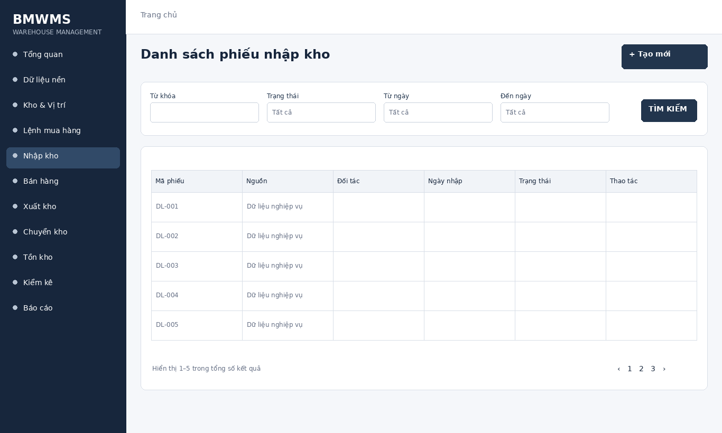
Figure UC-034: Wireframe for View inbound order list. Source: BMWMS.Web/Pages/Admin/Inbound/Index.cshtml

Field Description
Field Name | Field Type | Description
Từ khóa | Text box | Text box. Search by receipt number, PO, SO or partner; optional.
Trạng thái | Dropdown | Dropdown: All, Pending receipt, Recording actual receipt, Pending putaway, Completed, Cancelled.
Từ ngày | Date picker | Optional date filter for the beginning of the receiving period.
Đến ngày | Date picker | Optional date filter for the end of the receiving period.
Loại nguồn | Dropdown | Dropdown: All, PO, SO.
Sắp xếp | Dropdown | Dropdown: Newest or Oldest; default Newest.

Use Case Specification
Use Case ID | UC-034 | Use Case Name | View inbound order list
Primary Actors | Warehouse Manager; Warehouse Staff | Secondary Actors | BMWMS API; SQL Server database
Description | As an authorized warehouse manager, I want to perform view inbound order list so that the related warehouse activity is completed and traceable.
Preconditions | The actor is authenticated and authorized. Required master data and source transaction exist and are active.
Postconditions | The view inbound order list result is saved or displayed successfully. Related statuses and inventory balances remain consistent.
Normal Sequence/Flow | 1. Actor opens the View inbound order list screen.  2. System displays the available filters and current records.  3. Actor enters optional filter criteria.  4. Actor selects Filter/Search/View.  5. System validates the criteria and returns matching data.  6. Actor reviews the result or opens a record for more detail.
Alternative Sequences/Flows | A1. Actor leaves all filters blank; system displays the default paged result.  A2. No record matches; system displays an empty list without changing data.
Exception Flows | E1. Required or formatted data is invalid: system shows field-level validation and does not save.  E2. Actor is not authorized: system denies the operation.  E3. Record status changed or is not eligible: system reloads the latest data and disables the action.  E4. API/database/email service is unavailable: system shows an error and keeps the previous consistent state.
Business Rules | Actual received and rejected quantities cannot be negative. Accepted stock must have a putaway location; lot/expiry is required according to product settings.

UC-035 Create inbound order
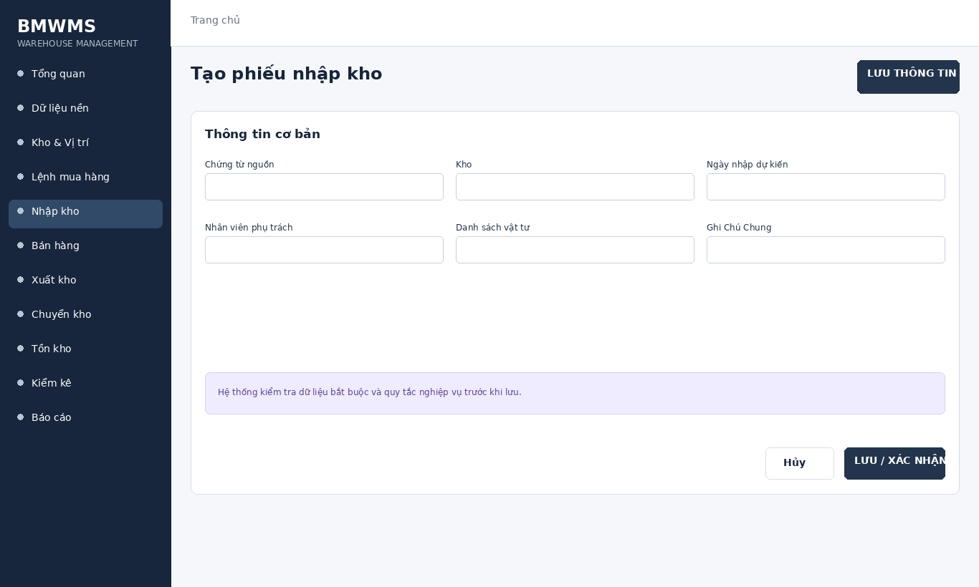
Figure UC-035: Wireframe for Create inbound order. Source: BMWMS.Web/Pages/Admin/Inbound/Create.cshtml

Field Description
Field Name | Field Type | Description
Chứng từ nguồn | Display field | PO or SO reference used to create the receipt.
Kho | Display field | Warehouse receiving the goods; required.
Ngày nhập dự kiến | Date picker | Date input used to schedule receipt.
Nhân viên phụ trách | Dropdown | Warehouse staff dropdown where assignment is required.
Danh sách vật tư | Display field | Expected products and quantities inherited from the source order.
Ghi Chú Chung | Text area | Optional operational notes.

Use Case Specification
Use Case ID | UC-035 | Use Case Name | Create inbound order
Primary Actors | Warehouse Manager; Warehouse Staff | Secondary Actors | BMWMS API; SQL Server database
Description | As an authorized warehouse manager, I want to perform create inbound order so that the related warehouse activity is completed and traceable.
Preconditions | The actor is authenticated and authorized. Required master data and source transaction exist and are active.
Postconditions | The create inbound order result is saved or displayed successfully. Related statuses and inventory balances remain consistent.
Normal Sequence/Flow | 1. Actor opens the relevant list or detail screen.  2. System displays the current data and actions permitted for the actor.  3. Actor selects Create.  4. System displays the required input fields or confirmation.  5. Actor enters/reviews the information and confirms.  6. System validates mandatory fields, quantities, authorization and current status.  7. System saves the transaction, updates the status and displays the result.
Alternative Sequences/Flows | A1. Actor cancels before confirmation; system returns to the previous screen without saving.  A2. Actor corrects invalid data and resubmits; system continues from the validation step.
Exception Flows | E1. Required or formatted data is invalid: system shows field-level validation and does not save.  E2. Actor is not authorized: system denies the operation.  E3. Record status changed or is not eligible: system reloads the latest data and disables the action.  E4. API/database/email service is unavailable: system shows an error and keeps the previous consistent state.
Business Rules | Actual received and rejected quantities cannot be negative. Accepted stock must have a putaway location; lot/expiry is required according to product settings.

UC-036 View inbound order details
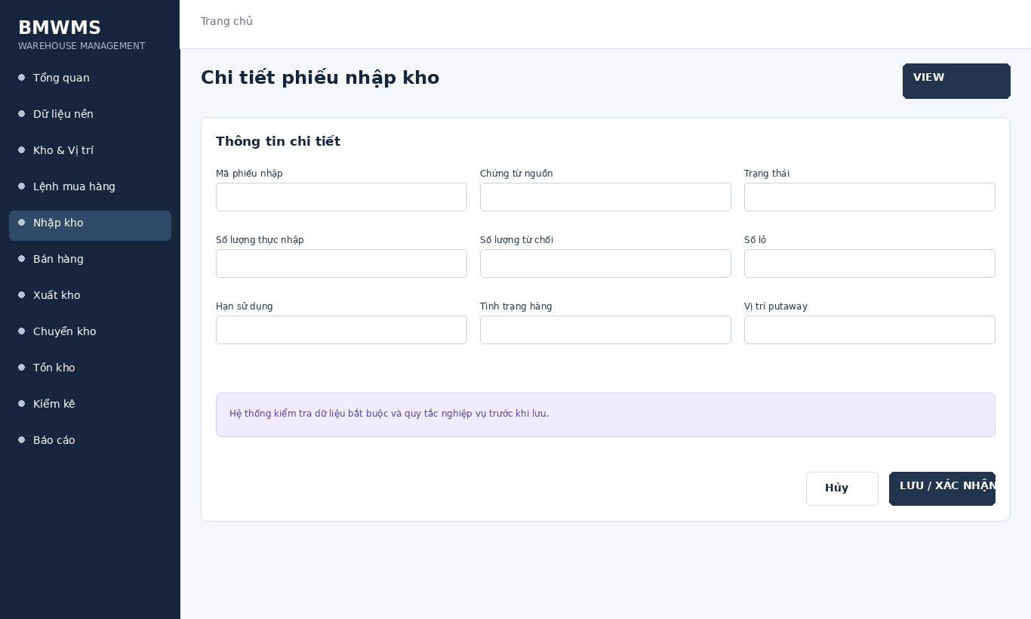
Figure UC-036: Wireframe for View inbound order details. Source: BMWMS.Web/Pages/Admin/Inbound/Details.cshtml

Field Description
Field Name | Field Type | Description
Mã phiếu nhập | Read-only field | Read-only system-generated inbound number.
Chứng từ nguồn | Read-only field | Read-only PO/SO reference.
Trạng thái | Read-only field | Read-only current receiving status.
Số lượng thực nhập | Number input | Numeric input for quantity physically received.
Số lượng từ chối | Number input | Numeric input for damaged or rejected goods.
Số lô | Text box | Text input required when lot tracking applies.
Hạn sử dụng | Date picker | Date input required when the product tracks expiry.
Tình trạng hàng | Dropdown | Selection for Good, Damaged or other configured condition.
Vị trí putaway | Dropdown | Zone/Rack/Bin selector used to place accepted stock.

Use Case Specification
Use Case ID | UC-036 | Use Case Name | View inbound order details
Primary Actors | Warehouse Manager; Warehouse Staff | Secondary Actors | BMWMS API; SQL Server database
Description | As an authorized warehouse manager, I want to perform view inbound order details so that the related warehouse activity is completed and traceable.
Preconditions | The actor is authenticated and authorized. Required master data and source transaction exist and are active.
Postconditions | The view inbound order details result is saved or displayed successfully. Related statuses and inventory balances remain consistent.
Normal Sequence/Flow | 1. Actor opens the View inbound order details screen.  2. System displays the available filters and current records.  3. Actor enters optional filter criteria.  4. Actor selects Filter/Search/View.  5. System validates the criteria and returns matching data.  6. Actor reviews the result or opens a record for more detail.
Alternative Sequences/Flows | A1. Actor leaves all filters blank; system displays the default paged result.  A2. No record matches; system displays an empty list without changing data.
Exception Flows | E1. Required or formatted data is invalid: system shows field-level validation and does not save.  E2. Actor is not authorized: system denies the operation.  E3. Record status changed or is not eligible: system reloads the latest data and disables the action.  E4. API/database/email service is unavailable: system shows an error and keeps the previous consistent state.
Business Rules | Actual received and rejected quantities cannot be negative. Accepted stock must have a putaway location; lot/expiry is required according to product settings.

UC-037 Edit inbound order
Figure UC-037: Wireframe for Edit inbound order. Source: BMWMS.Web/Pages/Admin/Inbound/Create.cshtml

Field Description
Field Name | Field Type | Description
Chứng từ nguồn | Display field | PO or SO reference used to create the receipt.
Kho | Display field | Warehouse receiving the goods; required.
Ngày nhập dự kiến | Date picker | Date input used to schedule receipt.
Nhân viên phụ trách | Dropdown | Warehouse staff dropdown where assignment is required.
Danh sách vật tư | Display field | Expected products and quantities inherited from the source order.
Ghi Chú Chung | Text area | Optional operational notes.

Use Case Specification
Use Case ID | UC-037 | Use Case Name | Edit inbound order
Primary Actors | Warehouse Manager; Warehouse Staff | Secondary Actors | BMWMS API; SQL Server database
Description | As an authorized warehouse manager, I want to perform edit inbound order so that the related warehouse activity is completed and traceable.
Preconditions | The actor is authenticated and authorized. Required master data and source transaction exist and are active.
Postconditions | The edit inbound order result is saved or displayed successfully. Related statuses and inventory balances remain consistent.
Normal Sequence/Flow | 1. Actor opens the relevant list or detail screen.  2. System displays the current data and actions permitted for the actor.  3. Actor selects Edit.  4. System displays the required input fields or confirmation.  5. Actor enters/reviews the information and confirms.  6. System validates mandatory fields, quantities, authorization and current status.  7. System saves the transaction, updates the status and displays the result.
Alternative Sequences/Flows | A1. Actor cancels before confirmation; system returns to the previous screen without saving.  A2. Actor corrects invalid data and resubmits; system continues from the validation step.
Exception Flows | E1. Required or formatted data is invalid: system shows field-level validation and does not save.  E2. Actor is not authorized: system denies the operation.  E3. Record status changed or is not eligible: system reloads the latest data and disables the action.  E4. API/database/email service is unavailable: system shows an error and keeps the previous consistent state.
Business Rules | Actual received and rejected quantities cannot be negative. Accepted stock must have a putaway location; lot/expiry is required according to product settings.

UC-038 Confirm inbound order
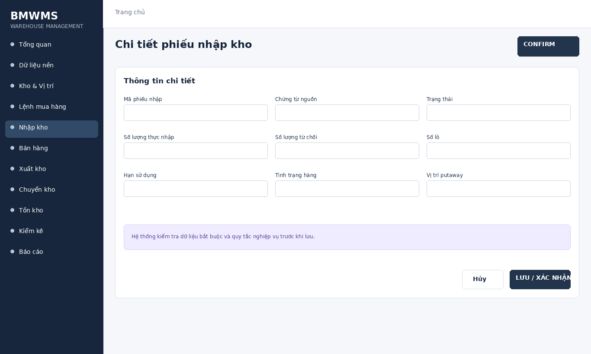
Figure UC-038: Wireframe for Confirm inbound order. Source: BMWMS.Web/Pages/Admin/Inbound/Details.cshtml

Field Description
Field Name | Field Type | Description
Mã phiếu nhập | Read-only field | Read-only system-generated inbound number.
Chứng từ nguồn | Read-only field | Read-only PO/SO reference.
Trạng thái | Read-only field | Read-only current receiving status.
Số lượng thực nhập | Number input | Numeric input for quantity physically received.
Số lượng từ chối | Number input | Numeric input for damaged or rejected goods.
Số lô | Text box | Text input required when lot tracking applies.
Hạn sử dụng | Date picker | Date input required when the product tracks expiry.
Tình trạng hàng | Dropdown | Selection for Good, Damaged or other configured condition.
Vị trí putaway | Dropdown | Zone/Rack/Bin selector used to place accepted stock.

Use Case Specification
Use Case ID | UC-038 | Use Case Name | Confirm inbound order
Primary Actors | Warehouse Manager; Warehouse Staff | Secondary Actors | BMWMS API; SQL Server database
Description | As an authorized warehouse manager, I want to perform confirm inbound order so that the related warehouse activity is completed and traceable.
Preconditions | The actor is authenticated and authorized. Required master data and source transaction exist and are active.
Postconditions | The confirm inbound order result is saved or displayed successfully. Related statuses and inventory balances remain consistent.
Normal Sequence/Flow | 1. Actor opens the relevant list or detail screen.  2. System displays the current data and actions permitted for the actor.  3. Actor selects Confirm.  4. System displays the required input fields or confirmation.  5. Actor enters/reviews the information and confirms.  6. System validates mandatory fields, quantities, authorization and current status.  7. System saves the transaction, updates the status and displays the result.
Alternative Sequences/Flows | A1. Actor cancels before confirmation; system returns to the previous screen without saving.  A2. Actor corrects invalid data and resubmits; system continues from the validation step.
Exception Flows | E1. Required or formatted data is invalid: system shows field-level validation and does not save.  E2. Actor is not authorized: system denies the operation.  E3. Record status changed or is not eligible: system reloads the latest data and disables the action.  E4. API/database/email service is unavailable: system shows an error and keeps the previous consistent state.
Business Rules | Actual received and rejected quantities cannot be negative. Accepted stock must have a putaway location; lot/expiry is required according to product settings.

UC-039 Assign inbound processing
Figure UC-039: Wireframe for Assign inbound processing. Source: BMWMS.Web/Pages/Admin/Inbound/Create.cshtml

Field Description
Field Name | Field Type | Description
Chứng từ nguồn | Display field | PO or SO reference used to create the receipt.
Kho | Display field | Warehouse receiving the goods; required.
Ngày nhập dự kiến | Date picker | Date input used to schedule receipt.
Nhân viên phụ trách | Dropdown | Warehouse staff dropdown where assignment is required.
Danh sách vật tư | Display field | Expected products and quantities inherited from the source order.
Ghi Chú Chung | Text area | Optional operational notes.

Use Case Specification
Use Case ID | UC-039 | Use Case Name | Assign inbound processing
Primary Actors | Warehouse Manager; Warehouse Staff | Secondary Actors | BMWMS API; SQL Server database
Description | As an authorized warehouse manager, I want to perform assign inbound processing so that the related warehouse activity is completed and traceable.
Preconditions | The actor is authenticated and authorized. Required master data and source transaction exist and are active.
Postconditions | The assign inbound processing result is saved or displayed successfully. Related statuses and inventory balances remain consistent.
Normal Sequence/Flow | 1. Actor opens the relevant list or detail screen.  2. System displays the current data and actions permitted for the actor.  3. Actor selects Assign.  4. System displays the required input fields or confirmation.  5. Actor enters/reviews the information and confirms.  6. System validates mandatory fields, quantities, authorization and current status.  7. System saves the transaction, updates the status and displays the result.
Alternative Sequences/Flows | A1. Actor cancels before confirmation; system returns to the previous screen without saving.  A2. Actor corrects invalid data and resubmits; system continues from the validation step.
Exception Flows | E1. Required or formatted data is invalid: system shows field-level validation and does not save.  E2. Actor is not authorized: system denies the operation.  E3. Record status changed or is not eligible: system reloads the latest data and disables the action.  E4. API/database/email service is unavailable: system shows an error and keeps the previous consistent state.
Business Rules | Actual received and rejected quantities cannot be negative. Accepted stock must have a putaway location; lot/expiry is required according to product settings.

UC-040 Receive goods
Figure UC-040: Wireframe for Receive goods. Source: BMWMS.Web/Pages/Admin/Inbound/Create.cshtml

Field Description
Field Name | Field Type | Description
Chứng từ nguồn | Display field | PO or SO reference used to create the receipt.
Kho | Display field | Warehouse receiving the goods; required.
Ngày nhập dự kiến | Date picker | Date input used to schedule receipt.
Nhân viên phụ trách | Dropdown | Warehouse staff dropdown where assignment is required.
Danh sách vật tư | Display field | Expected products and quantities inherited from the source order.
Ghi Chú Chung | Text area | Optional operational notes.

Use Case Specification
Use Case ID | UC-040 | Use Case Name | Receive goods
Primary Actors | Warehouse Manager; Warehouse Staff | Secondary Actors | BMWMS API; SQL Server database
Description | As an authorized warehouse manager, I want to perform receive goods so that the related warehouse activity is completed and traceable.
Preconditions | The actor is authenticated and authorized. Required master data and source transaction exist and are active.
Postconditions | The receive goods result is saved or displayed successfully. Related statuses and inventory balances remain consistent.
Normal Sequence/Flow | 1. Actor opens the relevant list or detail screen.  2. System displays the current data and actions permitted for the actor.  3. Actor selects Receive.  4. System displays the required input fields or confirmation.  5. Actor enters/reviews the information and confirms.  6. System validates mandatory fields, quantities, authorization and current status.  7. System saves the transaction, updates the status and displays the result.
Alternative Sequences/Flows | A1. Actor cancels before confirmation; system returns to the previous screen without saving.  A2. Actor corrects invalid data and resubmits; system continues from the validation step.
Exception Flows | E1. Required or formatted data is invalid: system shows field-level validation and does not save.  E2. Actor is not authorized: system denies the operation.  E3. Record status changed or is not eligible: system reloads the latest data and disables the action.  E4. API/database/email service is unavailable: system shows an error and keeps the previous consistent state.
Business Rules | Actual received and rejected quantities cannot be negative. Accepted stock must have a putaway location; lot/expiry is required according to product settings.

UC-041 Record lot and condition
Figure UC-041: Wireframe for Record lot and condition. Source: BMWMS.Web/Pages/Admin/Inbound/Create.cshtml

Field Description
Field Name | Field Type | Description
Chứng từ nguồn | Display field | PO or SO reference used to create the receipt.
Kho | Display field | Warehouse receiving the goods; required.
Ngày nhập dự kiến | Date picker | Date input used to schedule receipt.
Nhân viên phụ trách | Dropdown | Warehouse staff dropdown where assignment is required.
Danh sách vật tư | Display field | Expected products and quantities inherited from the source order.
Ghi Chú Chung | Text area | Optional operational notes.

Use Case Specification
Use Case ID | UC-041 | Use Case Name | Record lot and condition
Primary Actors | Warehouse Manager; Warehouse Staff | Secondary Actors | BMWMS API; SQL Server database
Description | As an authorized warehouse manager, I want to perform record lot and condition so that the related warehouse activity is completed and traceable.
Preconditions | The actor is authenticated and authorized. Required master data and source transaction exist and are active.
Postconditions | The record lot and condition result is saved or displayed successfully. Related statuses and inventory balances remain consistent.
Normal Sequence/Flow | 1. Actor opens the relevant list or detail screen.  2. System displays the current data and actions permitted for the actor.  3. Actor selects Record.  4. System displays the required input fields or confirmation.  5. Actor enters/reviews the information and confirms.  6. System validates mandatory fields, quantities, authorization and current status.  7. System saves the transaction, updates the status and displays the result.
Alternative Sequences/Flows | A1. Actor cancels before confirmation; system returns to the previous screen without saving.  A2. Actor corrects invalid data and resubmits; system continues from the validation step.
Exception Flows | E1. Required or formatted data is invalid: system shows field-level validation and does not save.  E2. Actor is not authorized: system denies the operation.  E3. Record status changed or is not eligible: system reloads the latest data and disables the action.  E4. API/database/email service is unavailable: system shows an error and keeps the previous consistent state.
Business Rules | Actual received and rejected quantities cannot be negative. Accepted stock must have a putaway location; lot/expiry is required according to product settings.

UC-042 Put away goods
Figure UC-042: Wireframe for Put away goods. Source: BMWMS.Web/Pages/Admin/Inbound/Create.cshtml

Field Description
Field Name | Field Type | Description
Chứng từ nguồn | Display field | PO or SO reference used to create the receipt.
Kho | Display field | Warehouse receiving the goods; required.
Ngày nhập dự kiến | Date picker | Date input used to schedule receipt.
Nhân viên phụ trách | Dropdown | Warehouse staff dropdown where assignment is required.
Danh sách vật tư | Display field | Expected products and quantities inherited from the source order.
Ghi Chú Chung | Text area | Optional operational notes.

Use Case Specification
Use Case ID | UC-042 | Use Case Name | Put away goods
Primary Actors | Warehouse Manager; Warehouse Staff | Secondary Actors | BMWMS API; SQL Server database
Description | As an authorized warehouse manager, I want to perform put away goods so that the related warehouse activity is completed and traceable.
Preconditions | The actor is authenticated and authorized. Required master data and source transaction exist and are active.
Postconditions | The put away goods result is saved or displayed successfully. Related statuses and inventory balances remain consistent.
Normal Sequence/Flow | 1. Actor opens the relevant list or detail screen.  2. System displays the current data and actions permitted for the actor.  3. Actor selects Put.  4. System displays the required input fields or confirmation.  5. Actor enters/reviews the information and confirms.  6. System validates mandatory fields, quantities, authorization and current status.  7. System saves the transaction, updates the status and displays the result.
Alternative Sequences/Flows | A1. Actor cancels before confirmation; system returns to the previous screen without saving.  A2. Actor corrects invalid data and resubmits; system continues from the validation step.
Exception Flows | E1. Required or formatted data is invalid: system shows field-level validation and does not save.  E2. Actor is not authorized: system denies the operation.  E3. Record status changed or is not eligible: system reloads the latest data and disables the action.  E4. API/database/email service is unavailable: system shows an error and keeps the previous consistent state.
Business Rules | Actual received and rejected quantities cannot be negative. Accepted stock must have a putaway location; lot/expiry is required according to product settings.

UC-043 Process customer return receipt
Figure UC-043: Wireframe for Process customer return receipt. Source: BMWMS.Web/Pages/Admin/Inbound/Index.cshtml

Field Description
Field Name | Field Type | Description
Từ khóa | Text box | Text box. Search by receipt number, PO, SO or partner; optional.
Trạng thái | Dropdown | Dropdown: All, Pending receipt, Recording actual receipt, Pending putaway, Completed, Cancelled.
Từ ngày | Date picker | Optional date filter for the beginning of the receiving period.
Đến ngày | Date picker | Optional date filter for the end of the receiving period.
Loại nguồn | Dropdown | Dropdown: All, PO, SO.
Sắp xếp | Dropdown | Dropdown: Newest or Oldest; default Newest.

Use Case Specification
Use Case ID | UC-043 | Use Case Name | Process customer return receipt
Primary Actors | Warehouse Manager; Warehouse Staff | Secondary Actors | BMWMS API; SQL Server database
Description | As an authorized warehouse manager, I want to perform process customer return receipt so that the related warehouse activity is completed and traceable.
Preconditions | The actor is authenticated and authorized. Required master data and source transaction exist and are active.
Postconditions | The process customer return receipt result is saved or displayed successfully. Related statuses and inventory balances remain consistent.
Normal Sequence/Flow | 1. Actor opens the relevant list or detail screen.  2. System displays the current data and actions permitted for the actor.  3. Actor selects Process.  4. System displays the required input fields or confirmation.  5. Actor enters/reviews the information and confirms.  6. System validates mandatory fields, quantities, authorization and current status.  7. System saves the transaction, updates the status and displays the result.
Alternative Sequences/Flows | A1. Actor cancels before confirmation; system returns to the previous screen without saving.  A2. Actor corrects invalid data and resubmits; system continues from the validation step.
Exception Flows | E1. Required or formatted data is invalid: system shows field-level validation and does not save.  E2. Actor is not authorized: system denies the operation.  E3. Record status changed or is not eligible: system reloads the latest data and disables the action.  E4. API/database/email service is unavailable: system shows an error and keeps the previous consistent state.
Business Rules | Actual received and rejected quantities cannot be negative. Accepted stock must have a putaway location; lot/expiry is required according to product settings.

2.7 Sales Order

UC-044 Create Sales Order
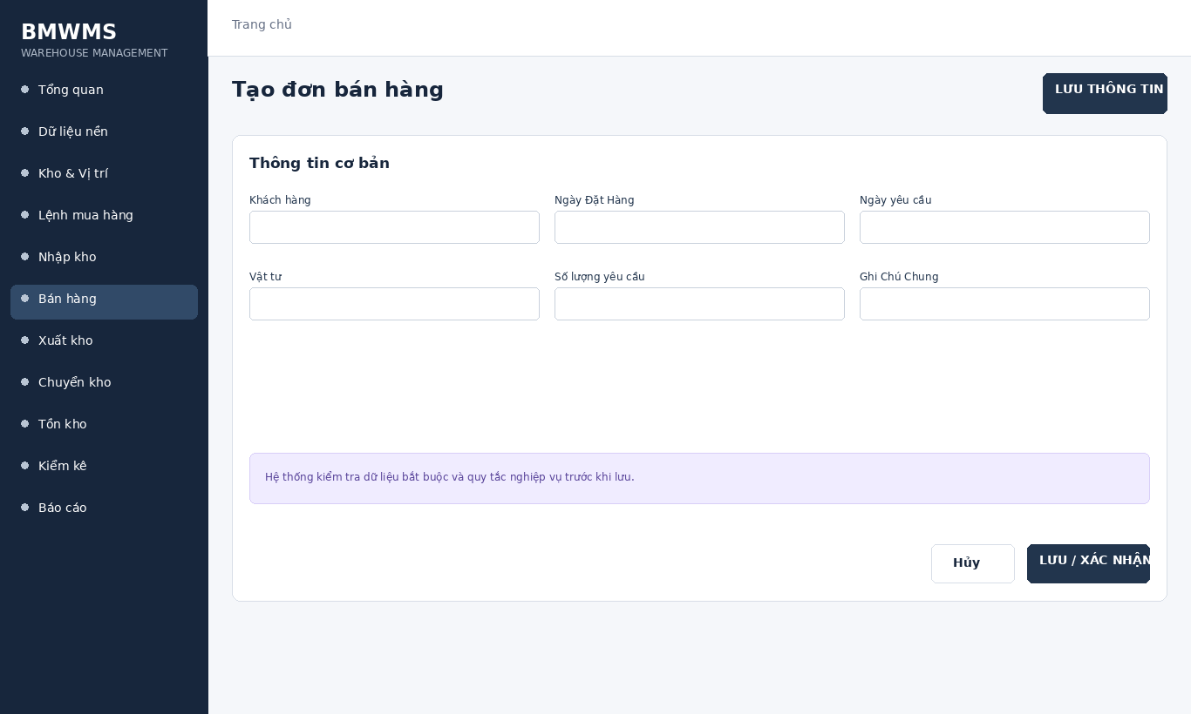
Figure UC-044: Wireframe for Create Sales Order. Source: BMWMS.Web/Pages/SalerOrder/Create.cshtml

Field Description
Field Name | Field Type | Description
Khách hàng | Dropdown | Customer selector; required.
Ngày Đặt Hàng | Date picker | Date input; required.
Ngày yêu cầu | Date picker | Date input; must not be earlier than Order date.
Vật tư | Dropdown | Product selector; required for each line.
Số lượng yêu cầu | Number input | Positive numeric input; required.
Ghi Chú Chung | Text area | Optional sales or delivery notes.

Use Case Specification
Use Case ID | UC-044 | Use Case Name | Create Sales Order
Primary Actors | Sales Staff | Secondary Actors | BMWMS API; SQL Server database
Description | As an authorized sales staff, I want to perform create sales order so that the related warehouse activity is completed and traceable.
Preconditions | The actor is authenticated and authorized. Required master data and source transaction exist and are active.
Postconditions | The create sales order result is saved or displayed successfully. Related statuses and inventory balances remain consistent.
Normal Sequence/Flow | 1. Actor opens the relevant list or detail screen.  2. System displays the current data and actions permitted for the actor.  3. Actor selects Create.  4. System displays the required input fields or confirmation.  5. Actor enters/reviews the information and confirms.  6. System validates mandatory fields, quantities, authorization and current status.  7. System saves the transaction, updates the status and displays the result.
Alternative Sequences/Flows | A1. Actor cancels before confirmation; system returns to the previous screen without saving.  A2. Actor corrects invalid data and resubmits; system continues from the validation step.
Exception Flows | E1. Required or formatted data is invalid: system shows field-level validation and does not save.  E2. Actor is not authorized: system denies the operation.  E3. Record status changed or is not eligible: system reloads the latest data and disables the action.  E4. API/database/email service is unavailable: system shows an error and keeps the previous consistent state.
Business Rules | Requested quantity must be positive. A product cannot appear twice in the same order.

UC-045 View Sales Order list
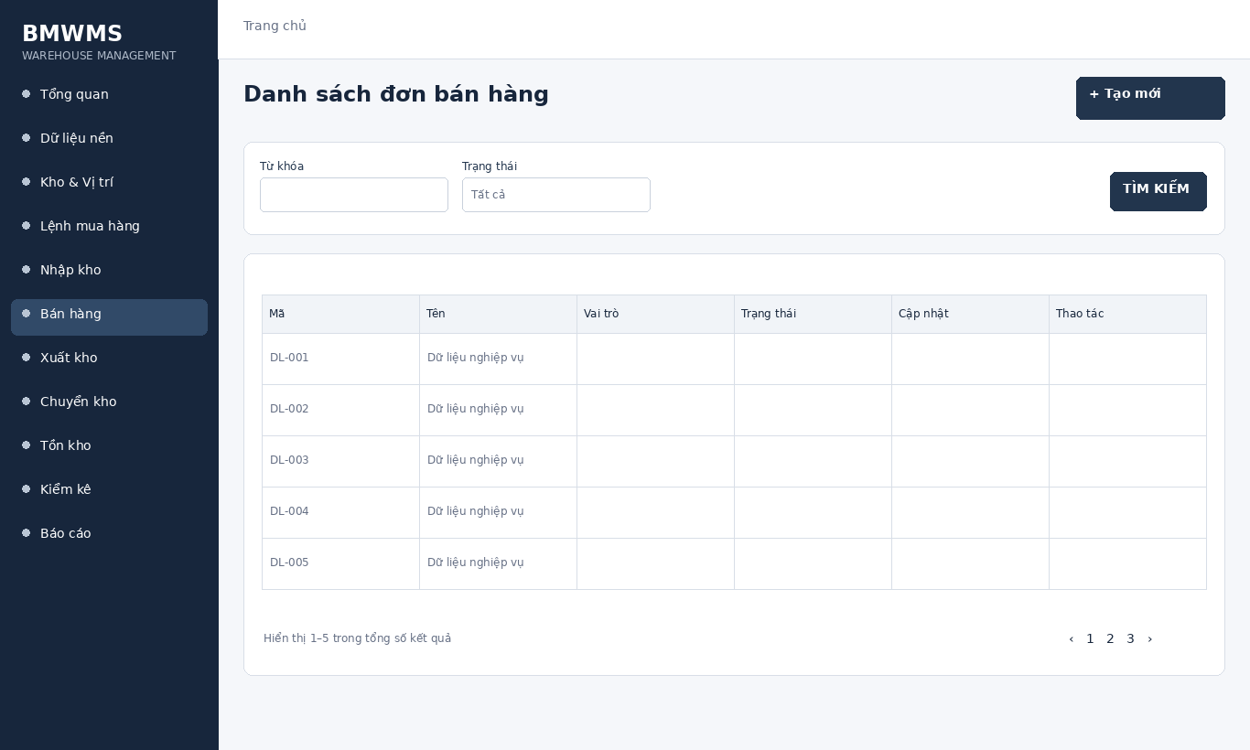
Figure UC-045: Wireframe for View Sales Order list. Source: BMWMS.Web/Pages/SalerOrder/Index.cshtml

Field Description
Field Name | Field Type | Description
Từ khóa | Text box | Text box. Search by sales order number or customer; optional.
Trạng thái | Dropdown | Dropdown used to filter sales orders by current status; default All.

Use Case Specification
Use Case ID | UC-045 | Use Case Name | View Sales Order list
Primary Actors | Sales Staff | Secondary Actors | BMWMS API; SQL Server database
Description | As an authorized sales staff, I want to perform view sales order list so that the related warehouse activity is completed and traceable.
Preconditions | The actor is authenticated and authorized. Required master data and source transaction exist and are active.
Postconditions | The view sales order list result is saved or displayed successfully. Related statuses and inventory balances remain consistent.
Normal Sequence/Flow | 1. Actor opens the View Sales Order list screen.  2. System displays the available filters and current records.  3. Actor enters optional filter criteria.  4. Actor selects Filter/Search/View.  5. System validates the criteria and returns matching data.  6. Actor reviews the result or opens a record for more detail.
Alternative Sequences/Flows | A1. Actor leaves all filters blank; system displays the default paged result.  A2. No record matches; system displays an empty list without changing data.
Exception Flows | E1. Required or formatted data is invalid: system shows field-level validation and does not save.  E2. Actor is not authorized: system denies the operation.  E3. Record status changed or is not eligible: system reloads the latest data and disables the action.  E4. API/database/email service is unavailable: system shows an error and keeps the previous consistent state.
Business Rules | Requested quantity must be positive. A product cannot appear twice in the same order.

UC-046 View Sales Order details
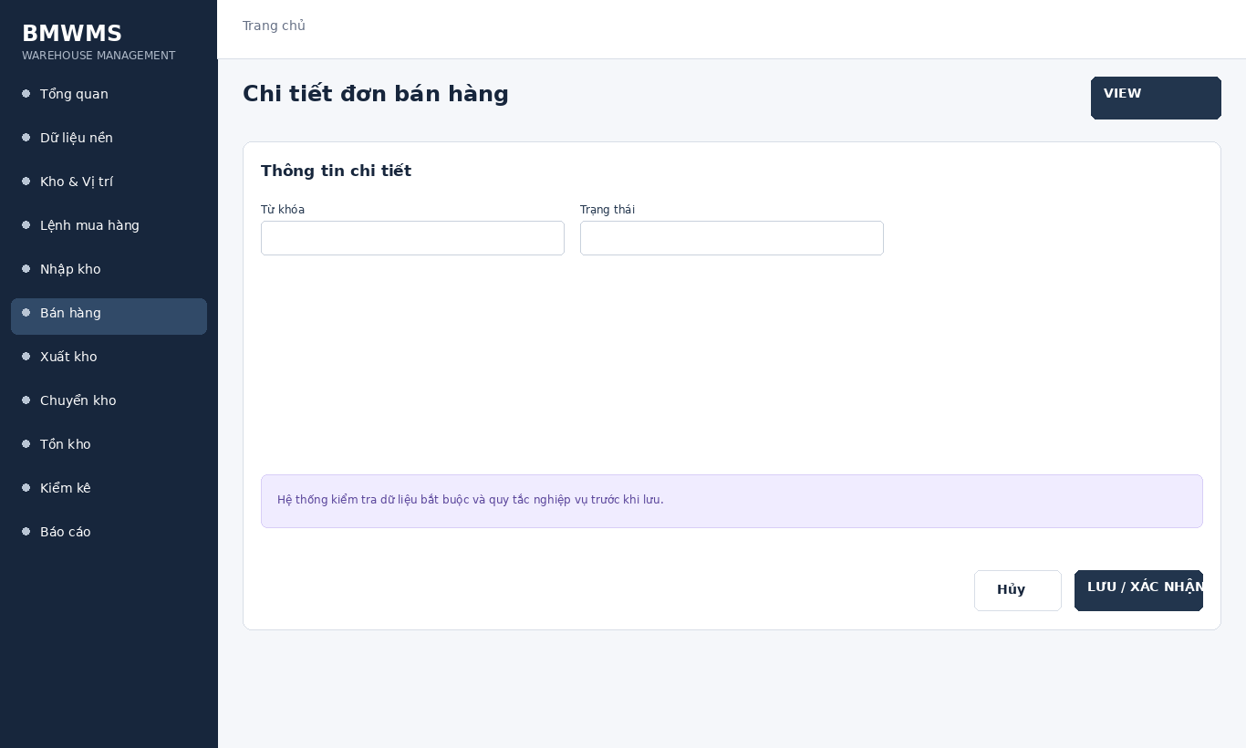
Figure UC-046: Wireframe for View Sales Order details. Source: BMWMS.Web/Pages/SalerOrder/Details.cshtml

Field Description
Field Name | Field Type | Description
Từ khóa | Text box | Text box. Search by sales order number or customer; optional.
Trạng thái | Dropdown | Dropdown used to filter sales orders by current status; default All.

Use Case Specification
Use Case ID | UC-046 | Use Case Name | View Sales Order details
Primary Actors | Sales Staff | Secondary Actors | BMWMS API; SQL Server database
Description | As an authorized sales staff, I want to perform view sales order details so that the related warehouse activity is completed and traceable.
Preconditions | The actor is authenticated and authorized. Required master data and source transaction exist and are active.
Postconditions | The view sales order details result is saved or displayed successfully. Related statuses and inventory balances remain consistent.
Normal Sequence/Flow | 1. Actor opens the View Sales Order details screen.  2. System displays the available filters and current records.  3. Actor enters optional filter criteria.  4. Actor selects Filter/Search/View.  5. System validates the criteria and returns matching data.  6. Actor reviews the result or opens a record for more detail.
Alternative Sequences/Flows | A1. Actor leaves all filters blank; system displays the default paged result.  A2. No record matches; system displays an empty list without changing data.
Exception Flows | E1. Required or formatted data is invalid: system shows field-level validation and does not save.  E2. Actor is not authorized: system denies the operation.  E3. Record status changed or is not eligible: system reloads the latest data and disables the action.  E4. API/database/email service is unavailable: system shows an error and keeps the previous consistent state.
Business Rules | Requested quantity must be positive. A product cannot appear twice in the same order.

2.8 Outbound

UC-047 Create outbound order
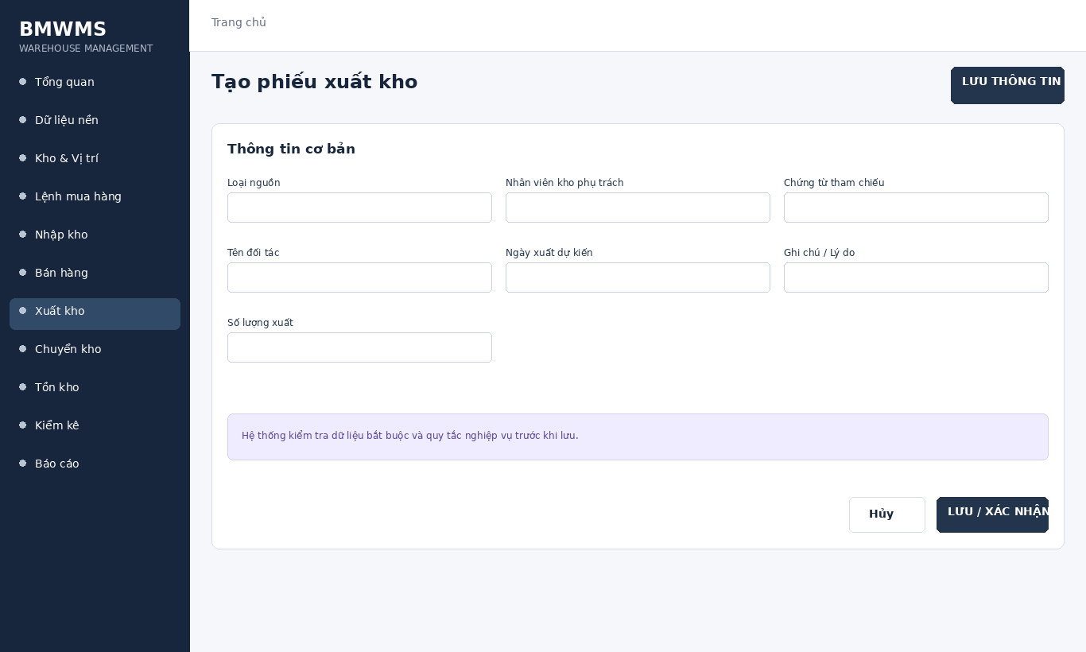
Figure UC-047: Wireframe for Create outbound order. Source: BMWMS.Web/Pages/OutboundOrders/Create.cshtml

Field Description
Field Name | Field Type | Description
Loại nguồn | Read-only field | Read-only value indicating supplier return or sales issue.
Nhân viên kho phụ trách | Dropdown | Dropdown of warehouse employees; required.
Chứng từ tham chiếu | Dropdown | PO/SO selector; required.
Tên đối tác | Dropdown | Read-only value populated from the selected reference.
Ngày xuất dự kiến | Date picker | Date input; default current date.
Ghi chú / Lý do | Text area | Multiline text; required for supplier return.
Số lượng xuất | Dropdown | Numeric quantity for each selected inventory line; cannot exceed available quantity.

Use Case Specification
Use Case ID | UC-047 | Use Case Name | Create outbound order
Primary Actors | Warehouse Manager; Warehouse Staff; Sales Staff | Secondary Actors | BMWMS API; SQL Server database
Description | As an authorized warehouse manager, I want to perform create outbound order so that the related warehouse activity is completed and traceable.
Preconditions | The actor is authenticated and authorized. Required master data and source transaction exist and are active.
Postconditions | The create outbound order result is saved or displayed successfully. Related statuses and inventory balances remain consistent.
Normal Sequence/Flow | 1. Actor opens the relevant list or detail screen.  2. System displays the current data and actions permitted for the actor.  3. Actor selects Create.  4. System displays the required input fields or confirmation.  5. Actor enters/reviews the information and confirms.  6. System validates mandatory fields, quantities, authorization and current status.  7. System saves the transaction, updates the status and displays the result.
Alternative Sequences/Flows | A1. Actor cancels before confirmation; system returns to the previous screen without saving.  A2. Actor corrects invalid data and resubmits; system continues from the validation step.
Exception Flows | E1. Required or formatted data is invalid: system shows field-level validation and does not save.  E2. Actor is not authorized: system denies the operation.  E3. Record status changed or is not eligible: system reloads the latest data and disables the action.  E4. API/database/email service is unavailable: system shows an error and keeps the previous consistent state.
Business Rules | Issued quantity cannot exceed reserved/available stock. Picking follows the configured FIFO/FEFO rule. Completion updates inventory.

UC-048 View outbound order list
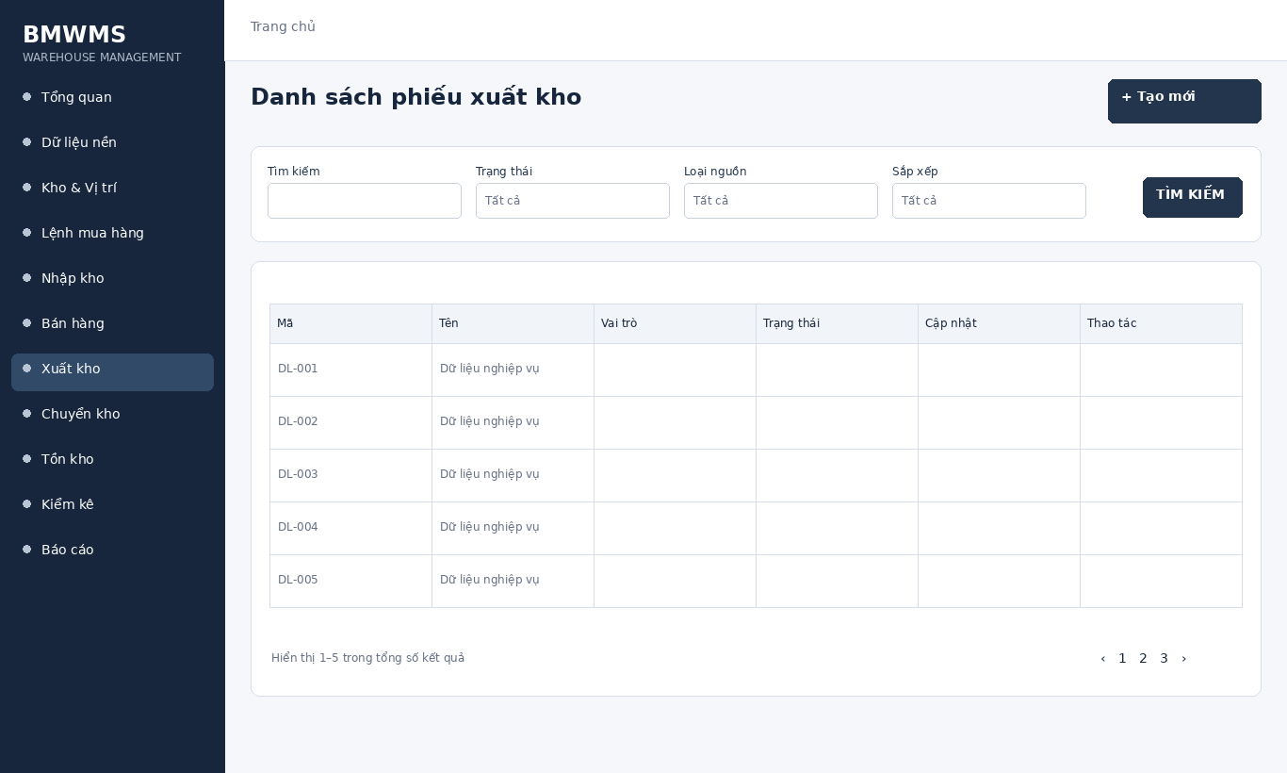
Figure UC-048: Wireframe for View outbound order list. Source: BMWMS.Web/Pages/OutboundOrders/Index.cshtml

Field Description
Field Name | Field Type | Description
Tìm kiếm | Text box | Text box. Search by outbound number, SO or PO; optional.
Trạng thái | Dropdown | Dropdown: All, Ready to issue, In progress, Pending batch approval, Issued, Cancelled.
Loại nguồn | Dropdown | Dropdown: All, PO, SO.
Sắp xếp | Dropdown | Dropdown: Newest or Oldest; default Newest.

Use Case Specification
Use Case ID | UC-048 | Use Case Name | View outbound order list
Primary Actors | Warehouse Manager; Warehouse Staff; Sales Staff | Secondary Actors | BMWMS API; SQL Server database
Description | As an authorized warehouse manager, I want to perform view outbound order list so that the related warehouse activity is completed and traceable.
Preconditions | The actor is authenticated and authorized. Required master data and source transaction exist and are active.
Postconditions | The view outbound order list result is saved or displayed successfully. Related statuses and inventory balances remain consistent.
Normal Sequence/Flow | 1. Actor opens the View outbound order list screen.  2. System displays the available filters and current records.  3. Actor enters optional filter criteria.  4. Actor selects Filter/Search/View.  5. System validates the criteria and returns matching data.  6. Actor reviews the result or opens a record for more detail.
Alternative Sequences/Flows | A1. Actor leaves all filters blank; system displays the default paged result.  A2. No record matches; system displays an empty list without changing data.
Exception Flows | E1. Required or formatted data is invalid: system shows field-level validation and does not save.  E2. Actor is not authorized: system denies the operation.  E3. Record status changed or is not eligible: system reloads the latest data and disables the action.  E4. API/database/email service is unavailable: system shows an error and keeps the previous consistent state.
Business Rules | Issued quantity cannot exceed reserved/available stock. Picking follows the configured FIFO/FEFO rule. Completion updates inventory.

UC-049 View outbound order details
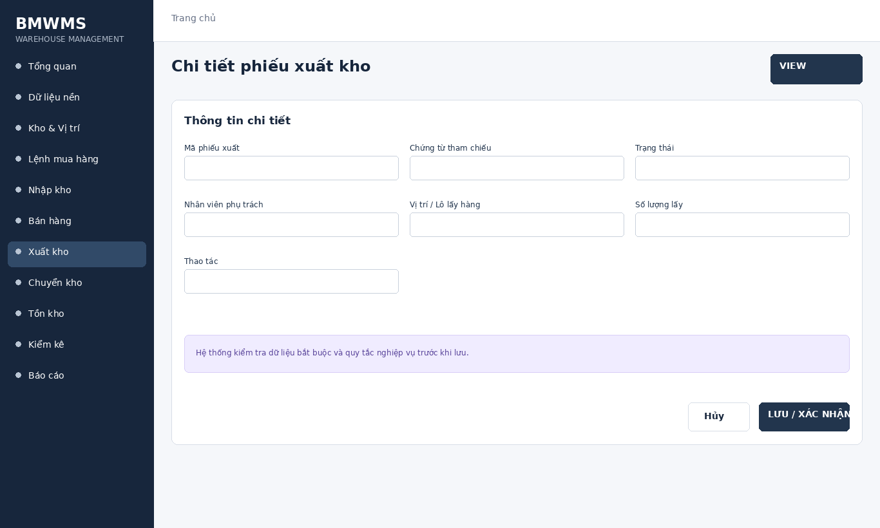
Figure UC-049: Wireframe for View outbound order details. Source: BMWMS.Web/Pages/OutboundOrders/Details.cshtml

Field Description
Field Name | Field Type | Description
Mã phiếu xuất | Read-only field | Read-only system-generated number.
Chứng từ tham chiếu | Read-only field | Read-only PO/SO reference.
Trạng thái | Read-only field | Read-only current outbound status.
Nhân viên phụ trách | Display field | Warehouse staff responsible for processing.
Vị trí / Lô lấy hàng | Display field | System proposal based on available inventory and rotation rule.
Số lượng lấy | Number input | Numeric input; cannot exceed reserved/available quantity.
Thao tác | Display field | Approve, Start, Pick, Complete, Cancel or Close remainder according to status.

Use Case Specification
Use Case ID | UC-049 | Use Case Name | View outbound order details
Primary Actors | Warehouse Manager; Warehouse Staff; Sales Staff | Secondary Actors | BMWMS API; SQL Server database
Description | As an authorized warehouse manager, I want to perform view outbound order details so that the related warehouse activity is completed and traceable.
Preconditions | The actor is authenticated and authorized. Required master data and source transaction exist and are active.
Postconditions | The view outbound order details result is saved or displayed successfully. Related statuses and inventory balances remain consistent.
Normal Sequence/Flow | 1. Actor opens the View outbound order details screen.  2. System displays the available filters and current records.  3. Actor enters optional filter criteria.  4. Actor selects Filter/Search/View.  5. System validates the criteria and returns matching data.  6. Actor reviews the result or opens a record for more detail.
Alternative Sequences/Flows | A1. Actor leaves all filters blank; system displays the default paged result.  A2. No record matches; system displays an empty list without changing data.
Exception Flows | E1. Required or formatted data is invalid: system shows field-level validation and does not save.  E2. Actor is not authorized: system denies the operation.  E3. Record status changed or is not eligible: system reloads the latest data and disables the action.  E4. API/database/email service is unavailable: system shows an error and keeps the previous consistent state.
Business Rules | Issued quantity cannot exceed reserved/available stock. Picking follows the configured FIFO/FEFO rule. Completion updates inventory.

UC-050 Edit outbound order
Figure UC-050: Wireframe for Edit outbound order. Source: BMWMS.Web/Pages/OutboundOrders/Create.cshtml

Field Description
Field Name | Field Type | Description
Loại nguồn | Read-only field | Read-only value indicating supplier return or sales issue.
Nhân viên kho phụ trách | Dropdown | Dropdown of warehouse employees; required.
Chứng từ tham chiếu | Dropdown | PO/SO selector; required.
Tên đối tác | Dropdown | Read-only value populated from the selected reference.
Ngày xuất dự kiến | Date picker | Date input; default current date.
Ghi chú / Lý do | Text area | Multiline text; required for supplier return.
Số lượng xuất | Dropdown | Numeric quantity for each selected inventory line; cannot exceed available quantity.

Use Case Specification
Use Case ID | UC-050 | Use Case Name | Edit outbound order
Primary Actors | Warehouse Manager; Warehouse Staff; Sales Staff | Secondary Actors | BMWMS API; SQL Server database
Description | As an authorized warehouse manager, I want to perform edit outbound order so that the related warehouse activity is completed and traceable.
Preconditions | The actor is authenticated and authorized. Required master data and source transaction exist and are active.
Postconditions | The edit outbound order result is saved or displayed successfully. Related statuses and inventory balances remain consistent.
Normal Sequence/Flow | 1. Actor opens the relevant list or detail screen.  2. System displays the current data and actions permitted for the actor.  3. Actor selects Edit.  4. System displays the required input fields or confirmation.  5. Actor enters/reviews the information and confirms.  6. System validates mandatory fields, quantities, authorization and current status.  7. System saves the transaction, updates the status and displays the result.
Alternative Sequences/Flows | A1. Actor cancels before confirmation; system returns to the previous screen without saving.  A2. Actor corrects invalid data and resubmits; system continues from the validation step.
Exception Flows | E1. Required or formatted data is invalid: system shows field-level validation and does not save.  E2. Actor is not authorized: system denies the operation.  E3. Record status changed or is not eligible: system reloads the latest data and disables the action.  E4. API/database/email service is unavailable: system shows an error and keeps the previous consistent state.
Business Rules | Issued quantity cannot exceed reserved/available stock. Picking follows the configured FIFO/FEFO rule. Completion updates inventory.

UC-051 Approve outbound order
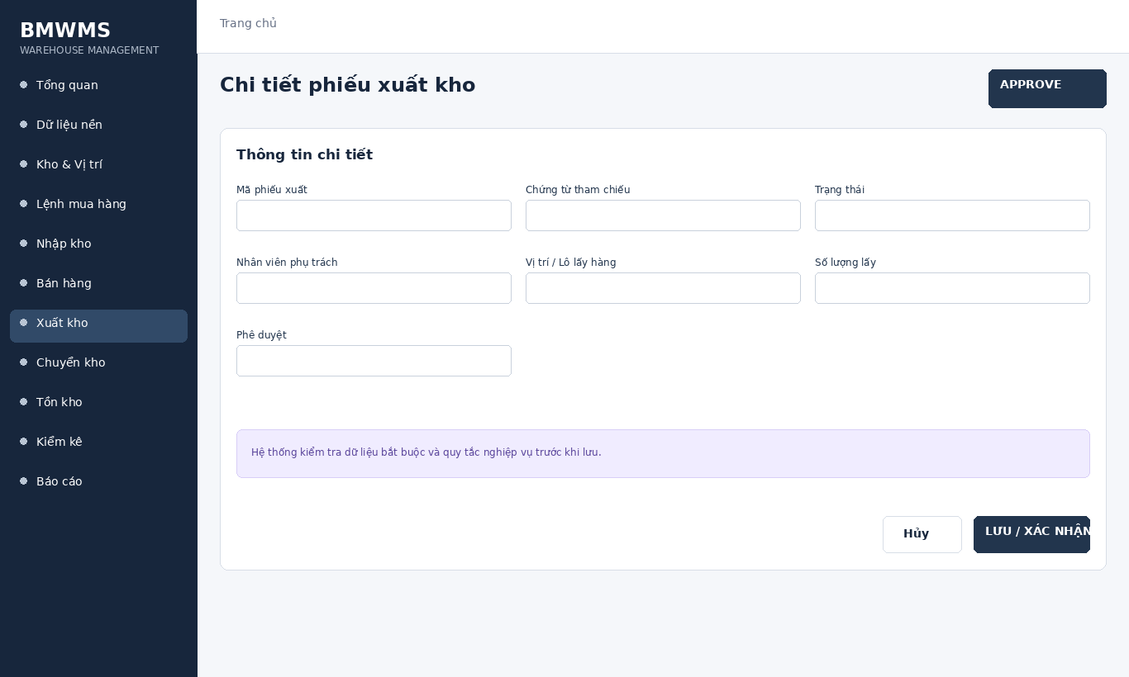
Figure UC-051: Wireframe for Approve outbound order. Source: BMWMS.Web/Pages/OutboundOrders/Details.cshtml

Field Description
Field Name | Field Type | Description
Mã phiếu xuất | Read-only field | Read-only system-generated number.
Chứng từ tham chiếu | Read-only field | Read-only PO/SO reference.
Trạng thái | Read-only field | Read-only current outbound status.
Nhân viên phụ trách | Display field | Warehouse staff responsible for processing.
Vị trí / Lô lấy hàng | Display field | System proposal based on available inventory and rotation rule.
Số lượng lấy | Number input | Numeric input; cannot exceed reserved/available quantity.
Phê duyệt | Display field | Approve, Start, Pick, Complete, Cancel or Close remainder according to status.

Use Case Specification
Use Case ID | UC-051 | Use Case Name | Approve outbound order
Primary Actors | Warehouse Manager; Warehouse Staff; Sales Staff | Secondary Actors | BMWMS API; SQL Server database
Description | As an authorized warehouse manager, I want to perform approve outbound order so that the related warehouse activity is completed and traceable.
Preconditions | The actor is authenticated and authorized. Required master data and source transaction exist and are active.
Postconditions | The approve outbound order result is saved or displayed successfully. Related statuses and inventory balances remain consistent.
Normal Sequence/Flow | 1. Actor opens the relevant list or detail screen.  2. System displays the current data and actions permitted for the actor.  3. Actor selects Approve.  4. System displays the required input fields or confirmation.  5. Actor enters/reviews the information and confirms.  6. System validates mandatory fields, quantities, authorization and current status.  7. System saves the transaction, updates the status and displays the result.
Alternative Sequences/Flows | A1. Actor cancels before confirmation; system returns to the previous screen without saving.  A2. Actor corrects invalid data and resubmits; system continues from the validation step.
Exception Flows | E1. Required or formatted data is invalid: system shows field-level validation and does not save.  E2. Actor is not authorized: system denies the operation.  E3. Record status changed or is not eligible: system reloads the latest data and disables the action.  E4. API/database/email service is unavailable: system shows an error and keeps the previous consistent state.
Business Rules | Issued quantity cannot exceed reserved/available stock. Picking follows the configured FIFO/FEFO rule. Completion updates inventory.

UC-052 Start outbound processing
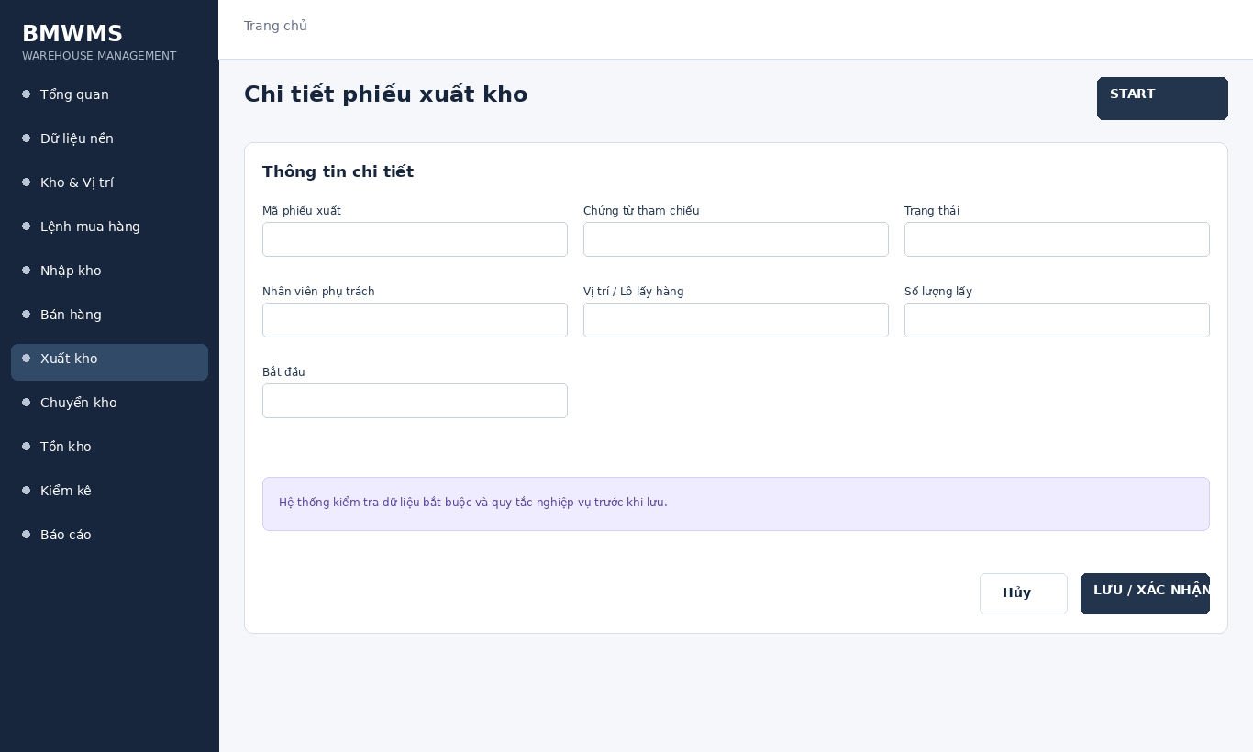
Figure UC-052: Wireframe for Start outbound processing. Source: BMWMS.Web/Pages/OutboundOrders/Details.cshtml

Field Description
Field Name | Field Type | Description
Mã phiếu xuất | Read-only field | Read-only system-generated number.
Chứng từ tham chiếu | Read-only field | Read-only PO/SO reference.
Trạng thái | Read-only field | Read-only current outbound status.
Nhân viên phụ trách | Display field | Warehouse staff responsible for processing.
Vị trí / Lô lấy hàng | Display field | System proposal based on available inventory and rotation rule.
Số lượng lấy | Number input | Numeric input; cannot exceed reserved/available quantity.
Bắt đầu | Display field | Approve, Start, Pick, Complete, Cancel or Close remainder according to status.

Use Case Specification
Use Case ID | UC-052 | Use Case Name | Start outbound processing
Primary Actors | Warehouse Manager; Warehouse Staff; Sales Staff | Secondary Actors | BMWMS API; SQL Server database
Description | As an authorized warehouse manager, I want to perform start outbound processing so that the related warehouse activity is completed and traceable.
Preconditions | The actor is authenticated and authorized. Required master data and source transaction exist and are active.
Postconditions | The start outbound processing result is saved or displayed successfully. Related statuses and inventory balances remain consistent.
Normal Sequence/Flow | 1. Actor opens the relevant list or detail screen.  2. System displays the current data and actions permitted for the actor.  3. Actor selects Start.  4. System displays the required input fields or confirmation.  5. Actor enters/reviews the information and confirms.  6. System validates mandatory fields, quantities, authorization and current status.  7. System saves the transaction, updates the status and displays the result.
Alternative Sequences/Flows | A1. Actor cancels before confirmation; system returns to the previous screen without saving.  A2. Actor corrects invalid data and resubmits; system continues from the validation step.
Exception Flows | E1. Required or formatted data is invalid: system shows field-level validation and does not save.  E2. Actor is not authorized: system denies the operation.  E3. Record status changed or is not eligible: system reloads the latest data and disables the action.  E4. API/database/email service is unavailable: system shows an error and keeps the previous consistent state.
Business Rules | Issued quantity cannot exceed reserved/available stock. Picking follows the configured FIFO/FEFO rule. Completion updates inventory.

UC-053 Pick goods
Figure UC-053: Wireframe for Pick goods. Source: BMWMS.Web/Pages/OutboundOrders/Index.cshtml

Field Description
Field Name | Field Type | Description
Tìm kiếm | Text box | Text box. Search by outbound number, SO or PO; optional.
Trạng thái | Dropdown | Dropdown: All, Ready to issue, In progress, Pending batch approval, Issued, Cancelled.
Loại nguồn | Dropdown | Dropdown: All, PO, SO.
Sắp xếp | Dropdown | Dropdown: Newest or Oldest; default Newest.

Use Case Specification
Use Case ID | UC-053 | Use Case Name | Pick goods
Primary Actors | Warehouse Manager; Warehouse Staff; Sales Staff | Secondary Actors | BMWMS API; SQL Server database
Description | As an authorized warehouse manager, I want to perform pick goods so that the related warehouse activity is completed and traceable.
Preconditions | The actor is authenticated and authorized. Required master data and source transaction exist and are active.
Postconditions | The pick goods result is saved or displayed successfully. Related statuses and inventory balances remain consistent.
Normal Sequence/Flow | 1. Actor opens the relevant list or detail screen.  2. System displays the current data and actions permitted for the actor.  3. Actor selects Pick.  4. System displays the required input fields or confirmation.  5. Actor enters/reviews the information and confirms.  6. System validates mandatory fields, quantities, authorization and current status.  7. System saves the transaction, updates the status and displays the result.
Alternative Sequences/Flows | A1. Actor cancels before confirmation; system returns to the previous screen without saving.  A2. Actor corrects invalid data and resubmits; system continues from the validation step.
Exception Flows | E1. Required or formatted data is invalid: system shows field-level validation and does not save.  E2. Actor is not authorized: system denies the operation.  E3. Record status changed or is not eligible: system reloads the latest data and disables the action.  E4. API/database/email service is unavailable: system shows an error and keeps the previous consistent state.
Business Rules | Issued quantity cannot exceed reserved/available stock. Picking follows the configured FIFO/FEFO rule. Completion updates inventory.

UC-054 Complete outbound order
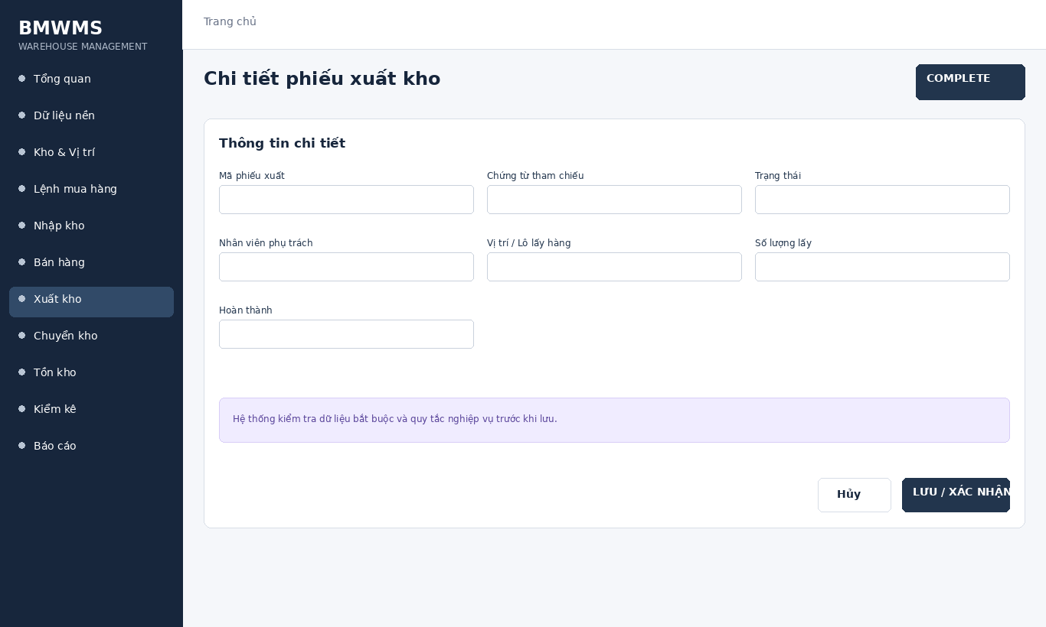
Figure UC-054: Wireframe for Complete outbound order. Source: BMWMS.Web/Pages/OutboundOrders/Details.cshtml

Field Description
Field Name | Field Type | Description
Mã phiếu xuất | Read-only field | Read-only system-generated number.
Chứng từ tham chiếu | Read-only field | Read-only PO/SO reference.
Trạng thái | Read-only field | Read-only current outbound status.
Nhân viên phụ trách | Display field | Warehouse staff responsible for processing.
Vị trí / Lô lấy hàng | Display field | System proposal based on available inventory and rotation rule.
Số lượng lấy | Number input | Numeric input; cannot exceed reserved/available quantity.
Hoàn thành | Display field | Approve, Start, Pick, Complete, Cancel or Close remainder according to status.

Use Case Specification
Use Case ID | UC-054 | Use Case Name | Complete outbound order
Primary Actors | Warehouse Manager; Warehouse Staff; Sales Staff | Secondary Actors | BMWMS API; SQL Server database
Description | As an authorized warehouse manager, I want to perform complete outbound order so that the related warehouse activity is completed and traceable.
Preconditions | The actor is authenticated and authorized. Required master data and source transaction exist and are active.
Postconditions | The complete outbound order result is saved or displayed successfully. Related statuses and inventory balances remain consistent.
Normal Sequence/Flow | 1. Actor opens the relevant list or detail screen.  2. System displays the current data and actions permitted for the actor.  3. Actor selects Complete.  4. System displays the required input fields or confirmation.  5. Actor enters/reviews the information and confirms.  6. System validates mandatory fields, quantities, authorization and current status.  7. System saves the transaction, updates the status and displays the result.
Alternative Sequences/Flows | A1. Actor cancels before confirmation; system returns to the previous screen without saving.  A2. Actor corrects invalid data and resubmits; system continues from the validation step.
Exception Flows | E1. Required or formatted data is invalid: system shows field-level validation and does not save.  E2. Actor is not authorized: system denies the operation.  E3. Record status changed or is not eligible: system reloads the latest data and disables the action.  E4. API/database/email service is unavailable: system shows an error and keeps the previous consistent state.
Business Rules | Issued quantity cannot exceed reserved/available stock. Picking follows the configured FIFO/FEFO rule. Completion updates inventory.

UC-055 Cancel outbound order
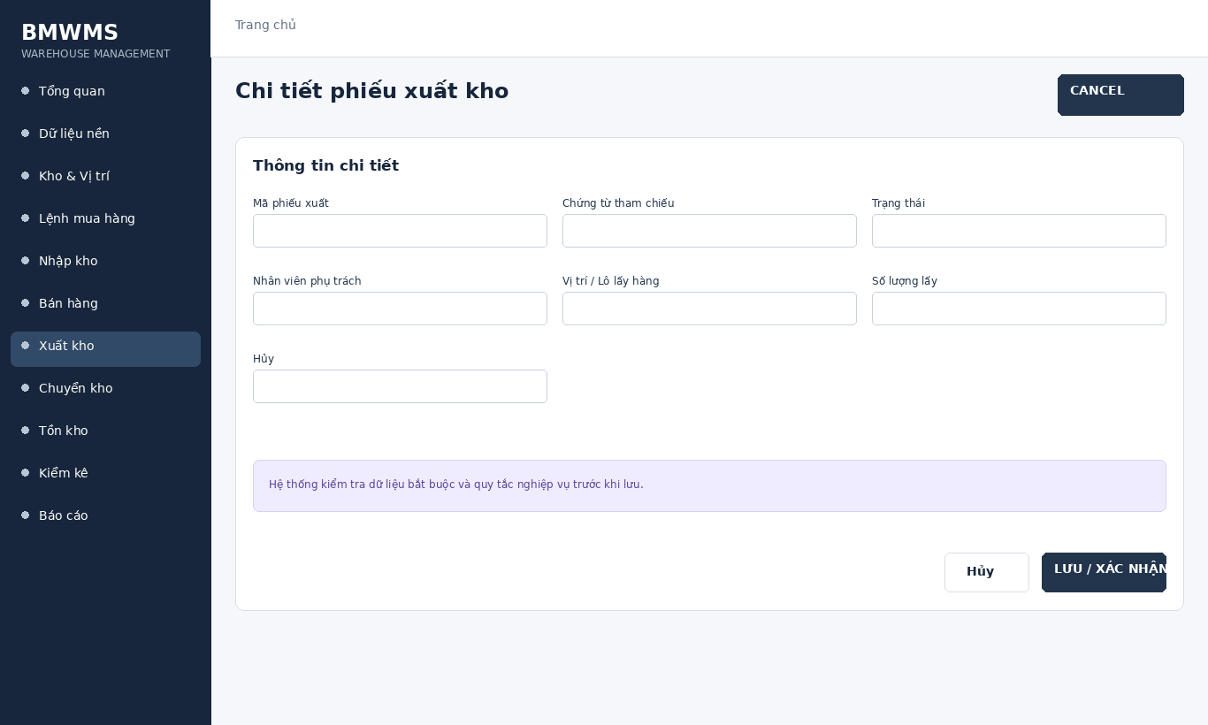
Figure UC-055: Wireframe for Cancel outbound order. Source: BMWMS.Web/Pages/OutboundOrders/Details.cshtml

Field Description
Field Name | Field Type | Description
Mã phiếu xuất | Read-only field | Read-only system-generated number.
Chứng từ tham chiếu | Read-only field | Read-only PO/SO reference.
Trạng thái | Read-only field | Read-only current outbound status.
Nhân viên phụ trách | Display field | Warehouse staff responsible for processing.
Vị trí / Lô lấy hàng | Display field | System proposal based on available inventory and rotation rule.
Số lượng lấy | Number input | Numeric input; cannot exceed reserved/available quantity.
Hủy | Display field | Approve, Start, Pick, Complete, Cancel or Close remainder according to status.

Use Case Specification
Use Case ID | UC-055 | Use Case Name | Cancel outbound order
Primary Actors | Warehouse Manager; Warehouse Staff; Sales Staff | Secondary Actors | BMWMS API; SQL Server database
Description | As an authorized warehouse manager, I want to perform cancel outbound order so that the related warehouse activity is completed and traceable.
Preconditions | The actor is authenticated and authorized. Required master data and source transaction exist and are active.
Postconditions | The cancel outbound order result is saved or displayed successfully. Related statuses and inventory balances remain consistent.
Normal Sequence/Flow | 1. Actor opens the relevant list or detail screen.  2. System displays the current data and actions permitted for the actor.  3. Actor selects Cancel.  4. System displays the required input fields or confirmation.  5. Actor enters/reviews the information and confirms.  6. System validates mandatory fields, quantities, authorization and current status.  7. System saves the transaction, updates the status and displays the result.
Alternative Sequences/Flows | A1. Actor cancels before confirmation; system returns to the previous screen without saving.  A2. Actor corrects invalid data and resubmits; system continues from the validation step.
Exception Flows | E1. Required or formatted data is invalid: system shows field-level validation and does not save.  E2. Actor is not authorized: system denies the operation.  E3. Record status changed or is not eligible: system reloads the latest data and disables the action.  E4. API/database/email service is unavailable: system shows an error and keeps the previous consistent state.
Business Rules | Issued quantity cannot exceed reserved/available stock. Picking follows the configured FIFO/FEFO rule. Completion updates inventory.

UC-056 Close sales remainder
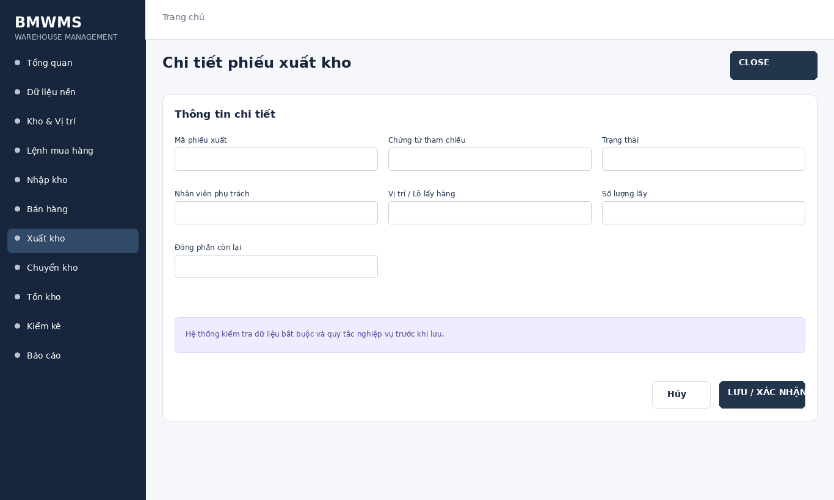
Figure UC-056: Wireframe for Close sales remainder. Source: BMWMS.Web/Pages/OutboundOrders/Details.cshtml

Field Description
Field Name | Field Type | Description
Mã phiếu xuất | Read-only field | Read-only system-generated number.
Chứng từ tham chiếu | Read-only field | Read-only PO/SO reference.
Trạng thái | Read-only field | Read-only current outbound status.
Nhân viên phụ trách | Display field | Warehouse staff responsible for processing.
Vị trí / Lô lấy hàng | Display field | System proposal based on available inventory and rotation rule.
Số lượng lấy | Number input | Numeric input; cannot exceed reserved/available quantity.
Đóng phần còn lại | Display field | Approve, Start, Pick, Complete, Cancel or Close remainder according to status.

Use Case Specification
Use Case ID | UC-056 | Use Case Name | Close sales remainder
Primary Actors | Warehouse Manager; Warehouse Staff; Sales Staff | Secondary Actors | BMWMS API; SQL Server database
Description | As an authorized warehouse manager, I want to perform close sales remainder so that the related warehouse activity is completed and traceable.
Preconditions | The actor is authenticated and authorized. Required master data and source transaction exist and are active.
Postconditions | The close sales remainder result is saved or displayed successfully. Related statuses and inventory balances remain consistent.
Normal Sequence/Flow | 1. Actor opens the relevant list or detail screen.  2. System displays the current data and actions permitted for the actor.  3. Actor selects Close.  4. System displays the required input fields or confirmation.  5. Actor enters/reviews the information and confirms.  6. System validates mandatory fields, quantities, authorization and current status.  7. System saves the transaction, updates the status and displays the result.
Alternative Sequences/Flows | A1. Actor cancels before confirmation; system returns to the previous screen without saving.  A2. Actor corrects invalid data and resubmits; system continues from the validation step.
Exception Flows | E1. Required or formatted data is invalid: system shows field-level validation and does not save.  E2. Actor is not authorized: system denies the operation.  E3. Record status changed or is not eligible: system reloads the latest data and disables the action.  E4. API/database/email service is unavailable: system shows an error and keeps the previous consistent state.
Business Rules | Issued quantity cannot exceed reserved/available stock. Picking follows the configured FIFO/FEFO rule. Completion updates inventory.

2.9 Transfer Order

UC-057 Create transfer order
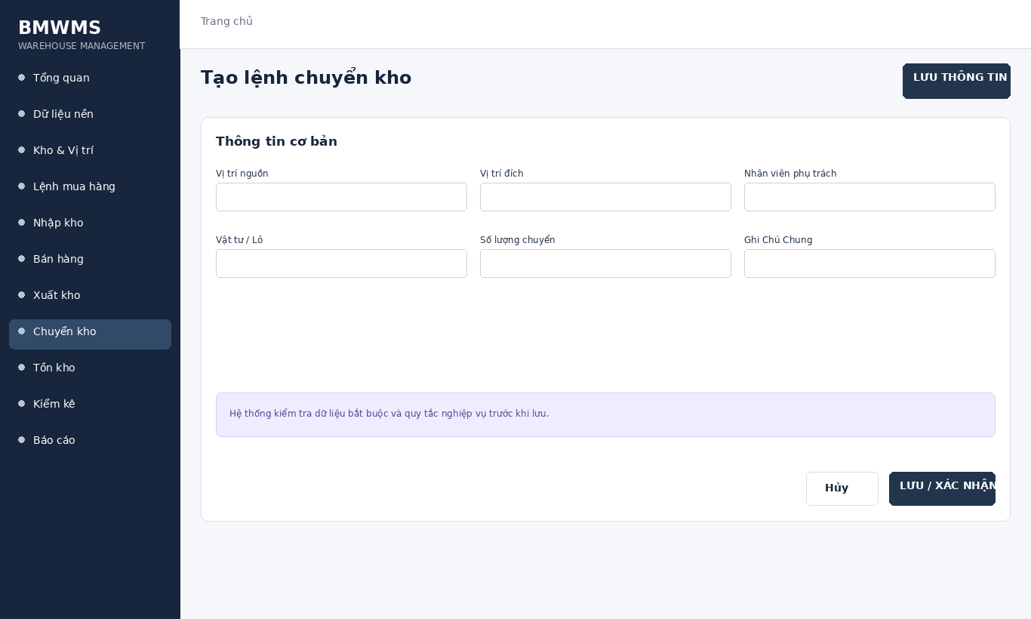
Figure UC-057: Wireframe for Create transfer order. Source: BMWMS.Web/Pages/Transfer/Create.cshtml

Field Description
Field Name | Field Type | Description
Vị trí nguồn | Display field | Storage location from which stock is moved; required.
Vị trí đích | Display field | Storage location receiving stock; required and different from source.
Nhân viên phụ trách | Display field | Warehouse staff responsible for execution.
Vật tư / Lô | Dropdown | Inventory item selected from the source location.
Số lượng chuyển | Number input | Positive numeric input; cannot exceed available stock.
Ghi Chú Chung | Text area | Optional transfer instructions.

Use Case Specification
Use Case ID | UC-057 | Use Case Name | Create transfer order
Primary Actors | Warehouse Manager; Warehouse Staff | Secondary Actors | BMWMS API; SQL Server database
Description | As an authorized warehouse manager, I want to perform create transfer order so that the related warehouse activity is completed and traceable.
Preconditions | The actor is authenticated and authorized. Required master data and source transaction exist and are active.
Postconditions | The create transfer order result is saved or displayed successfully. Related statuses and inventory balances remain consistent.
Normal Sequence/Flow | 1. Actor opens the relevant list or detail screen.  2. System displays the current data and actions permitted for the actor.  3. Actor selects Create.  4. System displays the required input fields or confirmation.  5. Actor enters/reviews the information and confirms.  6. System validates mandatory fields, quantities, authorization and current status.  7. System saves the transaction, updates the status and displays the result.
Alternative Sequences/Flows | A1. Actor cancels before confirmation; system returns to the previous screen without saving.  A2. Actor corrects invalid data and resubmits; system continues from the validation step.
Exception Flows | E1. Required or formatted data is invalid: system shows field-level validation and does not save.  E2. Actor is not authorized: system denies the operation.  E3. Record status changed or is not eligible: system reloads the latest data and disables the action.  E4. API/database/email service is unavailable: system shows an error and keeps the previous consistent state.
Business Rules | Source and destination must differ. Transfer quantity cannot exceed available inventory. Only approved transfers may be executed.

UC-058 View transfer order list
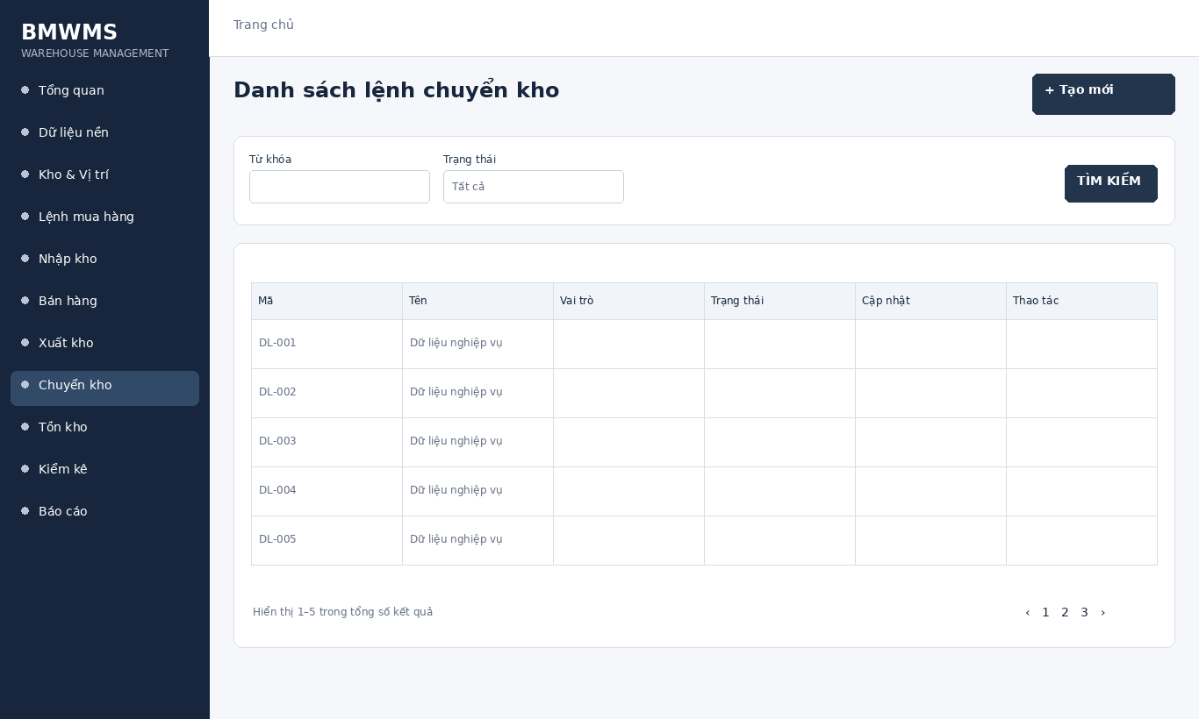
Figure UC-058: Wireframe for View transfer order list. Source: BMWMS.Web/Pages/Transfer/Index.cshtml

Field Description
Field Name | Field Type | Description
Từ khóa | Text box | Text box. Search by transfer number; optional.
Trạng thái | Dropdown | Dropdown: All, Draft, Approved, Assigned/read-only, Completed, Cancelled.

Use Case Specification
Use Case ID | UC-058 | Use Case Name | View transfer order list
Primary Actors | Warehouse Manager; Warehouse Staff | Secondary Actors | BMWMS API; SQL Server database
Description | As an authorized warehouse manager, I want to perform view transfer order list so that the related warehouse activity is completed and traceable.
Preconditions | The actor is authenticated and authorized. Required master data and source transaction exist and are active.
Postconditions | The view transfer order list result is saved or displayed successfully. Related statuses and inventory balances remain consistent.
Normal Sequence/Flow | 1. Actor opens the View transfer order list screen.  2. System displays the available filters and current records.  3. Actor enters optional filter criteria.  4. Actor selects Filter/Search/View.  5. System validates the criteria and returns matching data.  6. Actor reviews the result or opens a record for more detail.
Alternative Sequences/Flows | A1. Actor leaves all filters blank; system displays the default paged result.  A2. No record matches; system displays an empty list without changing data.
Exception Flows | E1. Required or formatted data is invalid: system shows field-level validation and does not save.  E2. Actor is not authorized: system denies the operation.  E3. Record status changed or is not eligible: system reloads the latest data and disables the action.  E4. API/database/email service is unavailable: system shows an error and keeps the previous consistent state.
Business Rules | Source and destination must differ. Transfer quantity cannot exceed available inventory. Only approved transfers may be executed.

UC-059 View transfer order details
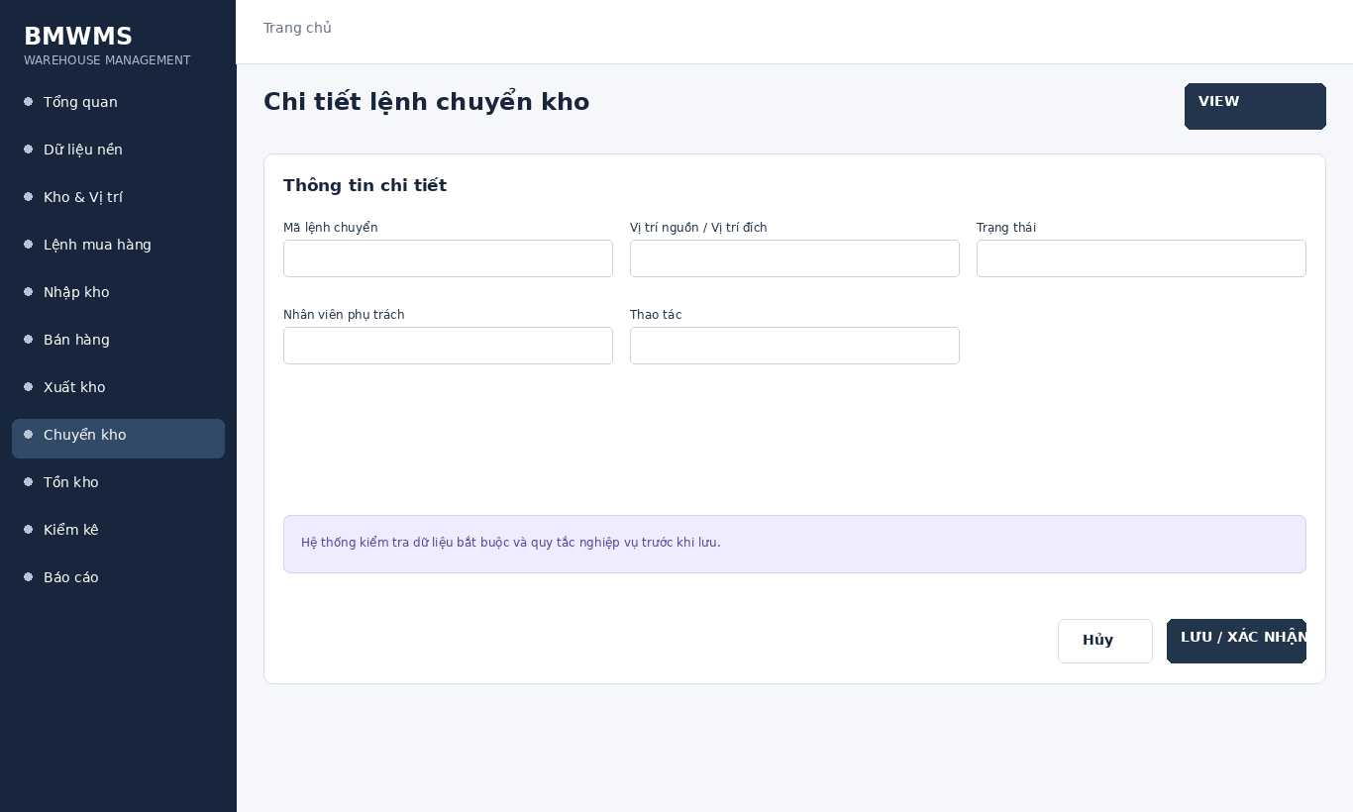
Figure UC-059: Wireframe for View transfer order details. Source: BMWMS.Web/Pages/Transfer/Details.cshtml

Field Description
Field Name | Field Type | Description
Mã lệnh chuyển | Read-only field | Read-only system-generated number.
Vị trí nguồn / Vị trí đích | Read-only field | Read-only locations involved in the transfer.
Trạng thái | Read-only field | Read-only current transfer status.
Nhân viên phụ trách | Display field | Warehouse employee responsible for the transfer.
Thao tác | Display field | Approve, Confirm execution or Complete according to status.

Use Case Specification
Use Case ID | UC-059 | Use Case Name | View transfer order details
Primary Actors | Warehouse Manager; Warehouse Staff | Secondary Actors | BMWMS API; SQL Server database
Description | As an authorized warehouse manager, I want to perform view transfer order details so that the related warehouse activity is completed and traceable.
Preconditions | The actor is authenticated and authorized. Required master data and source transaction exist and are active.
Postconditions | The view transfer order details result is saved or displayed successfully. Related statuses and inventory balances remain consistent.
Normal Sequence/Flow | 1. Actor opens the View transfer order details screen.  2. System displays the available filters and current records.  3. Actor enters optional filter criteria.  4. Actor selects Filter/Search/View.  5. System validates the criteria and returns matching data.  6. Actor reviews the result or opens a record for more detail.
Alternative Sequences/Flows | A1. Actor leaves all filters blank; system displays the default paged result.  A2. No record matches; system displays an empty list without changing data.
Exception Flows | E1. Required or formatted data is invalid: system shows field-level validation and does not save.  E2. Actor is not authorized: system denies the operation.  E3. Record status changed or is not eligible: system reloads the latest data and disables the action.  E4. API/database/email service is unavailable: system shows an error and keeps the previous consistent state.
Business Rules | Source and destination must differ. Transfer quantity cannot exceed available inventory. Only approved transfers may be executed.

UC-060 Approve transfer order
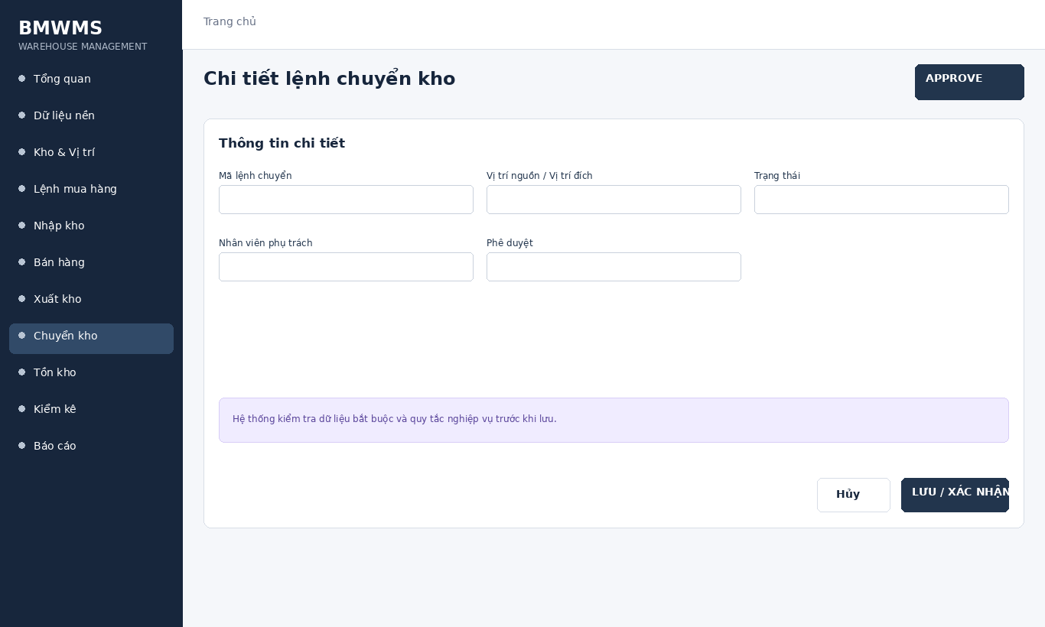
Figure UC-060: Wireframe for Approve transfer order. Source: BMWMS.Web/Pages/Transfer/Details.cshtml

Field Description
Field Name | Field Type | Description
Mã lệnh chuyển | Read-only field | Read-only system-generated number.
Vị trí nguồn / Vị trí đích | Read-only field | Read-only locations involved in the transfer.
Trạng thái | Read-only field | Read-only current transfer status.
Nhân viên phụ trách | Display field | Warehouse employee responsible for the transfer.
Phê duyệt | Display field | Approve, Confirm execution or Complete according to status.

Use Case Specification
Use Case ID | UC-060 | Use Case Name | Approve transfer order
Primary Actors | Warehouse Manager; Warehouse Staff | Secondary Actors | BMWMS API; SQL Server database
Description | As an authorized warehouse manager, I want to perform approve transfer order so that the related warehouse activity is completed and traceable.
Preconditions | The actor is authenticated and authorized. Required master data and source transaction exist and are active.
Postconditions | The approve transfer order result is saved or displayed successfully. Related statuses and inventory balances remain consistent.
Normal Sequence/Flow | 1. Actor opens the relevant list or detail screen.  2. System displays the current data and actions permitted for the actor.  3. Actor selects Approve.  4. System displays the required input fields or confirmation.  5. Actor enters/reviews the information and confirms.  6. System validates mandatory fields, quantities, authorization and current status.  7. System saves the transaction, updates the status and displays the result.
Alternative Sequences/Flows | A1. Actor cancels before confirmation; system returns to the previous screen without saving.  A2. Actor corrects invalid data and resubmits; system continues from the validation step.
Exception Flows | E1. Required or formatted data is invalid: system shows field-level validation and does not save.  E2. Actor is not authorized: system denies the operation.  E3. Record status changed or is not eligible: system reloads the latest data and disables the action.  E4. API/database/email service is unavailable: system shows an error and keeps the previous consistent state.
Business Rules | Source and destination must differ. Transfer quantity cannot exceed available inventory. Only approved transfers may be executed.

UC-061 Confirm transfer execution
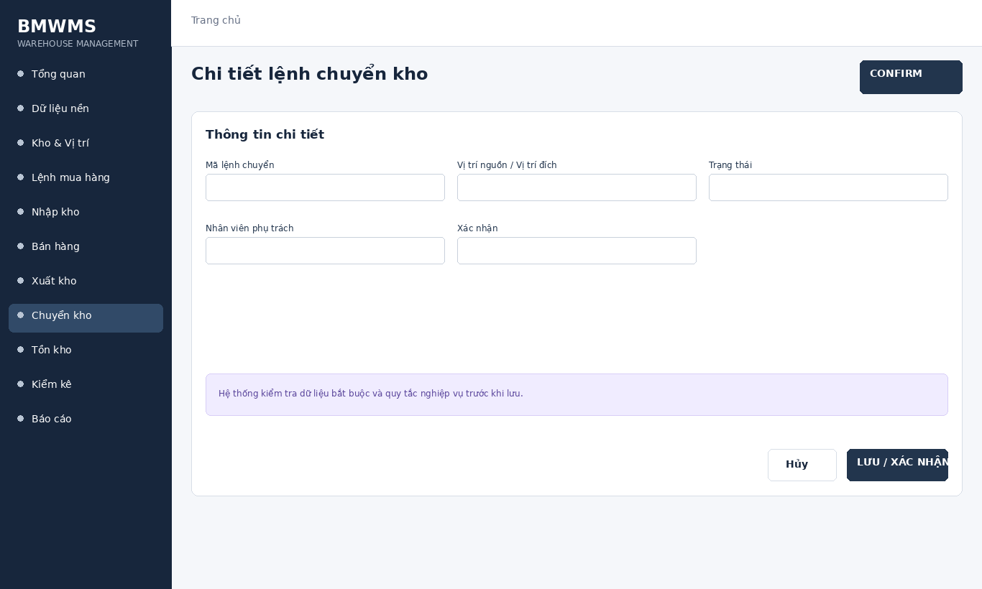
Figure UC-061: Wireframe for Confirm transfer execution. Source: BMWMS.Web/Pages/Transfer/Details.cshtml

Field Description
Field Name | Field Type | Description
Mã lệnh chuyển | Read-only field | Read-only system-generated number.
Vị trí nguồn / Vị trí đích | Read-only field | Read-only locations involved in the transfer.
Trạng thái | Read-only field | Read-only current transfer status.
Nhân viên phụ trách | Display field | Warehouse employee responsible for the transfer.
Xác nhận | Display field | Approve, Confirm execution or Complete according to status.

Use Case Specification
Use Case ID | UC-061 | Use Case Name | Confirm transfer execution
Primary Actors | Warehouse Manager; Warehouse Staff | Secondary Actors | BMWMS API; SQL Server database
Description | As an authorized warehouse manager, I want to perform confirm transfer execution so that the related warehouse activity is completed and traceable.
Preconditions | The actor is authenticated and authorized. Required master data and source transaction exist and are active.
Postconditions | The confirm transfer execution result is saved or displayed successfully. Related statuses and inventory balances remain consistent.
Normal Sequence/Flow | 1. Actor opens the relevant list or detail screen.  2. System displays the current data and actions permitted for the actor.  3. Actor selects Confirm.  4. System displays the required input fields or confirmation.  5. Actor enters/reviews the information and confirms.  6. System validates mandatory fields, quantities, authorization and current status.  7. System saves the transaction, updates the status and displays the result.
Alternative Sequences/Flows | A1. Actor cancels before confirmation; system returns to the previous screen without saving.  A2. Actor corrects invalid data and resubmits; system continues from the validation step.
Exception Flows | E1. Required or formatted data is invalid: system shows field-level validation and does not save.  E2. Actor is not authorized: system denies the operation.  E3. Record status changed or is not eligible: system reloads the latest data and disables the action.  E4. API/database/email service is unavailable: system shows an error and keeps the previous consistent state.
Business Rules | Source and destination must differ. Transfer quantity cannot exceed available inventory. Only approved transfers may be executed.

UC-062 Complete transfer order
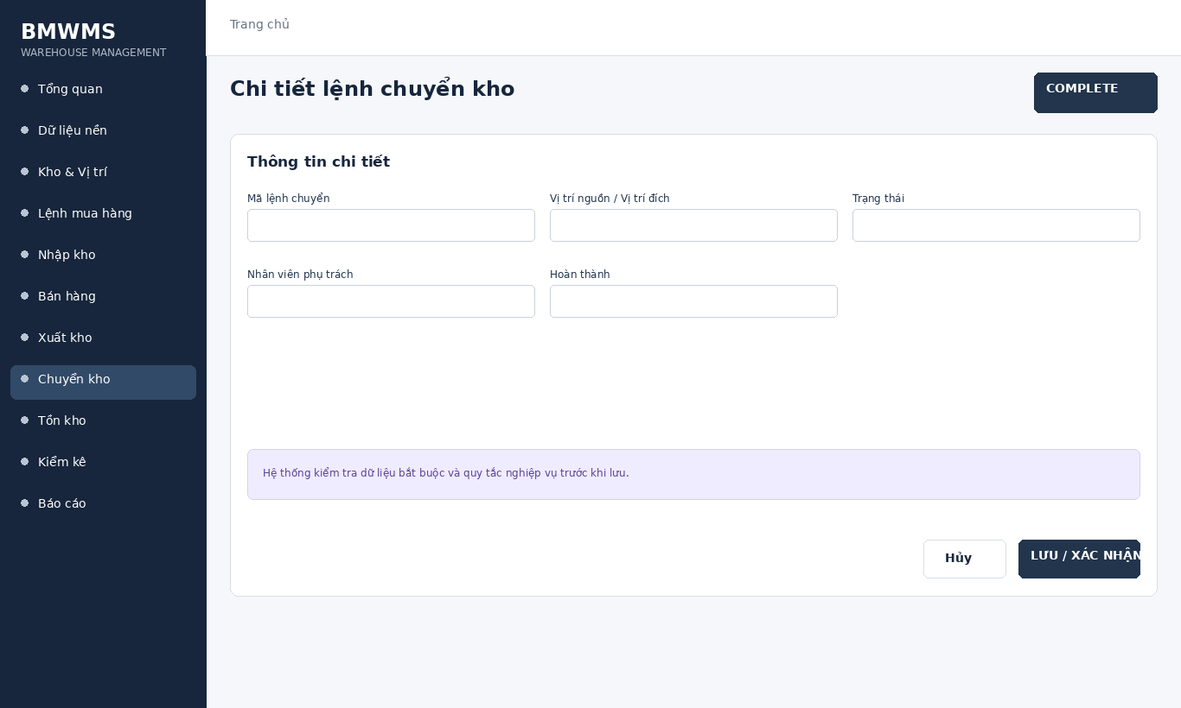
Figure UC-062: Wireframe for Complete transfer order. Source: BMWMS.Web/Pages/Transfer/Details.cshtml

Field Description
Field Name | Field Type | Description
Mã lệnh chuyển | Read-only field | Read-only system-generated number.
Vị trí nguồn / Vị trí đích | Read-only field | Read-only locations involved in the transfer.
Trạng thái | Read-only field | Read-only current transfer status.
Nhân viên phụ trách | Display field | Warehouse employee responsible for the transfer.
Hoàn thành | Display field | Approve, Confirm execution or Complete according to status.

Use Case Specification
Use Case ID | UC-062 | Use Case Name | Complete transfer order
Primary Actors | Warehouse Manager; Warehouse Staff | Secondary Actors | BMWMS API; SQL Server database
Description | As an authorized warehouse manager, I want to perform complete transfer order so that the related warehouse activity is completed and traceable.
Preconditions | The actor is authenticated and authorized. Required master data and source transaction exist and are active.
Postconditions | The complete transfer order result is saved or displayed successfully. Related statuses and inventory balances remain consistent.
Normal Sequence/Flow | 1. Actor opens the relevant list or detail screen.  2. System displays the current data and actions permitted for the actor.  3. Actor selects Complete.  4. System displays the required input fields or confirmation.  5. Actor enters/reviews the information and confirms.  6. System validates mandatory fields, quantities, authorization and current status.  7. System saves the transaction, updates the status and displays the result.
Alternative Sequences/Flows | A1. Actor cancels before confirmation; system returns to the previous screen without saving.  A2. Actor corrects invalid data and resubmits; system continues from the validation step.
Exception Flows | E1. Required or formatted data is invalid: system shows field-level validation and does not save.  E2. Actor is not authorized: system denies the operation.  E3. Record status changed or is not eligible: system reloads the latest data and disables the action.  E4. API/database/email service is unavailable: system shows an error and keeps the previous consistent state.
Business Rules | Source and destination must differ. Transfer quantity cannot exceed available inventory. Only approved transfers may be executed.

2.10 Inventory

UC-063 View inventory dashboard
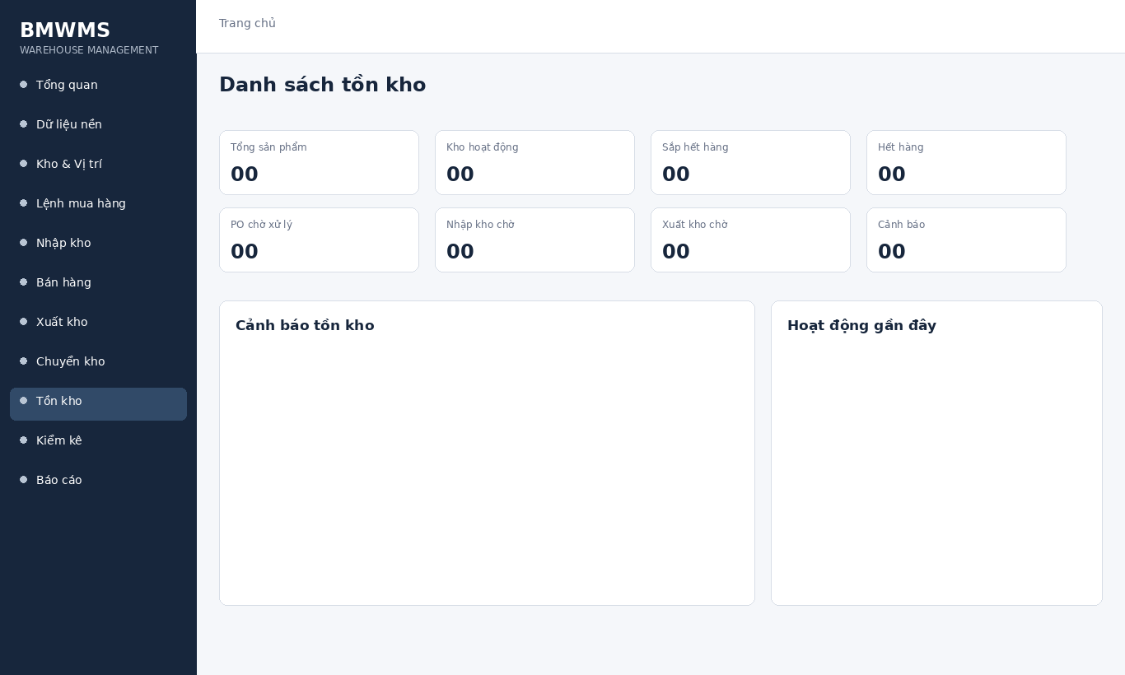
Figure UC-063: Wireframe for View inventory dashboard. Source: BMWMS.Web/Pages/Inventory/Index.cshtml

Field Description
Field Name | Field Type | Description
Từ khóa | Text box | Text box. Search by product code or product name; optional.
Kho | Dropdown | Dropdown; default All warehouses.
Vị trí lưu trữ | Dropdown | Dependent dropdown; default All locations.
Trạng thái | Dropdown | Dropdown: All, Normal, Low stock, Out of stock.

Use Case Specification
Use Case ID | UC-063 | Use Case Name | View inventory dashboard
Primary Actors | Warehouse Manager; Warehouse Staff | Secondary Actors | BMWMS API; SQL Server database
Description | As an authorized warehouse manager, I want to perform view inventory dashboard so that the related warehouse activity is completed and traceable.
Preconditions | The actor is authenticated and authorized. Required master data and source transaction exist and are active.
Postconditions | The view inventory dashboard result is saved or displayed successfully. Related statuses and inventory balances remain consistent.
Normal Sequence/Flow | 1. Actor opens the View inventory dashboard screen.  2. System displays the available filters and current records.  3. Actor enters optional filter criteria.  4. Actor selects Filter/Search/View.  5. System validates the criteria and returns matching data.  6. Actor reviews the result or opens a record for more detail.
Alternative Sequences/Flows | A1. Actor leaves all filters blank; system displays the default paged result.  A2. No record matches; system displays an empty list without changing data.
Exception Flows | E1. Required or formatted data is invalid: system shows field-level validation and does not save.  E2. Actor is not authorized: system denies the operation.  E3. Record status changed or is not eligible: system reloads the latest data and disables the action.  E4. API/database/email service is unavailable: system shows an error and keeps the previous consistent state.
Business Rules | Available quantity equals On hand minus Reserved. Inventory is tracked by product, location and lot where applicable.

UC-064 Search inventory
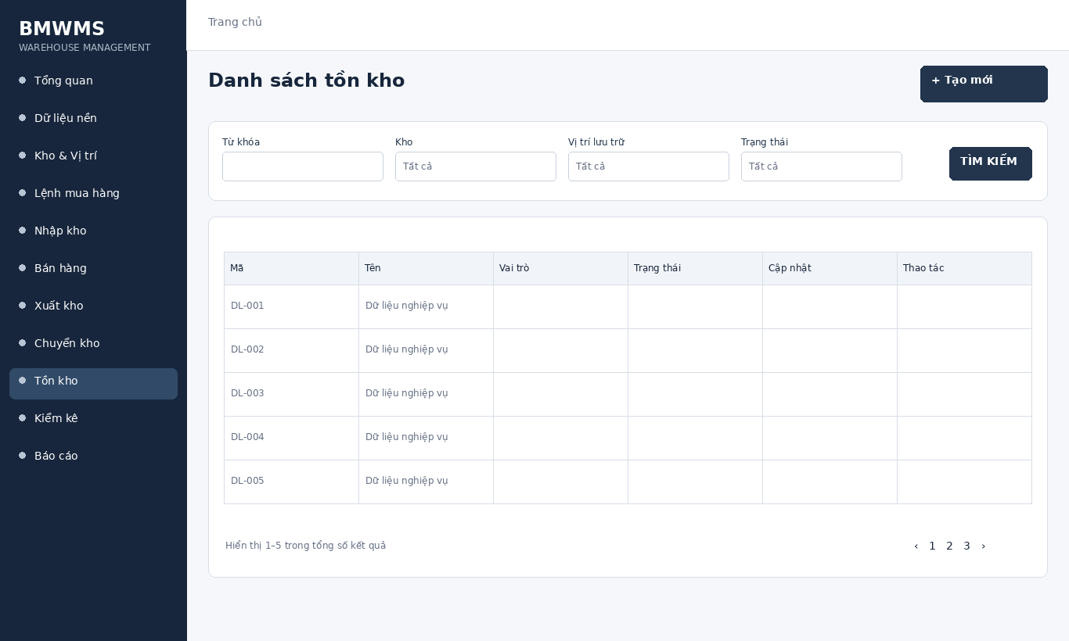
Figure UC-064: Wireframe for Search inventory. Source: BMWMS.Web/Pages/Inventory/Index.cshtml

Field Description
Field Name | Field Type | Description
Từ khóa | Text box | Text box. Search by product code or product name; optional.
Kho | Dropdown | Dropdown; default All warehouses.
Vị trí lưu trữ | Dropdown | Dependent dropdown; default All locations.
Trạng thái | Dropdown | Dropdown: All, Normal, Low stock, Out of stock.

Use Case Specification
Use Case ID | UC-064 | Use Case Name | Search inventory
Primary Actors | Warehouse Manager; Warehouse Staff | Secondary Actors | BMWMS API; SQL Server database
Description | As an authorized warehouse manager, I want to perform search inventory so that the related warehouse activity is completed and traceable.
Preconditions | The actor is authenticated and authorized. Required master data and source transaction exist and are active.
Postconditions | The search inventory result is saved or displayed successfully. Related statuses and inventory balances remain consistent.
Normal Sequence/Flow | 1. Actor opens the Search inventory screen.  2. System displays the available filters and current records.  3. Actor enters optional filter criteria.  4. Actor selects Filter/Search/View.  5. System validates the criteria and returns matching data.  6. Actor reviews the result or opens a record for more detail.
Alternative Sequences/Flows | A1. Actor leaves all filters blank; system displays the default paged result.  A2. No record matches; system displays an empty list without changing data.
Exception Flows | E1. Required or formatted data is invalid: system shows field-level validation and does not save.  E2. Actor is not authorized: system denies the operation.  E3. Record status changed or is not eligible: system reloads the latest data and disables the action.  E4. API/database/email service is unavailable: system shows an error and keeps the previous consistent state.
Business Rules | Available quantity equals On hand minus Reserved. Inventory is tracked by product, location and lot where applicable.

UC-065 View inventory by location
Figure UC-065: Wireframe for View inventory by location. Source: BMWMS.Web/Pages/Inventory/Index.cshtml

Field Description
Field Name | Field Type | Description
Từ khóa | Text box | Text box. Search by product code or product name; optional.
Kho | Dropdown | Dropdown; default All warehouses.
Vị trí lưu trữ | Dropdown | Dependent dropdown; default All locations.
Trạng thái | Dropdown | Dropdown: All, Normal, Low stock, Out of stock.

Use Case Specification
Use Case ID | UC-065 | Use Case Name | View inventory by location
Primary Actors | Warehouse Manager; Warehouse Staff | Secondary Actors | BMWMS API; SQL Server database
Description | As an authorized warehouse manager, I want to perform view inventory by location so that the related warehouse activity is completed and traceable.
Preconditions | The actor is authenticated and authorized. Required master data and source transaction exist and are active.
Postconditions | The view inventory by location result is saved or displayed successfully. Related statuses and inventory balances remain consistent.
Normal Sequence/Flow | 1. Actor opens the View inventory by location screen.  2. System displays the available filters and current records.  3. Actor enters optional filter criteria.  4. Actor selects Filter/Search/View.  5. System validates the criteria and returns matching data.  6. Actor reviews the result or opens a record for more detail.
Alternative Sequences/Flows | A1. Actor leaves all filters blank; system displays the default paged result.  A2. No record matches; system displays an empty list without changing data.
Exception Flows | E1. Required or formatted data is invalid: system shows field-level validation and does not save.  E2. Actor is not authorized: system denies the operation.  E3. Record status changed or is not eligible: system reloads the latest data and disables the action.  E4. API/database/email service is unavailable: system shows an error and keeps the previous consistent state.
Business Rules | Available quantity equals On hand minus Reserved. Inventory is tracked by product, location and lot where applicable.

UC-066 View inventory by lot/expiry
Figure UC-066: Wireframe for View inventory by lot/expiry. Source: BMWMS.Web/Pages/Inventory/Index.cshtml

Field Description
Field Name | Field Type | Description
Từ khóa | Text box | Text box. Search by product code or product name; optional.
Kho | Dropdown | Dropdown; default All warehouses.
Vị trí lưu trữ | Dropdown | Dependent dropdown; default All locations.
Trạng thái | Dropdown | Dropdown: All, Normal, Low stock, Out of stock.

Use Case Specification
Use Case ID | UC-066 | Use Case Name | View inventory by lot/expiry
Primary Actors | Warehouse Manager; Warehouse Staff | Secondary Actors | BMWMS API; SQL Server database
Description | As an authorized warehouse manager, I want to perform view inventory by lot/expiry so that the related warehouse activity is completed and traceable.
Preconditions | The actor is authenticated and authorized. Required master data and source transaction exist and are active.
Postconditions | The view inventory by lot/expiry result is saved or displayed successfully. Related statuses and inventory balances remain consistent.
Normal Sequence/Flow | 1. Actor opens the View inventory by lot/expiry screen.  2. System displays the available filters and current records.  3. Actor enters optional filter criteria.  4. Actor selects Filter/Search/View.  5. System validates the criteria and returns matching data.  6. Actor reviews the result or opens a record for more detail.
Alternative Sequences/Flows | A1. Actor leaves all filters blank; system displays the default paged result.  A2. No record matches; system displays an empty list without changing data.
Exception Flows | E1. Required or formatted data is invalid: system shows field-level validation and does not save.  E2. Actor is not authorized: system denies the operation.  E3. Record status changed or is not eligible: system reloads the latest data and disables the action.  E4. API/database/email service is unavailable: system shows an error and keeps the previous consistent state.
Business Rules | Available quantity equals On hand minus Reserved. Inventory is tracked by product, location and lot where applicable.

UC-067 View inventory transaction history
Figure UC-067: Wireframe for View inventory transaction history. Source: BMWMS.Web/Pages/Inventory/Index.cshtml

Field Description
Field Name | Field Type | Description
Từ khóa | Text box | Text box. Search by product code or product name; optional.
Kho | Dropdown | Dropdown; default All warehouses.
Vị trí lưu trữ | Dropdown | Dependent dropdown; default All locations.
Trạng thái | Dropdown | Dropdown: All, Normal, Low stock, Out of stock.

Use Case Specification
Use Case ID | UC-067 | Use Case Name | View inventory transaction history
Primary Actors | Warehouse Manager; Warehouse Staff | Secondary Actors | BMWMS API; SQL Server database
Description | As an authorized warehouse manager, I want to perform view inventory transaction history so that the related warehouse activity is completed and traceable.
Preconditions | The actor is authenticated and authorized. Required master data and source transaction exist and are active.
Postconditions | The view inventory transaction history result is saved or displayed successfully. Related statuses and inventory balances remain consistent.
Normal Sequence/Flow | 1. Actor opens the View inventory transaction history screen.  2. System displays the available filters and current records.  3. Actor enters optional filter criteria.  4. Actor selects Filter/Search/View.  5. System validates the criteria and returns matching data.  6. Actor reviews the result or opens a record for more detail.
Alternative Sequences/Flows | A1. Actor leaves all filters blank; system displays the default paged result.  A2. No record matches; system displays an empty list without changing data.
Exception Flows | E1. Required or formatted data is invalid: system shows field-level validation and does not save.  E2. Actor is not authorized: system denies the operation.  E3. Record status changed or is not eligible: system reloads the latest data and disables the action.  E4. API/database/email service is unavailable: system shows an error and keeps the previous consistent state.
Business Rules | Available quantity equals On hand minus Reserved. Inventory is tracked by product, location and lot where applicable.

2.11 Stocktake

UC-068 Create stocktake session
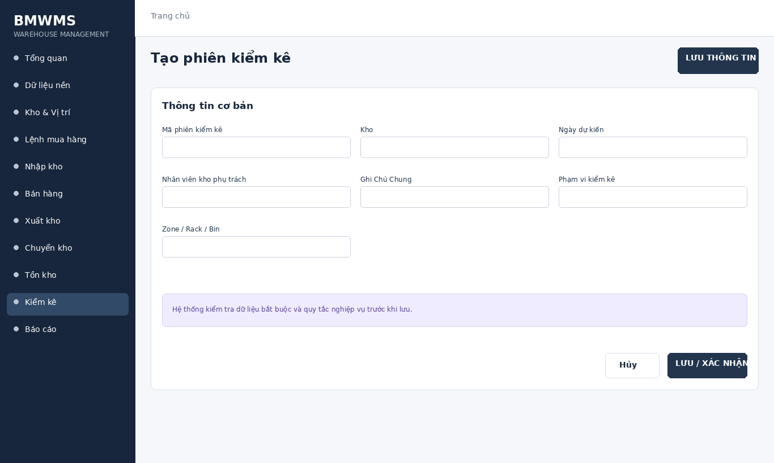
Figure UC-068: Wireframe for Create stocktake session. Source: BMWMS.Web/Pages/Stocktake/Create.cshtml

Field Description
Field Name | Field Type | Description
Mã phiên kiểm kê | Read-only field | Read-only; generated automatically when the record is created.
Kho | Dropdown | Dropdown of active warehouses; required.
Ngày dự kiến | Date picker | Date input; required; default current date.
Nhân viên kho phụ trách | Dropdown | Dropdown; required.
Ghi Chú Chung | Text area | Optional reason or special instruction.
Phạm vi kiểm kê | Radio button | Radio buttons: Full warehouse or Selected area; required.
Zone / Rack / Bin | Dropdown | Location selectors shown when Selected area is chosen.

Use Case Specification
Use Case ID | UC-068 | Use Case Name | Create stocktake session
Primary Actors | Warehouse Manager; Warehouse Staff | Secondary Actors | BMWMS API; SQL Server database
Description | As an authorized warehouse manager, I want to perform create stocktake session so that the related warehouse activity is completed and traceable.
Preconditions | The actor is authenticated and authorized. Required master data and source transaction exist and are active.
Postconditions | The create stocktake session result is saved or displayed successfully. Related statuses and inventory balances remain consistent.
Normal Sequence/Flow | 1. Actor opens the relevant list or detail screen.  2. System displays the current data and actions permitted for the actor.  3. Actor selects Create.  4. System displays the required input fields or confirmation.  5. Actor enters/reviews the information and confirms.  6. System validates mandatory fields, quantities, authorization and current status.  7. System saves the transaction, updates the status and displays the result.
Alternative Sequences/Flows | A1. Actor cancels before confirmation; system returns to the previous screen without saving.  A2. Actor corrects invalid data and resubmits; system continues from the validation step.
Exception Flows | E1. Required or formatted data is invalid: system shows field-level validation and does not save.  E2. Actor is not authorized: system denies the operation.  E3. Record status changed or is not eligible: system reloads the latest data and disables the action.  E4. API/database/email service is unavailable: system shows an error and keeps the previous consistent state.
Business Rules | Only the assigned counter enters results. Approval posts the variance adjustment; rejection returns the session for correction.

UC-069 View stocktake list
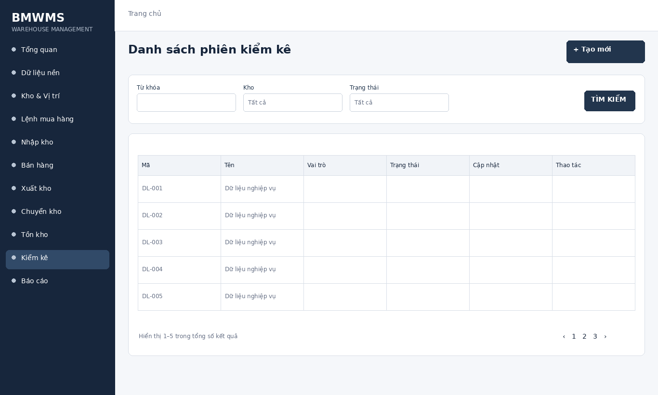
Figure UC-069: Wireframe for View stocktake list. Source: BMWMS.Web/Pages/Stocktake/Index.cshtml

Field Description
Field Name | Field Type | Description
Từ khóa | Text box | Text box. Search by stocktake number; optional.
Kho | Dropdown | Dropdown; default All warehouses.
Trạng thái | Dropdown | Dropdown: All, Scheduled, Counting, Pending approval, Completed, Rejected, Cancelled.

Use Case Specification
Use Case ID | UC-069 | Use Case Name | View stocktake list
Primary Actors | Warehouse Manager; Warehouse Staff | Secondary Actors | BMWMS API; SQL Server database
Description | As an authorized warehouse manager, I want to perform view stocktake list so that the related warehouse activity is completed and traceable.
Preconditions | The actor is authenticated and authorized. Required master data and source transaction exist and are active.
Postconditions | The view stocktake list result is saved or displayed successfully. Related statuses and inventory balances remain consistent.
Normal Sequence/Flow | 1. Actor opens the View stocktake list screen.  2. System displays the available filters and current records.  3. Actor enters optional filter criteria.  4. Actor selects Filter/Search/View.  5. System validates the criteria and returns matching data.  6. Actor reviews the result or opens a record for more detail.
Alternative Sequences/Flows | A1. Actor leaves all filters blank; system displays the default paged result.  A2. No record matches; system displays an empty list without changing data.
Exception Flows | E1. Required or formatted data is invalid: system shows field-level validation and does not save.  E2. Actor is not authorized: system denies the operation.  E3. Record status changed or is not eligible: system reloads the latest data and disables the action.  E4. API/database/email service is unavailable: system shows an error and keeps the previous consistent state.
Business Rules | Only the assigned counter enters results. Approval posts the variance adjustment; rejection returns the session for correction.

UC-070 View stocktake details
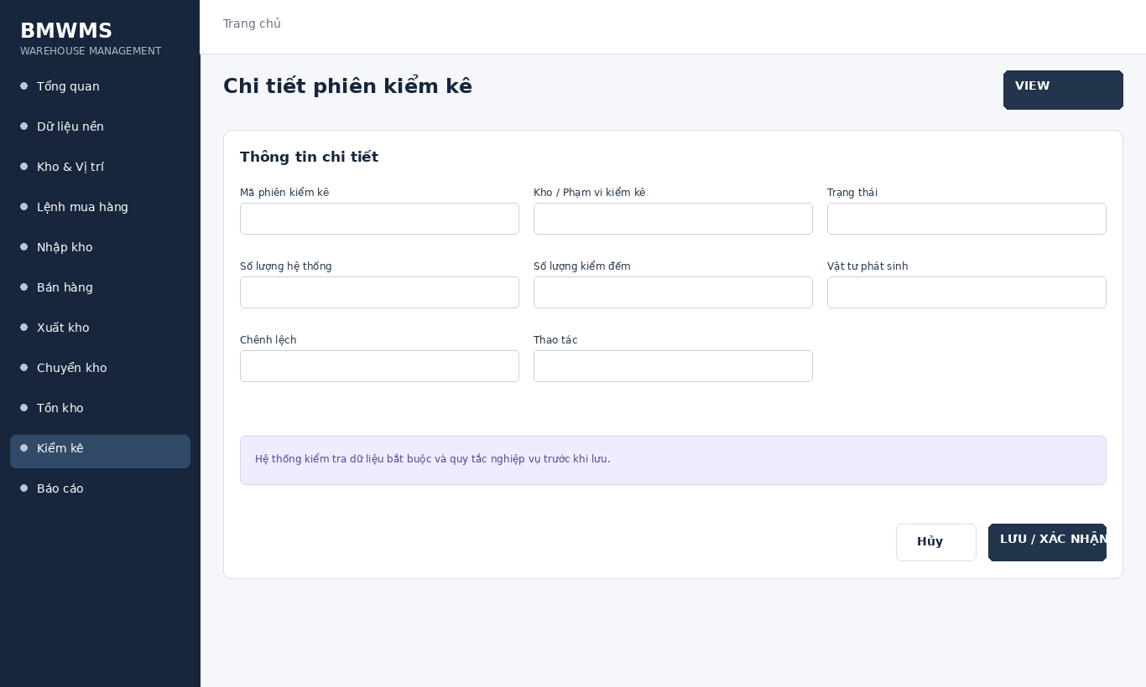
Figure UC-070: Wireframe for View stocktake details. Source: BMWMS.Web/Pages/Stocktake/Details.cshtml

Field Description
Field Name | Field Type | Description
Mã phiên kiểm kê | Read-only field | Read-only system-generated number.
Kho / Phạm vi kiểm kê | Dropdown | Read-only stocktake warehouse and selected locations.
Trạng thái | Read-only field | Read-only current stocktake status.
Số lượng hệ thống | Read-only field | Read-only on-hand quantity at the freeze/count point.
Số lượng kiểm đếm | Number input | Numeric input entered by the assigned counter.
Vật tư phát sinh | Display field | Product/lot/location fields used for an item not on the count sheet.
Chênh lệch | Display field | Calculated as Counted quantity minus System quantity.
Thao tác | Display field | Start, Submit, Approve or Reject according to role and status.

Use Case Specification
Use Case ID | UC-070 | Use Case Name | View stocktake details
Primary Actors | Warehouse Manager; Warehouse Staff | Secondary Actors | BMWMS API; SQL Server database
Description | As an authorized warehouse manager, I want to perform view stocktake details so that the related warehouse activity is completed and traceable.
Preconditions | The actor is authenticated and authorized. Required master data and source transaction exist and are active.
Postconditions | The view stocktake details result is saved or displayed successfully. Related statuses and inventory balances remain consistent.
Normal Sequence/Flow | 1. Actor opens the View stocktake details screen.  2. System displays the available filters and current records.  3. Actor enters optional filter criteria.  4. Actor selects Filter/Search/View.  5. System validates the criteria and returns matching data.  6. Actor reviews the result or opens a record for more detail.
Alternative Sequences/Flows | A1. Actor leaves all filters blank; system displays the default paged result.  A2. No record matches; system displays an empty list without changing data.
Exception Flows | E1. Required or formatted data is invalid: system shows field-level validation and does not save.  E2. Actor is not authorized: system denies the operation.  E3. Record status changed or is not eligible: system reloads the latest data and disables the action.  E4. API/database/email service is unavailable: system shows an error and keeps the previous consistent state.
Business Rules | Only the assigned counter enters results. Approval posts the variance adjustment; rejection returns the session for correction.

UC-071 Start stocktake
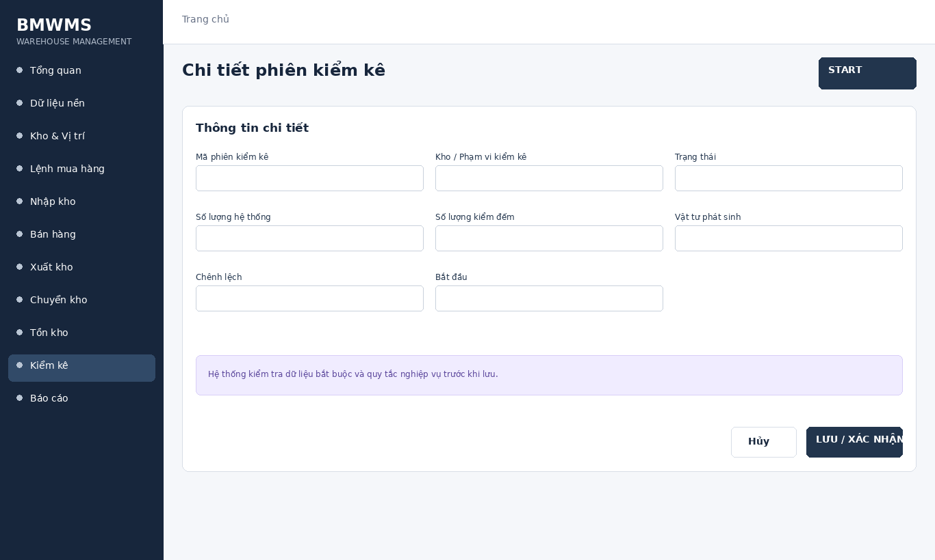
Figure UC-071: Wireframe for Start stocktake. Source: BMWMS.Web/Pages/Stocktake/Details.cshtml

Field Description
Field Name | Field Type | Description
Mã phiên kiểm kê | Read-only field | Read-only system-generated number.
Kho / Phạm vi kiểm kê | Dropdown | Read-only stocktake warehouse and selected locations.
Trạng thái | Read-only field | Read-only current stocktake status.
Số lượng hệ thống | Read-only field | Read-only on-hand quantity at the freeze/count point.
Số lượng kiểm đếm | Number input | Numeric input entered by the assigned counter.
Vật tư phát sinh | Display field | Product/lot/location fields used for an item not on the count sheet.
Chênh lệch | Display field | Calculated as Counted quantity minus System quantity.
Bắt đầu | Display field | Start, Submit, Approve or Reject according to role and status.

Use Case Specification
Use Case ID | UC-071 | Use Case Name | Start stocktake
Primary Actors | Warehouse Manager; Warehouse Staff | Secondary Actors | BMWMS API; SQL Server database
Description | As an authorized warehouse manager, I want to perform start stocktake so that the related warehouse activity is completed and traceable.
Preconditions | The actor is authenticated and authorized. Required master data and source transaction exist and are active.
Postconditions | The start stocktake result is saved or displayed successfully. Related statuses and inventory balances remain consistent.
Normal Sequence/Flow | 1. Actor opens the relevant list or detail screen.  2. System displays the current data and actions permitted for the actor.  3. Actor selects Start.  4. System displays the required input fields or confirmation.  5. Actor enters/reviews the information and confirms.  6. System validates mandatory fields, quantities, authorization and current status.  7. System saves the transaction, updates the status and displays the result.
Alternative Sequences/Flows | A1. Actor cancels before confirmation; system returns to the previous screen without saving.  A2. Actor corrects invalid data and resubmits; system continues from the validation step.
Exception Flows | E1. Required or formatted data is invalid: system shows field-level validation and does not save.  E2. Actor is not authorized: system denies the operation.  E3. Record status changed or is not eligible: system reloads the latest data and disables the action.  E4. API/database/email service is unavailable: system shows an error and keeps the previous consistent state.
Business Rules | Only the assigned counter enters results. Approval posts the variance adjustment; rejection returns the session for correction.

UC-072 Assign stocktake
Figure UC-072: Wireframe for Assign stocktake. Source: BMWMS.Web/Pages/Stocktake/Create.cshtml

Field Description
Field Name | Field Type | Description
Mã phiên kiểm kê | Read-only field | Read-only; generated automatically when the record is created.
Kho | Dropdown | Dropdown of active warehouses; required.
Ngày dự kiến | Date picker | Date input; required; default current date.
Nhân viên kho phụ trách | Dropdown | Dropdown; required.
Ghi Chú Chung | Text area | Optional reason or special instruction.
Phạm vi kiểm kê | Radio button | Radio buttons: Full warehouse or Selected area; required.
Zone / Rack / Bin | Dropdown | Location selectors shown when Selected area is chosen.

Use Case Specification
Use Case ID | UC-072 | Use Case Name | Assign stocktake
Primary Actors | Warehouse Manager; Warehouse Staff | Secondary Actors | BMWMS API; SQL Server database
Description | As an authorized warehouse manager, I want to perform assign stocktake so that the related warehouse activity is completed and traceable.
Preconditions | The actor is authenticated and authorized. Required master data and source transaction exist and are active.
Postconditions | The assign stocktake result is saved or displayed successfully. Related statuses and inventory balances remain consistent.
Normal Sequence/Flow | 1. Actor opens the relevant list or detail screen.  2. System displays the current data and actions permitted for the actor.  3. Actor selects Assign.  4. System displays the required input fields or confirmation.  5. Actor enters/reviews the information and confirms.  6. System validates mandatory fields, quantities, authorization and current status.  7. System saves the transaction, updates the status and displays the result.
Alternative Sequences/Flows | A1. Actor cancels before confirmation; system returns to the previous screen without saving.  A2. Actor corrects invalid data and resubmits; system continues from the validation step.
Exception Flows | E1. Required or formatted data is invalid: system shows field-level validation and does not save.  E2. Actor is not authorized: system denies the operation.  E3. Record status changed or is not eligible: system reloads the latest data and disables the action.  E4. API/database/email service is unavailable: system shows an error and keeps the previous consistent state.
Business Rules | Only the assigned counter enters results. Approval posts the variance adjustment; rejection returns the session for correction.

UC-073 Enter count results
Figure UC-073: Wireframe for Enter count results. Source: BMWMS.Web/Pages/Stocktake/Create.cshtml

Field Description
Field Name | Field Type | Description
Mã phiên kiểm kê | Read-only field | Read-only; generated automatically when the record is created.
Kho | Dropdown | Dropdown of active warehouses; required.
Ngày dự kiến | Date picker | Date input; required; default current date.
Nhân viên kho phụ trách | Dropdown | Dropdown; required.
Ghi Chú Chung | Text area | Optional reason or special instruction.
Phạm vi kiểm kê | Radio button | Radio buttons: Full warehouse or Selected area; required.
Zone / Rack / Bin | Dropdown | Location selectors shown when Selected area is chosen.

Use Case Specification
Use Case ID | UC-073 | Use Case Name | Enter count results
Primary Actors | Warehouse Manager; Warehouse Staff | Secondary Actors | BMWMS API; SQL Server database
Description | As an authorized warehouse manager, I want to perform enter count results so that the related warehouse activity is completed and traceable.
Preconditions | The actor is authenticated and authorized. Required master data and source transaction exist and are active.
Postconditions | The enter count results result is saved or displayed successfully. Related statuses and inventory balances remain consistent.
Normal Sequence/Flow | 1. Actor opens the relevant list or detail screen.  2. System displays the current data and actions permitted for the actor.  3. Actor selects Enter.  4. System displays the required input fields or confirmation.  5. Actor enters/reviews the information and confirms.  6. System validates mandatory fields, quantities, authorization and current status.  7. System saves the transaction, updates the status and displays the result.
Alternative Sequences/Flows | A1. Actor cancels before confirmation; system returns to the previous screen without saving.  A2. Actor corrects invalid data and resubmits; system continues from the validation step.
Exception Flows | E1. Required or formatted data is invalid: system shows field-level validation and does not save.  E2. Actor is not authorized: system denies the operation.  E3. Record status changed or is not eligible: system reloads the latest data and disables the action.  E4. API/database/email service is unavailable: system shows an error and keeps the previous consistent state.
Business Rules | Only the assigned counter enters results. Approval posts the variance adjustment; rejection returns the session for correction.

UC-074 Record unexpected items
Figure UC-074: Wireframe for Record unexpected items. Source: BMWMS.Web/Pages/Stocktake/Create.cshtml

Field Description
Field Name | Field Type | Description
Mã phiên kiểm kê | Read-only field | Read-only; generated automatically when the record is created.
Kho | Dropdown | Dropdown of active warehouses; required.
Ngày dự kiến | Date picker | Date input; required; default current date.
Nhân viên kho phụ trách | Dropdown | Dropdown; required.
Ghi Chú Chung | Text area | Optional reason or special instruction.
Phạm vi kiểm kê | Radio button | Radio buttons: Full warehouse or Selected area; required.
Zone / Rack / Bin | Dropdown | Location selectors shown when Selected area is chosen.

Use Case Specification
Use Case ID | UC-074 | Use Case Name | Record unexpected items
Primary Actors | Warehouse Manager; Warehouse Staff | Secondary Actors | BMWMS API; SQL Server database
Description | As an authorized warehouse manager, I want to perform record unexpected items so that the related warehouse activity is completed and traceable.
Preconditions | The actor is authenticated and authorized. Required master data and source transaction exist and are active.
Postconditions | The record unexpected items result is saved or displayed successfully. Related statuses and inventory balances remain consistent.
Normal Sequence/Flow | 1. Actor opens the relevant list or detail screen.  2. System displays the current data and actions permitted for the actor.  3. Actor selects Record.  4. System displays the required input fields or confirmation.  5. Actor enters/reviews the information and confirms.  6. System validates mandatory fields, quantities, authorization and current status.  7. System saves the transaction, updates the status and displays the result.
Alternative Sequences/Flows | A1. Actor cancels before confirmation; system returns to the previous screen without saving.  A2. Actor corrects invalid data and resubmits; system continues from the validation step.
Exception Flows | E1. Required or formatted data is invalid: system shows field-level validation and does not save.  E2. Actor is not authorized: system denies the operation.  E3. Record status changed or is not eligible: system reloads the latest data and disables the action.  E4. API/database/email service is unavailable: system shows an error and keeps the previous consistent state.
Business Rules | Only the assigned counter enters results. Approval posts the variance adjustment; rejection returns the session for correction.

UC-075 Submit stocktake result
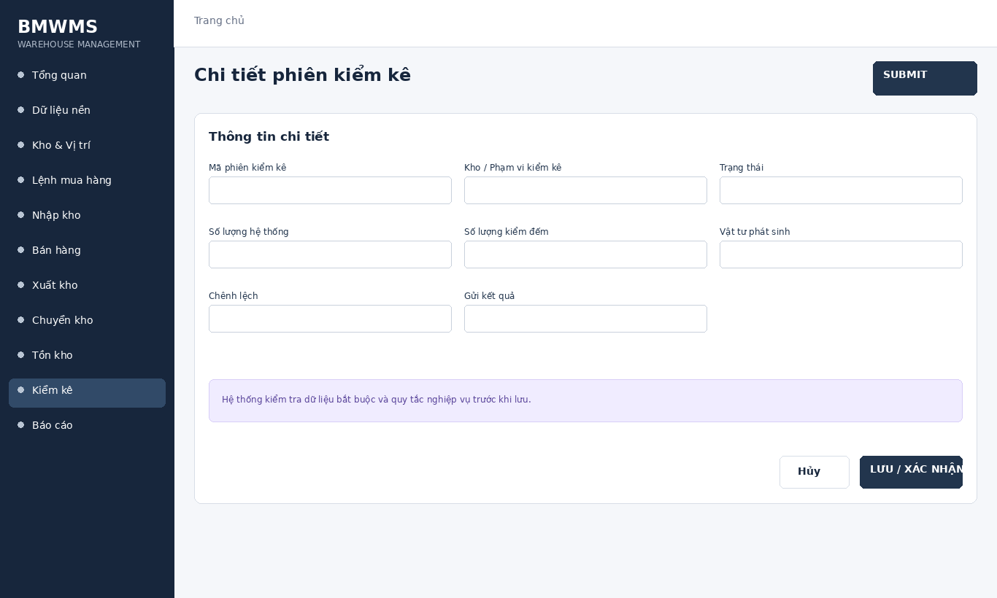
Figure UC-075: Wireframe for Submit stocktake result. Source: BMWMS.Web/Pages/Stocktake/Details.cshtml

Field Description
Field Name | Field Type | Description
Mã phiên kiểm kê | Read-only field | Read-only system-generated number.
Kho / Phạm vi kiểm kê | Dropdown | Read-only stocktake warehouse and selected locations.
Trạng thái | Read-only field | Read-only current stocktake status.
Số lượng hệ thống | Read-only field | Read-only on-hand quantity at the freeze/count point.
Số lượng kiểm đếm | Number input | Numeric input entered by the assigned counter.
Vật tư phát sinh | Display field | Product/lot/location fields used for an item not on the count sheet.
Chênh lệch | Display field | Calculated as Counted quantity minus System quantity.
Gửi kết quả | Display field | Start, Submit, Approve or Reject according to role and status.

Use Case Specification
Use Case ID | UC-075 | Use Case Name | Submit stocktake result
Primary Actors | Warehouse Manager; Warehouse Staff | Secondary Actors | BMWMS API; SQL Server database
Description | As an authorized warehouse manager, I want to perform submit stocktake result so that the related warehouse activity is completed and traceable.
Preconditions | The actor is authenticated and authorized. Required master data and source transaction exist and are active.
Postconditions | The submit stocktake result result is saved or displayed successfully. Related statuses and inventory balances remain consistent.
Normal Sequence/Flow | 1. Actor opens the relevant list or detail screen.  2. System displays the current data and actions permitted for the actor.  3. Actor selects Submit.  4. System displays the required input fields or confirmation.  5. Actor enters/reviews the information and confirms.  6. System validates mandatory fields, quantities, authorization and current status.  7. System saves the transaction, updates the status and displays the result.
Alternative Sequences/Flows | A1. Actor cancels before confirmation; system returns to the previous screen without saving.  A2. Actor corrects invalid data and resubmits; system continues from the validation step.
Exception Flows | E1. Required or formatted data is invalid: system shows field-level validation and does not save.  E2. Actor is not authorized: system denies the operation.  E3. Record status changed or is not eligible: system reloads the latest data and disables the action.  E4. API/database/email service is unavailable: system shows an error and keeps the previous consistent state.
Business Rules | Only the assigned counter enters results. Approval posts the variance adjustment; rejection returns the session for correction.

UC-076 Approve stocktake result
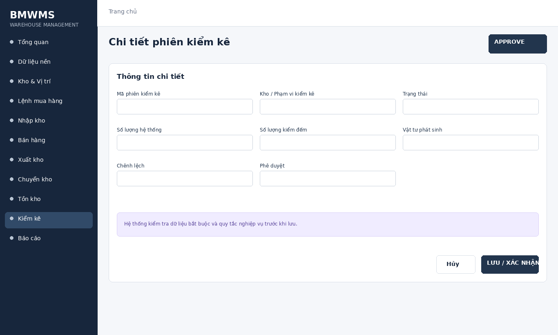
Figure UC-076: Wireframe for Approve stocktake result. Source: BMWMS.Web/Pages/Stocktake/Details.cshtml

Field Description
Field Name | Field Type | Description
Mã phiên kiểm kê | Read-only field | Read-only system-generated number.
Kho / Phạm vi kiểm kê | Dropdown | Read-only stocktake warehouse and selected locations.
Trạng thái | Read-only field | Read-only current stocktake status.
Số lượng hệ thống | Read-only field | Read-only on-hand quantity at the freeze/count point.
Số lượng kiểm đếm | Number input | Numeric input entered by the assigned counter.
Vật tư phát sinh | Display field | Product/lot/location fields used for an item not on the count sheet.
Chênh lệch | Display field | Calculated as Counted quantity minus System quantity.
Phê duyệt | Display field | Start, Submit, Approve or Reject according to role and status.

Use Case Specification
Use Case ID | UC-076 | Use Case Name | Approve stocktake result
Primary Actors | Warehouse Manager; Warehouse Staff | Secondary Actors | BMWMS API; SQL Server database
Description | As an authorized warehouse manager, I want to perform approve stocktake result so that the related warehouse activity is completed and traceable.
Preconditions | The actor is authenticated and authorized. Required master data and source transaction exist and are active.
Postconditions | The approve stocktake result result is saved or displayed successfully. Related statuses and inventory balances remain consistent.
Normal Sequence/Flow | 1. Actor opens the relevant list or detail screen.  2. System displays the current data and actions permitted for the actor.  3. Actor selects Approve.  4. System displays the required input fields or confirmation.  5. Actor enters/reviews the information and confirms.  6. System validates mandatory fields, quantities, authorization and current status.  7. System saves the transaction, updates the status and displays the result.
Alternative Sequences/Flows | A1. Actor cancels before confirmation; system returns to the previous screen without saving.  A2. Actor corrects invalid data and resubmits; system continues from the validation step.
Exception Flows | E1. Required or formatted data is invalid: system shows field-level validation and does not save.  E2. Actor is not authorized: system denies the operation.  E3. Record status changed or is not eligible: system reloads the latest data and disables the action.  E4. API/database/email service is unavailable: system shows an error and keeps the previous consistent state.
Business Rules | Only the assigned counter enters results. Approval posts the variance adjustment; rejection returns the session for correction.

UC-077 Reject stocktake result
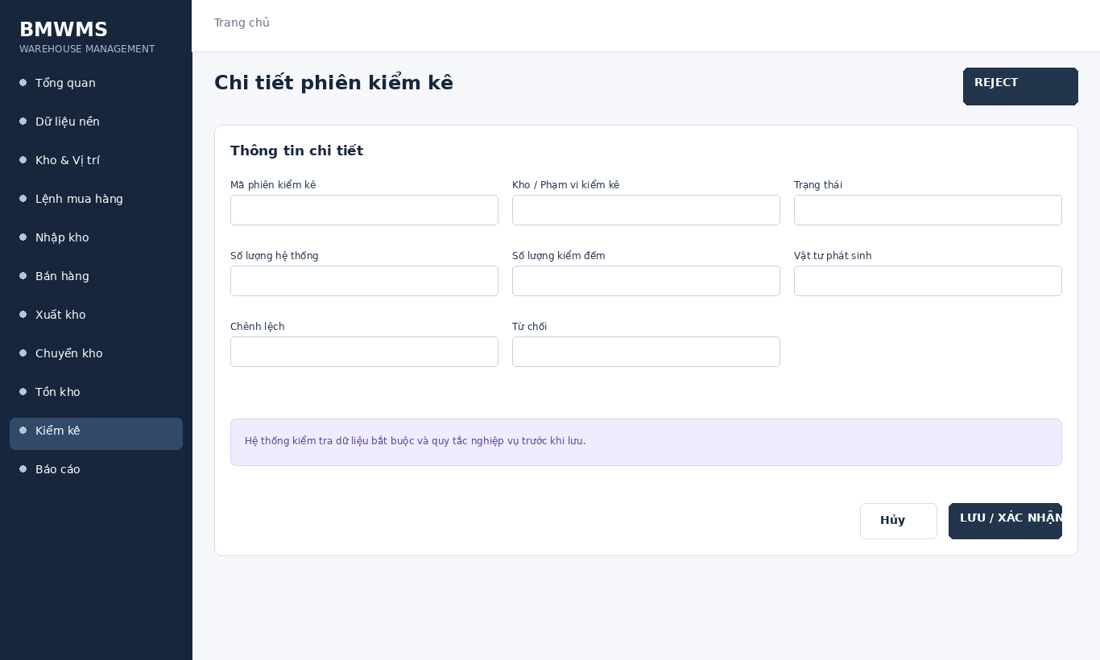
Figure UC-077: Wireframe for Reject stocktake result. Source: BMWMS.Web/Pages/Stocktake/Details.cshtml

Field Description
Field Name | Field Type | Description
Mã phiên kiểm kê | Read-only field | Read-only system-generated number.
Kho / Phạm vi kiểm kê | Dropdown | Read-only stocktake warehouse and selected locations.
Trạng thái | Read-only field | Read-only current stocktake status.
Số lượng hệ thống | Read-only field | Read-only on-hand quantity at the freeze/count point.
Số lượng kiểm đếm | Number input | Numeric input entered by the assigned counter.
Vật tư phát sinh | Display field | Product/lot/location fields used for an item not on the count sheet.
Chênh lệch | Display field | Calculated as Counted quantity minus System quantity.
Từ chối | Display field | Start, Submit, Approve or Reject according to role and status.

Use Case Specification
Use Case ID | UC-077 | Use Case Name | Reject stocktake result
Primary Actors | Warehouse Manager; Warehouse Staff | Secondary Actors | BMWMS API; SQL Server database
Description | As an authorized warehouse manager, I want to perform reject stocktake result so that the related warehouse activity is completed and traceable.
Preconditions | The actor is authenticated and authorized. Required master data and source transaction exist and are active.
Postconditions | The reject stocktake result result is saved or displayed successfully. Related statuses and inventory balances remain consistent.
Normal Sequence/Flow | 1. Actor opens the relevant list or detail screen.  2. System displays the current data and actions permitted for the actor.  3. Actor selects Reject.  4. System displays the required input fields or confirmation.  5. Actor enters/reviews the information and confirms.  6. System validates mandatory fields, quantities, authorization and current status.  7. System saves the transaction, updates the status and displays the result.
Alternative Sequences/Flows | A1. Actor cancels before confirmation; system returns to the previous screen without saving.  A2. Actor corrects invalid data and resubmits; system continues from the validation step.
Exception Flows | E1. Required or formatted data is invalid: system shows field-level validation and does not save.  E2. Actor is not authorized: system denies the operation.  E3. Record status changed or is not eligible: system reloads the latest data and disables the action.  E4. API/database/email service is unavailable: system shows an error and keeps the previous consistent state.
Business Rules | Only the assigned counter enters results. Approval posts the variance adjustment; rejection returns the session for correction.

2.12 Dashboard and Reports

UC-078 View general dashboard
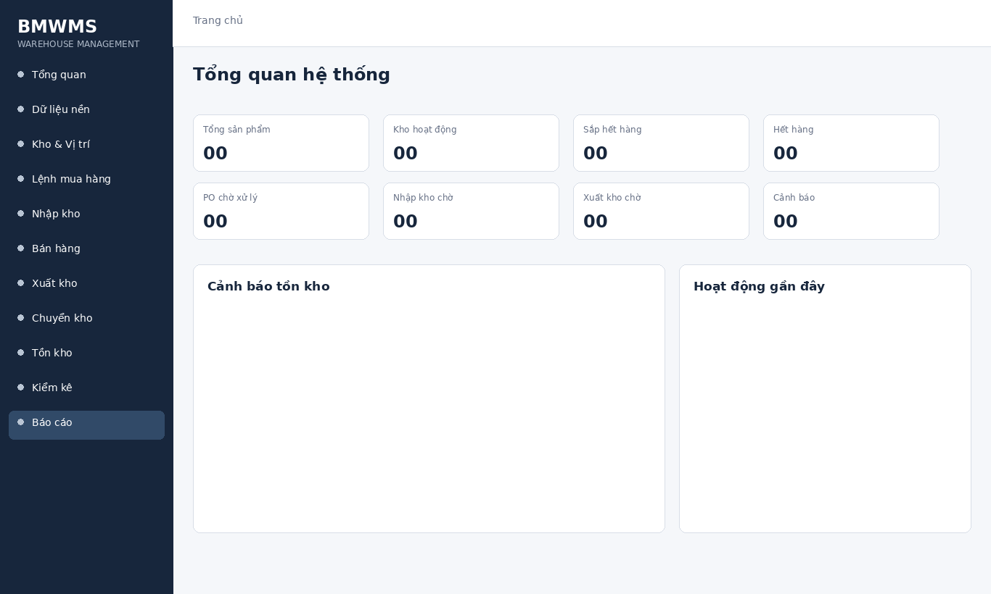
Figure UC-078: Wireframe for View general dashboard. Source: BMWMS.Web/Pages/Admin/Dashboard.cshtml

Field Description
Field Name | Field Type | Description
Từ ngày | Date picker | Optional date. Beginning of the reporting period.
Đến ngày | Date picker | Optional date. End of the reporting period.
Từ khóa / Vật tư | Text box | Optional text box for product, supplier, location or document code.
Trạng thái / Loại chứng từ | Dropdown | Dropdown whose values depend on the selected report; default All.
Xuất Excel | Button | Button that exports the currently filtered report.

Use Case Specification
Use Case ID | UC-078 | Use Case Name | View general dashboard
Primary Actors | System Administrator; Warehouse Manager; Accountant; Director | Secondary Actors | BMWMS API; SQL Server database
Description | As an authorized system administrator, I want to perform view general dashboard so that the related warehouse activity is completed and traceable.
Preconditions | The actor is authenticated and authorized. Required master data and source transaction exist and are active.
Postconditions | The view general dashboard result is saved or displayed successfully. Related statuses and inventory balances remain consistent.
Normal Sequence/Flow | 1. Actor opens the View general dashboard screen.  2. System displays the available filters and current records.  3. Actor enters optional filter criteria.  4. Actor selects Filter/Search/View.  5. System validates the criteria and returns matching data.  6. Actor reviews the result or opens a record for more detail.
Alternative Sequences/Flows | A1. Actor leaves all filters blank; system displays the default paged result.  A2. No record matches; system displays an empty list without changing data.
Exception Flows | E1. Required or formatted data is invalid: system shows field-level validation and does not save.  E2. Actor is not authorized: system denies the operation.  E3. Record status changed or is not eligible: system reloads the latest data and disables the action.  E4. API/database/email service is unavailable: system shows an error and keeps the previous consistent state.
Business Rules | Report results follow the selected filters. Excel export contains the same filtered data visible to the user.

UC-079 View inventory dashboard
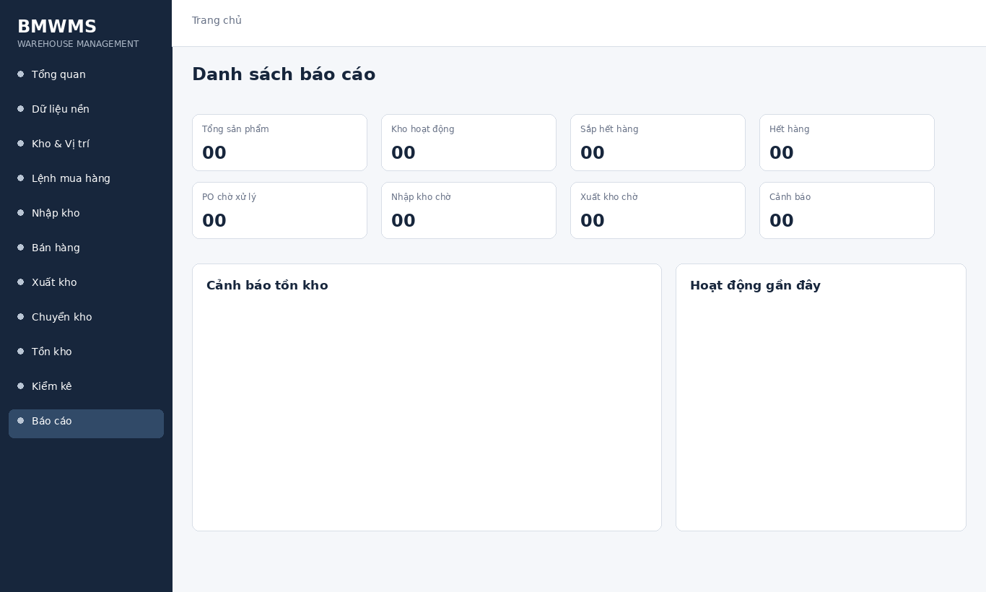
Figure UC-079: Wireframe for View inventory dashboard. Source: BMWMS.Web/Pages/Admin/Dashboard.cshtml

Field Description
Field Name | Field Type | Description
Từ ngày | Date picker | Optional date. Beginning of the reporting period.
Đến ngày | Date picker | Optional date. End of the reporting period.
Từ khóa / Vật tư | Text box | Optional text box for product, supplier, location or document code.
Trạng thái / Loại chứng từ | Dropdown | Dropdown whose values depend on the selected report; default All.
Xuất Excel | Button | Button that exports the currently filtered report.

Use Case Specification
Use Case ID | UC-079 | Use Case Name | View inventory dashboard
Primary Actors | System Administrator; Warehouse Manager; Accountant; Director | Secondary Actors | BMWMS API; SQL Server database
Description | As an authorized system administrator, I want to perform view inventory dashboard so that the related warehouse activity is completed and traceable.
Preconditions | The actor is authenticated and authorized. Required master data and source transaction exist and are active.
Postconditions | The view inventory dashboard result is saved or displayed successfully. Related statuses and inventory balances remain consistent.
Normal Sequence/Flow | 1. Actor opens the View inventory dashboard screen.  2. System displays the available filters and current records.  3. Actor enters optional filter criteria.  4. Actor selects Filter/Search/View.  5. System validates the criteria and returns matching data.  6. Actor reviews the result or opens a record for more detail.
Alternative Sequences/Flows | A1. Actor leaves all filters blank; system displays the default paged result.  A2. No record matches; system displays an empty list without changing data.
Exception Flows | E1. Required or formatted data is invalid: system shows field-level validation and does not save.  E2. Actor is not authorized: system denies the operation.  E3. Record status changed or is not eligible: system reloads the latest data and disables the action.  E4. API/database/email service is unavailable: system shows an error and keeps the previous consistent state.
Business Rules | Report results follow the selected filters. Excel export contains the same filtered data visible to the user.

UC-080 Inventory report
Figure UC-080: Wireframe for Inventory report. Source: BMWMS.Web/Pages/Admin/Dashboard.cshtml

Field Description
Field Name | Field Type | Description
Từ ngày | Date picker | Optional date. Beginning of the reporting period.
Đến ngày | Date picker | Optional date. End of the reporting period.
Từ khóa / Vật tư | Text box | Optional text box for product, supplier, location or document code.
Trạng thái / Loại chứng từ | Dropdown | Dropdown whose values depend on the selected report; default All.
Xuất Excel | Button | Button that exports the currently filtered report.

Use Case Specification
Use Case ID | UC-080 | Use Case Name | Inventory report
Primary Actors | System Administrator; Warehouse Manager; Accountant; Director | Secondary Actors | BMWMS API; SQL Server database
Description | As an authorized system administrator, I want to perform inventory report so that the related warehouse activity is completed and traceable.
Preconditions | The actor is authenticated and authorized. Required master data and source transaction exist and are active.
Postconditions | The inventory report result is saved or displayed successfully. Related statuses and inventory balances remain consistent.
Normal Sequence/Flow | 1. Actor opens the Inventory report screen.  2. System displays the available filters and current records.  3. Actor enters optional filter criteria.  4. Actor selects Filter/Search/View.  5. System validates the criteria and returns matching data.  6. Actor reviews the result or opens a record for more detail.
Alternative Sequences/Flows | A1. Actor leaves all filters blank; system displays the default paged result.  A2. No record matches; system displays an empty list without changing data.
Exception Flows | E1. Required or formatted data is invalid: system shows field-level validation and does not save.  E2. Actor is not authorized: system denies the operation.  E3. Record status changed or is not eligible: system reloads the latest data and disables the action.  E4. API/database/email service is unavailable: system shows an error and keeps the previous consistent state.
Business Rules | Report results follow the selected filters. Excel export contains the same filtered data visible to the user.

UC-081 Inbound report
Figure UC-081: Wireframe for Inbound report. Source: BMWMS.Web/Pages/Admin/Dashboard.cshtml

Field Description
Field Name | Field Type | Description
Từ ngày | Date picker | Optional date. Beginning of the reporting period.
Đến ngày | Date picker | Optional date. End of the reporting period.
Từ khóa / Vật tư | Text box | Optional text box for product, supplier, location or document code.
Trạng thái / Loại chứng từ | Dropdown | Dropdown whose values depend on the selected report; default All.
Xuất Excel | Button | Button that exports the currently filtered report.

Use Case Specification
Use Case ID | UC-081 | Use Case Name | Inbound report
Primary Actors | System Administrator; Warehouse Manager; Accountant; Director | Secondary Actors | BMWMS API; SQL Server database
Description | As an authorized system administrator, I want to perform inbound report so that the related warehouse activity is completed and traceable.
Preconditions | The actor is authenticated and authorized. Required master data and source transaction exist and are active.
Postconditions | The inbound report result is saved or displayed successfully. Related statuses and inventory balances remain consistent.
Normal Sequence/Flow | 1. Actor opens the Inbound report screen.  2. System displays the available filters and current records.  3. Actor enters optional filter criteria.  4. Actor selects Filter/Search/View.  5. System validates the criteria and returns matching data.  6. Actor reviews the result or opens a record for more detail.
Alternative Sequences/Flows | A1. Actor leaves all filters blank; system displays the default paged result.  A2. No record matches; system displays an empty list without changing data.
Exception Flows | E1. Required or formatted data is invalid: system shows field-level validation and does not save.  E2. Actor is not authorized: system denies the operation.  E3. Record status changed or is not eligible: system reloads the latest data and disables the action.  E4. API/database/email service is unavailable: system shows an error and keeps the previous consistent state.
Business Rules | Report results follow the selected filters. Excel export contains the same filtered data visible to the user.

UC-082 Outbound report
Figure UC-082: Wireframe for Outbound report. Source: BMWMS.Web/Pages/Admin/Dashboard.cshtml

Field Description
Field Name | Field Type | Description
Từ ngày | Date picker | Optional date. Beginning of the reporting period.
Đến ngày | Date picker | Optional date. End of the reporting period.
Từ khóa / Vật tư | Text box | Optional text box for product, supplier, location or document code.
Trạng thái / Loại chứng từ | Dropdown | Dropdown whose values depend on the selected report; default All.
Xuất Excel | Button | Button that exports the currently filtered report.

Use Case Specification
Use Case ID | UC-082 | Use Case Name | Outbound report
Primary Actors | System Administrator; Warehouse Manager; Accountant; Director | Secondary Actors | BMWMS API; SQL Server database
Description | As an authorized system administrator, I want to perform outbound report so that the related warehouse activity is completed and traceable.
Preconditions | The actor is authenticated and authorized. Required master data and source transaction exist and are active.
Postconditions | The outbound report result is saved or displayed successfully. Related statuses and inventory balances remain consistent.
Normal Sequence/Flow | 1. Actor opens the Outbound report screen.  2. System displays the available filters and current records.  3. Actor enters optional filter criteria.  4. Actor selects Filter/Search/View.  5. System validates the criteria and returns matching data.  6. Actor reviews the result or opens a record for more detail.
Alternative Sequences/Flows | A1. Actor leaves all filters blank; system displays the default paged result.  A2. No record matches; system displays an empty list without changing data.
Exception Flows | E1. Required or formatted data is invalid: system shows field-level validation and does not save.  E2. Actor is not authorized: system denies the operation.  E3. Record status changed or is not eligible: system reloads the latest data and disables the action.  E4. API/database/email service is unavailable: system shows an error and keeps the previous consistent state.
Business Rules | Report results follow the selected filters. Excel export contains the same filtered data visible to the user.

UC-083 Inbound-outbound-stock report
Figure UC-083: Wireframe for Inbound-outbound-stock report. Source: BMWMS.Web/Pages/Admin/Dashboard.cshtml

Field Description
Field Name | Field Type | Description
Từ ngày | Date picker | Optional date. Beginning of the reporting period.
Đến ngày | Date picker | Optional date. End of the reporting period.
Từ khóa / Vật tư | Text box | Optional text box for product, supplier, location or document code.
Trạng thái / Loại chứng từ | Dropdown | Dropdown whose values depend on the selected report; default All.
Xuất Excel | Button | Button that exports the currently filtered report.

Use Case Specification
Use Case ID | UC-083 | Use Case Name | Inbound-outbound-stock report
Primary Actors | System Administrator; Warehouse Manager; Accountant; Director | Secondary Actors | BMWMS API; SQL Server database
Description | As an authorized system administrator, I want to perform inbound-outbound-stock report so that the related warehouse activity is completed and traceable.
Preconditions | The actor is authenticated and authorized. Required master data and source transaction exist and are active.
Postconditions | The inbound-outbound-stock report result is saved or displayed successfully. Related statuses and inventory balances remain consistent.
Normal Sequence/Flow | 1. Actor opens the Inbound-outbound-stock report screen.  2. System displays the available filters and current records.  3. Actor enters optional filter criteria.  4. Actor selects Filter/Search/View.  5. System validates the criteria and returns matching data.  6. Actor reviews the result or opens a record for more detail.
Alternative Sequences/Flows | A1. Actor leaves all filters blank; system displays the default paged result.  A2. No record matches; system displays an empty list without changing data.
Exception Flows | E1. Required or formatted data is invalid: system shows field-level validation and does not save.  E2. Actor is not authorized: system denies the operation.  E3. Record status changed or is not eligible: system reloads the latest data and disables the action.  E4. API/database/email service is unavailable: system shows an error and keeps the previous consistent state.
Business Rules | Report results follow the selected filters. Excel export contains the same filtered data visible to the user.

UC-084 Product statistics
Figure UC-084: Wireframe for Product statistics. Source: BMWMS.Web/Pages/Admin/Dashboard.cshtml

Field Description
Field Name | Field Type | Description
Từ ngày | Date picker | Optional date. Beginning of the reporting period.
Đến ngày | Date picker | Optional date. End of the reporting period.
Từ khóa / Vật tư | Text box | Optional text box for product, supplier, location or document code.
Trạng thái / Loại chứng từ | Dropdown | Dropdown whose values depend on the selected report; default All.
Xuất Excel | Button | Button that exports the currently filtered report.

Use Case Specification
Use Case ID | UC-084 | Use Case Name | Product statistics
Primary Actors | System Administrator; Warehouse Manager; Accountant; Director | Secondary Actors | BMWMS API; SQL Server database
Description | As an authorized system administrator, I want to perform product statistics so that the related warehouse activity is completed and traceable.
Preconditions | The actor is authenticated and authorized. Required master data and source transaction exist and are active.
Postconditions | The product statistics result is saved or displayed successfully. Related statuses and inventory balances remain consistent.
Normal Sequence/Flow | 1. Actor opens the Product statistics screen.  2. System displays the available filters and current records.  3. Actor enters optional filter criteria.  4. Actor selects Filter/Search/View.  5. System validates the criteria and returns matching data.  6. Actor reviews the result or opens a record for more detail.
Alternative Sequences/Flows | A1. Actor leaves all filters blank; system displays the default paged result.  A2. No record matches; system displays an empty list without changing data.
Exception Flows | E1. Required or formatted data is invalid: system shows field-level validation and does not save.  E2. Actor is not authorized: system denies the operation.  E3. Record status changed or is not eligible: system reloads the latest data and disables the action.  E4. API/database/email service is unavailable: system shows an error and keeps the previous consistent state.
Business Rules | Report results follow the selected filters. Excel export contains the same filtered data visible to the user.

UC-085 Supplier statistics
Figure UC-085: Wireframe for Supplier statistics. Source: BMWMS.Web/Pages/Admin/Dashboard.cshtml

Field Description
Field Name | Field Type | Description
Từ ngày | Date picker | Optional date. Beginning of the reporting period.
Đến ngày | Date picker | Optional date. End of the reporting period.
Từ khóa / Vật tư | Text box | Optional text box for product, supplier, location or document code.
Trạng thái / Loại chứng từ | Dropdown | Dropdown whose values depend on the selected report; default All.
Xuất Excel | Button | Button that exports the currently filtered report.

Use Case Specification
Use Case ID | UC-085 | Use Case Name | Supplier statistics
Primary Actors | System Administrator; Warehouse Manager; Accountant; Director | Secondary Actors | BMWMS API; SQL Server database
Description | As an authorized system administrator, I want to perform supplier statistics so that the related warehouse activity is completed and traceable.
Preconditions | The actor is authenticated and authorized. Required master data and source transaction exist and are active.
Postconditions | The supplier statistics result is saved or displayed successfully. Related statuses and inventory balances remain consistent.
Normal Sequence/Flow | 1. Actor opens the Supplier statistics screen.  2. System displays the available filters and current records.  3. Actor enters optional filter criteria.  4. Actor selects Filter/Search/View.  5. System validates the criteria and returns matching data.  6. Actor reviews the result or opens a record for more detail.
Alternative Sequences/Flows | A1. Actor leaves all filters blank; system displays the default paged result.  A2. No record matches; system displays an empty list without changing data.
Exception Flows | E1. Required or formatted data is invalid: system shows field-level validation and does not save.  E2. Actor is not authorized: system denies the operation.  E3. Record status changed or is not eligible: system reloads the latest data and disables the action.  E4. API/database/email service is unavailable: system shows an error and keeps the previous consistent state.
Business Rules | Report results follow the selected filters. Excel export contains the same filtered data visible to the user.

UC-086 Stocktake statistics
Figure UC-086: Wireframe for Stocktake statistics. Source: BMWMS.Web/Pages/Admin/Dashboard.cshtml

Field Description
Field Name | Field Type | Description
Từ ngày | Date picker | Optional date. Beginning of the reporting period.
Đến ngày | Date picker | Optional date. End of the reporting period.
Từ khóa / Vật tư | Text box | Optional text box for product, supplier, location or document code.
Trạng thái / Loại chứng từ | Dropdown | Dropdown whose values depend on the selected report; default All.
Xuất Excel | Button | Button that exports the currently filtered report.

Use Case Specification
Use Case ID | UC-086 | Use Case Name | Stocktake statistics
Primary Actors | System Administrator; Warehouse Manager; Accountant; Director | Secondary Actors | BMWMS API; SQL Server database
Description | As an authorized system administrator, I want to perform stocktake statistics so that the related warehouse activity is completed and traceable.
Preconditions | The actor is authenticated and authorized. Required master data and source transaction exist and are active.
Postconditions | The stocktake statistics result is saved or displayed successfully. Related statuses and inventory balances remain consistent.
Normal Sequence/Flow | 1. Actor opens the Stocktake statistics screen.  2. System displays the available filters and current records.  3. Actor enters optional filter criteria.  4. Actor selects Filter/Search/View.  5. System validates the criteria and returns matching data.  6. Actor reviews the result or opens a record for more detail.
Alternative Sequences/Flows | A1. Actor leaves all filters blank; system displays the default paged result.  A2. No record matches; system displays an empty list without changing data.
Exception Flows | E1. Required or formatted data is invalid: system shows field-level validation and does not save.  E2. Actor is not authorized: system denies the operation.  E3. Record status changed or is not eligible: system reloads the latest data and disables the action.  E4. API/database/email service is unavailable: system shows an error and keeps the previous consistent state.
Business Rules | Report results follow the selected filters. Excel export contains the same filtered data visible to the user.

UC-087 Warehouse KPI report
Figure UC-087: Wireframe for Warehouse KPI report. Source: BMWMS.Web/Pages/Admin/Dashboard.cshtml

Field Description
Field Name | Field Type | Description
Từ ngày | Date picker | Optional date. Beginning of the reporting period.
Đến ngày | Date picker | Optional date. End of the reporting period.
Từ khóa / Vật tư | Text box | Optional text box for product, supplier, location or document code.
Trạng thái / Loại chứng từ | Dropdown | Dropdown whose values depend on the selected report; default All.
Xuất Excel | Button | Button that exports the currently filtered report.

Use Case Specification
Use Case ID | UC-087 | Use Case Name | Warehouse KPI report
Primary Actors | System Administrator; Warehouse Manager; Accountant; Director | Secondary Actors | BMWMS API; SQL Server database
Description | As an authorized system administrator, I want to perform warehouse kpi report so that the related warehouse activity is completed and traceable.
Preconditions | The actor is authenticated and authorized. Required master data and source transaction exist and are active.
Postconditions | The warehouse kpi report result is saved or displayed successfully. Related statuses and inventory balances remain consistent.
Normal Sequence/Flow | 1. Actor opens the Warehouse KPI report screen.  2. System displays the available filters and current records.  3. Actor enters optional filter criteria.  4. Actor selects Filter/Search/View.  5. System validates the criteria and returns matching data.  6. Actor reviews the result or opens a record for more detail.
Alternative Sequences/Flows | A1. Actor leaves all filters blank; system displays the default paged result.  A2. No record matches; system displays an empty list without changing data.
Exception Flows | E1. Required or formatted data is invalid: system shows field-level validation and does not save.  E2. Actor is not authorized: system denies the operation.  E3. Record status changed or is not eligible: system reloads the latest data and disables the action.  E4. API/database/email service is unavailable: system shows an error and keeps the previous consistent state.
Business Rules | Report results follow the selected filters. Excel export contains the same filtered data visible to the user.

UC-088 Low-stock alert
Figure UC-088: Wireframe for Low-stock alert. Source: BMWMS.Web/Pages/Admin/Dashboard.cshtml

Field Description
Field Name | Field Type | Description
Từ ngày | Date picker | Optional date. Beginning of the reporting period.
Đến ngày | Date picker | Optional date. End of the reporting period.
Từ khóa / Vật tư | Text box | Optional text box for product, supplier, location or document code.
Trạng thái / Loại chứng từ | Dropdown | Dropdown whose values depend on the selected report; default All.
Xuất Excel | Button | Button that exports the currently filtered report.

Use Case Specification
Use Case ID | UC-088 | Use Case Name | Low-stock alert
Primary Actors | System Administrator; Warehouse Manager; Accountant; Director | Secondary Actors | BMWMS API; SQL Server database
Description | As an authorized system administrator, I want to perform low-stock alert so that the related warehouse activity is completed and traceable.
Preconditions | The actor is authenticated and authorized. Required master data and source transaction exist and are active.
Postconditions | The low-stock alert result is saved or displayed successfully. Related statuses and inventory balances remain consistent.
Normal Sequence/Flow | 1. Actor opens the Low-stock alert screen.  2. System displays the available filters and current records.  3. Actor enters optional filter criteria.  4. Actor selects Filter/Search/View.  5. System validates the criteria and returns matching data.  6. Actor reviews the result or opens a record for more detail.
Alternative Sequences/Flows | A1. Actor leaves all filters blank; system displays the default paged result.  A2. No record matches; system displays an empty list without changing data.
Exception Flows | E1. Required or formatted data is invalid: system shows field-level validation and does not save.  E2. Actor is not authorized: system denies the operation.  E3. Record status changed or is not eligible: system reloads the latest data and disables the action.  E4. API/database/email service is unavailable: system shows an error and keeps the previous consistent state.
Business Rules | Report results follow the selected filters. Excel export contains the same filtered data visible to the user.

UC-089 Expiring-lot alert
Figure UC-089: Wireframe for Expiring-lot alert. Source: BMWMS.Web/Pages/Admin/Dashboard.cshtml

Field Description
Field Name | Field Type | Description
Từ ngày | Date picker | Optional date. Beginning of the reporting period.
Đến ngày | Date picker | Optional date. End of the reporting period.
Từ khóa / Vật tư | Text box | Optional text box for product, supplier, location or document code.
Trạng thái / Loại chứng từ | Dropdown | Dropdown whose values depend on the selected report; default All.
Xuất Excel | Button | Button that exports the currently filtered report.

Use Case Specification
Use Case ID | UC-089 | Use Case Name | Expiring-lot alert
Primary Actors | System Administrator; Warehouse Manager; Accountant; Director | Secondary Actors | BMWMS API; SQL Server database
Description | As an authorized system administrator, I want to perform expiring-lot alert so that the related warehouse activity is completed and traceable.
Preconditions | The actor is authenticated and authorized. Required master data and source transaction exist and are active.
Postconditions | The expiring-lot alert result is saved or displayed successfully. Related statuses and inventory balances remain consistent.
Normal Sequence/Flow | 1. Actor opens the Expiring-lot alert screen.  2. System displays the available filters and current records.  3. Actor enters optional filter criteria.  4. Actor selects Filter/Search/View.  5. System validates the criteria and returns matching data.  6. Actor reviews the result or opens a record for more detail.
Alternative Sequences/Flows | A1. Actor leaves all filters blank; system displays the default paged result.  A2. No record matches; system displays an empty list without changing data.
Exception Flows | E1. Required or formatted data is invalid: system shows field-level validation and does not save.  E2. Actor is not authorized: system denies the operation.  E3. Record status changed or is not eligible: system reloads the latest data and disables the action.  E4. API/database/email service is unavailable: system shows an error and keeps the previous consistent state.
Business Rules | Report results follow the selected filters. Excel export contains the same filtered data visible to the user.

UC-090 Overdue-order alert
Figure UC-090: Wireframe for Overdue-order alert. Source: BMWMS.Web/Pages/Admin/Dashboard.cshtml

Field Description
Field Name | Field Type | Description
Từ ngày | Date picker | Optional date. Beginning of the reporting period.
Đến ngày | Date picker | Optional date. End of the reporting period.
Từ khóa / Vật tư | Text box | Optional text box for product, supplier, location or document code.
Trạng thái / Loại chứng từ | Dropdown | Dropdown whose values depend on the selected report; default All.
Xuất Excel | Button | Button that exports the currently filtered report.

Use Case Specification
Use Case ID | UC-090 | Use Case Name | Overdue-order alert
Primary Actors | System Administrator; Warehouse Manager; Accountant; Director | Secondary Actors | BMWMS API; SQL Server database
Description | As an authorized system administrator, I want to perform overdue-order alert so that the related warehouse activity is completed and traceable.
Preconditions | The actor is authenticated and authorized. Required master data and source transaction exist and are active.
Postconditions | The overdue-order alert result is saved or displayed successfully. Related statuses and inventory balances remain consistent.
Normal Sequence/Flow | 1. Actor opens the Overdue-order alert screen.  2. System displays the available filters and current records.  3. Actor enters optional filter criteria.  4. Actor selects Filter/Search/View.  5. System validates the criteria and returns matching data.  6. Actor reviews the result or opens a record for more detail.
Alternative Sequences/Flows | A1. Actor leaves all filters blank; system displays the default paged result.  A2. No record matches; system displays an empty list without changing data.
Exception Flows | E1. Required or formatted data is invalid: system shows field-level validation and does not save.  E2. Actor is not authorized: system denies the operation.  E3. Record status changed or is not eligible: system reloads the latest data and disables the action.  E4. API/database/email service is unavailable: system shows an error and keeps the previous consistent state.
Business Rules | Report results follow the selected filters. Excel export contains the same filtered data visible to the user.

UC-091 Export report to Excel
Figure UC-091: Wireframe for Export report to Excel. Source: BMWMS.Web/Pages/Admin/Dashboard.cshtml

Field Description
Field Name | Field Type | Description
Từ ngày | Date picker | Optional date. Beginning of the reporting period.
Đến ngày | Date picker | Optional date. End of the reporting period.
Từ khóa / Vật tư | Text box | Optional text box for product, supplier, location or document code.
Trạng thái / Loại chứng từ | Dropdown | Dropdown whose values depend on the selected report; default All.
Xuất Excel | Button | Button that exports the currently filtered report.

Use Case Specification
Use Case ID | UC-091 | Use Case Name | Export report to Excel
Primary Actors | System Administrator; Warehouse Manager; Accountant; Director | Secondary Actors | BMWMS API; SQL Server database
Description | As an authorized system administrator, I want to perform export report to excel so that the related warehouse activity is completed and traceable.
Preconditions | The actor is authenticated and authorized. Required master data and source transaction exist and are active.
Postconditions | The export report to excel result is saved or displayed successfully. Related statuses and inventory balances remain consistent.
Normal Sequence/Flow | 1. Actor opens the Export report to Excel screen.  2. System displays the available filters and current records.  3. Actor enters optional filter criteria.  4. Actor selects Filter/Search/View.  5. System validates the criteria and returns matching data.  6. Actor reviews the result or opens a record for more detail.
Alternative Sequences/Flows | A1. Actor leaves all filters blank; system displays the default paged result.  A2. No record matches; system displays an empty list without changing data.
Exception Flows | E1. Required or formatted data is invalid: system shows field-level validation and does not save.  E2. Actor is not authorized: system denies the operation.  E3. Record status changed or is not eligible: system reloads the latest data and disables the action.  E4. API/database/email service is unavailable: system shows an error and keeps the previous consistent state.
Business Rules | Report results follow the selected filters. Excel export contains the same filtered data visible to the user.

3. Functional Requirements
The functional requirements are defined through the screen wireframes, Field Description tables and complete Use Case Specification tables in Section 2. Each wireframe reproduces the current deployed BMWMS navigation shell and the corresponding list, form, detail, dashboard, report or warehouse-map layout.
Requirement group | Covered use cases | Verification source
Authentication and Profile | UC-001 to UC-006 | Deployed BMWMS UI and corresponding Razor Pages
User and Role Management | UC-007 to UC-013 | Deployed BMWMS UI and corresponding Razor Pages
Master Data Management | UC-014 to UC-022 | Deployed BMWMS UI and corresponding Razor Pages
Warehouse and Storage | UC-023 to UC-026 | Deployed BMWMS UI and corresponding Razor Pages
Purchase Order | UC-027 to UC-033 | Deployed BMWMS UI and corresponding Razor Pages
Inbound | UC-034 to UC-043 | Deployed BMWMS UI and corresponding Razor Pages
Sales Order | UC-044 to UC-046 | Deployed BMWMS UI and corresponding Razor Pages
Outbound | UC-047 to UC-056 | Deployed BMWMS UI and corresponding Razor Pages
Transfer Order | UC-057 to UC-062 | Deployed BMWMS UI and corresponding Razor Pages
Inventory | UC-063 to UC-067 | Deployed BMWMS UI and corresponding Razor Pages
Stocktake | UC-068 to UC-077 | Deployed BMWMS UI and corresponding Razor Pages
Dashboard and Reports | UC-078 to UC-091 | Deployed BMWMS UI and corresponding Razor Pages

4. Non-functional Requirements
NFR-01 Security: API uses JWT authentication and role-based authorization. Web uses cookie authentication and session-managed API token.
NFR-02 Performance: Paged list APIs should return bounded page sizes; the API currently limits page size to 100 for Purchase Orders.
NFR-03 Data integrity: Unique keys, foreign keys, quantity rules and status validations protect transactional data.
NFR-04 Auditability: Operational changes such as PO confirmation and cancellation are written to audit logs in the current implementation.
NFR-05 Maintainability: The solution separates Web, API, Business and Repository projects.
NFR-06 Deployment: The system targets .NET 9, SQL Server and Docker compose files are provided for application/database setup.

5. Requirement Appendix

5.1 Business Rules
Feature | Business rule summary
Authentication and Profile | Authentication is role-based. Five consecutive invalid attempts lock the account for 15 minutes. Password recovery uses the registered email.
User and Role Management | Username and email must be unique. Only System Administrator can create users or assign roles.
Master Data Management | Codes are unique. Inactive master data cannot be selected for new transactions. Product rotation is FIFO or FEFO.
Warehouse and Storage | The hierarchy is Warehouse - Zone - Rack - Bin. A child location requires an active parent.
Purchase Order | A PO is created in DRAFT. Sending to the supplier changes it to CONFIRMED. Only DRAFT can be cancelled. Incomplete receipt may be continued or closed with remainder.
Inbound | Actual received and rejected quantities cannot be negative. Accepted stock must have a putaway location; lot/expiry is required according to product settings.
Sales Order | Requested quantity must be positive. A product cannot appear twice in the same order.
Outbound | Issued quantity cannot exceed reserved/available stock. Picking follows the configured FIFO/FEFO rule. Completion updates inventory.
Transfer Order | Source and destination must differ. Transfer quantity cannot exceed available inventory. Only approved transfers may be executed.
Inventory | Available quantity equals On hand minus Reserved. Inventory is tracked by product, location and lot where applicable.
Stocktake | Only the assigned counter enters results. Approval posts the variance adjustment; rejection returns the session for correction.
Dashboard and Reports | Report results follow the selected filters. Excel export contains the same filtered data visible to the user.

5.2 System Messages
Message type | Expected behavior
Validation | Display a field-level message and preserve the entered values.
Authorization | Deny the operation and return the user to an authorized screen.
Success | Confirm the completed operation and show the latest persisted state.
Service failure | Show a neutral error and preserve the previous consistent state.

