The International Conference on Management, Business, Economics, Law and Technology (COMBELT-2026)
June 3t^{th}, Danang, Vietnam
A MULTIMODAL STABLE FUSION APPROACH FOR FINE-GRAINED STOCK MOVEMENT PREDICTION: EMPIRICAL EVIDENCE FROM THE U.S. STOCK MARKET
Le Dien Tuanª, Nguyen Viet Khoaª, Tieu Thanh Mai Anhª, Ngo Tan Phong ª, Le Hung Phucª, Tran Vu Ha Myª, Chau Thi Da Huongª
ªThe University of Danang – University of Economics, 71 Ngu Hanh Son, Danang 550000, Vietnam
ABSTRACT
Short-horizon stock movement prediction is a central problem in quantitative finance. However, integrating heterogeneous market signals, including numerical and textual data, remains challenging due to the unstructured nature of financial texts and cross-modal directional conflicts that conventional fusion approaches fail to resolve. Therefore, this study proposes News-Knowledge Tri-modal Fusion (NKTriF), a deep learning architecture targeting this prediction task. The main contributions of this study are as follows: (i) a Cross-Attention fusion mechanism that jointly integrates three heterogeneous input modalities, including historical price indicators, financial news, and macroeconomic indices, to capture complex cross-modal interactions; (ii) a gating mechanism that regulates auxiliary-modality contribution to resolve cross-modal directional conflicts; and (iii) a structured financial news extraction pipeline that converts raw news into Subject-Relation-Object (S-R-O) triples via LLM few-shot prompting, thereby isolating ticker-specific impactful events from surrounding linguistic noise. Experimental results show that NKTriF outperforms current leading methods, confirming the viability of structured knowledge-driven multimodal fusion as a practical approach for quantitative trading applications.
Keywords: stock movement prediction; multimodal fusion; gated cross-attention; financial knowledge extraction
- Introduction
Stock movement prediction is a central problem in quantitative finance, directly supporting investment strategy, risk management, and algorithmic trading. Accurate short-horizon forecasting requires integrating heterogeneous market signals, including historical prices, macroeconomic conditions, and event-driven news. However, their differences in structure, update frequency, and temporal resolution make the integration of these information modalities into predicting models the crucial challenge.
Early approaches rely exclusively on numerical features, including historical stock price series and macroeconomic indices. Specifically, statistical methods model return autocorrelation and conditional variance within linear frameworks [1, 3, 10], while deep learning architectures capture more complex temporal dependencies through recurrent networks and Attention mechanisms [11, 12, 17, 20, 26]. However, all numerical approaches remain blind to event-driven information before it is absorbed into prices.
State-of-the-art research in this field integrates financial news, such as corporate announcements, earnings reports, and regulatory actions, to capture market-relevant events and model their effect on market sentiment. Progression in this line of work moves from document-level sentiment embeddings [16, 24] toward finer-grained structured event representations that isolate financially relevant content from surrounding linguistic noise [8], and more recently toward cross-modal fusion architectures that jointly process price dynamics and textual signals [21]. These advances consistently demonstrate that richer input representations improve directional forecasting accuracy.
Despite the consistent development, two critical gaps remain. First, existing frameworks lack a principled mechanism to resolve directional conflicts among modalities. For example, a stock's price may be declining while the news carries a positive sentiment. Without a conflict-aware regulation mechanism, conventional fusion treats all modalities as equally reliable, forcing the model to reconcile irreconcilable signals and yielding a joint representation that faithfully reflects none of them.
Second, raw financial news presents two compounding sources of noise that current approaches do not adequately address before fusion. At the article level, a single news article often covers multiple companies, making it difficult to isolate target-stock relevance. At the content level, financial articles contain substantial linguistic filler surrounding the financially important claims. Together, these two noise sources degrade the quality of textual representations fed into the model. Existing approaches encode financial news either at the headline or document level, diluting stock-specific signals with irrelevant content. Others reduce textual input to coarse-grained sentiment polarity, failing to capture the specific actors, actions, and magnitudes of market-moving events that sentiment labels alone cannot encode.
To address both gaps, this study proposes News-Knowledge Tri-modal Fusion (NKTriF), a deep learning architecture utilizing three modalities: historical price series, financial news, and macroeconomic indices. To reduce linguistic noise and isolate target-ticker sentiment from raw financial news, Subject-Relation-Object (S-R-O) triple extraction is applied via LLM few-shot prompting with schema-constrained output to standardize entities and relations into predefined taxonomies, thereby eliminating semantic variance across different surface-level expressions of the same event. Then, a sequential two-stage Gated Cross-Attention module integrates these three modalities with a price-conditioned stabilizing gate at each stage to suppress conflicting auxiliary signals. Together, these two components enable NKTriF to extract compact, ticker-specific signals from noisy news and integrate them stably with price and macroeconomic context, addressing the core extraction and fusion challenges that limit prior multimodal approaches.
The remainder of this paper is organized as follows. Section 2 reviews related work. Section 3 details the research methodology, including the proposed model’s architecture, evaluation metrics and the trading simulation. Section 4 presents experimental set-up, results, and in-depth analyses. Section 5 concludes with limitations and directions for future research.
- Related work
The earliest quantitative approaches treat stock prediction as a univariate time series problem. Box and Jenkins [4] propose ARIMA to model return autocorrelation, and Bollerslev [3] extends Engle's [10] ARCH model to GARCH for conditional variance estimation. Both remain standard reference points but are linear by construction and operate solely on price history. Deep learning addresses this by modeling nonlinear temporal dependencies: Fischer and Krauss [12] demonstrate that LSTM networks outperform statistical baselines on large-scale equity prediction, and Feng et al. [11] augment this with temporal attention to emphasize the most predictive time steps. Subsequent work expands the input space beyond single-stock price history by modeling cross-asset dependencies, with Qin et al. [20], Yoo et al. [26], and Huynh et al. [17] demonstrating consistent gains through attention-based multivariate architectures. Despite these advances, price-based models cannot anticipate event-driven price movements because their inputs only reflect information already absorbed by the market.
Financial news carries high-impact, event-driven signals that often precede price movements before they are fully reflected in market data. Recent research therefore attempts to incorporate textual information into stock prediction pipelines as a complementary modality. Early work encodes financial news using pretrained financial language models such as FinBert [25], capturing broad sentiment but diluting stock-specific signals with linguistic noise. Xu and Cohen [24] present a deep generative model that jointly processes tweet text and historical prices. Hu et al. [16] introduce a Hybrid Attention Network that applies intra-day attention to condense same-session articles into a single vector and temporal attention to weight historical sessions by predictive relevance. Both works demonstrate that textual signals carry exploitable predictive information, but these holistic encoding approach treats the entire document as a uniform input without distinguishing financially relevant content from surrounding noise. Ding et al. [8] show that structured event extraction, representing news as (Actor, Action, Object) triples, isolates financially relevant content more effectively than holistic encodings. More recently, Dolphin et al. [9] leverage large language models to extract entity mentions and sentiment from raw text, pairing this with a ticker-validation database to reduce entity disambiguation errors.
Combining historical price, macroeconomic indices, and textual signals requires reconciling modalities that differ in structure, update frequency, and reliability. The simplest approach, feature concatenation, treats all inputs equally regardless of data quality, making fused representations vulnerable to the noisiest modality. Cross-attention advances this by enabling asymmetric information retrieval, allowing models to selectively attend to more informative signals across modalities [22]. However, these standard fusion strategies provide no explicit mechanism to suppress conflicting or uninformative signals across modalities. These studies collectively underscore the growing importance of combining heterogeneous financial signals with a structured extraction pipeline and a stable, noise-resilient fusion mechanism for reliable stock movement prediction.
- Research methodology
  - Problem Statement
The problem of stock price movement prediction is formulated as a three-class classification task. For a given date $t$ and a target stock $s$, the price movement is defined based on the change in its closing price on the next trading day $t+1$. Similar to previous studies, this movement is categorized into three classes: Down, Flat, and Up, representing a significant price decline, a negligible change, and a significant increase, respectively.
The multimodal stock trend prediction task can be formulated as follows: given the observation window length $T$, the stock $s$, and the forecast date $t$, the goal is to use the multimodal information sequence from time $t-T+1$ to $t$, denoted as $M=\{P, N, E\}$, to predict the class $y∈\{\text{down}, \text{flat}, \text{up}\}$ at date $t+1$. Specifically, each modality is formulated as a temporal set over the observation window:
Price modality $\left(P\right)$: $P=\{P_{t-T+1}, P_{t-T+2},…, P_{t}\}$, where each $P_{i}$ contains the volatility-normalized log-returns for the open and high prices on date $i$, alongside the close price used to define the prediction target.
News modality $\left(N\right)$: $N=\{N_{t-T+1}, N_{t-T+2},…, N_{t}\}$, where each $N_{i}$ denotes the FinBERT daily embedding of financial news on date $i$. On days with no valid news, $N_{i}$ is set to a zero vector.
Macroeconomic modality $\left(E\right)$: $E=\{E_{t-T+1},E_{t-T+2},…,E_{t}\}$, where each $E_{i}$ comprises the five z-scored macroeconomic indices (lagged by one trading day) on date $i$.
  - Framework Overview
The proposed NKTriF model is an end-to-end deep learning framework for stock price movement prediction. It follows an encoder-fusion-decoder architecture comprising three sequential phases, as illustrated in Figure 1.
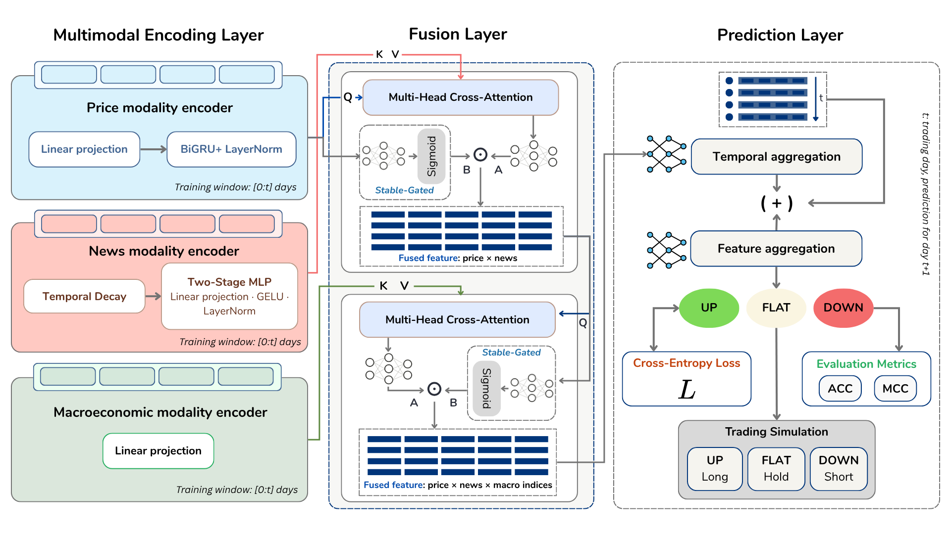Fig. 1. Framework of the proposed multi-modal NKTriF model.
Notation: $\left[0:t\right]$ denotes the historical observation window, and $t+1$ represents the target prediction day. In the Fusion Layer, $Q$, $K$, and $V$ denote the Query, Key, and Value matrices in the multi-head cross-attention mechanism, respectively. $A$ stands for the cross-attended unstable feature, and $B$ represents the stabilizing gate derived from the primary anchor, which are integrated via element-wise multiplication ($⊙$). In the Prediction Layer, $\left(+\right)$ indicates the concatenation of representations along the feature dimension, while $L$ denotes the optimization objective via Cross-Entropy Loss.
The Multimodal Encoding Layer maps each of the three input modalities into a shared $d$-dimensional latent space through a dedicated encoder. The Price Indicator Encoder transforms the log-return sequences into a sequential price representation via linear projection and bidirectional Gated Recurrent Unit (GRU) encoding. The News Encoder projects FinBERT daily embeddings, weighted by temporal decay and compressed through a two-stage linear projection, into the same latent space. The Macroeconomic Indicator Encoder applies a single linear projection to the five macroeconomic indices.
The Fusion Layer integrates the three encoded representations through two sequential Gated Cross-Attention (GCA) stages. In Stage 1, the price representation serves as the primary query to attend over the news representation, producing a price-news fused representation. In Stage 2, the price-news fused representation attends over the macroeconomic representation to produce the final joint representation. This cascading design reflects the functional asymmetry between news signals, which are short-horizon and event-driven, and macroeconomic signals, which are slow-moving and regime-level.
The Prediction Layer concatenates the fused joint representation with the original price encoding along a parallel stream. Each stream is independently compressed along the temporal dimension by a three-layer Multi-Layer Perceptron (MLP), after which the two representations are concatenated and projected into a three-class output: Down, Flat, or Up. These categorical outputs are optimized during training via Cross-Entropy Loss. The model's predictive accuracy is then evaluated using 2 standard classification metrics, including Accuracy and the Matthews Correlation Coefficient. Finally, to further validate its practical economic utility, these predictions are mapped to discrete market actions (Short for down, Hold for flat, Long for up) to drive a downstream trading simulation.
  - Multimodal Encoding Layer
Each input modality has a distinct structure, update frequency, and noise profile. A dedicated encoder is therefore designed for each modality, with the shared objective of projecting its respective inputs into the common representation space $R^{T×d}$, so that the cross-attention mechanism in Section 3.4 can compute modality interactions on commensurate representations.
Price modality encoder: Let $s^{o},s^{h},s^{c}∈R^{T×1}$ denote the volatility-normalized log-return sequences for the open, high, and close prices, respectively. The price indicator encoder maps these sequences into $H_{i}∈R^{T×d}$ as follows:
$$v^{c}=s^{c}W_{i}^{c}+b_{i}^{c},v^{o}=s^{o}W_{i}^{o}+b_{i}^{o},v^{h}=s^{h}W_{i}^{h}+b_{i}^{h}$$ | (1)
$$H_{\text{comb}}=[v^{c}∥v^{o}∥v^{h}] W_{i}+b_{i}∈R^{T×d}$$ | (2)
$$H_{i}^{\text{GRU}}=\text{BiGRU}(H_{\text{comb}})=[ \vec{H}∥\overset{⃖}{H} ]∈R^{T×d}$$ | (3)
$$H_{i}=\text{LayerNorm}(H_{i}^{\text{GRU}}+H_{\text{comb}})∈R^{T×d}$$ | (4)
where $W_{i}^{c},W_{i}^{o},W_{i}^{h}∈R^{1×d}$ denote the per-indicator projection matrices, $W_{i}∈R^{3d×d}$ denotes the combination projection matrix, and $b_{i}^{c},b_{i}^{o},b_{i}^{h},b_{i}$ are the corresponding bias vectors. Eq. (1) projects each indicator sequence independently to capture modality-specific dynamics. Eq. (2) constructs the aggregated representation $H_{\text{comb}}$ via concatenation and a subsequent linear projection. Eq. (3) feeds this sequence into a Bidirectional GRU [6], where $\vec{H}$ and $\overset{⃖}{H}∈R^{T×d/2}$ denote the forward and backward hidden state sequences, concatenated along the feature dimension. Eq. (4) applies a residual connection [13] followed by Layer Normalization [2] to stabilize training.
News modality encoder: Let $S^{n}∈R^{T×d_{\text{emb}}}$ denote the FinBERT daily embedding sequence, where $d_{\text{emb}}=768$. The news encoder maps $S^{n}$ into $H_{n}∈R^{T×d}$ as follows:
$$s_{t,\text{decay}}^{n}=s_{t}^{n}⋅exp⁡(-α⋅(T-t)),t=1,…,T$$ | (5)
$$H_{\text{mid}}=\text{LayerNorm}(\text{GELU}(S_{\text{decay}}^{n} W_{n1}+b_{n1}))∈R^{T×d_{\text{mid}}}$$ | (6)
$$H_{n}=\text{LayerNorm}(\text{GELU}(H_{\text{mid}} W_{n2}+b_{n2}))∈R^{T×d}$$ | (7)
where $α>0$ is the temporal decay coefficient, $t=1$ indexes the earliest day in the observation window, and $t=T$ indexes the forecast date, so that the decay weight $exp⁡(-α(T-t))$ is maximized at $t=T$, reflecting the stronger predictive signal carried by news closer to the forecast horizon. $W_{n1}∈R^{d_{\text{emb}}×d_{\text{mid}}}$ and $W_{n2}∈R^{d_{\text{mid}}×d}$ denote the two projection matrices, and $b_{n1}∈R^{d_{\text{mid}}}$, $b_{n2}∈R^{d}$ are the corresponding bias vectors. GELU activations [14] are applied after each projection, consistent with standard practice in transformer-based language models. LayerNorm [2] is applied before each subsequent transformation to stabilize the feature distribution.
Macroeconomic modality encoder: Let $S^{m}∈R^{T×5}$ denote the input sequence of macroeconomic indices. The encoder maps $S^{m}$ into $H_{m}∈R^{T×d}$ via a single linear projection:
$$H_{m}=S^{m}W_{m}+b_{m}∈R^{T×d}$$ | (8)
where $W_{m}∈R^{5×d}$ is the learnable projection weight matrix and $b_{m}∈R^{d}$ is the bias vector. A single linear layer suffices here because the macroeconomic indices are already structured, low-dimensional, and preprocessed as z-scored scalars, requiring no nonlinear feature extraction prior to fusion.
  - Fusion Layer
The fusion layer integrates the three encoded representations through two sequential GCA stages, each operating on a primary and an auxiliary modality. The price representation $H_{i}$ serves as the primary anchor throughout, with news fused before macroeconomic signals to reflect their functional asymmetry: news carries short-horizon, event-driven shocks, while macroeconomic indices capture slow-moving, regime-level conditions. A gating mechanism is applied at each stage to suppress auxiliary signals that conflict with the primary context.
Cross-attention: Let $H_{\text{primary}},H_{\text{aux}}∈R^{T×d}$ denote the primary and auxiliary sequence representations, respectively. Multi-head cross-attention produces an intermediate fused output $H_{\text{fused}}∈R^{T×d}$ as follows:
$$Q_{m}=H_{\text{primary}}W_{m}^{Q},K_{m}=H_{\text{aux}}W_{m}^{K},V_{m}=H_{\text{aux}}W_{m}^{V}$$ | (9)
$${\text{head}}_{m}=\text{softmax}\left(\frac{Q_{m}K_{m}^{⊤}}{\sqrt{d_{k}}}\right)V_{m}$$ | (10)
$$H_{\text{fused}}=[{\text{head}}_{1}∥⋯∥{\text{head}}_{M}] W^{O}∈R^{T×d}$$ | (11)
where $W_{m}^{Q},W_{m}^{K},W_{m}^{V}∈R^{d×d_{k}}$ denote the query, key, and value projection matrices for head $m$ (with $d_{k}=d/M$), and $W^{O}∈R^{Md_{k}×d}$ is the output projection matrix. Eq. (9) derives the query from the primary modality and the key-value pairs from the auxiliary modality, ensuring the primary representation governs which auxiliary information is attended to. Eq. (10) computes scaled dot-product attention for each head, where the scaling factor $\sqrt{d_{k}}$ prevents dot-product magnitudes from entering the saturation region of the softmax, preserving gradient flow during training [22]. Eq. (11) concatenates and linearly projects the outputs of all heads to produce $H_{\text{fused}}$.
Gated feature selection: The cross-attended output $H_{\text{fused}}$ captures cross-modal interactions but may incorporate conflicting or noisy auxiliary signals that degrade representation quality. A gating mechanism, following the Gated Linear Unit (GLU) of Dauphin et al. [7], is therefore applied to selectively retain compatible cross-modal information:
$$H_{a}=H_{\text{fused}} W_{a}+b_{a}$$ | (12)
$$H_{b}=σ(H_{\text{primary}} W_{b}+b_{b})$$ | (13)
$$H_{\text{gated}}=H_{a}⊙H_{b}$$ | (14)
where $W_{a},W_{b}∈R^{d×d}$ are learnable projection matrices, $b_{a},b_{b}∈R^{d}$ are the corresponding bias vectors, $σ(⋅)$ denotes the sigmoid function, and $⊙$ denotes element-wise multiplication. Eq. (12) applies a linear transformation to the fused output to produce candidate features $H_{a}$. Eq. (13) computes a soft selection gate $H_{b}∈(0,1)^{T×d}$ derived strictly from the stable primary anchor $H_{\text{primary}}$. Eq. (14) applies the gate via element-wise multiplication, suppressing auxiliary signals at positions where they are inconsistent with the primary context.
Sequential fusion: Denoting the full procedure of Eqs. (9) to (14) as $\text{GCA}(H_{\text{primary}},H_{\text{aux}})$, the two sequential stages produce the final joint representation $H_{i,n,m}∈R^{T×d}$ as follows:
$$H_{i,n}=\text{GCA}(H_{i}, H_{n})∈R^{T×d}$$ | (15)
$$H_{i,n,m}=\text{GCA}(H_{i,n}, H_{m})∈R^{T×d}$$ | (16)
where $H_{i}$, $H_{n}$, and $H_{m}$ denote the encoded price, news, and macroeconomic representations, respectively. Eq. (15) incorporates short-horizon news signals into the price context to produce the intermediate representation $H_{i,n}$. Eq. (16) extends this enriched representation with macroeconomic context, yielding the final fused representation $H_{i,n,m}$.
  - Prediction Layer
Let $H_{i,n,m}∈R^{T×d}$ denote the final fused representation and $H_{\text{orig}}=H_{i}∈R^{T×d}$ the original price encoder output. Retaining $H_{\text{orig}}$ as a parallel stream preserves the unmodified price signal, providing the decoder with a direct reference that is not subject to distortion introduced during cross-modal fusion. The prediction layer maps these representations into the final classification output as follows:
$$h_{\text{fused}}={\text{MLP}}_{τ}(H_{i,n,m})∈R^{1×d}$$ | (17)
$$h_{\text{orig}}={\text{MLP}}_{τ}(H_{\text{orig}})∈R^{1×d}$$ | (18)
$$h=[h_{\text{fused}}∥h_{\text{orig}}]∈R^{1×2d}$$ | (19)
$$p={\text{MLP}}_{f}(h)∈R^{1×3},\hat{y}=arg⁡\underset{c}{max⁡} p_{c}$$ | (20)
where ${\text{MLP}}_{τ}$ denotes a three-layer temporal compression network that progressively collapses the time dimension ($T→1$). Eqs. (17) and (18) apply ${\text{MLP}}_{τ}$ independently to the fused and original price representations. Eq. (19) concatenates the two compressed representations along the feature dimension. Eq. (20) projects $h$ onto the three-class output space via ${\text{MLP}}_{f}$($2d→3$), where each element $p_{c}$ represents the unnormalized logit for class $c∈\{\text{down}, \text{flat}, \text{up}\}$, and $\hat{y}$ is the predicted movement label.
  - Loss Function
The model is trained by minimizing the cross-entropy loss over three classes:
$$L=-\frac{1}{N}\sum_{n=1}^{N}{\sum_{c=1}^{3}{y_{n,c}}}log⁡\frac{exp⁡(p_{n,c})}{\sum_{j=1}^{3}{exp⁡(}p_{n,j})}$$ | (21)
where $N$ denotes the total number of training samples, $p_{n,c}$ denotes the predicted logit for class $c$ of sample $n$, and $y_{n,c}∈\{0, 1\}$ denotes the corresponding one-hot ground-truth label. All model parameters are optimized end-to-end using the AdamW optimizer [18], which decouples weight decay from the adaptive learning rate update to yield more consistent regularization across parameter groups.
  - Evaluation Metrics
Performance is evaluated using Accuracy (ACC) and the Matthews Correlation Coefficient (MCC), computed from the confusion matrix $C$ as follows:
$$\text{ACC}=\frac{\sum_{k}{C_{kk}}}{\sum_{k,l}{C_{kl}}}$$ | (22)
$$\text{MCC}=\frac{c⋅s-\sum_{k}{p_{k}}t_{k}}{\sqrt{\left(s^{2}-\sum_{k}{p_{k}^{2}})(s^{2}-\sum_{k}{t_{k}^{2}}\right)}}$$ | (23)
where $c=\sum_{k}{C_{kk}}$ is the total number of correct predictions, $s=\sum_{k,l}{C_{kl}}$ is the total sample count, $p_{k}=\sum_{l}{C_{kl}}$ is the number of samples predicted as class $k$, and $t_{k}=\sum_{l}{C_{lk}}$ is the true count of class $k$. Eq. (22) calculates the overall proportion of correctly classified samples. Eq. (23) computes the MCC [19], which accounts for all entries of the confusion matrix and remains robust under class imbalance. While ACC provides an intuitive measure of predictive correctness, it can be misleading when class distributions are skewed. MCC incorporates all cells of the confusion matrix and thus serves as a more reliable indicator in the three-class setting. All models are evaluated across five independent random seeds, and mean $±$ standard deviation is reported for both metrics.
  - Trading Simulation
While ACC and MCC measure classification quality at the label level, they do not capture whether the model's probabilistic outputs translate into economically useful signals. This section presents a supplementary trading simulation to illustrate that connection.
For each asset $i$ on trading day $t$, model inference yields a three-class probability distribution $p_{i,t}=(P_{i,t}^{\text{down}}, P_{i,t}^{\text{flat}}, P_{i,t}^{\text{up}})$. The portfolio executes a daily confidence-weighted rebalancing strategy across the asset universe as follows:
$${\text{Score}}_{i,t}=P_{i,t}^{\text{up}}-P_{i,t}^{\text{down}}∈(-1, +1)$$ | (24)
$$w_{i,t}^{+}=\frac{1}{2}⋅C⋅\frac{{\text{Score}}_{i,t}}{\sum_{j∈L_{t}^{+}}{{\text{Score}}_{j,t}}},∀ i∈L_{t}^{+}$$ | (25)
$$w_{i,t}^{-}=\frac{1}{2}⋅C⋅\frac{∣{\text{Score}}_{i,t}∣}{\sum_{j∈L_{t}^{-}}{∣}{\text{Score}}_{j,t}∣},∀ i∈L_{t}^{-}$$ | (26)
where $L_{t}^{+}$ and $L_{t}^{-}$ denote the sets of assets with positive and negative scores on day $t$, respectively, and $C$ denotes the total capital. Eq. (24) derives a continuous directional signal, with positive and negative values representing net upward and downward expectations; the range $\left(-1,+1\right)$ is strict because $P_{i,t}^{\text{flat}}>0$ under a softmax distribution. Eqs. (25) and (26) allocate capital proportionally to score magnitude across the long and short legs, with absolute values used in Eq. (26) to ensure positive weight assignments for short positions. The total capital $C$ is divided equally between the two legs to neutralize broad market exposure and isolate stock-specific predictive signals. All returns are calculated net of a 4 basis points per-side transaction cost to evaluate performance under realistic friction.
Performance is evaluated using two standard metrics as follows:
$$R_{\text{ann}}={\left(\prod_{t=1}^{T}{(}1+r_{t})\right)}^{252/T}-1$$ | (27)
$${\text{SR}}_{\text{ann}}=\frac{\overset{ˉ}{r}}{{\hat{σ}}_{r}}⋅\sqrt{252}$$ | (28)
The Geometric Annualized Return in Eq. (27) captures the compounded growth rate of the portfolio over the evaluation horizon, where $r_{t}$ denotes the daily portfolio return net of transaction costs and $T$ denotes the total number of evaluated trading days. The Annualized Sharpe Ratio in Eq. (28) quantifies risk-adjusted performance relative to a zero benchmark, consistent with the market-neutral construction of the portfolio, where $\overset{ˉ}{r}$ is the mean daily return and ${\hat{σ}}_{r}$ is the standard deviation of daily returns over the evaluation period.
- Experiments & Results
This section presents a comprehensive empirical evaluation designed to validate the predictive accuracy, structural robustness, and practical economic utility of the proposed NKTriF approach. First, the dataset construction and experimental setup are detailed. Next, the model's overall performance is benchmarked against established baselines. Subsequently, in-depth ablation studies are conducted to examine individual modality contributions, the gating mechanism, multimodal integration sequence, and hyperparameter sensitivity. Finally, a downstream trading simulation is performed to evaluate the model's real-world profitability under market frictions.
  - Dataset construction
The dataset comprises eight S&P 500 constituents across four sectors: TSLA and AMZN (Consumer Discretionary); AAPL, MSFT, GOOGL, and META (Technology); BA (Industrials); and WMT (Consumer Staples). The collection period spans January 1, 2022, to June 23, 2025, covering 869 valid trading sessions across diverse market regimes. As illustrated in Figure 2, the dataset construction pipeline operates on three independent raw data streams: stock price, macroeconomic indices, and financial news. Each modality undergoes distinct preprocessing before these parallel branches are synchronized via strict temporal and ticker alignment to form the unified prediction dataset.

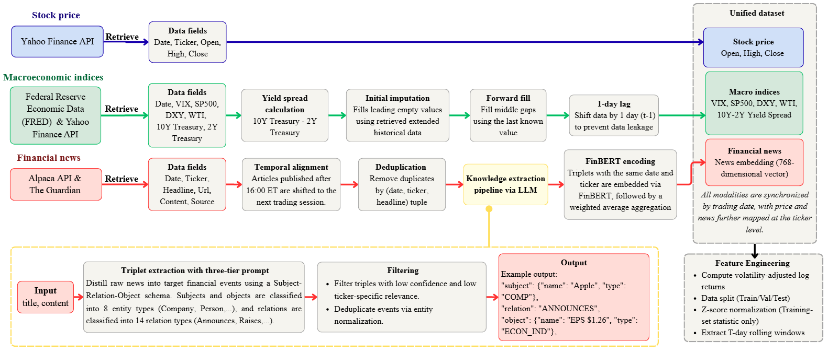
Fig. 2. The preprocessing and unified dataset construction workflow.
Stock price data: Daily open, high, and close prices for the eight tickers are retrieved from Yahoo Finance. During this initial preprocessing stage, raw price levels are deliberately preserved without mathematical transformations to facilitate strict temporal and cross-sectional alignment with the other input modalities.
Macroeconomic indices data: To capture macroeconomic context at the market level, five indices are incorporated as features shared across all tickers. Following Calomiris [5], we utilize four core indicators to model broad market dynamics: the CBOE Volatility Index (VIX) for market-implied volatility expectations, the S&P 500 daily return as a systematic risk factor reflecting broad market momentum, the 10Y–2Y Treasury yield spread to capture business cycle shifts and recession risks, and the US Dollar Index (DXY) to gauge relative USD strength. Additionally, drawing on Wang [23], WTI crude oil prices are incorporated to proxy for global energy and transportation cost conditions. Daily historical time-series for all selected indices were retrieved from Yahoo Finance and Federal Reserve Economic Data (FRED). To ensure no future information is leaked, initial missing observations are imputed by retrieving extended historical data prior to the study window. Remaining internal gaps are subsequently forward-filled using the last known value. Finally, all indices are lagged by one trading day to strictly prevent lookahead bias.
Financial news data: News articles are collected from two complementary sources: the Alpaca API, which provides a ticker-tagged financial news database, and The Guardian, which supplies in-depth commentary and analyses. To preserve temporal causality and prevent forward-looking bias, articles published after 16:00 Eastern Time are assigned to the subsequent valid trading session. The corpus then undergo deduplication, and records with missing textual content or publication timestamps were excluded, yielding 64,894 article-ticker assignments, where each (article, ticker) pair is treated as an independent observation.
To isolate ticker-specific events carrying strong market sentiment signals from surrounding linguistic noise, a structured knowledge extraction pipeline via LLM-based few-shot prompting is implemented. Each article is first classified into one of 4 article types to guide extraction scope, after which subjects and objects are constrained to 8 entity types and relations are mapped to 14 predefined categories. This structured transformation replaces verbose, multi-topic articles with concise, semantically precise event representations, enabling FinBERT to embed financially relevant content rather than peripheral linguistic context. Table 1 presents the full extraction schema, including entity types, relation categories, and article classification criteria.
Table 1. Extraction schema: entity types, relation types, and article classification.
Component | Content | Example
Entity types | 8 types: Company, Person, Government body, Regulatory body, Product, Economic indicator, Financial asset, Concept | “Apple” => Company
Relation types | 14 types: Announces, Raises, Cuts, Invests in, Divests, Appoints, Positively impacts, Negatively impacts, Competes with, Regulates, Supplies to, Controls, Signals, Relates to | "iPhone Raises revenue +18% to $39.6B" => Raises
Article classification | 4 types: Earnings/Guidance/Financial results (A), Corporate deal/M&A/Supply chain (B), Competitive/Regulatory/Geopolitical (C), Opinion/Interview/Soft news (D) | "Apple reported Q3 EPS $1.26, beat estimate $1.15" => Type A
The extracted triples then underwent a two-stage quality filtering process to remove low-reliability extractions and semantically redundant triples. News records yielding no qualifying triples after filtering were excluded from subsequent stages, reducing the dataset from 64,894 article-ticker assignments to a final set of 8,983 pairs comprising 17,698 validated triples across a diverse distribution of relation types. These triples were subsequently encoded using FinBERT and aggregated into daily weighted-average embedding vectors per ticker. Aggregation weights are assigned proportionally according to a composite relevance score incorporating the LLM's extraction confidence, estimated price impact, and ticker relevance of each triple.
Data synchronization and feature transformation: Prior to model training, all three modalities are aligned into a unified dataset via strict temporal and cross-sectional matching. Price and news features are joined by date and ticker, while macroeconomic indices are replicated across all tickers for each trading date. To preserve temporal continuity for rolling calculations, raw stock prices are first converted into volatility-adjusted log returns using a fixed 20-day realized volatility rolling window across the entire timeline. The dataset is then partitioned chronologically into training, validation, and test splits corresponding to approximately 70%, 15%, and 15% of observations, respectively, with no overlap between partitions. Subsequently, all numerical features, including both stock returns and macroeconomic indices, are z-score normalized exclusively using training-set statistics. Finally, to construct the temporal inputs required by the model, the scaled continuous data is segmented into rolling observation windows of length T.
The prediction target for each stock on each trading day is the next-session simple return computed from closing prices:
$$r_{t+1}=\frac{C_{t+1}-C_{t}}{C_{t}}$$
Each observation is assigned one of three directional labels based on rolling 20-day percentile thresholds: up if ${r_{t+1}>Q}_{67}$, down if ${r_{t+1}<Q}_{33}$, and flat otherwise. Computing thresholds over a rolling window rather than fixed global boundaries allows the labeling scheme to adapt to local return distributions across tickers and time periods. This produces a near-perfectly balanced class distribution across all eight tickers, as reported in Table 2.
Table 2. Label distribution across the experimental dataset.
Ticker | Sector | DOWN | FLAT | UP | Total
TSLA | Consumer Discretionary | 283 | 282 | 284 | 849
AAPL | Technology | 282 | 284 | 283 | 849
AMZN | Consumer Discretionary | 282 | 285 | 282 | 849
MSFT | Technology | 284 | 281 | 284 | 849
GOOGL | Technology | 283 | 282 | 284 | 849
META | Technology | 282 | 284 | 283 | 849
BA | Industrials | 284 | 281 | 284 | 849
WMT | Consumer Staples | 283 | 283 | 283 | 849
Total |  | 2,263 | 2,262 | 2,267 | 6,792
  - Baseline comparison
To validate our proposed model performance and compare it with current leading methods, six baseline models are selected. They are organized into three groups according to input modality:
Group 1 - Price only. LSTM [15], a two-layer network using the final hidden state as representation; and ALSTM [20], which augments LSTM with temporal attention over all hidden states.
Group 2 - Price + news. ALSTM-W, extending ALSTM with window-averaged FinBERT embeddings projected through a two-step bottleneck before concatenation; SLOT [21], integrating per-timestep price and text via cross-projection within an ALSTM backbone.
Group 3 - Price + macroeconomic indices. ESTIMATE [17], concatenating price and macro before multi-head attention; and DTML [26], modeling temporal and cross-variable dependencies via a multi-level Transformer.
All models share a uniform training protocol: identical chronological splits, $T=20$ look-back, and cross-entropy loss. Hyperparameter selection follows a grid-search strategy over learning rate 5e-5, 1e-4, 5e-4, hidden dimension 32, 64, 128, and dropout 0.1, 0.2, selecting the combination maximizing validation MCC. NKTriF additionally uses $M=4$ attention heads, temporal decay = 0.1, and modality dropout $p = 0.30$.
  - Results & Discussion
    - Model Performance Comparison
Table 3 reports test-set performance aggregated over five independent random seeds for all six baselines and NKTriF, grouped by input modality.
Table 3. Comparison of stock movement prediction performance across all models on the test set.
Methods | Sources | ACC | MCC
LSTM | Price | 0.4193 ± 0.0087 | 0.1220 ± 0.0134
ALSTM | Price | 0.4139 ± 0.0079 | 0.1162 ± 0.0117
ALSTM-W | Price + news | 0.3799 ± 0.0073 | 0.0642 ± 0.0115
SLOT | Price + news | 0.3709 ± 0.0073 | 0.0503 ± 0.0080
ESTIMATE | Price + macro | 0.3986 ± 0.0069 | 0.0996 ± 0.0105
DTML | Price + macro | 0.4188 ± 0.0045 | 0.1236 ± 0.0077
NKTriF (proposed) | Price + news + macro | 0.4324 ± 0.0086 | 0.1394 ± 0.0152
The best performance per metric is bolded.
NKTriF achieves the highest performance across both metrics (ACC = 0.4324, MCC = 0.1394), surpassing the second-best baseline, DTML, by 1.36 percentage points in ACC and by 0.0158 in MCC, corresponding to a relative MCC gain of 12.8%. The comparison between these models reveals a crucial insight regarding incremental modality integration. DTML establishes a competitive baseline by demonstrating that incorporating macroeconomic indices alongside price data yields a marginally higher MCC than the unimodal LSTM (0.1236 vs. 0.1220), suggesting that macroeconomic signals offer complementary predictive value when the integration mechanism preserves their informational structure. By further outperforming DTML, NKTriF demonstrates that introducing financial news as a third modality provides a distinct informational edge, provided it is integrated correctly.
Integrating news through conventional fusion techniques, however, actively degrades predictive accuracy. Both ALSTM-W (MCC = 0.0642) and SLOT (MCC = 0.0503) perform substantially worse than the unimodal LSTM baseline, falling short by 47.4% and 58.8% in relative MCC, respectively. This consistent degradation confirms that textual embeddings introduce representational noise that simple concatenation or cross-modal projection cannot suppress. Consequently, NKTriF's superiority stems not merely from processing more data sources, but specifically from its gated cross-attention architecture, which successfully filters transient linguistic noise while preserving substantive event-driven signals.
    - Individual modality contribution
To examine how each auxiliary modality contributes to the overall predictive performance of NKTriF, two ablation variants are evaluated: NKTriF-PM (price + macro, news excluded) and NKTriF-PN (price + news, macro excluded). Each variant is retrained from scratch under identical hyperparameters. The results are reported in Table 4.
Table 4. Ablation results on modality contribution across two evaluation metrics.
Variant | ACC | MCC | ΔMCC
NKTriF | 0.4324 ± 0.0086 | 0.1394 ± 0.0152 | -
NKTriF-PM | 0.4107 ± 0.0077 | 0.1048 ± 0.0098 | −0.0346 (-24.8%)
NKTriF-PN | 0.4170 ± 0.0227 | 0.1148 ± 0.0321 | −0.0246 (−17.6%)
ΔMCC relative to NKTriF: Negative ΔMCC indicates performance degradation upon removal, reflecting a positive marginal contribution of the removed modality.
As demonstrated by the ablation results, the two auxiliary modalities fulfill functionally distinct and complementary predictive roles. Removing the news branch (NKTriF-PM) produces a severe MCC degradation of −24.8%. This confirms that structured news provides the primary event-driven signals necessary for accurate next-session directional forecasting.
Conversely, removing the macroeconomic branch (NKTriF-PN) yields a comparatively smaller mean drop of −17.6%, but drastically inflates the cross-seed standard deviation by a factor of 2.1. This phenomenon suggests that: while the news modality drives absolute predictive accuracy, the macroeconomic indices act as a crucial structural regularizer. By supplying slow-moving, system-level context, the macro branch effectively anchors the model against transient noise, ensuring highly consistent performance across different initializations and market regimes.
    - Effect of stable gating mechanism
To examine whether the Gating mechanism constitutes a necessary architectural component, we evaluate an ablation variant denoted as NKTriF-NoGate. In this configuration, the sigmoid stabilization gate is removed, and the cross-attention output is integrated via direct residual addition, with all other network components and hyperparameters held constant. The results are reported in Table 5.
Table 5. Performance comparison between gated and non-gated fusion variants across two evaluation metrics.
Variant | ACC | MCC
NKTriF | 0.4324 ± 0.0086 | 0.1394 ± 0.0152
NKTriF-NoGate | 0.4131 ± 0.0248 | 0.1074 ± 0.0346
As reported in Table 5, gated fusion improves both mean performance and cross-seed consistency simultaneously. NKTriF achieves MCC = 0.1394, a 29.8% gain over NKTriF-NoGate (0.1074), while standard deviation decreases 2.3× from 0.0346 to 0.0152. These results confirm that the gating mechanism constitutes a necessary architectural component, contributing to both predictive accuracy and stability across initializations.
    - Effect of auxiliary integration order
To examine whether the sequence of auxiliary modality integration affects predictive performance, we compare the proposed configuration, NKTriF-NM (where news is integrated prior to macroeconomic indices: Price - News - Macro), against an inverted variant, NKTriF-MN (Price - Macro - News). Both variants are evaluated under identical experimental settings, with results reported in Table 6.
Table 6. Performance comparison of fusion order variants across two evaluation metrics.
Variant | ACC | MCC | ΔMCC
NKTriF-NM | 0.4324 ± 0.0086 | 0.1394 ± 0.0152 | -
NKTriF-MN | 0.4199 ± 0.0150 | 0.1163 ± 0.0228 | −0.0231
As evidenced in Table 6, news-first integration achieves the highest MCC (0.1394) and lowest variance (0.0152). NKTriF-MN records a degradation of −16.6% in MCC with notably higher variance (std = 0.0228). These results indicate that in sequential cross-attention fusion, modalities carrying short-horizon event signals should be integrated prior to slow-moving contextual ones to preserve the representational capacity for high-frequency information.
    - Effect of hyperparameters
Figures 3–5 report the effect of hidden dimension size, learning rate, and window size on NKTriF's predictive performance. Hidden dimension d = 64 yields the highest MCC, with d = 32 providing insufficient capacity for trimodal interactions and d ≥ 128 overfitting the limited training data. Learning rate lr = 1e-4 is similarly optimal, as larger values overshoot the loss minimum while lr = 5e-5 fails to converge within the training budget. Window size ws = 20 achieves the highest MCC and lowest cross-seed variance. Notably, the degradation at ws = 10 is 3.5× larger than at ws = 25, indicating that insufficient historical context is a more damaging failure mode than marginal over-extension.
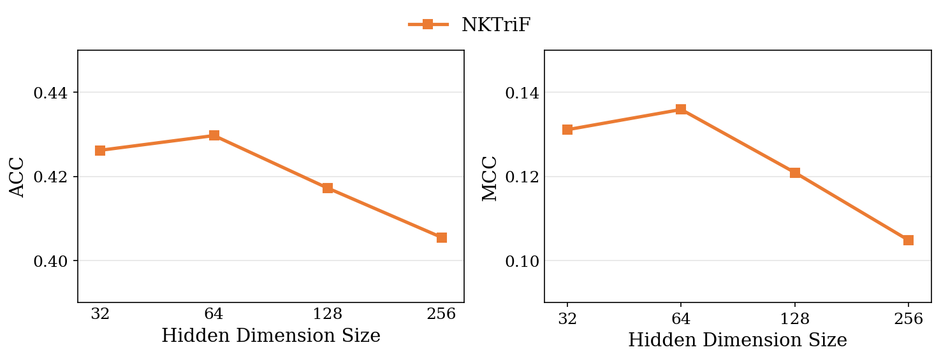Fig. 3. Performance of NKTriF with various hidden dimension sizes.
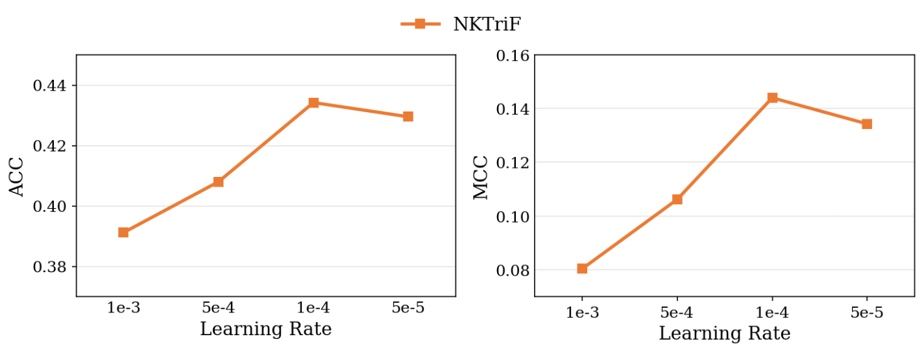
Fig. 4. Performance of NKTriF with various learning rates.
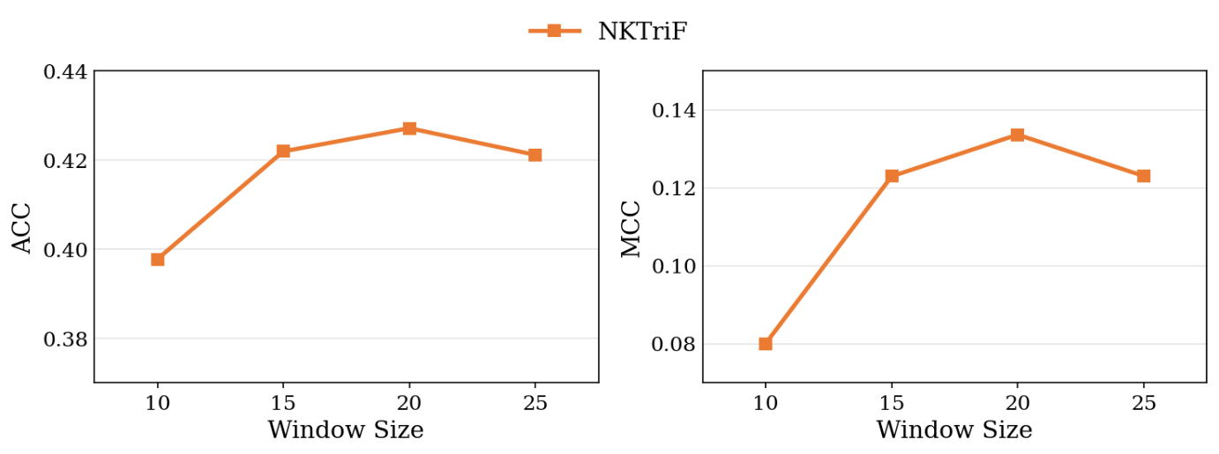
Fig. 5. Performance of NKTriF with various window sizes.
    - Trading simulation results
To demonstrate the practical economic viability of the predictive signals under realistic market frictions, we evaluate the models using the confidence-weighted portfolio strategy. The financial performance results are summarized in Table 7.
Table 7. Comparison of financial performance in Annualized Sharpe Ratio and Geometric Annualized Return in net-of-cost trading simulations.
Model | Sharpe (net TC) | Ann. Return
NKTriF (proposed) | +0.85 | +27.68%
LSTM | +0.78 | +26.98%
SLOT | −0.32 | +1.55%
ALSTM | −0.30 | −3.17%
ESTIMATE | −0.24 | −4.00%
ALSTM-W | −0.82 | −5.37%
DTML | −0.86 | −19.67%
Buy-and-Hold | - | −4.56%
The best performance per metric is bolded.
NKTriF achieves the strongest risk-adjusted profile (Sharpe = +0.85, Ann. Return = +27.68%), substantially outperforming the Buy-and-Hold benchmark (−4.56%). More critically, naive multimodal strategies exhibit severe economic degradation: ALSTM-W (Sharpe = −0.82) and DTML (Sharpe = −0.86) substantially underperform the price-only LSTM baseline (Sharpe = +0.78), demonstrating that unregulated auxiliary fusion introduces high-frequency noise that erodes trading returns through excessive portfolio turnover. The economic resilience of NKTriF confirms that its gated architecture suppresses transient noise and preserves capital during low-conviction regimes, translating classification gains into consistent profitability.
- Conclusion & future work
This study proposes NKTriF, a deep learning approach for short-horizon stock movement prediction that integrates historical price indicators, structured financial news, and macroeconomic indices. Empirical evaluations in this study demonstrate that this multimodal framework effectively enhances predictive performance. Crucially, the results show that the proposed price-conditioned gating mechanism significantly improves both prediction accuracy and cross-seed stability by successfully resolving directional conflicts among heterogeneous inputs. Furthermore, the evaluation reveals that integrating raw, unstructured news directly into the model actively degrades predictive performance. This outcome firmly establishes the crucial role of the schema-constrained knowledge extraction preprocessing step in isolating ticker-specific financial signals from surrounding linguistic noise prior to multimodal fusion.
In conclusion, the proposed architecture offers substantial practical implications for real-world financial applications. The explicit integration of schema-constrained event extraction and conflict-regulated fusion creates a transparent pipeline, allowing the processing of chaotic market data to be systematically audited. For quantitative analysts, this structural design provides a reliable mechanism to isolate genuine market signals from linguistic and cross-modal noise. Ultimately, this work could equip portfolio managers with the necessary framework to execute disciplined capital allocation strategies, effectively minimizing exposure to algorithmic trading risks during uncertain market regimes.
However, this study is currently limited by its focus on English-language financial news and US large-cap equities. Future research could extend the framework to emerging markets, such as Vietnam, where financial news infrastructure, ticker-tagging standards, and entity-to-ticker disambiguation remain less mature. Advancing in this direction would require robust entity resolution techniques and domain-adapted language models for local financial texts, particularly in markets where text-based stock prediction is not yet standardized. Additionally, because the current architecture operates primarily at a daily frequency, future work could incorporate lower-frequency periodic disclosures, such as earnings reports, annual filings, and earnings call transcripts. By designing an explicit temporal decay mechanism across post-publication sessions, future models could effectively capture long-term corporate fundamentals and synergize them with short-horizon event signals, thereby enhancing the framework's capacity for comprehensive, multi-horizon market forecasting.
REFERENCES
                - Ariyo, A. A., Adewumi, A. O., & Ayo, C. K. (2014). Stock price prediction using the ARIMA model. In 2014 UKSim-AMSS 16th International Conference on Computer Modelling and Simulation (pp. 106–112). IEEE. https://doi.org/10.1109/UKSim.2014.67
                - Ba, J. L., Kiros, J. R., & Hinton, G. E. (2016). Layer normalization. arXiv. https://doi.org/10.48550/arXiv.1607.06450
                - Bollerslev, T. (1986). Generalized autoregressive conditional heteroskedasticity. Journal of Econometrics, 31(3), 307–327. https://doi.org/10.1016/0304-4076(86)90063-1
                - Box, G. E. P., & Jenkins, G. M. (1976). Time series analysis: Forecasting and control (Rev. ed.). SSSHolden-Day.
                - Calomiris, C. W., Çakır Melek, N., & Mamaysky, H. (2026). Big Data Meets the Turbulent Oil Market. Financial Analysts Journal, 82(1), 35–59. https://doi.org/10.1080/0015198X.2025.2602524
                - Cho, K., van Merriënboer, B., Gulcehre, Ç., Bahdanau, D., Bougares, F., Schwenk, H., & Bengio, Y. (2014). Learning phrase representations using RNN encoder–decoder for statistical machine translation. In A. Moschitti, B. Pang, & W. Daelemans (Eds.), Proceedings of the 2014 Conference on Empirical Methods in Natural Language Processing (EMNLP) (pp. 1724–1734). Association for Computational Linguistics. https://doi.org/10.3115/v1/D14-1179
                - Dauphin, Y. N., Fan, A., Auli, M., & Grangier, D. (2017). Language modeling with gated convolutional networks. In D. Precup & Y. W. Teh (Eds.), Proceedings of the 34th International Conference on Machine Learning (Vol. 70, pp. 933–941). PMLR. https://doi.org/10.48550/arXiv.1612.08083
                - Ding, X., Zhang, Y., Liu, T., & Duan, J. (2015). Deep learning for event-driven stock prediction. In Q. Yang & M. Wooldridge (Eds.), Proceedings of the Twenty-Fourth International Joint Conference on Artificial Intelligence (IJCAI 2015) (pp. 2327–2333). AAAI Press. https://www.ijcai.org/Proceedings/15/Papers/329.pdf
                - Dolphin, R., Dursun, J., Chow, J., Blankenship, J., Adams, K., & Pike, Q. (2024). Extracting structured insights from financial news: An augmented LLM driven approach. arXiv. https://doi.org/10.48550/arXiv.2407.15788
                - Engle, R. F. (1982). Autoregressive conditional heteroscedasticity with estimates of the variance of United Kingdom inflation. Econometrica: Journal of the Econometric Society, 50(4), 987–1007. https://doi.org/10.2307/1912773
                - Feng, F., Chen, H., He, X., Ding, J., Sun, M., & Chua, T.-S. (2019). Enhancing stock movement prediction with adversarial training. In Proceedings of the Twenty-Eighth International Joint Conference on Artificial Intelligence (IJCAI-19) (pp. 5843–5849). International Joint Conferences on Artificial Intelligence Organization. https://doi.org/10.24963/ijcai.2019/810
                - Fischer, T., & Krauss, C. (2018). Deep learning with long short-term memory networks for financial market predictions. European Journal of Operational Research, 270(2), 654–669. https://doi.org/10.1016/j.ejor.2017.11.054
                - He, K., Zhang, X., Ren, S., & Sun, J. (2016). Deep residual learning for image recognition. In 2016 IEEE Conference on Computer Vision and Pattern Recognition (CVPR) (pp. 770–778). IEEE. https://doi.org/10.1109/CVPR.2016.90
                - Hendrycks, D., & Gimpel, K. (2016). Gaussian error linear units (GELUs). arXiv. https://doi.org/10.48550/arXiv.1606.08415
                - Hochreiter, S., & Schmidhuber, J. (1997). Long short-term memory. Neural Computation, 9(8), 1735–1780. https://doi.org/10.1162/neco.1997.9.8.1735
                - Hu, Z., Liu, W., Bian, J., Liu, X., & Liu, T.-Y. (2018). Listening to chaotic whispers: A deep learning framework for news-oriented stock trend prediction. In Proceedings of the Eleventh ACM International Conference on Web Search and Data Mining (WSDM ’18) (pp. 261–269). Association for Computing Machinery. https://doi.org/10.1145/3159652.3159690
                - Huynh, T. T., Nguyen, M. H., Nguyen, T. T., Nguyen, P. L., Weidlich, M., Nguyen, Q. V. H., & Aberer, K. (2023). Efficient integration of multi-order dynamics and internal dynamics in stock movement prediction. In Proceedings of the Sixteenth ACM International Conference on Web Search and Data Mining (WSDM ’23) (pp. 850–858). Association for Computing Machinery. https://doi.org/10.1145/3539597.3570427
                - Loshchilov, I., & Hutter, F. (2019). Decoupled weight decay regularization. In International Conference on Learning Representations (ICLR). https://doi.org/10.48550/arXiv.1711.05101
                - Matthews, B. W. (1975). Comparison of the predicted and observed secondary structure of T4 phage lysozyme. Biochimica et Biophysica Acta (BBA) - Protein Structure, 405(2), 442–451. https://doi.org/10.1016/0005-2795(75)90109-9
                - Qin, Y., Song, D., Chen, H., Cheng, W., Jiang, G., & Cottrell, G. W. (2017). A dual-stage attention-based recurrent neural network for time series prediction. In Proceedings of the Twenty-Sixth International Joint Conference on Artificial Intelligence (IJCAI-17) (pp. 2627–2633). https://doi.org/10.24963/ijcai.2017/366
                - Soun, Y., Yoo, J., Cho, M., Jeon, J., & Kang, U. (2022). Accurate stock movement prediction with self-supervised learning from sparse noisy tweets. In 2022 IEEE International Conference on Big Data (Big Data) (pp. 1691–1700). IEEE. https://doi.org/10.1109/BigData55660.2022.10020720
                - Vaswani, A., Shazeer, N., Parmar, N., Uszkoreit, J., Jones, L., Gomez, A. N., Kaiser, Ł., & Polosukhin, I. (2017). Attention is all you need. In Advances in Neural Information Processing Systems (Vol. 30, pp. 5998–6008). Curran Associates. https://doi.org/10.48550/arXiv.1706.03762
                - Wang, S., Bai, Y., Fu, K., Wang, L., Lu, C. T., & Ji, T. (2023, November). Alerta-net: A temporal distance-aware recurrent networks for stock movement and volatility prediction. In Proceedings of the International Conference on Advances in Social Networks Analysis and Mining (pp. 538-542). https://doi.org/10.1145/3625007.3627488
                - Xu, Y., & Cohen, S. B. (2018). Stock movement prediction from tweets and historical prices. In Proceedings of the 56th Annual Meeting of the Association for Computational Linguistics (Vol. 1, pp. 1970–1979). Association for Computational Linguistics. https://doi.org/10.18653/v1/P18-1183
                - Yang, Y., Uy, M. C. S., & Huang, A. (2020). FinBERT: A pretrained language model for financial communications. arXiv. https://doi.org/10.48550/arXiv.2006.08097
                - Yoo, J., Soun, Y., Park, Y.-C., & Kang, U. (2021). Accurate multivariate stock movement prediction via data-axis transformer with multi-level contexts. In Proceedings of the 27th ACM SIGKDD International Conference on Knowledge Discovery & Data Mining (pp. 2037–2045). Association for Computing Machinery. https://doi.org/10.1145/3447548.3467297

Corresponding author. Tel.: +84 935 286 818. Email address: ledientuan@due.edu.vn

