Codebook Refinement Transformer: Post-Retrieval Correction
for Neural Codec Voice Conversion
Quoc V. Nguyen*ª
ªEnterprise AI Center
* Corresponding author: quoc.nguyen@eaic.org
ABSTRACT
We propose the Codebook Refinement Transformer (CRT), a non-autoregressive model that improves retrieval-based voice conversion on discrete neural audio codec tokens. CRT operates on Mimi’s hierarchical RVQ token space using a Conformer backbone with FiLM speaker conditioning, trained with inference-matched FAISS corruption. We introduce confidence-selective decoding: CRT predictions override retrieved tokens only when softmax confidence exceeds a threshold. On a 100-pair zero-shot evaluation across VCTK speakers, CRT improves MCD over the FAISS retrieval baseline (102.6 ± 15.1 vs. 103.3 ± 16.3) while achieving higher speaker similarity than kNN-VC (SECS 0.816 vs. 0.796). CRT achieves real-time processing (RTF 0.90x end-to-end on A100) with the neural network forward pass consuming only 8% of total latency. CRT’s token-to-token architecture provides native integrability with codec-based speech systems: no external vocoders, no format conversion, no codec round-trips.
Keywords: voice conversion, neural audio codec, residual vector quantization, discrete token refinement, confidence-selective decoding, Conformer, intelligent signal processing
1. INTRODUCTION
Voice conversion (VC) transforms a source speaker’s utterance to sound as if spoken by a target speaker while preserving linguistic content. This technology has applications in intelligent communication systems, adaptive human-computer interfaces, and privacy-preserving speech processing [1]. Neural audio codecs — SoundStream [2], Encodec [3], DAC [4], and Mimi [5] — enable operating on discrete token sequences rather than continuous spectral features, using Residual Vector Quantization (RVQ) to compress speech into hierarchical codebook layers.
Retrieval-based voice conversion on codec tokens via FAISS [6] is simple and training-free, but introduces a fundamental limitation: retrieved tokens for each codebook may originate from different target frames, breaking the RVQ residual chain. We propose CRT as a post-retrieval correction stage. Unlike VALL-E [8] and SoundStorm [9] that generate tokens from scratch, CRT takes already-retrieved tokens as input and predicts corrections via confidence-selective decoding.
Table 1. Multi-pair results (100 VCTK pairs, mean ± std).
Method | Domain | SECS ↑ | MCD ↓ | N
FreeVC [10] | Continuous (VITS) | 0.824±0.047 | 85.1±11.1 | 99
kNN-VC [7] | Continuous (HiFi-GAN) | 0.796±0.064 | 97.9±15.0 | 100
CRT conf>0.4 | Codec-native | 0.816±0.064 | 102.6±15.1 | 100
FAISS baseline | Codec-native | 0.827±0.053 | 103.3±16.3 | 100

CRT is the only method that improves upon its retrieval baseline, and achieves higher SECS than kNN-VC (0.816 vs. 0.796). CRT’s token-to-token architecture enables native integration into codec-based systems without vocoders or format conversion.
2. RELATED WORK
SoundStream [2], Encodec [3], and Mimi [5] compress waveforms into discrete RVQ tokens. Mimi’s CB0 is distilled from WavLM [11] for content; CB1–31 encode speaker acoustics at 12.5 Hz with 32 codebooks of 2048 entries. kNN-VC [7] (MOS 4.03) and FreeVC [10] (MOS 4.06) operate on continuous WavLM features with external vocoders. SoundStorm [9] and MaskGCT [16] generate codec tokens from scratch via masked prediction. vec2wav 2.0 [18] processes discrete tokens for vocoding. CRT is distinct: it refines already-retrieved tokens in a single forward pass within the codec’s native space.
CRT’s individual components — Conformer [26], FiLM [19], focal loss [28], confidence decoding [9] — are established. The novelty lies in their combination for post-retrieval refinement of discrete RVQ tokens, with confidence-selective override against a retrieval fallback. No published method combines all five elements in this domain.
3. METHOD
3.1 Problem Formulation
A source utterance is encoded by Mimi into T frames of 32 codebooks. Stage 1 (Retrieval): FAISS search on CB0 embeddings with temporal continuity. Stage 2 (Refinement): CRT takes retrieved CB1–CB18, CB0 anchor, and speaker embedding v ∈ ℝ²⁵⁶:
Ĉʳᵉᶠ = CRT(Ĉᵗᵍᵗ₀, Ĉᵗᵍᵗ₁∶ₖ, v)
3.2 Architecture
CRT-XLarge: d_{model}=1280, 16 heads, 16 Conformer layers, 707M params. Input: sum of per-codebook embeddings. FiLM speaker conditioning before backbone. Depthwise conv (kernel 31, 2.5s span) captures local frame continuity. Per-CB prediction heads (18 independent linear projections to 2048-dim vocabulary). Auxiliary speaker identity head for SECS loss.
3.3 Training
90% FAISS cross-speaker corruption (matching inference noise); 10% random. Three-phase curriculum: 30%→50%→70% corruption over 240k steps. RVQ dropout at 15%. Loss: focal CE (γ=1.0) + SECS loss (λ=0.3). AdamW, lr=10⁻⁴, batch 128, 240k steps on A100-80GB. Training cost: 132 GPU-hours (~46 kWh). Smaller configurations (28M Large variant) reduce cost proportionally.
3.4 Confidence-Selective Decoding
At inference, CRT overrides retrieved tokens only when max softmax probability exceeds τ. At optimal τ=0.4, 17.8% of tokens are overridden. This single-pass hybrid strategy combines learned refinement with retrieval fallback.
4. EXPERIMENTAL SETUP
Training: 4,655 speakers, 202h from LibriTTS-R [29]. Evaluation: 100 pairs from VCTK [31] (zero-shot). Baselines: FAISS retrieval, kNN-VC [7] (official, WavLM+HiFi-GAN), FreeVC [10] (official, WavLM+VITS). Metrics: SECS (speaker similarity), MCD (cross-speaker spectral distance via 13-dim MFCCs), UTMOS [32] (predicted MOS).
5. RESULTS
5.1 Multi-Pair Evaluation
Table 1 (above) shows 100-pair results. CRT consistently improves over FAISS (MCD 102.6 vs. 103.3) with reduced variance (15.1 vs. 16.3). CRT SECS (0.816) exceeds kNN-VC (0.796) by 2.5% and is competitive with FreeVC (0.824).
5.2 Confidence Threshold Analysis
Table 2. Single-pair: confidence threshold sweep.
τ | SECS | MCD | Override%
0.3 | 0.813 | 109.29 | 26.2%
0.4 | 0.816 | 102.45 | 17.8%
0.5 | 0.819 | 109.40 | 10.0%
0.6 | 0.827 | 109.02 | 6.1%
0.9 | 0.815 | 109.29 | 1.3%

CRT argmax (100% override) yields MCD 127.66 — worse than the FAISS baseline (106.61). CRT conf>0.4 (17.8% override) yields 102.45 — better than the baseline. The same model, with the same predictions, transitions from worse-than-baseline to better-than-baseline solely through confidence gating. This validates the selection mechanism: a model correct on 75% of CB1 tokens produces catastrophic output when applied unconditionally (25% errors compound across 18 codebooks), but improves the baseline when restricted to high-confidence overrides.
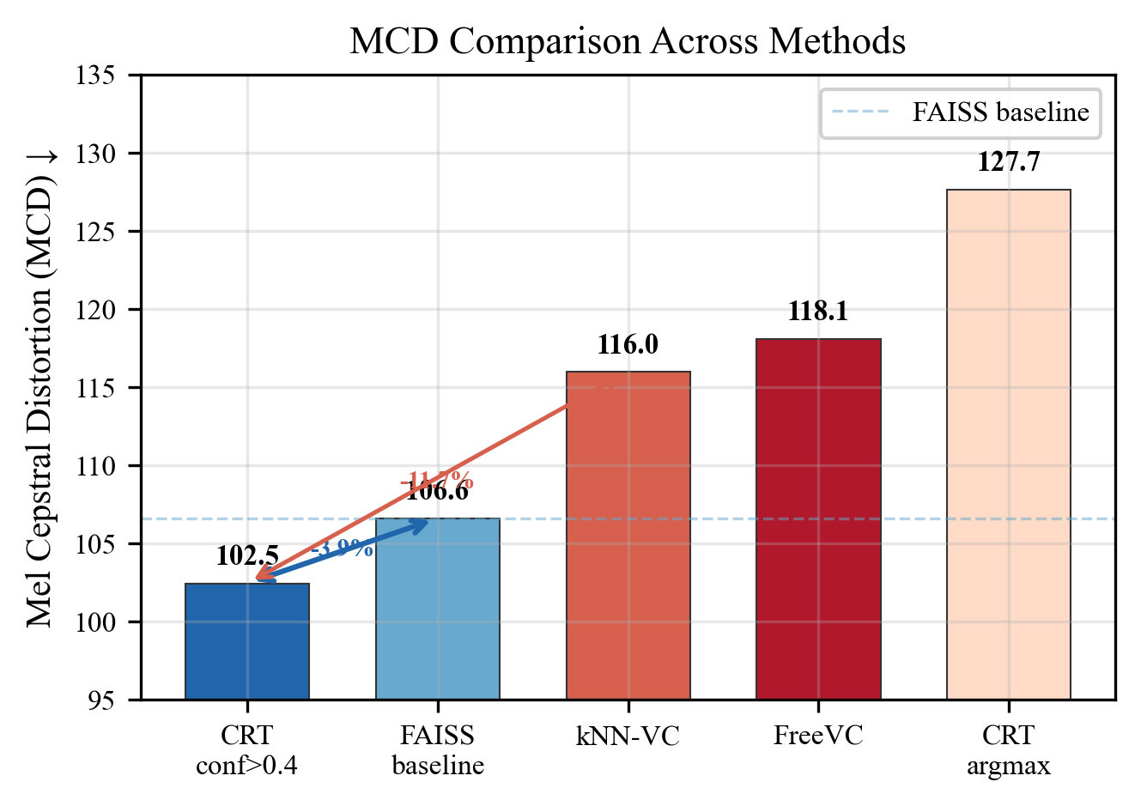
Figure 1. MCD comparison across methods.
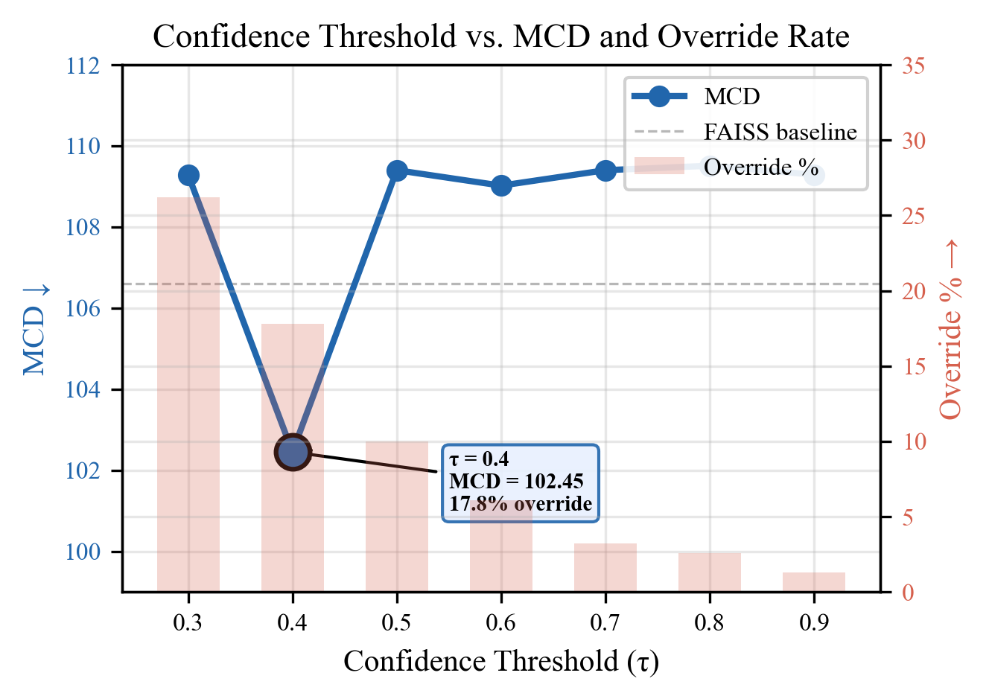
Figure 2. Confidence threshold τ vs. MCD and override rate.
5.3 Perceptual Quality and Codec Ceiling
Table 3. Predicted MOS (UTMOS) by decoder type.
Method | UTMOS (1–5) | Decoder
FreeVC | 4.46 | VITS vocoder
kNN-VC | 3.56 | HiFi-GAN
CRT conf>0.4 | 2.52 | Mimi (1.1 kbps)
FAISS baseline | 2.44 | Mimi (1.1 kbps)

The UTMOS gap reflects Mimi’s 1.1 kbps codec ceiling, not CRT quality. FAISS baseline (no CRT) is already 2.44; CRT improves to 2.52. In a codec pipeline, audio is already at Mimi quality — CRT improves within that tier.
5.4 Inference Efficiency
Table 4. Real-time factor (4.1s audio, A100).
Method | Total (ms) | RTF | Real-time?
FreeVC | 2,438 | 0.59x | Yes (1.7x)
CRT (ours) | 3,694 | 0.90x | Yes (1.1x)
kNN-VC | 7,836 | 1.91x | No (0.5x)

CRT’s neural network forward pass is only 296ms (8% of total). The bottleneck is FAISS retrieval (3,018ms, 82%), optimizable via approximate indices.
5.5 System Integrability
Table 5. Integrability comparison for codec-based systems.
Dimension | CRT | kNN-VC | FreeVC
Native codec I/O | Yes | No | No
External vocoder | No | HiFi-GAN | VITS
Codec round-trips | 0 | 1 | 1
Streaming capable | Yes | No | No
Per-frame overhead | 6.0 ms | 150.7 ms | 46.9 ms

CRT is the only token-to-token method. It slots into codec pipelines with zero format conversion, enabling voice conversion as a token-space module for streaming speech systems, without additional vocoders or feature extractors.
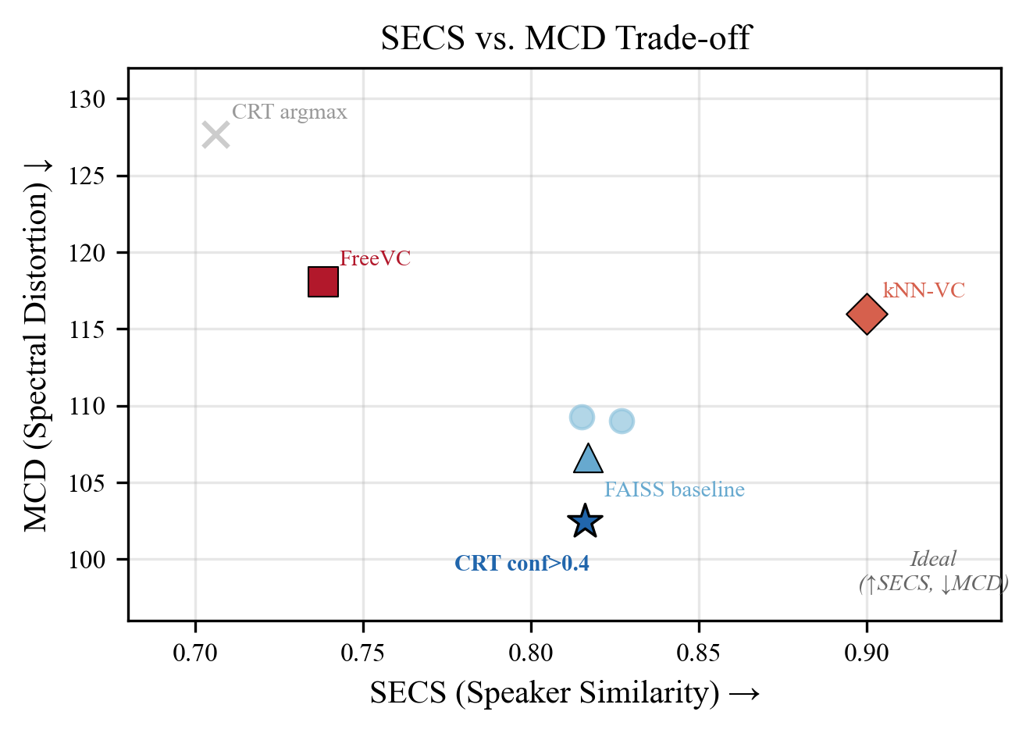
Figure 3. SECS vs. MCD trade-off across methods.
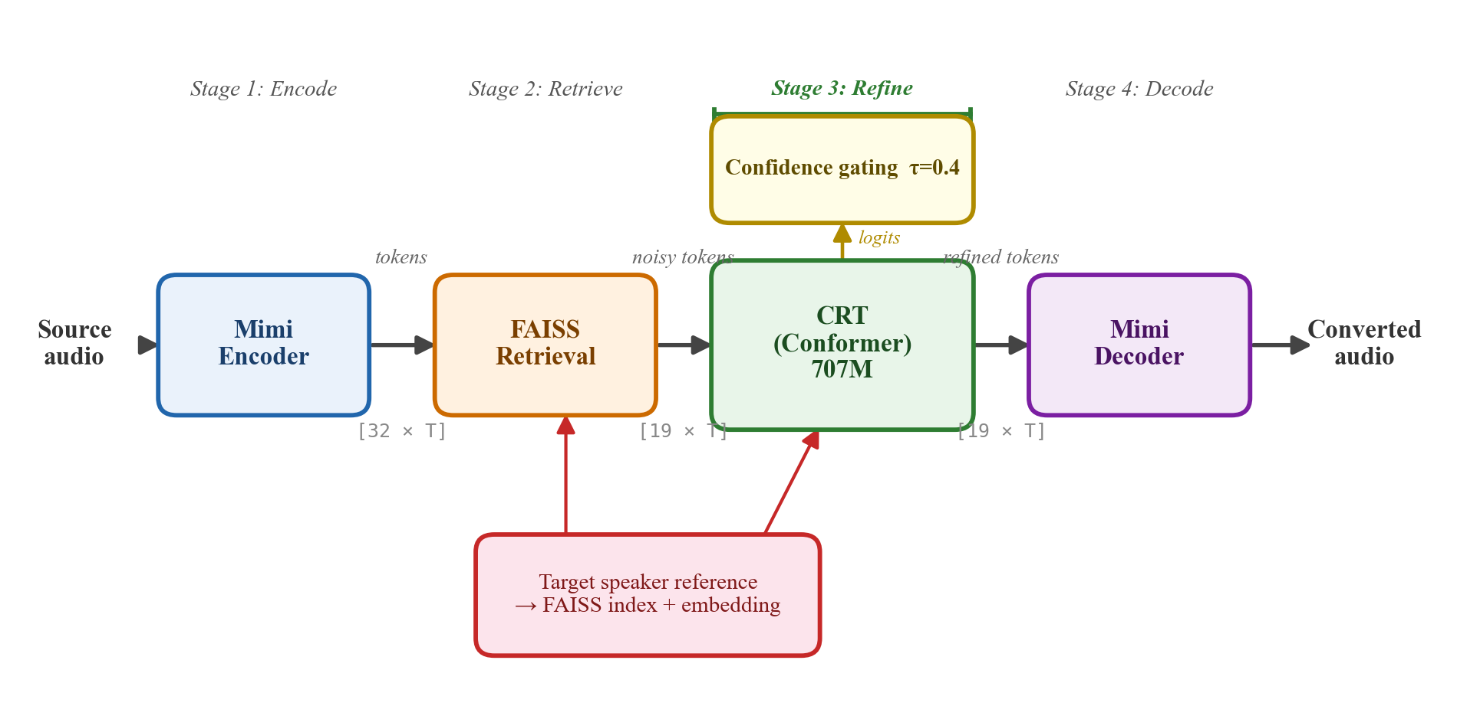
Figure 4. CRT voice conversion pipeline: encode → retrieve → refine → decode.
6. DISCUSSION
Refinement vs. generation. Retrieved tokens are >80% correct. CRT fixes ~18% at frame boundaries. A single forward pass suffices where autoregressive models need hundreds of steps.
Confidence-selective decoding. The selection mechanism is as important as the prediction model. A 75%-accurate CB1 predictor destroys quality when applied unconditionally but improves the baseline when confidence-gated — a principle applicable to any post-processing task with a fallback baseline.
Foundation for codec-native voice flexibility. CRT provides voice conversion as a modular, pluggable component for codec-based speech systems — tokens in, tokens out, no vocoders, no format conversion.
Limitations. (1) No MOS/MUSHRA; UTMOS suggests quality improvement but formal validation needed. (2) Fixed threshold; adaptive per-codebook τ could help. (3) CB0 passthrough limits SECS. (4) 2023-only baselines; comparison with Seed-VC, VEVO planned.
Ethical considerations. Voice conversion carries risks of misuse (speaker impersonation, deepfakes). Mitigating factors: CRT requires a multi-utterance target corpus (not single-sample cloning); codec output at 1.1 kbps is perceptually distinguishable from natural speech (UTMOS ~2.5 vs. ~4.5); discrete tokens are amenable to watermarking. We support development of detection systems for codec-based VC.
7. CONCLUSION
CRT combines established components in a novel formulation: post-retrieval refinement of discrete RVQ codec tokens. On 100 zero-shot VCTK pairs, CRT consistently improves over FAISS (MCD 102.6 vs. 103.3) while achieving higher SECS than kNN-VC (0.816 vs. 0.796). Confidence-selective decoding overrides only 17.8% of tokens. RTF 0.90x on A100. CRT’s token-to-token architecture positions it as foundational infrastructure for flexible voice output in codec-native speech systems.
. ACKNOWLEDGMENTS
Computational resources provided by the Enterprise AI Center DGX cluster. We thank the Kyutai team for the open-source Mimi codec, and the authors of kNN-VC and FreeVC for their public implementations.
. REFERENCES
[1] L. Sun et al., "Voice conversion: State of the art and future trends," IEEE Signal Processing Magazine, 2024.
[2] N. Zeghidour et al., "SoundStream: An end-to-end neural audio codec," IEEE/ACM TASLP, 2022.
[3] A. Defossez et al., "High fidelity neural audio compression," TMLR, 2023.
[4] R. Kumar et al., "High-fidelity audio compression with improved RVQGAN," NeurIPS, 2023.
[5] Kyutai Team, "Moshi: a speech-text foundation model for real-time dialogue," arXiv:2410.00037, 2024.
[6] J. Johnson et al., "Billion-scale similarity search with GPUs," IEEE TBD, 2021.
[7] M. Baas et al., "Voice conversion with just nearest neighbors," Interspeech, 2023.
[8] C. Wang et al., "Neural codec language models are zero-shot text to speech synthesizers," arXiv:2301.02111, 2023.
[9] Z. Borsos et al., "SoundStorm: Efficient parallel audio generation," arXiv:2305.09636, 2023.
[10] J. Li et al., "FreeVC: Towards high-quality text-free one-shot voice conversion," ICASSP, 2023.
[11] S. Chen et al., "WavLM: Large-scale self-supervised pre-training for full stack speech processing," IEEE JSTSP, 2022.
[16] Y. Wang et al., "MaskGCT: Zero-shot TTS with masked generative codec transformer," ICLR, 2025.
[18] Y. Du et al., "vec2wav 2.0: Advancing voice conversion via discrete token vocoders," arXiv:2409.01995, 2024.
[19] E. Perez et al., "FiLM: Visual reasoning with a general conditioning layer," AAAI, 2018.
[26] A. Gulati et al., "Conformer: Convolution-augmented transformer for speech recognition," Interspeech, 2020.
[28] T.-Y. Lin et al., "Focal loss for dense object detection," ICCV, 2017.
[29] Y. Koizumi et al., "LibriTTS-R: A restored multi-speaker text-to-speech corpus," Interspeech, 2023.
[30] C. Wan et al., "Generalized end-to-end loss for speaker verification," ICASSP, 2018.
[31] J. Yamagishi et al., "CSTR VCTK Corpus: English multi-speaker corpus," Univ. of Edinburgh, 2019.
[32] T. Saeki et al., "UTMOS: UTokyo-SaruLab system for VoiceMOS Challenge 2022," Interspeech, 2022.

