DVCfg: **DV_GENERATION_STEP Generation Step for change Unused bit in Davinci , update value timeout and Rx data timeout for com signal routing**

# Prerequisites

1. Davinci Configuration Pro
2. DvGroovy Execution Script file

UpdateTimeoutSignal.dvgroovy

# Step by step

2.1 Enable Script location tab.

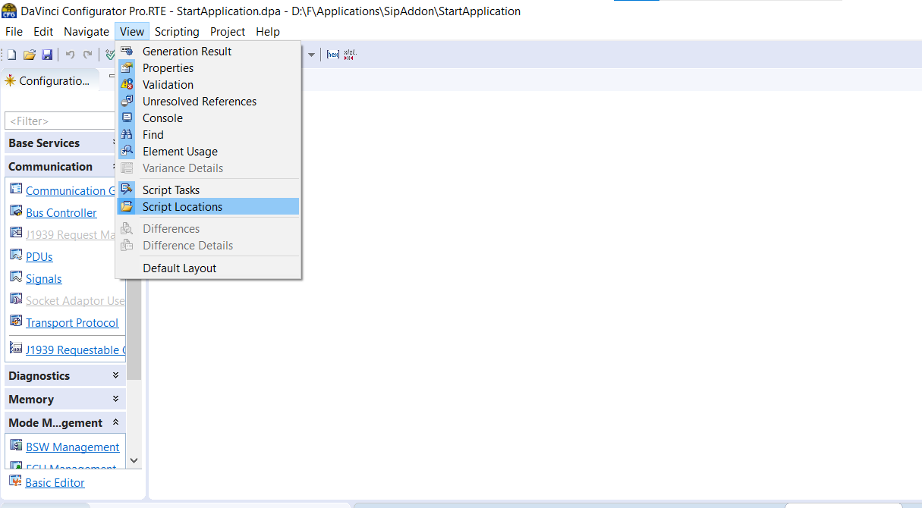

2.2 Add the Groovy script in the project. Create a new folder for the script as below:

Location : Applications\SipAddon\StartApplication\GroovyScript

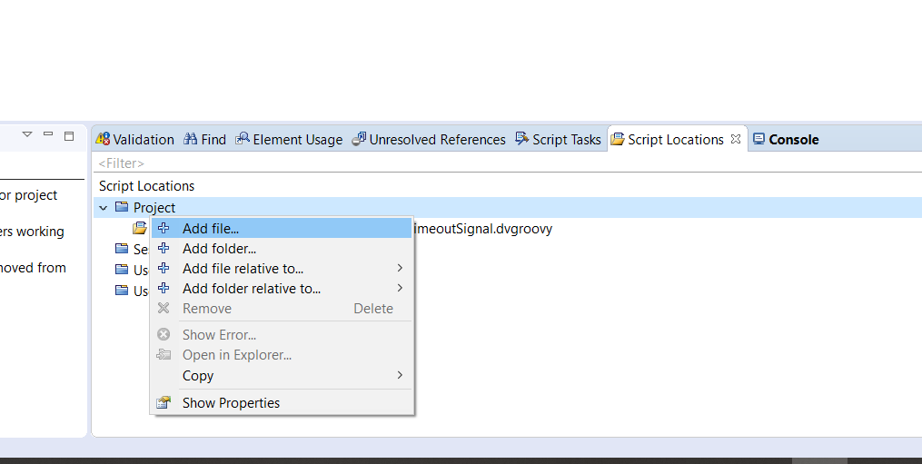

2.3 Go to Project Setting:

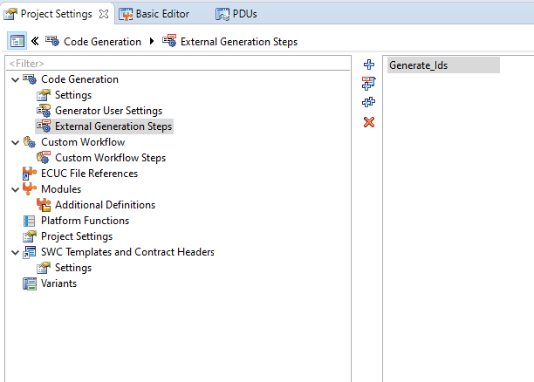

2.4 Add External Generation Steps and choose new script you want to run:

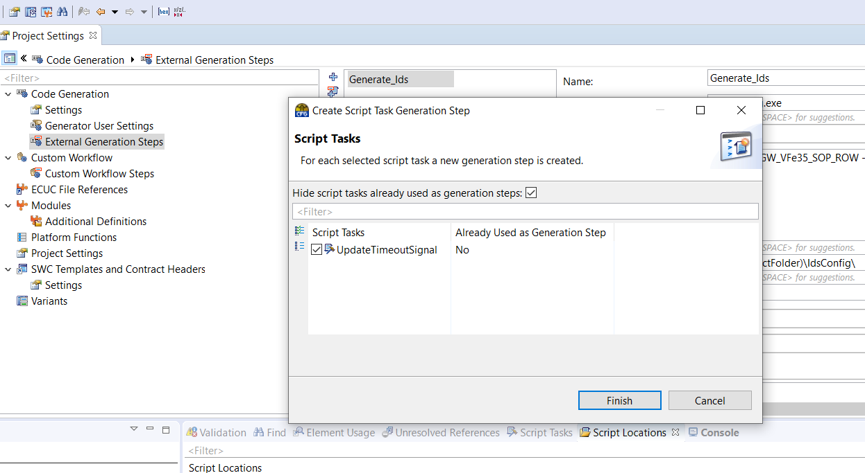

Pass argument :

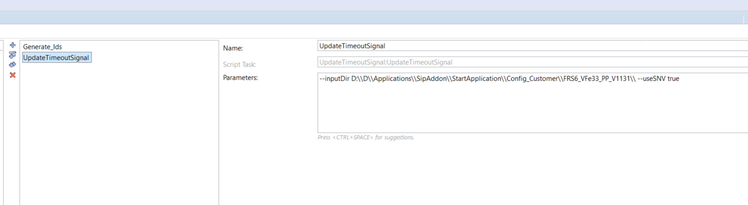

Syntax : --inputDir Path to input file(dbc,vsde) –useSNV true(false)

Example : --inputDir D:\\F\\Applications\\SipAddon\\StartApplication\\Config_Customer\\XGW_VFe35_SOP_ROW\\ --useSNV false

useSNV : true corresponding invalid value = 2^n bit – 1 incase missing attribute invalid value

: false corresponding invalid value = initial value incase missing attribute invalid value

2.5 Run and check for the result:

