**FPT ACADEMY INTERNATIONAL**



## FPT – APTECH COMPUTER EDUCATION

Uniform

|  |  |  |  |
| --- | --- | --- | --- |
| **Center Name** | | FPT – Aptech – HCM2  Address: 590 Cach Mang Thang Tam, District 3, Ho Chi Minh City | |
| **Instructor** |  | Ms. Le Mong Thuy |  |
| **Class** |  | T1.2110.E1 |  |
| **Group** |  | 3 |  |
| **Group members** | | **Name** | **Student ID** |
|  |  | Lương Hữu Nhân | Student1342782 |
|  |  | Nguyễn Tiến Đạt | Student1341534 |
|  |  | Nguyễn Xuân Thành  Nhâm Thiên Hưng | Student1345187  Student1345347 |
| **Duration** | Start date | 13-Jan-2022 |  |
|  |  |  |

**This is to certify that**

**Mr.:**

Lương Hữu Nhân

Nguyễn Tiến Đạt

Nguyễn Xuân Thành

Nhâm Thiên Hưng

**has successfully designed & developed**

eProject: A1UNIFORM

**Submitted by:**

Nhâm Thiên Hưng

**Date of issue:**

**Authorized Signature:**



**TABLE OF CONTENTS**

FPT – APTECH COMPUTER EDUCATION 1

ACKNOWLEGMENT 3

SYNOSIS 3

PROBLEM DEFINITION 5

CUSTOMER'S REQUIREMENTS SPECIFICATIONS (CRS) 6

Business/Project Objective: 6

Hardware/ Software Requirements: 7

SCOPE OF THE WORK (IN BRIEF) 8

Architecture and design of the system 9

Diagram of the website Error! Bookmark not defined.

TASK SHEET REVIEW 1 11

SITE MAP 12

MOCK OF THE WEBSITE 13

1. ***Homepage*** ***13***

***2. EXPERIENCE*** ***14***

***3. Leisure &Dinning*** ***15***

***4.1 hightech land section*** ***16***

***4.2-4.8 7 wonder-Park section*** ***17***

***5. Whats Up*** ***18***

***6. Contact us+business opportunities*** ***19***

***7. About us*** ***20***

***8.***

**9.**

**10.**

TASK SHEET REVIEW 2 21

WEBSITE DESCRIPTION

***1. EXPERIENCE*** ***22***

***2. What Up*** ***23-24***

***3. 7 wonder Park Characters*** ***25-26***

***4. Hightech land*** ***27-28***

***5. Home page*** ***29-30***

***6. Leisure &Dinning*** ***31-32***

***7. Contact us Business opportunities*** ***33-34***

***8. About us*** ***35***

**9.** Menu&footer 36

**10.** Java Script 37-42

TASK SHEET REVIEW 3 43

# ACKNOWLEGMENT

On behalf of all the members of group 3, I would like to thank you all for the hard works, supports to make this eProject complete successfully. Especially, Ms. Le Mong Thuy, our teacher, she helped us a lot from the day that we started to study at FPT Aptech. With this eProject, she has guided us with her enthusiasm and rigorous, because of her guiding, we would be able to finish this project. Besides, I want to thank all the team member of group 3, each of the team member has been working in order to complete this project. The last but not least, we would like to say thank you to our family for always supporting us, creating the best conditions for us to focus on the project, and putting faith in the dreams we pursue.

# SYNOSIS

A-1 uniforms was founded in 2016 and since then they have been one of the leading **Uniform Manufacturers in the country.** they supply many schools in country and they give them the best uniforms. They supply affordable school uniforms for girls and boys. When clients come, they cater to client’s vision. As a team of professionals they understand what clients want and deliver the best results.

At A-1 uniform designs are innovative and there are always fresh and new ideas for each and every client. The textiles are of excellent quality and they make each uniform according to the size requirements given. The fit is ingenious and they provide with the best. A-1 uniform is a part of a continuous strategic process of creative inputs from experts in the field. They consider each client differently and ensure the satisfaction with the end results. Each client is given the uttermost importance.

The entire team works together to achieve the same goal.

# PROBLEM DEFINITION

The Web site is to be created based on the following requirements.

1. The home page must describe the keywords or highlight of the shop along with all navigation link defined.
2. Products should be categorized as
   1. Shirts
   2. Skirts
   3. Frocks
   4. P.T. T-shirts
   5. P.T. shorts
   6. P.T. track pants
   7. Belts
   8. Ties
   9. Logos
   10. Socks
3. The “Contact Us” page should have the Address of the Company and the mail address which when clicked will invoke the local mail client from where they can send an email. Address of the Company should be displayed using GeoLocation API (e.g. GoogleMaps).
4. Contact Us page should also include the address and contact details of various outlets of A-1 uniforms in the city.
5. About us page
6. Feedback
7. Navigation must be smooth.
8. Color combination must be uniform throughout the project.

# CUSTOMER'S REQUIREMENTS SPECIFICATIONS (CRS)

**Client: A1UNIFORM**

### Business/Project Objective:

A-1 uniforms was founded in 2016 and since then they have been one of the leading Uniform Manufacturers in the country.

Looking at the demands and increasing power of web, the management of A-1 are looking for hosting a website of their products which will be easier to reach to them.

The website is to be developed for the Windows Platform using HTML5, JavaScript and Geolocation. The site should work well in all leading browsers including Chrome, IE, Firefox etc.

**Input to the system:**

* Filter a list of products for that user selected in Home & Shopping online page
* Leave comment to the ‘A1Uniform’ customer service in Feedback page
* Send mail to the A1Uniform company in Contact Us page.

**Output from the system:**

* Displaying result of products for that user selected in Cart page
* Display the local mail client when user click to the mail address in Contact Us page.

**Process**:

* Show and short the product in website.
* Show and sort size of some product.

**Expected delivery date:**

**List of deliverables:**

* + - * Document Word.
      * User Guide.
      * Source code.

### Hardware/ Software Requirements:

**Hardware**

* A minimum computer system that will help you access all the tools in the courses is a Pentium 166 or better
* 64 Megabytes of RAM or better

**Software**

* Notepad/HTML editor
* Dreamweaver
* IE 5.0/ Netscape 6.0

# SCOPE OF THE WORK (IN BRIEF)

After a long and detailed discussion, our group has decided to create a website contain the following webpages:

1. ***HOMEPAGE***: Display information about newest-selling products, an introduction about fun-zone
2. ***REGISTER***: Login to the page or regist a new account
3. ***PRODUCTS:*** Display all the products according to the output.
4. ***CART:*** Display all the added products.
5. ***PAYMENT:*** Display the total amount and methods for payment.
6. ***FEEDBACK:*** Display a text area for comments and information of the commenter.
7. ***CONTACT:*** Address of the Company,email…

# Architecture and design of the system

Webpage request



Requested Page

**RENDERING**

**ENGINE**

**CSS CODE**

**HTML CODE**

**WEB SERVER**

**WEB BROWSER**

**CLIENT**

**SERVER**

# Diagram of the website

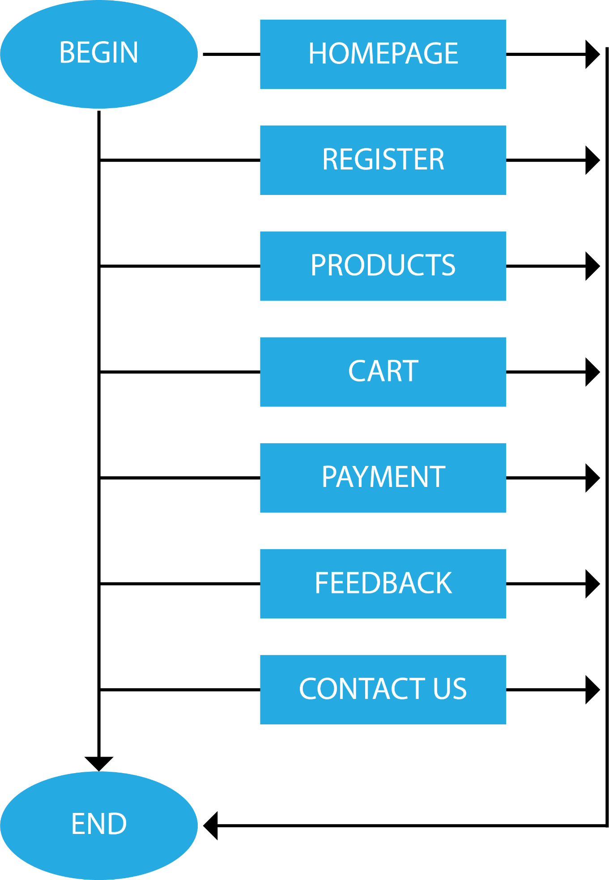



# TASK SHEET REVIEW 1

|  |  |  |  |  |  |  |  |
| --- | --- | --- | --- | --- | --- | --- | --- |
| **Project Ref. No.:**  **eP/Advertisement Portal Management**  **System/01** | | **Project Title:** | **Activity Plan Prepared By:** | **Date of Preparation of Activity Plan:** | | | |
| **Sr.**  **No.** | **Task** | **Actual**  **Start Date** | **Actual Days** | **Team**  **Mate Names** | **Status** |
| 1 | Problem Statement | UNIFORM | HƯNG | 15-Jan-22 | 1 | Đạt | Completed |
| 2 | Analysis requirements about the website | 15-Jan-22 | 1 | Thành | Completed |
| 3 | The scope of the work | 15-Jan-22 | 1 | Đạt + Nhân | Completed |
| 4 | Architecture and design of the system | 15-Jan-22 | 1 | Nhân | Completed |
| 5 | Diagram of the website | 15-Jan-22 | 1 | Hưng | Completed |
| 6 | Task Sheet | 15-Jan-22 | 1 | Hưng | Completed |

|  |  |
| --- | --- |
| **Date: 16-07-2021** | |
| Signature of Instructor:  **Ms. Le Mong Thuy** | Signature of Team Leader: |

# 

# SITE MAP

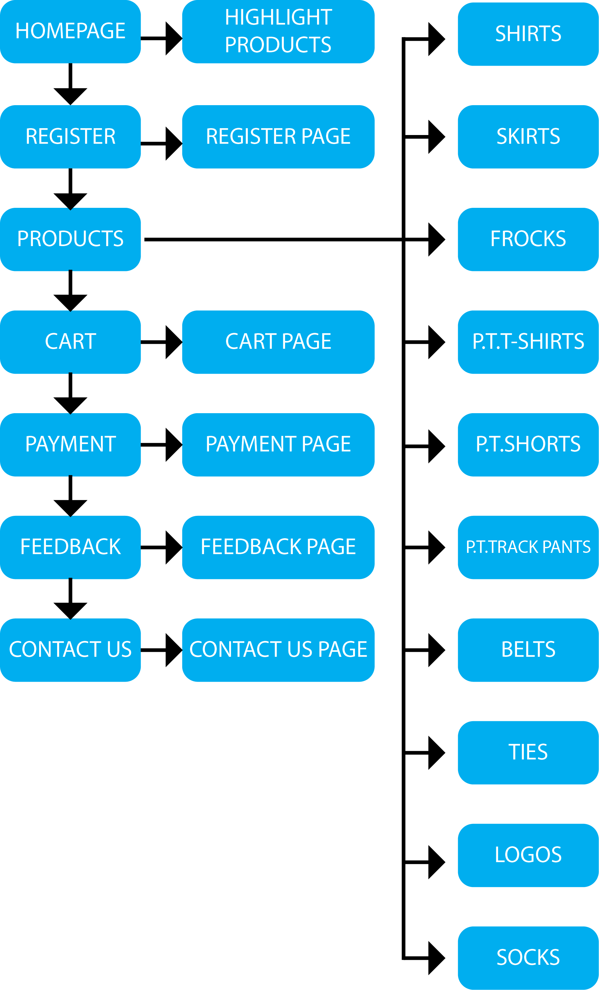

# MOCK OF THE WEBSITE

1. HOMEPAGE

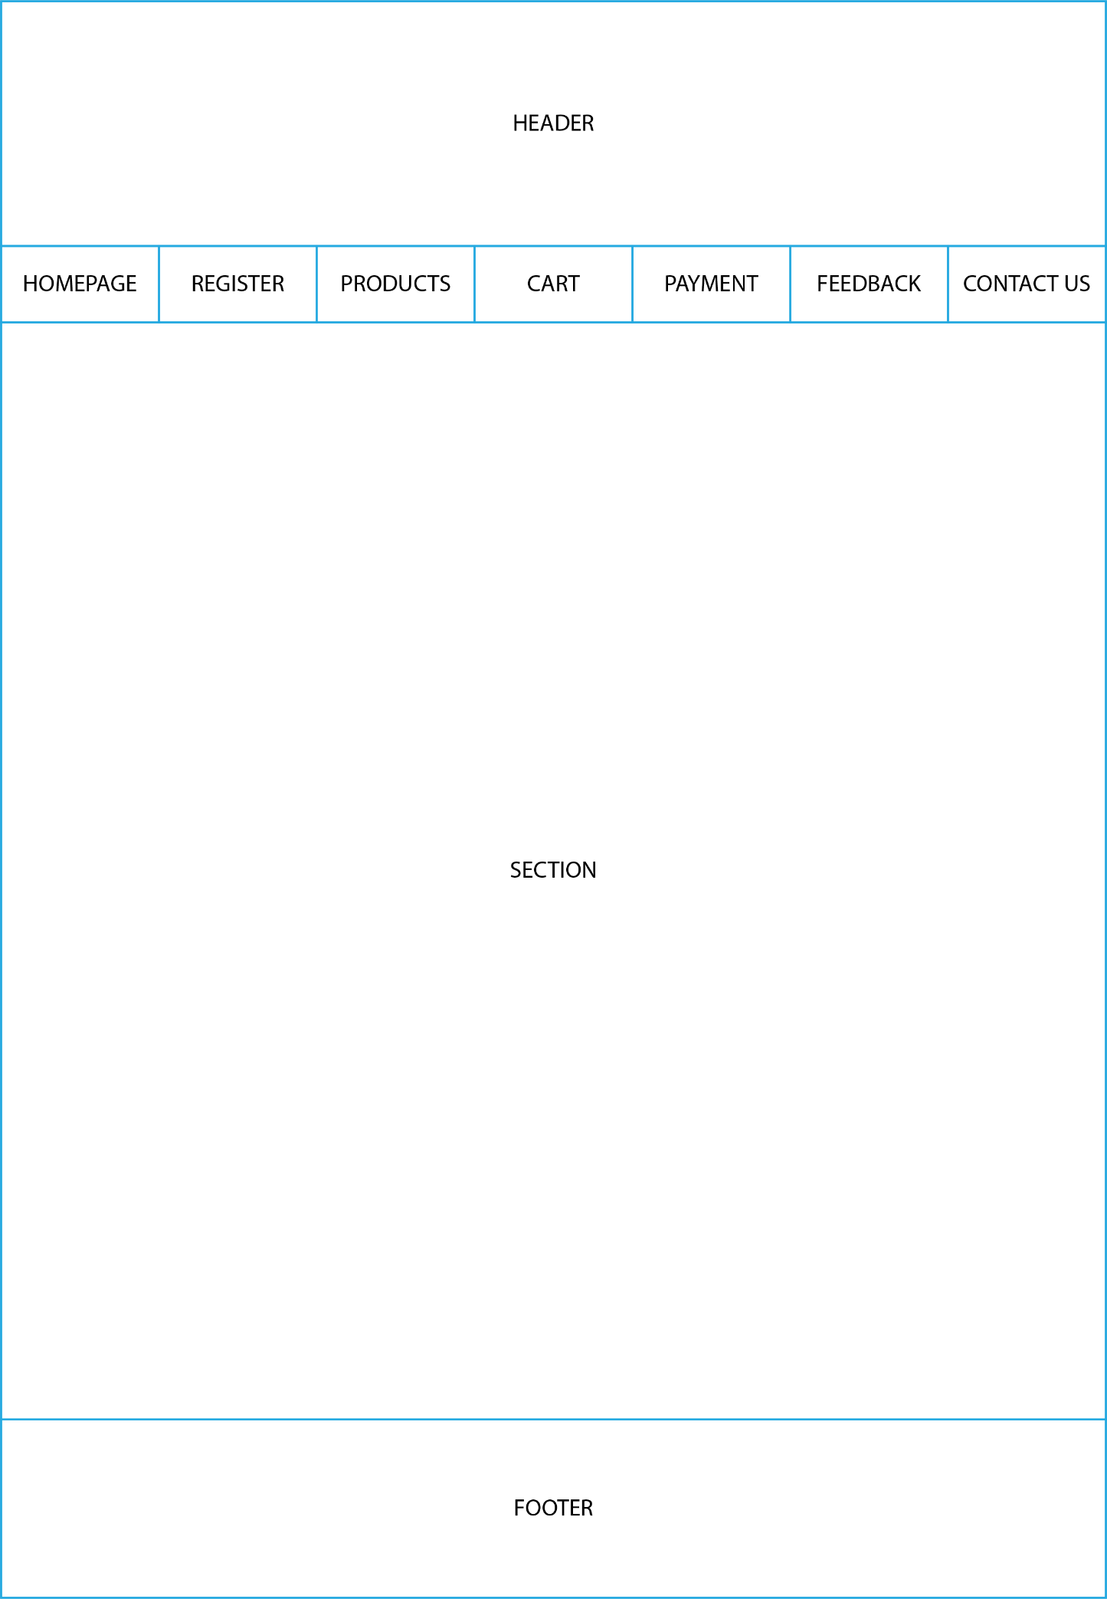

2. REGISTER

# 

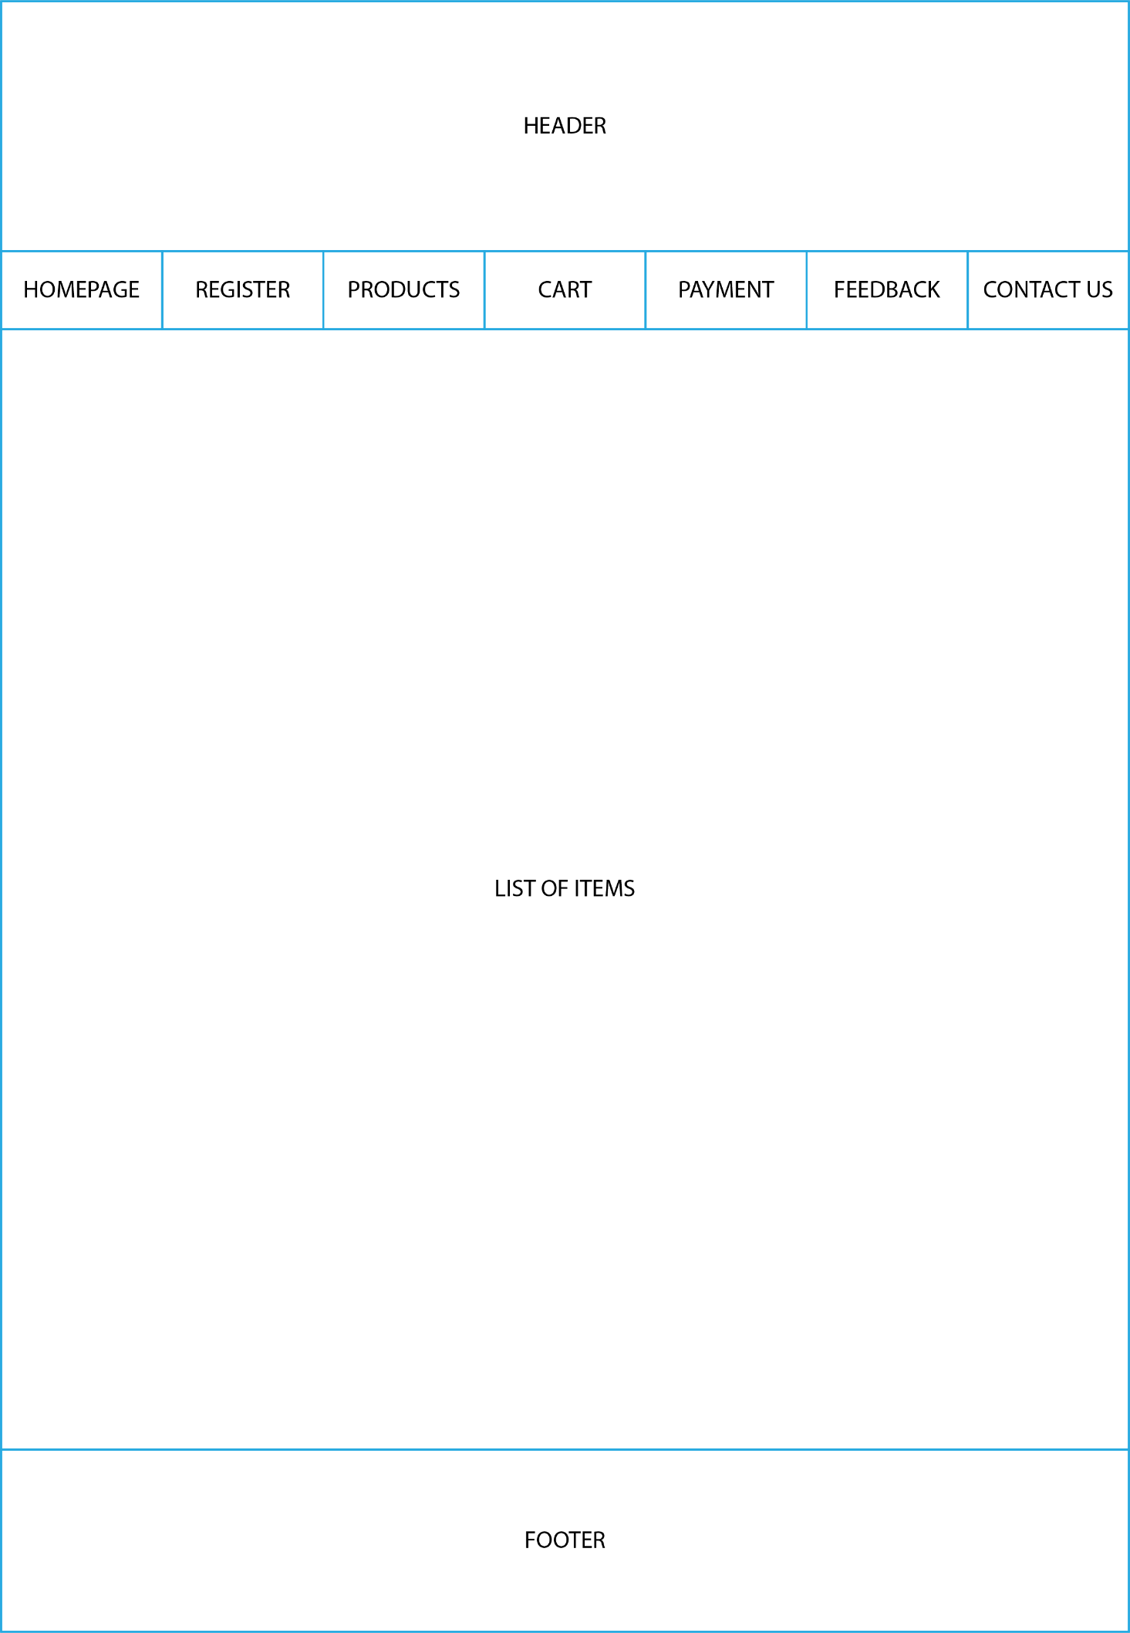3. PRODUCTS

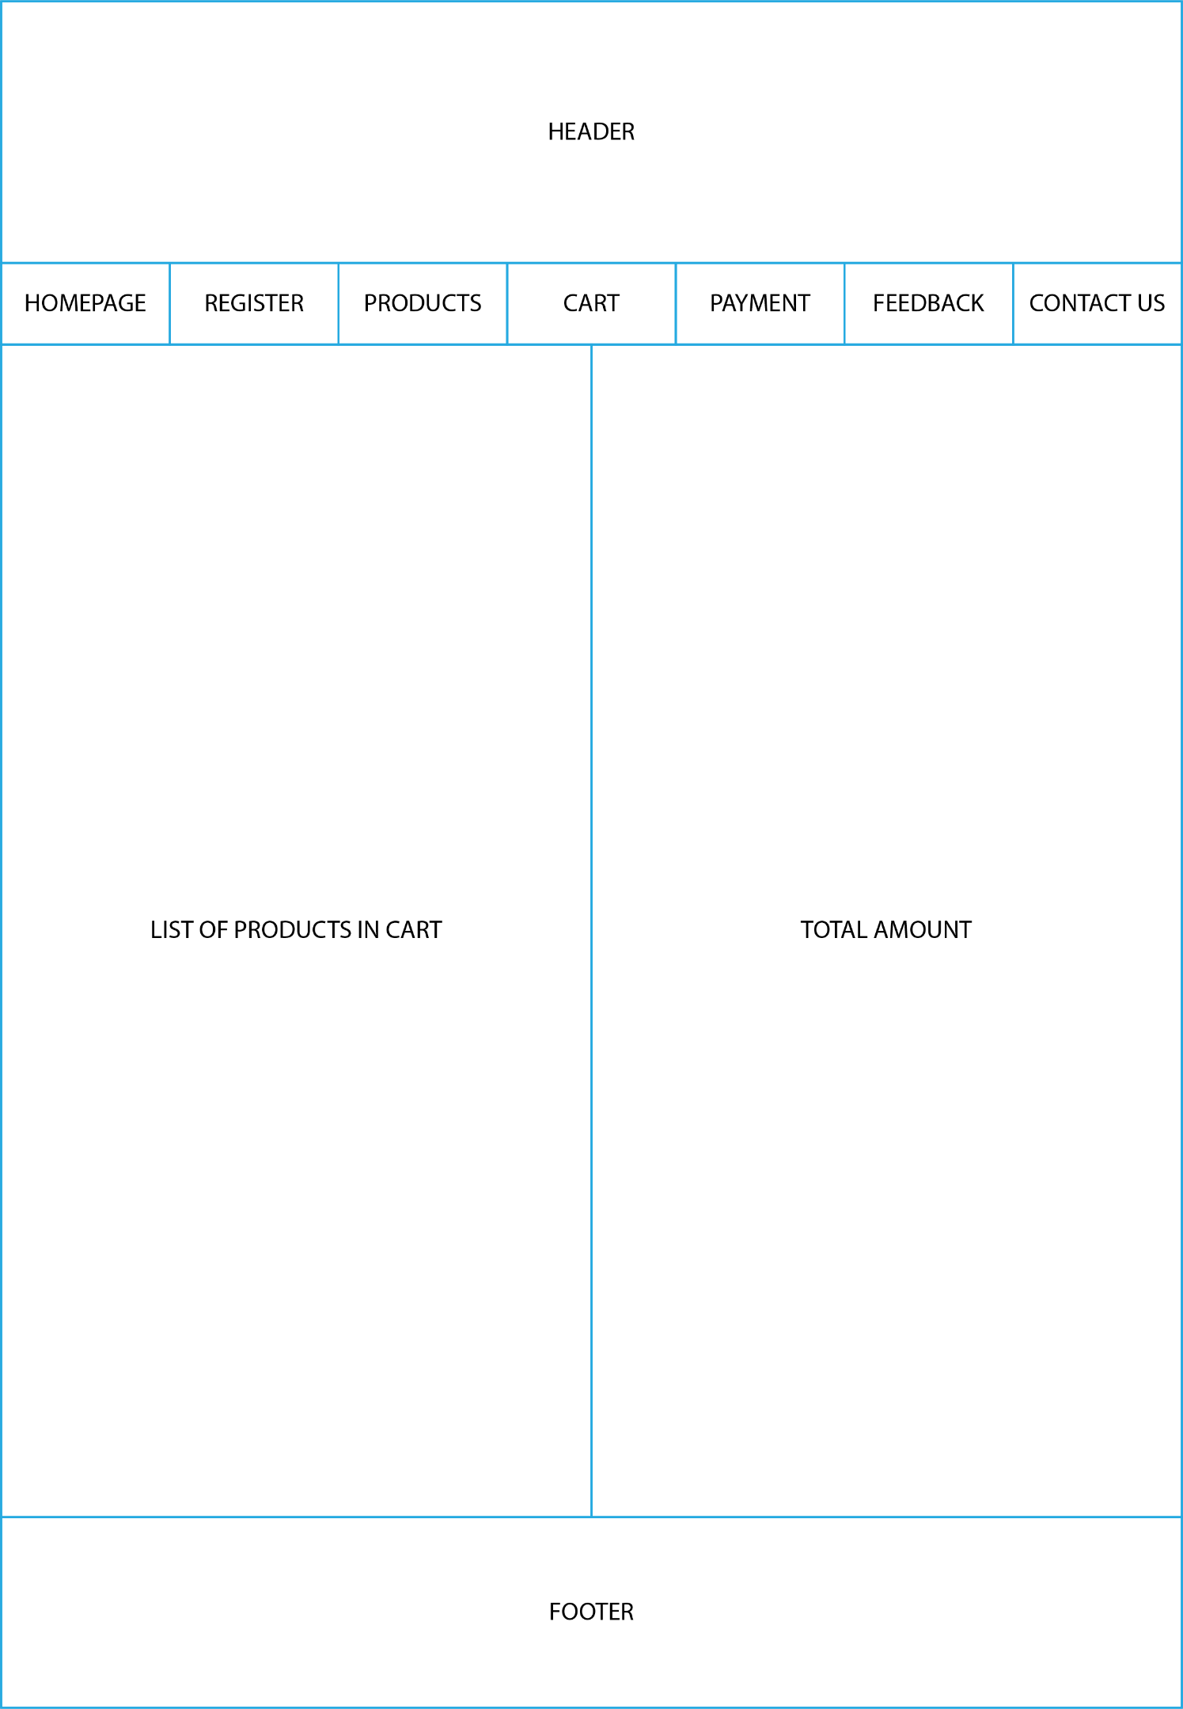4. CART

5. PAYMENT

# 

6. FEEDBACK

# 

7. CONTACT US

# 

# TASK SHEET REVIEW 2

|  |  |  |  |  |  |  |  |
| --- | --- | --- | --- | --- | --- | --- | --- |
| **Project Ref. No.:**  **eP/Advertisement**  **Portal**  **Management System/01** | | **Project Title:** | **Activity Plan Prepared By:** | **Date of Preparation of Activity Plan:** | | | |
| **Sr.**  **No.** | **Task** | **Actual Start Date** | **Actual Days** | **Team Mate Names** | **Status** |
| 1 | Site map | A1Uniform | Hưng | 20-01-2022 | 1 | Hưng + Đạt | completed |
| 2 | Mock of the website | 20-01-2022 | 1 | Đạt + Nhân | completed |
| 3 | Task sheet | 20-01-2022 | 1 | Nhân + Thành | completed |

|  |  |
| --- | --- |
| **Date:** **20-01-2022** | |
| Signature of Instructor:  **Ms. Le Mong Thuy** | Signature of Team Leader: |

# WEBSITE DESCRIPTION

**1.HOMEPAGE**

1. Description

This webpage displays following information: Navigation bar, slogan, featured products and footer

1. 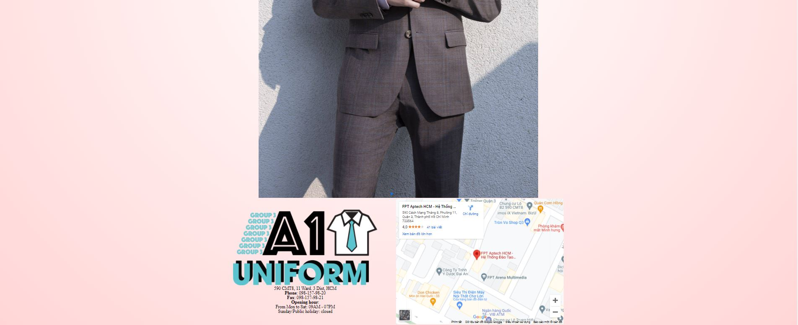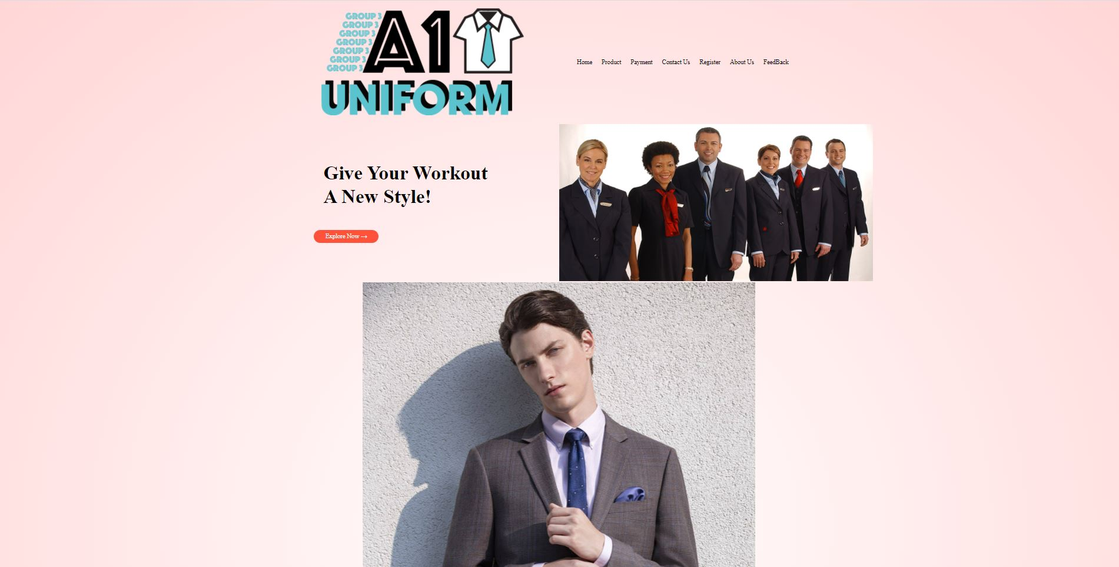Screenshoot

**2.PRODUCTS**

1. Description

This webpage displays following information: Products by category

1. 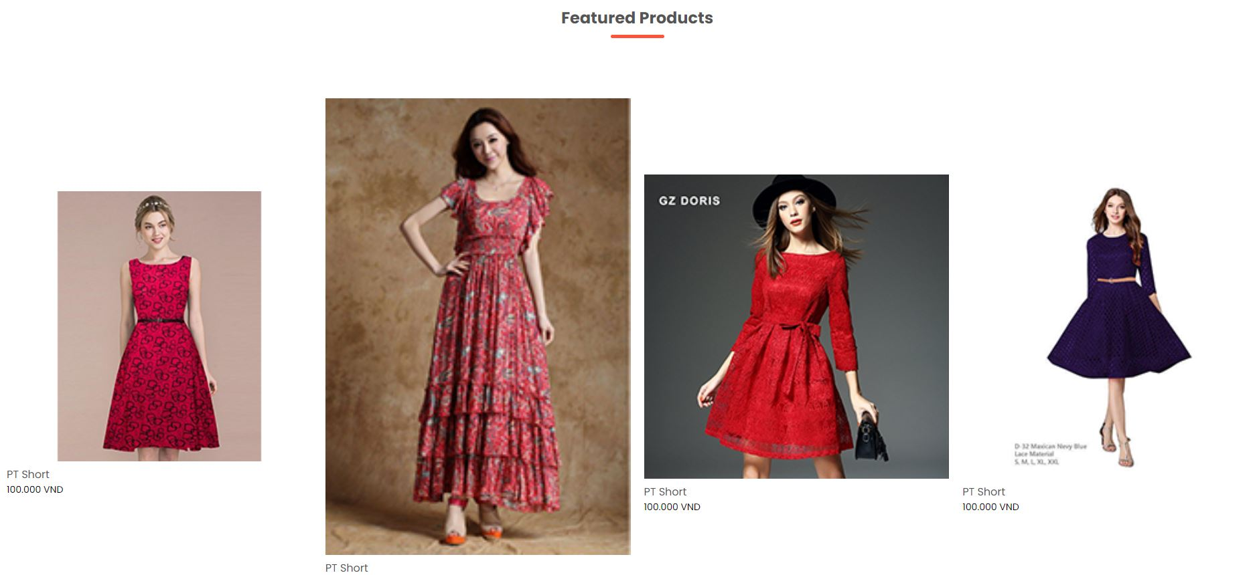Screenshoot

**3.CONTACT US**

1. Description:  
   This webpage displays following information: contact us form
2. Screenshot:

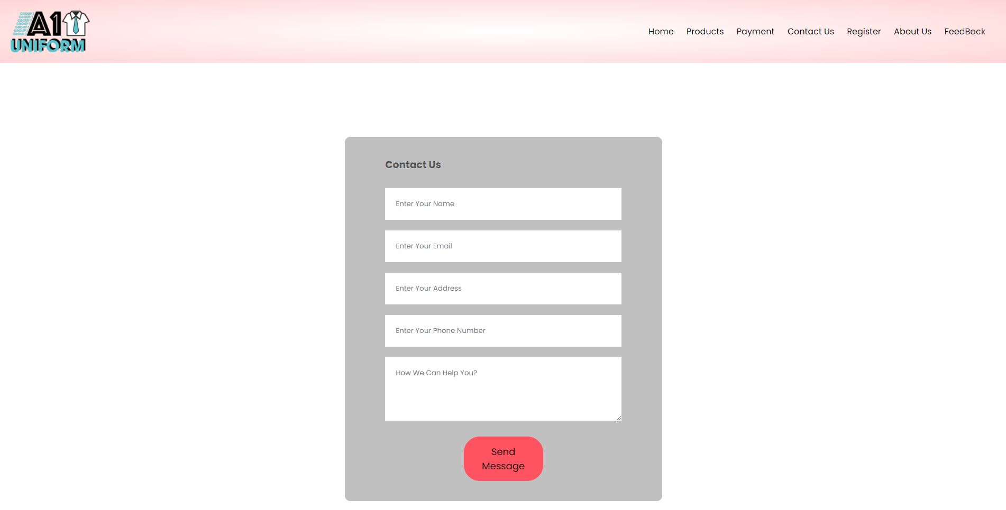

**4. REGISTER/ LOGIN PAGE**

1. Description:  
   This webpage displays following information: Register form or login form
2. Screen shot:

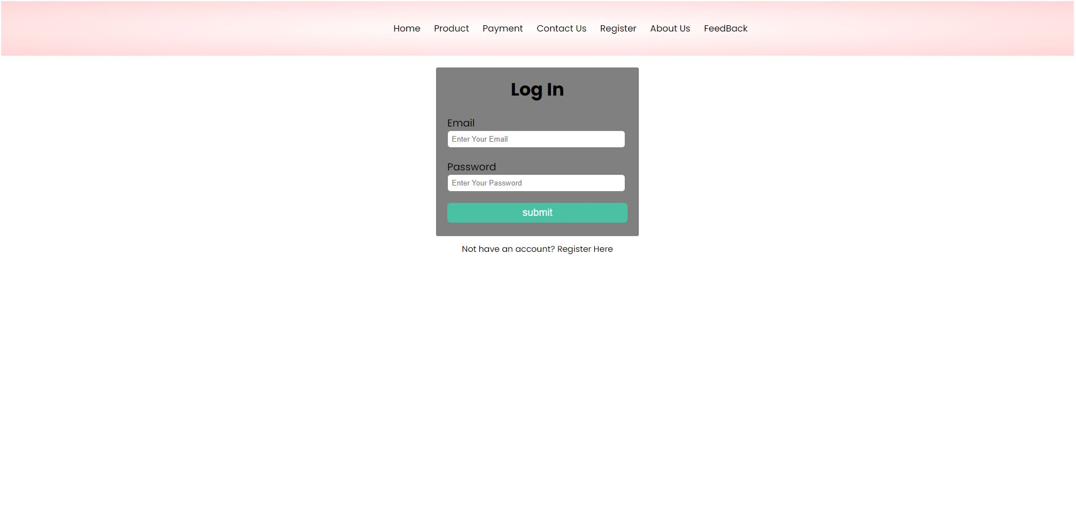

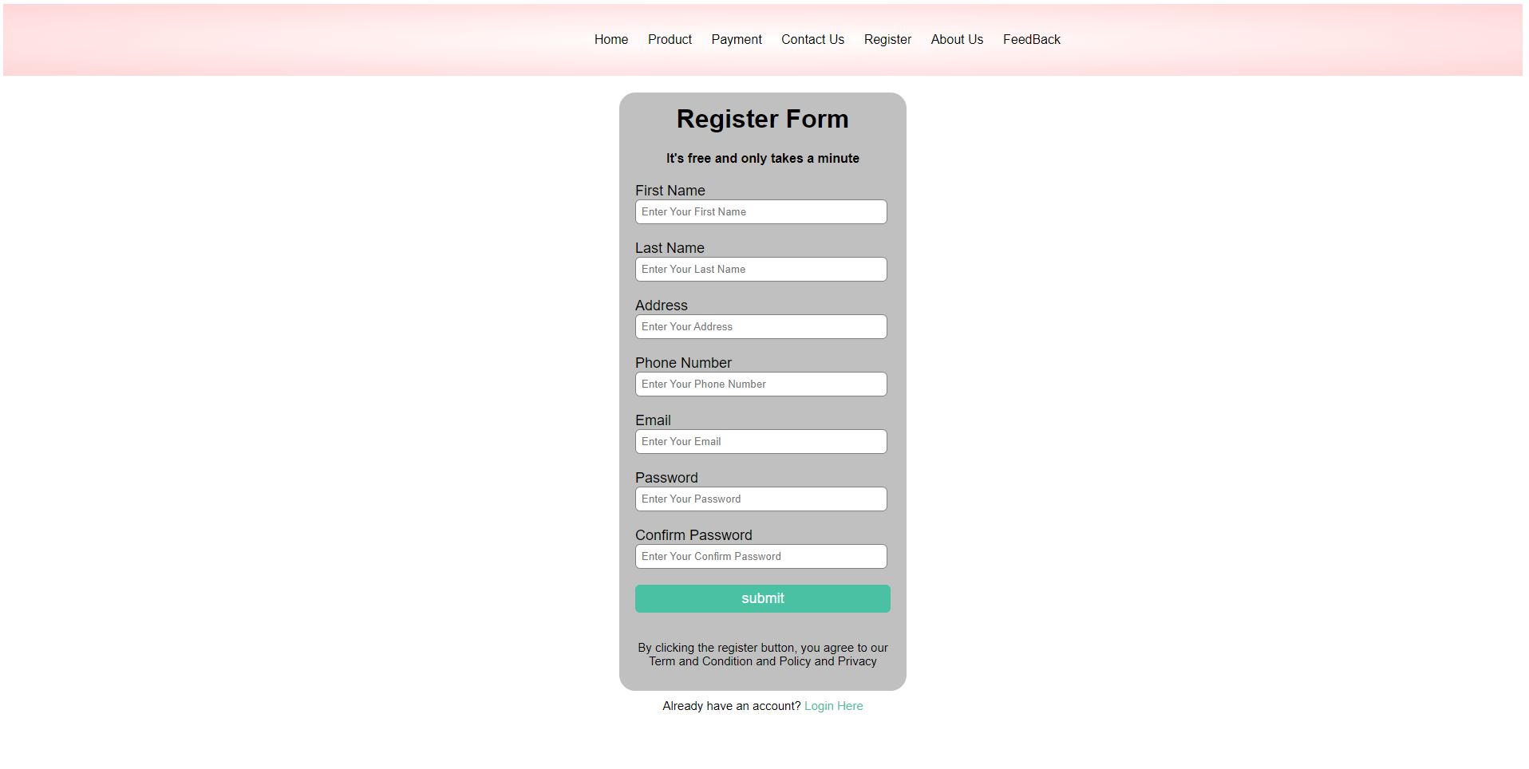

**5. PAYMENT PAGE**

1. Description:  
   This webpage displays following information: payment form
2. Screen shot:

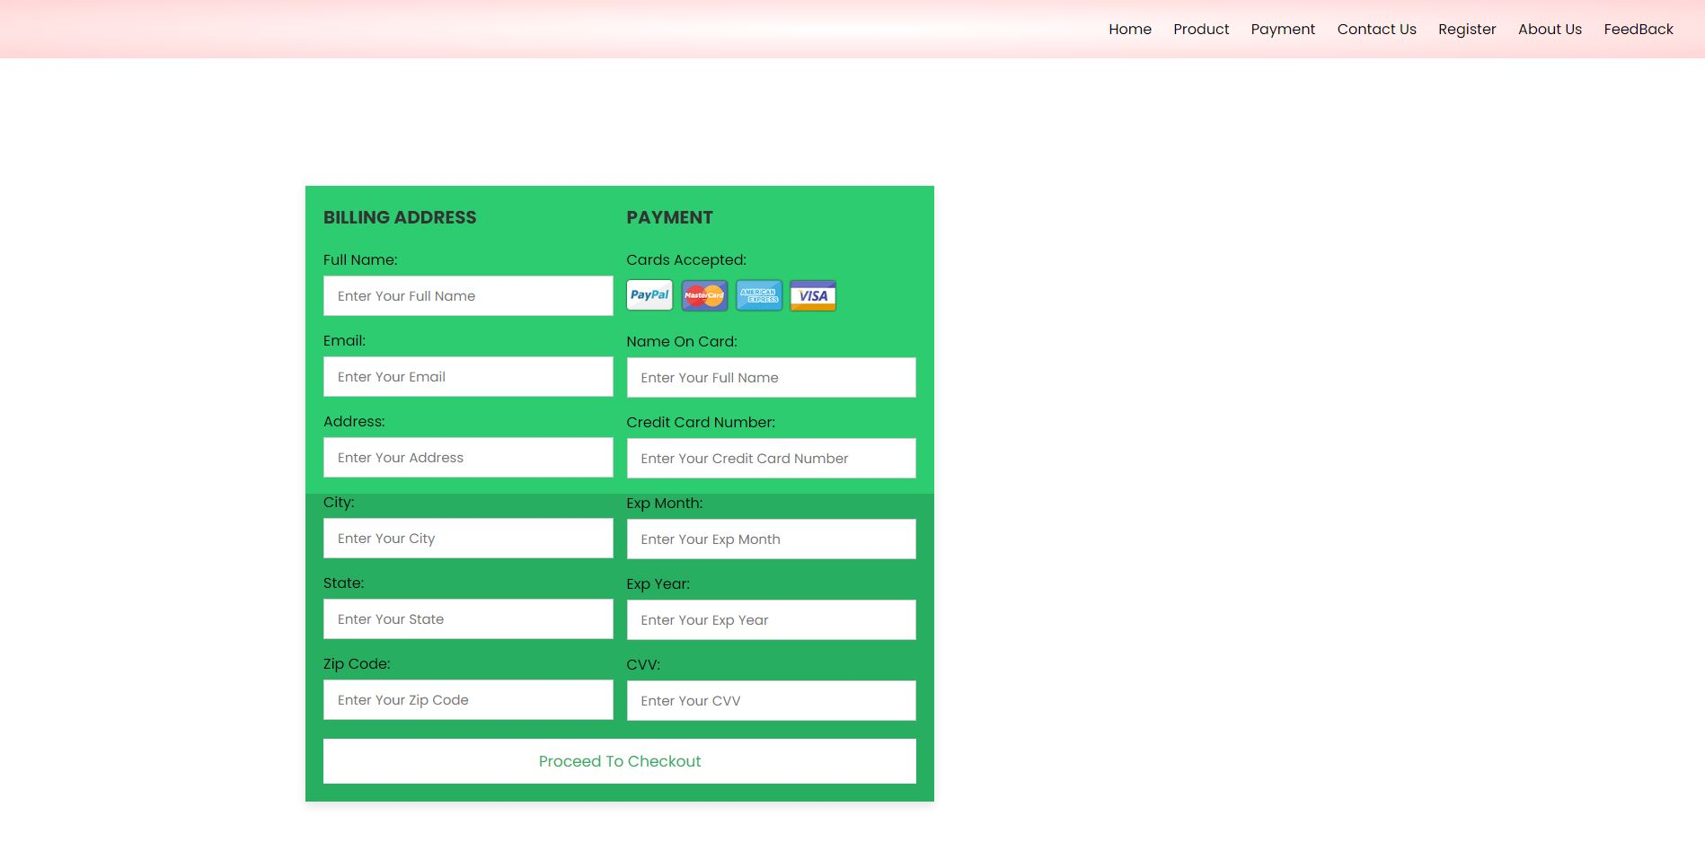

**6. MENU, FOOTER**

Description:This webpage displays following information:

Menu:display link of section in web:  
LOGO

Home: homepage

Products: products page

Payment: payment page

Contact us: contact us page

Register: register page

About us: about us page

Feedback: feedback page

Screen shot:



**9.Javascript**

1. **Script use for footer:**

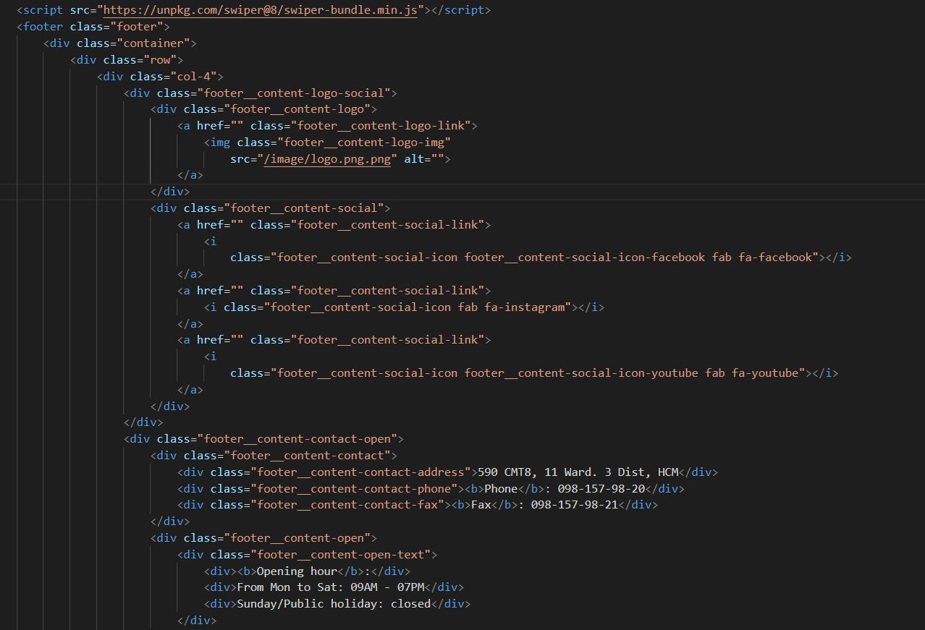

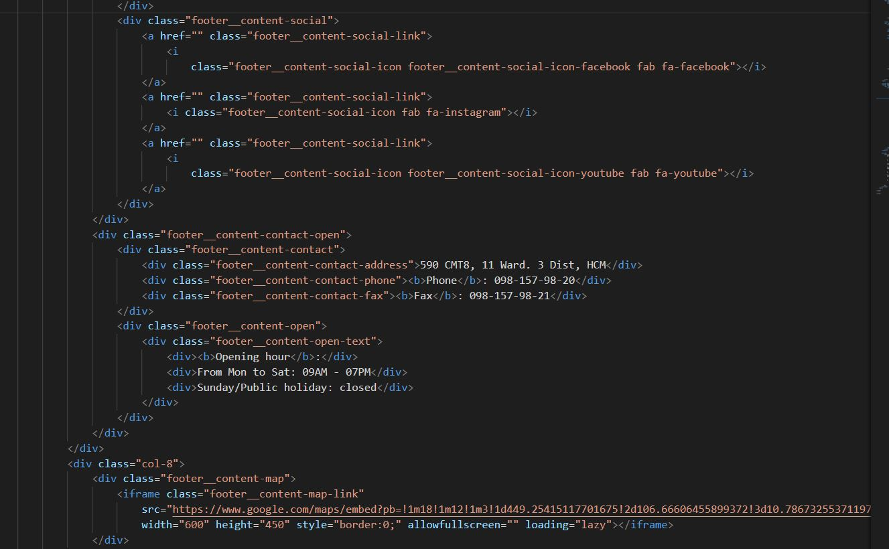

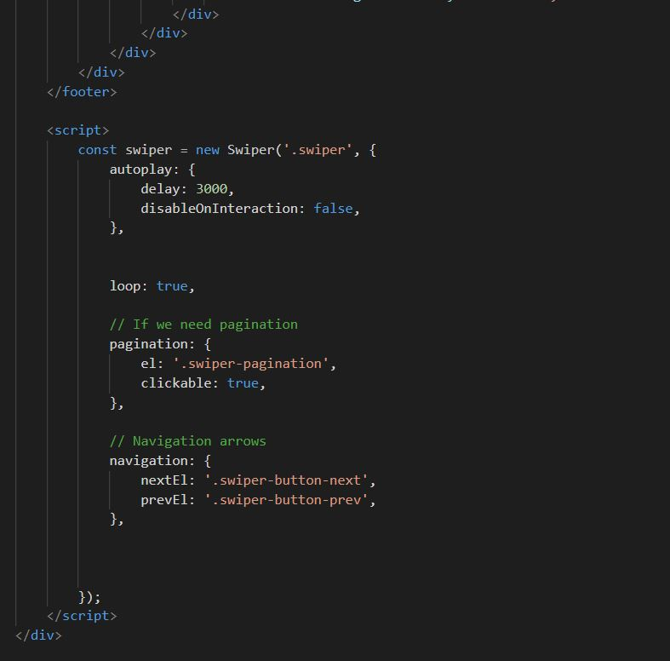

1. 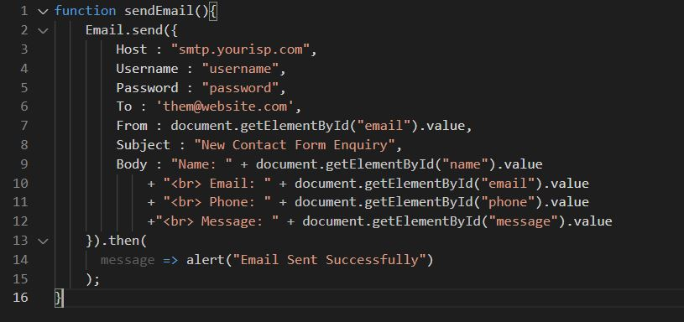**Json for Contact us page:**

# TASK SHEET REVIEW 3

|  |  |  |  |  |  |  |  |
| --- | --- | --- | --- | --- | --- | --- | --- |
| ***Project Ref. No.:***  ***eP/Advertisement Portal Management System/01*** | | ***Project Title:*** | ***Activity Plan Prepared By:*** | ***Date of Preparation of Activity Plan:*** | | | |
| ***Sr.***  ***No.*** | ***Task*** | ***Actual Start***  ***Date*** | ***Actual Days*** | ***Team Mate***  ***Names*** | ***Status*** |
| *1* | *Homepage* | *A1Uniform* | *Nhâm Thiên Hưng* | *07-01-2022* | *3* | *Đạt* | *Completed* |
| *2* | *Products* | *18-01-2022* | *1* | *Hưng* | *Completed* |
| *3* | *Contact us* | *25-01-2021* | *3* | *Nhân* | *Completed* |
| *4* | *Register/login page* | *03-02-2021* | *2* | *Thành* | *Completed* |
| *5* | *Payment page* | *05-02-2021* | *3* | *Đạt* | *Completed* |
| *6* | *Menu, Footer* | *07-02-2021* | *2* | *Thành* | *Completed* |
| *7* | *Javascript* | *01-02-2021* | *5* | *Nhân* | *Completed* |
| *8* | *Check & fix code* | *02-02-2021* | *5* | *Nhân* | *Completed* |
| *9* |  |  |  |  |  |  |  |
| *10* |  |  |  |  |  |  |  |
| *11* |  |  |  |  |  |  |  |
| *12* |  |  |  |  |  |  |  |
| *13* |  |  |  |  |  |  |  |

|  |  |
| --- | --- |
| **Date: 17-02-2022** | |
| Signature of Instructor:  **Ms. Le Mong Thuy** | Signature of Team Leader: |