D6 Food Bulk Agile Team Charter
CPUT Entrepreneurial WIL Digital Portfolio

1. Team Purpose and Vision

Why do we exist as a team?
We exist to design and develop an affordable, student-focused grocery platform that makes it easier for NSFAS students living in CPUT residences to buy groceries from wholesalers and arrange safe residence delivery or collection.

Team mission
Our mission is to work collaboratively and incrementally to build D6 Food Bulk, beginning with students in CPUT Cape Town Campus residences. We will organise work transparently, validate important business assumptions and deliver useful features that respond to students' needs and budgets.

Success definition
The team will consider the project successful when:
- Students can use the agreed core journey, from account registration and product browsing to cart, bulk ordering and payment.
- The solution clearly supports affordable grocery bundles, student savings and residence delivery or collection.
- Work is linked to user stories, assigned to a team member and tracked on Trello.
- Completed work meets its acceptance criteria and is reviewed and tested.
- Supplier prices, delivery costs and other business assumptions are clearly identified and validated before being presented as confirmed facts.
- The team completes the agreed project evidence and presentation requirements by the required deadlines.

Product or service
D6 Food Bulk is a digital platform that allows NSFAS students to access wholesaler groceries and create customised food bulks according to their needs and budgets. Its planned service includes student registration and authentication, a product catalogue, a shopping cart, bulk ordering, payment, and safe residence delivery or collection. The initial service area is CPUT residences at the Cape Town Campus.

2. Team Members and Roles
The team works cross-functionally. All members contribute to planning, task delivery, reviews, presentations and continuous improvement.
Team member | Role and contribution
Sinazo Ntsimbi | Team member. Contributes to product-backlog coordination, planning, research and validation, assigned Trello tasks, team discussions, reviews and presentations.
Sibulele Sanda Pama | Team member. Contributes to planning, website development, assigned Trello tasks, team discussions, reviews and presentations.
Tiyani Ngwana | Developer and portfolio contributor. Contributes to frontend and backend implementation, database integration, testing, bug fixing, technical evidence, Trello updates and sprint reviews.

Task ownership may change between sprints according to the user story, workload and skills required. Every Trello card must have a clear owner and deadline.

3. Ways of Working

3.1 Agile framework
The team uses a Kanban-style workflow in Trello to manage user stories and tasks.
The agreed workflow is:
- Add agreed user stories and tasks to the Product Backlog.
- Define acceptance criteria and split large activities into manageable tasks.
- Assign each task to an owner and add a deadline.
- Move active tasks to In Progress.
- Raise blockers early and record decisions or assumptions on the relevant card.
- Review and test completed work.
- Move work to Completed only when it meets the Definition of Done.
Trello is the shared source of truth for task ownership and status. Team members update cards when work starts, changes or finishes.

3.2 Ceremonies
Ceremony | Purpose | Timing
Sprint planning | Agree on the sprint goal, prioritise user stories, assign tasks and confirm acceptance criteria. | At the start of each sprint.
Daily stand-up | Share completed work, planned work and blockers. Keep the discussion short and focused. | Each working day, through an agreed meeting or WhatsApp update.
Taskboard walkthrough | Check work in the backlog, in progress and completed columns; identify missing tasks and bottlenecks. | During the sprint and whenever the board is unclear.
Sprint review | Demonstrate progress, compare completed work with user needs and gather team feedback. | At the end of each sprint.
Retrospective | Discuss what worked, what did not work and what the team will improve in the next sprint. | After each sprint review.

4. Working Agreements
We agree to:
- Show up prepared and on time for agreed meetings.
- Respect meeting timeboxes and keep stand-ups focused.
- Treat each other respectfully and listen to every team member's input.
- Give specific and constructive feedback about the work.
- Take ownership of assigned tasks and communicate progress clearly.
- Raise blockers, risks and missed deadlines as early as possible.
- Update Trello immediately when work begins, changes or is completed.
- Record important decisions and action items in writing.
- Separate confirmed decisions from assumptions that still need validation.
- Complete agreed sprint work before adding unplanned features.
- Ask for support when a task is unclear or cannot be completed on time.
- Review our working methods and commit to continuous improvement.

5. Communication

Primary channels
- WhatsApp: Daily coordination, short stand-up updates, reminders, quick questions and urgent blockers.
- Outlook email: Formal communication, meeting invitations, document sharing, submission information and decisions that need a lasting record.
- Trello: User stories, task assignments, deadlines, status updates, acceptance criteria and links to evidence.
- Microsoft Teams: Online meetings, presentations or demonstrations when required.

Response-time expectations
- Urgent blockers sent through WhatsApp should be acknowledged as soon as possible during normal working hours and, where possible, within two hours.
- Non-urgent WhatsApp messages should receive a response within the same working day.
- Outlook emails should receive a response within 24 hours on weekdays.
- A team member who is unavailable or expects a delay must notify the group and update affected tasks.

Remote or hybrid norms
- Join agreed online meetings on time and from a suitable environment where possible.
- Keep a microphone muted when not speaking and use a camera when a presentation or discussion benefits from it.
- Share files through Outlook or an agreed shared location instead of relying only on chat history.
- Post missed updates and action items in writing so absent members can catch up.
- Respect members' study schedules and agree on meeting times in advance.

6. Decision-Making
☒ Consensus
☐ Product Owner final decision
☐ Team vote as the first option
☐ Agile Lead decides after input
The team first discusses decisions openly and aims for consensus. Decisions should be guided by student needs, the agreed project scope, available evidence, technical feasibility and deadlines. Important decisions must be recorded in Trello or Outlook email.
If consensus cannot be reached within the available time, the team will:
- Clearly state the options, evidence, risks and deadline.
- Use a majority team vote.
- Record the outcome and any unresolved concern.
- Escalate academic requirements to the lecturer or project supervisor when the team still cannot proceed.
Technical decisions may be led by the member doing the implementation, but the impact must be explained to the team before the decision is finalised.

7. Definition of Done
A user story or task is Done only when:
- Its agreed acceptance criteria have been met.
- The required design, code, research or documentation has been completed.
- Relevant code has been reviewed and the feature has been tested at the appropriate level.
- Known critical defects have been fixed; non-critical issues are recorded and prioritised.
- Security, authentication and data-handling requirements have been checked where relevant.
- Supporting documentation and portfolio evidence have been updated.
- The Trello card contains an accurate status, links and notes.
- The work has been reviewed by at least one other team member.
- The result supports the agreed student-focused product outcome.
- The work has been demonstrated or deployed to the agreed environment when required.
Moving a card to Completed without meeting these conditions does not make the work Done.

8. Core Values and Behaviours
Value | Expected behaviour
Respect | We listen, communicate professionally and value each person's contribution.
Transparency | We keep task status, blockers, decisions and assumptions visible.
Accountability | We own assigned work, meet commitments and communicate delays early.
Trust | We act reliably, ask for help when needed and support one another.
Learning mindset | We accept feedback, test assumptions and improve after each sprint.
Student focus | We assess features and business decisions against real student needs, affordability and safety.

9. Risks and Constraints

Known risks
- Supplier prices, grocery availability and student demand may not be confirmed.
- Delivery costs, transport partners and delivery times may remain uncertain.
- Adding new ideas before committed sprint work is complete may cause scope creep.
- Incomplete Trello updates may reduce visibility and create duplicated or missed work.
- Delayed communication may block dependent tasks.
- Limited testing time may allow defects to remain in the application.
- Unverified assumptions may be presented incorrectly as final business decisions.

Dependencies
- Supplier and wholesaler information.
- Student feedback and validation of customer needs.
- Delivery or collection arrangements, including Block Agent responsibilities.
- Availability of team members and timely completion of dependent tasks.
- Trello, WhatsApp, Outlook email and Microsoft Teams access.
- The application stack and hosting services: React, Java, Spring Boot, Spring Security, TiDB, Vercel and Render.

Constraints
- The project runs within fixed academic deadlines and short sprint periods.
- Team members must balance project work with other academic responsibilities.
- The initial target area is limited to CPUT Cape Town Campus residences.
- Budget, supplier pricing, delivery costs and partner arrangements require validation.
- The team has limited time for research, development, testing and presentation preparation.

Risk response
The team will prioritise high-value work, divide large tasks, assign clear owners, record assumptions, validate business information before final decisions and escalate blockers early.

10. Review and Improvement
The charter will be reviewed:
☐ Quarterly
☐ Release
☒ At each retrospective
The team may update this charter when responsibilities, tools, project constraints or ways of working change. Changes require team agreement and must be communicated in writing.
Last updated: 24 October 2026

11. Team Commitment
By working on this team, we commit to the purpose, values, responsibilities and agreements outlined in this charter. The initials below record each member's agreement.
Name | Signature or agreement | Date
Sinazo Ntsimbi | SN | 17 July 2026
Sibulele Sanda Pama | SP | 17 July 2026
Tiyani Ngwana | TN | 17 July 2026

12. Evidence Alignment
This charter reflects the project's recorded practices and findings:
- The project purpose, target users, initial service area and technology stack are documented in the portfolio README.
- Trello task ownership, visible workflow, blocker reporting, team feedback and the student-focused outcome are documented in the Agile Team Charter reflection.
- The Product Backlog, In Progress and Completed workflow, daily stand-up questions, taskboard walkthrough, sprint review, risks and improvement actions are documented in the Agile Logbook for 14–17 July.
- Tiyani's implementation, testing, bug-fixing and review responsibilities are documented in the Sprint Backlog reflection.
- The Outlook communication screenshots document product-backlog preparation, Trello updates, Figma review, website planning and GitHub collaboration involving all three team members.
- WhatsApp and Outlook email were confirmed by the team as its primary communication channels.
Supplier pricing, delivery costs and delivery arrangements remain assumptions until validated.

Appendix A: Communication and Collaboration Evidence
The following Outlook email records show the team applying its communication and collaboration agreements between July and August 2026.

Product Backlog Preparation and Updates
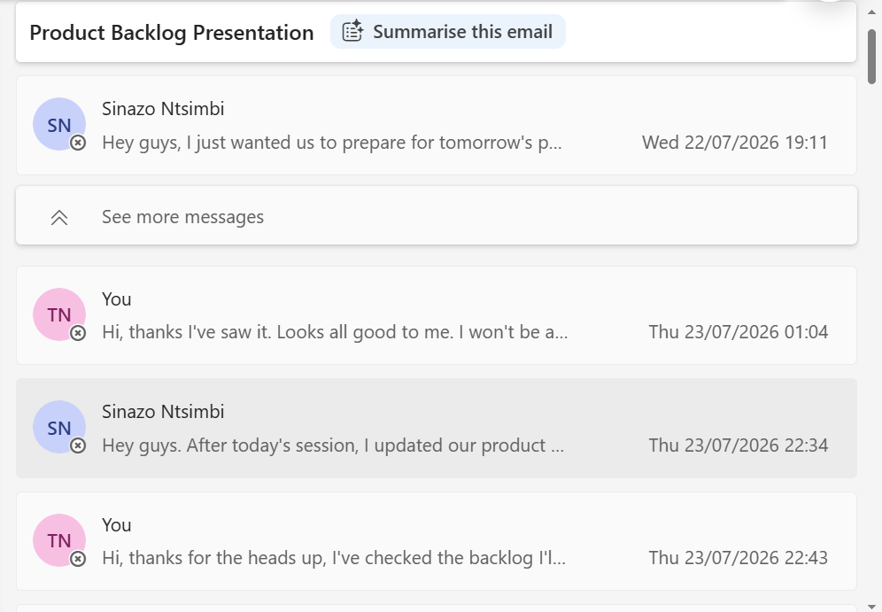
Outlook discussion between Sinazo Ntsimbi and Tiyani Ngwana about preparing and updating the Product Backlog, 22–23 July 2026.

Trello and Figma Review
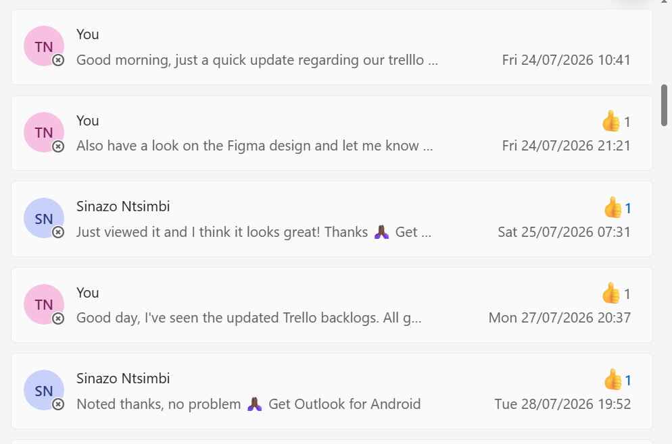
Outlook updates and acknowledgements concerning the Trello backlogs and Figma design, 24–28 July 2026.

Website and GitHub Collaboration
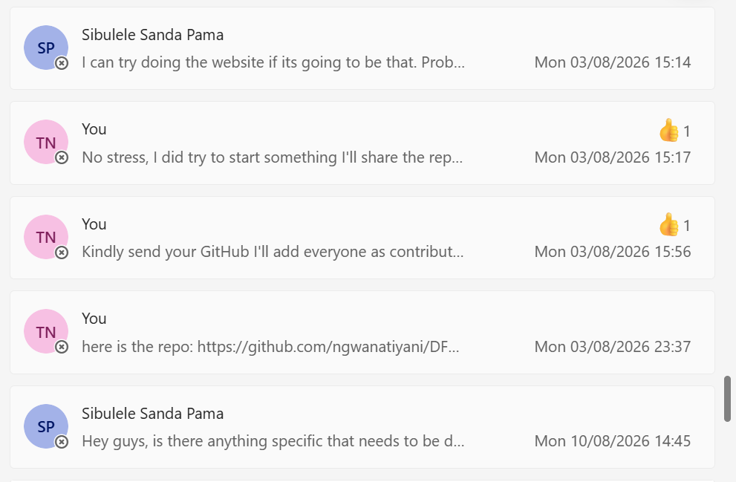
Outlook discussion between Sibulele Sanda Pama and Tiyani Ngwana about website work, repository sharing and contributor coordination, 3–10 August 2026.

