Knowledge, Attitude, and Practice of Breast Self Examination(BSE) amongst adolescent girls at Government Bilingual Schol and Bishop Jules, Buea,Cameroon

NGWASIRI CHELSEA
2025-10-26

Table 1: Demographic data
Characteristic | N = 315¹
Age group
10-13 | 1 (0.3%)
14-16 | 110 (35%)
17-19 | 204 (65%)
School
Bilingual grammar school | 165 (52%)
Bishop Jules Peter | 150 (48%)
Sex
Female | 315 (100%)
Religion
Christian | 309 (98%)
Islam | 6 (1.9%)
Residence
Rural area | 81 (26%)
Semi urban | 22 (7.0%)
Urban area | 212 (67%)
With whom do you stay with
Living alone | 12 (3.8%)
Living with both parents | 199 (63%)
Living with guardians | 43 (14%)
Living with single parent | 61 (19%)
What is your class
Form 5 | 144 (46%)
Lower sixth | 79 (25%)
Upper sixth | 92 (29%)
Do you have any disability
No | 299 (95%)
Yes | 16 (5.1%)
Do you have any family history of breast cancer
No | 250 (79%)
Yes | 65 (21%)
¹n (%)

Table 2: Description Of vairables assessing Knowledge
Characteristic | N = 315¹
Have you ever heard of breast self examination
No | 125 (40%)
Yes | 190 (60%)
If yes, where did you hear about it
Family | 23 (7.3%)
Friends | 38 (12%)
Health facility | 125 (40%)
Media | 54 (17%)
School | 75 (24%)
What is breast self examination
It involves exposing the breast for ventilation and circulation in order to prevent sweating and swelling | 61 (19%)
It is a cheap and simple step by step evaluation of the breast for any abnormality | 224 (71%)
It is a simple and important step in taking care of the breast for pleasure and reproductive purposes | 25 (7.9%)
It is the simple and prior sucking of the breast to ensure tenderness and proper development of the nipple | 5 (1.6%)
Why is breast self examination important
It helps in the early detection of breast cancer and abnormalities | 223 (71%)
It provides better circulation and ventilation of the breast | 78 (25%)
It provides maximum pleasure for both the man and the woman | 8 (2.5%)
It provides maximum pleasure for the female | 6 (1.9%)
How often should BSE be perform
Daily | 23 (7.3%)
Monthly | 203 (64%)
Never | 6 (1.9%)
Rarely | 32 (10%)
Weekly | 51 (16%)
At what age should you start performing BSE
10-12 | 8 (3.2%)
13-15 | 114 (46%)
16-18 | 102 (41%)
19-21 | 23 (9.3%)
Unknown | 68
Which part of the body should you use for BSE
A and B | 204 (65%)
Eyes | 2 (0.6%)
Fingers | 87 (28%)
Hands | 12 (3.8%)
Tongue | 2 (0.6%)
Upper arm | 8 (2.5%)
What should you do if you find a lump or abnormality during BSE
Consult a healthcare provider | 137 (44%)
Ignore it | 4 (1.3%)
Tell a family member | 171 (54%)
Tell a friend/peer | 2 (0.6%)
Unknown | 1
In which position do you perform BSE
All of the above | 91 (29%)
In the shower | 44 (14%)
Lying down | 28 (8.9%)
Standing | 28 (8.9%)
Standing in front of a mirror | 124 (39%)
Do you think BSE is a useful tool for maintaining breast health
Agree | 202 (64%)
Disagree | 46 (15%)
Strongly agree | 54 (17%)
Strongly disagree | 13 (4.1%)
¹n (%)

Figure 1
This is a visual representation of the overall knowledge distribution of BSE among adolescents females at Bilingual Grammar school and St Jules peter in Buea,cameroon
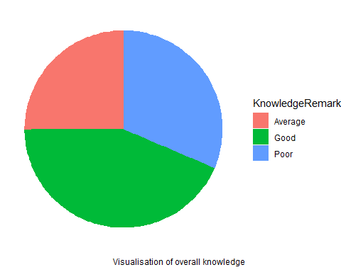

Table 3: Knowledge x sociodemographic data
This table shows the overall distribution of Knowledge, based on the demographic data abd stating thier p-value which was obtained using the chisq.test

Category | Average N = 79¹ | Good N = 137¹ | Poor N = 99¹ | p-value²
Age group |  |  |  | 0.450
10-13 | 0 (0.0%) | 0 (0.0%) | 1 (1.0%)
14-16 | 25 (31.6%) | 46 (33.6%) | 39 (39.4%)
17-19 | 54 (68.4%) | 91 (66.4%) | 59 (59.6%)
School |  |  |  | 0.109
Bilingual grammar school | 49 (62.0%) | 70 (51.1%) | 46 (46.5%)
Bishop Jules Peter | 30 (38.0%) | 67 (48.9%) | 53 (53.5%)
Sex
Female | 79 (100.0%) | 137 (100.0%) | 99 (100.0%)
Religion |  |  |  | 0.043
Christian | 75 (94.9%) | 135 (98.5%) | 99 (100.0%)
Islam | 4 (5.1%) | 2 (1.5%) | 0 (0.0%)
Residence |  |  |  | 0.126
Rural area | 22 (27.8%) | 39 (28.5%) | 20 (20.2%)
Semi urban | 8 (10.1%) | 11 (8.0%) | 3 (3.0%)
Urban area | 49 (62.0%) | 87 (63.5%) | 76 (76.8%)
With whom do you stay with |  |  |  | 0.221
Living alone | 3 (3.8%) | 5 (3.6%) | 4 (4.0%)
Living with both parents | 53 (67.1%) | 87 (63.5%) | 59 (59.6%)
Living with guardians | 13 (16.5%) | 12 (8.8%) | 18 (18.2%)
Living with single parent | 10 (12.7%) | 33 (24.1%) | 18 (18.2%)
What is your class |  |  |  | 0.066
Form 5 | 46 (58.2%) | 56 (40.9%) | 42 (42.4%)
Lower sixth | 16 (20.3%) | 33 (24.1%) | 30 (30.3%)
Upper sixth | 17 (21.5%) | 48 (35.0%) | 27 (27.3%)
Do you have any disability |  |  |  | 0.787
No | 74 (93.7%) | 130 (94.9%) | 95 (96.0%)
Yes | 5 (6.3%) | 7 (5.1%) | 4 (4.0%)
Do you have any family history of breast cancer |  |  |  | <0.001
No | 51 (64.6%) | 110 (80.3%) | 89 (89.9%)
Yes | 28 (35.4%) | 27 (19.7%) | 10 (10.1%)
¹n (%)
²Pearson's Chi-squared test; NA

Figure 2
The graph below compare the overallKnowledge of BSE between adolescent girls at Bilingual grammar school and Bishop Jules Peter
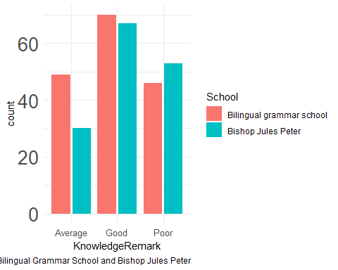

Description of variables assessing Attitude
Characteristic | N = 315¹
Have you ever heard of breast self examination
No | 125 (40%)
Yes | 190 (60%)
If yes, where did you hear about it
Family | 23 (7.3%)
Friends | 38 (12%)
Health facility | 125 (40%)
Media | 54 (17%)
School | 75 (24%)
What is breast self examination
It involves exposing the breast for ventilation and circulation in order to prevent sweating and swelling | 61 (19%)
It is a cheap and simple step by step evaluation of the breast for any abnormality | 224 (71%)
It is a simple and important step in taking care of the breast for pleasure and reproductive purposes | 25 (7.9%)
It is the simple and prior sucking of the breast to ensure tenderness and proper development of the nipple | 5 (1.6%)
Why is breast self examination important
It helps in the early detection of breast cancer and abnormalities | 223 (71%)
It provides better circulation and ventilation of the breast | 78 (25%)
It provides maximum pleasure for both the man and the woman | 8 (2.5%)
It provides maximum pleasure for the female | 6 (1.9%)
How often should BSE be perform
Daily | 23 (7.3%)
Monthly | 203 (64%)
Never | 6 (1.9%)
Rarely | 32 (10%)
Weekly | 51 (16%)
At what age should you start performing BSE
10-12 | 8 (3.2%)
13-15 | 114 (46%)
16-18 | 102 (41%)
19-21 | 23 (9.3%)
Unknown | 68
Which part of the body should you use for BSE
A and B | 204 (65%)
Eyes | 2 (0.6%)
Fingers | 87 (28%)
Hands | 12 (3.8%)
Tongue | 2 (0.6%)
Upper arm | 8 (2.5%)
What should you do if you find a lump or abnormality during BSE
Consult a healthcare provider | 137 (44%)
Ignore it | 4 (1.3%)
Tell a family member | 171 (54%)
Tell a friend/peer | 2 (0.6%)
Unknown | 1
In which position do you perform BSE
All of the above | 91 (29%)
In the shower | 44 (14%)
Lying down | 28 (8.9%)
Standing | 28 (8.9%)
Standing in front of a mirror | 124 (39%)
Do you think BSE is a useful tool for maintaining breast health
Agree | 202 (64%)
Disagree | 46 (15%)
Strongly agree | 54 (17%)
Strongly disagree | 13 (4.1%)
¹n (%)

Figure 3
This is a visual representation of the overall Attitude distribution of BSE among adolescent females at Bilingual Grammar school and St Jules peter in Buea,cameroon
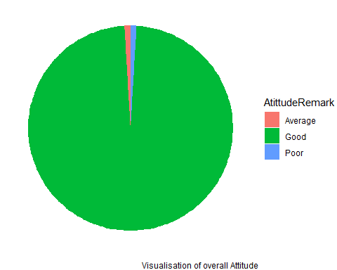

Attitude x Sociodemographic data
This table shows the overall distribution of adolescent girls Attitude towards BSE, on the demographic data and stating their p-value which was obtained using the chisq.test
Category | Average N = 3¹ | Good N = 309¹ | Poor N = 3¹ | p-value²
Age group |  |  |  | 0.124
10-13 | 0 (0.0%) | 1 (0.3%) | 0 (0.0%)
14-16 | 0 (0.0%) | 107 (34.6%) | 3 (100.0%)
17-19 | 3 (100.0%) | 201 (65.0%) | 0 (0.0%)
School |  |  |  | 0.641
Bilingual grammar school | 1 (33.3%) | 163 (52.8%) | 1 (33.3%)
Bishop Jules Peter | 2 (66.7%) | 146 (47.2%) | 2 (66.7%)
Sex
Female | 3 (100.0%) | 309 (100.0%) | 3 (100.0%)
Religion |  |  |  | 0.942
Christian | 3 (100.0%) | 303 (98.1%) | 3 (100.0%)
Islam | 0 (0.0%) | 6 (1.9%) | 0 (0.0%)
Residence |  |  |  | 0.781
Rural area | 0 (0.0%) | 80 (25.9%) | 1 (33.3%)
Semi urban | 0 (0.0%) | 22 (7.1%) | 0 (0.0%)
Urban area | 3 (100.0%) | 207 (67.0%) | 2 (66.7%)
With whom do you stay with |  |  |  | 0.425
Living alone | 0 (0.0%) | 12 (3.9%) | 0 (0.0%)
Living with both parents | 2 (66.7%) | 196 (63.4%) | 1 (33.3%)
Living with guardians | 1 (33.3%) | 42 (13.6%) | 0 (0.0%)
Living with single parent | 0 (0.0%) | 59 (19.1%) | 2 (66.7%)
What is your class |  |  |  | 0.982
Form 5 | 1 (33.3%) | 142 (46.0%) | 1 (33.3%)
Lower sixth | 1 (33.3%) | 77 (24.9%) | 1 (33.3%)
Upper sixth | 1 (33.3%) | 90 (29.1%) | 1 (33.3%)
Do you have any disability |  |  |  | 0.076
No | 3 (100.0%) | 294 (95.1%) | 2 (66.7%)
Yes | 0 (0.0%) | 15 (4.9%) | 1 (33.3%)
Do you have any family history of breast cancer |  |  |  | 0.452
No | 3 (100.0%) | 244 (79.0%) | 3 (100.0%)
Yes | 0 (0.0%) | 65 (21.0%) | 0 (0.0%)
¹n (%)
²Pearson's Chi-squared test; NA

Figure 4
The graph below compare the overall Practice of BSE between adolescent girls at Bilingual grammar school and Bishop Jules Peter
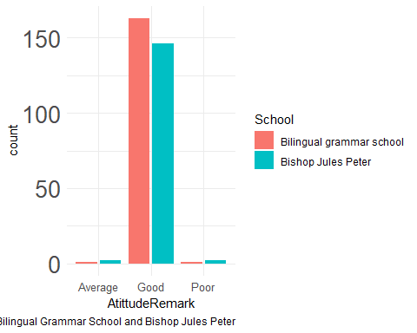

Description of variables assessing practice
Characteristic | N = 315¹
How often do you perform BSE
Daily | 8 (2.6%)
Monthly | 98 (31%)
Never | 4 (1.3%)
Rarely | 175 (56%)
Weekly | 28 (8.9%)
Unknown | 2
How long have you been practicing BSE
1-2 years | 28 (8.9%)
6 months to 1 year | 154 (49%)
6 months to 2 year | 1 (0.3%)
Less than 6 months | 111 (35%)
More than 2 years | 21 (6.7%)
Do you perform BSE at thesame time every month
No | 291 (92%)
Yes | 24 (7.6%)
How do you typically perform BSE
Lying down | 94 (30%)
Lying down Using a breast model or diagram | 1 (0.3%)
Sitting | 32 (10%)
Standing infront of a mirror | 177 (56%)
Using a breast model or diagram | 11 (3.5%)
Which part of your breast do you examine during BSE
Areola | 1 (0.3%)
Entire breast | 244 (77%)
Entire breast Nipples Areola Underarm area | 1 (0.3%)
Nipples | 61 (19%)
Underarm area | 8 (2.5%)
Do you use any aids or tools during BSE
Breast model | 9 (2.9%)
Breast self examination chart | 26 (8.3%)
Mirror | 181 (57%)
Videos or images gotten online | 99 (31%)
When last did you do a BSE
1-2 years | 15 (4.8%)
6 months to 1 year | 12 (3.8%)
Less than 6 months | 247 (78%)
More than 2 years | 41 (13%)
¹n (%)

Figure 5
This is a visual representation of the overall Practice of BSE among adolescents females at Bilingual Grammar school and St Jules peter in Buea,cameroon
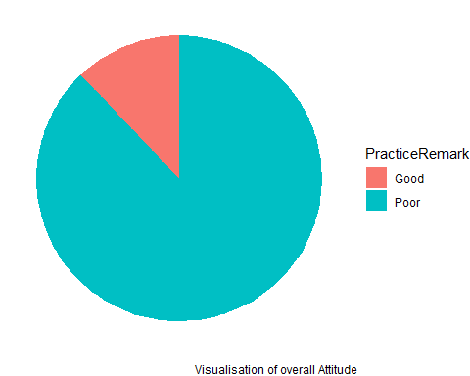

Practice x Sociodemographic Data
This table shows the overall distribution of Practice BSE among adolescent females, based on the demographic data and stating their p-value which was obtained using the chisq.test
Category | Good N = 38¹ | Poor N = 277¹ | p-value²
Age group |  |  | 0.580
10-13 | 0 (0.0%) | 1 (0.4%)
14-16 | 16 (42.1%) | 94 (33.9%)
17-19 | 22 (57.9%) | 182 (65.7%)
School |  |  | 0.889
Bilingual grammar school | 19 (50.0%) | 146 (52.7%)
Bishop Jules Peter | 19 (50.0%) | 131 (47.3%)
Sex
Female | 38 (100.0%) | 277 (100.0%)
Religion |  |  | >0.999
Christian | 37 (97.4%) | 272 (98.2%)
Islam | 1 (2.6%) | 5 (1.8%)
Residence |  |  | 0.120
Rural area | 14 (36.8%) | 67 (24.2%)
Semi urban | 4 (10.5%) | 18 (6.5%)
Urban area | 20 (52.6%) | 192 (69.3%)
With whom do you stay with |  |  | 0.105
Living alone | 1 (2.6%) | 11 (4.0%)
Living with both parents | 20 (52.6%) | 179 (64.6%)
Living with guardians | 4 (10.5%) | 39 (14.1%)
Living with single parent | 13 (34.2%) | 48 (17.3%)
What is your class |  |  | 0.823
Form 5 | 17 (44.7%) | 127 (45.8%)
Lower sixth | 11 (28.9%) | 68 (24.5%)
Upper sixth | 10 (26.3%) | 82 (29.6%)
Do you have any disability |  |  | 0.260
No | 38 (100.0%) | 261 (94.2%)
Yes | 0 (0.0%) | 16 (5.8%)
Do you have any family history of breast cancer |  |  | 0.256
No | 27 (71.1%) | 223 (80.5%)
Yes | 11 (28.9%) | 54 (19.5%)
¹n (%)
²Pearson's Chi-squared test; NA

Figure 6
The graph below compare the overall Practice of BSE between adolescent girls at Bilingual grammar school and Bishop Jules Peter
