I provided the heuristic method of AB_custom AB_Custom2, AB_Custom_3,
The
own = len(game.get_legal_moves(player))
opp = len(game.get_legal_moves(game.get_opponent(player)))
The AB_Improved heuristic is in fact custom_2

The test result as below
Round 1
custom_score: own - 1.5*opp
custom_2: own - opp
custom-3: 1.5*own - opp

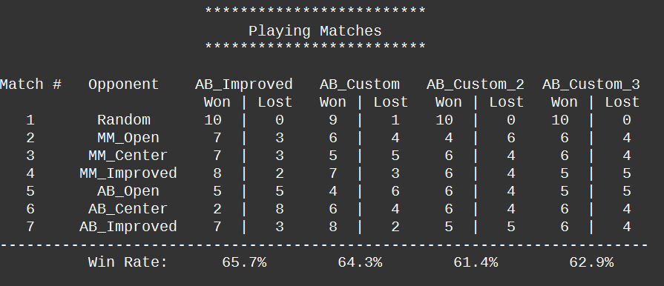

Round 2
custom_score: own - 2*opp
custom_2: own - opp
custom-3: 2*own - opp

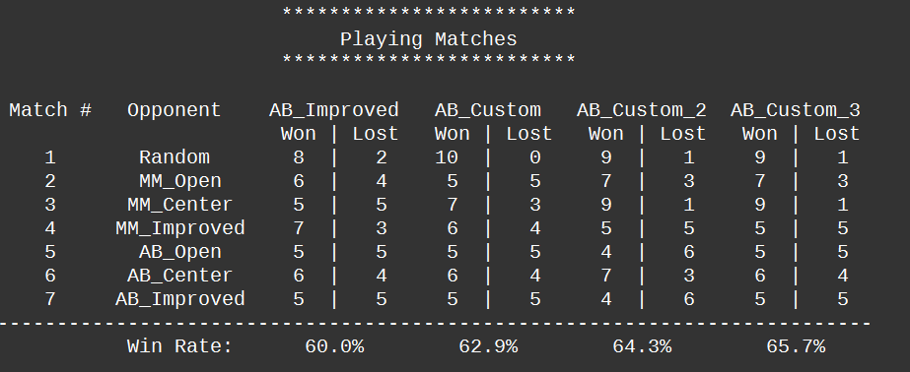

Round 3
custom_score: own - 2.5*opp
custom_2: own - opp
custom-3: 2.5*own – opp

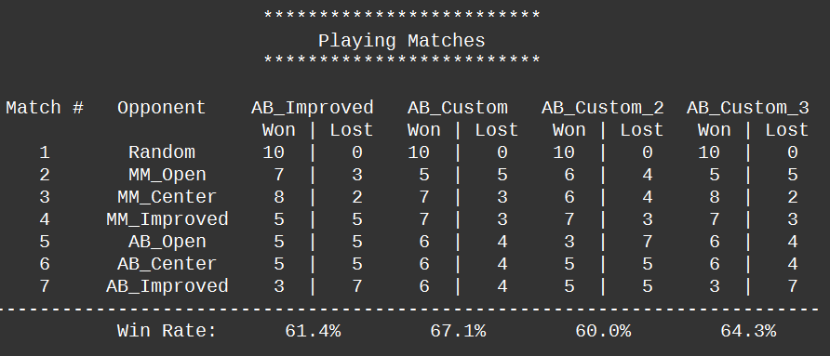

Round 4
custom_score: own - 3*opp
custom_2: own - opp
custom-3: 3*own – opp

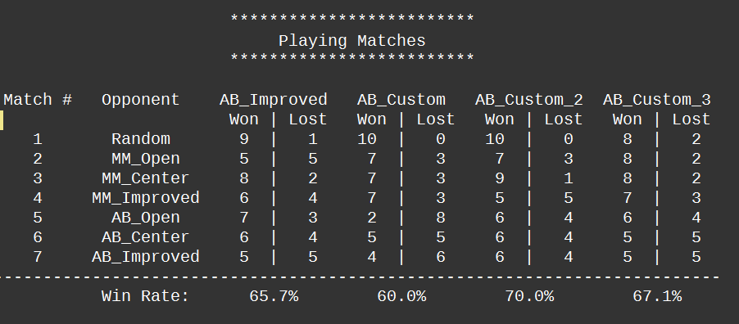

Round 5
custom_score: own**2 - opp**2
custom_2: own - opp
custom-3: -opp/own

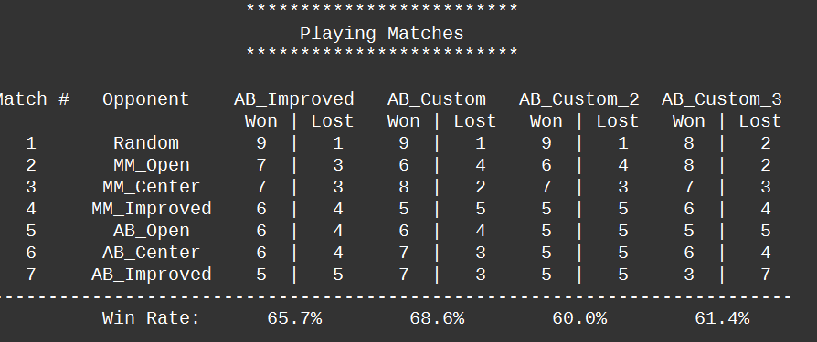

From round 1~5, I got the win rate gap against the AB_improved, the green shows the top 5 heuristics, Among them, I choose 3 to conduct test round #6.
You can see the data of Round # 6 and # Round 2 are stably outperform the AB_improved.

However, you should discuss a little why the results are the way they are. Why do you think your final combination of heuristics performs best of all?
From Round 1 to 5, I was testing the value of t, which varies in (1.5, 2, 2,5, 3), and test it against the AB_Improved. And the final results shows 2 are optimal to my machine and my code.

The reasoning is based on the test data. As for the performance and computational cost, they have been covered by the lecture.

Round 6
