AI – Search project

the optimal steps for Problem 1, 2, 3 are as below

Problem 1, step = 6 | Problem 2, step = 9 | Problem 3, step = 12
Load(C1, P1, SFO)  Fly(P1, SFO, JFK)  Unload(C1, P1, JFK)  Load(C2, P2, JFK)  Fly(P2, JFK, SFO)  Unload(C2, P2, SFO) | Load(C1, P1, SFO)  Fly(P1, SFO, JFK)  Load(C2, P2, JFK)  Fly(P2, JFK, SFO)  Load(C3, P3, ATL)  Fly(P3, ATL, SFO)  Unload(C3, P3, SFO)  Unload(C2, P2, SFO)  Unload(C1, P1, JFK) | Load(C2, P2, JFK)  Fly(P2, JFK, ORD)  Load(C4, P2, ORD)  Fly(P2, ORD, SFO)  Load(C1, P1, SFO)  Fly(P1, SFO, ATL)  Load(C3, P1, ATL)  Fly(P1, ATL, JFK)  Unload(C4, P2, SFO)  Unload(C3, P1, JFK)  Unload(C2, P2, SFO)  Unload(C1, P1, JFK)

Detail running results

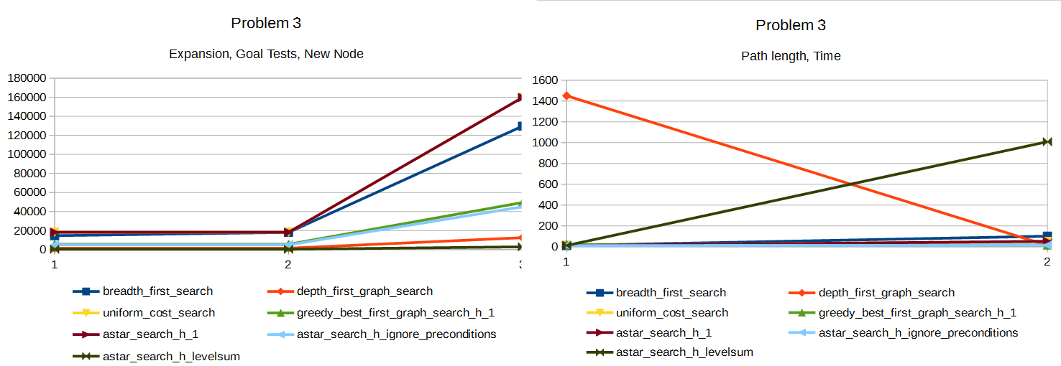

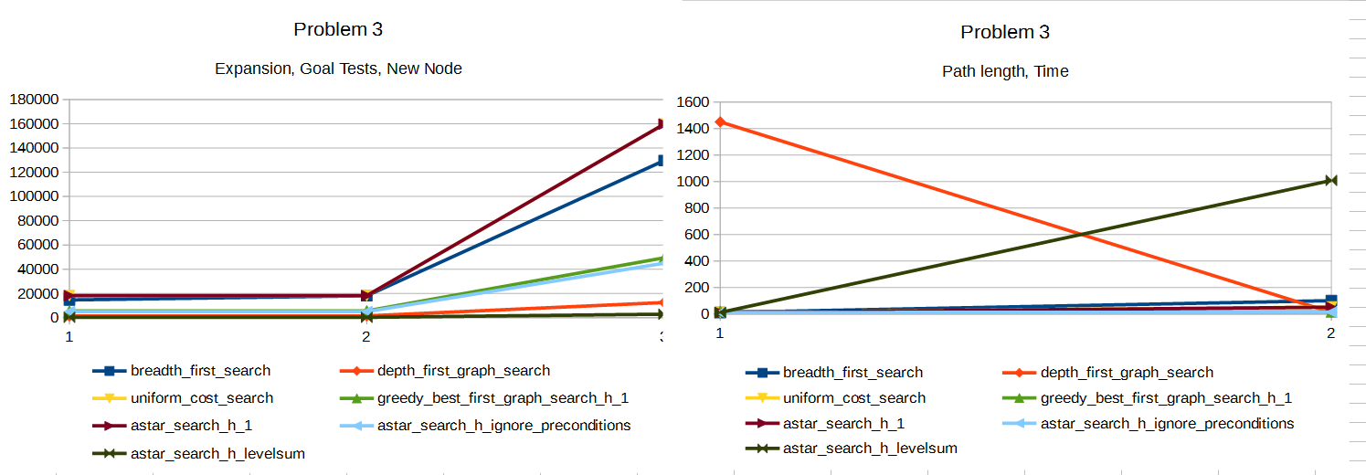
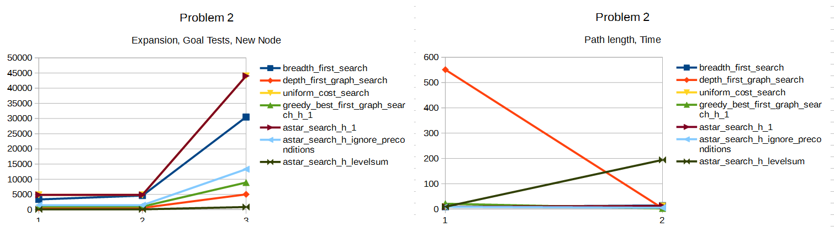

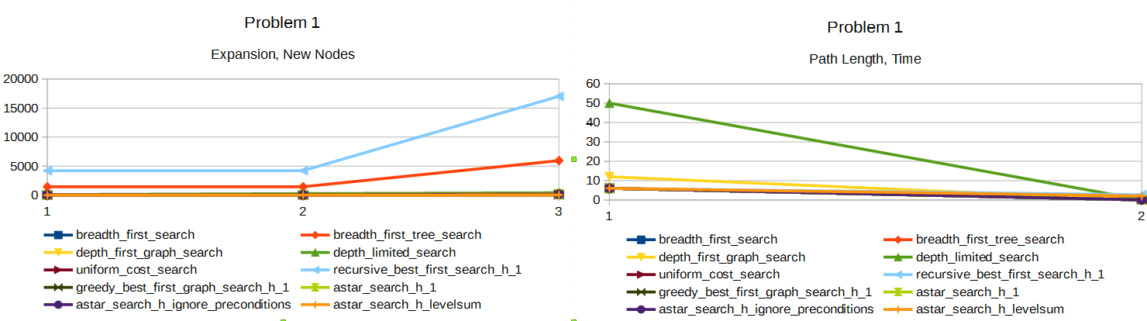

we can see A*-search with heuristics of level sum and A*-search_ignore_preconditions outperform other peers given that optimal strategy scheduled. level sum have the smallest expansion, new node and Goal tests, but its time cost is much higher than A*-search_ignore_preconditions due to the higher overhead of calculating the heuristic function, O(n^2) v.s. O(n). so after balancing all trade-off, A*-search_ignore_preconditions is the best.

