ABSTRACT
Keyword search has been the most widely used kind of querying nowadays, because of its user-friendly way. In recent years various approaches for free-form keyword search over RDBMS (Relational Database Management System) have been proposed. As the amount of available data in relational databases is growing rapidly, the need for general users to search such information is quickly increasing. Based on the major RDBMS, the search requires complex query languages and data schema for each user to know. Thus, free-form keyword search over RDBMS has been attracted. This thesis is intended to develop medicine information searching system based on free-form keyword search strategies. There are two modes in this system, such as search mode, administrator mode. In search mode, user can give a keyword query as an input. This keyword query may contain name of diseases, symptoms, or chemical name that is part of the information that he wants to know. The system returns the ranked result and allows user to choose top-k result. At last, user can get the name and information of the medicine that is appropriate to the given keyword query. In administrator mode, the authorized person only can visit. This mode provides the features such as, inserting new medicine products, deleting the products that is not required, can see the detail information of each medicine product. This system is implemented in java language.

CHAPTER 1
INTRODUCTION

Information retrieval (IR) is a field that has been developing in parallel with database systems for many years. With the advent of computers, it became possible to store large amounts of information; and finding useful information from such collections became a necessity. The amount of available structured data (in internet or intranet or even on personal desktops) for ordinary users grows rapidly. Besides data types such as number, date and time, structured databases usually also contain a large amount of text data, such as names of people, titles of books, indications of medicine, song lyrics and movies, descriptions or reviews of products, etc. The need for ordinary users to find information from text in these databases is dramatically increasing.
Applying the keyword search techniques in text database (IR) to relational databases is a challenging task because the two types of databases are different. First, in text databases, the basic information unit searched by users is documents. The goal of any information retrieval (IR) system is to identify documents relevant to a user's query. In order to do this, an IR system must assume some specific measure of relevance between a document and a query, For a given keyword query, IR systems compute a numeric score for each document and rank the documents by this score. The top ranked documents are returned as answers.
In relational databases, however, information is stored in the form of columns, tables and primary key to foreign key relationships. The logical unit of answers needed by users is not limited to an individual column value or even an individual tuple; it may be multiple tuples joined together. We need to assign a single ranking score for each tuple tree (joining network), which may consist of multiple tuples with text columns, in order to rank the answers effectively. In this system, state-of-the-art IR definition for a single attribute scoring function is used.
  - Overview of Medicine Information Searching System
In this system, the input is the keyword query in which the keywords may be the name of diseases, symptoms, ingredients of medicine, chemical name, etc. The system parses the keyword query into keywords. The system puts the keywords into non-free tuple sets constructor that produces tuple sets. These tuple sets contain at least one input keyword. The candidate network generator produces the joining tuples. For each joining tuple, the ranking algorithm called “single attribute IR-Style relevance score” is used to calculate the score. The resulted information is presented to the user according to the descending order of score.
  - Overview of Database Management System
A Database Management System (DBMS) is a set of computer programs that controls the creation, maintenance, and the use of the database in a computer platform or of an organization and its end user. It allows organizations to place control of organization-wide database development in the hands of database administrators (DBAs) and other specialists.
A DBMS is a system software package that helps the use of integrated collection of data records and files known as databases. It allows different user application programs to easily access the same database. The DBMSs may use any of a variety of database models, such as hierarchical, the network model or relational model. In large systems, a DBMS allows users and other software to store and retrieve data in a structured way. Instead of having to write computer programs to extract information, user can ask simple questions in a query language.
Thus, many DBMS packages provide Fourth-generation programming language (4GLs) and other application development features. It helps to specify the logical organization for a database and access and use the information within a database. It provides facilities for controlling data access, enforcing data integrity, managing concurrency controlled, restoring database[7].
1.3 Overview of Keyword Search Technology
Keyword search has been the most widely used kind of querying nowadays, especially for searching documents on the web because of its user-friendly way. In recent years various approaches for free-form keyword search over RDBMS have been proposed. They can allow search for combinations of interesting terms and produce results across multiple tuples in different relations. In other words, answers are not limited to the individual tuples, but are assembled from joining tuples of multiple tables [9].
1.4 Overview of Information Retrieval
For thousands of years people have realized the importance of archiving and finding information. With the advent of computers, it became possible to store large amounts of information; and finding useful information from such collections became a necessity. The field of Information Retrieval (IR) was born in the 1950s out of this necessity. Over the last forty years, the field has matured considerably. Several IR systems are used on an everyday basis by a wide variety of users.
An information retrieval process begins when a user enters a query into the system. Queries are formal statements of information needs, for example search strings in web search engines. In information retrieval a query does not uniquely identify a single object in the collection. Instead, several objects may match the query, perhaps with different degrees of relevancy.
An object is an entity which keeps or stores information in a database. User queries are matched to objects stored in the database. Depending on the application the data objects may be, for example, text documents, images or videos. Often the documents themselves are not kept or stored directly in the IR system, but are instead represented in the system by document surrogates.
Most IR systems compute a numeric score on how well each object in the database match the query, and rank the objects according to this value. The top ranking objects are then shown to the user. The process may then be iterated if the user wishes to refine the query [9].
1.5 Objectives of Thesis
The objectives of the thesis are:
- To know more about RDBMS.
- To study query language more detail.
- To assist user in searching information by entering keyword only.
- To obtain information that is more relevant to user’s requirement.
1.6 Motivation of Thesis
With the amount of available text data in relational databases growing rapidly, the need for ordinary user to search such information is dramatically increasing. Even though the major RDBMS have provider full-text search capabilities, they still require users to have knowledge of the database schema and use a structured query language to search information.
Answers needed by users are not limited to individual tuples but results assembled from joining tuples from multiple tables are used to form answers. A single score for each answer is needed to estimate its relevance to a given query. These score are used to rank the most relevant answers as high as possible.
This thesis is intended to develop the implementation of the keyword search over RDBMS. In this thesis, we use algorithm of joining tuples over one RDBMS. For the ranking of result, the novel IR ranking strategy called “state-of-the-art IR relevance score function” is used. The system will help the user who wants to know the detail information of medicine. The result is the name of the medicine, its indication, its ingredient, dosage, company and country which produces this medicine. The input from user is the symptoms of disease, ingredient, etc.
1.7 Organization of Thesis
The previews of thesis are following:
Chapter(1) describes the introduction of the system, overview of the system, overview of the database management system and keyword search technology, objectives and history of thesis.
Chapter(2) theoretical background of the system
Chapter(3) describes the detail explanation of implemented theories and algorithms of the system.
Chapter(4) deals with design and implementation of the system.
Chapter(5) concludes the thesis with suggestion for limitation and further extensions of the system.

CHAPTER 2
Relational Database Management System
A database is an integrated collection of logically related records or files consolidated into a common pool that provides data for one or multiple users. The DBMS accepts requests for data from an application program and instructs the operating system to transfer the appropriate data. The queries and responses must be submitted and received according to a format that conforms to one or more applicable protocols. When a DBMS is used, information systems can be changed much more easily as the organization's information requirements change. New categories of data can be added to the database without disruption to the existing system.
The data in a database is organized according to their data structures or types. The relational model occurs most commonly. One way of classifying databases involves the type of content, for example bibliographic, full-text, numeric, image. Other models such as the hierarchical model and the network model use a more explicit representation of relationships. The model tends to determine the query language that is available to access the database. One community used query language for the relational database is SQL, although SQL syntax and function can vary from one DBMS to another.
The fundamental assumption of the relational model is that all data is represented as mathematical n-ary relations, an n-ary relation being a subset of the Cartesian product (rows) of n domains. Data are operated upon by means of a relational calculus or relational algebra, these being equivalent in expressive power. The relational model of data permits the database designer to create a consistent, logical representation of information. The basic relational building block is the domain or data type. A tuple is an unordered set of attribute values. An attribute is an ordered pair of attribute name and type name. An attribute value is a specific valid value for the type of the attribute. This can be either a scalar value or a more complex type. Consistency is achieved by including declared constraints in the database design, which is usually referred to as the logical schema.
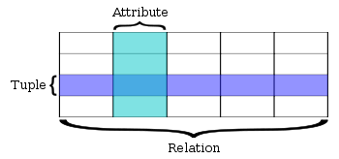
figure2. Relational Database Terminology
.
2.1 Components of Relational Database Management System
There are five components in relational database management system [10].
- Interface drivers - A user or application program initiates either schema modification or content modification. These drivers which are built on top of SQL. They provide methods to prepare statements, execute statements, fetch results, etc. Examples include DDL, DCL, DML, ODBC, and JDBC. Some vendors provide language-specific proprietary interfaces. For example, MySQL provides drivers for PHP, Python, etc.
- SQL engine - This component interprets and executes the SQL query. It comprises three major components (compiler, optimizer, and execution engine).
- Transaction engine - Transactions are sequences of operations that read or write database elements, which are grouped together.
- Relational engine - Relational objects such as Table, Index, and Referential integrity constraints are implemented in this component.
- Storage engine - This component stores and retrieves data records. It also provides a mechanism to store metadata and control information such as undo logs, redo logs, lock tables, etc.
2.2 Database Modeling Language
A data modeling language to define the schema of each database hosted in the DBMS, according to the DBMS database model. The four most common types of models are the:
- hierarchical model
- network model
- relational model, and
- object model
The hierarchical structure was used in early mainframe DBMS. Records’ relationships form a treelike model. This structure is simple but nonflexible because the relationship is confined to a one-to-many relationship. IBM’s IMS system and the RDM Mobile are examples of a hierarchical database system with multiple hierarchies over the same data, RDM Mobile is a newly designed embedded database for a mobile computer system. The hierarchical structure is used primary today for storing geographic information and file systems.
The network structure consists of more complex relationships. Unlike the hierarchical structure, it can relate to many records and accesses them by following one of several paths. In other words, this structure allows for many-to-many relationships.
The relational structure is the most commonly used today. It is used by mainframe, midrange and microcomputer systems. It uses two-dimensional rows and columns to store data. The tables of records can be connected by common key values. The model is not easy for the end user to run queries with because it may require a complex combination of many tables.
The object oriented structure has the ability to handle graphics, pictures, voice and text, types of data, without difficultly unlike the other database structures. This structure is popular for multimedia Web-based applications. It was designed to work with object-oriented programming languages such as Java.
2.3 Database System Architecture
The database system architecture is divided into three levels, known as the internal, conceptual, and external level [7].
- The external level (also known as the user logical level) is the one closet to the user, that is , it is the one concerned with the way the data is seen by individual users; and
- The internal level (also known as the physical level) is the one closet to the users, that is, it is the one concerned with the way the data is physically stored.
- The conceptual level (also known as the community logical level, or sometimes just the logical level, unqualified) is a level of indirection between the other two.
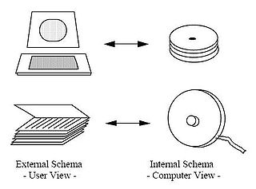
figure2. Traditional View of Data

2.3.1 External Level
The external level is the individual user level. A user can be either an application programmer or an end user. Each user has a language at his or her disposal.
The language will be either a conventional programming languages (eg. Java, C#, VB, C++) or a query language or some special purpose language, perhaps forms-driven or menu-driven, tailored to that user’s requirements and supported by some online application program. The important thing about all such language is that they will include a data sublanguage. It means that a subset of the total language that is concerned specifically with database objects and operations. In principal, data sublanguage is really a combination of at least two subordinate languages (DML). DDL supports the definition or declaration of database objects, and a data manipulation language (DML) supports the manipulation or processing of such objects [7].
2.3.2 Conceptual Level
The conceptual view is a representation of the entire information content of the database in a form that is somewhat abstract in comparison with the way in which the data is physically stored. The conceptual view is a view of the total database content, and the conceptual schema is a definition of that view. The definitions in the conceptual schema are intended to include security and integrity constraints [7].
2.3.3 Internal Level
The internal view is a low-level representation of the entire database. It consists of many occurrences of each of many types of internal record. The internal view assumes an infinite linear address space, details of how that address space is mapped to physical storage are highly system-specific and are deliberately omitted from the general architecture.
The internal view is described by means of the internal schema, which not only defines the various stored record types but also specifies what indexes exist, how stored fields are represented, what physical sequence the stored records are in, and so on[7].
2.4 Client-Server Architecture
A database system can be regarded as having a very simple two-part (also called front ends).
The server is just the DBMS itself. It supports all of the basic DBMS functions- data definitions, data manipulation, data security and integrity, and so on. It provides all of the external, conceptual, and internal level support.
The clients are the various applications that run on top of the DBMS – both user-written applications and built-in applications, that is, applications provided by the DBMS vendor or by some third party [7].

Applications
DBMS
End users
Clients
Server
Database
Figure2. Client/Server architecture
2.5 Data Normalization
In the field of relational database design, normalization is a systematic way of ensuring that a database structure is suitable for general-purpose querying and free of certain undesirable characteristics—insertion, update, and deletion anomalies—that could lead to a loss of data integrity. The concept of normalization and the First Normal Form (1NF) was introduced in 1970[24]. Higher normal forms were defined in subsequent years, the most recent being the Sixth Normal Form (6NF) was introduced [25]. The concept of the first three normal form are as follows [7]:
- First normal form: A relvar is in 1NF if and only if, in every legal value of that relvar, every tuple contains exactly one value for each attribute.
- Second normal form: (definition assuming only one candidate key, which we assume is the primary key):A relvar is in 2NF if and only if it is in 1NF and every nonkey attribute is irreducibly dependent on the primary key.
- Third normal form: A relvar is in 3NF if and only if, for all time, each tuple consists of a primary key value that identifies some entity, together with a set of zero or more mutually independent attribute values that describe that entity in some way.
Databases intended for Online Transaction Processing (OLTP) are typically more normalized than databases intended for Online Analytical Processing (OLAP). OLTP Applications are characterized by a high volume of small transactions such as updating a sales record at a supermarket checkout counter. The expectation is that each transaction will leave the database in a consistent state. By contrast, databases intended for OLAP operations are primarily "read mostly" databases. OLAP applications tend to extract historical data that has accumulated over a long period of time. For such databases, redundant or "denormalized" data may facilitate business intelligence applications. Specifically, dimensional tables in a star schema often contain denormalized data. The denormalized or redundant data must be carefully controlled and users should not be permitted to see the data until it is in a consistent state. The normalized alternative to the star schema is the snowflake schema. In many cases, the need for denormalization has waned as computers and RDBMS software have become more powerful, but since data volumes have generally increased along with hardware and software performance, OLAP databases often still use denormalized schemas[26].
2.5.1 Database Schema
Database schema consists of a set of entities (relvars or tables) and the relationships between them [7].
- Star schema: The most common modeling paradigm. A large central table(fact table) and a set of smaller attendant tables(dimension tables).
- Snowflake schema: The snowflake schema is a variant of the star schema model, where some dimension tables are normalized, thereby further splitting the data into additional tables.
- Fact constellation: Multiple fact tables to share dimension tables. This kind of table can be viewed as a collection of stars, and hence is called galaxy schema or fact constellation.
2.6 Definition of Metadata
Metadata is "data about data", of any sort in any media. Metadata is also called meta data, or sometimes metainformation. Metadata is text, voice, or image that describes what the audience wants or needs to see or experience. The audience could be a person, group, or software program.
Metadata is important because it aids in clarifying and finding the actual data[12].An item of metadata may describe an individual datum, or content item, or a collection of data including multiple content items and hierarchical levels, such as a database schema. In data processing, metadata provides information about, or documentation of, other data managed within an application or environment. This commonly defines the structure or schema of the primary data.

2.7 Information Retrieval
Information retrieval (IR) is a field that has been developing in parallel with database systems for many years. With the advent of computers, it became possible to store large amounts of information; and finding useful information from such collections became a necessity. Several IR systems are used on an everyday basis by a wide variety of users.
An information retrieval process begins when a user enters a query into the system. Queries are formal statements of information needs, for example search strings in web search engines. In information retrieval a query does not uniquely identify a single object in the collection. Instead, several objects may match the query, perhaps with different degrees of relevancy.
An object is an entity which keeps or stores information in a database. User queries are matched to objects stored in the database. Depending on the application the data objects may be, for example, text documents, images or videos. Often the documents themselves are not kept or stored directly in the IR system, but are instead represented in the system by document surrogates.
Most IR systems compute a numeric score on how well each object in the database match the query, and rank the objects according to this value[9]. Assume an object is as a document. In order to do this, an IR system must assume some specific measure of relevance between a document and a query. A fundamental problem in IR research is thus to formalize the concept of relevance. A different formalization of relevance generally leads to a different retrieval model.
The existing models can be roughly grouped into three major categories, depending on how they define/measure relevance. In the first category, relevance is assumed to be correlated with the similarity between a query and a document. In the second category, a binary random variable is used to model relevance and probabilistic models are used to estimate the value of this relevance variable. In the third category, the relevance uncertainty is modeled by the uncertainty of inferring queries from documents or vice versa [14].
2.7.1 Similarity-based Models
In a similarity-based retrieval model, it is assumed that the relevance status of a document with respect to a query is correlated with the similarity between the query and the document at some level of representation. The more similar to a query a document is, the more relevant the document is assumed to be.
The vector space model is the most well-known model of this type. In the vector space model, a document and a query are represented as two term vectors in a high-dimensional term space. Each term is assigned a weight that reflects its importance to the document or the query. Given a query, the relevance status value of a document is given by the similarity between the query vector and document vector as measured by some vector similarity measure, such as the cosine of the angle formed by the two vectors.
Formally, a document d may be represented by a document vector 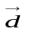= (x₁,x₂,..,x_{n}), where n is the total number of terms and xi is the weight assigned to term i. Similarly, a query q can be represented by a query vector 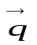= (y₁,y₂,..,y_{n}). The weight is usually computed based on the so-called TF-IDF weighting, which is a combination of three factors: (1) the local frequency of the term (in a document or query); (2) the global frequency of the term in the whole collection; (3) document length. With the cosine measure, we have the following similarity function of the document and query:
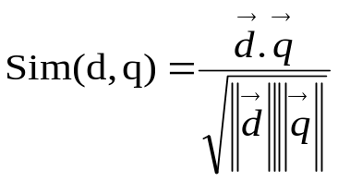
The vector space model naturally decomposes a retrieval model into three components: (1) a term vector representation of query; (2) a term vector representation of document; (3) a similarity/distance measure of the document vector and the query vector. However, the "synchronization" among the three components is generally unspecified; in particular, the similarity measure does not dictate the representation of a document or query. Thus, the vector space model is actually a general retrieval framework, in which the representation
of query and documents as well as the similarity measure can all be arbitrary in principle.
Related to its generality, the vector space model can also be regarded as a procedural model of retrieval, in which the task of retrieval is naturally divided into two separate stages: indexing and search. The indexing stage explicitly has to do with representing the document and the query by the "indexing terms" extracted from the document and the query. The indexing terms are often assigned different weights to indicate their importance in describing a document or a query. The search stage has to do with evaluating the relevance value (i.e., the similarity) between a document vector and a query vector. The flexibility of the vector space model makes it easy to incorporate different indexing models. The vector space model is by far the most popular retrieval model due to its simplicity and effectiveness. The following is a typical effective weighting formula with pivoted document length normalization taken from [15]:

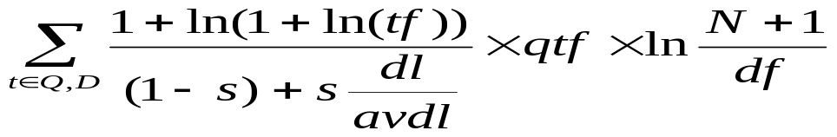
where s is an empirical parameter (usually 0.20), and
tf is the term's frequency in document
qtf is the term's frequency in query
N is the total number of documents in the collection
df is the number of documents that contain the term
dl is the document length, and
avdl is the average document length.
The main criticism for the vector space model is that it provides no formal framework for the representation, making the study of representation inherently separate from the relevance estimation. The separation of the relevance function from the weighting of terms has the advantage of being flexible, but makes it very difficult to study the interaction of representation and relevance measurement. The semantics of a similarity/relevance function is highly dependent on the actual representation (i.e., term weights) of the query and the document. As a result, the study of representation in the vector space model has been so far largely heuristic. The two central problems in document and query representation are the extraction of indexing terms/units and the weighting of the indexing terms. A new generation of similarity-based retrieval models [16][17][18] has been proposed based on the idea of representing documents and queries with statistical language models.
2.7.2 Probabilistic Relevance Model
Given a query, a document is assumed to be either relevant or non-relevant, but a system can never be sure about the true relevance status of a document, so it has to rely on a probabilistic relevance model to estimate it. Formally, let random variables D and Q denote a document and query, respectively. Let R be a binary random variable that indicates whether D is relevant to Q or not. It takes two values which we denote as r ("relevant") and ("not relevant"). The task is to estimate the probability of relevance, i.e., p(R = r |D, Q).
The probability p (R = r| D, Q) can be estimated directly using a discriminative (regression) model. Regression models provide a principled way of exploring heuristic features and ideas. One important advantage of regression models is their ability to learn from all the past relevance judgments, in the sense that the parameters of a model can be estimated based on all the relevance judgments, including the judgments for different queries or documents. However, because regression models are based on heuristic features in the first place, lots of empirical experimentation would be needed in order to find a set of good features.
Alternatively, p(R = r |D,Q) can be estimated indirectly using a generative model in the following way (Lafferty and Zhai, 2003):
p(R = r |D,Q) =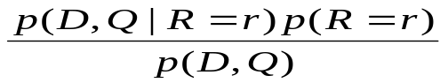

Equivalently, we may use the following log-odds ratio to rank documents:
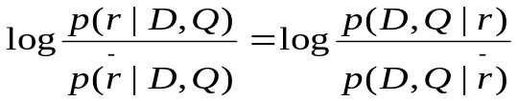
There are two different ways to factor the conditional probability p(D,Q/R), corresponding to "document generation" and "query generation".
With document generation, p(D,Q/R) = p(D/ Q,R)p(Q/R), thus we end up with the following ranking formula:
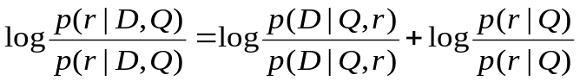
Most classic probabilistic retrieval models are based on document generation [20]. The Binary Independence Retrieval (BIR) model is perhaps the most well known classical probabilistic model [21].
With query generation, p(D,Q|R) = p(Q|D,R)p(D |R), thus we end up with the following ranking formula:
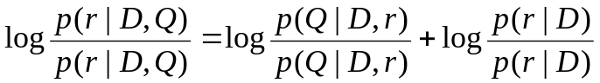
Under the assumption that conditioned on the event R = , the document D is independent of the query Q, i.e., p(D,Q|R = ) = p(D |R = ) p(Q|R = ), the formula becomes:

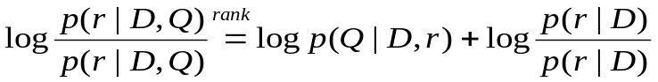
There are two components in this model. The major component p(Q|D, r) can be interpreted as a "relevant query model" conditioned on a document. That is, p(Q|D, r) is the probability that a user who likes document D would use Q as a query. The second component p(r |D) is a prior that can be used to encode a user's bias on documents.
2.7.3 Probabilistic Inference Models
In a probabilistic inference model, the relevance uncertainty of a document with respect to a query is modeled by the uncertainty associated with inferring/proving the query from the document. Depending on how one defines what it means by .proving a query from a document, different inference models are possible.
The inference network model is a much more general formalism than most of the models that we have discussed above. With different ways to realize the probabilistic relationship between the observation of documents and the satisfaction of the user's information need, one can obtain many different existing specific retrieval models, such as Boolean, extended Boolean, vector space, and conventional probabilistic models. More importantly, the inference network model can potentially go beyond the traditional notion of topical relevance; indeed, the goal of inference is a very general one, and at its highest level, the framework is so general that it can accommodate almost any probabilistic model. The generality makes it possible to combine multiple evidences, including different formulations of the same query. The query language based directly on the model has been an important and practical contribution to IR technology [14].
Most techniques used by IR systems can be implemented under this model. In the simplest implementation of this model, a document instantiates a term with a certain strength, and the credit from multiple terms is accumulated given a query to compute the equivalent of a numeric score for the document. From an operational perspective, the strength of instantiation of a term for a document can be considered as the weight of the term in the document, and document ranking in the simplest form of this model becomes similar to ranking in the vector space model and the probabilistic models described above. The strength of instantiation of a term for a document is not defined by the model, and any formulation can be used [15].
  - Keyword Search Technology
Searching for information is an indispensable component of our lives. Web search engines are widely used for searching textual documents, images, and videos. There are also vast collections of structured and semi-structured data both on the Web and in enterprises, such as relational databases, XML, data extracted from text documents, workflows, etc. Traditionally, to access these resources, users have to learn structured query languages, such as SQL and XQuery; they also need to access data schemas of each individual application domain, which are most likely complex, fast-evolving, or even unavailable in Web applications. A natural question to ask is whether we can empower users to effectively access structured data using keyword queries.
Ideally the result of a keyword search over structured data will automatically assemble relevant pieces of data that are in different locations but are inter-connected and collectively relevant to the query. There are several advantages of such an approach. First, it can relieve casual users from the steep learning curve of studying structured query languages and data schemas when accessing structured data. Second, it allows users to easily access heterogeneous databases. For instance, for websites with database back-ends, this approach provides a more flexible search method than the existing solution that uses a fixed set of pre-built template queries. Furthermore, this approach helps to reveal interesting or unexpected relationships among entities. Making database searchable will substantially increase the information volume that a user can access, have potential to provide search results with better quality compared with keyword search on textual documents, and thus increase the database usability and make significant impact to people's lives [22].
2.8.1 Keyword Search Technology in Relational Databases
Applications in which plain text coexists with structured data are pervasive. Furthermore, text and structured data are often stored side by side within standard relational database management systems (RDBMSs), as the following example illustrates[1].
Consider a customer-service database from a large vendor of computer equipment. One table in the database, Complaints(prodId, custId, date, comments), logs each complaint received as a tuple with an internal identifier of the customer who made the complaint (custId), an identifier of the main product involved in the complaint (prodId), when the complaint was made (date), and a free-text description of the problem reported by the customer (comments). Another table in the database, Products (prodId, manufacture, model).The prodId attribute of the Complaints relations is a foreign key into Products. An example instance of this relations are:

prodId | custId | date | Complaints
p121 | c3232 | 6-30-2002 | "disk crashed after just one week of moderate use on an IBM Netvista X41"
p132 | c3131 | 7-3-2002 | "lower-end IBM Netvista caught fire, starting apparently with disk"

Table2.1 Complaints Table

prodId | Manufacture | Model
p121 | "Maxtor" | D540X
p131 | "IBM" | "Netvista"

Table2.2 Products Table

Commercial RDBMSs generally provide querying capabilities for text attributes that incorporate state-of-the-art information retrieval (IR) relevance ranking strategies. This search functionality requires that queries specify the exact column or columns against which a given list of keywords is to be matched. For example, a query:
"SELECT * FROM Complaints C
WHERE CONTAINS (C.comments, ’disk crash’, 1) > 0
ORDER BY score(1) DESC"
on Oracle 9.1 1 returns the rows of the Complaints table above that match the keyword query [disk crash], sorted by their score as determined by an IR relevance-ranking algorithm. Intuitively, the score of a tuple measures how well its comments field matches the query [disk crash].
The requirement that queries specify the exact columns to match can be cumbersome and inflexible from a user perspective: good answers to a keyword query might need to be “assembled” –in perhaps unforeseen ways– by joining tuples from multiple relations:
Assume a keyword query [Maxtor on ibm netvista] is searched. Then the best answer is the tuple that results from joining the first tuple in both relations on the prodId attribute. This join correctly identifies that the complaint by customer c3232 is about a Maxtor disk drive (from the manufacturer attribute of the Products relation) on an IBM Netvista computer (from the comments attribute of the Complaints relation).

CHAPTER 3
SYSTEM DESIGN
3.1 Introduction to the Proposed System
This proposed system is a system that provides user who wants to search the information related with the medicine. The system gives user the information that is most related to the user's request.The input is the keyword query in which the keywords may be part of the information such as the name of diseases, symptoms, ingredients of medicine, chemical name, etc.
The system parses the keyword query. That is, the system saves words that are related to the predefined words as the keywords otherwise removes them. The system puts the keywords into non-free tuple sets constructor that produces non-free tuple sets by using the full-text search capabilities of underlying RDBMS. Non-free tuple sets are the tuples that contain at least one input keyword.
Non-free tuple sets are input to the candidate network generator. The candidate network generator produces the joining tuples. Each joining tuple consists of at least one non-free tuple set. The task of the candidate network generator is to define or generate the joining tuples by consideration the three criterions. This step by step methods are described as algorithm of candidate network generator.
The result from the candidate network is joining tuples. Thus, the ranking algorithm called “single attribute IR-Style relevance score” is used to calculate the score to rank each join tuples to determine the best relevant choice. The resulted joining tuple is input to the query processor. The query processor generates query and fetches the information. The resulted information is presented to the user.

Non-free Tuple Sets Constructor
Constructor
Query Processor
Candidate Network Generator
Keyword Query
Full-text Indexes
Database
A Sentence
Figure 3.1 Overview of System Design

3.2 Preprocessing the Input Sentence
In our system, we accept the sentence as input. Thus, we parse the sentence first. For parsing, the following task is carried out in our system.
- Stopwords Removal
  - The task is to remove words that do not bear useful information for IR. They are the words such as of, in, about, with, I, although etc. In other words, stopwords are words not to be used as index. In English grammar , they can be categorized as
    - Prepositions
    - Articles
    - Pronoun
    - Some adverbs and adjectives
    - Some frequent words
The removal of stopwords usually improves IR effectiveness.
3.3 Relevance-Ranking Functions
The IR community has focused over the last few decades on improving the quality of relevance-ranking functions for text document collections. We have been discussed in above. Our system builds on the IR work by exploiting the IR-style relevance ranking functionality that modern RDBMSs routinely include, typically over individual text attributes. For example, Oracle 9i Test and IBM DB2 Text Information Extender use standard SQL to create full text indexes on text attributes of relations. Microsoft SQL Server 2005 also provides tools to generate full text indexes, which are stored as files outside the database[1].
Result ranking has been addressed by many keyword-search systems for relational data. In DISCOVER keyword-search system and DBXplorer keyword-search system assign a score to a joining tree of tuples T in the following way. Given a query Q, both systems assign:
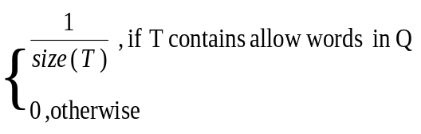
Score(T,Q)= (3.1)

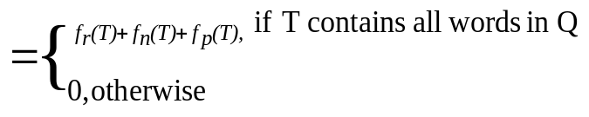BANKS keyword-search system uses the following scoring scheme.
Score(T,Q) (3.2)
where 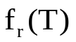 measures how “related” the relations of the tuples of T are, 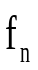(T) depends on the weight of the tuples of T –as determined by a PageRank-inspired technique, and 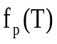 is a function of the weight of the edges of T. The approaches above capture the size and "structure" of a query result in the score that it is assigned, but do not leverage further the relevance-ranking strategies developed by IR community over the years. In this proposed system, we implement the scoring function called "state-of-the-art IR definition" that is developed by IR community [1].
3.3.1 State-of-the-art IR Definition
Our score function includes IR-style relevance ranking functionality over individual text attributes. For a query Q relies on [1]:
- Single-attribute IR-style relevance scores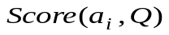for each textual attribute 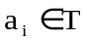 and query Q, as determined by an IR engine at the RDBMS, and
- A function Combine, which combines the single-attribute scores into a final score for T.
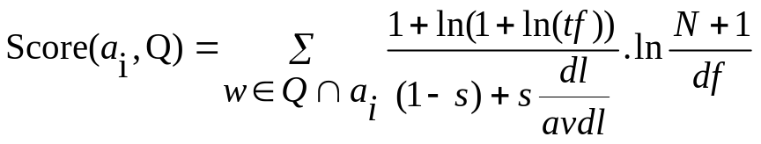A state-of-the-art IR definition for a single-attribute scoring function Score is as follows:
(3.3)

where for a word w,
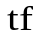is the frequency of w in 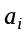, 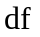 the number of tuples in ‘s relation with word w in this attribute, dl is the size of in characters, avdl is the average attribute-value size, N is the total number of tuples in 's relation and s is a constant (usually 0.2).
Combining single attribute scores for a joining tree of tuples T into a final score for the tree. We define the score of T for Q as
Score (T,Q)=Combine(Score(A,Q),size(T))
,where Score(A,Q)=(Score(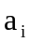,Q),..,Score(,Q)). A definition for Combine is:
Combine (Score(A,Q),size(T))=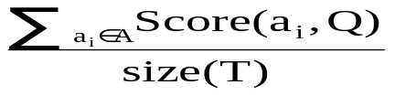 (3.4)
A combining function Combine satisfies the tuple monotonicity property if, for every query Q and joining trees of tuples T and  derived from the same CN(candidate network) such that (i) T consists of tuples t₁,…..,t_{n} while consists of tuples 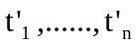 and (ii) Score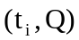 Score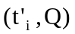 for all i, it follows that Score(T,Q)Score(,Q). [1]
3.4 Evaluation of Joining Tree of tuples
Assume a database has n relations R,…..,R. Each relation R_{i} has m attributes 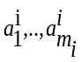. The schema graph G is a directed graph that captures the primary key to foreign key relationships in the database schema. It has a node R_{i} for each relation R_{i} of the database and an edge R_{i} R_{j} for each primary key to foreign key relationship from a set of attributes of R_{i} to a set of attributes of R_{j} .The undirected version of G is defined as G_{u}.
A joining network of tuples j is a tree of tuples where for each pair of adjacent tuples t_{i,},t_{j} j, where t_{i} R_{i} , t_{i}R_{j} ,there is an edge (R_{i}, R_{j}) in G_{u} and(t^{i}t^{j})(R_{i}R_{j}) [4].
Group
GId
Cname
Dosage

Product
PId
Pname
Indication
GId
MId
Manufacture
MId
Mname
Company

Figure 3.2 Schema of the Medicine database

3.4.1 Algorithm of Candidate Network Generator
The algorithm used to generate joining tuples is as follows[4]:
Algorithm Candidate Networks Generator
Input: tuple set graph G_{TS}, T, k₁,…,k_{m}
Output: set of candidate networks with size up to T
{
Q: queue of joining networks of tuple sets
Pick a keyword k_{t} { k_{t} ,…,k_{m} }
For each tuple set 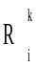 where i=1,…,n and k_{t} K do
Add joining networks of tuple sets to Q
while Q not empty do{
Get head C from Q
if C satisfies the pruning condition then ignore C
else if C satisfies the acceptance conditions then output C
/* There is no reason to extend accepted joining networks of tuple sets*/
else
for each tuple set adjacent in G_{TS} (ignoring edge direction) to a node of C
if(K={} OR 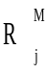 (C),M{}keywords(C)=keywords((C)))
/*Expansion rule*/
And (size of C< T) then{
If 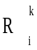 is adjacent to in C=[…] then C 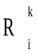[[…]]
Put C in Q
}
else ignore } }
Figure 3. 3 Algorithm for Generating the Candidate Networks
The candidate network generation algorithm is shown in Figure3. First , we create the tuple set graph G_{TS}. A node is created for each no-empty tuple set , including the free tuple sets. An edge 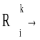 is added if the schema graph G has an edge 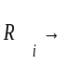 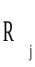. The algorithm is based on a breadth-first traversal of G_{TS}. We keep a queue Q of “active” joining networks of tuple sets. In each round, we pick from Q an active joining network of tuple sets J and either (i) discard J because of pruning condition or (ii) output J as a candidate network or (iii) expand J into larger joining networks of tuple sets (and place them in Q). We start the traversal from all tuple sets that contain a randomly selected keyword k_{t} {k_{t} ,…,k_{m}}.
- Pruning Condition
- The condition that the joining networks of tuple sets contain non-free tuple set more than once.
- Acceptance Condition
- The joining network of tuple sets J contain at least two keywords, that is, keywords (J)= {k_{t} ,…,k_{m}}.
- Expansion Rule
- The size of joining network of tuple sets must not exceed the constant (T). For example T=3 or 4 etc… based on the database schema.
3.5 Query Processor
In this stage, the joining tuple sets are input to the query processor. We put one joining tuple set for each time. The query processor accepts them if the output result is fewer than k, that is, top-k. And then it executes the parameterized query. For this, we prepare in advance a parameterized query that performs appropriate joins.

3.5.1 Query Language
A query is the formulation of a user information need. A database retrieval system should define the syntax and semantics of the query language it supports. The most elementary keyword-based query form is single-word query. Other basic keyword-based query forms include phrase query, proximity query, Boolean query, and pattern matching [2].
In our proposed system, we implement SQL as query language. SQL (Structured Query Language) is a database computer language designed for managing data in relational database management systems (RDBMS), and originally based upon Relational Algebra. Its scope includes data query and update, schema creation and modification, and data access control. SQL was one of the first languages for relational model and became the most widely used language for relational databases.
The SQL language is sub-divided into several language elements, including:
- Clauses which are in some cases optional, constituent components of statements and queries.
- Expressions which can produce either scalar values or tables consisting of columns an rows of data.
- Predicates which specify conditions that can be evaluated to SQL, Boolean truth values and which are used to limit the effects of statements and queries, or to change program flow.
- Queries which retrieve data based on specific criteria.
- Statements which may have a persistent effect on schemas and data, or which may control transactions, program flow, connections, sessions, or diagnostics.

CHAPTER 4
IMPLEMENTATION
4.1 Introduction
In our proposed system, there are two parts or modes. They are search mode and administrator mode.
In search mode, user can give a sentence as an input. This sentence contains name of disease, symptoms, or chemical name that is part of the information that he wants to know. The system returns the ranked result and allows user to choose top-k result. Our system can support top-5 result. By default, user can get the information of the medicine that is the top-1 result. If user wants to see the other results, the system allows top-5 result to user.
In administrator mode, the authorized person can only visit. He has the permission of updating the medicine data. This mode provides the features such as, inserting new medicine products, deleting the products that is not required or no longer used, showing the detail information of each medicine products.
This system is implemented in java language and connected to the RDBMS through JDBC (java database connectivity).

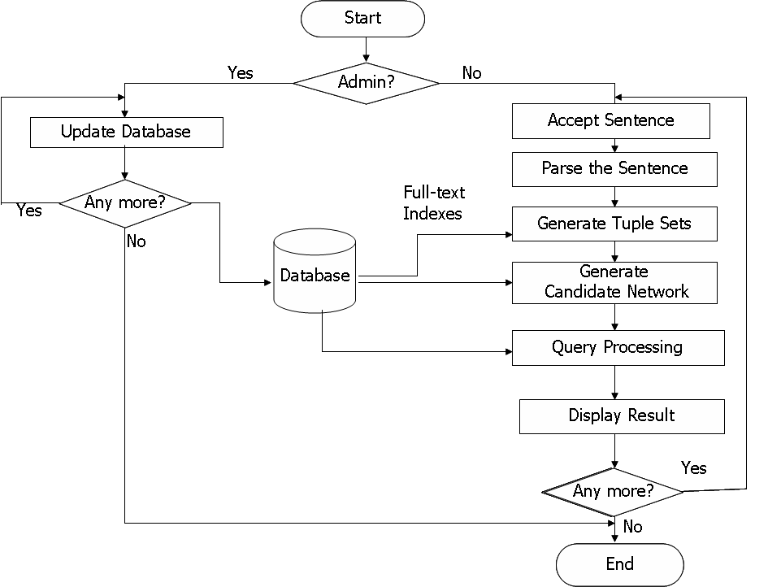

Figure 4.1 System Flow Diagram

4.2 Database Design
We create a medicine database with three tables: Product table, Manufacture table and Group table. Each table has tupleId attribute to identify each individual tuple.
4.2.1 Product table
The product table has six attributes. The attributes "Indication" and "Product_Name" have the text attribute values.
tupleId | PId | Product_Name | Indication | GId | MId
p001 | 1 | Chericof | Used for symptomatic treatment of acute inflammation of upper respiratory tract(rhinitis, sinusitis and tracheitis ), especially associated with allergy and symptomatic treatment of common cold | 1 | 1
p002 | 2 | Enervon-C | Provides the body with optimum energy build-up and strengthens the body defenses against stress in periods of rapid growth and development, physical and mental strains. Pregnancy and lactation; cardiovascular, gastrointestinal and hepatic disorders; acute and chronic infections; hyperthyroidism, febrile and toxic conditions; traumatic injuries, burns and fractures; and before and after surgical interventions. | 2 | 1
p003 | 3 | BETADINE | Degerming of the skin preoperatively and postoperatively for major and minor surgical procedures, for preoperative scrubbing and washing by surgeons and theatre staff, or throat and mouth infections, vaginal infections, for the prevention of infections in cuts and abrasions, minor surgical procedures and burns, depending on the presentation used. | 3 | 2
p004 | 4 | GINSOMIN | Provides ginseng, vitamins and mineral supplement in the relief of fatigue and stress. | 4 | 3
p005 | 5 | Air-X | Accumulation of gas in the gastrointestinal tract: sensation of pressure and fullness in epigastrium; temporary meteorism following dietary indiscretions or lack of physical exercise, postoperative meteorism ; gastro-cardiac syndrome; in preparation for x-ray examination ( stomach, intestine, gallbladder, kidney) and before gastroscopy. | 5 | 2
Figure 4.2 Product Table
4.2.2 Group Table
The Group table has four attributes. The attributes "Ingredient" and "Dosage" have text attributes values.
tupleId | GId | Ingredient | Dosage
g001 | 1 | Chlorpheniramine maleate BP 8mg, Paracetamol BP 200mg. Phenylephrine hydrochloride BP 25mg | For adults and children 12 years and over, the recommended dose is 1 capsule every 12 hours for 1-3 days for the treatment of common cold,3-6 days for allergic rhinitis,6-12 days for the treatment of sinusitis and 30 days for chronic rhinitis .
g002 | 2 | Vitamins B-complex , and C. | 1 filmcap daily, or as prescribed by the physicians.
g003 | 3 | Povidone-iodine. | Dependent on the presentation used. In general, the preparation should be applied full strength and according to the instructions provided on the labeling.
g004 | 4 | Extract of Panax ginseng, multivitamins and minerals. | 1 cap daily or as directed by the physicians.
g005 | 5 | Simethicone alone, or with silicon dioxide. | Tablet:1-2 tabs to be thoroughly chewed after meals in preparation for x-rays, 2 or 3 days before examination.
Figure 4.3 Group Table
4.2.3 Manufacture Table
The Manufacture table has four attributes. The attributes "Company" and "Country" have the text attribute value.
tupleId | MId | Company | Country
g001 | 1 | Ranbaxy | India
g002 | 2 | United Lab | Malaysia
g003 | 3 | Mundipharma | USA
g004 | 4 | Rx Co.Ltd | Thailand
g005 | 5 | Mega Products Ltd | USA
Figure 4.4 Manufacture Table

4.3 Interface Design
4.3.1 Home Page
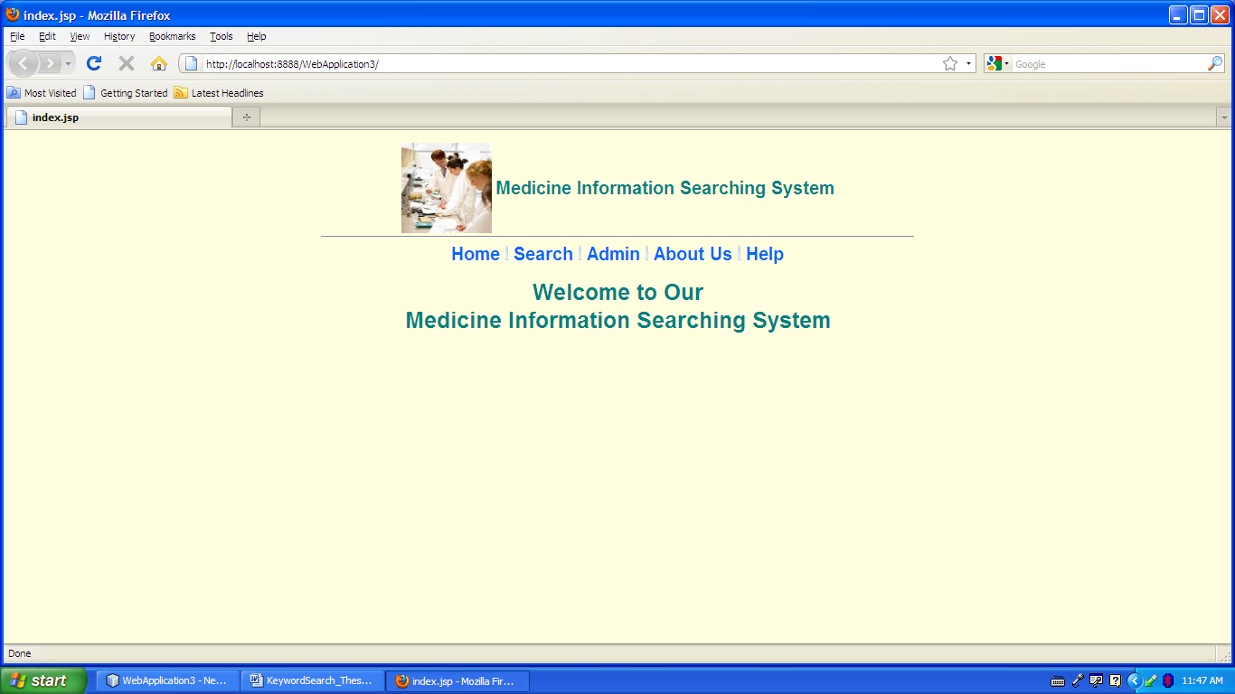
Figure 4.5 Home Page
This is the first page from our proposed system. It shows "Welcome to Our Medicine Information Searching System" text. From this page, user can navigate search page, admin page, about us page and help page.

4.3.2 Search Page
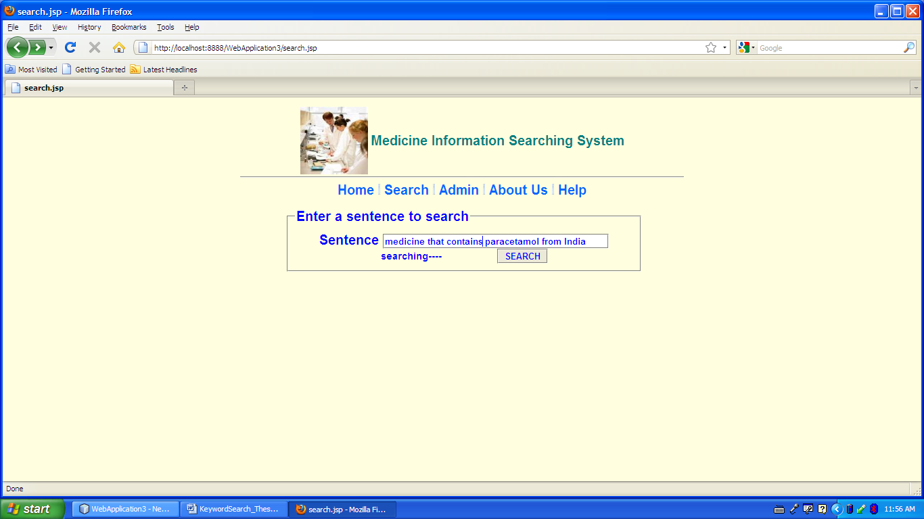
Figure 4.6 Search Page
When user navigate search page, this page will be appeared. User can enter a sentence that contains name of diseases, symptoms, or chemical name that is part of the information that he wants to know. If user clicks SEARCH button without entering any word or sentence, "please enter a sentence to search" will be appeared. In Figure 4.6, we show the example of entering a sentence "medicine that contains paracetamol from India" and the clicking of SEARCH button.

4.3.3 Result Page
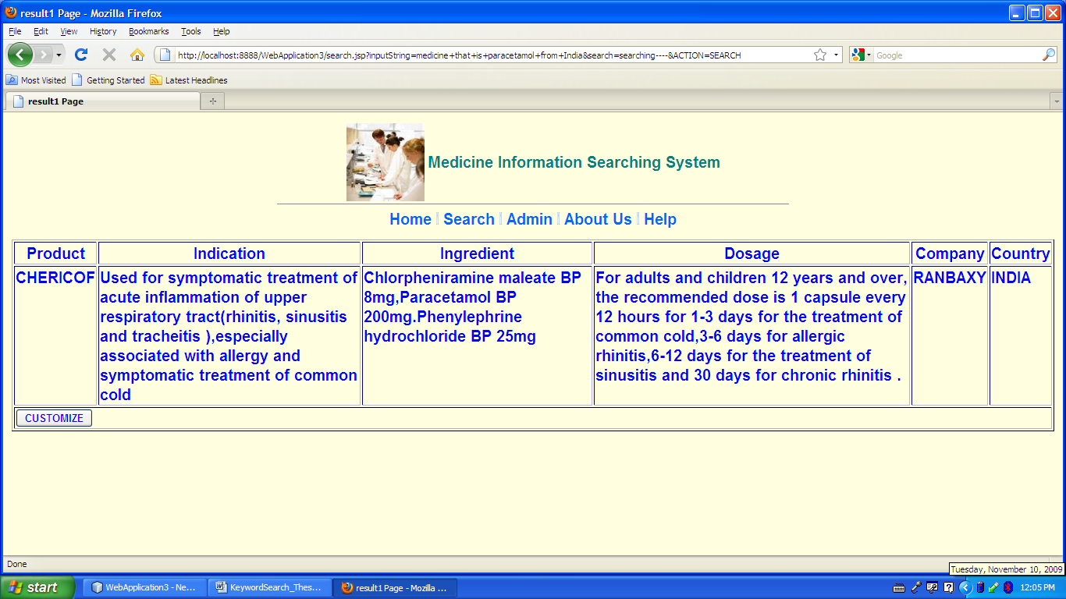
Figure 4.7 Result Page
This is the Result Page when user enter the sentence "medicine that contains paracetamol from India". The result is displayed in table with six fields- Product, Indication, Ingredient, Dosage, Company and Country. This is the result with the highest score , that is, top-1 result. If user want to see the other result, he can navigate the customize page by CUSTOMIZE button.

4.3.4 Customize Page
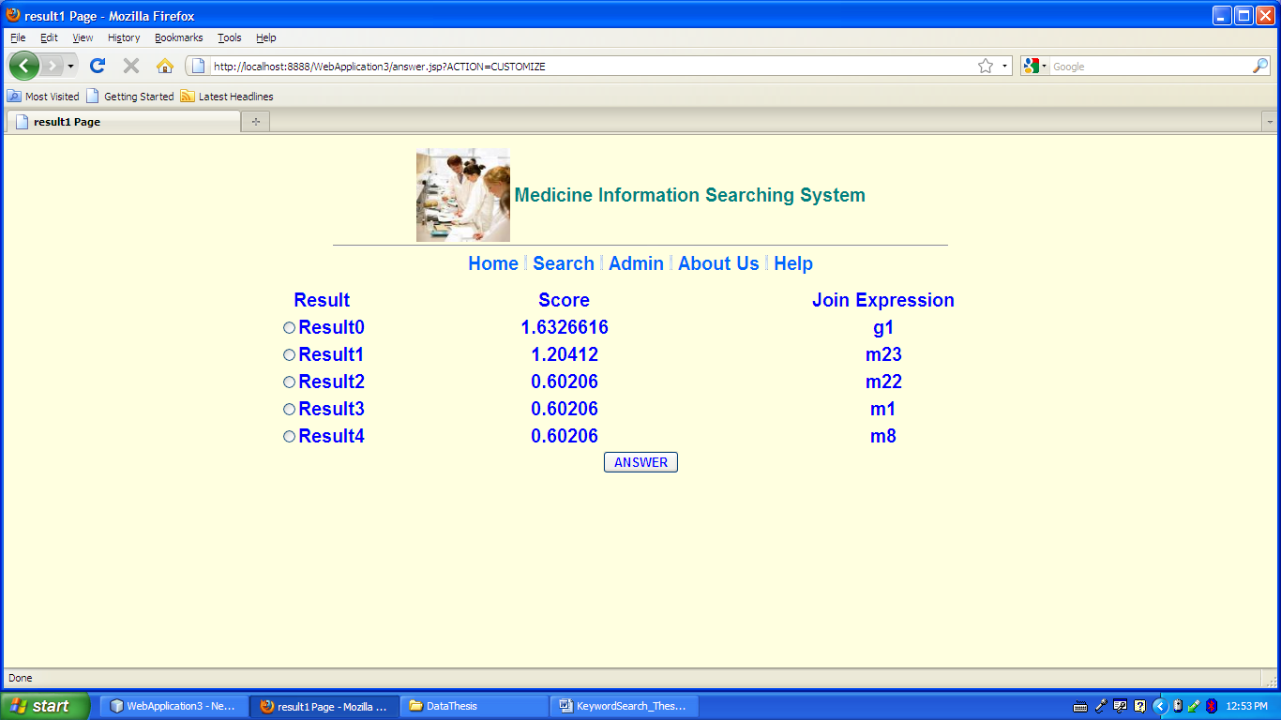
Figure 4.8 Customize Page
This page will be displayed when user navigates the customize page from result page by clicking the CUSTOMIZE button. The page shows top-5 result of the input string. The score and the join expression of each result is described. User can search the answer of each result expression by choosing the radio button and clicking the ANSWER button.

4.3.5 Admin Page
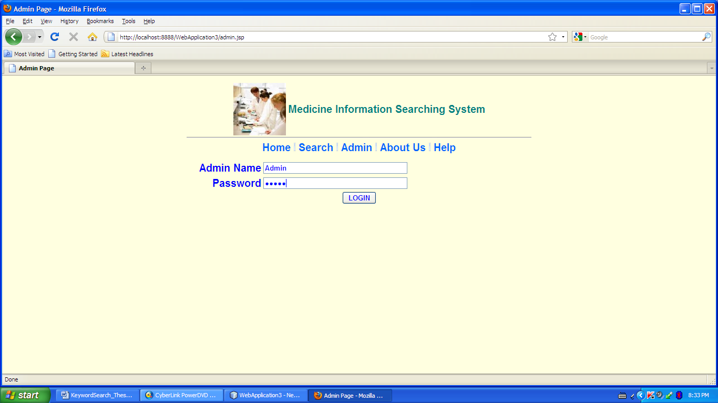
Figure 4.9 Admin Page
This is the admin page that allows the authorized person only. The user that have the admin name and password is allowed. If the login is succeed, the update page will be entered.

4.3.6 Update Page
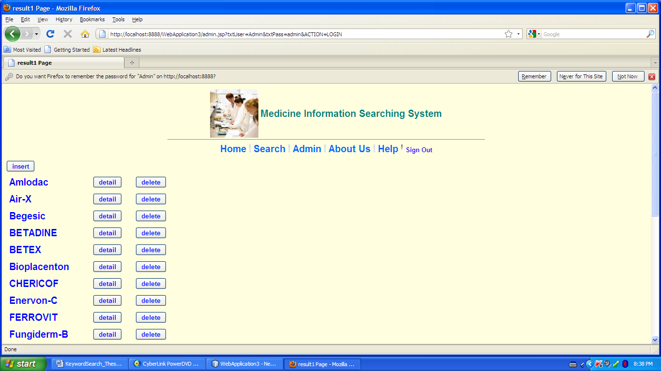
Figure 4.10 Update Page
The update page is displayed when the admin login is succeed. The features of this page are inserting data, describing the detail of each medicine product and deleting each product that is not required or no longer used.

4.3.7 Detail Page
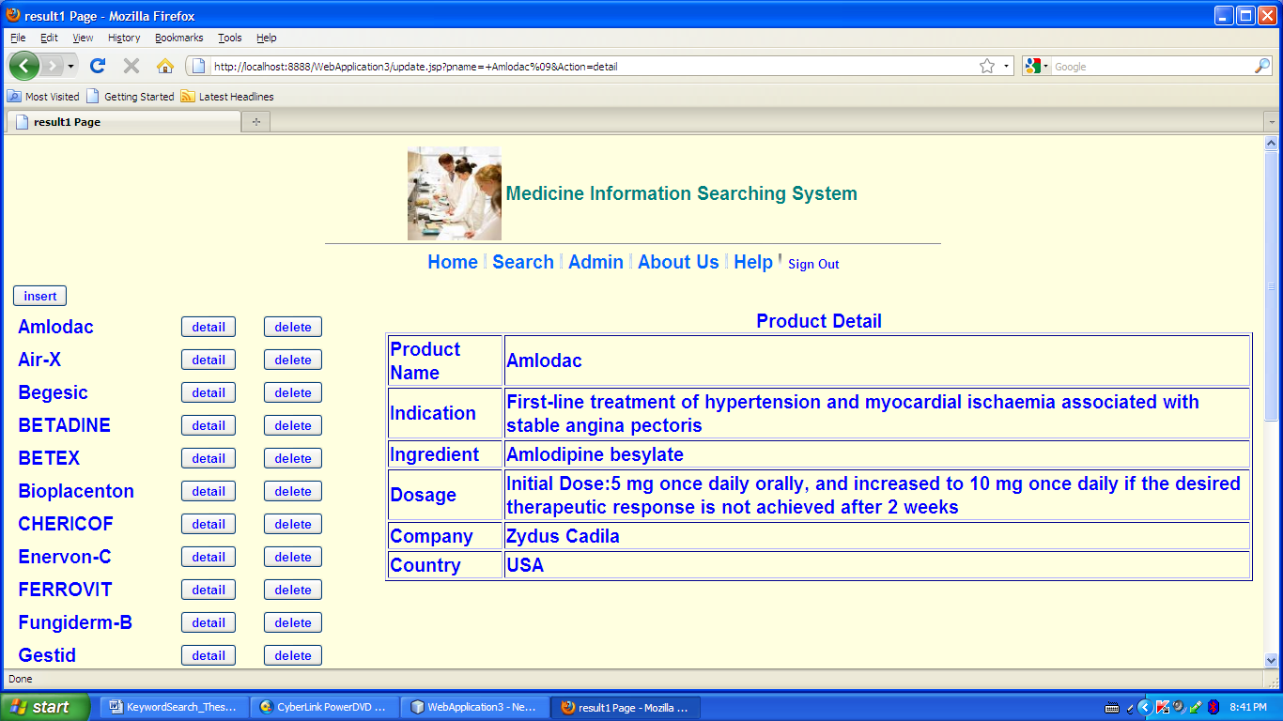
Figure 4.11 Product Detail Page
This page is navigated by clicking the detail button of medicine "Amlodac". The detail description of medicine is showed.

4.3.8 Insert Page
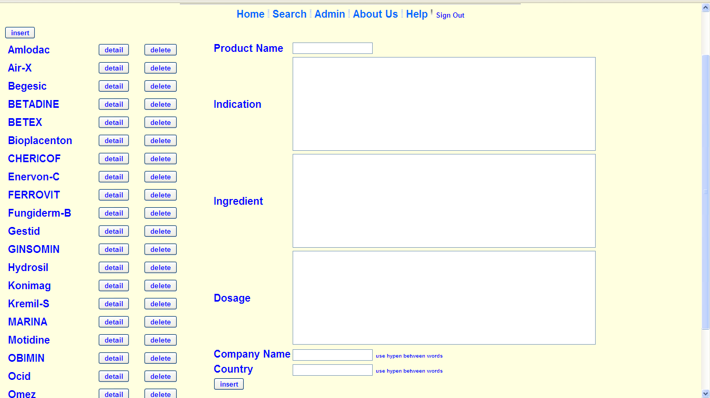
Figure 4.12 Insert Page
This page is navigated by clicking the insert button from the update page. The insert form is appeared. User must fill all fields. The product must be the new product that is not in the medicine database.

4.3.9 Help Page
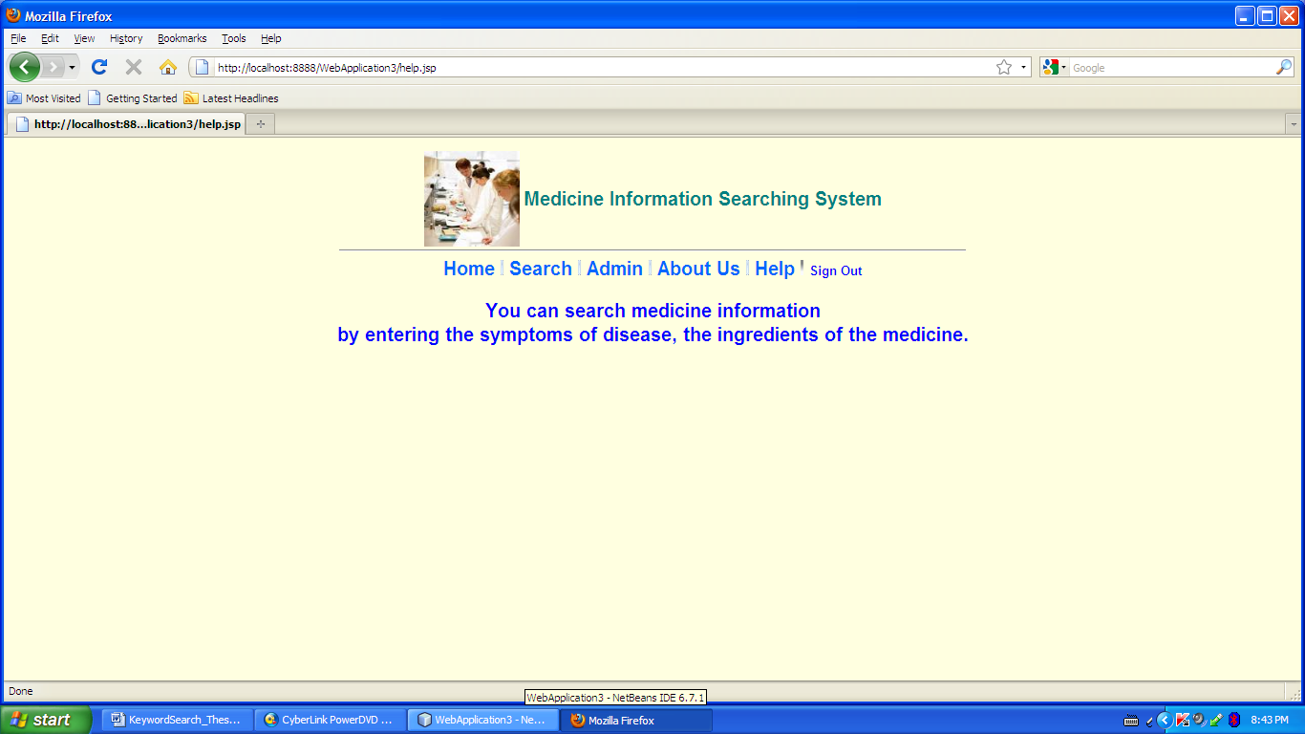
Figure 4.13 Help Page
This page is navigated by clicking the Help tag. User can see the guideline of how to search medicine information.

4.3.10 About Us Page

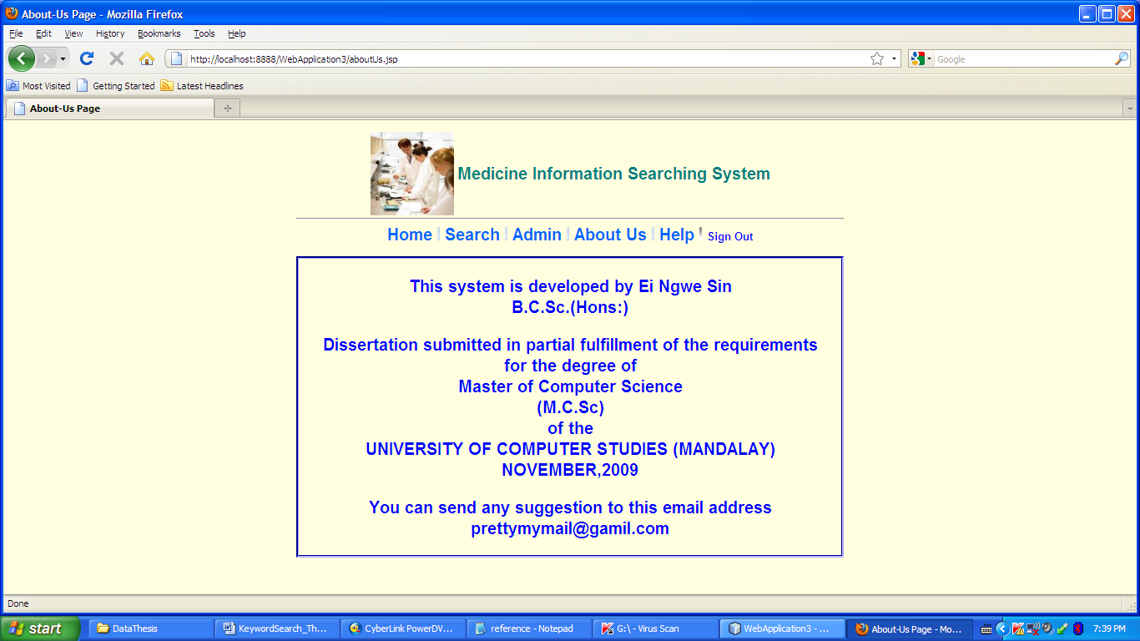
Figure 4.14 About Us Page

This page is navigated by the About Us tag. It displays the information of the history of the system .

CHAPTER 5
CONCLUSION
As the amount of information stored in databases increases, the need for efficient information discovery from such databases is dramatically increasing. Keyword search enables information discovery without requiring from the user to know the schema of the database, SQL or some QBE-like interface[4], and the roles of the various entities and terms used in the query.
In this thesis, we presented a medicine information searching system that is based on free-form keyword search strategies. The input query in our system is simply a list of keywords, and does not need to specify any relation or attribute names. The answer to such a query consists of a rank of joining expression which includes tuples from multiple relations. These tuples are combined via joins. We used a ranking function called "state-of-the-art IR definition". This function leverages and extends the ability of underlying relational database systems to provide keyword search on individual text attributes and rank tuples accordingly.
5.1 Benefits of Thesis
From the technical point of view, this thesis is the implementation of the free-form keyword search strategies over RDBMS. Firstly, we gain more knowledge of keyword search technology. We also have a chance to study the problems and difficulties of applying keyword search over RDBMS. Moreover, we can learn the algorithms, methods and strategies that is used to apply keyword search over RDBMS.
From the application point of view, this system is an information retrieval (IR) system. This system is intended to use in medical field. The user may be any person who wants to get the medicine information. User can get medicine information by entering keywords only. Instead of interacting with medicine specialists, our system can give information immediately. Thus, our system saves time and money.
5.2 Limitations of the Thesis
- This system is only intended to retrieve information from medicine database. It cannot be used for multiple RDBMSs.
- The information can be retrieved literally.
- Identifying keywords requires more effective methods.
5.3 Further Extension
- More efficient ranking functions must be developed and may be added to the system because the relevancy of the answer is the important part of the system.
- We have to do more extensive experiments on different real databases.
- We will also consider more complex situation such as keyword search in multi-database with semantically related information but different structure.

