PE_PRN212_SU25_TrialTest  
SPRING 2025  
Subject: PRN212  
Duration: 85 minutes

**INSTRUCTIONS**

**Please read the instructions carefully before doing the questions.**

* You are **NOT allowed** to use any other materials. You are **NOT allowed** to use any device to share data with others.
* You must use IDE as **Visual Studio 2019 or later, MSSQL Server 2016** **or later database** for your development tools.

**IMPORTANT – Before you start doing your solution, MUST do the following steps:**

1. To do your program, you must use **Windows Presentation Foundation (WPF), apply 3-Layer architecture**, there are at least 2 Projects fortheSolution*. The database connection string must get from appsettings.json file.*

***In the case your program connects directly to database from WPF Windows/Pages or you hardcode connection string, you will get 0 point.***

1. Create Solution in Visual Studio 2019/2022 named **PE_PRN212_SU25_TrialTest_StudentName**. Inside the Solution, Project WPF named: **ResearchProjectManagement_StudentCode.**
2. Create your MS SQL database named **SU25ResearchDB** by running code in script **SU25ResearchDB.sql.**
3. Set the default user interface for your project as **Login** window/page.
4. ***If there are syntax errors or compilation errors in your PE program, you will not pass the PE requirements, the point will be 0.***
5. ***Your work will be considered invalid (0 point) if your code inserts stuff that is unrelated to the test.***

Create an application using **Windows Presentation Foundation (WPF)** with .NET8/ .NET9, C#, and Entity Framework Core. A MS SQL Server database will be created to persist the data and it will be used for reading and managing data.

The below Figure is a part of **SU25ResearchDB** database.

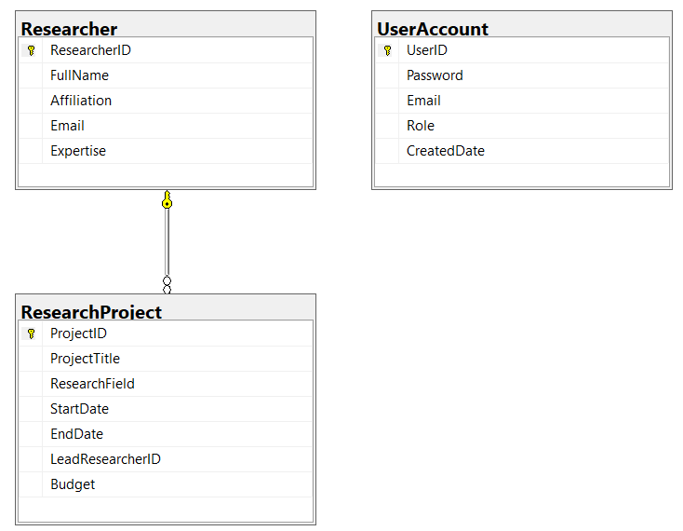

Note that: *Role: Administrator = 1; Manager = 2; Staff = 3; Member = 4.*

1. **(0.5 point)** Design Login Window/Page includes UI controls for login function.

|  |  |
| --- | --- |
| ***Object Type*** | ***Properties*** |
| Window | Title: **Login Window SU 2025**  Height: **400**  Width: **700**  FontFamily: **Tahoma**  FontSize: **26**  Background: **#FFF5F5DC**  WindowStartupLocation: **CenterScreen** |
| Label | FontFamily: **Arial**  FontSize: **24**  Foreground: **#FF6B705C** |
| TextBox | Height: **32**  Background: **#FFFFF8EB** |
| Button | Padding: **10**  Background: **#FFB38B82**  Foreground: **#FFFFFFFF (White)** |

***Table 1. Properties of Login Window/Page***

1. **(1.0 point)** The permissions are defined in Table 2, you must use email/password for the *authentication/authorization* process.

|  |  |  |  |  |
| --- | --- | --- | --- | --- |
| ***Role***  ***Function*** | ***Administrator*** | ***Manager*** | ***Staff*** | ***Member*** |
| ***Create*** | 🗸 | 🗸 |  |  |
| ***Update*** | 🗸 | 🗸 |  |  |
| ***Delete*** | 🗸 |  |  |  |
| ***View list of items*** | 🗸 | 🗸 | 🗸 |  |
| ***View detail of an item*** | 🗸 | 🗸 | 🗸 |  |
| ***Search*** | 🗸 | 🗸 | 🗸 |  |

***Table 2. Permissions to implement functions in the test***

* *The Create, Update functions for ResearchProject are required Manager role or Administrator role*.
* *The Delete functions for ResearchProject are required Administrator role*.
* *The search and View list, View detail functions for ResearchProject are required Administrator or Manager role or Staff role*
* Other role (*Member role*) cannot do any functions in this case. Display *“You have no permission to access this function!”*.
* No Authentication *“Invalid Email or Password!”*.
* If login is successful, the main **Research Project Management Window/Page** will open, otherwise you must be shown a suitable message.

1. **(1.0 point)** Design **Research Project Management** Window/Page, This window/page includes UI controls for CRUD actions with **ResearchProject** information. Note: The **LeadResearcherID/FullName** will come from the **Researcher** table. Design a window that allows you to view the list of records, create a new item, update an existing item, and delete a specific item.

|  |  |
| --- | --- |
| ***Object Type*** | ***Properties*** |
| Window | Title: **Research Project Management - SU 2025**  Height: **500**  Width: **800**  FontFamily: **Tahoma**  FontSize: **13**  Background: **#FFF5F5DC**  WindowStartupLocation: CenterScreen |
| Label | FontFamily: **Arial**  FontSize: **12**  Foreground: **#FF6B705C** |
| TextBox | Height: **14**  Background: **#FFFFF8EB** |
| Button | Padding: **5**  Background: **#FFB38B82**  Foreground: #FFFFFFFF (White) |

***Table 3. Properties of Research Project Management Window/Page***

1. **(1.5 points)** *Please check the permissions listed in Table 2; In case you do the authentication/authorization wrong, you will not get any points for this section;* Display a list of all research projects from the **ResearchProject** table along with the *FullName* of the *LeadResearcher* from the **Researcher** table.
2. **(1.5 points)** *Please check the permissions listed in Table 2; In case you do the authentication/authorization wrong, you will not get any points for this section;* Search the *research projects* by *Project Title* **OR** *Research Field* using a relative search. The UI for this function contains only **one** input field. In case you do the authentication/authorization wrong, you will not get any points for this section.
3. **(1.0 point)** *Please check the permissions listed in Table 2; In case you do the authentication/authorization wrong, you will not get any points for this section.* Delete the selected item(s) with the confirmation then update the list of *items*.
4. **(2.0 points)** *Please check the permissions listed in Table 2; In case you do the authentication/authorization wrong, you will not get any points for this section*; Implement the add new item function with the following *requirements:*

* The *LeadResearcherID / FullName* will come from the **Researcher** table (you can use ComboBox UI control in this case)
* All fields are required.
* StartDate must be earlier than EndDate.
* *ProjectTitle* must be between 5 and 100 characters. Each word in the *ProjectTitle* must start with a capital letter or a digit (1-9). *ProjectTitle* cannot contain special characters such as $,%,^, @.

1. **(1.5 points)** *Please check the permissions listed in Table 2; In case you do the authentication/authorization wrong, you will not get any points for this section.* Update an existing item with the *same validation requirements with* the *Add*function.

Note: You can use your different Window/Page or use the data grid view for this update function (update by *ProjectID*).

.