**DISTRIBUTED SYSTEMS**

**Assignment 4**

**Service Oriented**

**Distributed Systems**

**SOA web services**

**Student: Nagy Imola**

**Group: 30241**

**Date: 27.11.2018**

1. Conceptual Architecture

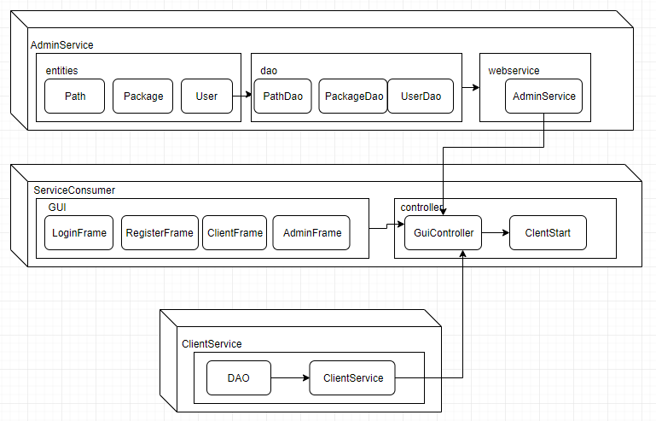

Figure 1. Conceptual architecture

1. Deployment Diagram

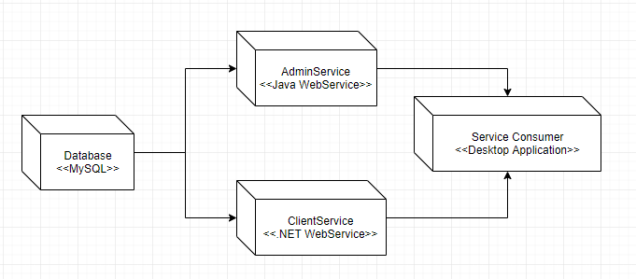

Figure 2. Deployment Diagram

1. Database diagram

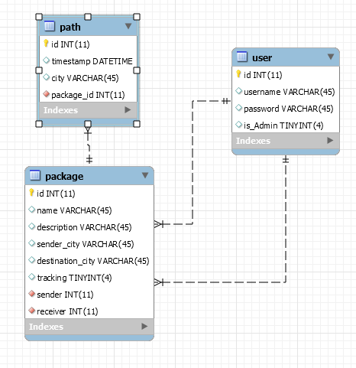

Figure 3. Database diagram

1. Readme

* Import the database to MySQL Workbench.
* Open and start the client service with VisualStudio 2017 editor.
* Open and start the admin service with Intelij IDEA editor.
* Open and start the application from Intellij IDEA editor.
* If you are a client, log in with credentials or register. You can see your sent and ordered packages and you can also follow the path of a package.
* If you are an administrator log in with credentials. You can see the clients, add/remove packages, register a package for tracking, add node to, or just check the path of a package.