TUNKU ABDUL RAHMAN UNIVERSITY OF MANAGEMENT AND TECHNOLOGY
FACULTY OF COMPUTING AND INFORMATION TECHNOLOGY
BMMS2094 STATISTICS FOR DATA SCIENCE
GROUP ASSIGNMENT REPORT
Forecasting Monthly Solar Irradiance in Kuala Lumpur
NASA POWER evidence for renewable-energy planning
Dataset
NASA POWER Monthly API: ALLSKY_SFC_SW_DWN, 2001-2025
Member | Student ID | Signature | Contribution
[MEMBER 1 NAME] | [ID] | [SIGNATURE] | 25%
[MEMBER 2 NAME] | [ID] | [SIGNATURE] | 25%
[MEMBER 3 NAME] | [ID] | [SIGNATURE] | 25%
[MEMBER 4 NAME] | [ID] | [SIGNATURE] | 25%
Semester I, Session 2026/2027
Submission date: [INSERT DATE]

Forecasting Monthly Solar Irradiance in Kuala Lumpur
A comparative R analysis of 300 NASA POWER observations
ABSTRACT
This study forecasts monthly all-sky surface shortwave downward irradiance for Kuala Lumpur using 300 NASA POWER observations from 2001-01 to 2025-12. Four course-aligned models and a seasonal-naive benchmark were evaluated on 2024-2025. SARIMA achieved the lowest RMSE (0.201 kWh/m2/day), MAE (0.162) and MAPE (3.51%). Its residual Ljung-Box p-value was 0.223. The 2026 forecast preserves pronounced seasonal resource variation. The results can support preliminary solar planning but do not represent site-specific generation or climate-change attribution.
Keywords - NASA POWER, solar irradiance, renewable energy, SARIMA, SDG 7.
I. INTRODUCTION
Reliable expectations of solar-resource seasonality support renewable-energy planning, maintenance scheduling and capacity assessment. NASA POWER provides analysis-ready solar and meteorological time series globally [1]. This study asks which syllabus-aligned model most accurately forecasts Kuala Lumpur's monthly solar irradiance and what the forecast implies for resource variability.
II. OBJECTIVES
The objectives are to (1) retrieve and validate a reproducible NASA POWER series; (2) describe trend, seasonality and serial dependence; (3) compare four forecasting methods using a recent holdout; and (4) interpret the 2026 forecast for renewable-energy planning without equating irradiance with electricity output.
III. DATASET AND SDG ALIGNMENT
The target is ALLSKY_SFC_SW_DWN at 3.1390 N, 101.6869 E. NASA reports monthly average daily solar energy in kWh/m2/day [1], [2]. The JSON response contains annual YYYY13 entries, which were removed. The resulting January 2001-December 2025 series has 300 continuous months and no -999 fill-value gaps. The study aligns primarily with SDG 7.2 on increasing renewable energy's share [3].

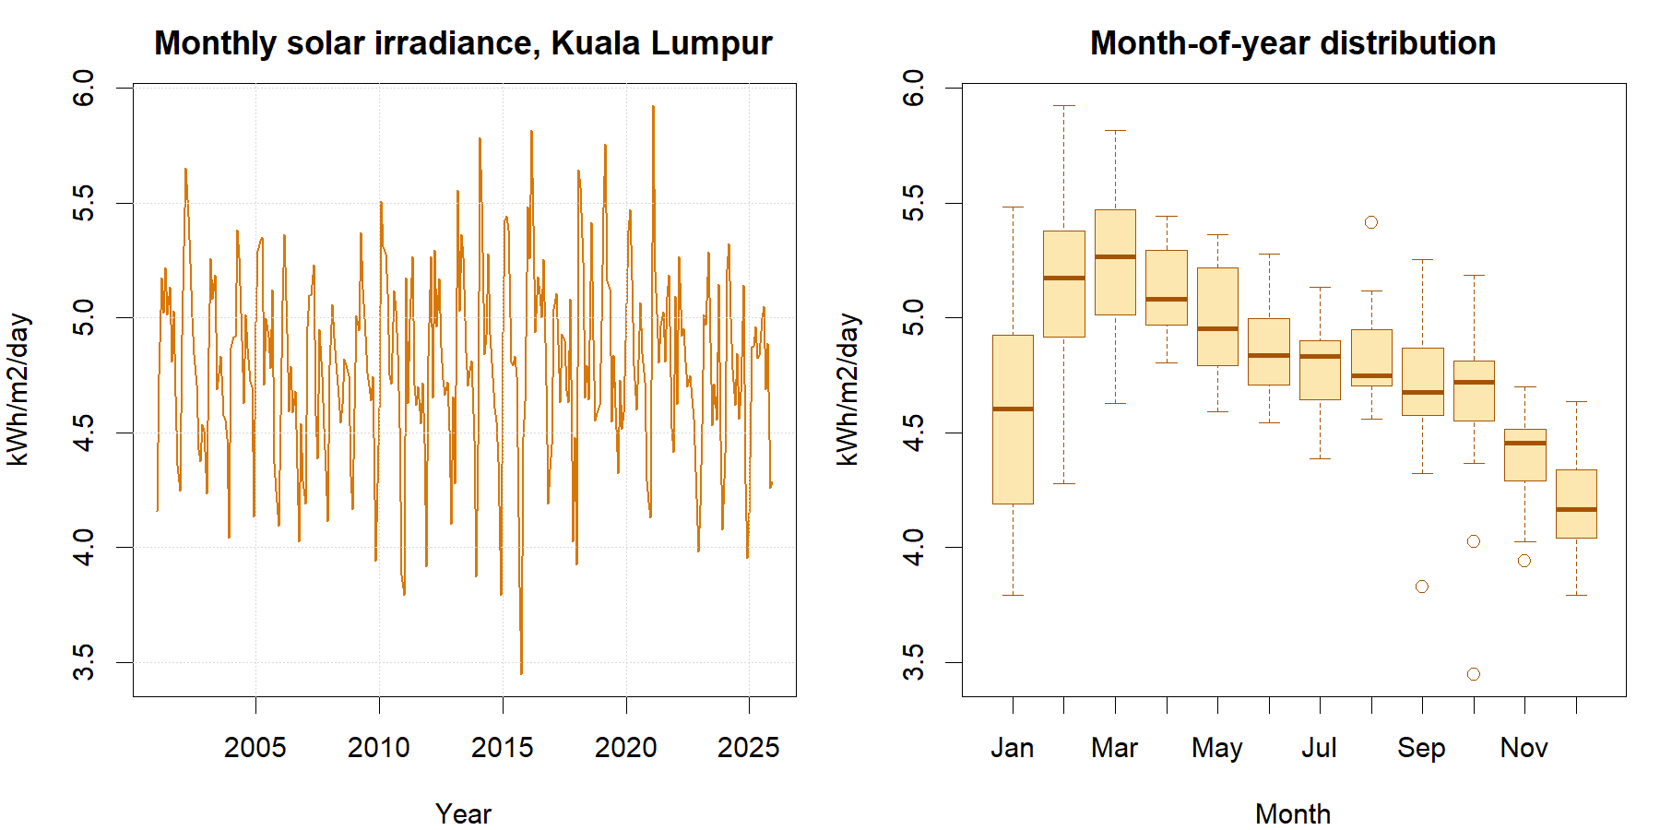
Fig. 1. Monthly Kuala Lumpur solar irradiance and seasonal distribution.
IV. DESCRIPTIVE FINDINGS
Average irradiance was 4.793 kWh/m2/day, with a standard deviation of 0.406. Observed values ranged from 3.448 to 5.924. Calendar-month averages peaked in Mar at 5.246 and were lowest in Dec at 4.200 kWh/m2/day, demonstrating a clear annual cycle.
V. DATA PREPARATION
The R script retrieves and preserves the official JSON, extracts monthly parameter values, removes YYYY13 annual records, converts YYYYMM keys to dates, maps -999 to missing, and checks the expected 300-month calendar, duplicates, gaps and physical range. No interpolation was required.
VI. EXPERIMENTAL DESIGN
January 2001-December 2023 formed the training set; January 2024-December 2025 was an untouched 24-month test. Member assignments are trend-plus-season regression, additive Holt-Winters, ETS, and SARIMA. Seasonal naive is shared. Accuracy is assessed with MAE, RMSE, MAPE, MASE and sMAPE, followed by residual ACF and Ljung-Box diagnostics.
SARIMA stabilisation: the selected ARIMA(1,0,0)(2,1,0)[12] uses d = 0 because no ordinary trend difference was selected, but D = 1 applies the seasonal difference Delta[12] y(t) = y(t) - y(t-12). This removes the repeating annual level before the autoregressive terms are estimated. The period [12] represents monthly data with one yearly cycle; forecasts are subsequently returned to the original kWh/m2/day scale.
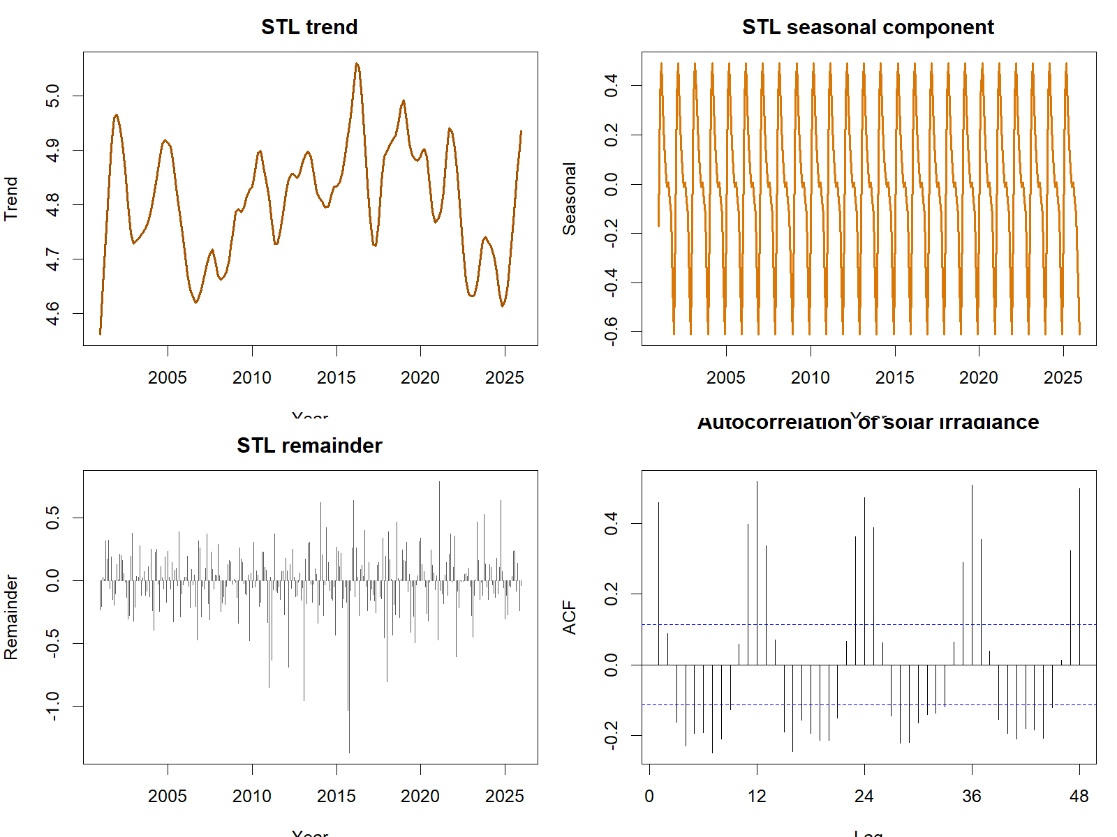
Fig. 2. STL decomposition and autocorrelation of solar irradiance.

VII. FORECAST ACCURACY
Model | Train  MAE | Test  MAE | Train  RMSE | Test  RMSE
SARIMA | 0.226 | 0.162 | 0.309 | 0.201
Holt-Winters | 0.237 | 0.168 | 0.306 | 0.211
ETS | 0.044 | 0.193 | 0.058 | 0.230
Trend + season | 0.215 | 0.201 | 0.279 | 0.240
Seasonal naive | 0.300 | 0.232 | 0.403 | 0.287
TABLE I. Training residual accuracy versus untouched 24-month test accuracy.
SARIMA ranked first with RMSE 0.201, MAE 0.162, MAPE 3.51% and MASE 0.539. Its training RMSE was 0.309 versus test RMSE 0.201. Holt-Winters was close behind on the test set with RMSE 0.211. Training figures are in-sample residual errors, while test figures measure forecasts for unseen months; model selection therefore uses test RMSE. Seasonal naive had test RMSE 0.287, indicating that modelling dependence beyond a fixed annual repeat improved accuracy.
VIII. DIAGNOSTICS
The selected SARIMA specification was ARIMA(1,0,0)(2,1,0)[12]. Its Ljung-Box statistic was 28.92 with p = 0.223, providing no evidence of residual autocorrelation at lag 24. The seasonal-naive residuals remained strongly autocorrelated.
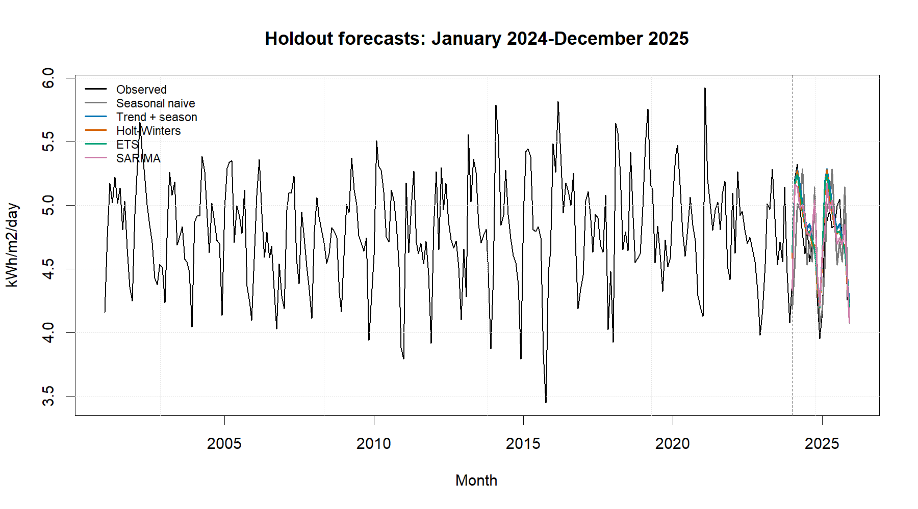
Fig. 3. Training history and common 24-month test forecasts. The dashed line marks the train-test split; coloured lines are model forecasts and black is observed data.

IX. 2026 FORECAST
Month | Forecast | 95% interval
2026-01 | 4.285 | 3.68-4.89
2026-02 | 4.816 | 4.19-5.44
2026-03 | 5.035 | 4.41-5.66
2026-04 | 4.973 | 4.35-5.59
2026-05 | 5.012 | 4.39-5.63
2026-06 | 4.814 | 4.19-5.44
2026-07 | 4.764 | 4.14-5.39
2026-08 | 4.796 | 4.17-5.42
2026-09 | 4.628 | 4.01-5.25
2026-10 | 5.053 | 4.43-5.68
2026-11 | 4.353 | 3.73-4.97
2026-12 | 4.123 | 3.50-4.75
TABLE II. SARIMA forecasts in kWh/m2/day.
The 2026 point forecasts range from 4.123 in 2026-12 to 5.053 kWh/m2/day in 2026-10. Seasonal resource variation is larger than the estimated long-run movement, supporting month-aware rather than annual-average planning.
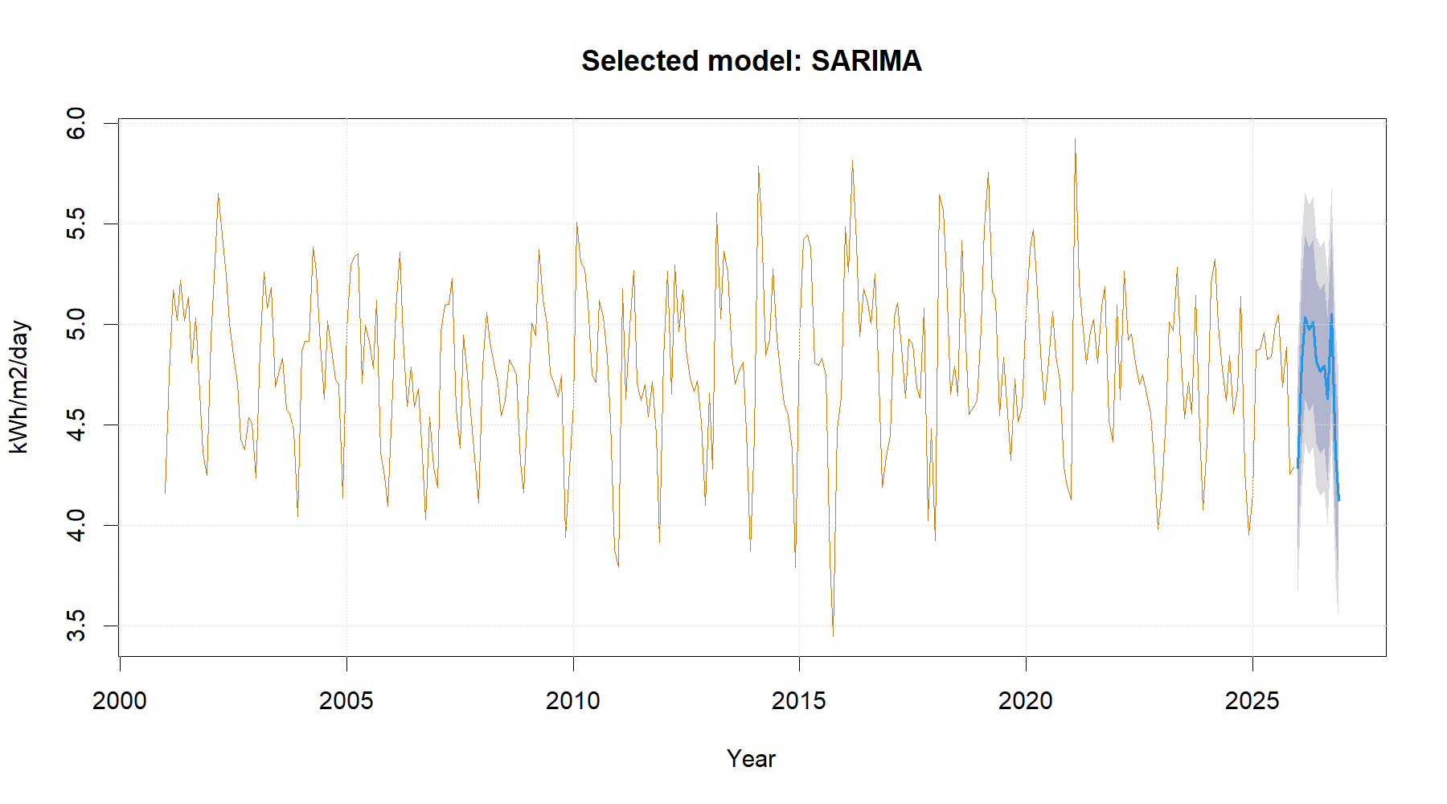
Fig. 4. Selected SARIMA forecast with 80% and 95% intervals.

X. DISCUSSION
The close SARIMA and Holt-Winters results indicate that stable annual seasonality explains much of the predictable variation, while SARIMA's seasonal differencing and autoregressive terms better captured remaining dependence. Forecasts can help frame seasonal expectations for feasibility studies, storage assessments and maintenance planning, but engineering simulations require finer-resolution and site-specific inputs.
XI. LIMITATIONS
POWER solar values represent the approximately 1-degree grid cell containing Kuala Lumpur rather than a ground station [2]. Monthly averages hide daily cloud variability and extremes. Irradiance is not electricity production: panel area, efficiency, orientation, shading, temperature, degradation and system losses are excluded. Starting in 2001 avoids the major pre-2001 source transition, but the analysis still cannot attribute changes to climate change.
XII. RECOMMENDATIONS
Use the forecast as an initial solar-resource baseline, then validate decisions against local station records and engineering yield models. Update the series annually, monitor residual diagnostics, and examine daily variability when sizing storage or backup capacity. Investment decisions should consider forecast intervals rather than point estimates alone.
XIII. CONCLUSION
SARIMA produced the best recent holdout accuracy and acceptable residual diagnostics. The 2026 results preserve meaningful month-to-month variation, offering a defensible statistical input to renewable-energy planning aligned with SDG 7.2, subject to spatial and engineering limitations.
REFERENCES
[1] NASA POWER, 'Monthly API,' 2026. https://power.larc.nasa.gov/docs/services/api/temporal/monthly/
[2] NASA POWER, 'Data Sources,' 2026. https://power.larc.nasa.gov/docs/methodology/data/sources/
[3] United Nations, 'Goal 7: Affordable and Clean Energy,' 2026. https://sdgs.un.org/goals/goal7
[4] R. J. Hyndman and G. Athanasopoulos, Forecasting: Principles and Practice, 3rd ed. OTexts, 2021.
[5] R Core Team, R: A Language and Environment for Statistical Computing. Vienna, Austria, 2026.

