Blurs an image using the normalized box filter.

The function smoothes an image using the kernel:

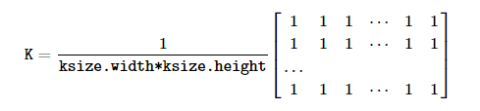

The call blur(src, dst, ksize, anchor, borderType) is equivalent to boxFilter(src, dst, src.type(), anchor, true, borderType).

**Parameters**

|  |  |
| --- | --- |
| **src** | input image; it can have any number of channels, which are processed independently, but the depth should be CV_8U, CV_16U, CV_16S, CV_32F or CV_64F. |
| **dst** | output image of the same size and type as src. |
| **ksize** | blurring kernel size. |
| **anchor** | anchor point; default value Point(-1,-1) means that the anchor is at the kernel center. |
| **borderType** | border mode used to extrapolate pixels outside of the image, see **cv::BorderTypes** |