Blurs an image using the box filter.

The function smoothes an image using the kernel:

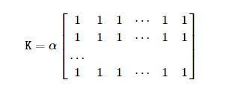

where

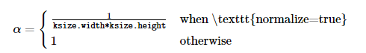

Unnormalized box filter is useful for computing various integral characteristics over each pixel neighborhood, such as covariance matrices of image derivatives (used in dense optical flow algorithms, and so on). If you need to compute pixel sums over variable-size windows, use **cv::integral**.

**Parameters**

|  |  |
| --- | --- |
| **src** | input image. |
| **dst** | output image of the same size and type as src. |
| **ddepth** | the output image depth (-1 to use **src.depth()**). |
| **ksize** | blurring kernel size. |
| **anchor** | anchor point; default value Point(-1,-1) means that the anchor is at the kernel center. |
| **normalize** | flag, specifying whether the kernel is normalized by its area or not. |
| **borderType** | border mode used to extrapolate pixels outside of the image, see **cv::BorderTypes** |